1 Title
An investigation of automatic rail lubrication and coating system
2 Introduction:
In recent years, with the rapid development of China's rail transport, passenger trains and goods trains become more and more efficient. However, the high transport speed, density and train axle weight lead to an increase in the interaction force between the wheels and rails, which aggravates the wear and tear of the rails^{[1]}. The interaction force between the rails and the train and the curve radius of the rails have a great relationship, will increases when the curve radius decreases, especially when the train in the small radius curve rail section, the wear and tear of the rails will be more serious, making frequent replacement of the rails, the cost increase, the railway capacity decrease^{[2]}. Reasonable and effective wheel and rail lubrication can reduce wheel and rail wear, energy saving and improve locomotive traction efficiency also has important significance, and can improve the safety of train operation^{[3]}. Therefore, reducing wear and extending the service life of curved rails in railway transport has become an important issue in the development of heavy-duty railway transport.
How to reduce wheel and rail wear and improve the safety of the train during travel has always been the focus of train technology research. At present, there are two main methods to reduce wheel-rail wear: one is rail grinding, this method is to carry out on-site grinding maintenance of the rail, is a common method of railway management in line maintenance operations; another method is wheel-rail lubrication, it is by changing the actual roughness of the contact surface, reduce the movement of wear, this method is widely used in many mechanical devices^{[4-5]}, these two methods are important means to solve the wheel-rail wear problem, but in the absence of effective lubrication measures, simply using rail grinding operations for line maintenance, the potential life of the rail will also lose 95%^{[6]}, therefore, wheel-rail lubrication in reducing wheel-rail wear has important significance.
3 Literature Review:
Ever since the advent of rail transport, the wear and tear of tracks and wheel edges has been a problematic issue for technicians. In order to adapt to the development process of modern society, the speed of trains is inevitable, and the key to high-speed train operation is how to reduce wheel and rail wear, to ensure the safety of traffic. Along with the rapid development of high-speed railway technology, wheel and rail lubrication technology is also becoming increasingly mature. Different design requirements of rail transport tools basically have their own different lubrication tools and lubrication methods. A variety of new lubrication devices are emerging, especially in combination with electronic control technology, automation, intelligent devices gradually become the mainstream today.
To understand the design principles of lubrication devices should first understand how the wheel track is worn. Only in theory know the principle of wear and tear, can we prescribe the right medicine, reasonable set lubrication. Generally when trains through the curve, due to the weight and speed of the train, the train body will be subject to inertial force and centripetal force, which will cause the train wheel edge partly squeezed the inner side of the track^{[7]}. In this case, the wheel rim of the train slides and rolls alongside the rail side, and this condition causes pitting or spalling of the wheel-rail surface material due to the alternating contact stresses, and this degree of wear is intense^{[8-9]}. When the train passes through the straight track, due to the wheel-rail travel gap and the conical tread design of the wheel makes the wheel easy to produce serpentine motion^{[10]}. The serpentine motion causes the train to swing laterally on one side and rotate around a plumb axis passing through its centre of gravity on the other. This type of motion causes the wheel pairs to strike the side of the rail heavily, creating impact and bringing wear at the same time^{[11]}. Reducing vehicle wear can be achieved by lubricating the wheel-rail sides, changing the wheel-rail manufacturing process, adjusting the track design parameters to make the wheel-rail fit more reasonable, and avoiding serpentine train movements^{[12-13]}. The most obvious effect of wheel-rail lubrication, lubrication of the rails can not only reduce the wear between the rails and wheels, reduce the repair and maintenance costs of the rails and wheels, reduce the use of fuel when the train is running, but also can reduce the friction coefficient between the wheel rim and the side of the rails, so that the derailment coefficient is reduced, which is of great significance for the safe operation of the vehicle.
Foreign for train wheel and rail lubrication research started earlier, track lubrication technology is also more mature. Foreign has developed a variety of high technology content of wheel and rail lubrication device, these more mature wheel and rail lubrication device are artificial rail oiling trolley, rail skid, fixed wheel-rail lubricator, on-board rim lubrication devices^{[14]}. Manual oiling trolley is the earliest applied to wheel and rail lubrication lubrication device, the structure is simple, the operation is easy, the lubrication effect is good, has a strong adaptability, can be oiled and lubricated for all sections. However, it is completely a human machine, the technology level is very low, only the trolley as a carrier, the specific lubrication operation is carried out by workers, now the manual oiling trolley is still in use, mainly for some complex sections of oiling^{[15]}. The manual oiling trolley is shown in Figure 1.1.
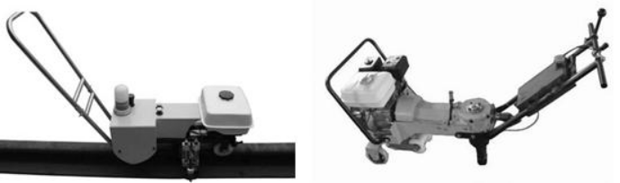Figure 1.1 Manual oiling trolley
The rail trolley is an internal combustion locomotive used to spray lubricating material onto the inner edge of the rails^{[16]}. The design idea still does not escape the limitations of manual work, but only improves the efficiency of manual work and the automation of the device. This is illustrated in Figure 1.2. At the same time greatly improve the efficiency, reduce the labour intensity, lubrication effect is very good, to PCM1 type as the representative of the rail skid is widely used in many countries in Europe, but it is complex and expensive, so the operation and maintenance costs are much more and the market competitiveness is not strong.
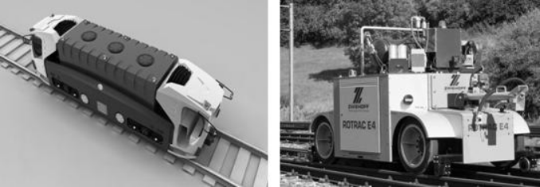
Figure 1.2 rail skid
Fixed wheel-rail lubricator is mainly the PC-5 produced in Russia^{[17]} as the main representative, which automatically sprays lubricating oil between the wheels and rails through the oil storage device installed on the shoulder or track, which can reduce the wear and driving resistance of the curved section, as shown in Figure 1.3.
The main body of the PC-5 lubricator is a lubricant suction and pressure spraying device fixed to the shoulder or track, which is connected to the oil storage device via a pipeline. This device is simple, reliable and effective and can work stably in harsh environments. The advent of new types of grease has also greatly enhanced the lubrication effect of the device.
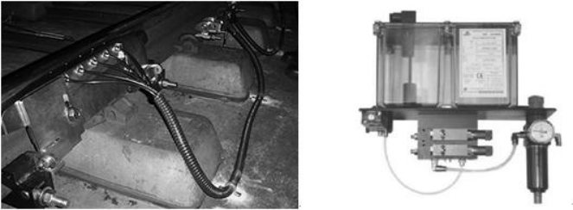
Figure 1.3 Fixed wheel-rail lubricator
On-board rim lubrication devices are installed on trains and are represented by the ATC10 rim lubricator^{[18-19]}, as shown in Figure 1.4. The principle of operation is that the lubricant is pressed into the nozzle along the pipeline from the storage container, the valve opens after receiving a sensor signal, the air compresses and pushes the plunger to move, spraying out a quantity of lubricant, and when the valve is cut off, the nozzle is reset by the action of the reset spring.
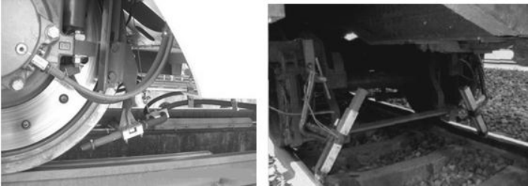
Figure 1.4 On-board rim lubrication devices
Chinese train lubrication research started late. Since the 1990s, along with the four major speed increases of Chinese passenger trains, Chinese overall train technology level has steadily improved^{[20]}, especially in recent years, focused on the development of high-speed railway construction, train lubrication device research has also entered a new stage. Traditional lubrication methods have been unable to meet the requirements of modern railway development^{[21-23]}. At present, China mainly uses vehicle-mounted rail lubrication system to lubricate and protect the rails and wheels. This lubrication system sprays lubricant or applies solid lubricating material to the top side of the rail, this operation can ensure that the lubricant does not pollute the top of the rail or the wheel tread, avoid the lubricant to have an impact on the train braking^{[24-27]}. This method has achieved better results.
However, the disadvantages of on-board lubricators in terms of use and maintenance are revealed for trains with relatively slow speeds such as urban railways or urban ordinary trains^{[28-31]}. As the metro often starting and braking, bringing vehicle-mounted lubricator a great impact, making it easy to be damaged, and urban rail transport operation for the time requirements are strict, can not ensure timely replacement and replenishment of the consumed lubricant, resulting in the loss of lubrication effect^{[32]}. At the same time, the vehicle-mounted lubrication device is not only expensive but not easy to maintain. The cost of use is high. In recent years, the rapid development of ground lubrication device, gradually become a new choice. Now put into use the ground device is mainly spraying oil and the grease lubrication^{[33-34]}, spraying oil lubrication mostly using hydraulic devices, with sensors or manual operation, lubricating within a specified time^{[35-36]}. Grease lubrication is a mainly independent design lifting device, also with all kinds of sensors, through the circuit control power unit, lifting lubrication block to achieve lubrication^{[37-38]}.
4 Methods
1. Review information related to automatic coating control. Conduct research on key technologies such as coating point determination and automatic coating control.
2. Compare different hardware control structures, analyse the advantages and disadvantages of various existing systems and determine the structure to be used for the project. Determine the chip to be used according to the selected scheme, draw circuit schematics, produce circuit boards, and conduct circuit welding and debugging.
3. Build and test the hardware platform and complete the implementation of the lower computer.
4. Determining the automatic control software requirements based on the analysis and write the upper computer using the Qt platform.
5. Conduct field operation tests on software and hardware, and complete system debugging and improvement.
Overall system framework design：
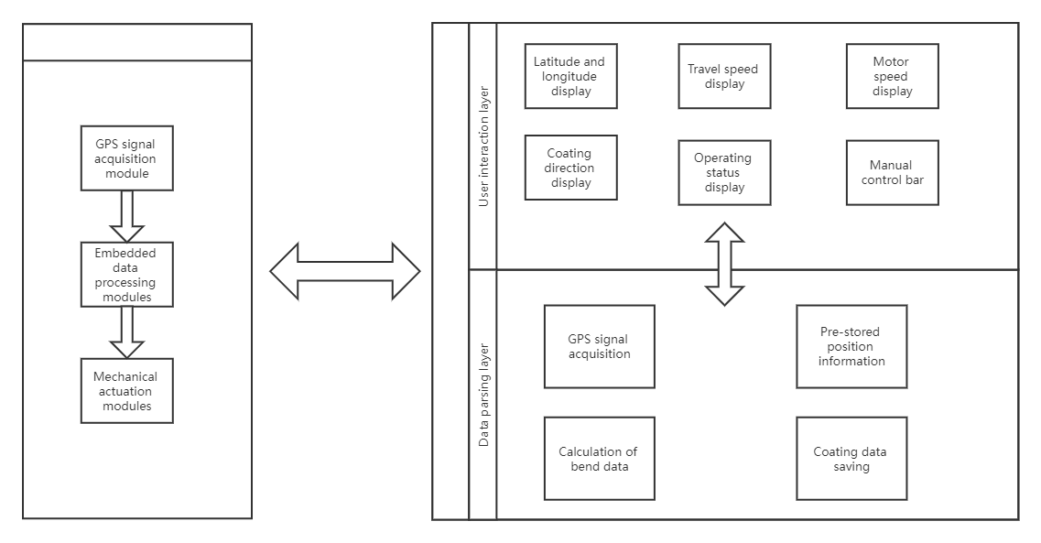
Overall flowchart：
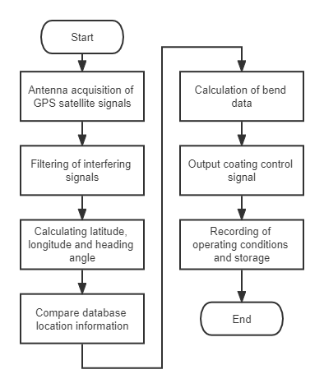
5 Results:
According to the specific functions of the equipment to complete the construction of the control platform; design the lower computer automatic coating control system hardware platform and complete the relevant driver writing; design the processing scheme of the position data, select the processing algorithm and simulation; design the upper computer program, complete the train speed and position display, route record, coating automatic control and other functions.
1. develop the design of the automatic rail lubrication and coating system, mainly the selection of the coating material and the determination of the bend identification algorithm based on the existing automatic coating device.
2. to complete the selection of chips for the main control module, power supply module, positioning module and control module according to the selected hardware structure, to design the hardware circuit and to debug the implementation.
3. designing the upper computer page through research, writing the automatic coating upper computer control software as well as debugging.
4. after completing the system hardware and software design, conduct field tests on the train and record the phenomena and data to complete the system interconnection.
6 Resources & Planing
6.1 Resources Required
Hardware resource:PC,MC9S12XET256, Applicator
software resource：Qt，codewarrior
6.2 Timeable
Start time and end time | Task
2022.03-2022.4 | Access to some relevant information
2022.04-2022.05 | Design a overall system
2022.05-2022.07 | Design circuits, write programs and test
2022.07- 2022.08 | write the paper
7 Reference
[1]Cao Aiti. Design of rail curve lubrication system [J]. Science and Technology Innovation,2019(22):177-178.
[2]Sun Guoying, Liu Xueyi, Wan Fugang. Rail wear on small radius curves[J]. Journal of Southwest Jiaotong University,2016(01):65-70.
[3]Dinh Quang Truong, Bui Ngoc Minh Truong, Kyoung Kwan Ahn et al..Development of an electronically controlled variable displacement vane pump for engine lubrication[J]. International Journal of Precision Engineering and Manufacturing, 2015, 16(9).
[4]Zhang Nian. Development of rail lubrication technology in China[J]. China Railway,2009(09):38-43.
[5]Jae-Heum Moon, Hyeong-Dae Lee, Seok-Il Kim. Lubrication characteristics analysis of an air-oil lubrication system using an experimental design method[J]. International Journal of Precision Engineering and Manufacturing, 2013, 14(2).
[6]Wang Wenbin, Fan Qinhai, Liu Li. Research on rail surface friction control technology to prevent and control side wear of curved rails [J]. Modern urban rail transportation,2015(01):78-81.
[7]Jianxi Wang,Xi Chen,Xiangguo Li,Yanjie Wu. Influence of heavy haul railway curve parameters on rail wear[J]. Engineering Failure Analysis,2015,57.
[8]Sufficient Experimental Methods in Inves-tigation of Dynamic Behavior of Track Components and Track System. Sadeghi,J. Proceeding of the 7th International Con-ference on Mechanics of Systems, University of Wol-longong . 2002
[9] Sun Hongxu, Xing Wei, Tao Lin. Research on model transformation method based on finite state machine[J]. Computer Technology and Development,2012,22(02):10-13+17.
[10]Hyun-Joon Kim, Kuk-Jin Seo, Kyeong Hee Kang et al.. Nano-lubrication: A review[J]. International Journal of Precision Engineering and Manufacturing, 2016, 17(6).
[11] Liu Yueming, Li Jianyong, Cai Yonglin, Nie Meng. Current status and development trend of rail grinding technology[J]. China Railway Science,2014,35(04):29-37.
[12] Li Xinyuan, Fan Yougang. On solid lubrication wear reduction technology for curved rails [J]. Shanxi Science and Technology,2013,28(01):67-69.
[13] Luo GW, Li W. Research on lubrication and friction control of heavy-duty railway rails[J]. Railway Construction,2011(04):114-116.
[14]Koray Kiliçay, Mustafa Ulutan. Investigation of the solid lubrication effect of commercial boron-based compounds in end milling[J]. International Journal of Precision Engineering and Manufacturing, 2016, 17(4).
[15] Zhou Liang. Experimental study on wear reduction measures for curved tracks in Shanghai metro[J]. Urban Rail Transit Research,2009,12(09):62-66.
[16] Zhang Qing. Research on the prediction of rail wear in heavy-duty railways[D]. Southwest Jiaotong University,2017.
[17] Yang Bolong. Solid lubricants and load-bearing fixtures for locomotive wheels and rails[J]. Locomotive Electric Transmission,2013(03):68-70.
[18] Huang Xinlin, Wang Gang, Liu Chungang. Application of finite state machines in microcontroller programming[J]. Journal of Harbin University of Technology,2008(04):7-9.
[19]Shaofeng Wu, Dianrong Gao, Yingna Liang et al.. Experimental study on influence of dimples on lubrication performance of glass fiber-epoxy resin composite under natural seawater lubrication[J]. Chinese Journal of Mechanical Engineering, 2017, 30(1).
[20] Lu, Quan-Sen, Li, Jun, Bao, Hong. Application of optocoupler isolation technology in intelligent measurement and control systems [J]. Mechanics and Electronics,2017(02):53-56.
[21] Cao Enping. Lepers wheel edge lubrication system[J]. Urban Rail Transit Research,2014(02):69-71+74.
[22] Zhao Qingsong,Su Min. Design and implementation of an ARM-based DC motor speed control system[J]. Microcomputer Information,2007(02):173-175.
[23]SADEGHI J.,AKBARI B..Field investigation on effects of railway track geometric parameters on rail wear[J].Journal of Zhejiang University Science A(Science in Engineering),2006(11):1846-1855.
[24] Wang S. M., Zhang J. M., Wang R. M.. Train wheel-track lubrication system based on embedded microcontroller AVR8535[J]. Automation and Instrumentation,2006(02):25-27+51.
[25]W. Zhong,J.J. Hu,P. Shen,C.Y. Wang,Q.Y. Lius. Experimental investigation between rolling contact fatigue and wear of high-speed and heavy-haul railway and selection of rail material[J]. Wear,2010,271(9).
[26] Luo GW, Li W. Research on rail lubrication and friction control for heavy-duty railways[J]. Railway Construction,2011 (04):114-116
[27] Zhang Xuehua. The utility of dry lubrication technology in rail side wear reduction [J]. Urban Rail Transit Research,2008(06):50-52
[28] Zhou Liang. Experimental study on wear reduction measures for curved rails in Shanghai metro [J]. Urban Rail Transit Research,2009,12(09):70-74
[29] Li Hongke, Wu Hansong, Liu Fen. A new approach to the simulation of brushless DC motor control system based on RTW [J]. Microcomputer Information,2005(06):12-14.
[30]Kapoor A, Schmid F, Fletcher D. Managing the critical wheel/rail interface. Railway Gazette International,2012,158(1):25-28
[31]J.Sadeghi, B.Akbari. Field investigation on effects of railway track geometric parameters on rail wear[J]. Journal of Zhejiang University SCIENCE A . 2006,7 (11):P1846-1855
[32]Joe Kalousek, Eric Magel. Modifying and managing friction[J]. Railway Track & Structures, 2017(05):31-32
[33]Valeriy Kossov,Andrey Lunin,Andrey Spirov,Yury Panin,Natalja Ivaškovska,Aleksandrs Nikolajevs. The technology of rail lubrication by the hauling locomotive intrain formation[J]. Procedia Computer Science,2019,149.
[34]W.-J. Wang,Z.-K. Fu,J. Guo,Y.-Q. Zhang,Q.-Y. Liu,M.-H. Zhu. Investigation on Wear Resistance and Fatigue Damage of Laser Cladding Coating on Wheel and Rail Materials under the Oil Lubrication Condition[J]. Tribology Transactions,2016,59(5).
[35]Guillermo Idárraga Alarcón,Nico Burgelman,Juan Meza Meza,Alejandro Toro,Zili Li. The influence of rail lubrication on energy dissipation in the wheel/rail contact: A comparison of simulation results with field measurements[J]. Wear,2015,330-331.
[36]John Samuels, Henry Li. New advances in wheel-rail contact stress reduction on North American railways[J]. Foreign Railway Vehicles,2007(05):26-33.
[37] Yang Zuowei. Research on rail wear and mitigation measures for railway curves [D]. Shijiazhuang University of Railways,2018.
[38]G. Kabacaoğlu, İ. Temizer. Homogenization of soft interfaces in time-dependent hydrodynamic lubrication[J]. Computational Mechanics, 2015, 56(3).

