ACBA 4010: Construction Technology – Past & Present

Activity 1: Materials
From the list below, identify each material used in traditional construction.

Stone, Steel, Blocks, Glass, Timber, Cladding, Bricks, Roof tiles, Mortar

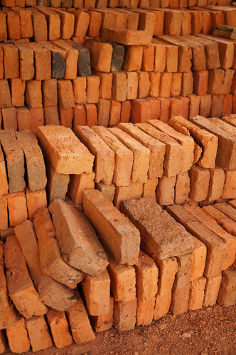 | Bricks
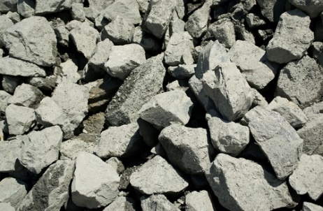 | stone
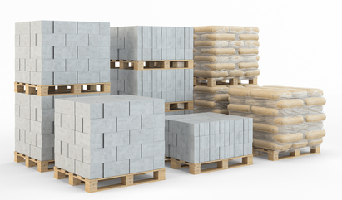 | blocks
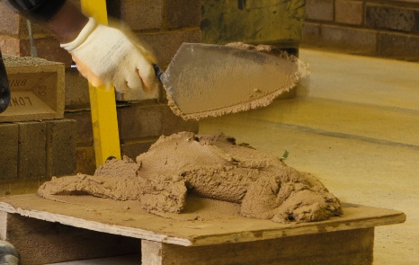 | cement
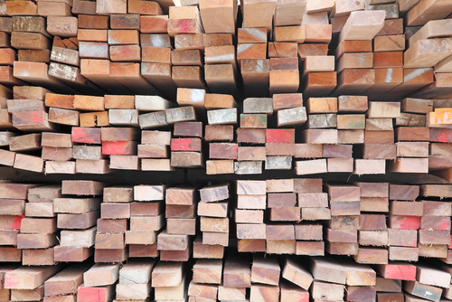
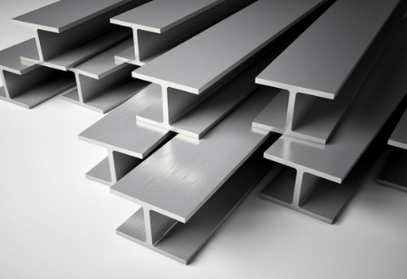 | steel
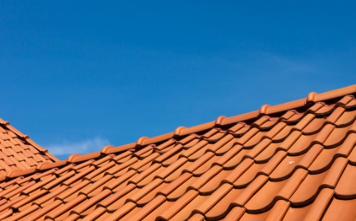 | Roof tilies
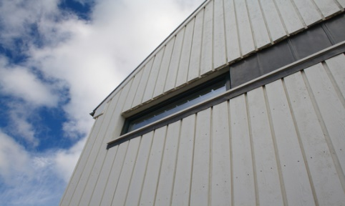 | cladding
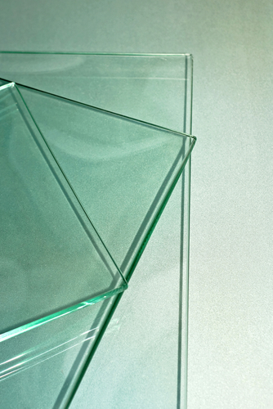 | glass

