TITLE: MKM SBMA7138.

ASSESSMENT 1

COURSE NAME: MARKETING MANAGEMENT

STUDENT NAME: AYOOLA ADEBOBAJO OLANIYI

ID NO: 1710674

LECTURER: TUSHARA BALENDRAN

To begin with, Kotler et al, (2009) defined Innovation Marketing as ‘the utilization of a unique marketing approach not currently in use and can entail modifications of all the elements of the marketing mix such as the product, price, promotion and even packaging’. The main objectives of marketing innovations are first to address consumer and/or customer needs, open up new markets, position the organisation’s product appropriately on the market and basically to drive incremental sales and revenue for the organisation. Marketing Innovation Strategy, on the other hand, simply refers to the strategy used by an individual or an organisation to reach their target market via the deployment of different kinds of communication.
The focus of this assessment is to rigorously examine how The Coca-Cola Company can devise innovative marketing strategies to raise awareness of the Coca-Cola brands and also to appraise the customer journey across communication channels so as to enable potential stakeholder’s expectations to be met.
When we talk about innovative marketing strategies for raising awareness of brands, emphasis should be placed on marketing communication which relate to messages and media which are deployed to reach the market. As part of promotion, which is one of the elements of the marketing mix, marketing communication involves the use of integrated marketing communication vehicles such as advertising, branding, publicity, print, broadcast and internet media, sales promotion, public relations, direct marketing, graphic design, packaging, sponsorship, online marketing etc. to drive awareness for the brand at different stages of the product life cycle.
Primarily, most business organisations or marketing communicators will centre all their awareness campaign and marketing dollars on creating and deploying print materials such as posters, handbills, the traditional print media but by engaging in sophisticated marketing research, organisations and/or marketing communicators have developed into the use of more important ingredients of marketing and branding to achieve consistency and regularity in the delivery of the message right across the business concern. As a matter of fact, current directions in business are due to marketing communication i.e. the shift from customer service to customer relations and from human resources to human solutions as well as the evolution of trends like blogging, emailing and other online innovations can all be linked to the development ofmarketing communication.
Kotler, K & Burton, (2009) outline ‘the marketing communication message as having 4 parts: encoding/decoding, noise and response.
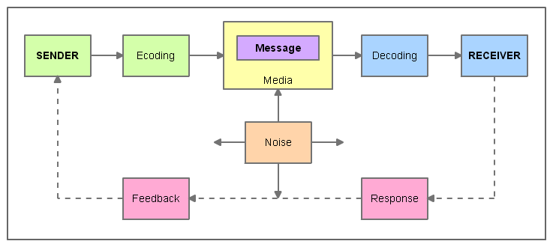
Realistically speaking, what this is saying is that marketing is strictly ‘communication between two people’meaning that there is the encoding and decoding of a message (communication); it is a two way process (between) and there is a sender and a receiver (two people). What marketing organisations are trying to do is creating messages that will appeal to existing and potential customers of their products and services and delivering those messages to their target market with as little noise distraction as possible.It is important to emphasize here that the basic objective of the organisation’s efforts at creating messages that works is to tap into opportunities available with potential customers and new markets as well as capture market shares from competition in existing markets.
However, it is one thing to be able to create a great message capable enough to target potential customers and markets, it is another to build equity for the brand. Building equity for the brand is a way of creating awareness for the brand because if the brand is strong like in the case of Coca-Cola, consumers will desire it; customers will carry it and they will talk about it. When you have a product with strong brand equity, you will attract more patronage from your customers. These same customers will be the ones who will recommend you to other potential users of your product. This way, you would have built very loyal customers and you are less likely to lose them to competition. However, if a successful brand is not created, the brand message will just appear mostly as noise distractions irrespective of which medium the message have been aired. So the first thing to do is create a strong brand and there are four major levels leading to creating a brand that wins. Keller, K.L, (2013) explains that ‘the idea behind the Brand Equity Model or simply called the Customer-Based Brand Equity (CBBE) Model is pretty straight forward; for organisations to create and develop brand that is strong and successful, it is important that they understand how the consumers think and feel about the brand’. He went further to illustrate that ‘there are evidently four levels that must be followed if an organisation is interested in building strong brand equity and that these four levels represent four fundamental questions which users of the brand often unconsciously ask about the brand’.
These steps, which contain six building blocks, must be in place in other for a marketing organisation to birth a winning brand. This is presented in the pyramid below:
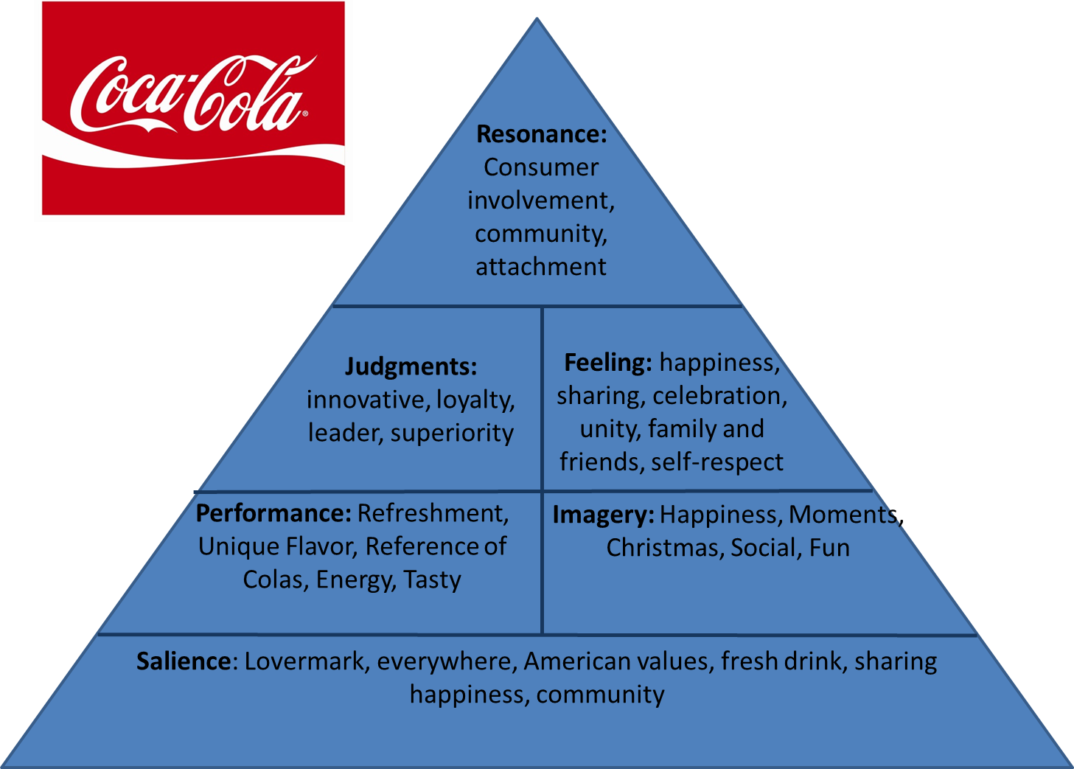
From "Strategic Brand Management: Building, Measuring, and Managing Brand Equity" by Kevin Lane Keller. © Pearson Education Limited 2013.
The goal of the first level is to create "brand salience," or awareness which involves ensuring that your brand stands out of the crowd and that the customer recognizes and are aware of the brand. The organisation should be able to sell her product because it meets the needs of the customers. Coca-Cola, at this level, has demonstrated that she is familiar with the needs of their consumers and so has been able to create some Unique selling proposition around sharing, happiness, community, ubiquity, pervasive availability everywhere etc and has been able to massively communicated these USPs to her consumers and customers alike how their needs will be fulfilled by their brand.
The goal of level two is identifying and communicating the brand meaning and what the brand can do especially in the area of ‘performance’ and ‘imagery’. Performance speaks to how good the product of the firm meets the consumers' needs while imagery speaks to the way the social and psychological needs of the consumers are met. The Coca-Cola Company, at this level, has invested massively in awareness creation by emphasising the extrinsic and intrinsic values of the Coca-Cola brand. The brand delivers on performance by promoting USPs as refreshing drink, unique flavour, it’s tasty etc and delivers on imagery by selling propositions as happiness, fun, Christmas etc. If the organisation wants to build consumer loyalty for their brand, that brand must meet and probably exceed the needs and expectations of the consumers and that need can be met if the consumer gains positive experience from the product. Positive experience, in itself, is derivable from the performance of the product.
The third level will highlight consumer response to the brand and in most cases; consumer response is indicated by their judgements and feelings. Consumers will always judge the brand at the level of quality, credibility, consideration and superiority. The Coca-Cola prides itself as a quality brand, one that is genuine and one that has character and has continued to demonstrate leadership in this area. The brand is credible and innovative especially with expansions into different flavours and pack sizes. As much as possible, the brand has put into consideration the needs of the consumer particularly in the area of taste, density, sugar levels etc and has been able to meet these consumer needs. As a matter of fact, the brand has stayed loyal to meeting these needs on a consistent basis over a period of 200 years. Besides, the brand has also demonstrated in a number of ways her superiority over its closest competition Pepsi. This superiority can be noticed in the area of packaging, great tasting, quality of distribution and service, impactful advertising and media deployment etc
It comes a point in time when the consumer feels a psychological attachment or bond with the product. This is the point of Brand Resonance. It is the most difficult but the most desirable level to be. At this level, the consumers are not only behaviourally loyal to the brand, they are also attitudinally loyal. They seize every opportunity to associate and engage with the brand even when they are not physically buying or consuming the product. The Coca-Cola brand has done a great deal of work in this area to gain die hard loyalists. To these groups of loyal consumers, Coca-Cola is food that cannot be missed. A large number of customers join the Coca-Cola VIP Clubs; engage in online chats, Sales rallies, special events and community projects sponsored by Coca-Cola. Many consumers follow the brand on social media and similar number of consumers takes part in loyalty contests.
All of these have built a very strong equity for the Coca-Cola brand and has also generated a massive awareness for the brand not just in the eyes of the consumers but also in their minds. However, for the brand to be extremely successful, organisation’s efforts must be directed towards improving consumer and customer perceptions in service quality as well as close any gap that may exist. The sketch below shows determinants of perceived service quality:
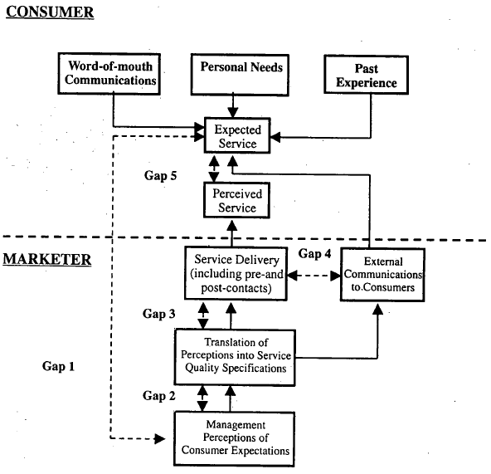
Gap 1 reveals that organisational managers do not usually have a proper comprehension of the needs and expectations of the customer. They are bereft of adequate information which are relevant to evaluating the organisation’s service delivery efforts. Where properly carried out, marketing research will help to close this gap. Coca-Cola managers are fully involved in marketing research in all the markets where they operate. This marketing effort provides the organisation with insights into consumer and/or customer preferences. The knowledge of consumer preferences enable the organisation invest her dollar budget behind promoting the brand
Gap 2 illustrates that even where organisation’s managers are very clear about the needs of the consumers and/or customers, that realisation do not usually get catapulted into any meaningful policy standards. Most times, customer service policies are ambiguous, badly disseminated to staff and poorly implemented. These inadequacies affect staff performance and service levels are sub-optimized. To close this gap, clearly communicate policies and procedures to service staff. One thing the Coca-Cola management does very well is to disseminate information which helps employees to deliver best in class performance. The Chief Executive Officer of the Company, Mr. James Quincey said, ‘we will make available to everyone transparent, readable and easy-to-locate information that will assist all stakeholders make informed decisions without the guesswork’. It is important to state here that every excellent service delivery is all geared towards creating awareness for the brand.
Gap 3 suggests that there exits gaps between service quality specifications and service delivery that will need to be closed. This is because service employees are not living up to set service quality and even organisation’s managers treat service delivery with kid gloves. Therefore, to achieve optimum service quality, employees are to be backed up with rewards and logistics in order to encourage them to deliver best in class service quality. To close this gap, time good enough to achieve excellent service as well as, training, equipment, motivation etc are to be provided to service staff. Measurement and evaluation of performance need to be carried out and the outcome of that evaluation should form part of the basis for wage increments. The Coca-Cola company implements a number of training programmes for different categories of staff ranging from ITMO (In-trade Market Opportunities), MIT (Market Impact Teams training) etc for service deliverers; RDS (Route Distribution Systems training), equipment placement and route riding training programs for supervisors and LME (Leadership in Marketplace Excellence) training for line managers. Where the staff has been properly trained and motivation is high, professional service will be delivered. That way the customers and consumers and the firm are the better for it as the product will be pervasively available and it will always be put at the risk of being consumed.
Gap 4 points out that there is a gap between what promotion is supposed to be and the perception of what it is. It illustrates further that even the best of service delivery may not always cut the dice for some customers and/or consumers if for example unrealistic high expectations have been created in the customer as a result of a communication message wrongly deployed by the organisation. To close this gap, organisations should always ensure that realistic promotions are used to create awareness for the brand. This is one area where the Coca-Cola brand has excelled. Since early 2016, the company has devoted a large chunk of its marketing budget into building massive awareness of its low and no-sugar beverages. For instance, at a meeting in New York, CEO James Quincey announced that, ‘the One Brand global advertising, which unites all four Trademark Coca-Cola brands i.e. Coca-Cola, Coke Zero, Diet Coke/Coca-Cola Light and Coca-Cola Life in the Taste the Feeling campaign will continue to be leveraged as the organisation’s commitment to offering a Coca-Cola for all tastes and lifestyles’.
This global marketing strategy does not limit awareness creation only to one brand but have combined four brands in one and all massively promoted.
Gap 5 points out that there is gap between perceived service and expected service a result of company managers failing to close one or more of the other four gaps. The customer is actually dissatisfied with the actual service because of the dichotomy between the customer’s expectation and actual experience. What the customer or the consumer has in mind is completely different from what they are getting. Therefore, how you deal with customer will determine whether you can keep the customer or not. To close this gap, getting feedback from the customer will actually minimize customer dissatisfaction. In some markets, like the European market, the Coca-Cola Company has devised a means to listen to the consumer’s complaints and/or feedback about the business by setting up a rapid-response consumer interaction centre in London. In addition, the company also decided to expand, in 2014, the customer service team to include a huge new social media capability. Part of this function is handling consumer queries which come in by phone or email. In Africa, for example, the Division Office created a Consumer and/or customer Satisfaction Survey Form to receive feedback on regularly .
When gaps in service quality are closed, of a necessity, the average consumer of the product, Coca-Cola, will have a lasting experience. The positive experience turns the consumer to the product advocate
The focus of this assessment, which is to rigorously examine how The Coca-Cola Company can devise innovative marketing strategies to raise awareness of the Coca-Cola brands would not have been adequately appraised without discussing the elements of Integrated Marketing Communications.
Belch, G, & Belch, M, described integrated marketing communication as ‘an approach that helps to deliver the objectives of a marketing campaign using different well articulated promotional methods that are designed to buttress one another’. The IMC simply makes sure that the different types of communications and messages are integrated. Most times, what the marketing organisation does is to carefully incorporate and coordinate its numerous communication channels to deliver clear and consistent messages about the organisation and her product or service. To achieve this, the marketer prepares a communication message that is clear, logical and imperative. The integrated marketing communication process is very important for managing the communication mix with the target audiences and for maintaining a very strong market position.
However, improvement in technologies i.e. the internet, mobile devices etc are changing how marketing companies connect with their consumers and customers. A number of front line initiatives are impacting the IMC campaign of organisations and this study will illustrate how firms and their communications agencies are using integrated marketing communications to create awareness for their brands.
The diagram below shows the different elements of the integrated marketing communication. Each of the elements will be examined to show how they have been used to create awareness for Coca-Cola.
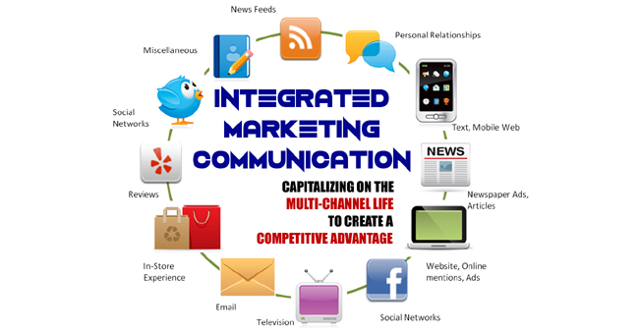
Source: McGraw-Hill Ryerson Limited, 2005
Advertising: Advertising is an element of the communication mix used by marketers of products and services to create awareness for their products. Advertising agencies create paid advertisements messages which marketers use to inform and influence the buying behaviours of consumers. There are two types of advertising. The first is known as above the line advertising which is a type of communication that pays for the space it uses i.e. Cinema, Radio, TV, Press etc. The second is called below the line advertising which is any other type of communication other than the sales personnel. The key advertising agency of the Coca-Cola brand is McCann-Ericson. This agency creates the advertising messages deployed globally to create awareness for the Coca-Cola brand. In early 2016, the Coca-Cola Company working in tandem with the advertising agency launched ‘the One Brand global advertising, which unites all four Trademark Coca-Cola brands i.e. Coca-Cola, Coke Zero, Diet Coke/Coca-Cola Light and Coca-Cola Life in the Taste the Feeling campaign will continue to be leveraged as the organisation’s commitment to offering a Coca-Cola for all tastes and lifestyles’. The advertisements were deployed globally using various above-the-line media such as TV, radio, Print, Billboards etc. In some markets, the global messages were cascaded into local languages so as to reach the illiterate audiences. Simultaneously also, below-the-lime communications were also deployed in the form of posters to shops and stores, handbills or flyers, banners etc. This is a massive exposure for the Coca-Cola brand.
It is imperative to mention here that the advertisement message that is created by the adverting agencies or marketing communicators can only be exposed using various forms of Media. The media include Print such as newspapers; a medium whose coverage and reach is very high; one in which large amount of information can be provided and a medium that can be used to target specific markets. However, because of high illiteracy levels in some parts of the world, advertising or promotional messages can be translated to local dialects or languages. Besides, because of large amount of noise associated with newspapers, Coca-Cola also diversified into the use of magazines. Coca-Cola specially uses the feminine magazines to massively promote Diet Coke to target female consumers, a niche market. Another media vehicle massively utilized by the Coca-Cola Company to air their advertising campaign is the Television. The TV is fit for purpose because it is a multi sensory medium which has the capability of delivering advertising message by audio and by visual presentation of the product. Except in developing markets where electricity is a luxury, television has the ability to reach a very wide audience. However, despite the fact that the TV medium is not cheap, messages on it are short. A cheaper medium than the TV is radio. Even though it is not multi sensory; only audio, it is however a veritable tool to reach targeted customers out of home while on the move or travelling. In Africa, for instance, Coca-Cola is exposed more on radio than on television because of transmission difficulties arising from power challenges and battery fitted radios are common place in developing markets. Across North Africa and in northern part of Nigeria, the Cinema is very popular and so to reach especially the male audiences, Coca-Cola exposes advertising messages via this medium. Apart from the fact that the Cinema can be used to target a local geographical area, films can also be segregated according to psychographics and demographics so it can be used to target specific group of people. Another form of media used by Coca-Cola is Hoarding; also called Outdoor billboards. The billboard presents a visual imagery of the product and this gets the attention of the target audience. Coca-Cola deploys advertising campaigns on 8 sheet, 16 sheet and 40 sheet posters as well as on spectacular billboards across towns and cities on paid for sites. As much as possible, some of these spectaculars are fitted with lighted bulbs. However, as impactful as the outdoors can be situational factors like time and weather condition can impact on its effectiveness. Besides, direct response advertisements can always be created by competition.
Another element of the IMC used to create awareness for the brand is Sales Promotion. Sales promotion is a type of marketing initiative directed at consumers or the distributors and aimed at new product roll outs; or to get rid of inventories nearing out-of-date or to generate incremental sales on a temporary basis. It could also be for new product usage or trials. Examples include merchandising in dumb bins, POS materials and product demonstrations. Others include coupons, incentive to wholesalers and/or retailers, free gifts discount prices, Buy-One-Get-One-Free etc Coca-Cola is also involved in using sales promotion as means of creating awareness for the product as well as selling additional cases. She implements TDIs (Trade Discount incentives) for different categories of wholesalers and retailers. In many markets, it is common place to discount case prices so as to increase through puts.
One strategy that is used to create awareness and brand preference with the end cosumer is the Pull and Push Strategy. See diagram below: 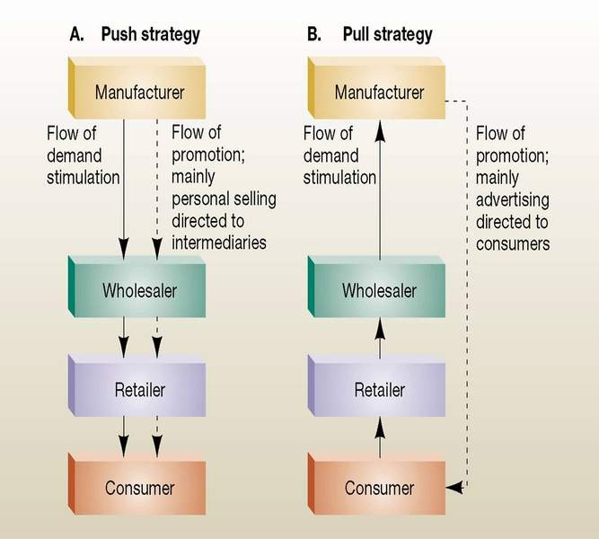
Any initiative by the organisation that influences the third party to stock the company’s products is the Push strategy. This strategy actually push the products out of the company’s warehouse and push them into the third party’s stock room. Coca-Cola implements dealer loaders or trade discount incentives (TDI) to push more cases into the stock room of the middlemenn. Pull strategy, on the other hand, is any initaiative devised that encourages the consumers to demand your products from the retailer’s store. Coca-Cola implements consumer promotions to pull the consumers into the retailers’ outlets.
Another element of the communication mix used by Coca-Cola to create awareness for the brand is Public Relations. Public Relation is about reputation, abour gaining support and it is about influencing public opinions and behaviour. The Coke Company employs External Affairs Directors in every Region office whose main duty is to ensure poitive image and good reputation for the Company and its brands. The External Affairs Directors, of a necessity, must maintain good relationships with the media and be able to manage crisis when they arise. A major draw back of this is that we cannot control the messages that the journalists write.
Publicity is also used to generate awareness for the Coca-Cola brand. Publicity is simply the vehicle for passing information or news to a public audience using the media. The message being passed attracts public attention for example news, awareness about a product and service. The Coca-Cola Company uses publicity to create awareness for the Coke Zero when it was rolled out in Atlanta in 2007 and then later in United Kingdom seven years later. Many people, today, are turning to Facebook to publicize products and/or organisation. The challenge though is that it is practically difficult to control the message passed.
Sponsorship is a very successful vehicle to create awareness for a firm’s product or services and Coca-Cola uses this vehicle maximumly. A few of Coca-Cola sponsored events include: American Idol, a music talent hunt; BET Network, an entertainment show; NASCAR, Sports car racing; NBA Basketball championship; NCAA, a 13 year association; the Olympic Games as well as the World Cup age grade championship just to mention a few. The sustained and continued use of this vehicle has created massive awareness for the Coca-Cola brand all over the world.
One other promotional tool deployed by Coca-Cola to reach its target audience is Direct Marketing. This is a vehicle used by marketing organisations to reach their customers via different media i.e. emails, mobile phones, online adverts, text messages, websites, promotional letters, flyers, catalogue distribution. Direct Marketing relies on data base which is used for relationship marketing. In Nigeria, for example, the Coca-Cola Company resulted to sending personalised letters and emails to specific target customers to inform them of the launch of the new Fanta Chapman. Chapman is a cocktail drink very popular among the rich and served only in five star hotels. Apart from the fact that the direct mail served to sensitize the consumers, it also hid the strategy and the main message from competition.
Another modern day vehicle for creating awareness for the brand is Digital Marketing This is advertising carried via digital channels as search engines, websites, content marketing, social media, mobile apps, email marketing etc. This is becoming a very big vehicle for disseminating information about an organisations offerings. It is so popular now that Tony Wright, CEO of marketing firm WrightIMC, on Search Engine Journal exclaimed, ‘Then along came digital marketing’. Coca-Cola has resulted to mass customization with the website
Conclusion: I will conclude with the stages in the Integrated Marketing Communication Campaign
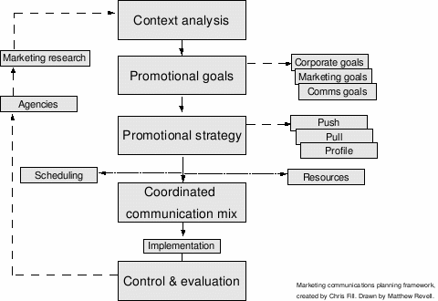
For an organisation or brand to win with IMC, the target audience must be defined, then the promotional goals and relevant budget must be set i.e. how much are we spending on the advertisement or the promotions. Besides, we need to design the promotion mix i.e. what combination of promotion, what strategy are we going to focus on and what media are we deploying and finally we must of a necessity evaluate the results achieved i.e. has the company achieved its objectives. One way we can do this is via marketing research or to analyse the sales data generated..
References
- Belch, G.E, & Belch, M.A, (Aug., 2011), Advertising and Promotion: An Integrated Marketing Communications Perspective Hardcover – 1 Aug 2011
- Kotler, Keller & Burton (2009), Marketing Management.
- Keller, K.L, (2013), ‘Strategic Brand Management: Building, Measuring, and Managing Brand Equity’ © Pearson Education Limited.
- https://www.mindtools.com/pages/article/keller-brand-equity-model.htm
- https://www.coca-cola.co.uk/stories/cokes-way-forward-new-business-strategy-to-focus-on-choice-convenience-and-the-consumer
- OECD, 2005, “The Measurement of Scientific and Technological Activities: Guidelines for Collecting and Interpreting Innovation Data: Oslo Manual, Third Edition” prepared by the Working Party of National Experts on Scientific and Technology Indicators, OECD, Paris, para. 169.

