Contemporary Themes in the Hotel and Hospitality Sector
BMIH6001
Lecturer: Dr Ernest Balutie Wavei
Student Name : Zoi Michalari
Conference Presentation
Topic: How Economic Uncertainty and Regulatory Changes Affect Long-Term Financial Stability in Hospitality?

AI Declaration
“I confirm that I have not used any AI tools in the research and creation or this assignment. I confirm that I have not presented any AI generated materials as my own work. I confirm I have copies of my drafts, notes, and other resources I used, which may be asked to provide in evidence”

Slide 1:
Title
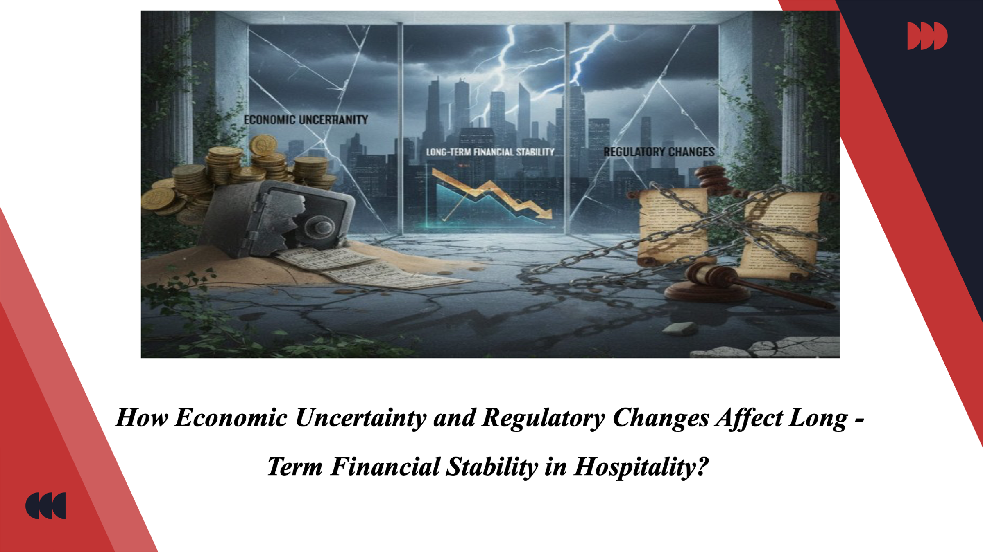
Slide 2:
Introduction
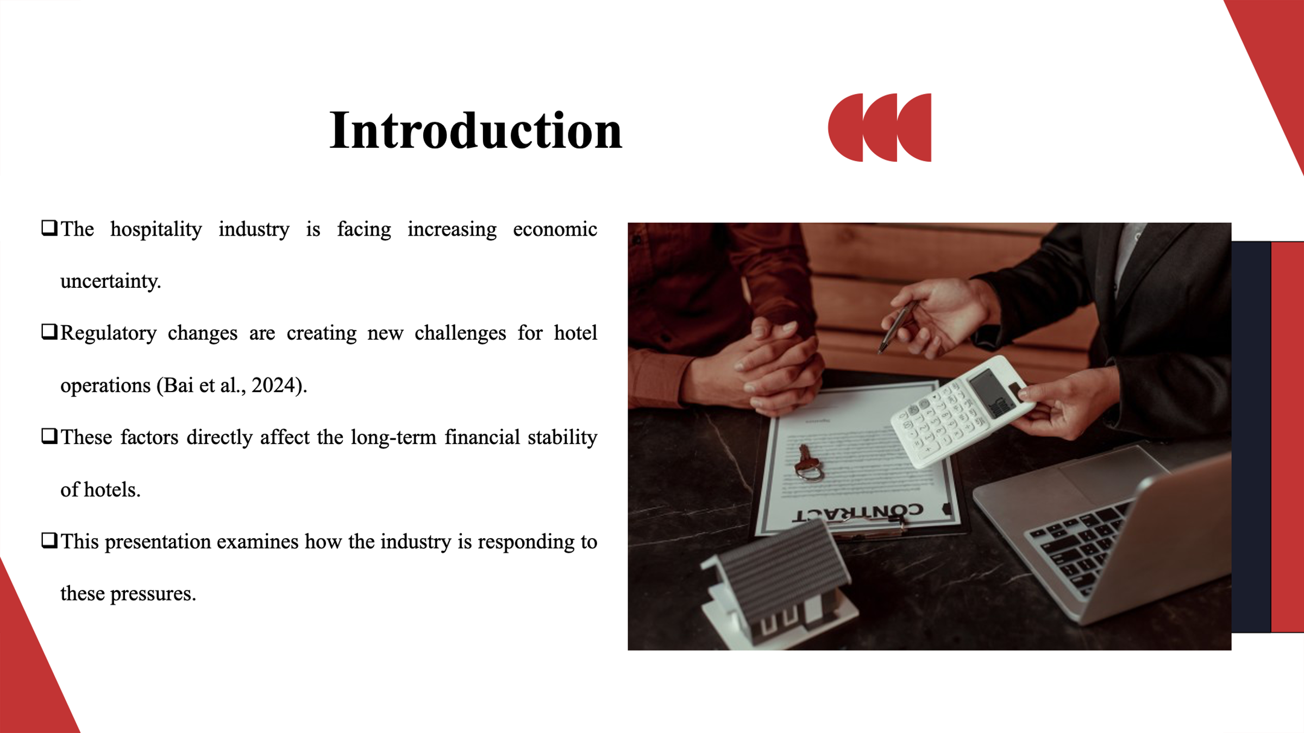
The hospitality industry is experiencing economic uncertainty in its history due to an increased inflation rate, variable demand in the market, and instability in the global market (Bai et al., 2024). Concurrently, the changes in regulation such as labour laws, minimum wages and visa restrictions are posing operational difficulties.
Slide 3:
Hospitality Industry Context
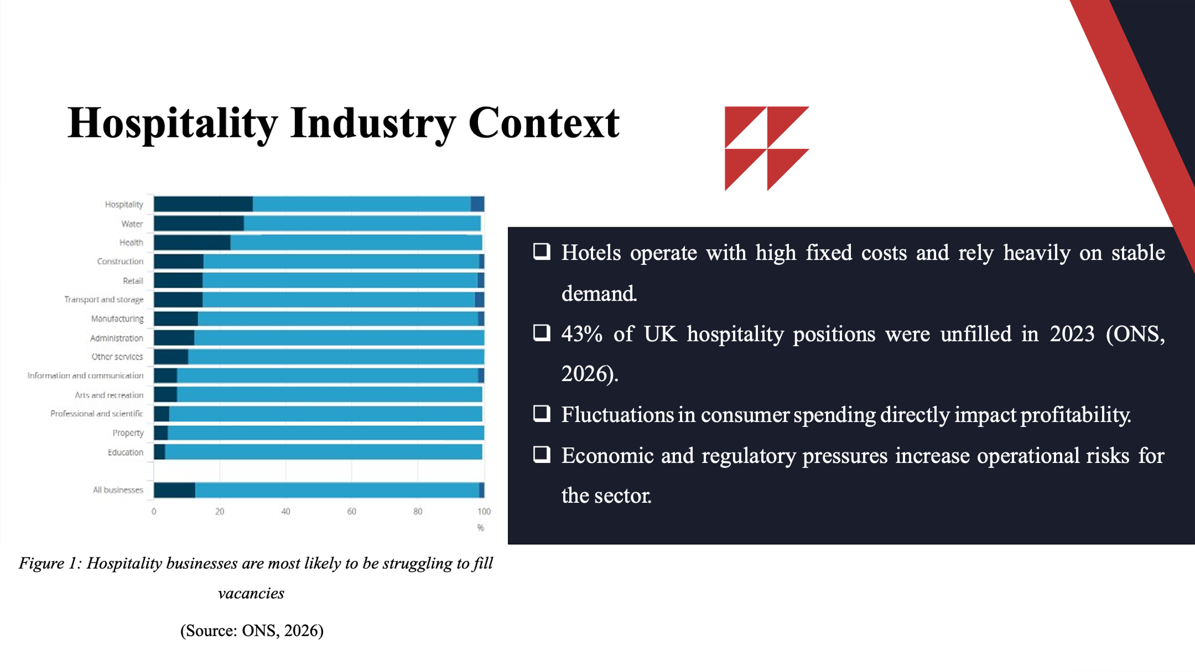
Hotels are extremely so because of the high fixed costs such as utilities, staffing and the maintenance and therefore it is highly sensitive to external economic shocks. In 2023, 43% of the jobs in the UK hospitality were not filled, which leads to the issue of workforce shortage that has a direct impact on service quality and operational efficiency (ONS, 2026). The changes in consumer spending, which are as a result of the uncertainty surrounding the economy, also affect the stability of profits and revenues. Operational risks are also heightened by regulatory requirements as hotels have to meet changing requirements of complying with rules and regulations.
Slide 4:
Research Focus
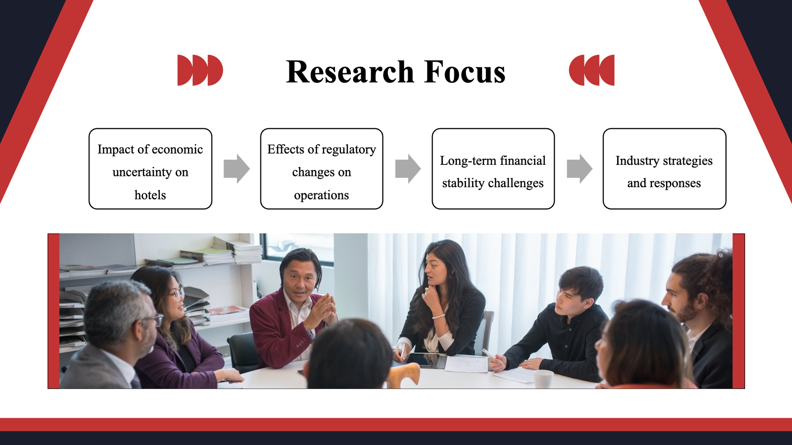
This study aims to evaluate how economic insecurity affects the activities of a hotel with increasing prices and changing demand. Also, it determines how regulatory change impact on workforce management and compliance. Moreover, strategies and responses by industries used to reduce these pressures are analysed based on the study including adjustments in prices, employee retention and innovations.
Slide 5:
Literature Review: Key Theories
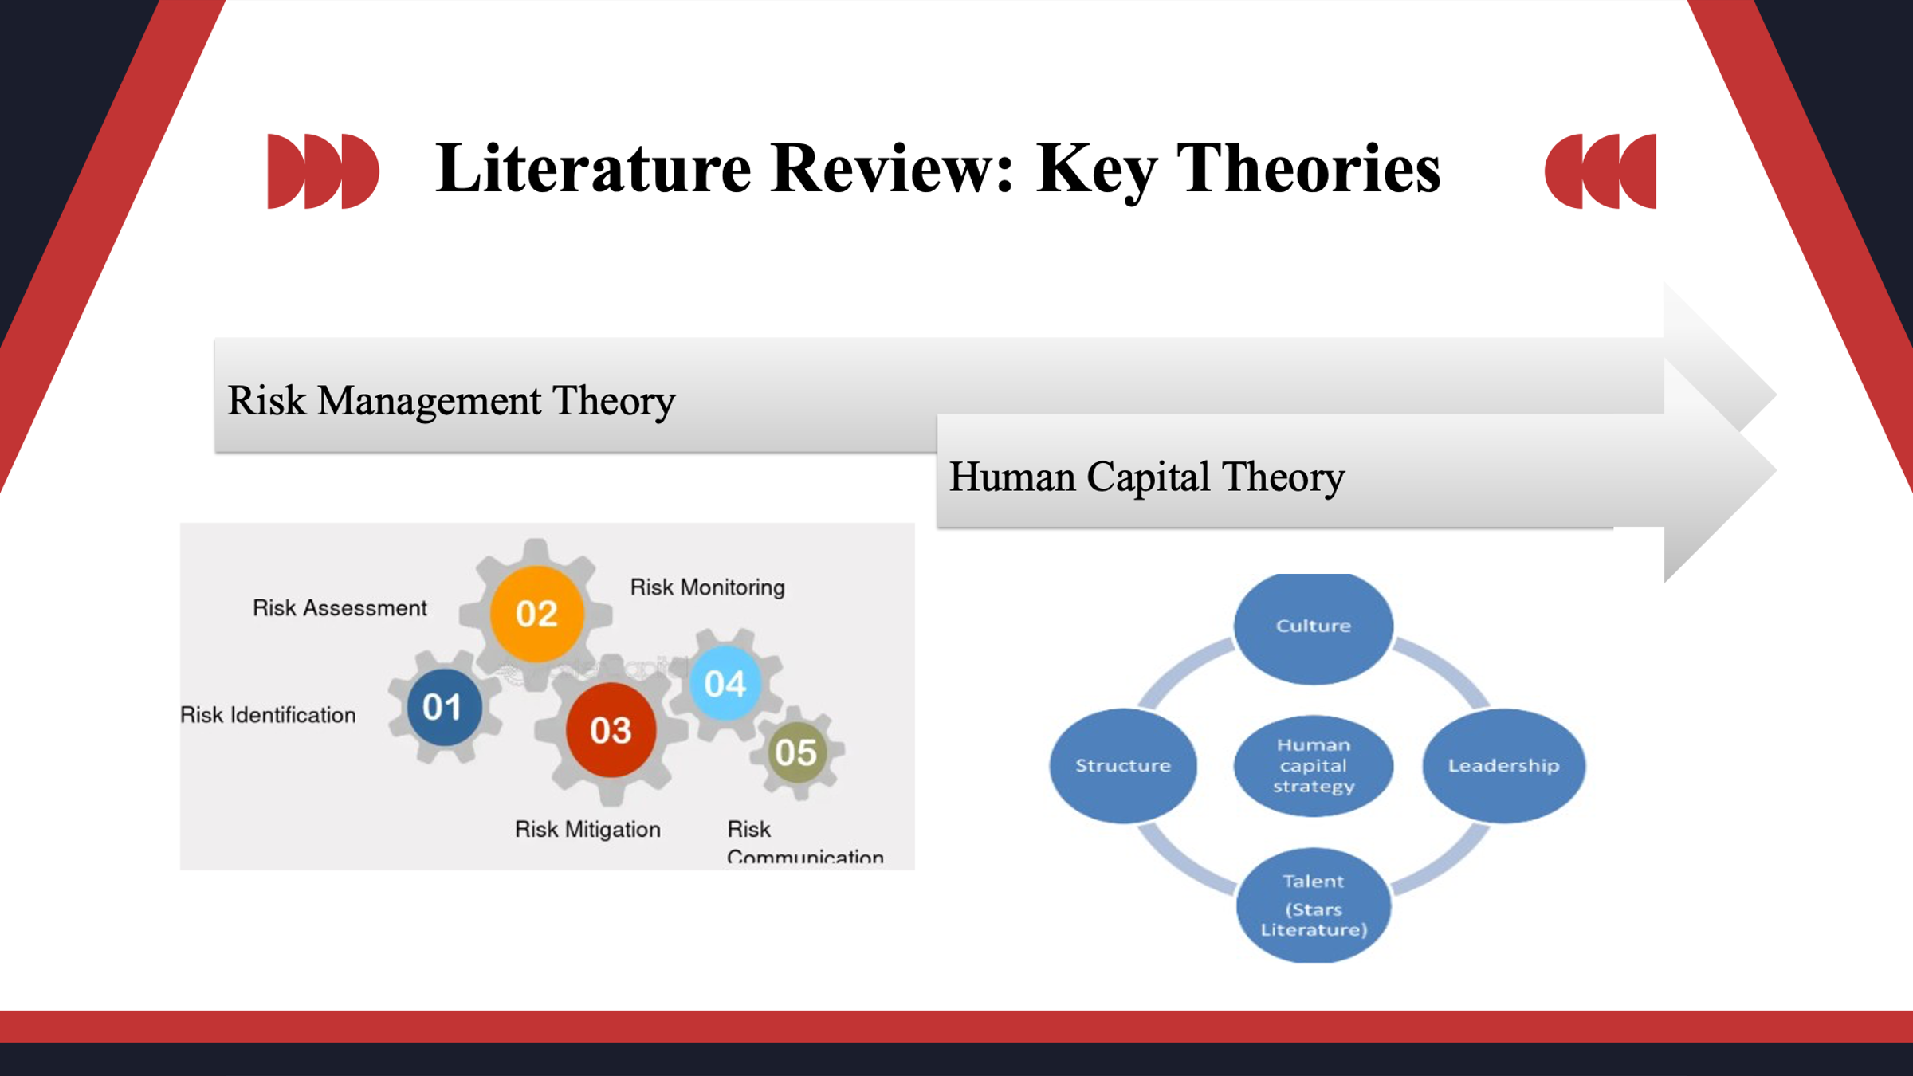
The study is based on two important theoretical frameworks. The Risk Management Theory focuses on how organisations should predict, assess, and react to financial and operating uncertainties whereby the concept is highly applicable with volatility in the hospitality markets. Human Capital Theory is an approach that pays attention to performance of organisational that depends on workforce skills, productivity and retention.
Slide 6:
Literature Review: Economic Uncertainty & Hospitality Impact
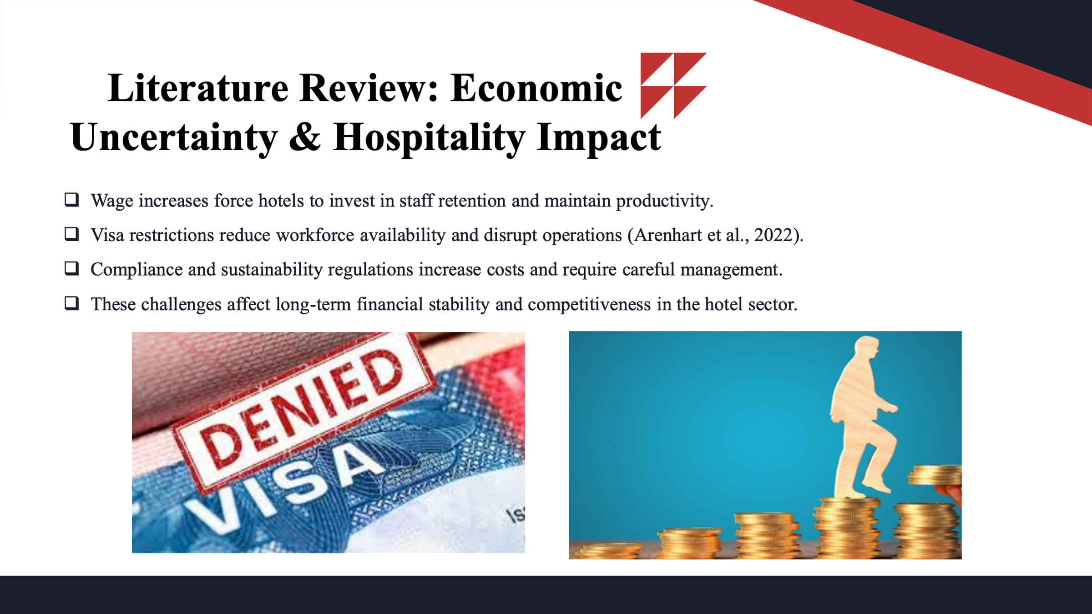
Economic uncertainty has various impacts on hotels. Pay raise is required to attract and retain employees and this increases the operating expenses. Visa limits also limit the availability of workforce leading to the provision of gaps in the staffing that interferes with operations and delivery of services (Arenhart et al., 2022). Adherence to sustainability and other laws also increases the cost of operation. All these impact on financial stability in the long term, affecting profitability, cash flow and ability to engage in strategic investment.
Slide 7:
Literature Review: Regulatory Changes & Hospitality Impact
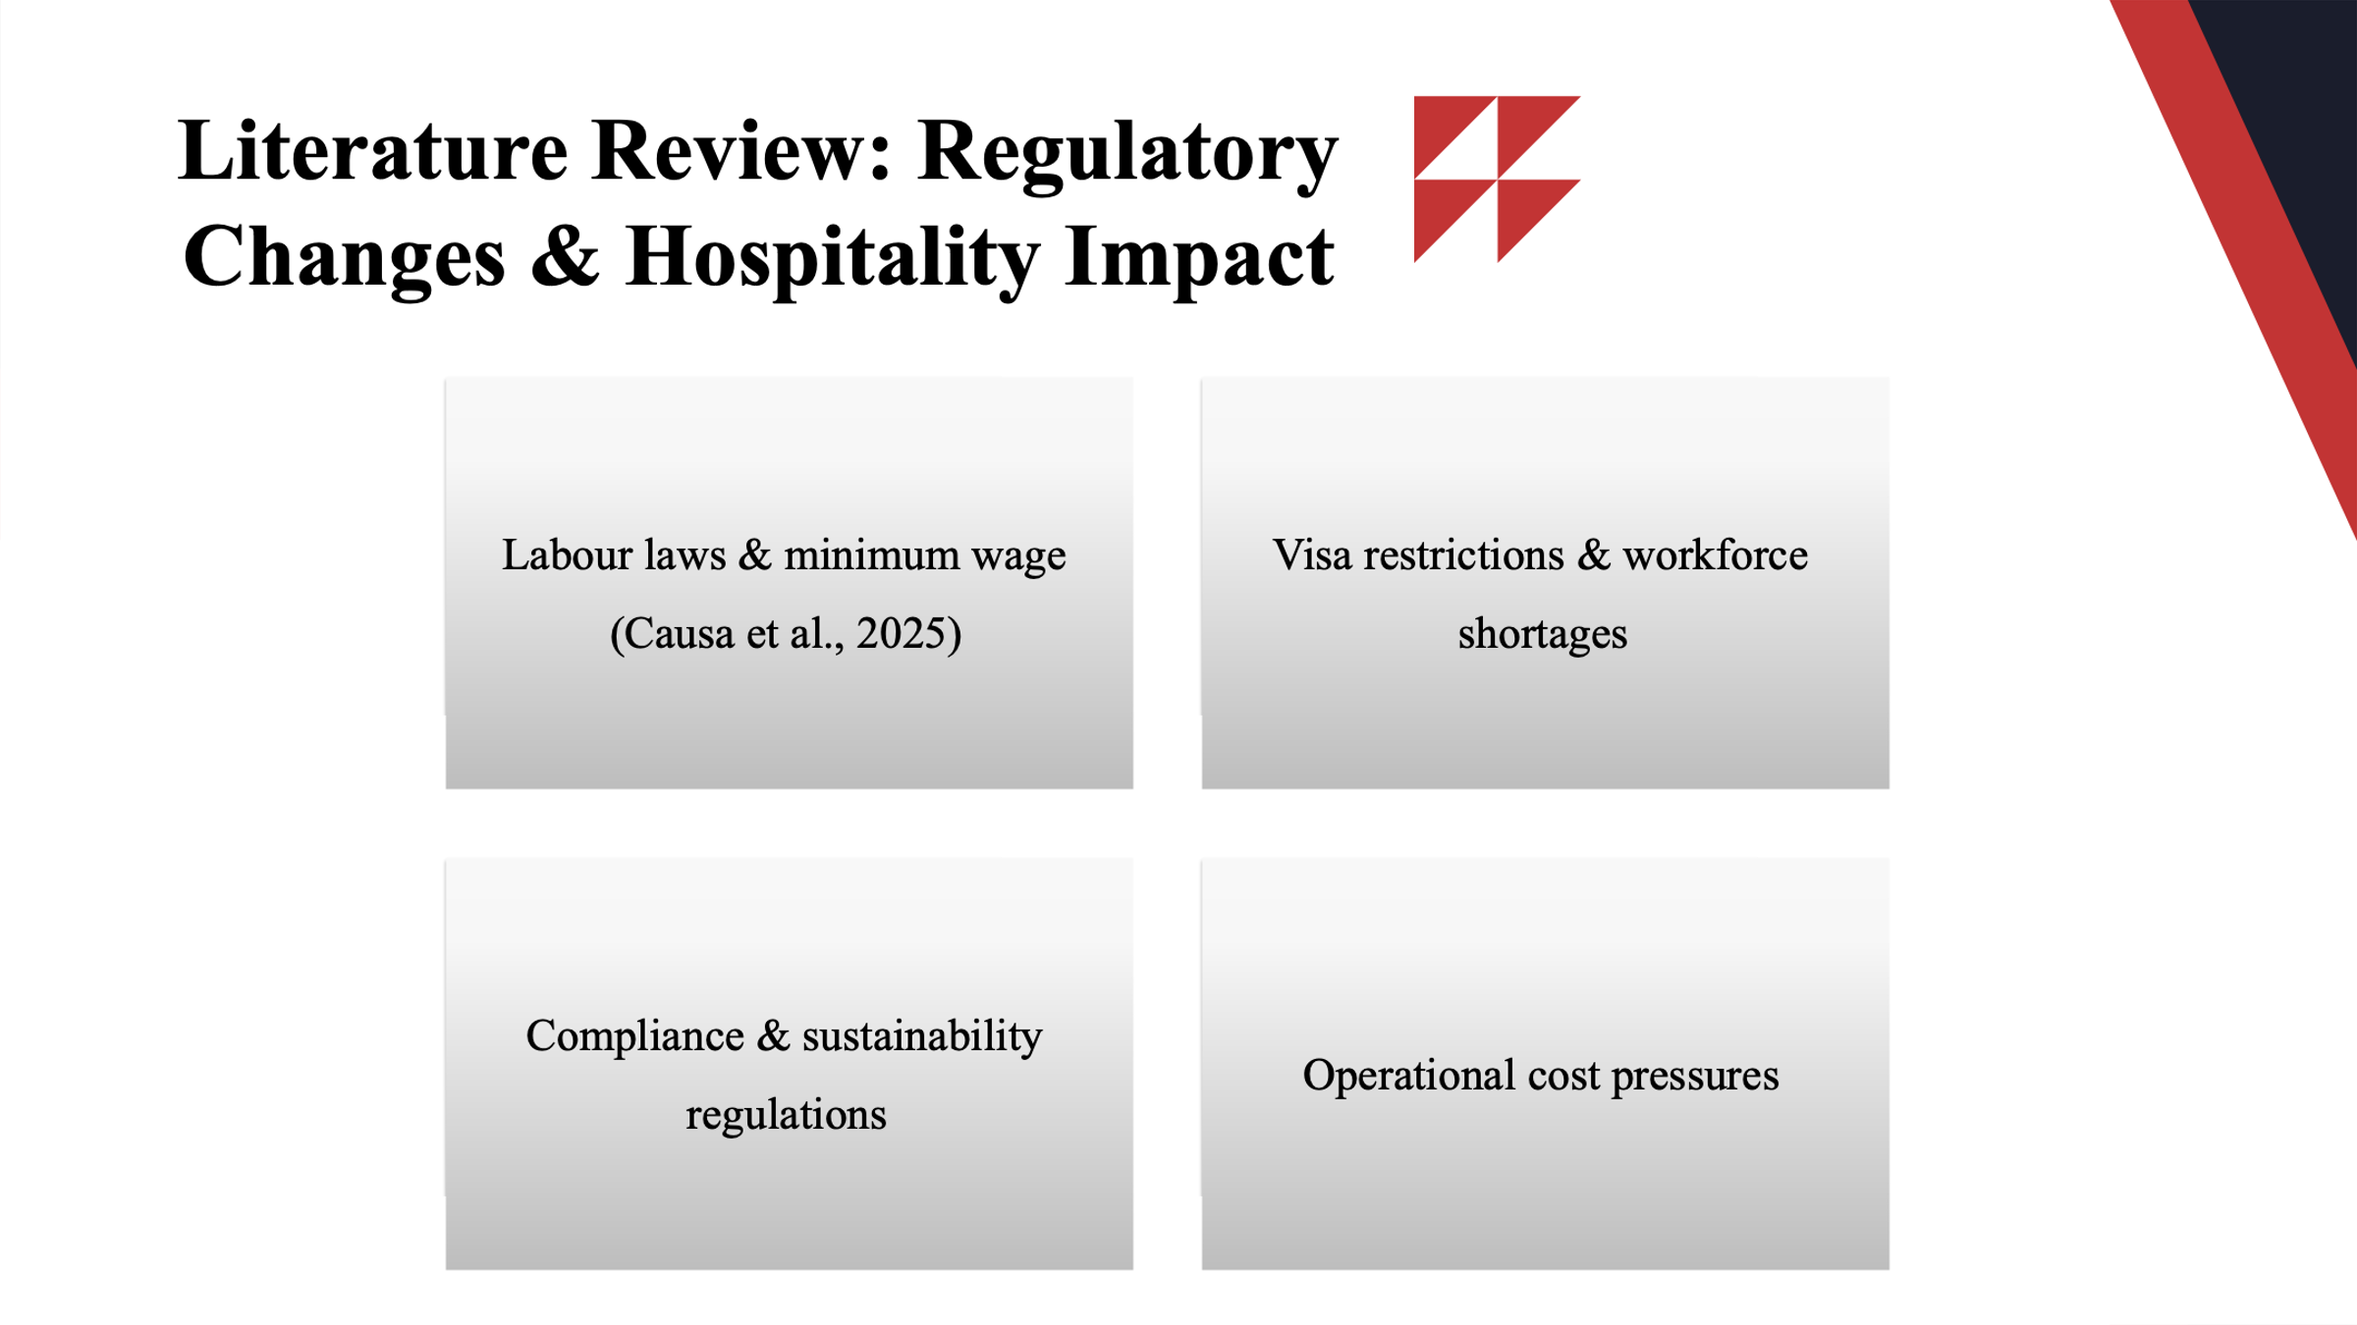
Any alterations in the regulations including labour laws and minimum wage adjustments have a direct impact on the operations of hotels in regard to cost. Visa restrictions make it challenging to access international employees with skills, adding to the problem of workforce shortage. There are also the compliance requirements such as health, safety and environmental requirements which also introduce extra costs and operational complexity (Causa et al., 2025). All these changes pose a problem to financial planning and risk management. There is a need to change so that hotels remain efficient and service providers without compromising quality and regulations.
Slide 8:
Method: PESTLE Summary
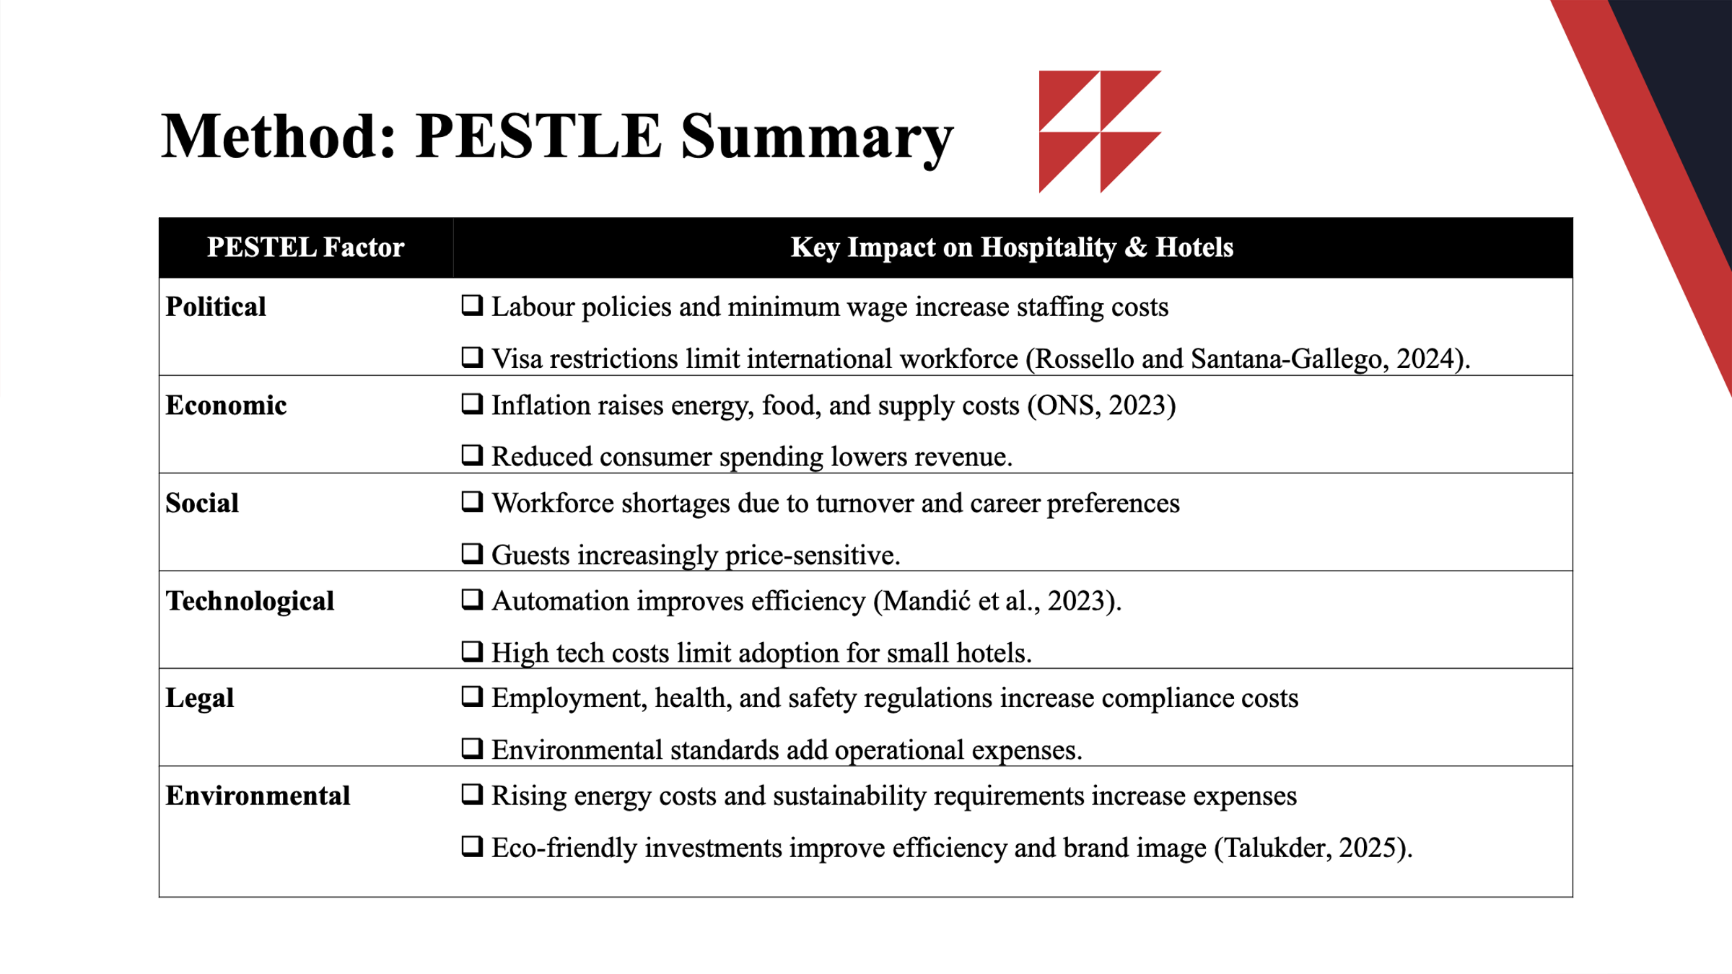
The research is a qualitative one based on the secondary data provided by industry reports, academic journals, and government sources. PESTLE analysis was used to analyse the macro-environmental forces that has a bearing on hotels. Political and legal influences are labour policies and visa limitations. Economic reasons are inflation and decreased customer expenditure. The social factors include the shortage of the workforces, and guest expectation. The technological factors emphasize on automation and digital solutions. Sustainability requirements and the increase of energy costs are considered environmental aspects.
Slide 9:
Industry Responses to The Chosen Contemporary Issue: Rising Operational Costs
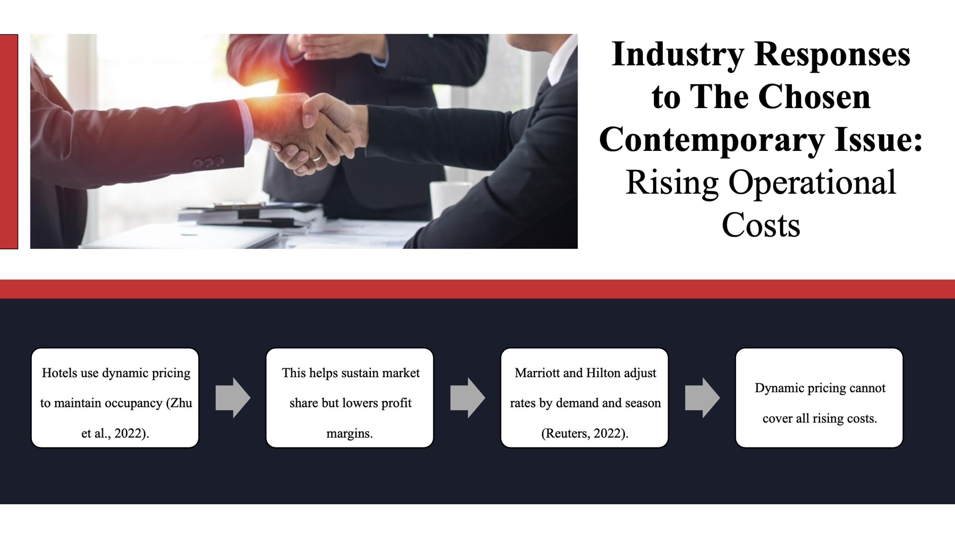
The dynamic pricing strategies to address the increasing costs of operations in the hotels are enabling hotels to set room rates dynamically depending on the demand and crops of the season (Zhu et al., 2022). This methodology is adopted by major chains like Marriott, Hilton, to stay afloat in occupancy and market share albeit at limited profit margins (Reuters, 2022). Dynamic pricing will give some flexibility but not be able to entirely compensate the increasing costs of energy, food and supplies. The smaller hotels are usually unable to adopt these strategies because of the lack of influence and resources in the market.
Slide 10:
Industry Responses to The Chosen Contemporary Issue: Labour & Regulatory Pressures
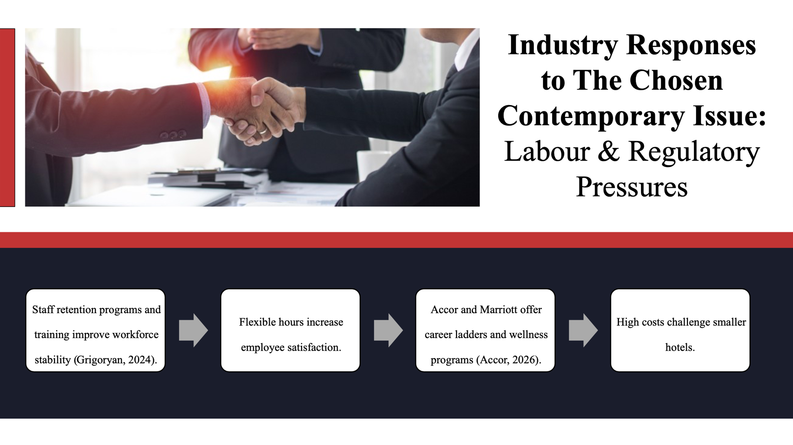
Hotels are adopting staff retention programs, training programs and flexible working arrangements to tackle labour issues and regulatory demands (Grigoryan, 2024). The Accor and Marriott programs developed include career ladder and wellness assistance, the purpose of which is to increase the workforce satisfaction and stability (Accor, 2026). These programs enhance productivity, decrease turnover, and favour the quality of service. It is important to balance the price of workforce initiatives and the efficiency of the operation. Effective retention measures enable hotels to be financially stable in the long-term, as well as meet changing labour and regulatory requirements.
Slide 11:
Industry Responses to The Chosen Contemporary Issue: Technology & Compliance
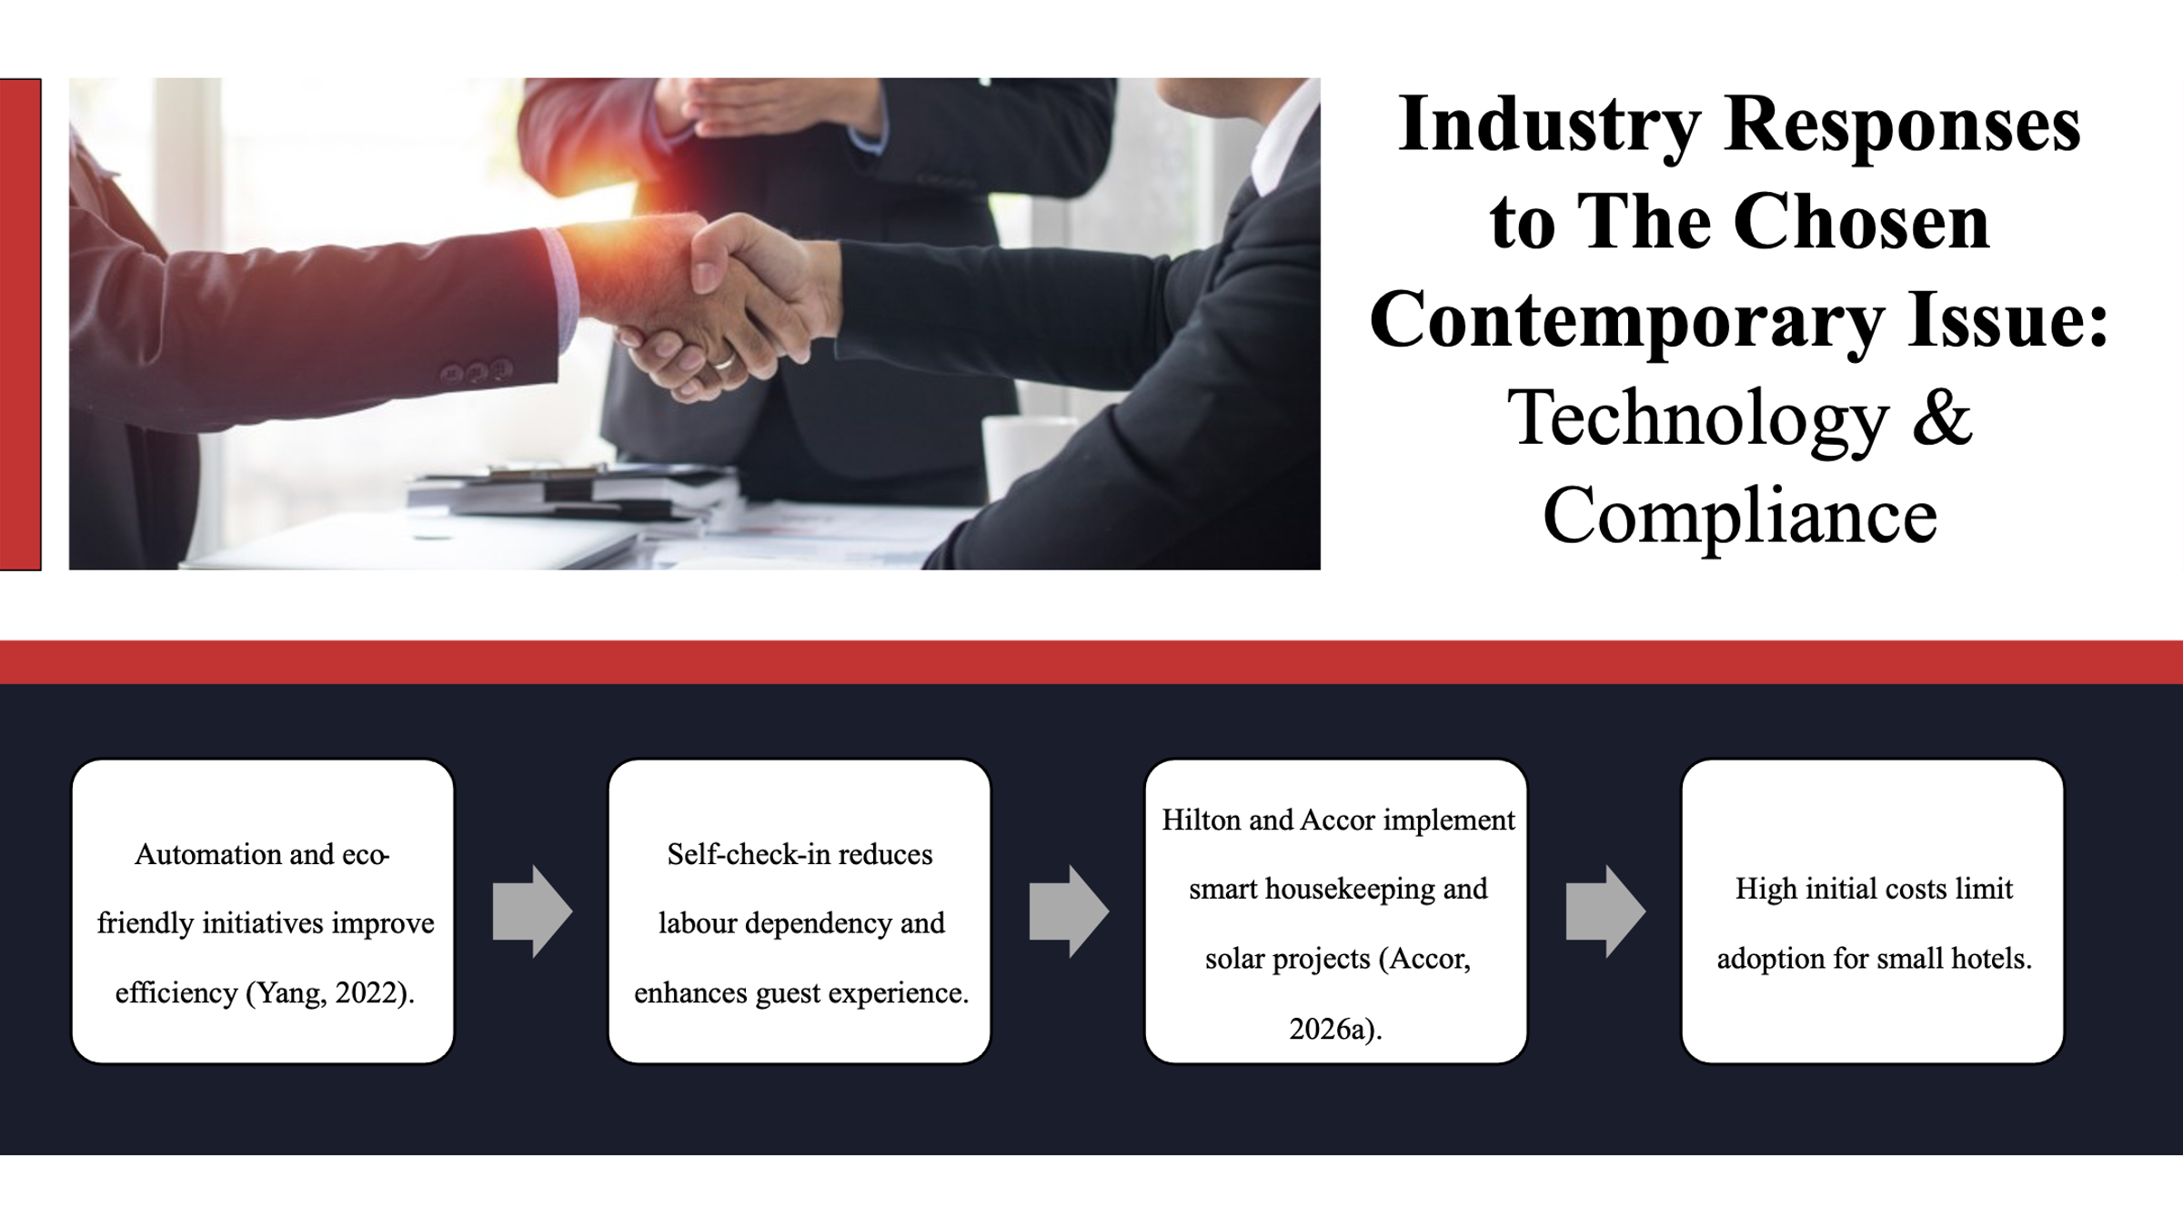
The use of technology and compliance programs assists hotels to keep costs in check and enhance operational fullness. Automation (self-check-in, smart housekeeping, etc.) decreases dependency on labour and improves the experience of the guests (Yang, 2022). Environmentally friendly investments such as solar panels and low-energy systems enhance cost-effectiveness in the long-run and a positive brand image. Hilton and Accor have been successful in administering these programs and the supply of better sustainability and operational performance (Accor, 2026a). Though, it is very expensive to install and therefore small hotels cannot use it because of the high start-up costs which they may not be able to locate funds.
Slide 12:
Conclusion
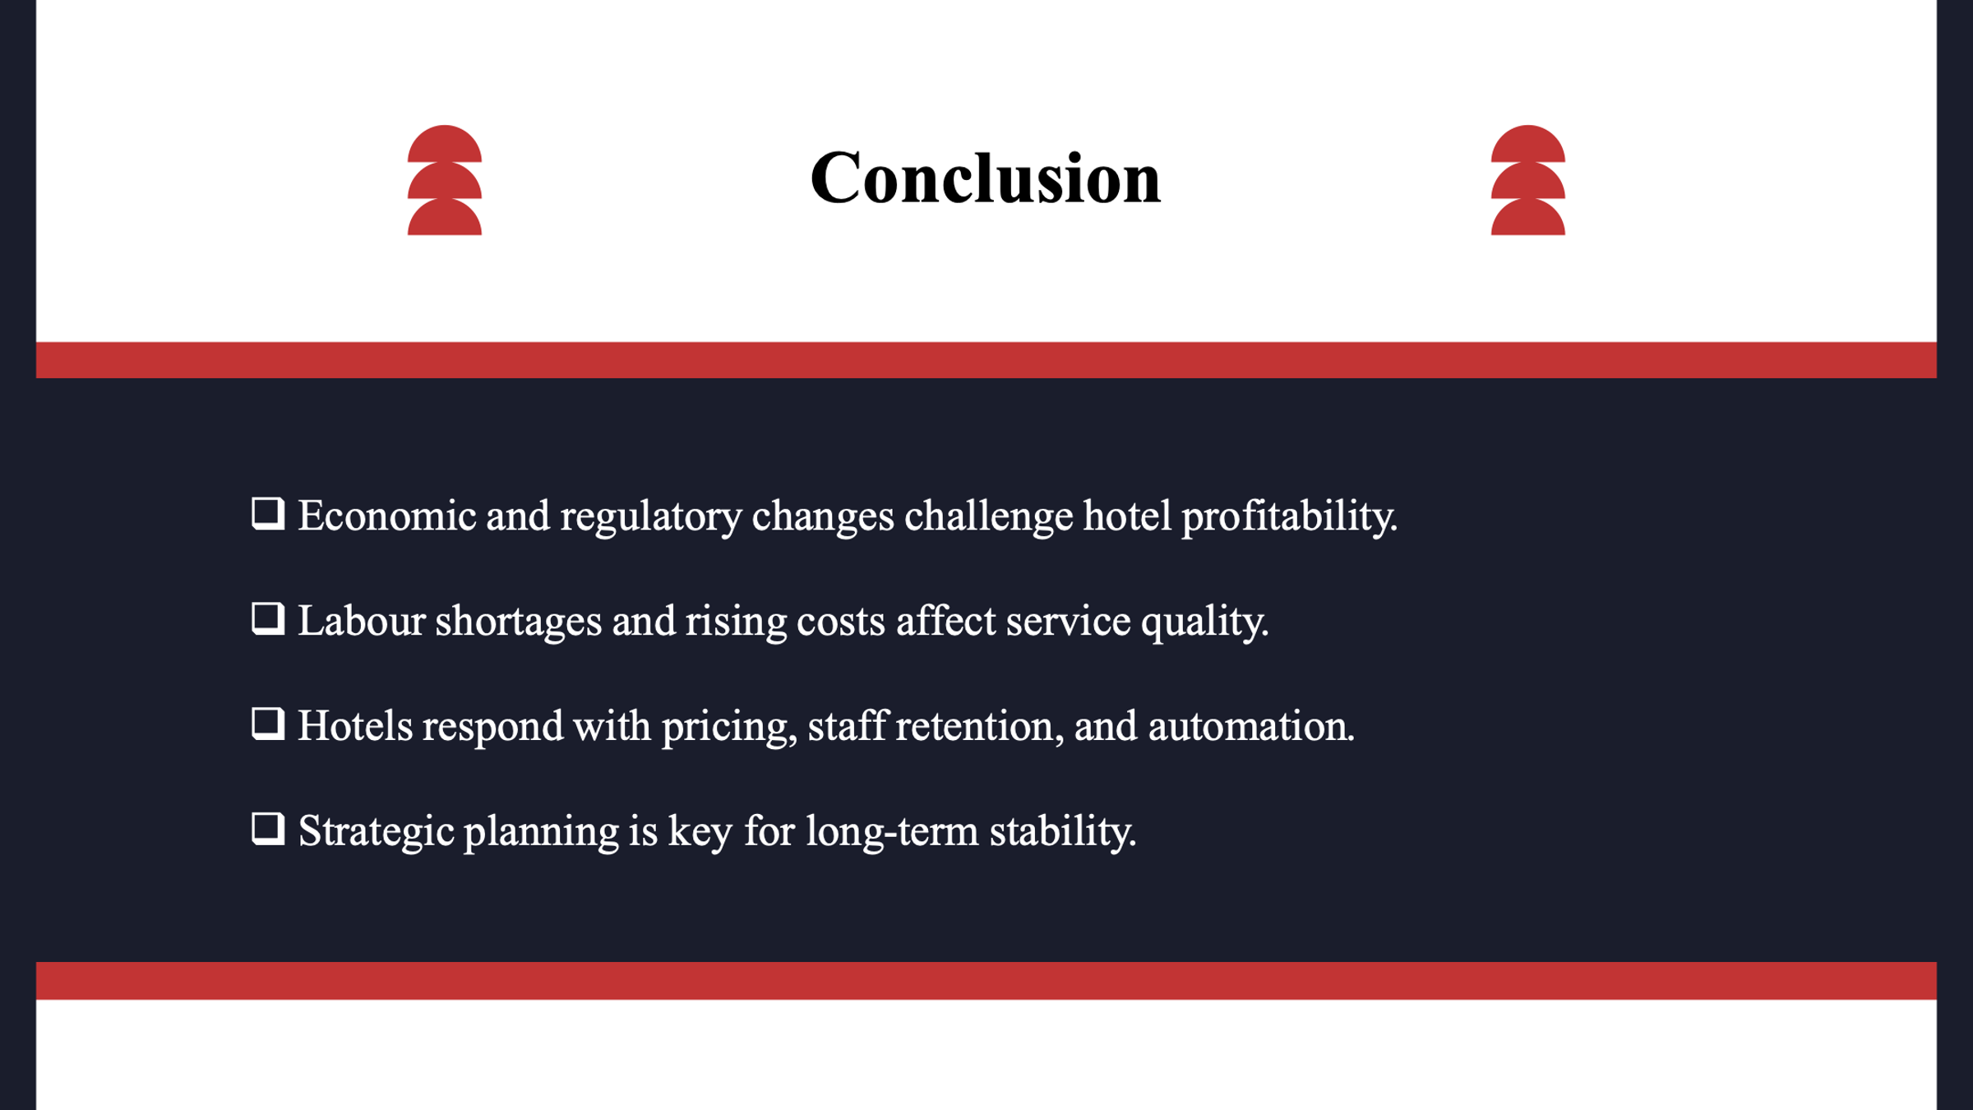
Conclusively, the economic unpredictability and regulatory policies pose new serious difficulties to the profitability and financial sustainability of the hotel sector, in the long run. Increased costs of operations, the lack of labour, and the necessity of required measures of the regulatory compliance influence the quality of the provided services, cash flow, and opportunity to invest. Dynamic pricing, workforce retention, adoption of technology, and sustainability are some of the responses that the hotels are undertaking. Competitiveness and resilience require strategic planning and pro-active management.
Slide 13:
Recommendations
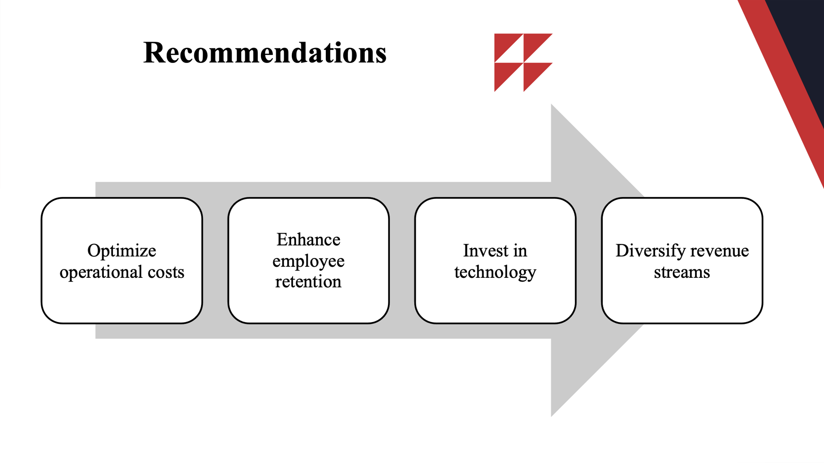
It is recommended that there should be optimisation of the operational cost by energy and waste-saving efforts. Also, training, career development and wellness programs must be used to improve employee retention. Moreover, technology and automation can be invested into to enhance efficiency and decreasing reliance on labour. In addition, revenue generator is to be diversified in terms of revenues through ancillary services and digital products in order to eliminate dependency on old room revenues.
Slide 14:
Thank You

Slide 15:
References
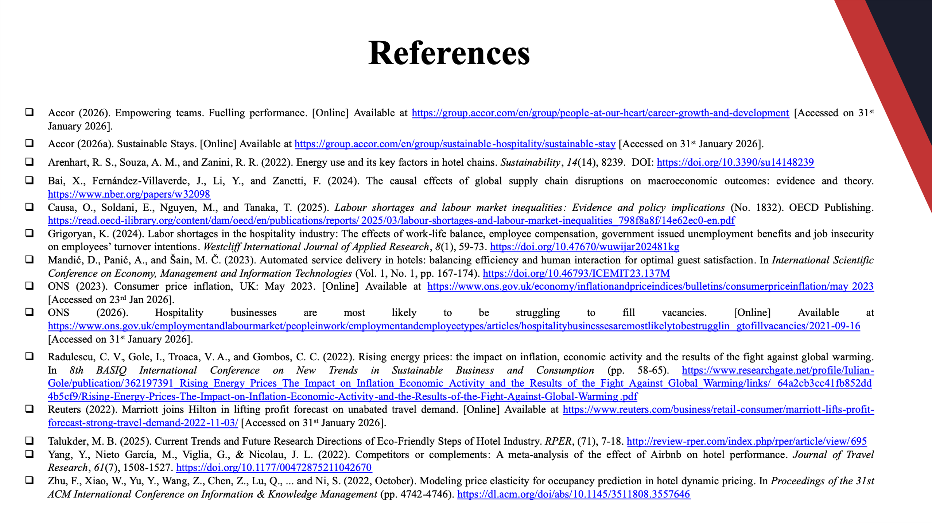
Accor (2026). Empowering teams. Fuelling performance. [Online] Available at https://group.accor.com/en/group/people-at-our-heart/career-growth-and-development [Accessed on 31st January 2026].
Accor (2026a). Sustainable Stays. [Online] Available at https://group.accor.com/en/group/sustainable-hospitality/sustainable-stay [Accessed on 31st January 2026].
Arenhart, R. S., Souza, A. M., and Zanini, R. R. (2022). Energy use and its key factors in hotel chains. Sustainability, 14(14), 8239. DOI: https://doi.org/10.3390/su14148239
Bai, X., Fernández-Villaverde, J., Li, Y., and Zanetti, F. (2024). The causal effects of global supply chain disruptions on macroeconomic outcomes: evidence and theory. https://www.nber.org/papers/w32098
Causa, O., Soldani, E., Nguyen, M., and Tanaka, T. (2025). Labour shortages and labour market inequalities: Evidence and policy implications (No. 1832). OECD Publishing. https://read.oecd-ilibrary.org/content/dam/oecd/en/publications/reports/2025/03/labour-shortages-and-labour-market-inequalities_798f8a8f/14e62ec0-en.pdf
Grigoryan, K. (2024). Labor shortages in the hospitality industry: The effects of work-life balance, employee compensation, government issued unemployment benefits and job insecurity on employees’ turnover intentions. Westcliff International Journal of Applied Research, 8(1), 59-73. https://doi.org/10.47670/wuwijar202481kg
Mandić, D., Panić, A., and Šain, M. Č. (2023). Automated service delivery in hotels: balancing efficiency and human interaction for optimal guest satisfaction. In International Scientific Conference on Economy, Management and Information Technologies (Vol. 1, No. 1, pp. 167-174). https://doi.org/10.46793/ICEMIT23.137M
ONS (2023). Consumer price inflation, UK: May 2023. [Online] Available at https://www.ons.gov.uk/economy/inflationandpriceindices/bulletins/consumerpriceinflation/may2023 [Accessed on 23rd Jan 2026].
ONS (2026). Hospitality businesses are most likely to be struggling to fill vacancies. [Online] Available at https://www.ons.gov.uk/employmentandlabourmarket/peopleinwork/employmentandemployeetypes/articles/hospitalitybusinessesaremostlikelytobestrugglingtofillvacancies/2021-09-16 [Accessed on 31st January 2026].
Radulescu, C. V., Gole, I., Troaca, V. A., and Gombos, C. C. (2022). Rising energy prices: the impact on inflation, economic activity and the results of the fight against global warming. In 8th BASIQ International Conference on New Trends in Sustainable Business and Consumption (pp. 58-65). https://www.researchgate.net/profile/Iulian-Gole/publication/362197391_Rising_Energy_Prices_The_Impact_on_Inflation_Economic_Activity_and_the_Results_of_the_Fight_Against_Global_Warming/links/64a2cb3cc41fb852dd4b5cf9/Rising-Energy-Prices-The-Impact-on-Inflation-Economic-Activity-and-the-Results-of-the-Fight-Against-Global-Warming.pdf
Reuters (2022). Marriott joins Hilton in lifting profit forecast on unabated travel demand. [Online] Available at https://www.reuters.com/business/retail-consumer/marriott-lifts-profit-forecast-strong-travel-demand-2022-11-03/ [Accessed on 31st January 2026].
Talukder, M. B. (2025). Current Trends and Future Research Directions of Eco-Friendly Steps of Hotel Industry. RPER, (71), 7-18. http://review-rper.com/index.php/rper/article/view/695
Yang, Y., Nieto García, M., Viglia, G., & Nicolau, J. L. (2022). Competitors or complements: A meta-analysis of the effect of Airbnb on hotel performance. Journal of Travel Research, 61(7), 1508-1527. https://doi.org/10.1177/00472875211042670
Zhu, F., Xiao, W., Yu, Y., Wang, Z., Chen, Z., Lu, Q., ... and Ni, S. (2022, October). Modeling price elasticity for occupancy prediction in hotel dynamic pricing. In Proceedings of the 31st ACM International Conference on Information & Knowledge Management (pp. 4742-4746). https://dl.acm.org/doi/abs/10.1145/3511808.3557646

