Strategic Management

(Company: HDFC)

Name of the Student-Pendyala Bikshapathy
Student’s ID- 2128324
Module Code : LCMB7003
Lecturer : Gladius Kulothungan

Executive Summary
Strategic management is an excellent organizational technique for achieving goals and objectives and organizing the company's many divisions to gain a competitive edge. Strategic management assists the business in making the best use of its resources and gives employees guidelines for being more productive. HDFC incorporates advanced technologies in the organization to digitally transform the workplace to become effective. It employs several forms of strategic management by using data and resources and developing an organizational strategy to undertake continual planning and monitoring of staff behavior. Strategic management assists in identifying the areas that require improvement and offers general guidance to employees to become productive while also managing the corporate culture and work ethics. In this study, the author studies strategic management and evaluates competitive advantage. The author assesses current research work to comprehend the many factors in the company that contribute to competitive advantage and profitability, as well as to make effective decisions to plan and execute the sustainable competitive advantage. Strategic strategy leadership assists the organization in effectively managing strategic management in the company by effectively analyzing rivals in the global market and regularly meeting customers' demands and desires. The digital transformation of the HDFC bank supports better production, satisfies customer requirements to achieve a competitive advantage, and automates the entire workplace.

Table of Contents

1. Introduction 5
2. The Company Profile 6
2.1 History 7
2.2 Distribution Network 7
2.3 Technology 7
2.4 Management 8
2.5 Business 8
2.6 Organization Structure and Hierarchy 9
2.7 Promoter 9
3. Strategic Management Process (SMP) 10
3.1 Strategic Management Process of HDFC bank 10
3.2 Strategic Developments from 2019 to 2022 11
3.3 Strategic interpretations from 2019 to 2022 12
3.4 Analytical tools involved in the process 12
4. Vision, Mission, and Business Focus 12
4.1 Vision 12
4.2 Mission 13
4.3 Business Focus 13
5. Environmental analysis 13
5.1 Internal Environmental Analysis 14
5.1.1 SWOT Analysis 14
5.1.2 BCG Matrix 16
5.2 External Environmental analysis 17
5.2.1 PESTLE Analysis 17
5.2.2 Impact of environmental analysis on the organization 18
6. The Industry Analysis 19
6.1 Industry Analysis (Using Porter’s Five Forces) 19
7. The competitor’s analysis 20
7.1 Major Players in India 20
7.2 Competitive SWOT Analysis 22
8. Management Issues involved 24
9. Strategies to be implemented for further development 25
9.1 Strategy 25
9.2 Corporate-level strategy 25
9.2.1 Factors involved 26
9.3 business level strategy 26
9.3.1 Factors involved 26
9.4 Functional level strategy 26
9.4.1 factors involved 27
9.5 promotional strategies of HDFC bank 27
9.5.1 Factors involved 27
10. Discussion on how the company will gain a competitive advantage in the coming three years 27
11. Conclusion and Recommendations 29
References 31

1. Introduction
HDFC is India's leading private Bank that offers customer services. It provides housing and finance loans along with online net banking. India's largest private Bank was founded in 1994, and its headquarters is located in Mumbai, Maharashtra, effectively generating revenue and profit. With its proper strategic management and bringing competitive advantage in the global market. It provides life insurance and personal loan and meets the customer's various needs (Tiwari et al.,2022).
HDFC established a plan and considered several factors. The descriptive strategic management technique discusses how HDFC builds strategies, whereas a qualitative methodology focuses on implementing programs. These points of view disagree on whether procedures are formed by an analytic process that considers all risks and rewards. These are similar to basic driving ideas to be implemented for organizational growth (Goel,2022). The organization's strategic management assists it in Efficiently utilizing manual resources to coordinate all aspects and providing advice to personnel to reach the organizational objectives and goals and complete the corporate mission and vision. It is the most effective and successful approach for gaining a competitive advantage and controlling internal purposes via improved management implementation. The HDFC bank uses the management strategy to provide flexibility and build the organizational system to exit with the changing environment and benchmark the product quickly. Proper planning and designing help the company compete with its rivalries. Business etiquette, human talents and competencies, and organizational structure are all critical variables in determining how well the banks achieve their stated goals. In a changing business climate, rigid organizations may need help to prosper. Managers may need help to identify if goals have been reached and if a barrier exists between strategy design and implementation. In the changing market scenario, the Bank is inevitably developing organizational strategies and playing a pivotal role in improving the sector to connect with potential customers and bring advancement to achieve future gold and success. The strategic management of the HDFC bank supports it in developing its different strategies and tactics to become competitive and reach the horizon in developing countries. It plays its financial role and speeds up the nation's growth, effectively moving the finance and circulating the surplus money (Patel and Dwivedi,2022).
The author has effectively analyzed the importance of the HDFC bank in the Indian market and provides its services that bring progressively advancement and advanced technology to transform the workplace to get diversification. The Bank effectively manages and controls its business strategies and extends its abilities to directly contact the depositors and the borrowers as well as attract potential customers to take the facilities of the Bank and effectively play its role in taking deposits and money transfers with advancement. The banks are vehicles that move surplus or extra money to the deficit and provide loans to creditors who want to borrow the money. Banks play the role of a financial foundation that revolves around the traditional banking system, like depositing and crediting money or lending money and doing profitable activities (Anjaneyulu,2022). The Bank is directly playing its role in developing India's growth, changing the advanced banking system's scenario, providing credits, and reaching the country's remote corners. Cloud-native lending technology with digital procedures for each stage of the client experience, including application, loan processing, quality screening and decisions, disbursement, and lending service, is a significant component of the program. It promotes risk reduction and speed by automating the credit checking process and utilizing a machine learning-based decision engine. In this 24 century dynamic world, bands are playing. Significant role And providing advanced facilities like net banking and online banking to settle the bills of electric bill water effectively will, and other utility bills without facing any problems; if the customer links the statements to the account number, the invoices are automatically get paid (Mehta and Mathur,2022).

2. The Company Profile

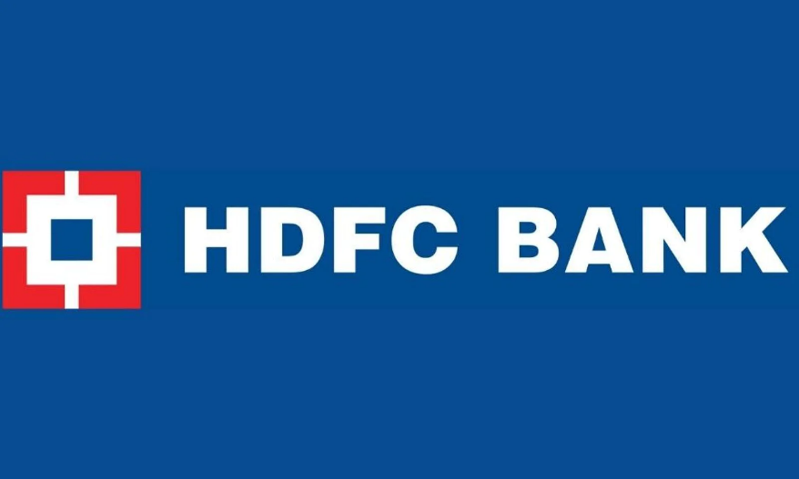
Figure- The Logo of HDFC bank
Source (Tiwari et al.,2022)

2.1 History
HDFC Bank was established in August 1994 in Mumbai and started its journey as commercial banking in January 1995, which provides loans to potential customers in housing development. It is one of the leading banks in India that provides its services to 550 cities across India, and it has managed 1416 branches in different locations. The company effectively transformed the workplace to bring better management and provide services to the International internet markets in the retail mortgage loan as well as connecting with the large corporate client for better enhancing the credit facilities. The company has a strong market reputation and effectively competes with market rivalries (Borthakur,2022).
The partnership will enhance HDFC's consumer experiences and corporate operations, leading to increased operational agility, efficiency, and business development. The organization cooperated with a home financing company to digitally upgrade its banking operations. The ambitious project aims to automate and agilely manage HDFC's loan lifecycle.

2.2 Distribution Network
The distribution network of the company is significant in this process because the headquarter of the Bank is located in Mumbai, Maharashtra, and its controls all the branches in different cities of India, effectively managing and handling strategic management and better leadership quality to satisfy customer needs and wants to bring advancement in this sector. On March 31, 2014, the company effectively reported its distribution network of 3,403 branches in Different cities of India, which is referred to as 2,171 cities. Its components are effectively linked up with the headquarter and provide real-time information and knowledge to all the employees working real-time and comprehend the knowledge and experiences to provide better customer services. Digitalization supports the company in providing customer support in 1397 locations and delivering telephonic banking to solve customer problems and queries and bring an effective and positive outcome. The Bank has equipped its ATM services across India, which generally numbered 11,256 across India, and its services and networks. The ATM network is easily accessible by all domestic or international debit cards such as Visa, MasterCard, Electron, Mastro, or other cardholders (Liu et al.,2022).

2.3 Technology
The company has understood the changing business scenario and incorporated advanced technologies in the organizations to highly automate the services in terms of achieving the information and analyzing the real-time data for the development of the organizational strategies to provide proper knowledge and information to the employees to achieve productivity and manages the corporate work ethics and work culture to speed up the business activities. The technology and the communication system have automated the entire system so that it is effectively connected with all the branches of India and provides online services (Choudhury et al.,2022). The technology supports the Bank to fast transfer funds to its customers. It gives different advanced facilities to retail customers, such as automated teller machines (ATMs) to take out the money when needed. The automatic engine also supports customers to deposit cash at ATMs anytime and anywhere without human interference or support. The technology effectively motivates customers to invest, which brings out substantial efforts. Moreover, digitalization and technology have transformed the workplace, supported the development of advanced infrastructures to support people and potential customers, and incorporated software into its growth (Iqbal and Tanty, 2022).

2.4 Management
Sashidhar Jagdishan, The chairman of the HDFC Bank, effectively manages all the Business activities and effectively takes the business decisions to guide the customers and all the branches to keep everyone in the same place to achieve the organizational objectives and mission, and vision. The administrative authorities of the banks are highly skilled and have professional expertise and effectively handle the management team by recruiting the best skills, experience, and knowledgeable employees in the organization to successfully utilize the manual power to achieve competitive strength in the global market and complete the rivalries (Nazeer et al.,2022).

2.5 Business
HDFC Bank effectively provided product services and outstanding facilities to the customers to fulfill consumer needs and wants. Moreover, the wide range of banking services supports HDFC bank in achieving a competitive advantage in the Global market and encourages investment to enable successful business strategies (Sunitha and Venu Madhav,2022)
i) Wholesale banking- Wholesale banking effectively provides commercial and transactional banking facilities encompassing capital finance, trade services, transactional services, and cash management. It effectively brings solutions to problems and issues. It effectively enhances the customer base and facilitates better supply chain management to benefit its corporate customers and evaluate the strong customer orientation. The company better deals with mutual funds, stock exchanges, and customer care corporate customers.
ii)Treasury- The company effectively manages foreign exchange, derivatives, and local currency, including the money market, debt securities, and Equities. HDFC Bank effectively manages the risk and the product structures and manages the Bank's treasury items to fulfill the customer requirement as well as its deposit of 25% for the government securities to deal with the market risk and the investment portfolio.
iii) Retail banking- The company effectively provides customer services to the target market and delivers the facilities to a one-stop window to fulfill the requirements. It is effectively expanding its brand in different cities in the country to understand customer behavior better and satisfy the requirements with bitter securities.

2.6 Organization Structure and Hierarchy
The company's structure supports success and growth. It enhances collaboration and cooperation by effectively connecting with the different branches to speed up its development and achieve the bottom line. The company provides financial advice to potential customers, plays responsibilities as a financial consultant, and connects with more customers effectively. HDFC Bank provides services in opening new accounts with customers, creating a robust database providing financial advice, handling the administrative department, and managing the executive department (Choudhury et al.,2022).
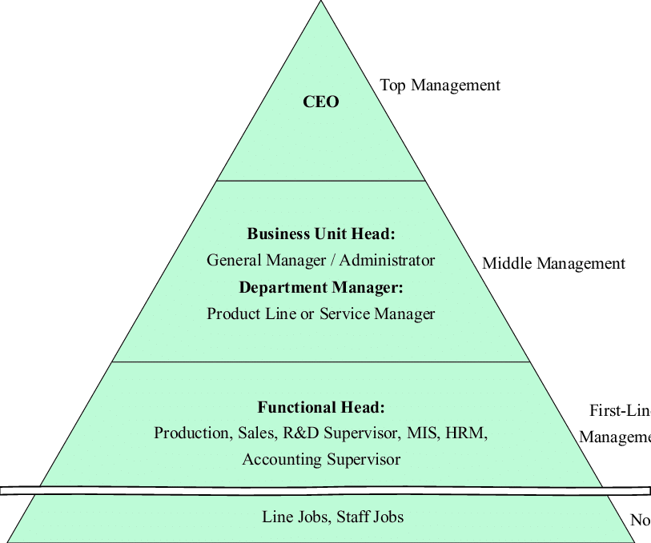
Figure: organizational hierarchy
Source (Karimi et al.,2022)

2.7 Promoter
HDFC bank has an outstanding record in providing housing finance and managing the impeccable track record in the international market, continually growing in business operations and providing its services, and becoming the market leader in mortgages. The company has an outstanding strategy in providing retail mortgage loans and handling the different market segments to generate a large corporate client base for better credit facilities. It successfully manages the financial market and strong brand reputation by providing nutritional information to the stakeholders and constantly growing in the Indian Marketplace (Singh and Henge,2022).

3. Strategic Management Process (SMP)
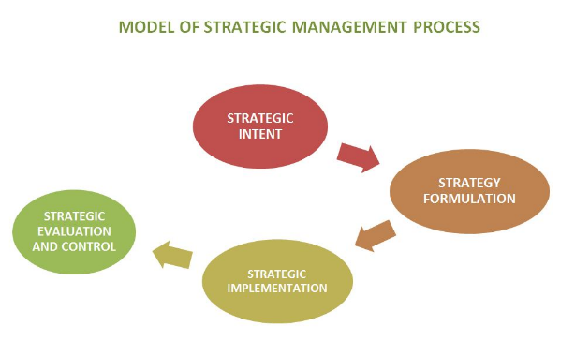
Figure- The model for strategic management process in HDFC bank
Source : (Reddy et al.,2022)

3.1 Strategic Management Process of HDFC bank
Currently, the Bank is developing its business strategies to expand its product range and reach the ruler and the remote corner of the country to effectively deal with the challenges and provide banking facilities to every customer in the City. Its quality services support the Bank to purchase customer loyalty and trust along with its business strategies, and the strong leadership quality brings a competitive advantage in every sector (Saikrishna and PM, 2022).
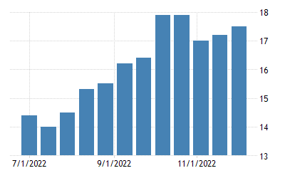
Figure: Projected growth rate
Source :(Robert and Ramakrishnan, 2022)
The Bank aims to deliver its product services to retail and wholesale clients while also achieving successful growth and income generation year after year. HDFC Bank's share capital was 650 crore in 2020, owning 21.15 percent of its equity. The Global Private Finance and Investment Management Survey, an essential guide for the international financial administration business, offers a complete analysis of the top individual financial operations - by region and service area. It serves 13 unique product and client segments. The poll is based on responses from personal financiers and investment managers worldwide who describe which companies they consider competitors in their local market. The branches are effectively increasing in different cities of the country, and recently the Bank held 6,342 units in 3,188 towns in march 2022.

Strategy Implementation in HDFC
The process of putting plans into practise to achieve desired outcomes is known as strategy implementation. In essence, it is the art of getting things done. Each corporation's success depends on its ability to implement decisions and carry out crucial strategies consistently, efficaciously, and successfully. They must identify crucial variables and define clear goals. The first phase in the process is straightforward: The goals of the new strategy must be identified by HDFC. Establishing a plan for purchasing there may be challenging without a clear picture of what they hope to achieve. After identifying the goals they're aiming for and the obstacles in their path, HDFC should create a roadmap for achieving those goals, set expectations for their team, and openly discuss their execution strategy to ensure there is no misunderstanding. It can be challenging to implement a strategy successfully, and it demands strong management and leadership skills. Delegation skills that work, persistence, emotional intelligence, thorough organisational skills, and communication skills are essential.

3.2 Strategic Developments from 2019 to 2022
The current market strategy of HDFC Bank is to incorporate advanced technology to deal with the uncertain contingencies of the coronavirus and pandemic and provide adequate services to the customers, which effectively deals with the risk factors. HDFC innovation stock has entirely incorporated financials and has begun to expand its involvement in the healthcare industry. It is still heavily invested in metals and commodities equities in general. It continues to be highly productive in resources and technology if allowed the chance. HDFC Bank provides services in different market sectors and deploys the branch in the retail site by following the strategy principles In wholesale banking, retail banking, and treasury (Krishnamoorthy and Mahabub Basha,2022). The company is actively targeting its potential customers, following the segmentation targeting and positioning strategies, and developing strong customer orientation by providing loan and net banking facilities depositary ATM. The company has strongly registered its presence on social media marketing and advertising its services on the social media platforms such as Facebook, Instagram, Linkedin, and Twitter. The promotional content supports the company in connecting with potential customers worldwide and provides digital and online services to attract many followers (Nagpal and Mishra,2022).

3.3 Strategic interpretations from 2019 to 2022
HDFC bank has effectively developed its interpretation goal to connect with potential customers worldwide and provide possible services. The interpretation strategy of the HDFC Bank is to better deal with the potential customer and analysis the entire management strategies and overview of the banking industry, effectively analyzing the strength and weaknesses to boost the financial performance, brand image, and support to have a competitive advantage and achieve the bottom line (Dar et al.,2022).

Strategy Review
The banking industry in India is thriving and growing. Indian banks make up 1.7% of global banks. As was already mentioned, the HDFC Bank's goal is to become the premier bank in India. The goal is to improve customer franchise for various businesses in order to become the preferred banking service for target customer segments and the retail market, as well as to produce a healthy profitability growth consistent with the bank's appetite for risk. Franchises that are targeted by HDFC Bank have successfully increased their market share over time while maintaining a healthy level of profitability and capital adequacy.

Strategy Analysis
This represents a long-term strategy for developing a market-wanting and competitive good or service. In this segment of the HDFC Bank case study, they will go through each of their many marketing strategies. In order to achieve its goal of being a world-class Indian bank, HDFC Bank compares itself to global standards and best practises in the areas of product offerings, technology, service standards, risk management, audit, and conformity. It aims to achieve a healthy profitability growth that is consistent with the Bank's risk appetite, as well as to establish strong customer franchises across the various enterprises to become a preferred banking provider for target retail and wholesale client groups. The Bank is committed to doing that while upholding the greatest standards of morality, professionalism, governance, and regulatory compliance. The main objective of the Bank's business is to keep creating new goods and technology. The main objective of the bank is to keep good relationships with its customers.

3.4 Analytical tools involved in the process
HDFC Bank uses different analytical tools and technologies to enhance product services and satisfy potential customers worldwide. The Bank positively utilizes the 78 technologies to help potential customers and their requirements. This includes Google Font API, Apple mobile with clips icon, and using the IPqwery to effectively provide insurance financial affairs to satisfy customer needs and enhance productivity. The banking software is fast and supports improving the workflow by minimizing human efforts and reducing the chance of error and mistakes. 360-degree data value visualization support HDFC Bank to explore the various data to enhance business performance and activities to manage the entire operations (Sharma, 2022).

4. Vision, Mission, and Business Focus

4.1 Vision
To establish an Indian Bank of World Class. By providing a vast selection of pertinent goods and services
1) Customer-specific solution
2) Make specific unrivaled client service
3) Offering the remedy at the appropriate cost
4) Have a broad and deep reach

4.2 Mission
Being "a Top-notch Indian Bank" is the mission. The mission is to set up substantial customer establishments in various areas to become a preferred provider of banking services for target retail and discount client gatherings and to create proper growth in benefits, keeping with the Bank's appetite for risk. They pledge to carry out this commitment while upholding the most excellent standards of morality, professionalism, corporate governance, and legality (Ansoff et al., 2018).

4.3 Business Focus
A top-tier Indian bank is what HDFC Bank aspires to become. The Bank is devoted to maintaining the best guidelines of ethical quality, fantastic skill, corporate obligation, and lawful consistence. The five critical upsides of functional greatness, client center, item initiative, individuals, and manageability structure the groundwork of HDFC Bank's business reasoning (Aguinis and Solarino, 2019). The faculty at HDFC Bank is youthful and propelled, and the organization is focused on understanding its objective of being a top-level Indian bank. The five critical upsides of the client center, functional greatness, item initiative, individuals, and maintainability structure underpin the HDFC Bank business reasoning. HDFC Bank believes that our people's great qualities and remarkable efforts will ultimately determine who we are as a bank and how successful we are. As a result, HDFC Bank is dedicated to attracting, keeping, and advancing the most outstanding talent in the sector.

5. Environmental analysis
The term "environment" describes all external elements that impact a business. Most, if not all, environmental influences are external and beyond any one industrial organization's administration or control (Teece et al., 2019).
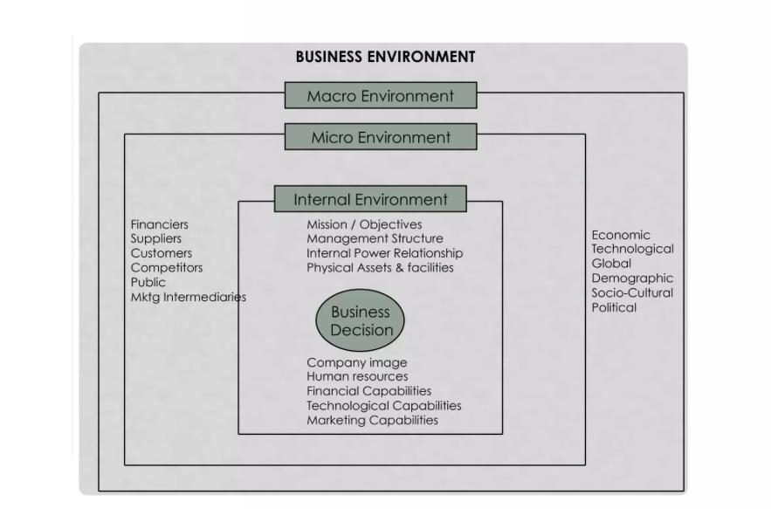
Figure-Business Environment of HDFC
Source – (Ansoff et al., 2018)

5.1 Internal Environmental Analysis

5.1.1 SWOT Analysis
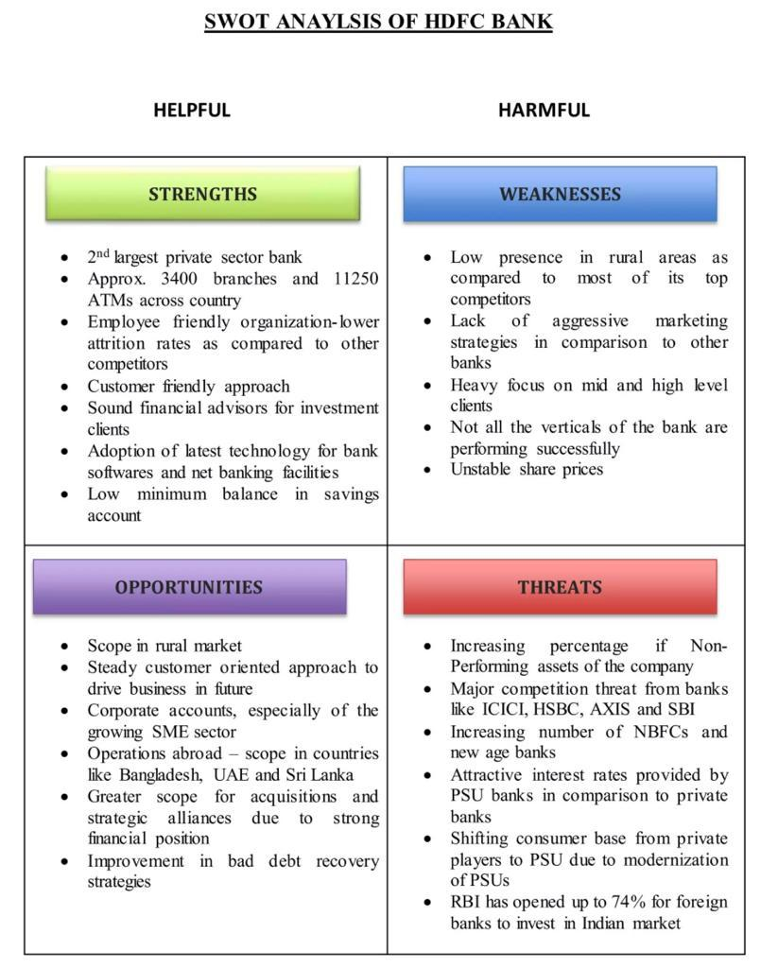
SWOT Analysis of HDFC Bank
(Source – Aguinis and Solarino, 2019)
Strengths
- With 2,201 branches and 7,110 ATMs, HDFC Bank is the second-largest private banking sector in India.
- Customers can use telephone banking at more than 800 HDFC Bank outlets throughout 1,174 cities in India.
- The highest level of customer satisfaction is found at HDFC Bank compared to other private banks.
Weaknesses
- While ICICI Bank, a direct competitor of HDFC Bank, is growing in the rural sector while HDFC lacks a significant presence, HDFC cannot benefit from first mover advantage.
- The Bank primarily caters to high-end customers (Henry, 2021).
- Specific product categories the Bank offers could be better and have more market reach.
Opportunities
- Compared to government banks, HDFC Bank has more robust asset quality metrics. Hence profit growth is projected to increase.
- HDFC Bank's portfolio of bad debts has improved compared to government banks, and the recovery rate for bad debts is high.
- Due to its excellent financial position, HDFC has more chances for acquisitions and strategic relationships abroad (Boselie et al., 2018).
Threats
- Despite the modest variance, it's not a positive indicator of the Bank's financial stability.
- Nonbanking financial institutions and new-generation banks are expanding in India.
- Due to ICICI's significant threat, HDFC cannot increase its market share.

5.1.2 BCG Matrix
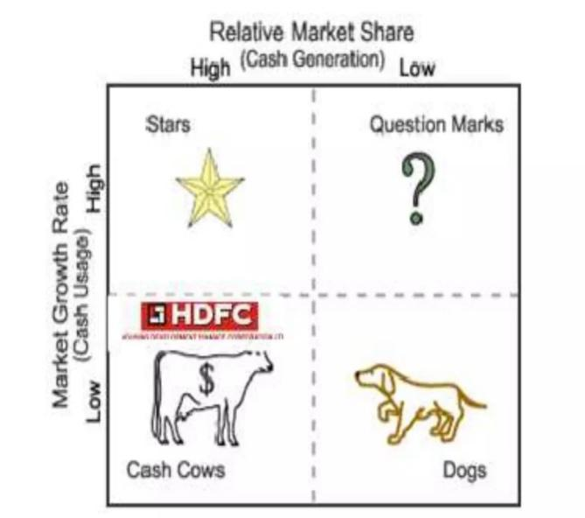
Figure- BCG Matrix
(Source – Teece et al., 2019)

HDFC Bank
HDFC Bank holds the BCG matrix's star position. Due to their substantial market share and rapid market growth, HDFC Bank. The banking sector has enormous development potential due to rising customer disposable income, an expanding working class, and increased market volatility.
HDFC Insurances
Most of HDFC's products are in the star position in the insurance business. High market share and rapid expansion are characteristics of HDFC insurance products.
HDFC Mutual Funds
Mutual funds are a veritable gold mine. It illustrates HDFC's massive market share and a moderate market expansion rate in the mutual fund industry. We should invest in only successful products and try to buy those with slow market growth rates that do well if enough money is invested (Scholes et al., 2020).
Margin and expansion
The resources needed to expand are only one part of the problem. Will the business keep growing? The economy's slow expansion rate raises the possibility that growth may be problematic. The first quarter of the 2009 fiscal year saw only a 43% increase in HDFC Bank's profits. As a result, it might be claimed that HDFC Bank is the BCG matrix's cash cow (Shipilov et al., 2018).

5.2 External Environmental analysis

5.2.1 PESTLE Analysis
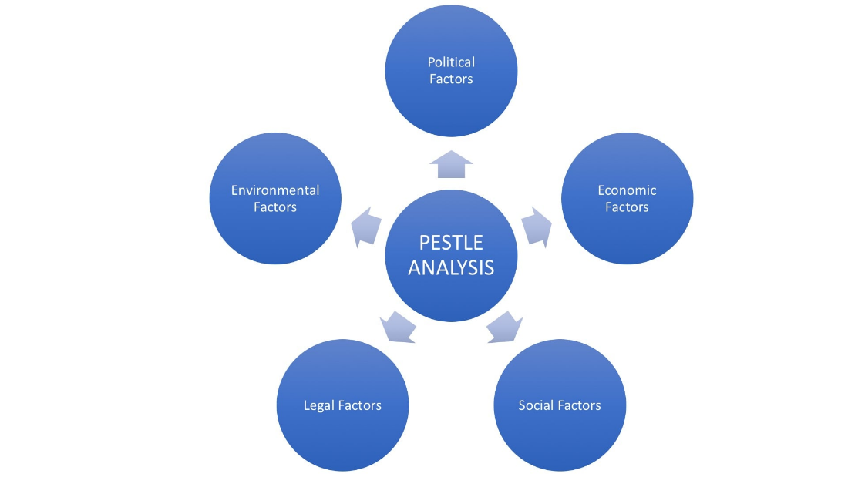
Figure- PESTLE Analysis
(Source – Boselie et al., 2018)
Political factors
- As a financial institutions, banks are constantly constrained by laws and regulations.
- The RBI tightly regulates banks and other financial institutions, and government budget decisions impact banking operations.
- The success of other private businesses is impacted by government assistance for PSU banks.
- The RBI will permit foreign banks to invest up to 74% of their total capital in the Indian market (Moutinho and Vargas-Sanchez, 2018).
Economic factors
- The operations of the Bank are impacted by monetary policy changes every year.
- The interest rates at which banks lend money are influenced by decisions made about monetary policy.
- To combat inflation and other related financial concerns, the RBI has altered its monetary rates 13 times over the past two years.
- The banking industry has contributed significantly to the country's rising GDP, strengthening the economy.
Social factors
- The spending power of Indian consumers has increased significantly, and their way of life is changing quickly.
- The regional market is also increasing.
- The idea of banking has gradually started to permeate rural residents' consciousness and is affecting their daily lives and the performance of the rural banks.
Technological factors
- ATMs are now widely distributed across banks.
- Automated voice-responsive devices assist banks in addressing consumers' minor inquiries.
- A notable advancement in the banking industry is internet banking, or banking through the Internet.
Environmental factors
- Joining The Anti-Plastic Drive Is HDFC Bank
- One of the top banks in India, HDFC Bank, is working with the local government to inform residents about the harm plastic bags due to the environment and provide recycled paper bags as an alternative.
- By adopting the tagline HDFCMF Online, HDFC Bank encourages its clients to conduct business with them online, particularly regarding mutual funds (Henry, 2021).
Legal factors
- They are launching the relevant legal actions required by Collections and assisting Collections in meeting targets and timelines.
- Effective vendor management includes prompt bill payment.
- They are ensuring that no adverse orders are passed against the Bank and handling the disputes brought against it successfully before all forums and statutory bodies.

5.2.2 Impact of environmental analysis on the organization
Businesses can identify internal and external factors that may positively or negatively impact their operations by conducting an environmental analysis (Swayne et al., 2018). Companies can anticipate opportunities and difficulties by considering economic and technological factors. In terms of detecting, evaluating, and responding to environmental issues, HDFC Bank has been at the forefront. It has also been tracking its greenhouse gas emissions.

6. The Industry Analysis

6.1 Industry Analysis (Using Porter’s Five Forces)
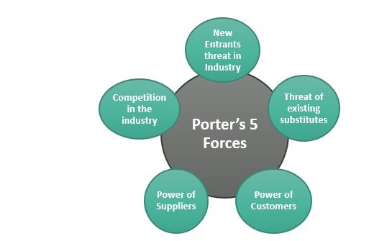
Figure- Porter’s 5 Force
Source (Panda et al.,2022)
Competition in the industry- HDFC Bank effectively analyses the external data and the current market trends to become competitive and provide adequate services to deal with the rivalry and create value for the customers to become productive and solve the complexity to successfully achieved the bottom line (Hla,2022).
The new Entrants in the industry- HDFC Bank effectively manages its strategic management policies to provide the guideline to the employees to work hard for organizational growth and analyze the current data and the external factors to develop the market strategy to better deal with the business risk and achieve the market share. The industry is expanding its businesses overseas, analyzing the barriers, utilizing its resources, and strengthening its entry into the new market (Kaakandikar et al.,2022).
Supplying power- HDFC Bank effectively delivers its banking services to potential customers. It develops new market strategies to better understand customer behavior and requirements and fulfill their needs and wants (Torney et al.,2022).
Analyzing the customer power- HDFC Bank effectively supports the customers and doing its business in the Indian market and bringing growth and productivity. The company supports the demographic and analyses its earning power to provide better services in this market (Goel,2022).
Recognizing the threat- The strategic management of the HDFC Bank supports identifying the areas that need development and effectively gathering information by utilizing advanced Technologies to develop the market strategy to deal with the threat and develop the organizational approach to achieve competitive advantage in the global market. ICICI is a significant threat (Agarwal,2022).

7. The competitor’s analysis

7.1 Major Players in India
1. HDFC BANK LTD
2. ICICI BANK LTD
3. PUNJAB NATIONAL BANK LTD
4. STATE BANK OF INDIA LTD
5. AXIS BANK LTD
6. BANK OF BARODA LTD
7. FEDERAL BANK LTD
Below is a table outlining the comparative analysis:
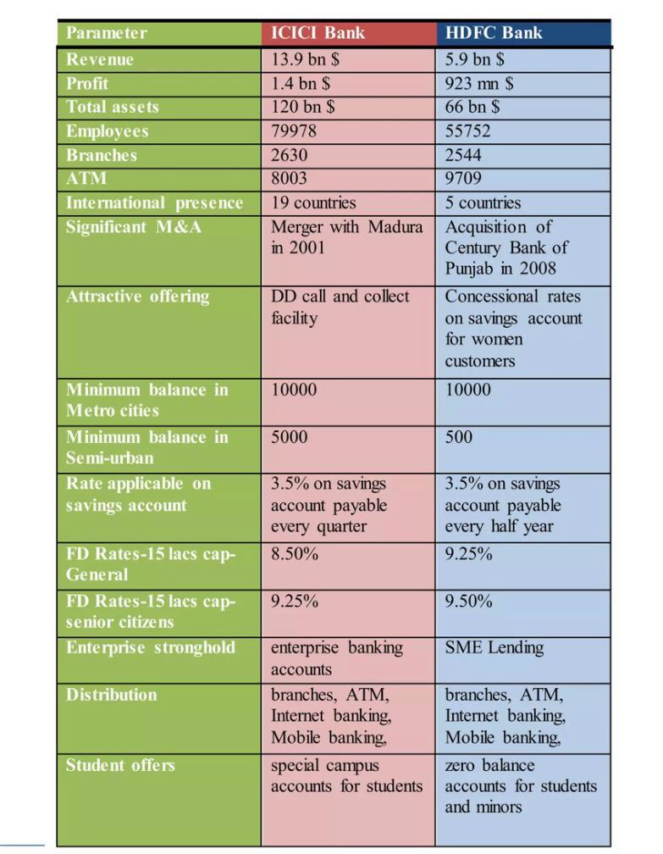
Figure- Competitive Analysis
(Source – Swayne et al., 2018)

7.2 Competitive Analysis
1. Strength-Opportunity Analysis (SO Strategy)
Strength
- In the Indian banking system, HDFC Bank has the most fantastic, authorized capital base and can raise the most money.
Opportunity
- It is clear that the market for finance requirements is growing and that the increase in surplus disposable income of Indian citizens has significantly fueled the rise in savings deposits (Aguinis and Solarino, 2019).
Strategy
- Based on the analysis of Strengths and Opportunities, HDFC Bank's most straightforward strategy might be to enter India's rural sector to increase its market share and set itself apart from all other Pvt. Banks.
2. Strength - Threat Analysis (S-T Strategy)
Strength
- Although it has many branches and offers a wide range of services, HDFC Bank is also renowned for having cheap operating costs.
Threat
- India has attracted numerous multinational financial and banking institutions known for their cutting-edge work and low operating costs.
Strategy
- To maintain minimal operating costs and ongoing business, HDFC Bank should market itself effectively and offer top-notch customer care to win over new clients and retain existing ones.
3. Weakness - Opportunity Analysis (W-O Strategy)
Weakness
- Although HDFC Bank has more responsible workers, it still needs to catch up regarding workforce responsiveness in the banking business. It is a well-known fact (Scholes et al., 2020).
Opportunity
- India is currently regarded as one of the top locations for outsourcing business process tasks.
Strategy
- Since outsourcing customer care and BPO services has shown themselves to be very profitable for multinational businesses, HDFC Bank should follow suit to provide good customer service while maintaining clients' expectations.
4. Weakness - Threat Analysis (W-T Strategy)
Weakness
- Despite having a global reach, HDFC Bank has struggled to maintain the highest customer care and banking operations levels.
Threat
- Many foreign banks, like CITI Bank, have recently entered India. Since these banks are renowned for functioning and upholding high customer service standards, they pose a danger to HDFC Bank from outside entry (Moutinho and Vargas-Sanchezed, 2018).
Strategy
- Given the threat of new competitors, HDFC Bank could provide its clients with more perks or lower some of the prices for any additional work they perform.

8. Management Issues involved
To manage their operations, small business owners and managers must deal with various challenging scenarios. Financing the business, developing products that appeal to clients, finding and keeping suitable workers, achieving multiple goals, and even staying up to date with laws and policies may all be challenging (Lieberman et al., 2020).
Regulatory Changes were observed: The regulatory environment for financial services is constantly changing due to political unrest, public opinion, rising economies, and other factors. Each month, new policies or adjustments to current rules are adopted. Banks may need help to comply with the constantly evolving standards. Still, they must do so to avoid exposing themselves to the compliance risk and its unavoidably severe consequences.
Growing customer expectations: Today's consumer is skilled at performing chores like banking on their gadget instead of by hand. It has caused mobile banking apps to become more commonplace; finding a financial organization that still needs a mobile app is common. Mobile apps usually supplement a financial institution's physical services rather than a one-stop shop for saving. Even for more technologically advanced banks, the quality of their mobile app frequently needs to be higher than that of their online banking platform.
Breach of Cybersecurity: As the financial goods market has become increasingly tech-based, security has become a cost of business. Malware, phishing, and Denial of Service attacks are among the many cybersecurity threats that are becoming so complex that legacy systems put in place before the emergence of Big Data analytics cannot fight against them. As a result, bank cybersecurity administrators frequently experience false positives and spend a lot of time investigating problems that don't affect them (Lieberman et al., 2020).
Identity theft & Fraud: Like cybersecurity, bank security executives frequently become frustrated by the high number of false positives for fraud and identity theft. Clients can see misrepresentation and fraud misleading up-sides, which can impede their capacity to finish exchanges and, now and again, cost them cash. It is the significant primary differentiation between this bank danger and the end. Misleading up-sides so significantly impede bank tasks and lower and immense client bliss.
Upsurge in Rivalry: In the cutting-edge world, traditional banks face expanding contests from online banks anxious to catch a piece of the pie and progressive organizations like Apple, Amazon, and Google going into the finserv business. It needs to be more straightforward for nearby and territorial banks since they need assistance to extend their geographic reach to compensate for lost clients. Conventional banks must learn to communicate with their customers similarly to their non-conventional competitors to fend off this incursion, which frequently necessitates a complete rethink of their customer engagement strategy (Kim et al., 2019).

9. Strategies to be implemented for further development

9.1 Strategy
A thorough, well-coordinated plan comprising commitments and actions intended to build on key strengths and gain a competitive edge is referred to as a strategy. When a corporation uses a technique that its rivals can only reproduce or find inexpensive to try to mimic, it has an advantage over its competitors. A thorough plan outlining how the company will carry out its mission and meet its goals is known as a strategy.

9.2 Corporate-level strategy
Leaders employ a corporate-level system, a multi-layered organization chart, to define, frame, and achieve specific business goals (VahdatiRoohani et al., 2019). The business can use a corporate-level procedure to increase its profits in the upcoming fiscal year.

9.2.1 Factors involved
1. Vision: The primary reason for the visioning section is to set the association's critical level course, notably the vision, mission, and maybe corporate attributes. The company's future vision has become an essential aspect of corporate management.
2. Setting objectives: The purpose of the actual setting is to support the visioning assumptions created and turn them into a progression of unquestionable level goals for the organization.
3. Investment strategy: This corporate system section references decisions regarding the most efficient allocation of capital and human resources in light of stated objectives and aims.
4. The beneficial tradeoffs or prioritization: One of the most challenging aspects of a business system is prioritization, or separating essential tradeoffs.

9.3 business level strategy
The business-level system is an innovative way for a firm to emphasize its unique resources, boost its competitive edge, and support the many parts of the organization's function as a unified whole (VahdatiRoohani et al., 2019).

9.3.1 Factors involved
1. Differentiate target market and buyers: They must first identify the finest clientele for their firm and the objective market they need to enter before implementing organizational transformations.
2. Discover their needs: HDFC can begin investigating the needs of its customer base once they have outlined its objective market, identified competitors, and the appropriate clientele for that market.
3. Discuss how to take extra care of their needs: Since it is now so evident which materials and furniture items are preferred by their target market, work with other company executives to identify suppliers.

9.4 Functional level strategy
The tasks and goals assigned to various departments that support their corporate-level Strategy and business-level technique are known as practical-level procedures. These processes outline the outcomes they must obtain from the regular operations of specific company divisions (Kim et al., 2019).

9.4.1 factors involved
Detail: The practical level system will be the most detailed of the three methodologies. They will, of course, have specific goals and essential elements for each division.
Arrangement: Methodologies at the practical level should always align with those at the commercial and corporate levels above them.
Progress: It is not challenging to combine excessive data and become wholly immersed in information while attempting to quantify their improvement.
Current assets: Every adequate level methodology they establish should take advantage of the existing resources, including employees and hardware, each division provides to the table.

9.5 Promotional strategies of HDFC bank
HDFC uses computerized technology and other contemporary tools and methods to promote its brand and services. The company advertises services on its website, including credit, charge cards, and other offerings. It has amassed a sizable chunk of the pie in India over time as a significant financial administration association. With a constant focus on customer comfort, HDFC has strong brand shareholdings (Werder et al., 2018).

9.5.1 Factors involved
Division: One of the main focuses of their marketing strategy should be identifying these groups and their needs through statistical analysis and market research.
Time-saving strategies: Companies should decide which marketing campaigns to implement after designing their marketing strategies.
Examining and evaluating: A crucial step that should be considered is observing and assessing their methodology's effectiveness (Teece, 2019). This control element can help them understand how their Strategy works in practice and shed light on their potential future marketing strategies.
Marketing strategy: Create a marketing plan that outlines how they intend to carry out that approach and gauge its effectiveness once they have chosen it.

10. Discussion on how the company will gain a competitive advantage in the coming three years
The competitive advantage is the ability of an HDFC to create goods or supply services more effectively than its rivals. It enables HDFC to produce profit for the company and its stockholders while reaping high profits. For HDFC, an aggressive edge is anything unique and cannot be easily duplicated. Internally generated costs are what set the company apart from its rivals. To create a competitive advantage over the next three years, HDFC must identify its unique value offer that will appeal to its target market and be unrivaled by rivals (Steiss, 2019).
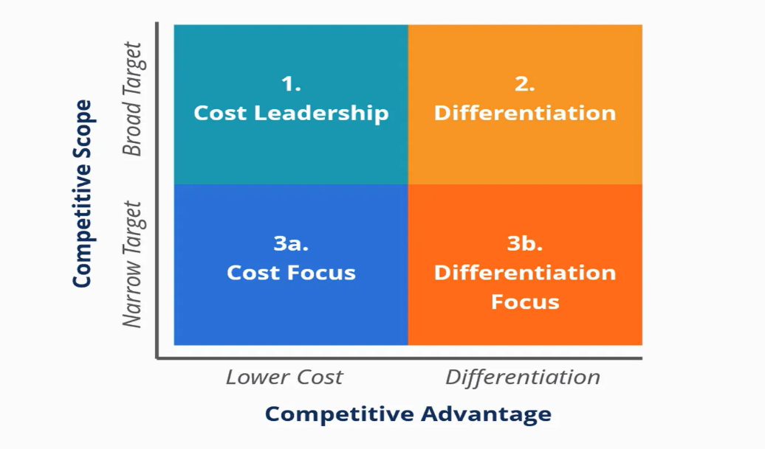
Figure- Competitive advantage
(Source – Hoskisson et al., 2019)
1. Cost Leadership
The cost management plan aims to produce or issue a suitable carrier at the lowest possible cost. It is done by making goods typically well-liked by consumers at more bass and more advantageous prices than those of comparable interests. By combining large sales volumes with low profitability margins per unit, HDFC will employ this Strategy to maximize profit. To prevent competitors from duplicating their value proposition, businesses will look for the best possibilities while producing an exceptional or presenting carrier.
2. Discrimination
A differentiation strategy is creating unique products or services that set them apart from their rivals. The essential aspects of the products or services must be maintained or improved. Thus, HDFC that uses this Strategy must continually spend money on R&D. Agencies frequently persuade clients to pay a better price, which results in more significant margins. It is accomplished by giving a specific product with a particular proposition of price (Hoskisson et al., 2019).
3. Focus
A focused approach uses a technique for determining a gap market's needs before creating solutions aligned to the specific need area. Two variations of the attention strategy exist:
(I) Cost Focus: Lowest-fee manufacturer in a crowded market segment
(ii) Differentiation Focus: Personalized or one-of-a-kind cost-upload goods in a focused, small market segment (Teece, 2019)

11. Conclusion and Recommendations
After analyzing the entire strategic management, the author effectively concluded the topic and brought strong recommendations in this section. The author summarizes the whole report in this section and brings the organization's mission and vision. HDFC Bank is a dynamic bank. It provides quality and sustainable services to potential customers worldwide. It incorporates advanced technology to speed up its businesses and bring sustainability to achieve a competitive advantage in the Global market. The company develops its product strategies, analyzes the external environment, evaluates the business vision, mission, and objectives, and formulates the entire system to better understand the financial factors and human resources to achieve strength. HDFC Bank effectively recognizes the economic power to support ordinary people and the customer. It acts as an advisory consultant to connect more potential customers and standard the relationship for long-term business and productivity. It incorporates the advanced technology in the sector to maximize the profit and effectively recover the credit risk. The company effectively provides mobile and online banking to satisfy customer needs and wants and deal with a competitive rivalry like the Andhra Bank, Allahabad Bank ICICI Bank. The bargaining power of the customer supports the organization in quickly connecting with the clients and following the RBI regulations to provide adequate services. The strength opportunities of the bank support expansion are businesses in the country as well as developing the Strategy to deliver quality services and generate continuous growth and revenue. The sustainability and the product leadership quality support connecting with the potential customer and help the people analyze the social and environmental aspects. The business strategy of HDFC Bank support managing a high standard of quality and handling credit risk management and innovative product services to attract the target customer and reduce the cost of funds. The Strategy supports HDFC Bank to achieve high standards, deliver high-quality services to fulfill customer demand, and provide modern advanced banking facilities to potential customers.

Recommendations
- The administrative regulations and policies create heavy pressure, and the company must develop rigid actions analyzing the advanced information technology for new product development.
- The company has to be focused on the varieties to perform successfully, follow aggressive marketing strategies, and prioritize high-level clients.
- Banks have to be developed risk management as well as analyze competitive issues to become more productive.

References

Agarwal, S., A STUDY ON HDFC BANK WITH SPECIAL REFERENCE TO 'EMPLOYEE MORALE.'
Aguinis, H. and Solarino, A.M., 2019. Transparency and replicability in qualitative research: The case of interviews with elite informants. Strategic Management Journal, 40(8), pp.1291-1315.
Anjaneyulu, K., Performance Analysis of HDFC Bank Limited.
Ansoff, H.I., Kipley, D., Lewis, A.O., Helm-Stevens, R. and Ansoff, R., 2018. Implanting strategic management. Springer.
Bogers, M., Chesbrough, H., Heaton, S. and Teece, D.J., 2019. Strategic management of open innovation: A dynamic capabilities perspective. California Management Review, 62(1), pp.77-94.
Boon, C., Eckardt, R., Lepak, D.P. and Boselie, P., 2018. Integrating strategic human capital and strategic human resource management. The International Journal of Human Resource Management, 29(1), pp.34-67.
Borthakur, M., 2022. The service marketing mix of HDFC bank. Shanlax International Journal of Management, 9(3), pp.64-66.
Bosu, A. and Mishra, D., A Comparative Performance Measurement of Select Indian Commercial Banks: Application of Balanced Scorecard Model. Journal of Commerce, 43(1), pp.112-126.
Burgelman, R.A., Floyd, S.W., Laamanen, T., Mantere, S., Vaara, E. and Whittington, R., 2018. Strategy processes and practices: Dialogues and intersections. Strategic management journal, 39(3), pp.531-558.
Choudhury, P.K., Mishra, N. and Zipporah, G., 2022. Factors influencing Digital Banking Service Quality: A comparative study between SBI and HDFC bank in Hyderabad, India. Journal of Contemporary Issues in Business and Government Vol, 28(02).
Choudhury, P.K., Mishra, N. and Zipporah, G., 2022. Factors influencing Digital Banking Service Quality: A comparative study between SBI and HDFC bank in Hyderabad, India. Journal of Contemporary Issues in Business and Government Vol, 28(02).
Dar, G.F., Padi, T.R., Rekha, S. and Dar, Q.F., 2022. Stochastic Modeling for the Analysis and Forecasting of Stock Market Trend using Hidden Markov Model. Asian Journal of Probability and Statistics, 18(1), pp.43-56.
Ginter, P.M., Duncan, W.J. and Swayne, L.E., 2018. The strategic management of health care organizations. John Wiley & Sons.
Goel, R., 2022. FUNDAMENTAL AND TECHNICAL ANALYSIS OF HDFC BANK (Doctoral dissertation).
Goel, R., 2022. FUNDAMENTAL AND TECHNICAL ANALYSIS OF HDFC BANK (Doctoral dissertation).
Henry, A., 2021. Understanding strategic management. Oxford University Press.
Hitt, M.A., Ireland, R.D. and Hoskisson, R.E., 2019. Strategic management: Concepts and cases: Competitiveness and globalization. Cengage Learning.
Hla, K.K., 2022. A Study on the Organizational Performance of Myanmar Agricultural Development Bank (Doctoral dissertation, MERAL Portal).
Hoffmann, W., Lavie, D., Reuer, J.J. and Shipilov, A., 2018. The interplay of competition and cooperation. Strategic Management Journal, 39(12), pp.3033-3052.
Iqbal, Z. and Tanty, G., Impact Analysis of Covid 19 On Performance of HDFC Bank.
Johnson, G., Whittington, R., Regnér, P., Angwin, D. and Scholes, K., 2020. Exploring Strategy. Pearson UK.
Kaakandikar, R., Nangare, V.V., Sawant, A.P. and Injekar, G.K., IMPACT OF NON PERFORMING ASSETS ON PROFITABILITY OF BANKS: A STUDY OF HDFC BANK.
Krishnamoorthy, D.N. and Mahabub Basha, S., 2022. An empirical study on construction portfolio with reference to BSE. Int J Finance Manage Econ, 5(1), pp.110-114.
Kumar, I., Prakash, B. and Verma, J.K., 2022. FACTORS AFFECTING QUALITY OF WORK LIFE (QWL) OF BANK MANAGERS IN PUBLIC AND PRIVATE SECTOR BANKS IN BIHAR, INDIA: A COMPARATIVE STUDY. Academy of Strategic Management Journal, 21, pp.1-12.
Liu, Z., Jiang, J. and Xu, Z., 2022. Study of the Frost Resistance of HDFC Based on a Response Surface Model and G.M. (1, 1) Model. Advances in Materials Science and Engineering, 2022.
Mehta, R. and Mathur, M., 2022. Vakrangee: changing lives in rural India. Emerald Emerging Markets Case Studies, 12(4), pp.1-21.
Moutinho, L. and Vargas-Sanchez, A. eds., 2018. Strategic management in tourism, cabi tourism texts. Cabi.
Nagpal, T. and Mishra, M., 2022. An Optimized H.R. Analytics Approach to Impact Decision-Making Process in Banking Sector to increase employee performance. NeuroQuantology, 20(21), p.17.
Nazeer, I., Prasad, K.D.V., Vemuri, V.P., Solunke, S. and Shishram, G.S., CURRENT SCENARIO OF EMPLOYEE PERFORMANCE MANAGEMENT SYSTEM IN BANKING SECTOR-A STUDY.
Patel, A. and Dwivedi, V.J., 2022. A COMPARATIVE STUDY ON PROFITABILITY AND LONG-TERM SOUNDNESS OF SELECTED PRIVATE LIFE INSURANCE COMPANIES IN INDIA.
Saikrishna, M.B. and PM, R., Monetary Performance of Top Five Blue Chip Companies In India.
Sharma, B., A Study of the Implementation of Learning & Growth Perspective of Balance Scorecard in Private Banks.
Singh, B. and Henge, S.K., 2022. Prediction of Stock Price Movements Using Statistical and Hybrid Regression Techniques to Reduce Diversify Risk. In International Conference on Intelligent and Fuzzy Systems (pp. 456-462). Springer, Cham.
Steiss, A.W., 2019. Strategic management for public and nonprofit organizations. Routledge.
Sunitha, G. and Venu Madhav, V., 2022. CLIENT COMPANIES’PERCEPTION TOWARDS CREDIT RISK OF PRIVATE SECTOR BANKS WITH REFERENCE TO ICICI, HDFC, AXIS BANK, IDBI, AND YES BANK. Indian Journal of Finance and Banking, 9(1), pp.10-18.
Tafreshi, M., Hoseini, E. and VahdatiRoohani, M., 2019. Role of strategic management of talent in organizational performance (Case Study: University of Medical Sciences of Mashhad). In annual Conference of Strategic Management.(in Persian).
Teece, D.J., 2019. A capability theory of the firm: an economics and (strategic) management perspective. New Zealand Economic Papers, 53(1), pp.1-43.
Tiwari, R., Chauhan, A.S. and Singh, P., 2022. Role Of Leadership For Sustainability In Indian Banking: A Case Of HDFC Bank. Tiwari, R., Chauhan, AS, & Praveen Singh, H.(2022). Role Of Leadership For Sustainability In Indian Banking: A Case Of HDFC Bank. Journal of Positive School Psychology, 6, pp.67-74.
Torney, M.R., Walse, K.H. and Thakare, V.M., 2022. An Effective Framework for design of Dataset Using Twitter. International Journal of Next-Generation Computing, 13(5).
Wang, W., Hoang, D.T., Hu, P., Xiong, Z., Niyato, D., Wang, P., Wen, Y. and Kim, D.I., 2019. A survey on consensus mechanisms and mining strategy management in blockchain networks. Ieee Access, 7, pp.22328-22370.
Wenzel, M., Stanske, S. and Lieberman, M.B., 2020. Strategic responses to crisis. Strategic Management Journal, 41(7/18).
Zerfass, A., Verčič, D., Nothhaft, H. and Werder, K.P., 2018. Strategic communication: Defining the field and its contribution to research and practice. International Journal of Strategic Communication, 12(4), pp.487-505.

