BA Business Management
Entrepreneurship
Student Name: Andi Manea
Student Number:2113863
Lecturer Name: Essa Bah
LCBB5001_BIRM

Business plan

Table of Contents
Overview of the business idea and it’s product/service. 3
Ownership and Legal format of the startup. 3
1. Management of the company (Owner, employees and the requirements for external professional service/ experts). 4
2. Explanation of the target market and the marketing strategies the company will adopt to reach their customers. 4
Evaluation of the business idea by using the SWOT analysis model. 5
3. Assessment of the current external environment by using the PESTEL analysis model. 7
Identification of the key marketing factors by using the 4Ps of marketing mix model. 8
A cash flow forecast for the first 12 months- startup costs cannot exceed £25,000. 9
Reference List: 11

Overview of the business idea and it’s product/service.

The business idea is to operate a food truck offering traditional Romanian cuisine in the UK. The food truck will serve authentic Romanian dishes such as mici (grilled minced meat rolls), sarmale (cabbage rolls stuffed with minced meat and rice), and langos (deep-fried dough topped with cheese and sour cream), among others(Vianello,2016).

According to the Office for National Statistics (ONS), there were an estimated 411,000 Romanian-born individuals living in the UK as of 2021, making it one of the largest Eastern European migrant communities in the UK. This presents a potential market for Romanian cuisine( ONS,2021).

In addition, the UK street food market has been growing rapidly in recent years, with consumers seeking unique and diverse food offerings. According to a report by MCA Insight, the UK street food market is expected to reach a value of £1.2 billion by 2023, indicating significant growth opportunities for food truck businesses(MCA,nd)

Furthermore, the COVID-19 pandemic has caused a shift towards outdoor dining, with more consumers looking for takeout and delivery options. A food truck can cater to these changing consumer preferences and offer a convenient and accessible option for customers( Statista, nd).

Overall, a Romanian food truck can tap into a growing market for diverse cuisine, and cater to the needs of customers seeking unique and authentic food experiences.

Ownership and Legal format of the startup.

Based on the business idea of a Romanian food truck operating in the UK, a possible legal format for the startup is a sole trader. This legal format involves an individual owning and running the business as a self-employed person.One of the main advantages of a sole trader legal format is the simplicity and ease of setting up the business. There are minimal legal requirements, and the owner has full control over the business decisions and operations. Additionally, the process of filing taxes as a sole trader is generally straightforward, and the owner is eligible for certain tax deductions and allowances( Vianello,2018).However, it is important to note that as a sole trader, the owner is personally responsible for all aspects of the business, including finances and liabilities. This means that there is no legal separation between the owner and the business, and any debts or legal issues can impact the owner's personal finances and assets( ONS,2017).Overall, the decision to choose a sole trader legal format for a Romanian food truck business in the UK would depend on the specific circumstances and preferences of the owner. It is important to weigh the advantages and disadvantages of this legal format and consider other options such as partnerships, limited liability companies, or other legal entities before making a final decision.

Management of the company (Owner, employees and the requirements for external professional service/ experts).

As the owner of the Romanian food truck, I will be responsible for managing all aspects of the business, including menu planning, cooking, marketing, finances, and logistics. I have extensive experience in Romanian cuisine and cooking techniques, having worked in several restaurants and food trucks in the past. I am also well-versed in food safety regulations and have completed relevant training courses( Brandau,2014).
In terms of employees, I plan to hire at least two employees, including a chef and a cashier or server. I will carefully screen and interview candidates to ensure that they have relevant experience and training in the food industry, particularly in Romanian cuisine. I believe that having a knowledgeable and skilled team is crucial to the success of the business.
In addition to hiring employees, I may also require external professional services such as a web designer, accountant, or marketing consultant. I will carefully consider the resources needed to effectively manage these services and ensure that they align with the overall goals and vision of the business(Khan,2014).

Overall, I believe that my experience and knowledge in Romanian cuisine and the food industry, as well as my ability to effectively manage employees and external professional services, will contribute to the success of the Romanian food truck business.

Explanation of the target market and the marketing strategies the company will adopt to reach their customers.

Both target market and marketing strategies are important for any startup because they help to identify the ideal customers and how to effectively reach them, which is crucial for the success of the business( OND,2017).

According to the business idea of a Romanian food truck operating in the UK, the target market would be individuals who are interested in trying new and unique cuisines, particularly Romanian cuisine. This may include Romanian immigrants living in the UK, as well as individuals who are interested in exploring diverse food offerings. Additionally, the food truck may attract individuals who are seeking quick and convenient meal options while on the go(The Guardian,2018).

To reach this target market, the Romanian food truck may adopt several marketing strategies, such as:

Social media marketing: Using social media platforms such as Facebook, Instagram, and Twitter to promote the food truck and engage with potential customers. This can include posting pictures of the food, announcing the truck's location and hours, and offering special deals or promotions.
Collaborations: Partnering with local businesses or events to offer catering or pop-up food truck services. This can help to increase the visibility of the food truck and reach a larger audience( Vianello,2016).
Flyers and posters: Distributing flyers and posters in the local area to promote the food truck and inform potential customers about the menu and location.
Word of mouth: Encouraging satisfied customers to spread the word about the food truck and recommend it to their friends and family.
It is important to note that pricing may also be a factor in reaching the target market, particularly if the food truck is targeting a price-sensitive audience. The food truck may consider offering affordable menu options or special deals to attract customers( The Guardian,2018).

Overall, identifying the target market and implementing effective marketing strategies is crucial for the success of the Romanian food truck business. By understanding the needs and preferences of its target market and effectively reaching them, the food truck can build a loyal customer base and achieve long-term success.

Evaluation of the business idea by using the SWOT analysis model.

SWOT Analysis

Strengths:

Unique and authentic Romanian cuisine that can differentiate the business from competitors.
Ability to move to different locations to reach a wider audience.
Opportunity to build a loyal customer base through social media engagement.
Weaknesses:

Limited menu options due to the nature of a food truck.
Dependence on good weather and location for business operations.
Lack of seating or space for customers to dine-in.
Opportunities:

Growing trend towards diverse and unique food offerings in the UK.
Ability to partner with local events or businesses for catering opportunities.
Potential to expand the business to include catering or a brick-and-mortar location in the future( Romanian Insider,2021).
Threats:

Intense competition from other food trucks and restaurants offering similar cuisine.
Changing consumer preferences and trends in the food industry.
External factors such as economic downturns or natural disasters that can impact business operations.
Example:
Strength – Our fastfood track offers unique and authentic Romanian cuisine, which can be a significant advantage in a market that values diverse food offerings. By differentiating itself from competitors, Dracula's Kitchen can attract customers who are interested in exploring new and unique flavors. To maximize this strength, Dracula's Kitchen track can focus on developing and refining its menu to offer a range of popular and lesser-known Romanian dishes. It can also leverage social media platforms to showcase its food and engage with potential customers( Edrawmx,2017).

Overall, conducting a SWOT analysis can provide valuable insights and information for any startup, including a Romanian food truck. By identifying strengths, weaknesses, opportunities, and threats, the business can develop strategies that leverage its strengths, mitigate weaknesses, capitalize on opportunities, and mitigate threats to achieve long-term success.

Assessment of the current external environment by using the PESTEL analysis model.
Political:

Brexit and potential changes to import/export regulations for food products.
Changes in UK regulations related to food safety and hygiene.
Economic:

Potential impact of economic downturns on consumer spending on food and dining out.
Changes in exchange rates that can impact the cost of importing food products( FTI,2021)

Sociocultural:

Growing trend towards diverse and unique food offerings in the UK.
Increasing demand for healthy and sustainable food options( ONS,2021).
Technological:

Increased use of social media platforms for marketing and engagement with customers.
Use of food delivery apps and services that can impact foot traffic to the food truck(The Guardian,2018).
Environmental:

Increasing focus on reducing food waste and promoting sustainability.
Impact of weather and climate change on business operations.
Legal:

Regulations related to food safety, hygiene, and licensing for food trucks.
Employment laws related to hiring employees and providing safe working conditions.
Example:
Sociocultural - Dracula's Kitchen can leverage the growing trend towards diverse and unique food offerings in the UK. By offering authentic and unique Romanian cuisine, the food truck can attract customers who are interested in exploring new and unique flavors. To capitalize on this trend, Dracula's Kitchen can focus on developing a menu that offers a range of popular and lesser-known Romanian dishes, while also prioritizing the use of high-quality, fresh, and sustainable ingredients. Additionally, the food truck can use social media platforms to showcase its food and engage with potential customers, which can help to build a loyal customer base and increase awareness of the brand( Vianello,2016).

Overall, conducting a PESTEL analysis can provide valuable insights and information for any startup, including a Romanian food truck operating in the UK. By identifying political, economic, sociocultural, technological, environmental, and legal factors that can impact the business, Dracula's Kitchen can develop strategies that leverage opportunities and mitigate potential threats to achieve long-term success.

Identification of the key marketing factors by using the 4Ps of marketing mix model.
The 4Ps of marketing mix refer to Product, Price, Place, and Promotion. These are the four key factors that a business should consider when developing a marketing strategy. Product refers to the goods or services that the business offers, price refers to the amount that customers will pay for the product or service, place refers to the location where the product or service is offered, and promotion refers to the methods used to communicate and market the product or service to potential customers.

Product: The product is the unique and authentic Romanian cuisine offered by the food truck. To differentiate itself from competitors, Dracula's Kitchen can focus on offering a range of popular and lesser-known Romanian dishes, while also prioritizing the use of high-quality and fresh ingredients(Kotler,2016)

Price: The price of the product will depend on the cost of ingredients and operations, as well as the competition in the market. Dracula's Kitchen can consider offering affordable menu options or special deals to attract customers, while also ensuring that the pricing aligns with the overall brand image and quality of the product.

Place: The place where the product is offered is crucial for a food truck. Dracula's Kitchen will need to carefully select locations that are easily accessible and visible to potential customers, while also ensuring that the locations have the necessary permits and permissions to operate.

Promotion: Promotion is important for building brand awareness and attracting customers. Dracula's Kitchen can use social media platforms to showcase its food and engage with potential customers, as well as collaborate with local events or businesses to increase visibility. Additionally, the food truck can offer special deals or promotions to incentivize customers to try the food and return in the future(Khan,2014).

Overall, the 4Ps of marketing are important for any startup, including Dracula's Kitchen Romanian Food Truck. By considering product, price, place, and promotion, the business can develop a marketing strategy that maximizes its strengths and effectively reaches its target market(Brandau,2014).

A cash flow forecast for the first 12 months- startup costs cannot exceed £25,000.

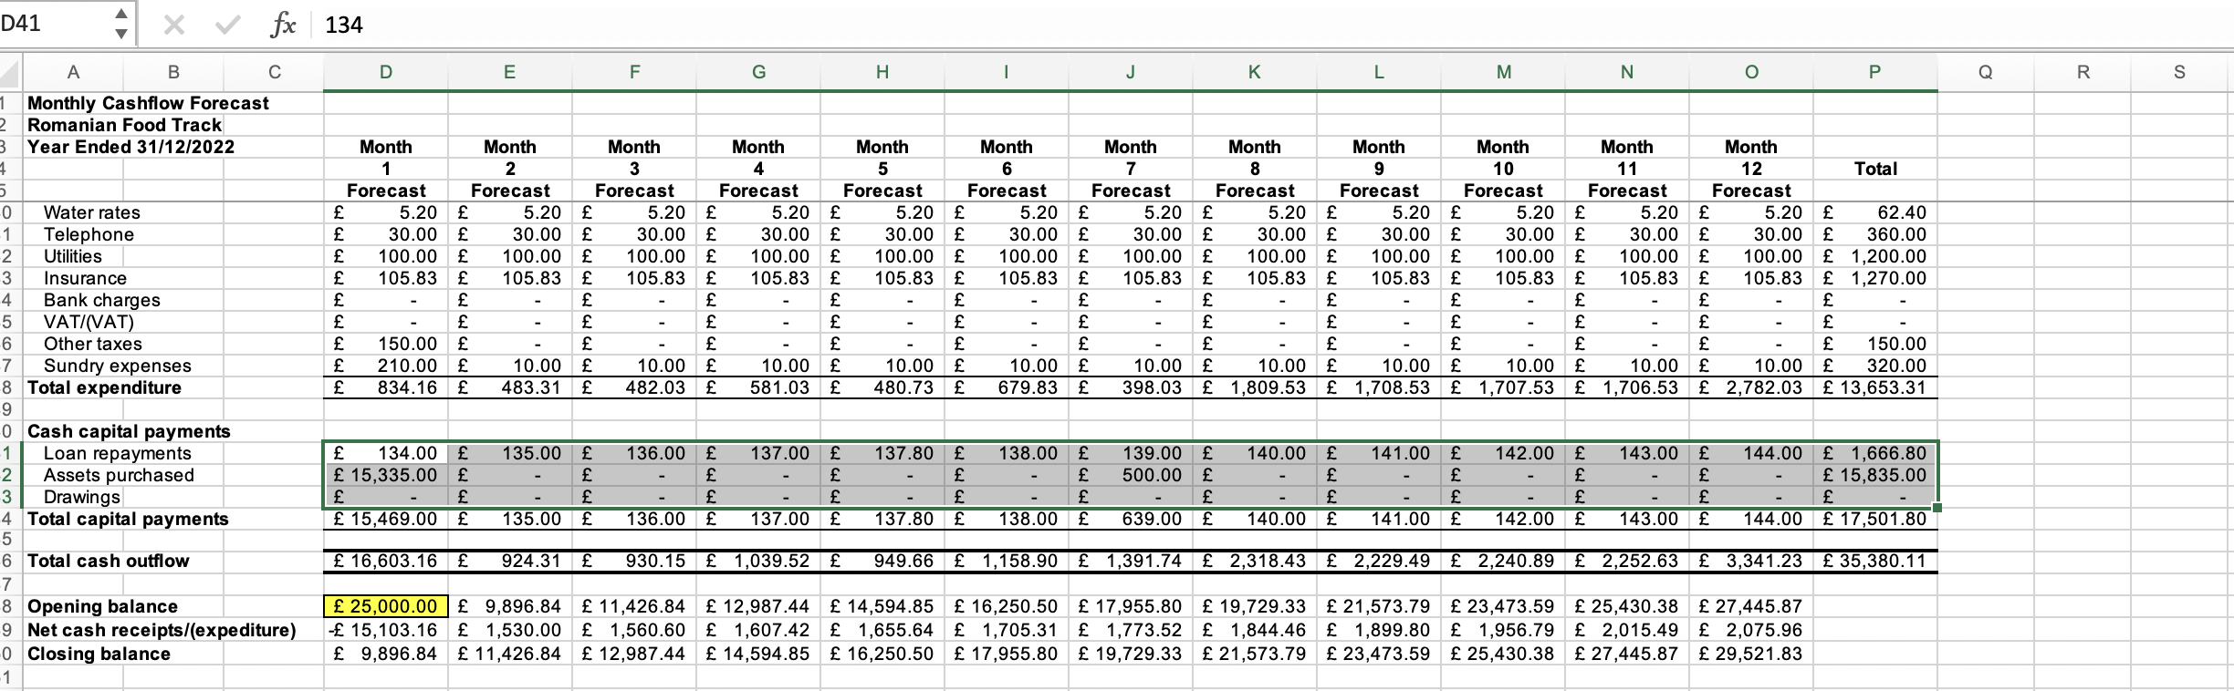

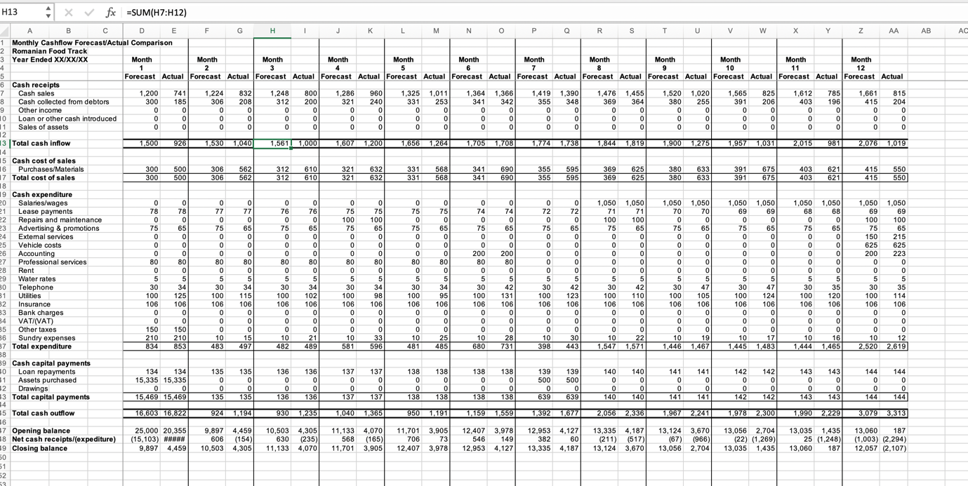

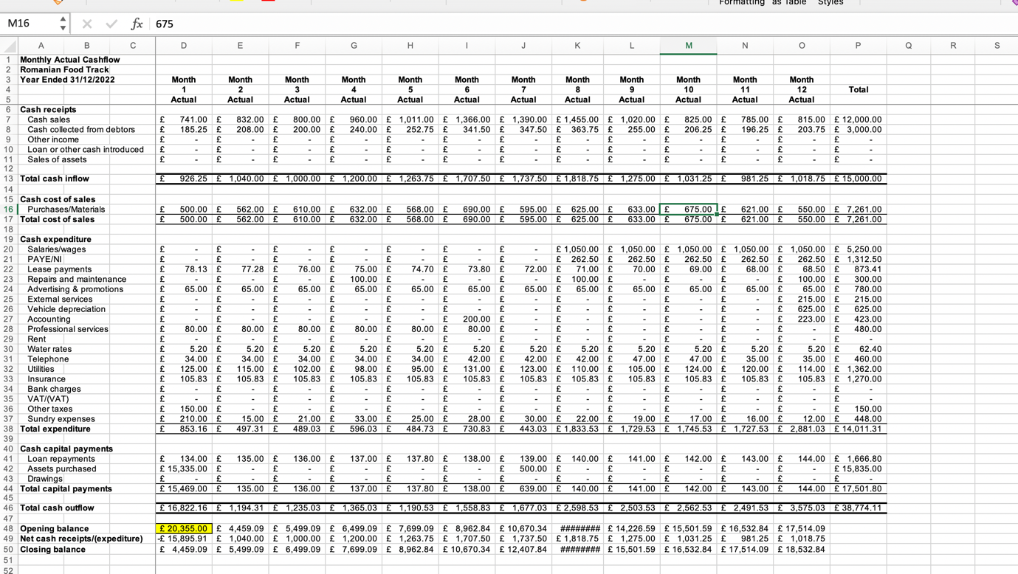

Reference List:

Beck, K. (2011). Taco Bell’s meaty marketing campaign.Customer Relation-
ship Management, 15, 12–13.
Bellman, E. (2009). Corporate news: McDonald’s plans expansion in India. Wall Street Journal (Eastern Edition), New York, NY. June 30, B4.

Bergen, M., Dutta, S., & Walker, C., Jr. (1992). Agency relationships in marketing: A review of the implications and applications of agency and related theories.Journal of Marketing, 56(3), 1.
Bhushan, R. (2012, Oct 11). Domino’s, Pizza Hut use delivery and dine-ins to whet the taste buds of demanding Indians.The Economic Times (Online) Retrieved from http://articles.economictimes.indiatimes.com/2012-10-10/
news/34363627_1_dine-in-stores-yum-restaurants-pizza-hut
[Accessed at 28th feb 2023]

Brandau, M. (2014a). Pizza Hut tests interactive table for ordering, payment.Nation’s Restaurant News. Retrieved from http://nrn.com/technology/
pizza-hut-tests-interactive-table-ordering-payment
[Accessed at 28th feb 2023]

Brandau, M. (2014b). QSRs adopt fast-casual traits to compete. Nation’s Restaurant News, 48(4), 1–28
[Accessed at 28th feb 2023]

EdrawMax. (2021). Restaurant Industry PESTEL Analysis - Key Factors Affecting The Restaurant Industry.EdrawMax Retrieved from https://www.edrawmax.com/article/restaurant-industry-pestel-analysis.html
[Accessed at 28feb2023]
Hill, T., & Westbrook, R. (1997). SWOT analysis: It’s time for a product recall. Long Range Planning, 30(1), 46-52.

Khan, M. (2014) Restaurant Franchising. 3rd edn. Apple Academic Press. Available at: https://www.perlego.com/book/1509799/restaurant-franchising-concepts-regulations-and-practices-third-edition-pdf (Accessed: 1 March 2023).
Kotler, P., & Keller, K. L. (2016). Marketing management (15th ed.). Pearson.
Office for National Statistics. (2017). UK population by country of birth and nationality. ONS.Available at: https://www.ons.gov.uk/peoplepopulationandcommunity/populationandmigration/internationalmigration/bulletins/ukpopulationbycountryofbirthandnationality/2017/previous/v1[Accessed at 28feb2023]
Romania-Insider. (2021). One million Romanians live in the UK, making up the second-largest foreign-born community.Romania-Insider Retrieved from https://www.romania-insider.com/one-million-romanians-uk
[Accessed at 28feb2023]

Statista (n.d) Available at: https://www.statista.com/outlook/dmo/online-food-delivery/united-kingdom
[Accessed at 28feb2023]

The Guardian. (2018, May 24). Romanians are second most common non-UK nationality in country. The Guardian .Retrieved from https://www.theguardian.com/uk-news/2018/may/24/romanian-second-most-common-non-british-nationality-uk
[Accessed at 28feb2023]
Vianello, G. (2016) Restaurant Marketing. [edition unavailable]. Engage Editore. Available at: https://www.perlego.com/book/1087550/restaurant-marketing-azioni-semplici-a-basso-costo-per-aumentare-clienti-scontrino-medio-e-fatturato-del-tuo-locale-pdf (Accessed: 1 March 2023).

