  ENTREPREneurship | Jaliya de Silva  BA - International Hotel Management


Entrepreneurship can be defined as a person who creates a new business in the face of risk and uncertainty for the purpose of achieving profit and growth by identifying significant opportunities and assembling the necessary resources to capitalized them (Zimmerer and Scarborough, 2005).
In economics, land labour capital organisation and enterprise are the most vital five factors need for the basis of production. Hence, most people come up with excellent ideas but never act on upon, only entrepreneurs act on their ideas. Entrepreneur exhibit the ability of creativity which enables them to develop new ideas and discover new ways of looking at problems and opportunities. Innovation is the ability apply those creative solutions to those problems to enhance people’s lives. Entrepreneur’s always succeeded by thinking and doing new things or doing old things in a new way. They always make an effort to transform that new ideas into product, service, or business venture. Peter Drucker says Innovation is the specific instrument of the entrepreneurs (Drucker, 1985).
Successful entrepreneurs come up with new ideas and find ways to make them work to solve the problem. Creativity and innovation are most essential factors to a company to be successful, it also can define as the signature of entrepreneurial business. innovation and creativity largely lie at small enterprises as they have the strength to complete with large rivals. Generally small companies can create powerful effective and competitive advantage over big rivals (Burns, 2011). Entrepreneur plays a very important role in the economic growth. He or she should have a thorough knowledge about the current economic and political financial stability.
Enterprise can be defined as for-profit business, which commonly associated with business ventures. Any business can operate as an enterprise, depending on their company’s structure for an example, different levels, divisions, locations, departments, which collaborate to achieve one ultimate goal of profit. Hence, customer relationship management plays a significant role in the enterprise business process as it involves collaboration with other departmental employees and customers and potential customers (Zucchella, Hagen and Serapio, 2018).
Intrapreneuship defines it allows their employees to come up with ideas enhance business opportunities within the company. Intrapreneur is a person who takes a risk in order to solve a given problem. For an example: Google and PlayStation.
Creativity ideas may appear abruptly. Results of creative process consist of seven steps which are

preparation investigation process transformation incubation illumination verification implementation.

Preparation step involves getting mind ready for creative thinking, this includes personal experience, education, on the job training, work experience and so on. This formal creativity helps to build t formal creativity and innovation. for an example Agarwal at the age of 18 he seems to harbour dreams of entrepreneurship. For an example Ritesh Agarwal at the age of eight he was harbouring dreams of becoming an entrepreneur as he got that influence from the entrepreneurial parental background. His intention compelled him to engage with coding software’s and take up a part time job in the I.T and took part of global annual forum for improving science in Asia. industry at his early age. Ritesh wanted to open budget hotels in India as those hotels did not meet his standards and requirements, as he experienced lot poor mannerism from staff mainly in budget hotels across India. Then he had the intention of opening his own budget hotel consist of good standard room for reasonable price with quality customer service standards.

Investigation: This point needs lots of understanding about the problem, situation and create new ideas and concepts in a particular field. Ritesh first studied the problem and understood its basic components. According to entrepreneurship, creative thinking comes about when people make careful observation about the world and investigate the way things work (Hisrich, 2016). Ritesh spent several years of researches based on accommodation facilities in the area as well as in other cities in India. He took time to discuss his ideas with those who have already engaged in the hospitality lodging industry. Which led him come up with new discoveries and approaches to old problems.

Transformation involves viewing the similarities and difference in the information collected. This method consists of two types of thinking methods which are convergent and divergent patterns. This assignment only considers convergent thinking method. Convergent thinking is the ability to see similarities and the connection with various data and events (Zimmerer and Scarborough, 2005). Ritesh Agarwal searched for similarities in the lodging industry and their business models. Ritesh business model quite unique business compare its competitors like Yatra, MakeMyholiday, Goibibo and Mango Hotels. OYO Hotels use the aggregator business model which is similar to Uber. OYO list rooms under their own branded network of hotels. Agarwal’s ability to use its own convergent thinking developed a new face to the lodging industry and well as its rapid growth.

Incubation: In fact, during this phase, it may appear that the creative person is loafing. After opening Oravel hotel, he had few failures thus he walked away from the lodging industry to refresh his mind. Isolation enables the subconscious mind to work on the problem and future opportunities. (Løwe Nielsen et al., 2017). According to entrepreneurial expert suggests that the three b’s bed, bath and bus are conducive to creativity (Burns, 2011). Eventually Retesh Agarwal came up with a vibrant idea with benefit to tourist and the results are consistent with reality and the theory worked.

Verification: validating ideas accurately is a vital aspect for entrepreneurs, it may include experiments, running’s, conducting, stimulations, test marketing a product and service building prototypes and many more to verify the next idea will work and practise to implement.(Zucchella, Hagen and Serapio, 2016). Sometimes ideas appears to have bright future, when it put to the test of reality entrepreneur must carefully consider some areas which are

- Will it work
- Is there a need for it?
- If so, what is the best application of the idea in the market
- Does the product and service ideas fit in to the core competencies
- How much will it cost to produce or to provide
(Zimmerer and Scarborough, 2005).

When OYO hotels launched, they used product and service justification form, to collect information from the idea generators as well as from other departments of the company. Hence it can lead to verify the potential of each idea.

Implementation: focus of this step is to transform the idea to reality. OYO hotels developed reasonable and comfortable accommodation to travellers for its segmented target. The key success was their idea for a useful product and service turned in to reality. As one creativity expert explains; “Becoming more creative in reality just a matter of paying attention to that endless flow of ideas you generate and learning to capture and act upon the new that’s within you” (Zimmerer and Scarborough, 2005).
Todays, global competitive environment in the hospitality business either big or small not thinking and acting upon strategically, which can be extremely vulnerable (Morey, 2016). Future of small business may expect a greater change and uncertainty due to political changes and rapid technological advances. “Knowledge is no longer just a factor of production” says futurist Alvis Toffler (Zimmerer and Scarborough, 2005). Hence intellectual capital is likely to be the source of its competitive advantage in the marketplace. Therefore, OYO hotels mainly focus on customer capital, established customer base, positive reputation, ongoing relationships, and a goodwill that company builds up overtime with customers. Building a competitive advantage is not enough therefore, company needs to put effort to build a sustainable competitive advantage in the long run (Burns, 2011). OYO hotels gained gradual sustainable advantage through its ability develop core competencies which enables them to serve better its target customers than its rivals. Mainly focused on superior quality, customer service, innovation, team building flexibility, responsiveness which enabled them to compete with their competitors. Over the rapid growth of OYO hotels, they focused on buying poorly managed hotel properties for the right price, but each circumstance is unique. Ritesh Agarwal CEO of OYO hotels established the criteria their acquisition must meet the criteria such as a quality product, a good name, market potential, and a solid formula that they could improve upon. OYO hotels invested €300 million in vacation home rentals business and its eagerness to expand its footprint in Europe and possibility to compete with the global giant Airbnb as of one of its investors in Europe. OYO claims third biggest fast-growing hotel chain as it operates over 23,000 hotels and 125,000 vacation homes. It entered China in 2018 covering over 100 cities. In the US it has established in over 21 states. In August 2019, OYO acquired its first US property, the Hooters casino hotel in Las Vegas spending $ 135 million, same year OYO acquired Indian hotel chain, Leisure Group for $145 million. OYO discovered Leisure group “Indian hotel chain” a medium size company who faced bankruptcy. Leisure Group company was known for its outstanding products and service in the lodging industry. Looking beyond the financial problems OYO hotels acquired the Leisure group as they saw the it has a great potential. OYO did was stabilized the business invested several million Indian Rupees.
Earlier OYO rooms used a aggregator business model, but it’s totally different to Airbnb business model. Then OYO used the mix of business models such as aggregator and franchise. From 2018 company came up with a new face as it has built good reputation among its customers and built brand equity, Ritesh Agarwal decided upon its business model to be pure franchise business model. Currently company gets over 75 percent of revenue from hotels under franchise models (Pahwa, 2019). For example, Ritesh Agarwal makes personal visits to some of his franchise hotels to make sure they are performing up to the company’s high-quality standards. Maintaining quality is very important aspect, that franchisers retain the right to terminate the franchise contract and to repurchase the hotel if the franchisee fails to comply with established standards (The Caterer, 2019).

OYO hotels paying more attention for E-commerce strategies. Web is the most efficient way for especially lodging and hospitality industry sell their product to millions of potential customers. The department of commerce India reports over 40 percent of Indian using internet. Over the decade the population of internet users increased dramatically. The hospitality industry always taken the first place to capitalize on new technologies. Customers frequently seeking information before buying or selling product and service on internet especially hospitality industry. Hotel e commerce, plays a vital role in the hotel business as of such as increase credibility and it makes extremely easy to make hotel reservation and avoid long queues and check inn forms and make checkout process intuitive (Patel, Patel and Patel, 2019)
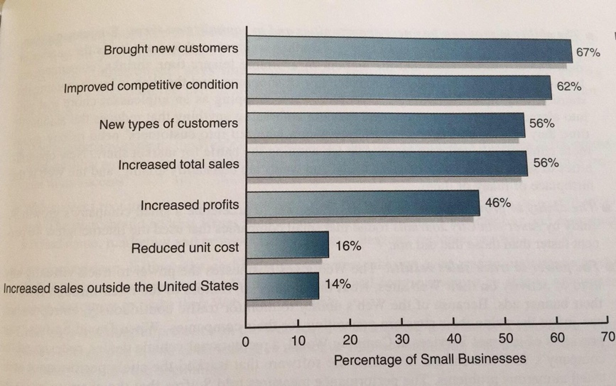
(Zimmerer and Scarborough, 2005)

Conclusion
Ritesh Agarwal is the founder of OYO hotels. He was a college dropout. He currently operates 200 cities in India and 332 cities in China, 60 cities in the US and 14 cities in Europe. He became a millionaire at the age of 22. At 17 he founded Ovavel travels then turned it to OYO rooms. he’s current net worth is USD 5 billion. He has acquired many accolades and titles including Forbes under 30” in the consumer tech sector and won the worlds young entrepreneur award.

Reference:
Hisrich, R. (2016). International entrepreneurship. 3rd ed. California: Sage publication, p.23.

Zimmerer, T. and Scarborough, N. (2005). Essentials of entrepreneurship and small business management. 4th ed. Upper Saddle River, N.J: Pearson Prentice Hall, pp.50- 52.
øwe Nielsen, S., Klyver, K., Evald, M. and Bager, T. (2017). Entrepreneurship in theory and practice. 2nd ed. Cheltenham: Edward Elgar, p.68.

Zucchella, A., Hagen, B. and Serapio, M. (2016). International entrepreneurship. 1st ed. Cheltelham: Edward edgar, p.44.

Morey, D. (2016). Innovating innovation. 1st ed. Forida: Mango publishing group, p.36.

Burns, P. (2011). Entrepreneurship and small business. 4th ed. Basingstoke: Palgrave Macmillan, p.109.

Pahwa, A. (2019). Business Model of Oyo Rooms - How Oyo Rooms Work | Feedough. [online] Feedough. Available at: https://www.feedough.com/business-model-oyo-rooms/#Oyo-Rooms-An-Aggregator-or-A-Franchisor [Accessed 20 Oct. 2019].

The Caterer. (2019). Oyo hits 100 UK hotels. [online] Available at: https://www.thecaterer.com/news/hotel/oyo-hits-100-uk-hotels [Accessed 20 Oct. 2019]

Løwe Nielsen, S., Klyver, K., Evald, M. and Bager, T. (2017). Entrepreneurship in theory and practice. 2nd ed. Cheltenham: Edward Elgar, p.232.

Aulet, B. (2014). Disciplined entrepreneurship. 1st ed. New Jersey: Wiley and sons, pp.20-21.

Brentano, F. (2014). Psychology from an empirical standpoint. 2nd ed. oxfordshire: Roughtledge classics, pp.8-10.

