Research project: case study based on an electives experience
An exploratory case study arising from practise (noticing) and investigated further through identified research tools. The assignment concludes with the identification of an intervention which can be piloted throughout Professional Teaching Experience and evidenced through reflection in the Professional Learning Standards.

Target | Example
1.Try to use literature to support your work in offering differing viewpoints and challenges to what you are proposing | Page 2-3  Maslow’s hierarchy of needs
2. Please ensure that you proofread your work really carefully | Throughout

This research project aims to explore how a specific setting, referred to as School C, fosters the wellbeing of its youngest learners with the overarching aims being to identify the resources and support accessible to School C’s learners in relation to wellbeing and to explore learners and staff’s perception of these. The rationale for choosing well-being as the problem statement was to develop a more secure understanding of the provisions available to support mental health within a primary school setting. Furthermore, given the significant role of optimal wellbeing in relation to both development and overall happiness it was deemed essential to tailor this research to specifically address this sector, promoting children and young people’s wellbeing is a key part of keeping them safe, helping them develop and ensuring they have positive outcomes into adulthood (NSPCC, 2019).

School C is situated in an urban town within South Wales where poverty rates are higher than the national average of 21%, (Welsh Government, 2023). The school currently has 336 pupils on roll with 48.5% of pupils eligible for FSM (free school meals), (ESTYN, 2023). Poverty has the ability to negatively impact on wellbeing through mitigating factors such as lack of opportunities, social inequality and limited access to necessities, individuals living in the most deprived areas report higher levels of mental ill health and lower levels of well-being than those living in the most affluent areas (Knifton and Inglis, 2020). Thus, further reinforcing my reasoning for employing the overarching theme of wellbeing for my research project.

In the context of this project, the research question proposed is ‘’What are staff and learners’ perception of the resources and activities available to support the wellbeing of the school’s youngest learners?’’. After formulating the research question, it became imperative to establish objectives that align with the overarching goal of the project. Thus, the outlined objectives include organising a group interview with foundation phase learners, distributing a questionnaire to all teaching staff within the designated setting, observing pertinent interventions and class activities, and undertaking a thorough review of relevant literature. Given that my research focused on learners in the foundation phase, it spanned across diverse classrooms and included a spectrum of students. The topic of wellbeing is crucial in the context of students within the Welsh Professional Learning Program (PLP). In alignment with the PLP, educators are encouraged to integrate strategies that foster a positive and supportive learning environment, where students feel emotionally secure and motivated to learn. Moreover, the fundamental values and dispositions embodied in the "rights of the learner" within the professional standards for teaching and learning in Wales include a focus on wellbeing. Educators are obligated to exert their utmost efforts in nurturing favourable outcomes for learners, aligning with the imperative to prioritize the overall wellbeing of learners, the needs and rights of learners will be central and take priority in the teacher’s approach to their job, (Welsh Government, 2019).

Wellbeing is broadly defined by Oxford English Dictionary (2001) as, the state of being healthy, happy, or prosperous. Pupil wellbeing is a multifaceted concept encompassing the physical, mental, and social aspects of a learners life. Abraham Maslow's Hierarchy of Needs remains a foundational theory in understanding the importance of pupil wellbeing, Maslow suggests that children's ability to be motivated by “growth needs” (e.g., academic achievement) first requires satisfaction of “deficiency needs” (e.g., physiological needs, safety needs, and love/belonging needs), (Noltemeyer et al., 2012). Therefore, In the context of learners’ wellbeing, Maslow's theory suggests that for students to thrive academically and personally, their basic deficiency needs must be met. If students are struggling with hunger, a lack of safety, or feelings of isolation, it becomes challenging for them to focus on academic achievement or personal growth, thus, hindering development, ensuring that students' fundamental needs are met is crucial for fostering their overall wellbeing, (Noltemeyer et al., 2012).

Psychologist Ed Diener from the University of Illinois conducted a global study to assess the validity of the well-known Hierarchy of needs and although certain findings align with Maslow's theory, there are also distinct deviations observed within his results, research shows that the order in which these needs are met had little impact on people’s satisfaction with life (Diener, 2023). The accuracy of this research can be inferred given the relatively large sample size, during our research we analysed surveys on food, shelter, safety, money, social support, respect, and emotions taken in 123 different countries between 2005 and 2010, (Diener, 2023).
Diner’s research further delves into the aspect of wellbeing through addressing the pyramid directly, the needs in which Maslow described are important for well-being, but thinking about them as a rigid, pyramidal hierarchy is not supported by the available evidence, (Diener, 2023). Nonetheless, the evidence supporting this specific claim is not evident in his writing, undermining the strength of this aspect of the report. Diener further suggested that to maximise the effectiveness of Maslow's Hierarchy of Needs pyramid that individuals must abandon a one-size-fits-all approach through recognising its inherent inadequacy in real-world applications, the basic components in the hierarchy are essential for human health and happiness, but it is important to remember that there is a lot of variation from one person to the next ,(Diener, 2023).

John Bowlby's attachment theory emphasises the importance of early bonds between infants and caregivers for healthy emotional and psychological development, primary caregivers who are available and responsive and responsive to an infant’s needs allow the child to develop a sense of security (Cherry, 2023). Bowlby's theory highlights the critical role of secure attachments in fostering emotional security and resilience, both key elements of achieving positive wellbeing.

During the 1970s, psychologist Mary Ainsworth significantly built upon Bowlby's initial research. Her pioneering "strange situation" study unveiled the significant impact of attachment on behaviour, she identified three main attachment styles, secure (type B), insecure avoidant (type A), and insecure ambivalent/resistant (type C), (McLeod, 2023). Her research indicated that children who experienced secure attachments were found to exhibit more positive behaviours and emotional regulation, securely attached children develop a positive working model of themselves (McLeod, 2023). Conversely, insecure attachments, as identified in Ainsworth's study, may lead to challenges in emotional regulation and difficulties in forming stable relationships, which can impact mental health and overall wellbeing throughout life, accordingly, insecure attachment styles are associated with an increased risk of social and emotional behavioural problems via the internal working model (McLeod, 2023).

Bowlby and Ainsworth's work is crucial as it forms the basis for the Attachment Theory, providing valuable insights into the impact of early caregiver-child relationships on emotional and social development. Nevertheless, there are some controversies surrounding their work. A contemporary investigation into Bowlby's attachment theory suggests that cultural values may exert varying influences on what is considered acceptable in attachment patterns, what is considered a secure attachment in one culture might not align with behaviours typically associated with secure attachment in another culture (Main, 2023). Further critiques scrutinise the way and age at which particular attachments supposedly initiate, challenging aspects of John Bowlby's research, Schaffer & Emerson (1964) noted that, specific attachments started at about eight months, and very shortly thereafter, the infants became attached to other people and by 18 months, very few (13%) were attached to only one person, (Mcleod, 2023). However, Bowlby and Ainsworth's work remains valuable as it significantly contributed to the understanding of an Attachment Theory, which has profound implications for child development and wellbeing, the theory's enduring influence, despite its controversies, attests to its foundational role in our understanding of human attachment (Main, 2023).

Through this research, the intent is to incorporate the concepts from Bowlby's attachment theory into said future teaching practices by integrating activities that focus on building attachments to improve student well-being. Furthermore, understanding attachment patterns can guide interventions and resource allocation to foster positive social connections, contributing to emotional and psychological well-being.

In the course this research, a methodology based on a case study approach was employed, as the research involved an in-depth and detailed examination of a specific case or instance within its real-life context, exploring the resources and support available to support wellbeing in School C. The research undertaken adhered to the standard structure of a case study methodology, a case study is an in-depth study of one person, group, or event (Cherry, 2022). Engaging in a case study approach for this research offered personal advantages, including forming a more in-depth understanding of the subject, as a case study allows for a detailed examination of a specific instance namingly School C, which allowed for a rich and thorough understanding of the context, interactions, and dynamics within that particular setting. Further, a case study allows for the capture of the diverse perspectives of learners, teachers, and the overall school community.

The case study approach not only upholds ethical standards but also facilitates a nuanced understanding of individual experiences and contextual factors. Additionally, the in-depth nature of case studies allows for a comprehensive exploration, fostering a more complete and respectful representation of the participants involved, because of their in-depth, multi-sided approach, case studies often shed light on aspects of human thinking and behaviour that would be unethical or impractical to study in other ways (Mcleod, 2019). In addition, a case study allows researchers to obtain a substantial amount of data due to its comprehensive and multi-faceted nature. Case studies often incorporate various data sources, including interviews, observations, documents, and archival records. This multiplicity of sources enables researchers to gather diverse and rich information, case studies allow a researcher to investigate a topic in far more detail than might be possible if they were trying to deal with a large number of research participants (Mcleod, 2019). Furthermore, researchers often employ triangulation, combining multiple methods and data sources to validate and strengthen their findings, this methodological strategy enhances the robustness and reliability of the collected data (Mcleod, 2019).

In contrast, there are various drawbacks associated with employing a case study approach. The inability to generalize findings is considered a limitation of the case study as the detailed, context-specific nature of the research makes it challenging to apply the results to broader populations or settings, a case study approach cannot necessarily be generalized to the larger population (Mcleod, 2019). A further limitation of this approach is the in-depth and subjective nature of case studies. Researchers may inadvertently bring their own biases or preconceptions into the interpretation of data, potentially influencing the findings and conclusions of the study, when conducting a case study, it is very possible for the author to form a bias which can be for the subject; the form of data collection, or the way the data is interpreted (Universal class, 2019). Yet, some argue that this susceptibility to researcher bias is not unique to the case study approach but is a challenge inherent in any form of research, the question of subjectivism and bias toward verification applies to all methods, not just to the case study and other qualitative methods (Flyvbjerg, 2006).

For the present research project, the selected sample included a focus group interview and a comprehensive questionnaire which was distributed to all teachers in School C. The use of a focus group within a case study approach encompasses the interactive nature of a focus group through fostering discussions dynamic conversations among participants and the main benefit of a focus group is that it allows researchers to collect insightful data while connecting with the sample (Smith, 2022). In order to mitigate bias, It was requested for class teachers from two different classes to nominate two students each for a group interview. These students had obtained consent from their parents or guardians to participate in the research and submitted their consent forms, ensuring the ethical conduct of the interview process.

In the course of the research endeavour, a mixed methods approach was employed, encompassing the acquisition of both quantitative and qualitative data, a mixed methods design is characterised by the combination of at least one numerical and one non-numerical research component (Schoonenboom and Johnson, 2017). The adoption of a mixed methods approach was decided upon its ability to address the research question from multiple perspectives, allowing for a more thorough exploration and interpretation of the phenomenon under investigation.

In the course of the research, three distinct research methodologies were employed, encompassing observation, questionnaires, and interviews. Initially, observation will be taken into consideration. Observation is broadly defined by Webster (2019) as
an act or instance of noticing or perceiving and the acquisition of information from a primary source. Moreover, employing observation as a research instrument is a widely recognized and esteemed method of gathering data, as a common method, it is very easily followed and accepted (Choudhury, 2015).

The significance of observation is exemplified by its instrumental role in Mary Ainsworth's adaptation of John Bowlby's esteemed attachment theory. Through systematic observation, Ainsworth was able to refine and expand upon the original theory. This provided a deeper insight into the complexities of attachment patterns, Ainsworth’s Strange Situation experiment used structured observational research to assess and measure the quality of attachment (Kimble and Wertheimer, 2003).

Employing observation as a research tool has both advantages and disadvantages. One notable benefit is its capacity to observe phenomena in its natural context. This approach allows researchers to witness behaviours and interactions in authentic settings, providing a more genuine and holistic understanding of the subject under investigation, they describe the phenomenon precisely as it occurs in the natural research environment (Prasanna, 2023). A further benefit of employing observation as a research method is that it is profoundly reliable as it doesn't depend on individuals' verbal accounts, ensuring a more objective and accurate depiction of events and behaviours, in the observation method the information accuracy can be checked by various testing meaning the data collected by observation is much more reliable (Prasanna, 2023).
Conversely, the utilisation of observation as a research tool also presents certain drawbacks. One primary limitation is its inability to capture attitudes and thoughts, as observation predominantly concentrates on observable behaviours and actions, neglecting the subjective aspects of individuals' experiences, one cannot study opinions by this means (Singh, 2010). A further constraint is its intrusive quality, as observation can potentially disrupt natural behaviours and environments, influencing the very phenomena it seeks to study, people usually perform better when they know they are being observed (CDCP, 2018).
In the observation, an unstructured approach was chosen to authentically capture the natural setting of the classroom. The decision not to use an observation tool such as the Leaven Scale was made to avoid imposing predefined categories or criteria on the observation process. Opting for a more open-ended and unstructured approach allowed for a nuanced exploration of the natural setting without preconceived notions, enabling the capture of a broader range of behaviours and interactions in their authentic context. This approach was chosen to promote flexibility and a comprehensive understanding of the observed phenomena without the constraints of a specific measurement tool, it is appropriate when the problem has yet to be formulated precisely and flexibility is needed in observation to identify key components of the problem and to develop hypothesis (Project, 2015).
The second research method employed was a questionnaire, considered an effective means of data collection. This method is valued for its ability to gather comprehensive information from participants in a structured and standardised format, a questionnaire is a research instrument consisting of a series of questions for the purpose of gathering information from respondents (Mcleod, 2023b).
One benefit of utilising a questionnaire as a research tool is its simplicity, enabling pre-conducted administration without supervision. This permits individuals to independently complete the questionnaire, expediting the data collection process, data can be collected relatively quickly because the researcher would not need to be present when completing the questionnaires (Mcleod, 2023b). Moreover, questionnaires facilitate anonymity for respondents, encouraging more honest and uninhibited responses, questionnaires can yield high quality usable data, achieve good response rates and provide anonymity (Marshall, 2005).
Nevertheless, the utilization of questionnaires, despite their undeniable utility, is accompanied by certain inherent limitations that warrant careful consideration. The standardized nature of questionnaires may inadvertently lead to participant misunderstandings or misinterpretations, introducing a potential source of response error, if there are confusions caused by the questionnaire the researcher cannot clarify these (Marshall, 2005). Furthermore, another limitation of questionnaires is the potential for low response rates, which may compromise the representativeness of the sample and introduce a response bias, the lower the response rate in a survey the more likely it is to have sampling bias (Doymer, 2022).
In terms of the questionnaire employed, it was pre-designed with a focus on closed-ended questions in a multiple-choice format (see appendix 4). This deliberate choice was driven by the intention to gather quantitative data, aligning with the research objective of a mixed methods approach. Additionally, a closed-ended format facilitates a more straightforward and efficient process of obtaining specific and quantifiable responses, these questions work best when you understand the exact topics you want feedback on and aim to collect data that can be easily segmented for reporting purposes (Team, 2022).
The third and final research method employed was a focus group interview, acknowledged for its efficacy in gathering valuable data, interviews are an excellent way to gather detailed information (DeCarlo, 2018).
Advantages of interviews include their capacity to provide in-depth insights, allowing for clarification and probing, fostering rapport between the interviewer and the participant, they help you explain, better understand, and explore research subjects' opinions, behaviour, experiences, phenomenon, (DeBose, 2018). Furthermore, interviews allow researchers to collect original and first-hand data directly from participants. The open dialogue in interviews encourages participants to express their thoughts authentically, contributing to the generation of original and rich qualitative data, it allows the researcher to obtain original and unique data directly from a source based on the study’s requirements (Clements, 2021).
On the other hand, researcher bias is a potential drawback within interviews, stemming from the interviewer's personal perspectives or expectations influencing the data collection process, interviewer bias might undermine the validity of unstructured interviews (Thompson, 2016). Another limitation of the use of an interview as a research method is the increased complexity in interpreting non-numerical data, it is difficult to quantify data, compare answers and find stats and trends because the data gained is qualitative (Thompson, 2016). Additionally, interviews can be time-consuming, demanding a substantial investment in terms of scheduling, conducting, and transcribing, interviews may take a relatively long time to conduct (Thompson, 2016).
For the interview, a chosen semi-structured format balanced the flexibility of open-ended questions for exploring perspectives with the needed structure for consistency and comparison across responses, this method gives the researcher the freedom to probe the interviewee to elaborate or to follow a new line of inquiry (Barclay, 2018). The interview consisted of eleven direct questions (see appendix 2.). The questions were crafted to encourage extended discussions rather than eliciting brief one-word responses. The interview was recorded using a personal device, and the transcriptions of participants' responses were later conducted. It is paramount to note that consent was obtained for both the recording and transcription processes and all data was destroyed post-research project.
The presentation of data is integral for comprehending results and identifying prevalent themes. Effectively presenting findings enhances the overall understanding of the research outcomes, effective data presentation makes complex information clear and concise (Smyth, 2022).
Regarding the unstructured observation, meticulous notetaking was ensured, capturing a wealth of information. Later that evening, a refining process narrowed down the notes to those pertinent to the investigation. This meticulous approach contributes to the dependability of the data, ensuring its reliability and consistency. Furthermore, this method enhances the transferability of the findings, allowing for potential application to similar contexts or settings.
In the context of the questionnaire, the results were obtained using Microsoft Forms, the chosen platform for administering the survey. Following data collection, a conversion into pie charts was conducted, given the numerical format of the data (see appendix 5). These pie charts serve as visual representations, illustrating each participant's responses to distinct questions. This visual approach not only aids in data accessibility but also bolsters the credibility of the presentation, facilitating a more transparent interpretation of the participants' viewpoints.
Regarding the interview, transcription was carried out post-conduct. This meticulous process enhances the dependability of the data, ensuring accuracy and consistency. Additionally, the thoroughness of transcription contributes to the credibility of the findings, providing a reliable basis for the recognition and analysis of common themes in respondents' responses.
Triangulating the three sets of data, derived from unstructured observations, questionnaire responses, and interview transcripts, serves as a robust approach to validating and enhancing the overall credibility of the research findings. The diverse methods employed offer multiple perspectives on the research topic, providing a comprehensive understanding of the phenomena under investigation, triangulation refers to the use of multiple methods or data sources in research to develop a comprehensive understanding of phenomena (Carter et al., 2014).
Ethical considerations in research involve prioritising participants' well-being, rights, and confidentiality, ensuring the study adheres to principles of integrity and respect. This is crucial to uphold the credibility, reliability, and moral responsibility of the research process, it is important to adhere to ethical principles in order to protect the dignity, rights and welfare of research participants (World Health Organisation, 2022).
Prior to initiating the research at School C, an ethics form was submitted in accordance with BERA (2018) guidelines to ensure the study's ethical integrity (refer to appendix 1). Upon completion, the form received approval, allowing the research to commence at School C. Another vital component in ensuring ethical practice is obtaining consent, broadly defined as, permission for something to happen or agreement to do something (Cambridge Dictionary, 2024). Obtaining consent involves securing voluntary agreement from participants to participate in the research, signifying their awareness of the study's purpose, potential risks, and their rights. This was ensured by dispatching letters to parents of the children involved in the interview process, accompanied by a letter explaining the research's purpose and the rationale for their child's participation (see appendix 6,7).
Although consent had been obtained, it was also crucial to secure assent from the students involved on the day of the interview. Assent involves gaining the voluntary agreement of the students to participate in the research, assent is the agreement of someone not able to give legal consent to participate in the activity (Davidson, 2019). This was accomplished by verbally asking the students if they wished to participate and explicitly informing them that they were not obligated to answer any questions and could withdraw from the process at any given time.
The term positionality is widely defined as, an individual’s world view and the position they adopt about a research task and its social and political context (Gary and Holmes, 2020). It encompasses the various factors that shape the researcher's viewpoint, including their background, experiences, values, and beliefs. As a researcher understanding and managing positionality is an ethical responsibility to safeguard the well-being of participants. It ensures that the research process is conducted with respect and sensitivity to diverse perspectives, without positionality on the part of the researcher, their research may not be conducted ethically (Gary and Holmes, 2020.
In regard to the questionnaire, all data gathered was kept anonymous and confidential, as respondents' identities were not visible, and no names were solicited. This approach was deliberately chosen to prioritise the privacy and confidentiality of the participants, ensuring a secure and ethical handling of their responses.
In the context of the data collection results, noticeable connections and recurring themes appear to intertwine, indicating patterns and relationships within the gathered information. Nevertheless, as a reflective practitioner, it becomes apparent that there is room for improvement in refining both the research tools and the formulation of questions.
A prevalent theme evident across all three research methods is the check-in system, observed in action throughout the entire school. It emerged as a primary tool for promoting well-being in School C. However, insights gleaned from the questionnaire and interview responses suggest a potential discrepancy in its perceived effectiveness. The questionnaire results indicate that 57% of staff consider the resources available for supporting well-being as 'somewhat effective,' signalling room for improvement (see appendix 5). Parallel findings from the interviews revealed that the focus group perceived the check-in as monotonous, with participants often selecting the same emotion as their peers, raising concerns about the tool's reliability (see appendix 3).
Moreover, despite 71% of teachers indicating that the resources for supporting well-being within the school were highly effective in the questionnaire, insights from the interviews paint a contrasting picture. The interview group expressed dissatisfaction with the check-in system, frequently selecting emotions inaccurately and expressing a preference for a more engaging and enjoyable approach.
While a majority of teachers in the questionnaire expressed satisfaction with the resources, the qualitative data from the interviews unveils concerns about the check-in system's engagement and effectiveness. This incongruity implies a need for a more in-depth investigation and potential adjustments to the well-being tool.
Upon reflection of the research process and project, it becomes apparent that the research question might have been more effective if specifically tailored to focus on the check-in system, given its central role in School C's well-being support. Unfortunately, this adjustment wasn't feasible as this insight emerged during the final days of my time in the school, after the questionnaire had already been distributed and some responses collected. The findings from the interview phase further affirmed the significance of the check-in system, highlighting its potential impact on the overall well-being support within the school.
Nevertheless, the impact of these findings on School C's well-being practices has been tangible. After presenting the results to senior staff and the headteacher, they acknowledged the need for a change in the way well-being was monitored. They expressed similar concerns as those highlighted in my research, signifying a direct influence on the use of the check-in system. Consequently, School C has committed to adopting a variety of other strategies based on the preferences and responses identified through this research, underscoring the practical implications and real-world impact of this project.
In conclusion, the research revealed that School C predominantly relies on a check-in system as a means to monitor well-being. Through employing Gibbs reflective cycle throughout this process, I have reflected on the need for refinement in the interview and questionnaire questions. To effectively address and answer the research question, further precision and clarity in formulating questions is essential. This reflection underscores the ongoing nature of the research process, highlighting the importance of iterative improvements for a more comprehensive understanding of the chosen topic for all parties involved.
This research process has positively influenced my future practices by enhancing my skills as a reflective practitioner. It has also emphasised the significance of pupil voice, as indicated by the teachers' awareness that the children in School C enjoyed and found value in the check-in system, when this was not the case. In my future practice, I am committed to incorporating opportunities for pupil voice whenever feasible, recognising its importance in understanding and addressing the needs and perspectives of student.
It can be inferred that my research has the potential to influence other researchers through its transferability. The focus on well-being monitoring in a school setting is a topic relevant to many educational contexts. Other researchers examining well-being initiatives in schools could draw insights from this study, especially the challenges and benefits associated with a particular tool such as the check-in system. Additionally, the methods and approaches used within this research, such as the combination of questionnaire and interviews, as well as the use of reflective practice, can serve as a model for researchers in similar fields or with comparable research questions.

Appendices

- Ethics Form……………………………………………. Appendix 1
- Learner Interview Questions…………………………. Appendix 2
- Learner Interview Responses………………………...Appendix 3
- Staff Questionnaire Questions……………………….Appendix 4
- Staff Questionnaire Responses……………………...Appendix 5
- Information Sheet……………………………………...Appendix 6
- Consent Form…………………………………………. Appendix 7

Appendix 1

Interview schedule

- Do you feel happy in school? Why is that? Can you tell me more about than?, Is this always the case?..

- What is your favourite part of school? Why is that?.. Is there any particular reason for your answer?

- What activities or subjects do you enjoy the most? Why?..

- Does sir/miss often ask how you are feeling? how does she do this>

- Do you use a daily check in? how does this work?

- Do you always put your name next to how you are really feeling?

- Is there any other way that miss checks if your okay? Any games ?

- What do you like about the check in?

- What do you not like about the check-in? How would you change it?

- What happens if you put sad on the check in?

- Is there anything else you’d like to tell me about it?

Appendix 3
Interviewer- do you feel happy in school ?
Child A,B,C - yes
Interviewer - great ,so you're all saying yes, Josh can you tell me why you feel happy in school?
Child A - I don't know
Interviewer- does anyone want to help Jack why do they feel happy ? go on!
Child B – umm I feel happy because I get to go on action stations
Interviewer- waw, that does sound fun
Child C- I know , I know im so happy in school because they take care of everyone and look out for us to make sure were all okay
Interviewer- awh, that is lovely!
Child A- oh I know now, because I can see my friends!
Interviwer, that’s a good reason ! These are all very good answers!
Child B- oh wait, I have another one- because you get to learn more!
Interviwer - that’s very true!
Child B – and they just love us !
Interviwer – im sure of that! Now then, can anyone tell me what is your favourite part about school?
Child C- well, on Friday we get golden time
Interviewer – is golden time fun?
Child C- Yes
Child B- its like a really long action station
Child C- and ive got one more answer, I love my teachers they just help me with stuff and make sure I’m okay
Interviewer- aw , that is lovely I am so pleased to hear that!
Child B- yeah they do!
Interviwer – that’s brilliant! Right, my next question for you all is , does miss often ask how you are feeling?
Child A- no , we use buckets and they have our faces on it then we put a stick in the bucket of how we are feeling
Child B- no, we have a hook with our faces on like a little branch and its either drust,grac,cyffroes or hapus and we just put it on a tree with a hook now the teachers know how were feeling
Child A – yeah, we do the same but with buckets !
Interviwer – I think I saw them actually when I came for a little walk to your classes! Are they called check-ins?
Child A,B,C – yes
Interviewer- so, say for example you were sad so you put your face in the sad bucket what happens then?
Child c- Miss will come to speak to us
Child A- and she asks us why we are sad
Interviwer – that’s good! So do you always put your face on the right emotion that youre feeling?
Child B- yes
Child C- I do
Child A – no
Interviwer – why is that ?
Child A – I don’t know
Interviwer- well its good for Miss to know how your feeling so that she can help you
Child A- most of the time I do feel happy
Interviwer- well that’s good then!
Interviewer- Is there any other way that Miss asks if your okay? Weve spoken about the check-in system but is there anything else
Child A,B,C – no
Interviewer – so you just do the check in?
Child A- yep,
Interviwer- okay, so what do you like about the check-in ?
Child C- Nothing
Interviwer- nothing at all?
Child b- I don’t like it because I have to find my name and it takes ages then I just put my name in the same tub as everyone else
Child C- yeah some of them flip over and it’s hard to find
Child A- it’s boring!
Interviwer- so you don’t like anything about the check-in system?
Child A- no
Child C- nothing at all
Interviwer- would you prefer to do something else about showing your emotions to miss instead of the check-in?
Child A,B,C – yes!
Interviwer- Okay, so like what?
Child A- Maybe play a game
Child C – Yeah
Child B- And we can say our feelings in a game
Inteviwer- that is a brilliant idea, I love it!

Appendix 4

1. How effective would you deem the use of a ''check-in'' system in line with supporting wellbeing?

Very effective
Somewhat effective
Somewhat ineffective
Very ineffective

2. In terms of curriculum design how essential would you deem wellbeing?

Most important
Relatively important
Not important

3. How would you deem the resources available to students to support wellbeing within the school?
.
Highly effective
Somewhat effective
Relatively effective

4. Have you faced any challenges whilst employing any wellbeing strategies/interventions?
Yes
No

5. How often is wellbeing implemented within your classroom as a primary focus?
Daily
Weekly
Monthly

Appendix 5

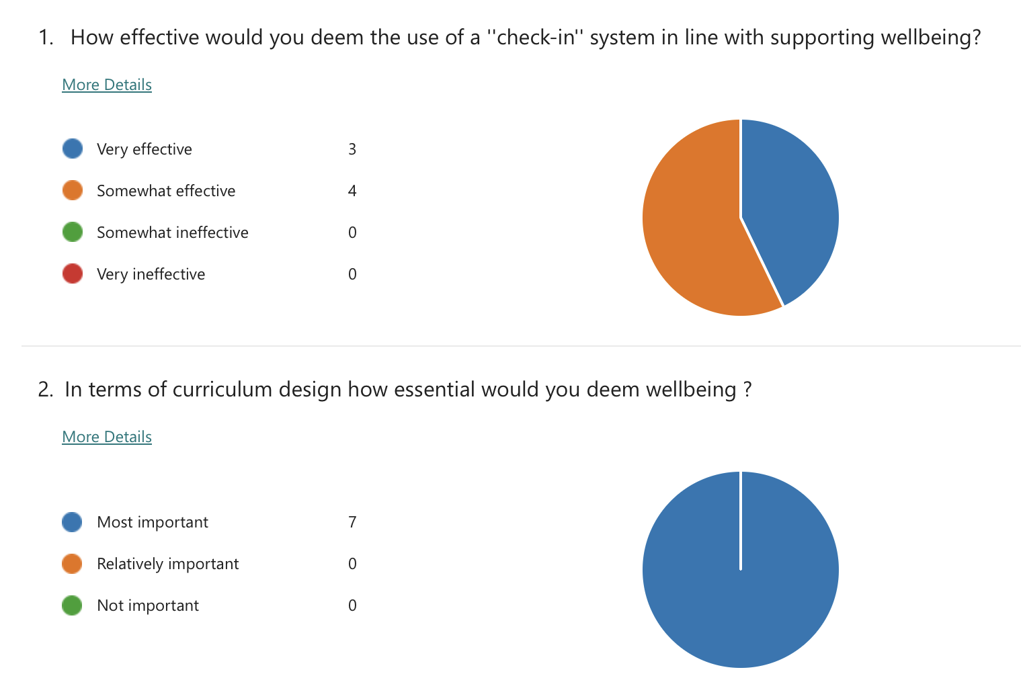

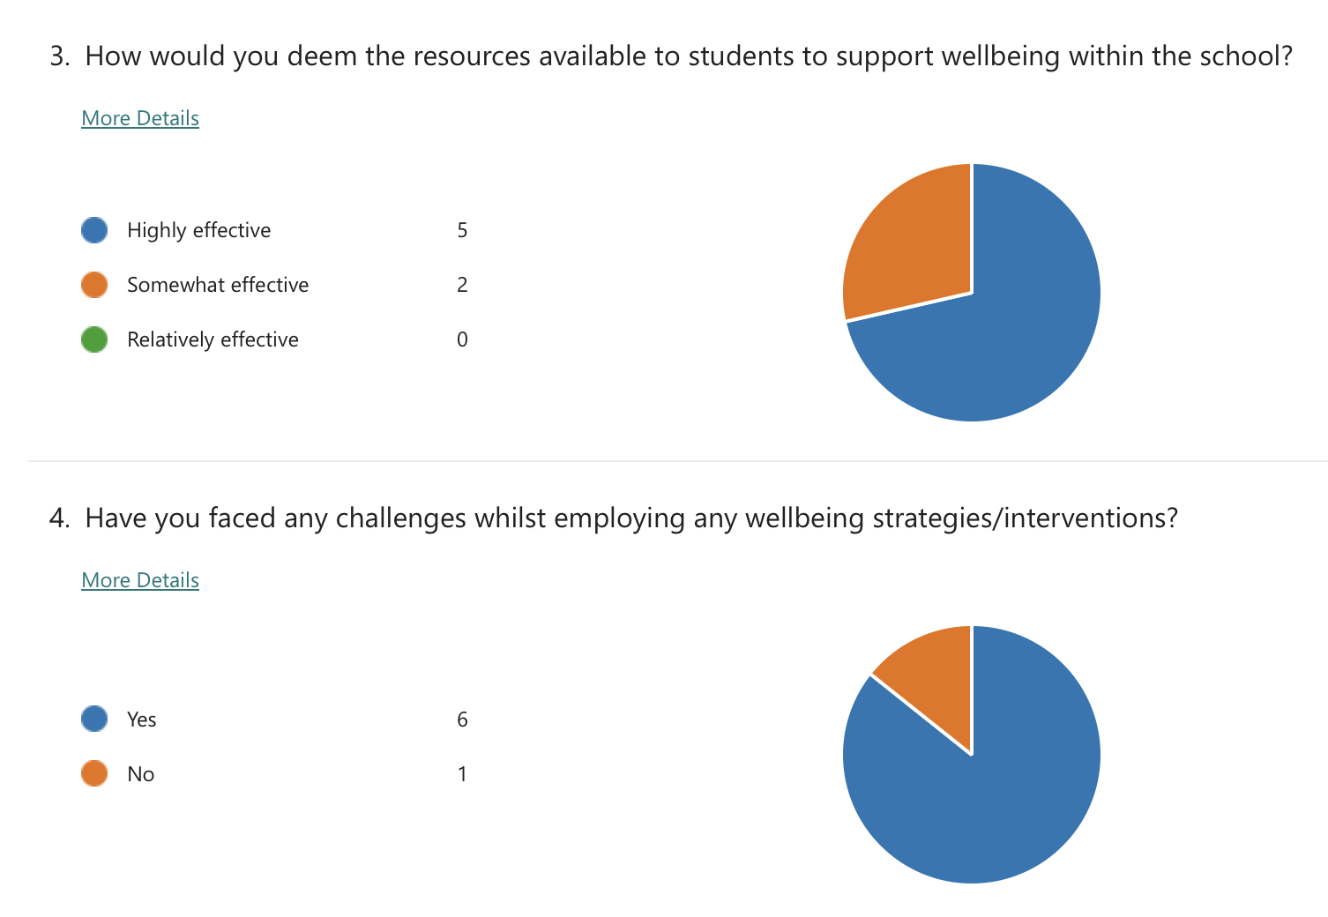

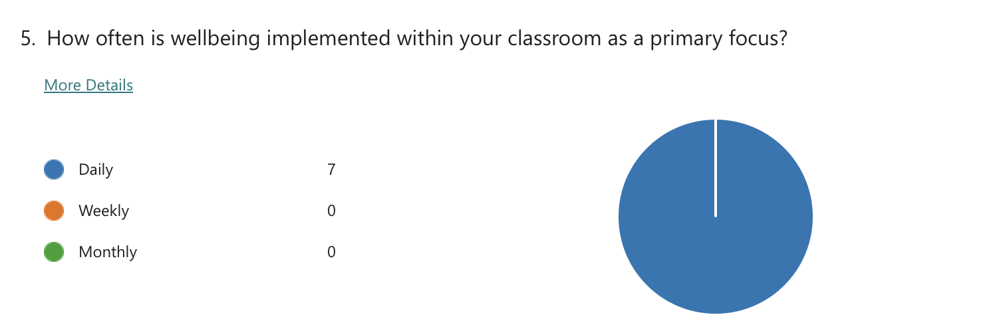

Appendix 6

Dear Parent / Guardian,

My name is Gwen, and I am studying for a BAEd qualification at Yr Athrofa, University of Wales Trinity Saint David.

I would like to invite your child to participate in my research project. The title of the project is ‘’what are staff and learners’ perception of the resources and support available to the schools youngest learners in relation to wellbeing?’’. Through your child’s participation, I hope to gather their thoughts and opinions on this topic and devise a presentation at the end of the week to outline my findings, these will be discussed with stakeholders within the school.

The process of my research project will include interviewing children in focus groups and observing whole-class activities. All names will be kept strictly confidential and will only be known by myself, the researcher. Your child’s participation in this study is completely voluntary so you or your child can withdraw from the study at any stage. Your child will also be asked to give their assent before the beginning of the study.

After careful and precise analysis of the data obtained from the lesson observation and group interview, I would be happy to provide you with a copy of the findings at your request. The results of the research will be discussed in a university assignment that will contribute to my QTS course. The results of this study will be stored on a one drive through HWB which is encrypted with a password and all raw data will be destroyed once the assessment has been marked.

I thank you in advance for your time.

Yours sincerely,

Gwen Quick Hughes

Appendix 7

Name of Researcher: Gwen Quick Hughes

Please initial box

1.I confirm that I have read and understand the information sheet dated 27.11.23 for the above study. 

2.I understand that my child’s participation is voluntary and that I am free to withdraw my child from the study at any time, without giving any reason.

3. I understand that my child can choose to withdraw at any time, without giving a reason.

4. I understand that the information given by my child will be used in a university assignment
.

5. I understand that my child’s name will not appear at any time.

6. I agree for my child to take part in the above study.

_____________________ _____________________________ __________
Child’s name Parent signature Date

When completed, please return this slip to the school by the 27th of November 2023

Reference list
Barclay, C. (2018). Semi-Structured Interviews. [online] KnowHow, pp.1–3. Available at: https://know.fife.scot/__data/assets/pdf_file/0028/177607/KnowHow-Semistructured-interviews.pdf [Accessed 30 Dec. 2023].
Cambridge Dictionary (2024). Consent. [online] @CambridgeWords. Available at: https://dictionary.cambridge.org/us/dictionary/english/consent# [Accessed 30 Dec. 2023].
Carter, N., Bryant-Lukosius, D., DiCenso, A., Blythe, J. and Neville, A.J. (2014). The Use of Triangulation in Qualitative Research. Oncology Nursing Forum, [online] 41(5), pp.545–547. doi:https://doi.org/10.1188/14.ONF.545-547.
Centers for Disease Control and Prevention (2018). Data collection methods for program evaluation: observation. [online] Available at: https://www.cdc.gov/healthyyouth/evaluation/pdf/brief16.pdf [Accessed 28 Dec. 2023].
Cherry, K. (2022). How to Write a Psychology Case Study. [online] Verywell Mind. Available at: https://www.verywellmind.com/how-to-write-a-psychology-case-study-2795722 [Accessed 16 Dec. 2023].
Cherry, K. (2023). What Is Attachment theory? [online] Verywell Mind. Available at: https://www.verywellmind.com/what-is-attachment-theory-2795337 [Accessed 15 Dec. 2023].
Choudhury, A. (2015). Advantages and Limitations ‘Observation’ Method for Data Collection. [online] Your Article Library. Available at: https://www.yourarticlelibrary.com/social-research/data-collection/advantages-and-limitations-observation-method-for-data-collection/64507 [Accessed 27 Dec. 2023].
Clements, J. (2021). What Are the Benefits of Using Interviews in Research? [online] Legal Transcription Service. Available at: https://www.legaltranscriptionservice.com/blog/what-the-benefits-of-using-interviews-in-research/ [Accessed 29 Dec. 2023].
Davidson, L. (2019). Consent and Assent | Institutional Review Board. [online] Uaf.edu. Available at: https://www.uaf.edu/irb/faqs/consent-and-assent/ [Accessed 30 Dec. 2023].
DeBose, K. (2018). Research Guides: Research Methods Guide: Interview Research. [online] guides.lib.vt.edu. Available at: https://guides.lib.vt.edu/researchmethods/interviews#:~:text=Interviews%20are%20most%20effective%20for [Accessed 29 Dec. 2023].
DeCarlo, M. (2018). 13.1 Interview research: What is it and when should it be used? pressbooks.pub, [online] 3(1). Available at: https://pressbooks.pub/scientificinquiryinsocialwork/chapter/13-1-interview-research-what-is-it-and-when-should-it-be-used/ [Accessed 29 Dec. 2023].
Diener, E. (2023). Is Maslow’s Famous Hierarchy of Needs Still Relevant Today? [online] Verywell Mind. Available at: https://www.verywellmind.com/updating-maslows-hierarchy-of-needs-2795269#:~:text=However%2C%20research%20shows%20that%20the [Accessed 15 Dec. 2023].
Doymer, B. (2022). How Response Rates Can Affect the Outcome of a Study and What to Do about It. [online] TASO. Available at: https://taso.org.uk/news-item/how-response-rates-can-affect-the-outcome-of-a-study-and-what-to-do-about-it/#:~:text=The%20lower%20the%20response%20rate [Accessed 29 Dec. 2023].
ESTYN (2023). A report on Cadle Primary School Middle Road Fforestfach SA5 5DU Date of inspection: February 2023 by Estyn, His Majesty’s Inspectorate for Education and Training in Wales. [online] Available at: https://www.estyn.gov.wales/system/files/2023-03/Inspection%20report%20Cadle%20Primary%20School%202023.pdf [Accessed 15 Dec. 2023].
Flyvbjerg, B. (2006). Five Misunderstandings about case-study Research. Qualitative Inquiry, 12(2), pp.219–245. doi:https://doi.org/10.1177/1077800405284363.
Gary, A. and Holmes, D. (2020). Researcher Positionality -A Consideration of Its Influence and Place in Qualitative Research -A New Researcher Guide. [online] pp.1–10. Available at: https://files.eric.ed.gov/fulltext/EJ1268044.pdf [Accessed 30 Dec. 2023].
Kimble, G.A. and Wertheimer, M. (2003). Portraits of Pioneers in Psychology: Volume V. [online] Google Books. Psychology Press. Available at: https://books.google.co.uk/books?hl=en&lr=&id=w7LwgIKuSMkC&oi=fnd&pg=PT356&dq=mary+ainsworth+observation&ots=gstGrXr1ln&sig=ww_knYX1seBzCvTLgmtMoVNQyvA#v=onepage&q=mary%20ainsworth%20observation&f=false [Accessed 28 Dec. 2023].
Knifton, L. and Inglis, G. (2020). Poverty and mental health: policy, practice and research implications. BJPsych Bulletin, [online] 44(5), pp.193–196. doi:https://doi.org/10.1192/bjb.2020.78.
Main, P. (2023). Bowlby’s Attachment Theory. [online] www.structural-learning.com. Available at: https://www.structural-learning.com/post/bowlbys-attachment-theory#:~:text=Overemphasis%20on%20the%20Mother%2DChild [Accessed 15 Dec. 2023].
Marshall, G. (2005). The purpose, Design and Administration of a Questionnaire for Data Collection. Radiography, 11(2), pp.131–136. doi:https://doi.org/10.1016/j.radi.2004.09.002.
Mcleod, S. (2019). Case Study Method. [online] Simply Psychology. Available at: https://www.simplypsychology.org/case-study.html [Accessed 26 Dec. 2023].
Mcleod, S. (2023a). Mary Ainsworth Strange Situation Experiment. [online] Simply Psychology . Available at: https://www.simplypsychology.org/mary-ainsworth.html#:~:text=separated%2C%20and%20reunited.- [Accessed 3 Jan. 2024].
Mcleod, S. (2023b). Questionnaire: Definition, examples, design and types. [online] Simply Psychology. Available at: https://www.simplypsychology.org/questionnaires.html [Accessed 29 Dec. 2023].
Noltemeyer, A., Bush, K., Patton, J. and Bergen, D. (2012). The relationship among deficiency needs and growth needs: An empirical investigation of Maslow’s theory. Children and Youth Services Review, [online] 34(9), pp.1862–1867. doi:https://doi.org/10.1016/j.childyouth.2012.05.021.
NSPCC (2019). Promoting mental health and wellbeing. [online] NSPCC Learning. Available at: https://learning.nspcc.org.uk/child-health-development/promoting-mental-health-wellbeing/ [Accessed 15 Dec. 2023].
Oxford English Dictionary (2001). Wellbeing - Quick Search Results | Oxford English Dictionary. [online] www.oed.com. Available at: https://www.oed.com/search/dictionary/?scope=Entries&q=wellbeing [Accessed 15 Dec. 2023].
Prasanna (2023). Advantages and disadvantages of observation method | merits and demerits of observation in marketing. [online] APlusTopper. Available at: https://www.aplustopper.com/advantages-and-disadvantages-of-observation-method/ [Accessed 28 Dec. 2023].
Project, E. (2015). OBSERVATION – ADVANTAGES AND DISADVANTAGES. [online] ENEMS PROJECT. Available at: https://enemsproject.wordpress.com/2015/12/12/observation-2/#:~:text=In%20unstructured%20observation%2C%20the%20researcher [Accessed 29 Dec. 2023].
Schoonenboom, J. and Johnson, R.B. (2017). How to Construct A mixed Methods Research Design. KZfSS Kölner Zeitschrift Für Soziologie Und Sozialpsychologie, [online] 69(2), pp.107–131. doi:https://doi.org/10.1007/s11577-017-0454-1.
Singh, K. (2010). Features, Advantages and Disadvantages of Observation - Total MBA Guide. [online] Total MBA Guide. Available at: https://www.mbaofficial.com/mba-courses/research-methodology/features-advantages-and-disadvantages-of-observation/ [Accessed 28 Dec. 2023].
Smith, J. (2022). Focus Groups: Advantages and Disadvantages | StudySmarter. [online] StudySmarter UK. Available at: https://www.studysmarter.co.uk/explanations/marketing/marketing-information-management/focus-groups/#:~:text=A%20focus%20group%20is%20a%20primary%20research%20method%20used%20to [Accessed 27 Dec. 2023].
Smyth, J. (2022). Data Presentation: a Comprehensive Guide. [online] www.prezent.ai. Available at: https://www.prezent.ai/zenpedia/data-presentation-guide#:~:text=Why%20are%20data%20presentations%20important%3F&text=Clarity%3A%20Data%20presentations%20make%20complex [Accessed 30 Dec. 2023].
Team, T.E. (2022). Close-ended questions: Definition, types, examples, and advantages. [online] Delighted. Available at: https://delighted.com/blog/close-ended-questions [Accessed 29 Dec. 2023].
Thompson, K. (2016). Interviews in Social Research: Advantages and Disadvantages. [online] ReviseSociology. Available at: https://revisesociology.com/2016/01/23/interviews-in-social-research-advantages-and-disadvantages/?utm_content=cmp-true [Accessed 29 Dec. 2023].
Universal class (2019). The Strengths and Weaknesses of Case Studies. [online] UniversalClass.com. Available at: https://www.universalclass.com/articles/business/a-case-studies-strengths-and-weaknesses.htm [Accessed 26 Dec. 2023].
Webster, M. (2019). Definition of OBSERVATION. [online] Merriam-webster.com. Available at: https://www.merriam-webster.com/dictionary/observation [Accessed 28 Dec. 2023].
Welsh Government (2019). Professional Standards for Teaching and Leadership. [online] Available at: https://hwb.gov.wales/api/storage/19bc948b-8a3f-41e0-944a-7bf2cadf7d18/professional-standards-for-teaching-and-leadership-interactive-pdf-for-pc.pdf [Accessed 15 Dec. 2023].
Welsh Government (2023). Relative income poverty: April 2021 to March 2022. [online] GOV.WALES. Available at: https://www.gov.wales/relative-income-poverty-april-2021-march-2022-html [Accessed 15 Dec. 2023].
World Health Organisation (2022). Ensuring Ethical Standards and Procedures for Research with Human Beings. [online] www.who.int. Available at: https://www.who.int/activities/ensuring-ethical-standards-and-procedures-for-research-with-human-beings#:~:text=It%20is%20important%20to%20adhere [Accessed 30 Dec. 2023].

