
STUDENT NAME: MUHAMMAD ANSAAR KHALID
STUDENT ID: 2130064
SUPERVISOR: KONSTANTINA MARI
COURSE: MASTER’S IN BUSINESS ADMINISTRATION
PROPOSAL FOR DISSERTATION
DISSERTATION TITLE: TO INVESTIGATE THE INFLUENCE OF VARIOUS MODES OF ADVERTISING ON BUYING BEHAVIOURS OF CUSTOMERS IN THE UK

Table of content
Topics | Page No.
- Introduction  1.2 Methodology  1.2.1 Research Philosophy, Approach and Strategy  1.2.2 Primary and secondary data collection  1.2.3Development of questionnaire  1.2.4Analysis of the data through Microsoft Excel  1.3 Aims and objectives  1.4 Literature review  1.5 Limitations  1.6 Ethical consideration  1.7 Timeframe  1.8Mini-conclusion  References | 3  4  5  5  7  8  8  8  10

TO INVESTIGATE THE INFLUENCE OF VARIOUS MODES OF ADVERTISING ON BUYING BEHAVIOURS OF CUSTOMERS IN THE UK
  - Introduction
Advertising is basically taken as a marketing tool to increase customers (Britannica, 2023). Multinational companies (MNCs) and business giants use different modes of advertisements to attract audience and increase their sales (Weiss, 2023). The most widely used digital mode is digital advertising through various social media platforms, search engine marketing, display ads, audio and video streaming ads etc.(Amazon Ads, 2023); while other traditional modes are printing ads in newspapers, magazines and on billboards, and broadcasting audio and visual ads on radio and television. People find it easier to have advertisements with just a single click on mobile phones, tablets and laptop screens. Some other ways also include product placements, brochures and space advertisements (Sernoff, 2022). On one hand, these advertisements provide instant information to the customers about the products; on the other hand, this is the fastest way toinfluence the customer’s behaviours to buy these products. Therefore, companies and business giants intentionally make advertisements to influence their target audience and increase their sales. Similarly, customers also tend to have various buying behaviours. Some are habitual or spendthrift buyers, some are frugal or complex buyers, some are variation-seekers, some are impulsive buyers, and some are tough decision makers or analytical buyers (Indeed, 2023). All of these buyers react differently to the product advertisements. For that reason, the companies and business giants first decide their targeted customers and design the ads pertinently. UK, being one of the world’s highest immigrant acceptor country, too is enriched with variety of customers that behave differently to different ads (Vargas-Silva and Rienzo, 2022). Keeping in view this, the present study is designed to investigate the influence of various modes of advertising on buying behaviours of customers in the UK.The review of existing literature also depicts the need of this investigation. Consequently, the research questions as well as methodology are designed to investigate the different behaviours of customers towards various modes of advertising in the UK.

1.2 Research Methodology
1.2.1 Research Philosophy, Approach and Strategy
For the present study, positivist research philosophy, deductive research approach, and quantitative research strategy and questionnaire method will be opted for investigation. Positivist research philosophy is best suited for quantitative evaluation of available information (Muhaise et al., 2020). According to this philosophy, all existing theories are used and interpreted during the investigation. Deductive research approach is chosen for quantitative analyses of the data to move from general theories to the straight conclusion (Maarouf, 2019). The research strategy will be questionnaire development and data collection succeeded by quantitative analysis.
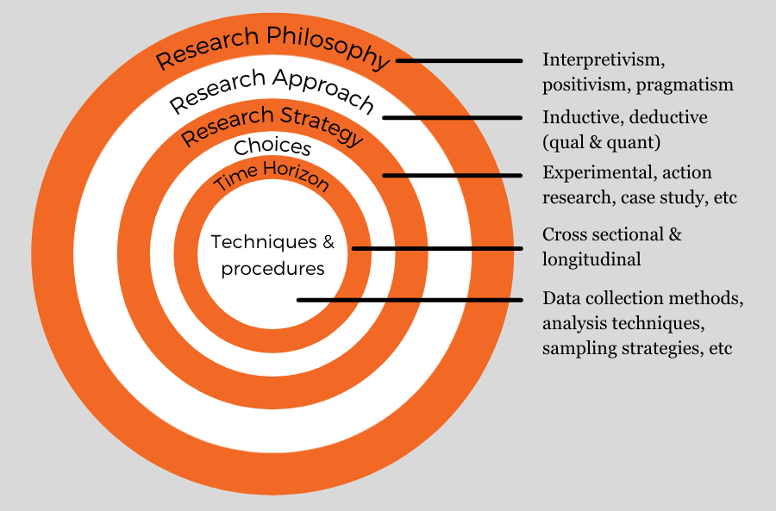
Fig. 1: Saunders’ Research Onion (Saunders et al., 2007)
1.2.2 Primary and Secondary Data Collection
The primary data will be collected in the form of questionnaire from the general public. Sample size will be kept as 100. The secondary data will be gathered from available resources like research article, books and internet blogs and authentic websites.
    - Development of Questionnaire
On the basis of primary and secondary research questions derived from objectives of this study, several questions will be made to understand the public opinion. The main question type will be dichotomous where people will agree or disagree in the form of Yes or No. These will be 20 to 25 in number. Some open ended questions will also be included to ensure the truest public opinion about their behavior while shopping after seeing ads on various platforms. The questions will be arranged in a way that most important (primary) questions will be asked first while secondary questions will be asked later. Also, 5-6 demographic questions will be asked such as age group, gender, income or education level. To ensure the privacy of people, the answers of the participants will be kept anonymously.
    - Analysis of the data through Microsoft Excel
The collected primary data through questionnaire will be analyzed through Microsoft Excel software. The percentage of all agreed or disagreed answers will be calculated. A report will be generated and presented in the form of charts for better understanding.
1.3 Aims and Objectives
The present study is aimed at investigatingthe influence of various modes of advertising on buying behaviours of customers in the UK. Keeping in view the aims, the objectives of the present research are to:
- understandthe use of various modes of advertisements in the UK
- analyse the influence of various modes of advertisements on customer’s buying behaviours in the UK
- find the reasons of the most popularmodes of advertisements among public in the UK
- observe the least liked modes of advertisements among public in the UK
1.4 Literature Review
Advertising contains all the necessary activities required topresent a sponsored message to promote sales of products (Stanton, 1984).Advertisements act as an initiation point for shopping by customers. Ehrenberg’s Awareness-Trail-Reinforcement (ATR) model (1974) testify to it.The advertisements are basically considered as marketing tool to increase customers for product sale (Britannica, 2023). Various multinational companies, business giants and ads agencies use different modes of advertisements to attract audience and increase their sales (Weiss, 2023). The digital advertisement is the most widely used mode now a days and is through various social media platforms like Google, Bing, Facebook, Instagram, Twitter, LinkedIn, Pinterest and Amazon (Gibbons, 2020).It also includessearch engine marketing, display ads, audio and video streaming ads etc.(Amazon Ads, 2023). Some traditional modes of ads are printing ads in newspapers, magazines and on billboards, and broadcasting audio and visual ads on radio and television. People find it easier to have advertisements with just a single click on mobile phones, tablets and laptop screens. Some other rare ways also include product placements, brochures and space advertisements (Sernoff, 2022). When compared, digital modes of advertisements are more cost effective, non-intrusive, non-interruptive, provide real time outcomes and fast publicity, improve brand image, include global participation, and easy for analyses than the traditional modes of advertisements (Saini, 2017).
Siddiqui et al. (2021)investigated the effect of advertisements on consumer’s different buying behaviours and inferred that advertising has heavy influence on consumer’s choice to prefer buying certain products over others. Additionally, they mentioned that the economic status of customer is one of the key factors that influence their access to various ads and buying choices. Dhore and Godbole (2018) identified impact of e-advertisements on buying behaviours of customers in India. The research showed that due to fast prevailing internet facilities, e-ads are heavily affecting customer behaviours now and people are frequently changing their buying choices on the basis of ads. Shetty et al. (2019) found out that marketing campaigns that include high quality ads bring out the best purchasing response from customers. Their study revealed that people aged between 18 to 28 were among the most frequent buyers and their economic independence was also one of the prominent feature while getting influenced from certain ads.
The way advertisements are designed also influence the customers to start purchasing products. Niaziet al. (2012) investigated the ways of effective advertisements and also analysed theirimpact on buying behaviours.Dhore and Godbole (2018) also endorsed the point of view that customers having access to internet based and social media based forums are more influenced by such ads. Mbura and Kagoya (2021) also identified effect of radio, newspaper, TV and online ads on people as customers in Tanzania. The study revealed that people got influenced by only those modes that were accessible to them, such as TV and Radio were high rated while online mode was least rated. Due to this acquired data, Tanzanian companies focused more on provision of high rated advertisement platforms. Some of the key global advertising platforms are Google, Bing, Facebook, Instagram, Twitter, LinkedIn, Pinterest and Amazon, while less common are Bidvertiser or AdRoll etc. (Gibbons, 2020). Hamze (2020) also conducted a similar study in Kurdistan where 40% of the population showed likeness towards a specific way of advertisement. Such studies are, therefore, considered as most useful while policy making by the MNCs and business giants.
Quality-oriented advertisementsurge the clients to show long-term loyalty towards the business giants. Sometimes, fashion trend-setters like to get inspiration from heroes and heroines that act in the ads. Ahmed and Ashfaq (2013) said that all these ads include huge investment from the MNCs for promotional purpose. Haider and Shakib (2018) and Ha et al. (2011) concluded that it is due to the ads that people switch their loyalties from one long-time brand to another. Therefore, one can say that advertisements play a reformatory role in customers’ lives. It affects human psyche directly and forces them to change their priorities within less time span. A book titled Persuasion in advertising (2003) written byO’Shaugnessy also endorses this point of view that it is the trick incorporated while making ads that directly hit customer’s psyche and persuade him to buy the product.
1.5 Limitations
The study acknowledges that absence of researcher during data collection may alter the nature of responses. Additionally, the present research only includes the one-way responses from customers and doesn’t include any opinion from advertising firms as well as MNCs which becomes its limitation. Thus, the one-way limited collection of data from one stakeholder, i.e. customers, is limitation of this research.

1.6 Ethical Considerations
The present work is drawn in line with the acquirement of pre-consent from the public who will take part in questionnaire. They will be well-informed about the purpose of acquiring data before providing them with the questionnaire and all their answers will be kept confidentially and will be anonymous.
  - Timeframe
Table 1: Gantt Chart showing time plan for dissertation
Steps | Weeks
Steps | 2 | 4 | 6 | 8 | 10 | 12
Introduction
Literature Review
Methodology
Empirical Analysis
Data Analysis through Excel
Conclusion and Discussion
Dissertation Submission
  - Mini-conclusion
Conclusively, advertising plays an important role in customer’s decision making for any purchase. Various new modes of advertisement, for instance LinkedIn, Meta (Facebook) or other digital forums, are used by MNCs and business giants to directly target customers to increase their sales.It is also pertinent to see that these customers may switch their favourite brands and companies after getting attracted from certain ads. Therefore, customers’ loyalties may change due to these advertisements. Such changes in customers’ behaviours are attributed to ads offered by MNCs and business giants that requires huge investments at their ends. Keeping in view the existing literature, there is a need to investigate the influence of advertising on customer markets in the UK so that MNCs and business giants can reshape their existing policies and address the issues they are dealing with the least prioritized items. The present work will further provide a roadmap to the investors, business giants and policy makers in the UK for improved sales and better business relations with customers.
References
Ahmed, S., Ashfaq, A. 2013. Impact of Advertising on Consumers’ buying behavior through Persuasiveness, Brand Image, and Celebrity endorsement. Global Media Journal 6(2), pp. 149.
Amazon ads. 2023. What is digital advertising? A beginner’s guide. Available online from: <https://advertising.amazon.com/library/guides/what-is-digital-advertising#:~:text=What%20are%20the%20different%20types%20of%20digital%20advertising%3F,Audio%20advertising%20...%206%20Social%20media%20advertising%20> accessed on 10 March 2023.
Britannica, The Editors of Encyclopaedia. 2023. “advertising”. Encyclopedia Britannica, available online from:<https://www.britannica.com/topic/advertising> accessed on 12 March 2023.
Dhore, A., Godbole, S. 2018. A descriptive study of the effectiveness of Internet advertising on consumer buying behavior in Nagpur city. International Journal of Latest Engineering and Management Research 3(5), pp. 1-3.
Ehrenberg, A.S.C. 1974. Repetitive Advertising and the Consumer. Journal of Advertising Research 14(2),pp. 25-33.
Gibbons, M. 2020. 18 best paid advertising platforms, Web FX. Available online from: <https://www.webfx.com/blog/marketing/paid-advertising-platforms/#:~:text=Online%20advertising%20platforms%20list%201%201.%20Google%20Ads,Pinterest%20Ads%20...%208%208.%20Amazon%20Ads%20> accessed on 10 March 2023.
Ha, H. Y., John, J., Janda, S.,Muthaly, S. 2011. The effects of advertising spending on brand loyalty in services. European journal of marketing 45(4), pp 673-691.
Haider, T., Shakib, S. 2018. A study on the influences of advertisement on consumer buying behavior. Business Studies Journal 9(1), pp. 1-13.
Hamze, M.M. 2020. An analysis of advertisement, customer's purchasing performance and behaviors: a case study on Kurdistan region. Humanities Journal of University of Zakhlo 8(2), pp. 30.
Indeed Editorial Team. 2023. 11 types of customer Buying Behaviours, available online from: <https://www.indeed.com/career-advice/career-development/types-of-buying?utm_campaign=earnedsocial%3Acareerguide%3Asharedirectshare%3AUS&utm_content=11%20Types%20of%20Customer%20Buying%20Behaviors&utm_medium=social&utm_source=directshare> accessed on 10 March 2023.
Maarouf, H., 2019. Pragmatism as a supportive paradigm for the mixed research approach: Conceptualizing the ontological, epistemological, and axiological stances of pragmatism. International Business Research 12(9), pp.1-12.
Mbura, O.K., Kagoya, S.M. Effect of Advertisement on Consumers’ Buying Behaviour of Real Estates in Tanzania: Insight from the National Housing Corporation. Tanzanian Economic Review 11(1), pp. 137-155.
Muhaise, H., Ejiri, A.H., Muwanga-Zake, J.W.F., Kareyo, M., 2020. The research philosophy dilemma for postgraduate student researchers. International Journal of Research and Scientific Innovation7, pp.202-204.
Niazi, G.S.K., Siddiqui, J., Shah, B.A., Hunjra, A.I. 2012. Effective advertising and its influence on consumerbuying behavior. Information Management and Business Review 4(3), pp. 114-119.
Shetty, S., Sowmya, Maiya, U. 2019. Impact of advertisement of consumer buying behavior. International Journal of Advance and Innovative Research 6(2), pp. 32-36.
O'Shaugnessy, J. O’Shaughnessy, N. 2003. Persuasion in Advertising. Routledge Press.
Saini, S. 2017.11 Benefits of digital marketing over traditional marketing. Available online from: <https://technians.com/blog/benefits-digital-marketing-over-traditional-marketing/#author-readmore>accessed on 18 March 2023.
Saunders, M., Lewis, P., Thornhill, A. 2007. Research Methods for Business Students, (6thed.) London: Pearson.
Sernoff, L. 2022. 10 Types of advertising and how to use them effectively. WiX Blog, available online from: <https://www.wix.com/blog/2021/05/types-of-advertising#:~:text=10%20Types%20of%20advertising%201%2001.%20Online%20search,...%208%2008.%20Product%20placement%20...%20More%20items> accessed on 16 March 2023.
Siddiqui, M.S., Johri, A., Shoeb, A., Saxena, A.K., Siddiqui, J.H., Usmani, K. 2021. A study on the influence and impact of advertising to consumer purchasebehaviour in rural areas of India. Academy of Strategic Management Journal 20(5), pp. 1-22.
Vargas-Silva, C., Rienzo, C. The Migration Observatory. 2022. Migrants in the UK: An overview. Available online from: <https://migrationobservatory.ox.ac.uk/resources/briefings/migrants-in-the-uk-an-overview/> accessed on 8 March 2023.
Weiss, A. 2023. Does advertising lead to higher sales? MarketingProfs. Available online from: <https://www.marketingprofs.com/Tutorials/Advertising_Sales.asp> accessed on 18 March 2023.

