

CONROD DYNAMIC FORCES REPORT

Analytical Methods and Study Skills

Chloe Underwood (1650758)

Abstract
A report evaluating the forces that a con-rod undertakes whilst operating within an engine using the correct figures gathered from sufficient data research and analysing the maximum force and change of RPM (revs per minute).

Contents
- Introduction…………………………………………………………………………………………………………2
- Engine Research………………………………………………………………………………………………….3

- The Forces …………………………………………………………………………………………………. 4
- Calculations ………………………………………………………………………………………………….5
- Results ………………………………………………………………………………………………….6
- Analysis ………………………………………………………………………………………………….7
- Conclusion ………………………………………………………………………………………………….10
- References ………………………………………………………………………………………………….11

1.0 Introduction
This report will include how different factors of the engine affect the impact of the con-rod, depending on the force it is undergoing. With the correct research on the selected engine, the factors will be entered into a spreadsheet that will then produce values that will be analysed to find where the maximum and minimum forces occur. These factors include: con-rod length, crank radius, engine speed, and the mass of the piston. The spreadsheet includes 3 graphs: acceleration, mass and velocity. Using the data collected from research, a test will be run by changing the rpm by 1000 intervals. Therefore, this report will contain 3 graphs per interval: 4000, 5000 & 6000 RPM.
The selected engine to carry out this report is based on a Nissan Skyline GTR R32 engine. This engine was chosen as it has always been one of a personal selective favourite. These measurements had not been easily accessible, however; very interesting.

2.0 Engine Research
The engine chosen for this task is a RB26DETT, taken from a Nissan Skyline GTR 32. This engine is a very popular engine within the Japanese modification society and tuning companies. The RB engine is so popular that it is often found in many vehicles that share similarities , such as; Nissan Silvia s13, PS13, S14, S15, Nissan 350Z, Ford Mustang and Infiniti G35. (WikiMotors, 2015-2018)
“In contrast to RB25DET, RB26DETT uses cylinder block without oil port, also it has crankshaft with 73.7 mm piston stroke, connecting rods are installed (as on RB25DET NEO), new pistons (they are 1mm lower), and compression ratio is 8.5. Cylinder block is covered with aluminium head with 24 valves and no variable valve timing system. RB26DETT camshafts: duration 240/236 degrees, lift 8.58/8.28 mm. Also instead of hydraulic lifters, the engine has solid lifters.
Inlet valves are 34.5 mm in diameter, while diameter of exhaust valves is 30 mm. The intake system uses individual throttle bodies. Each of 6 throttle bodies is 45 mm in diameter. RB26DETT firing order is 1-5-3-6-2-4.
Air gets into intake manifold with help of two Garrett M24 turbochargers with ceramic impeller. Maximal boost pressure is 10 psi (0.7 bar). Fuel injectors are 444 cc/min.
With these modifications the Nissan Skyline GTR R32 is capable of producing an additional 280 HP at 6,800 RPM, and 353 NM of torque at 4,400 RPM.
Nissan Skyline GT-R R34 uses ball bearing Garrett M24 turbochargers. These are RB26DETT Red top engines. However, engines installed on Skyline GTR R32 and Skyline GTR R33, usually they are called RB26DETT Black top. “(WikiMotors, 2015-2018)
This engine had been discontinued back in 2002 and made an appeared back in 2007. However, manufactures had developed the engine during this period and produced a VR38DETT, which was used for the Nissan GTR R35. These modifications were made to rectify the faults within the original engine produced. These modification included:
“improved cylinder block (cooling system was updated), marked as 24U, and also reinforced connecting rods, pistons, turbochargers Garrett M24 with steel impeller, upgraded turbo manifold.”
(WikiMotors, 2015-2018)
Once these modifications had been made, the engine was introduced into the skyline GTR r34 Nur spec known as the “RB26DETT Gold top”.

3.0 The Forces

During a normal four stroke cycle of an internal combustion engine, there are so many different forces that are being applied simultaneously to each different component of the engine. A lot of forces are exerted into the con-rod whilst the piston travels between the TDC (Top Dead Centre) and the BDC (Bottom Dead Centre) of the piston travel. There is a large force applied to the top of the piston during the combustion process, where this force puts a lot of stress trough the piston gudgeon pin, connecting the piston to the con-rod. When the force is pushing the piston down, this force travels through the con-rod, following an angular path as shown below in figure 1.

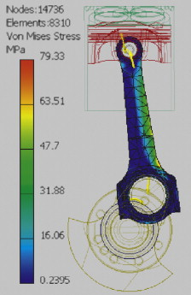
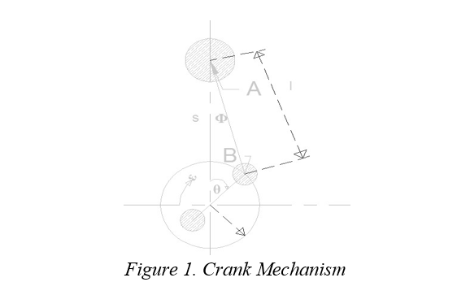

Figure 2: Harrison, M (2004)

However, the forces on the piston want to push the con-rod straight down, it’s unable to do this due to the bottom of the con-rod being attached to a crank shaft, which is rotating around a point. This therefore causes the con-rod to rotate off of the force path and with enough force being applied this could cause the con-rod to deform which may fracture or break the con-rod, therefore sending a connected part to go through the engine block. (Harrison, M. 2004). The typical forces through a con-rod are shown clearly in figure 2.

4.0 Calculation/ Methodology
In order to carry out this test, certain measurements from the selected engine had to be gathered through research, such as:
- Crank radius
- Crank angle
- Con-rod length
These measurements were then submitted into a prebuilt excel spread sheet to create graphs of forces at 3 different RPM intervals, these were selected from 4000, 5000 and 6000. Producing a clear understanding of the change of force during each RPM.
The excel spreadsheet was set up with the following equations:
Crank Angle (radians)=Time Interval × ω . Where ω stands for the angular velocity of the con-rod which changes each time the rpm changed and time interval was 0.002seconds.
Crank Angle (degrees)=Crank Angle (radians)×180/π
Distance X=Sin(Crank Angle (Radians))×Crank Radius This distance refers to the distance between the crank pin and the centreline.
Inv Sine Phi=Distance/(Con-rod length)
Phi, φ (radians)= sin^(-1)(Inv Sine Phi).
Height=Crank Radius × cos (Crank Angle (radians))+Conrod Length ×cos (Phi(Radians))
Engine Specification:
Conrod length: 4.800 Inches (121.5mm) ( (Maxpeedingrods, 2019)
Crank radius = 54.965mm (Maxspeedingrods,2019)
Piston Weight: 522g (0.522kg)
RPM: between 4000-6000

5.0 Results
Once the researched data was selected into the spreadsheet, these are the following results.
At 4000rpm, the max tensile force on the rod shows as 7655.768N and ω is 418.879
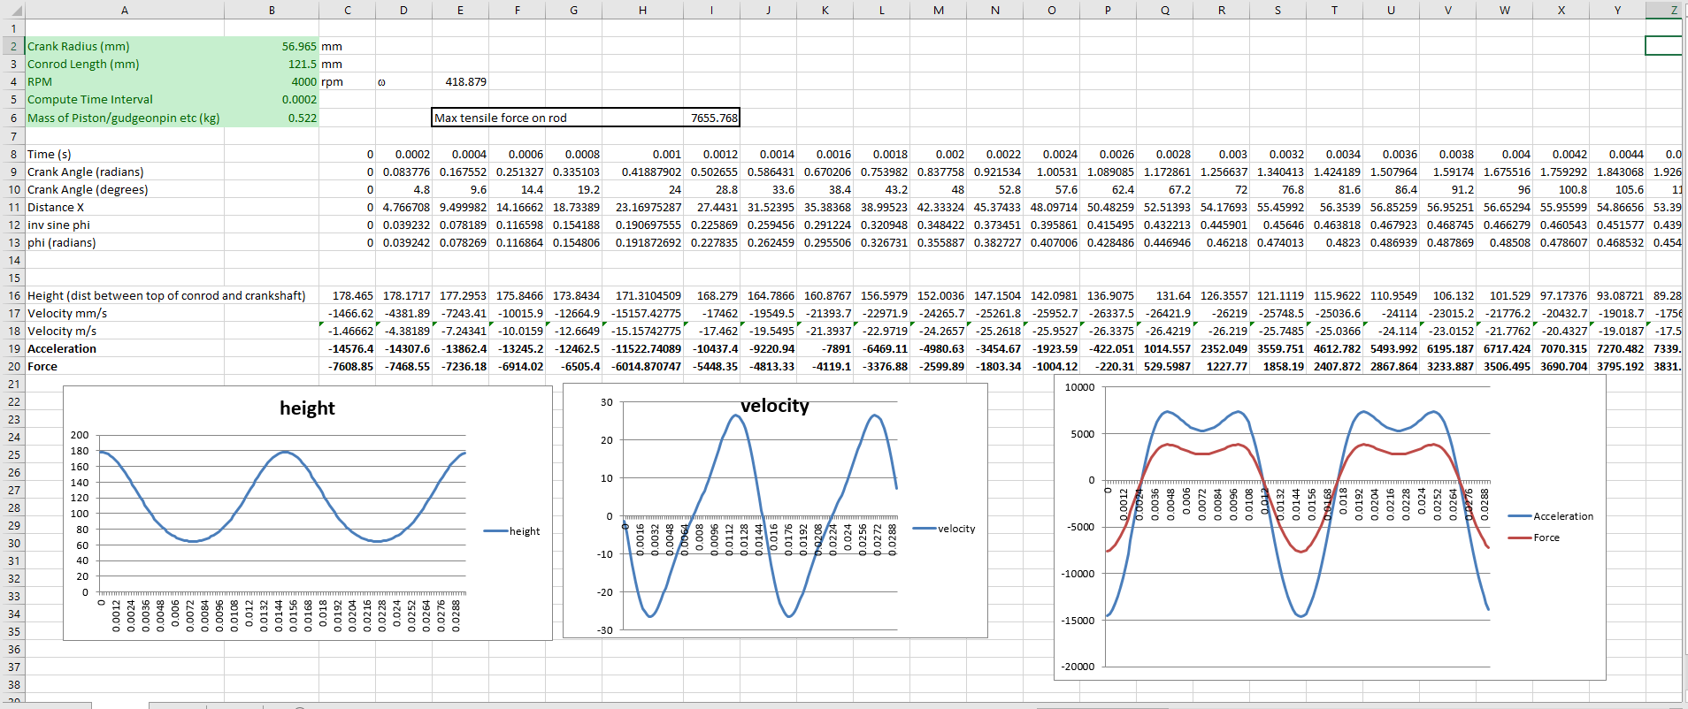

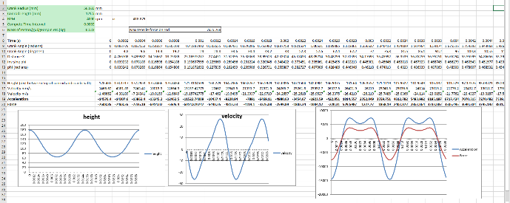
Results @5000RPM: Max tensile force= 11955.26N and ω is 523.5988.

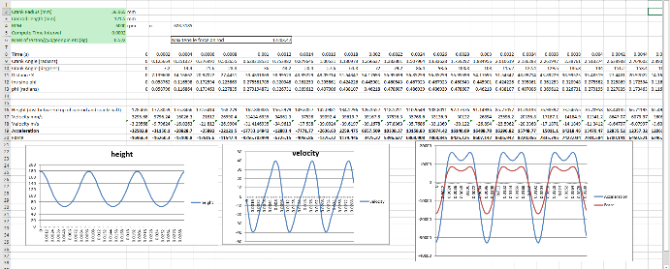
Results @6000RPM: Max tensile force= 17203.47N and ω is 628.3185.

6.0 Analysis
In these height graphs, a clear difference is shown when the RPM changes the frequency on the graph increase. However, the height on each graph stays the same. This is because the piston travel doesn’t change. This replicates for each graph, as the rpm increases, the more frequent the waves are.
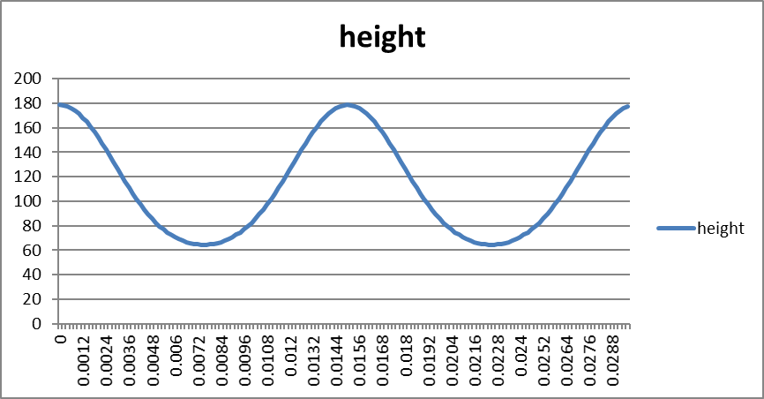

Figure 3: Height on con-rod@
4000RPM.

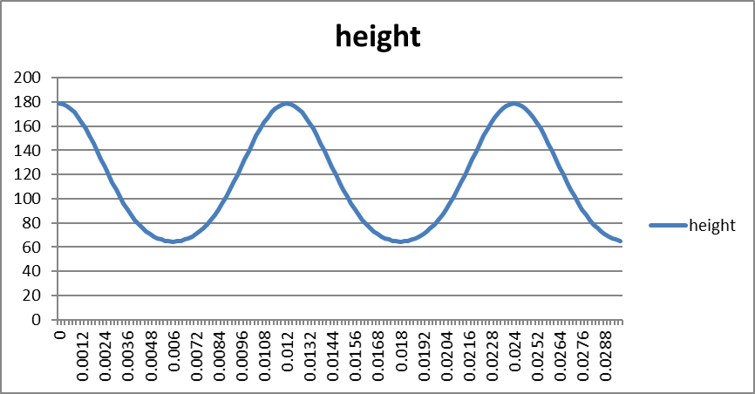

Figure 4: Height on con-rod@ 5000RPM.

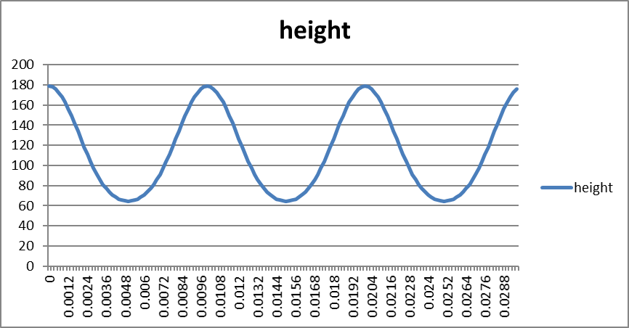
Figure 5: Height on con-rod@ 6000RPM.

In the following graphs, a clear difference is shown in height of velocity when the RPM increases. All graphs show the maximum and minimum velocity, which increases both height and frequency. This is due to the piston travelling at a higher speed with the higher rpm.
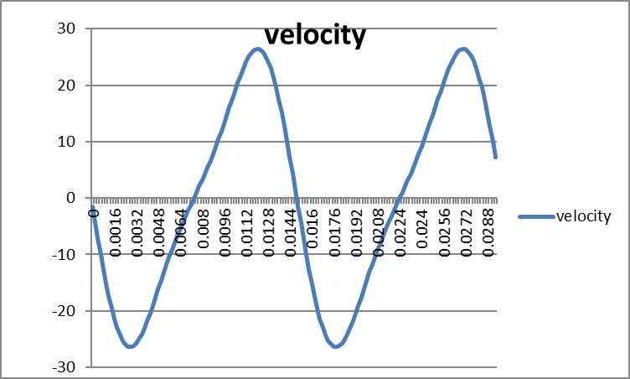

Figure 6: Velocity on con-rod@ 4000RPM.

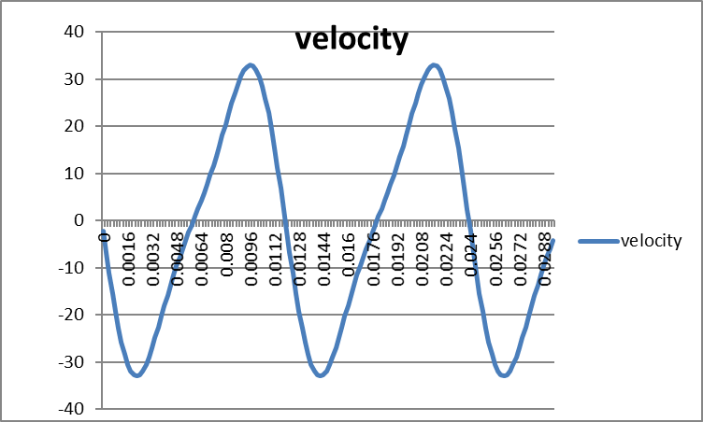

Figure 7: Velocity on con-rod@ 5000RPM.

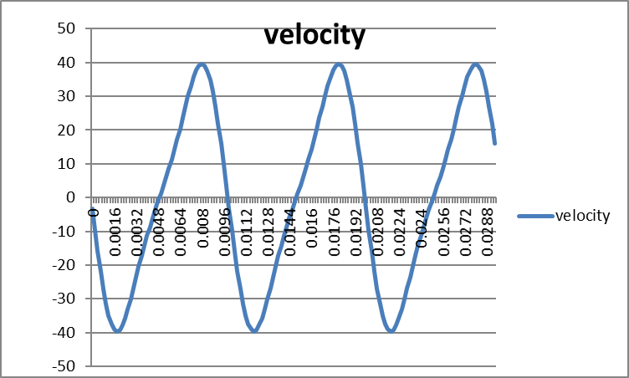

Figure 8: Velocity on con-rod@ 6000RPM.

The following graphs show a clear increase of both acceleration and force when the rpm increases. As the rpm increases by 1000 intervals each time the acceleration increases by approximately 5000 and the force by 1000. When these values increase it has an impact on the max tensile force. Therefore the greater the acceleration, the greater the force. When travelling between strokes the piston will accelerate, decelerate and a stop in both directions.
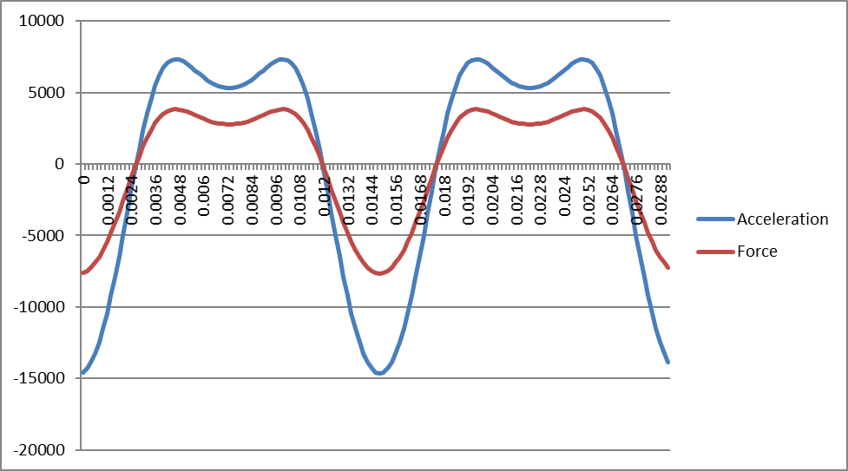

Figure 9: Acceleration and force on con-rod@ 4000RPM.

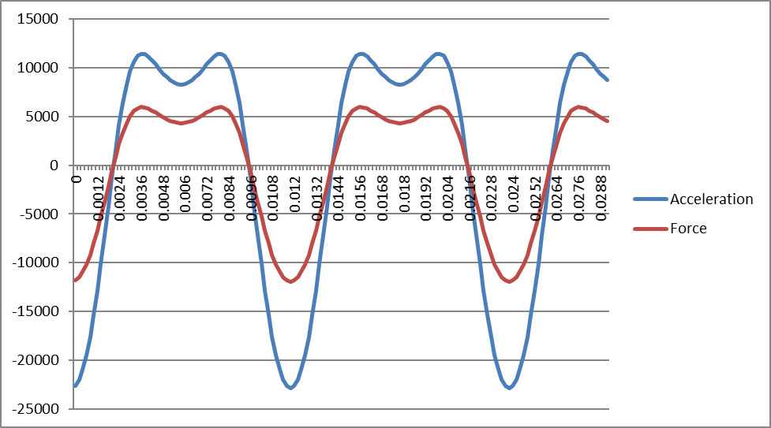

Figure 10: Acceleration and force on con-rod@ 5000RPM.

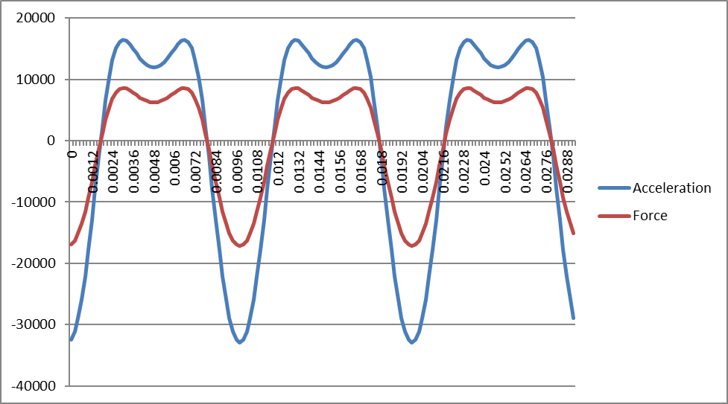

Figure 11: Acceleration and force on con-rod@ 6000RPM.

A clear comparison can be made between the max tensile forces at each RPM. At 4000rpm the maximum tensile force reached 7655.768, at 5000rpm this increases to 11955.26 and at 6000rpm this increases to 17203.47. Summarised, this confirms that the higher RPM generates a greater force through the higher acceleration of the con rod. In affect when the con-rod is travelling at higher speeds it experiences a greater tensile force.

7.0 Conclusion
Overall, the database and research gathered for this assignment goes to show how much of an impact the engine RPM has on the forces on the con-rod. This database have shown why it is important not to operate engines at high revolutions per minute as the con-rod is operating under great force and the durability of the con-rod could decrease. In conclusion, this assignment has given a clear understanding how the RPM affects the forces within the engine.

References
RB26DETT ENGINE INFORMATION:
DSport. (2019). DSport. R34 Skyline GT-R 788 Horsepower Streetcar. Sourced from: https://dsportmag.com/the-cars/features/r34-skyline-gt-r-788-horsepower-streetcar/4/ (Accessed 08 Dec. 2019)
Maxpeedingrods (2019). MaxpeedingRods. 4340 Steel Crank Crankshaft for Nissan Skyline GTR R32 R33 R34 RB25 RB26 77.7mm. Sourced from: https://www.maxpeedingrods.co.uk/high-performance-nissan-skyline-gt-r-2-6l-rb26-rb26det-4340-en24-chrome-moly-billet-crankshaft-77-7mm-stroke.html (Accessed 08 Dec. 2019)
TopGear (2019). TopGear. Nissan Skyline GT-R 2.6 Twin Turbo 2dr. Sourced from: https://www.topgear.com/car-reviews/nissan/26-twin-turbo-2dr/spec (Accessed 08 Dec. 2019)
EVO(2018). EVO. Nissan Skyline GT-R R32 - review, history, prices and specs. Sourced from: https://www.evo.co.uk/nissan/skyline/gt-r-r32 (Accessed 08 Dec. 2019)
WikiMotors. (2015-2018). WikiMotors. Nissan RB26DETT Engine. Sourced from: http://mywikimotors.com/rb26dett/ (Accessed 08 Dec. 2019)
Harrison, M. (2004). Sciencedirect. Conrod. Sourced from: https://www.sciencedirect.com/topics/engineering/conrod (Accessed 08 Dec. 2019)

