Victoria Jeffreys

Student number 1303685

Driving Performance

BMHR7016

07/05/2024

Word Count – 3282

Welcome to our Lunchtime Learning Sessions for Line Managers.
Over five weeks, these sessions will equip our manufacturing team Line Managers with skills to lead high-performing teams. Attendance is encouraged but not mandatory.
Sessions, each lasting 1 hour, will be held weekly on a Wednesday in person during lunchtime in the conference room. Refreshments will be provided. Topics include:
Week 1 - The Crucial Role of Line Managers in Influencing Performance
Week 2 - Leading Effective Teams: Evidence and Practice.
Week 3 - Strategies for Employee Retention.
Week 4- Approaches to Managing Capability.
Week 5 - The Use of Coaching and Mentoring in assisting performance.
1 - The Crucial Role of Line Managers in Influencing Performance | p.2
2 - Leading Effective Teams: Evidence and Practice. | p.11
3 - Strategies for Employee Retention. | p.19
4- Approaches to Managing Capability. | p.25
5 - The Use of Coaching and Mentoring in assisting performance. | p.33
References | p.40
Appendix | p.50
Link to Canva Slides to see slide content more clearly | p.51
(Not included in word count)

Session 1 - The Crucial Role of Line Managers in Influencing Performance
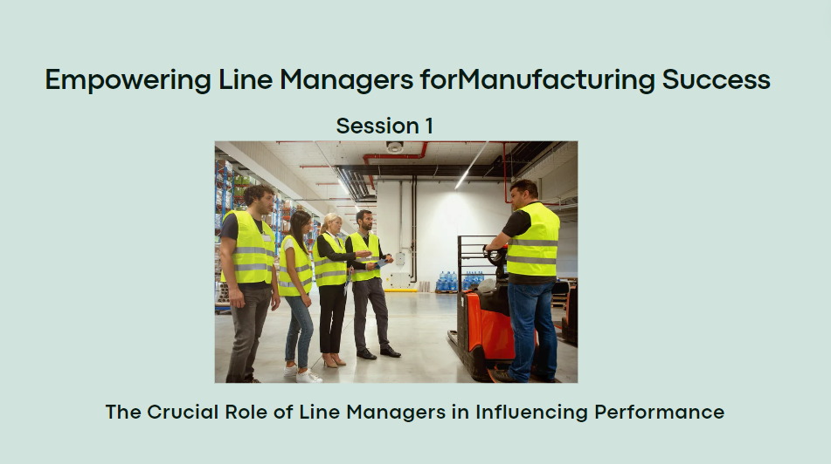
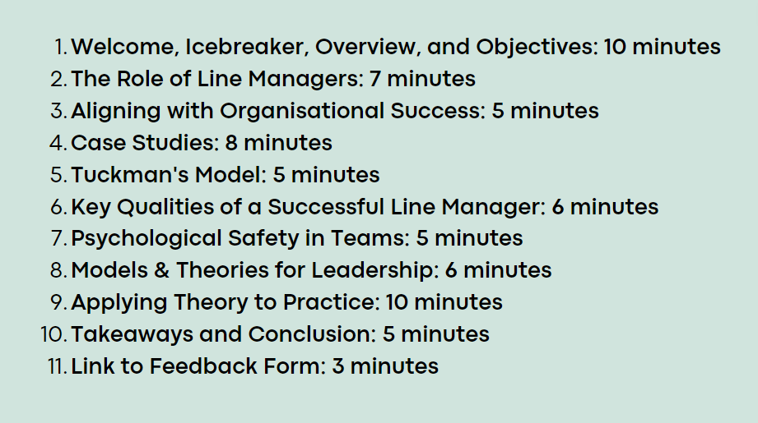


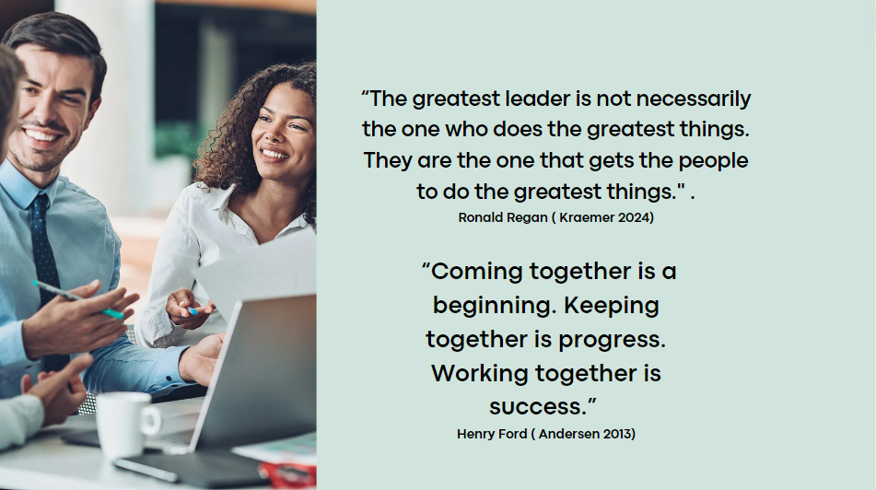

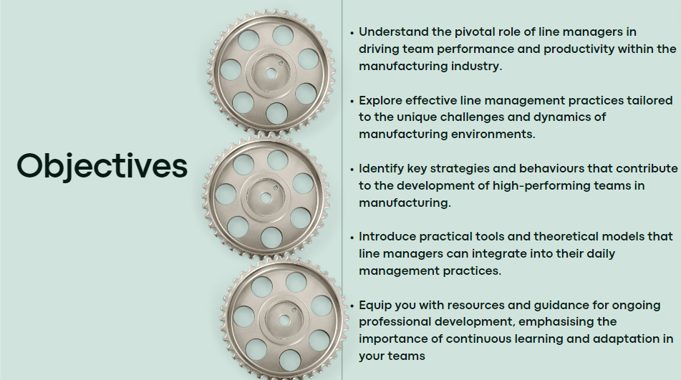
The critical importance of line management in organisational success (CIPD, 2024). We'll analyse how effective management practices directly impact productivity, quality, and team cohesion. By understanding these dynamics, we can better navigate challenges and optimise performance in the manufacturing context.

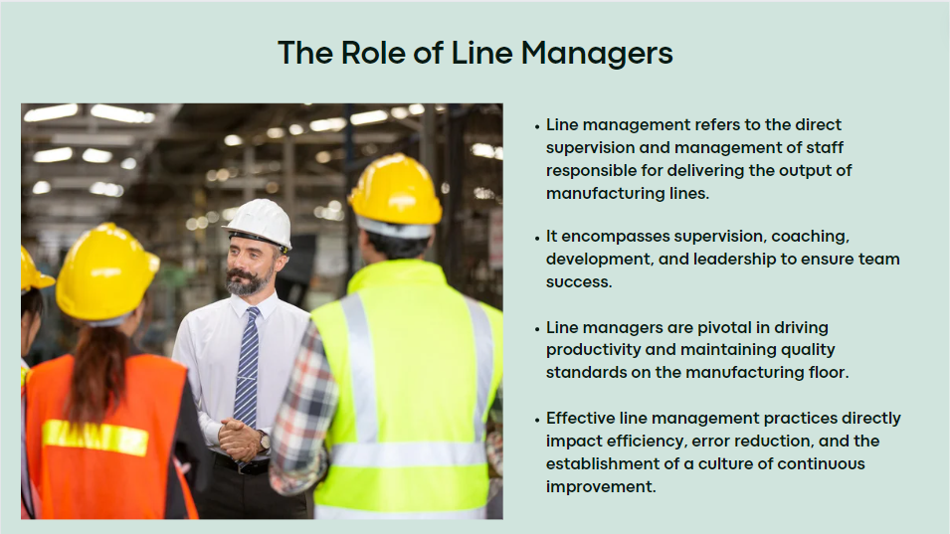
Line management drives productivity and quality through supervision, coaching, and leadership (Ibarra & Scoular, 2019). Effective practices extend to mentorship and empowerment (Armstrong, 2016). Examples from Toyota and GE highlight feedback, development, and collaboration (Foster Capital, 2024), but success depends on organisational context (Zaleznik, 2004; McKinsey & Company, 2021).

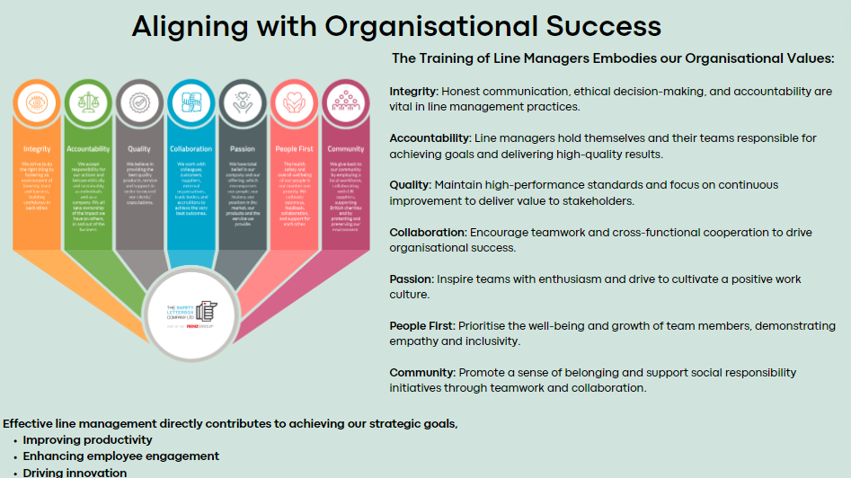
Highlight alignment of training principles with The Safety Letter Box’s values and strategic objectives (Brassey, et al., 2019; The Safety Letter Box Company Ltd, 2023).
Emphasise how effective line management, psychological safety, and SMART goals support transparency, accountability, and continuous improvement (Gallo, 2023; Armstrong, 2018; Hutchinson, 2013).
Connect implementation of these principles to driving team success and creating a culture of excellence and innovation.
Discuss strategies for integrating these principles into daily operations.

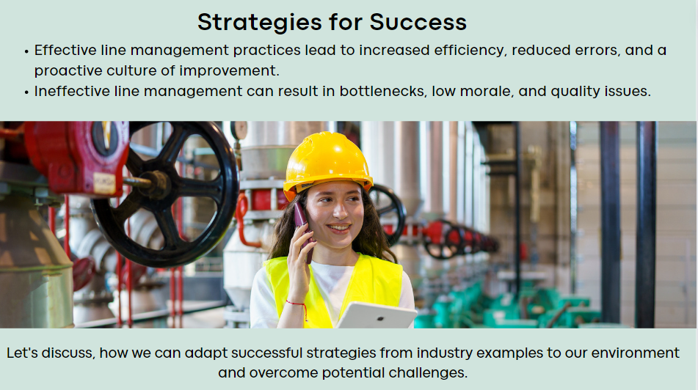
Effective line management practices enhance team performance, efficiency, and proactive improvement (Rees & French, 2016; Watson & Reissner, 2014).
Ineffective line management can cause bottlenecks, low morale, and quality issues, harming productivity, and success (CIPD, 2023; Shaban, et al., 2017).

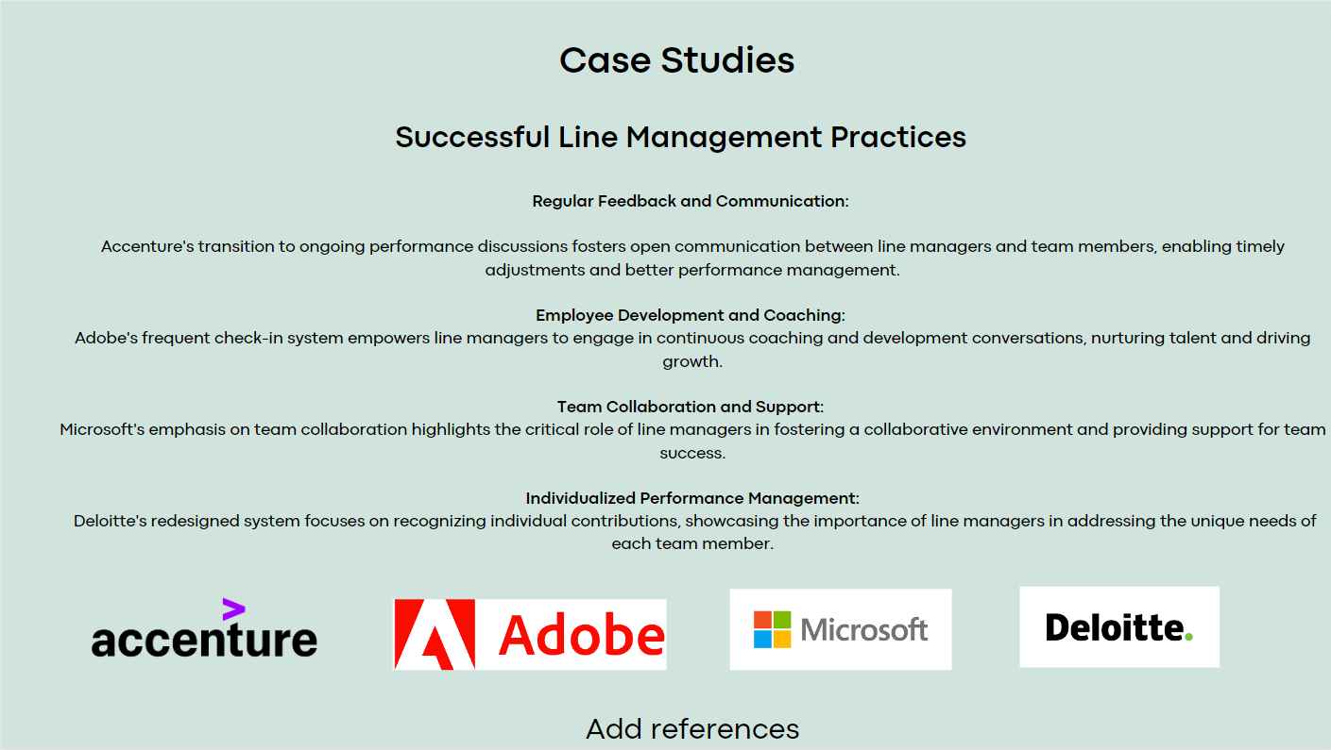
Toyota's lean principles show effective line management, boosting efficiency (Potter, 2021). Inadequate management causes delays and defects (Shih, 2022). – Appendix -1
Effective line management requires planning, training, and cultural alignment. Overcoming challenges like resource constraints is crucial. Reflecting on practices helps identify strengths and areas for improvement (McKinsey& Company, 2023)
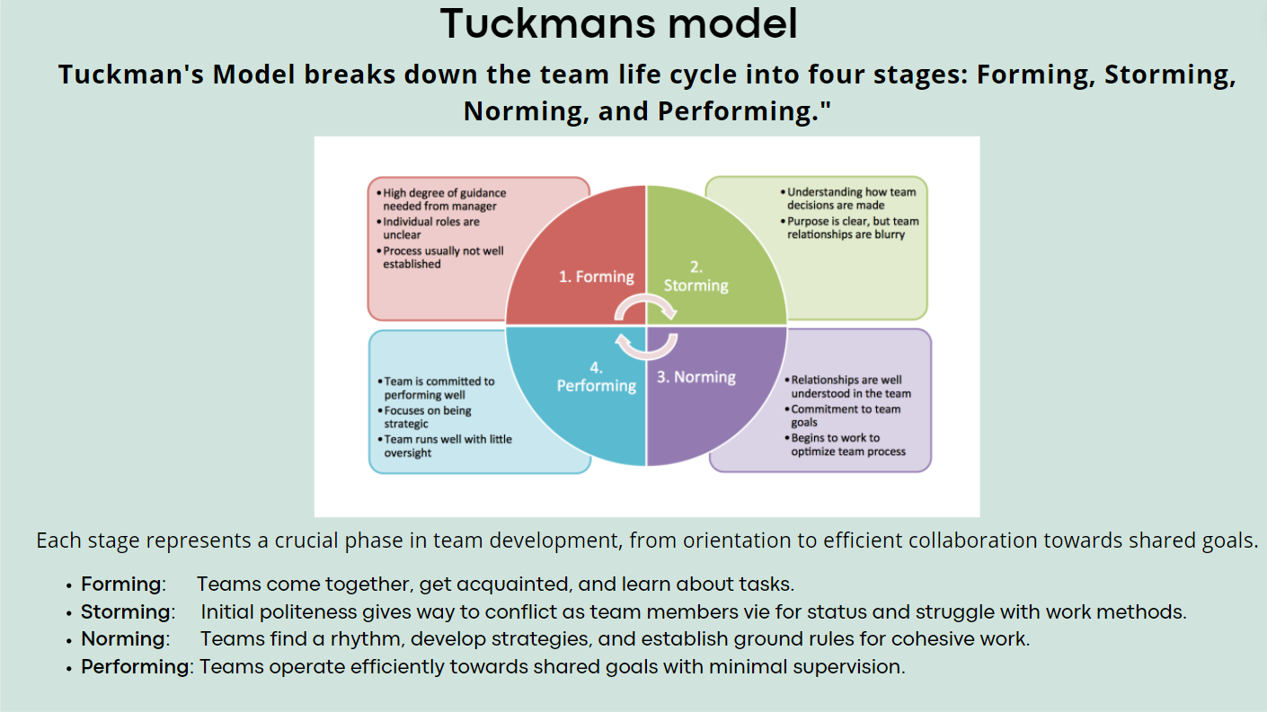
Tuckman's model is a widely recognised framework that describes the stages of group development, providing insights into how teams evolve over time.
The model consists of five stages: Appendix -2
Forming: Initial stage characterised by orientation and exploration as team members establish roles and objectives.
Storming: Conflict emerges as team members express individual perspectives and vie for influence.
Norming: Resolution of conflicts and establishment of cohesive norms and procedures.
Performing: Peak stage of productivity and synergy as the team operates efficiently.
Adjourning: Final stage marked by task completion and disbandment. (Stein, n.d.)
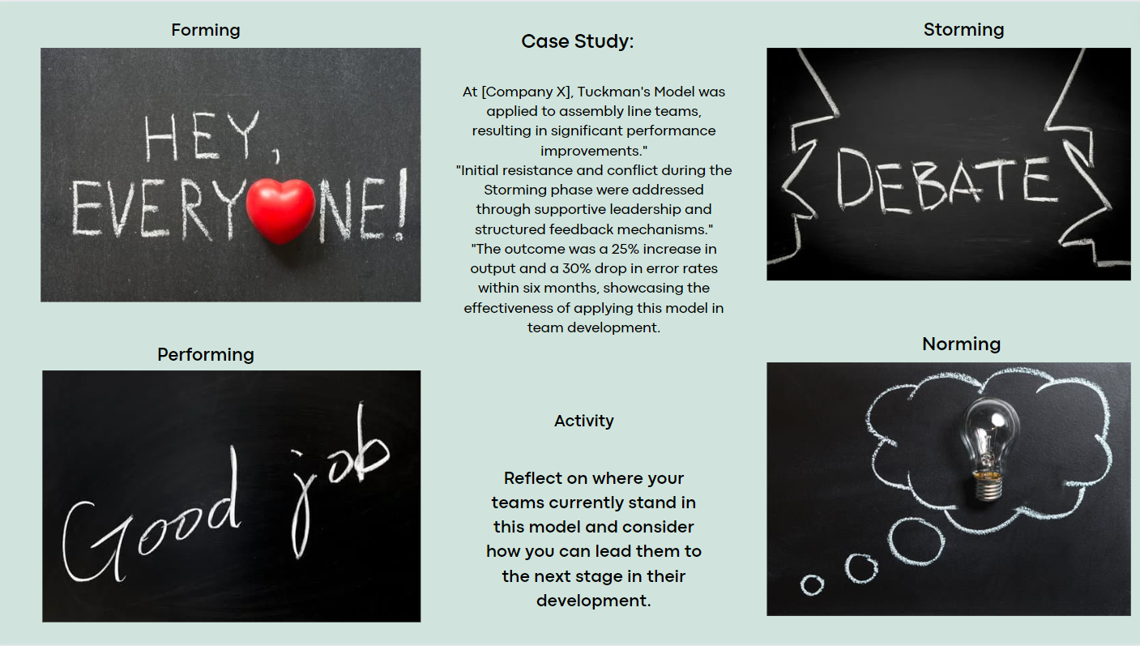
Tuckman's model isn't linear; teams may regress or overlap stages, requiring adaptation. Encouraging reflection on the team's stage and strategies is crucial (The Open Univeristy, 2024).

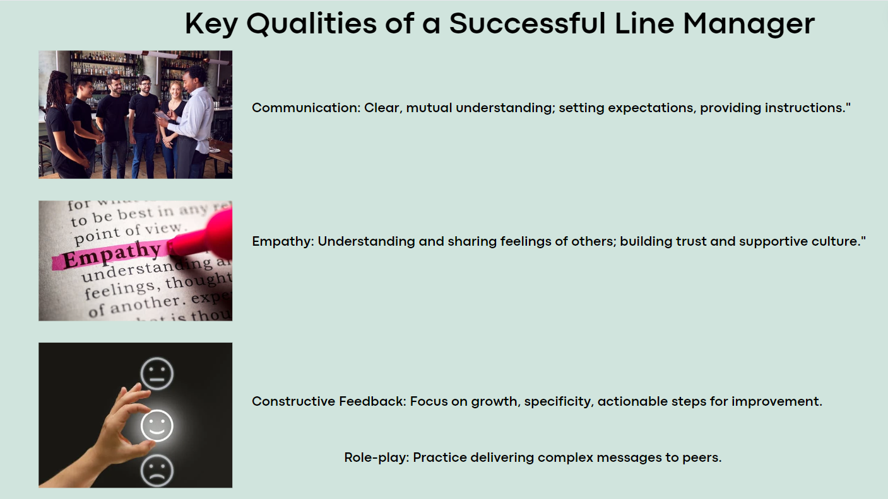
Communication: Vital for line managers in manufacturing, ensuring clarity, collaboration, and conflict resolution.
Empathy: Builds trust and morale, crucial for productivity in manufacturing teams
Constructive Feedback: Develops continuous improvement in fast-paced manufacturing environments.
Adaptability: Crucial for navigating technological and market changes efficiently
Leadership: Inspires teams toward goals, essential for performance in manufacturing.
Balance and reflection are vital for line management success (CIPD, 2015;Goodwin, et al., 2023)

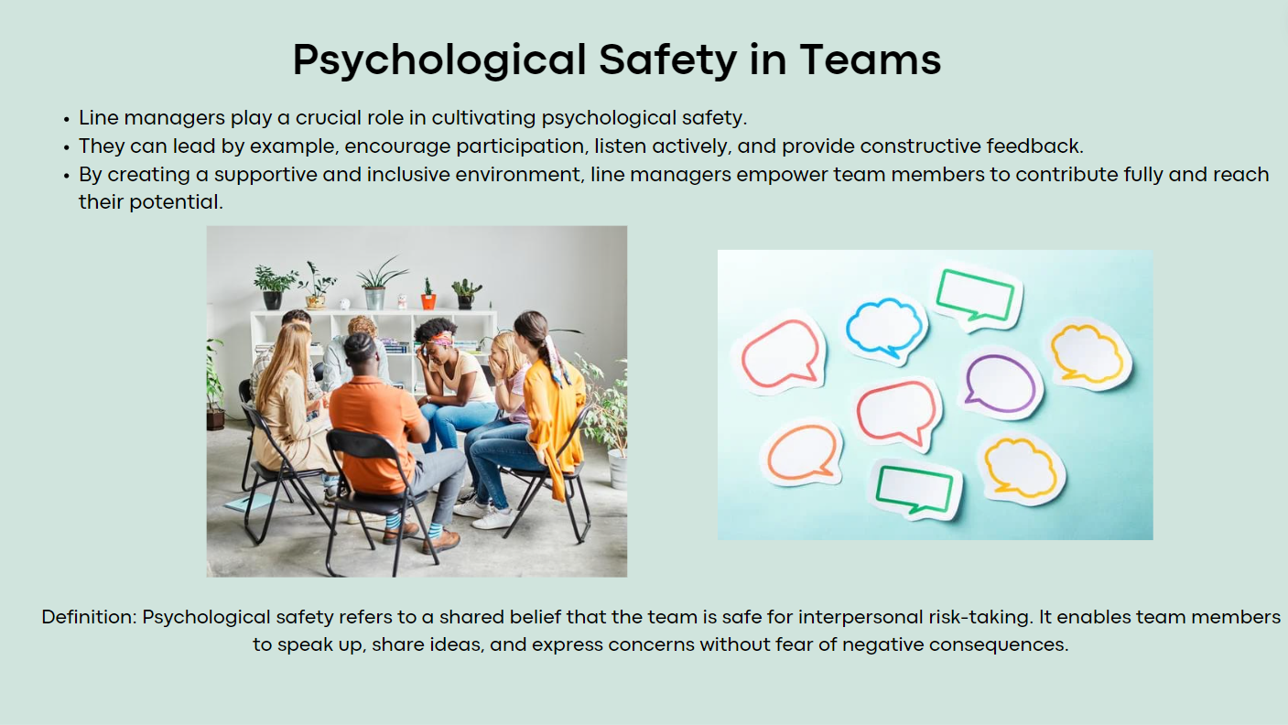
Psychological contracts are crucial for understanding employee reactions to breaches.
Recent studies extensively discuss the role of psychological contracts in employee retention (CIPD, 2024).
Psychological safety develops an environment where team members freely express themselves.
Encourages innovation and high performance through open communication.
Trust, respect, openness, and supportiveness are vital for psychological safety.
High psychological safety correlates with increased productivity, collaboration, and resilience (Horn, 2009; Gallo, 2023).

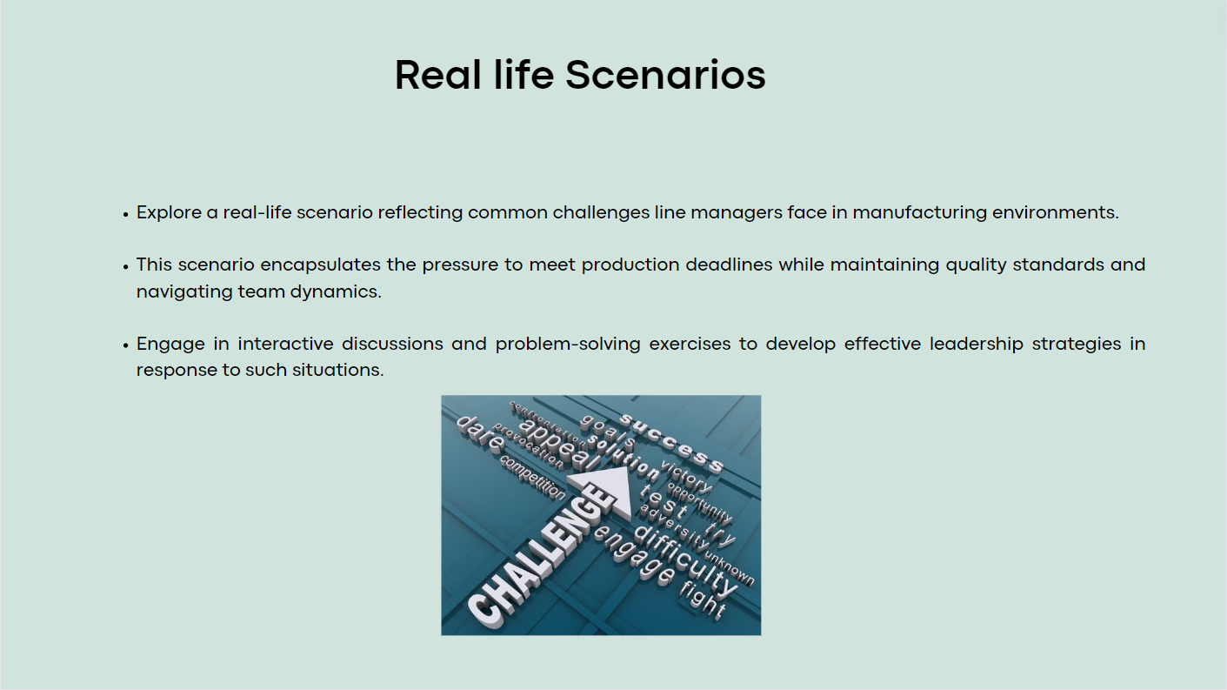

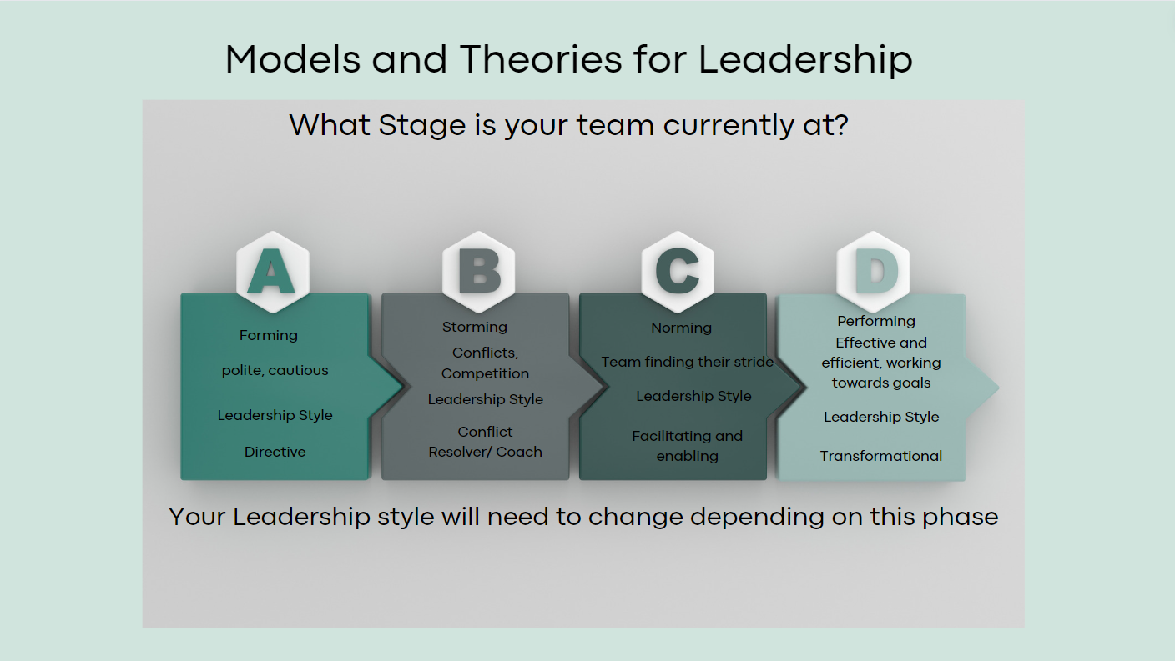

Tuckman's Model: Describes teams' journey from formation to disbandment with stages like forming, storming, norming, performing, and adjourning.
Adapting Leadership: Leadership styles change with team stages.

Use directive or coaching style in forming, participative or coaching in storming, supportive or delegative in norming, delegative or transformational in performing, and coaching or affiliative in adjourning (Armstrong, 2018; Bonebright, 2010).
Reflect on your team's stage to adjust leadership.

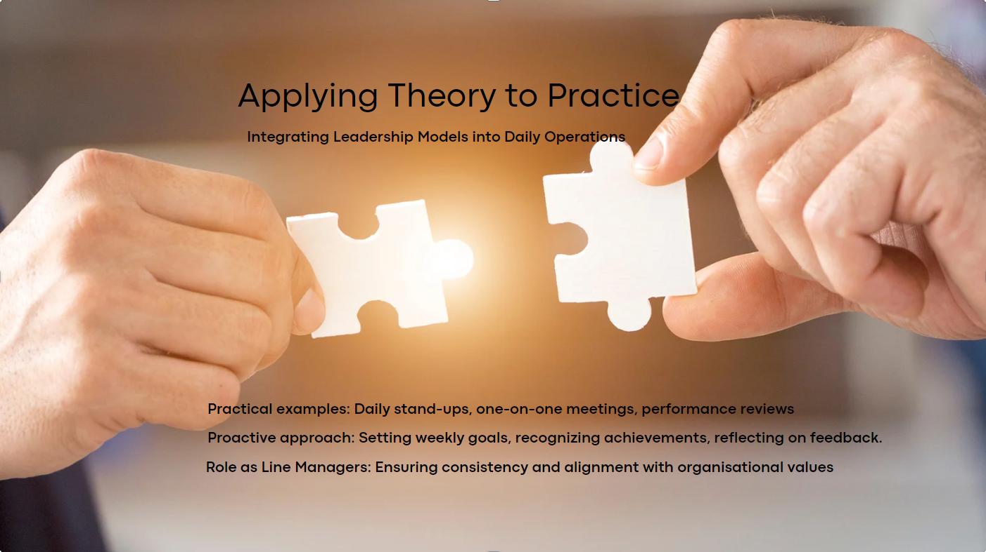

Daily Stand-ups: These meetings promote communication, ensuring alignment with organisational goals.
One-on-One Meetings: Personal sessions enhance employee growth and engagement through feedback and coaching.
Performance Reviews: Regular assessments align individual goals with organisational objectives.
Goal Setting: SMART goals motivate team members, contributing to organisational success.
Recognising Achievement: Celebrating accomplishments reinforces desired behaviours.
Ensuring Alignment: Leadership actions aligned with values create trust and cohesion.
Continuous Improvement: Encouraging learning supports innovation and adaptability.
Practices like clear communication and goal alignment encourage excellence, (Rogelberg, 2022; Armstrong, 2016; Rees & French, 2016; Hutchinson, 2013; Horn, 2009; Watson & Reissner, 2014)

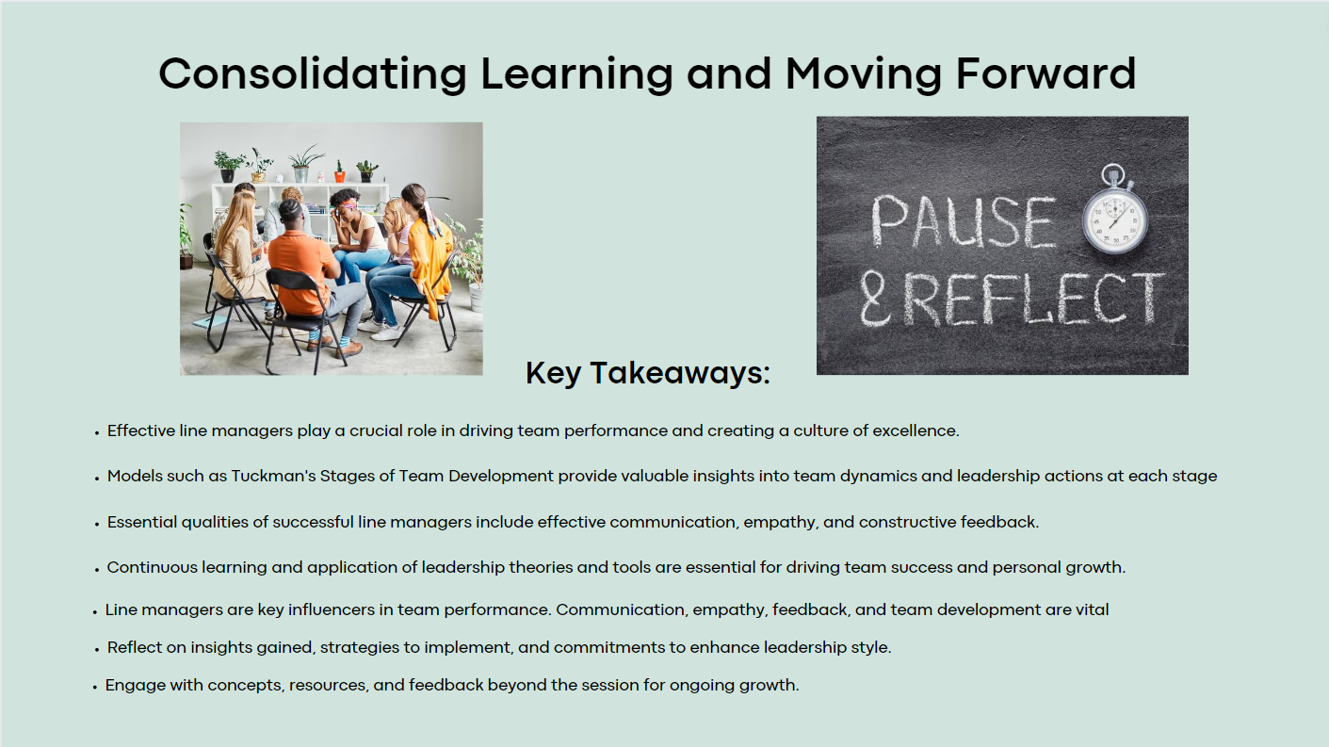
Line managers extend beyond supervision, impacting team performance through mentorship and empowerment.
Practices like feedback and collaboration boost efficiency, supporting continuous improvement.
Psychological Safety: Trust and openness develop innovation and higher performance.
Adaptive Leadership: Tuckman's model guides adjusting styles to team development.
SMART Goals: Ensure clarity, accountability, and alignment with objectives. These insights stress adaptation, commitment, and cultural alignment. Line managers can apply them in manufacturing for success (Mazzetti & Schaufeli, 2022; CIPD, 2024).

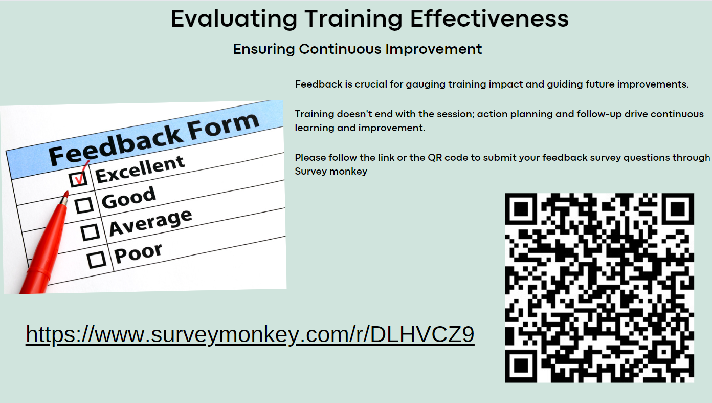

Appendix -3

Session 2 – Leading Effective Teams

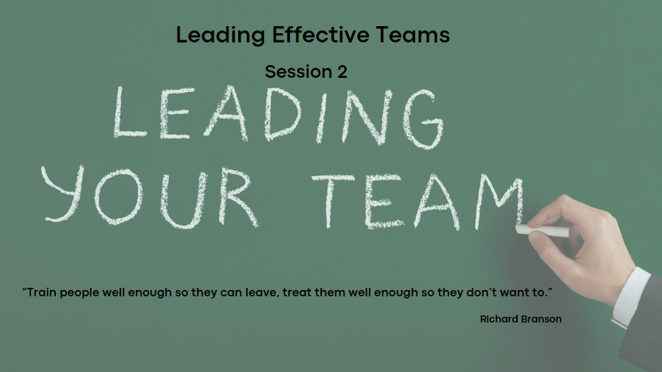
The crucial role of effective team leadership in driving success (CIPD, 2023; Watson & Reissner, 2014). By the end, you'll understand what it takes to lead teams effectively and its impact on our goals.
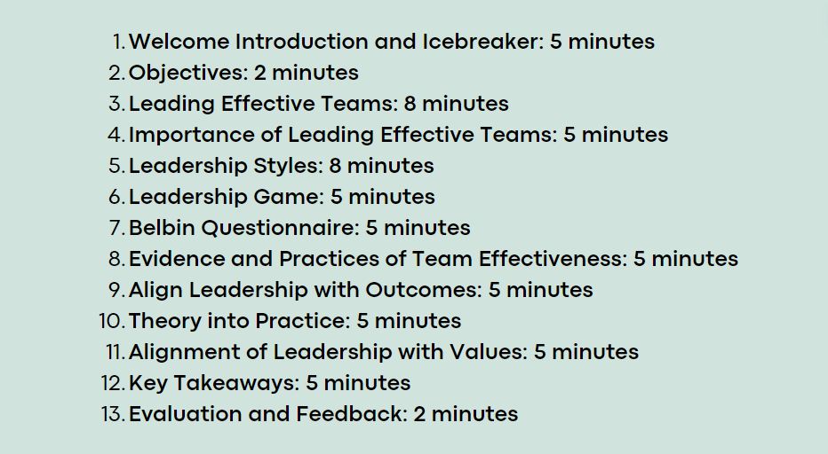
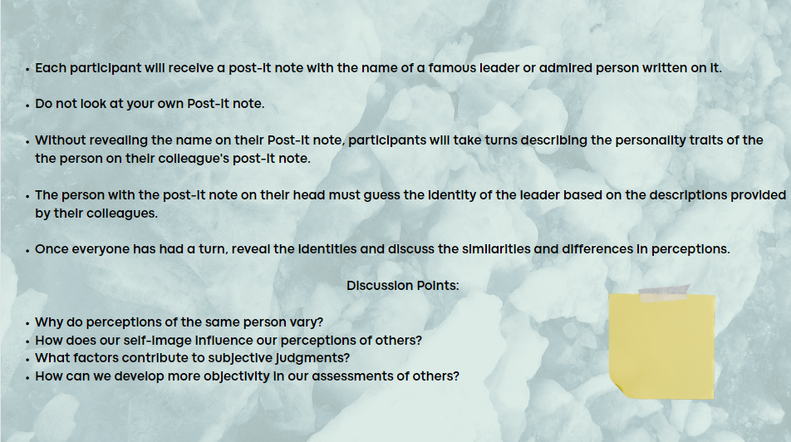
A post-it Note with a famous leader's name. Describe the person on your colleague's note without revealing it. The challenge is for the person with the note on their head to guess the leader's identity. Discussion to follow.

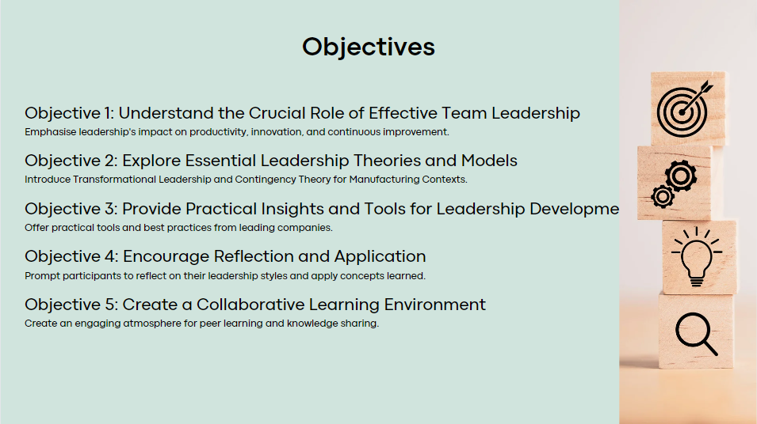
• Understand effective team leadership (Armstrong, 2016)
• Explore leadership styles and applications
• Apply leadership concepts in real-world scenarios
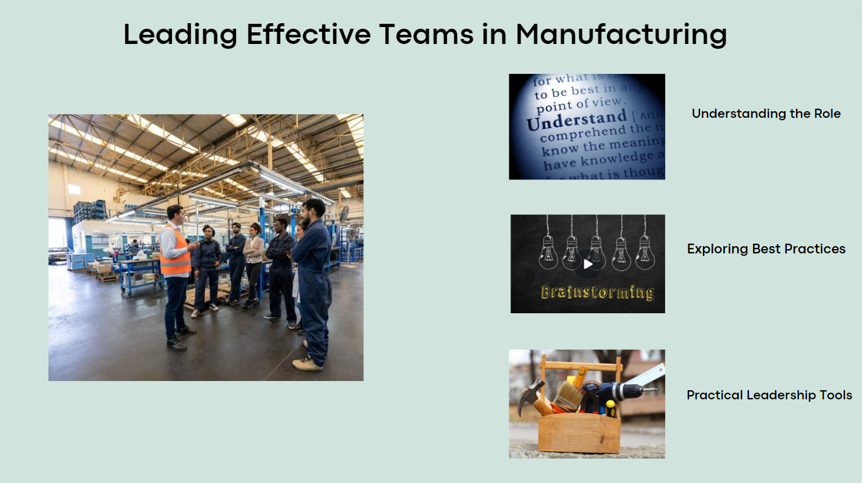
The importance of effective team leadership for organisational success. Effective teams drive productivity, innovation, and satisfaction (Watson, et al., 2020). We'll explore team leadership, drawing from Armstrong's Performance Management Cycle and real-world examples from Toyota (Toyota, 2024). Let's understand how effective team leadership enhances organisational excellence. - Appendix -4, Appendix -5
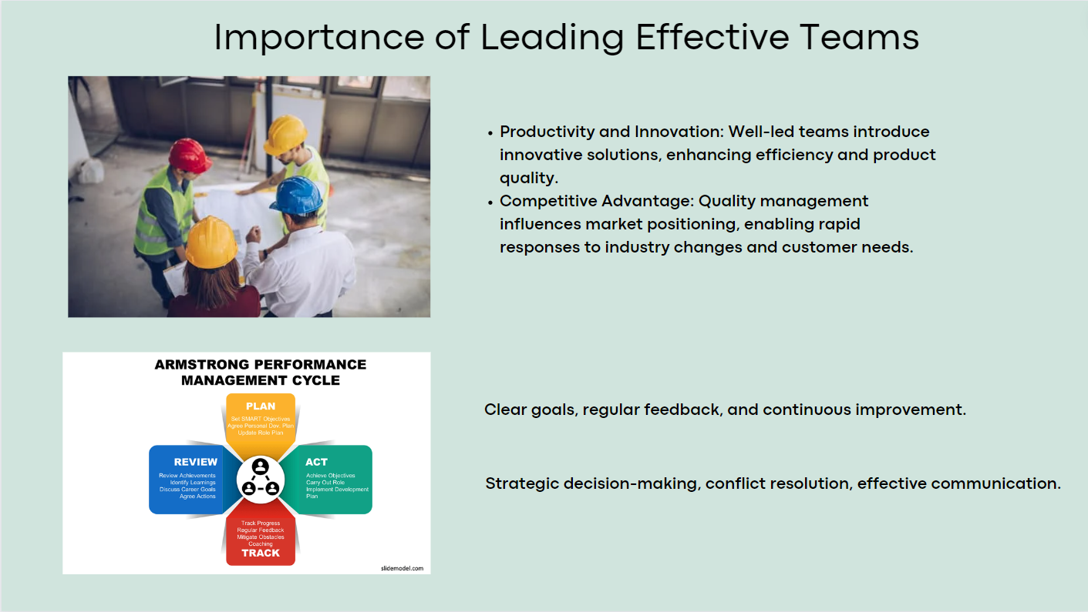
Effective team leadership fundamental in driving success. Leadership impacts innovation and productivity, and shapes ethical decision-making (The Economic Times, 2023). Porter highlights leadership's competitive advantage, but we must assess its relevance to our company (Porter, 1985). Let's explore leading effective teams for collaboration, communication, and accountability (Management in Practice, 2023).
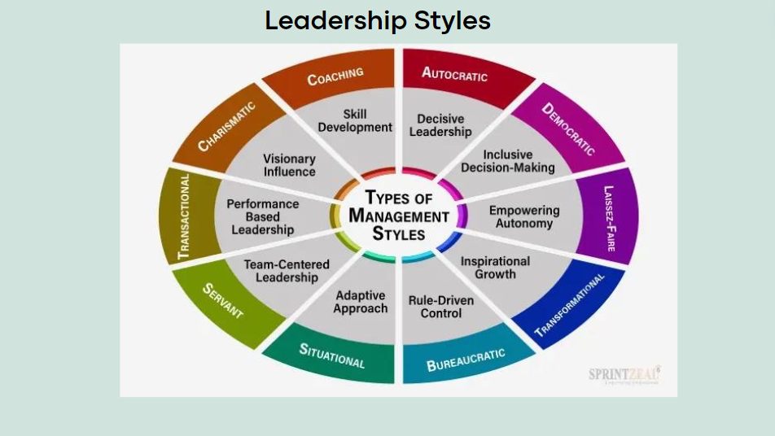
Leadership styles are pivotal in shaping team dynamics and organisational success in manufacturing (Cakir & Adiguzel, 2020). Acknowledging Kurt Lewin's classification of autocratic, democratic, and laisses-faire styles (Carlin, 2019), we lay the foundation for our discussion. This framework allows us to explore each style's nuances and applications in manufacturing contexts.

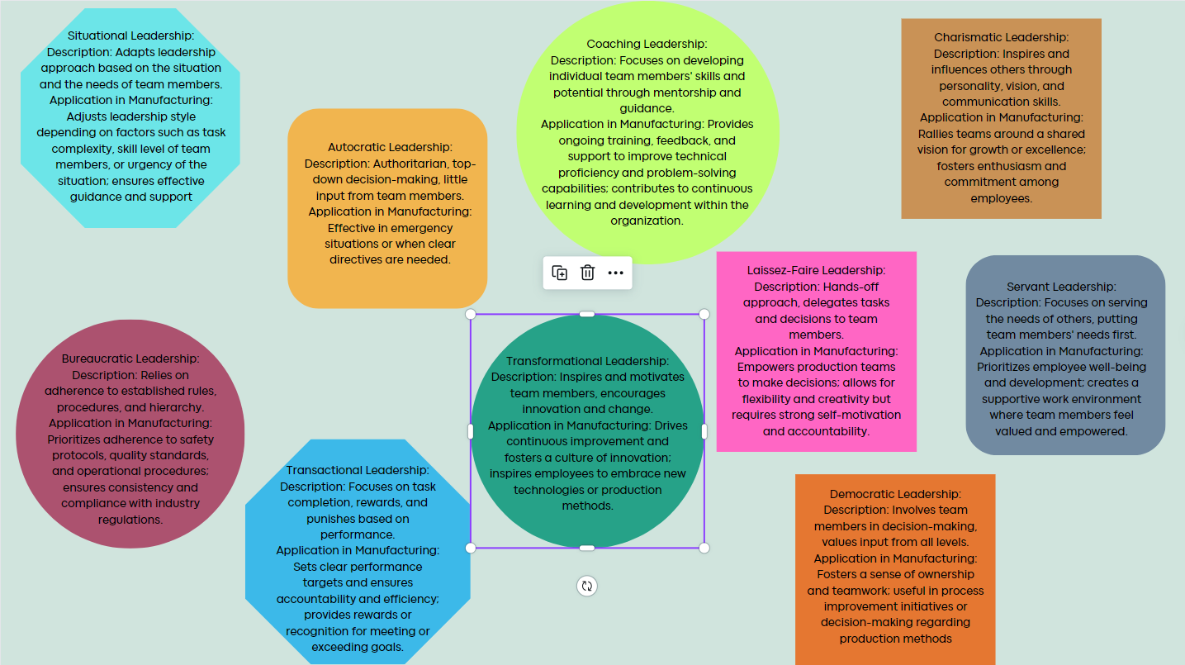
While acknowledging the evolution of leadership styles, particularly Tannenbaum and Schmidt's emphasis on situational leadership, we'll critically analyse each style. Examining their strengths, limitations, and applicability in manufacturing, we aim to inform and improve our leadership practices, developing innovation and collaboration in the manufacturing environment (Tannenbaum & Schmidt, 1973).
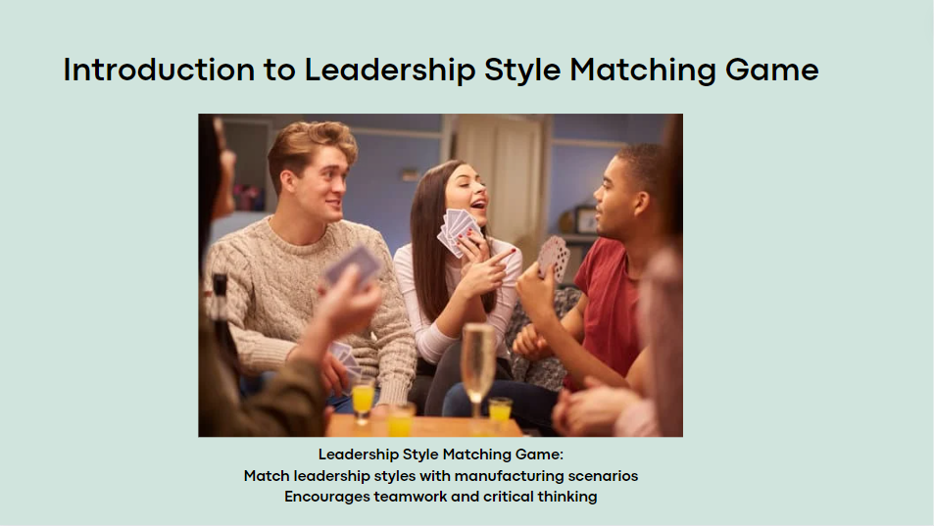
Participants play the Leadership Style Matching Game, matching styles with scenarios, developing teamwork and discussions on effective leadership. It's an interactive way to apply knowledge practically Appendix -6
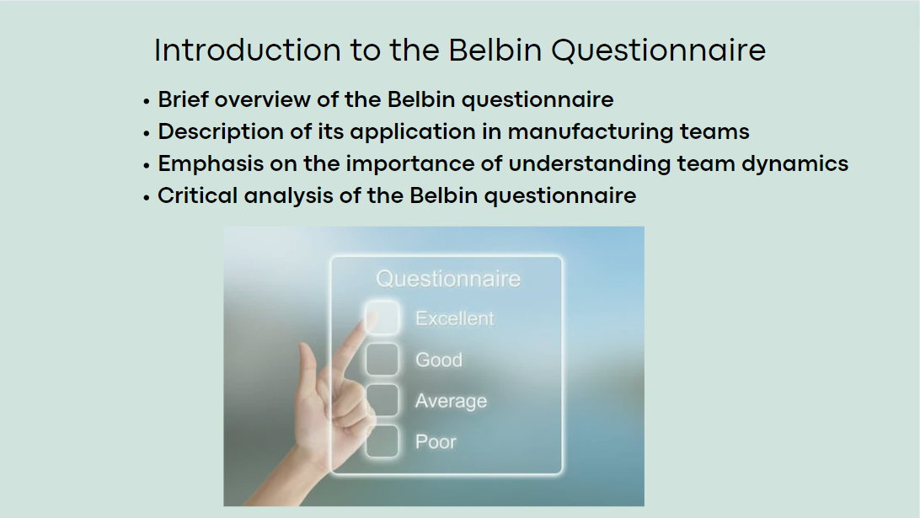
The Belbin questionnaire, a tool for identifying team roles and strengths. Developed by Dr. Meredith Belbin, it helps individuals understand their contributions in a team. It enhances collaboration and performance. However, results should be critically analysed (Belbin, 2024). Appendix - 7
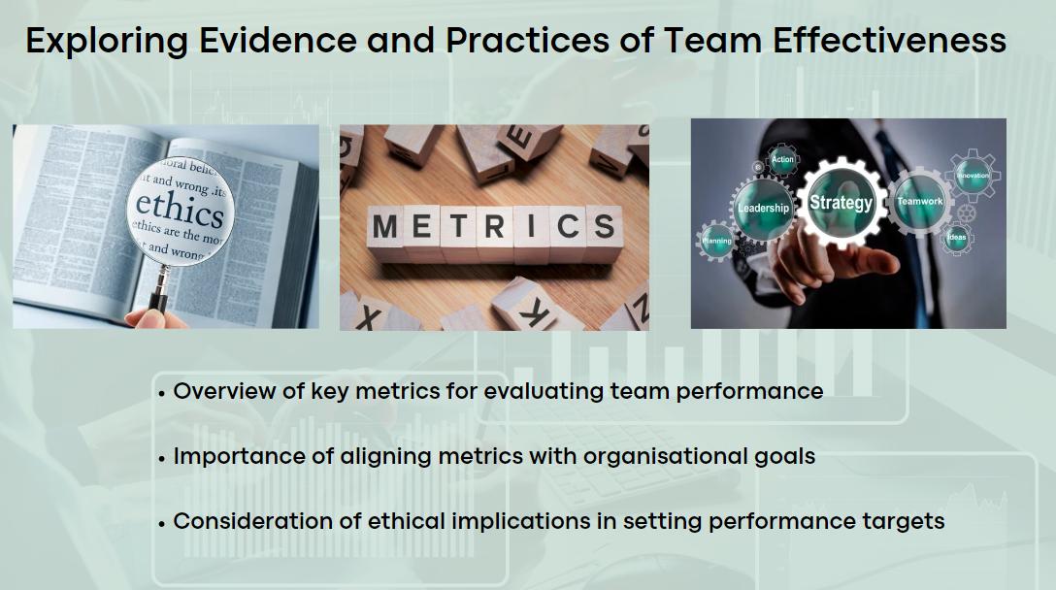
The role of metrics is key in assessing team performance and guiding decisions. Leaders use key performance indicators (KPIs) to gauge effectiveness and identify areas for improvement. Metrics should align with goals and prioritise employee well-being. We'll also discuss ethical considerations and reflect on performance targets' implications (Mind Tools, 2024; Setiawan & Purba, 2020).
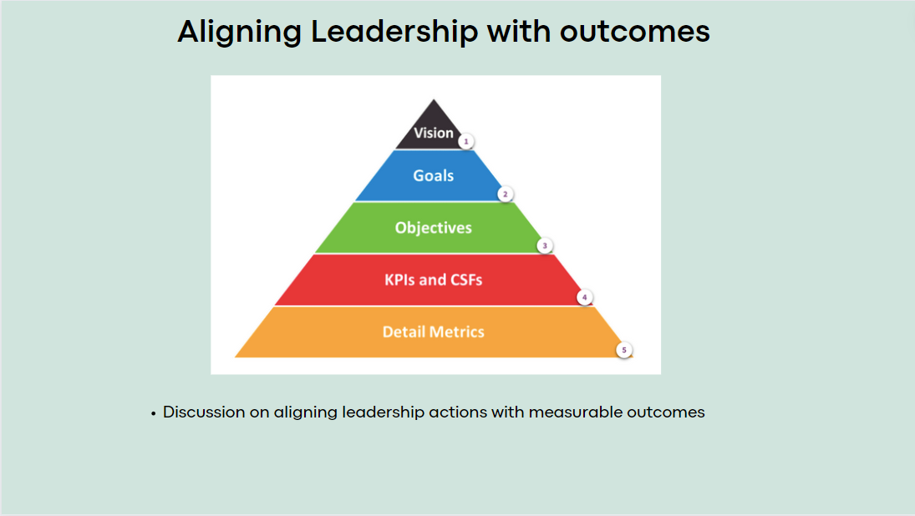
In this section, we'll explore data-driven HR practices, like Google's approach, for recruitment and engagement (Inside HR, 2023). Leaders must ensure fairness in analytics, guided by ethics. We'll discuss aligning leadership actions with outcomes and effective strategies using a case study as a handout – Appendix - 8
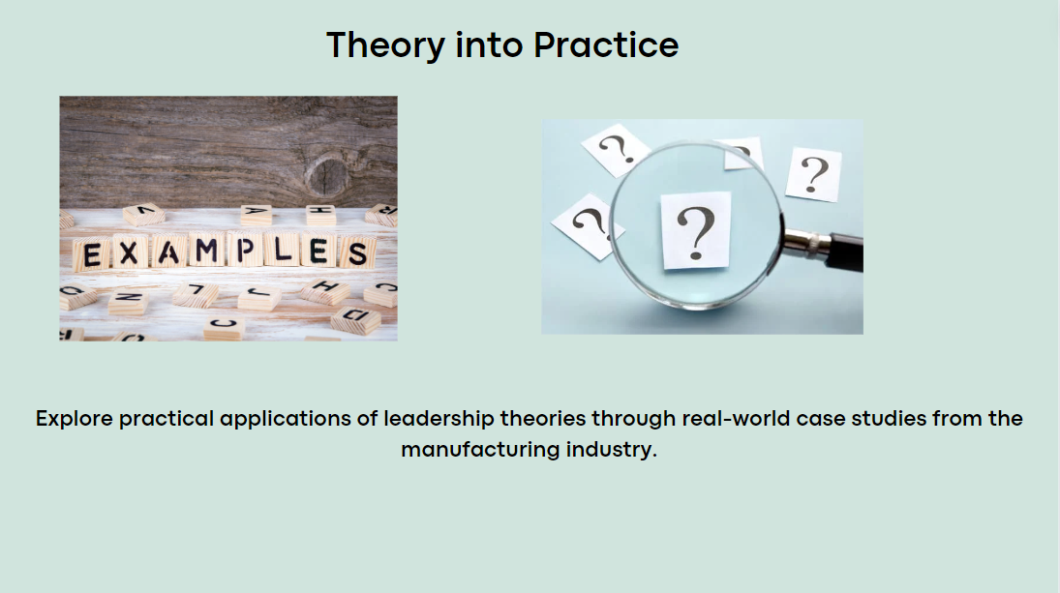
From theory to practice, exploring real-world case studies from the manufacturing industry. These studies offer practical insights into how leadership theories are applied in diverse scenarios. Review the handouts, considering the strategies used, challenges faced, and outcomes achieved. We'll analyse these cases to extract valuable lessons for our leadership practices (McGiboney, 2018). Appendix - 9
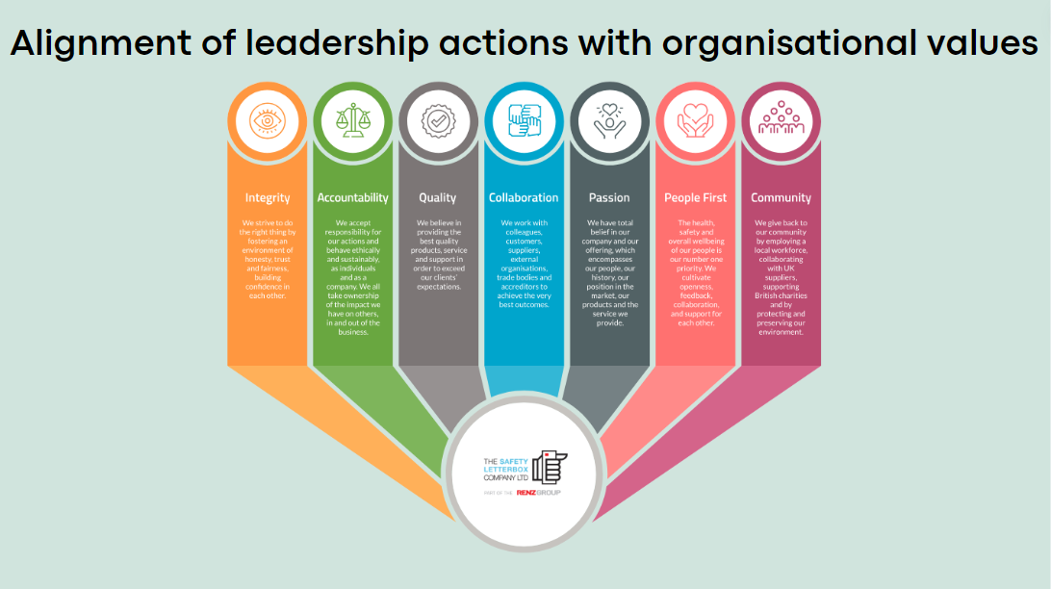
Let's integrate organisational values into leadership actions, emphasising integrity, quality, and collaboration. Aligning leadership practices with these values drives success in manufacturing. Reflect on how your leadership embodies these core values (Williams & Andersen, 2023).
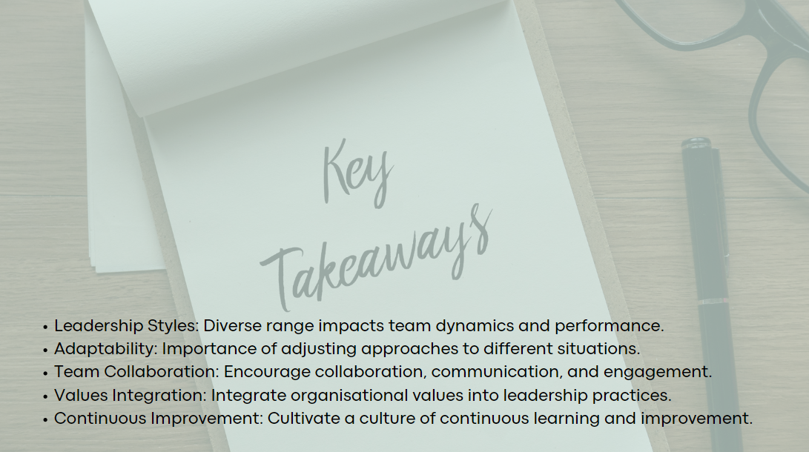
- Leadership Styles: Recognise diverse styles and their impact on teams.
- Adaptability: Understand the importance of flexible leadership.
- Team Collaboration: Develop teamwork, communication, and engagement.
- Values Integration: Align leadership with organisational values.
- Continuous Improvement: Embrace ongoing learning for better leadership.

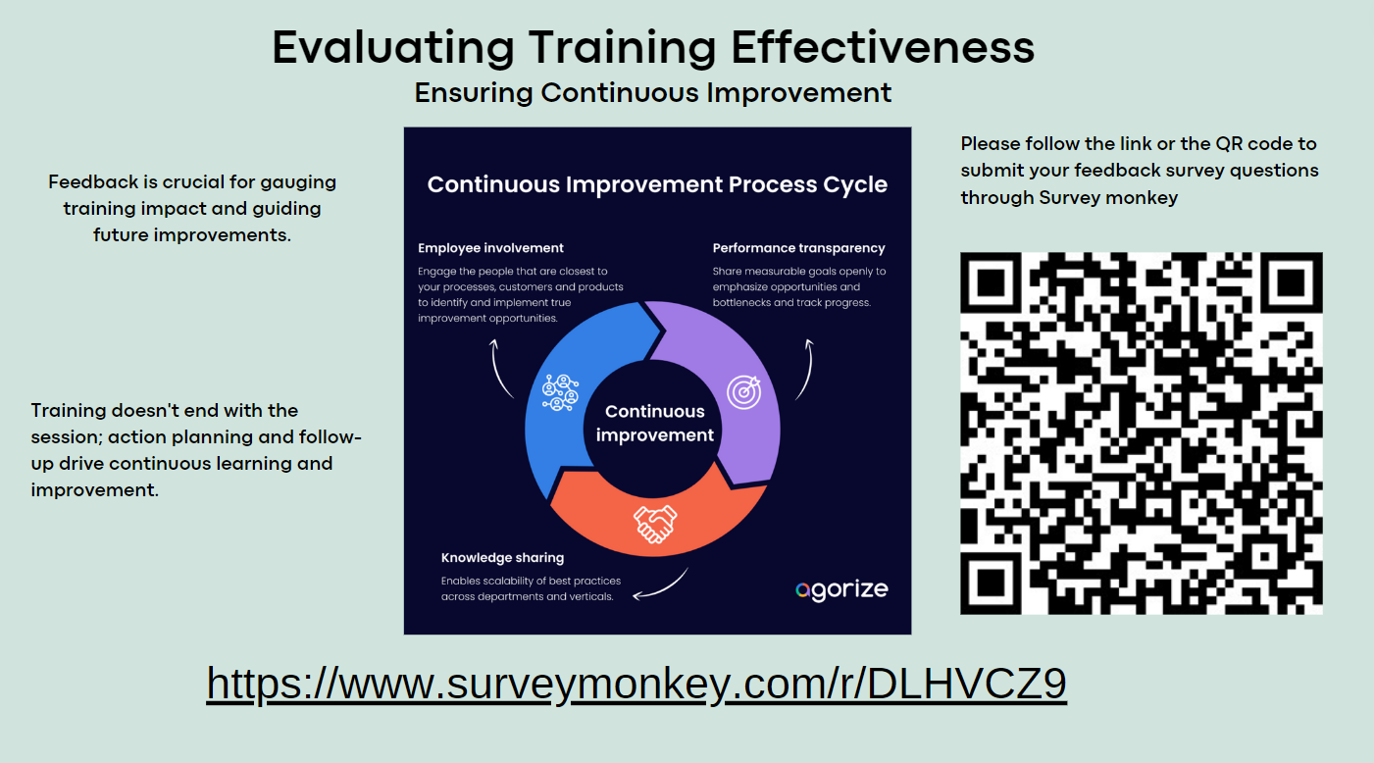
Evaluating training ensures objectives are met and goals achieved. Feedback guides future improvements. Remember, training is ongoing; action planning and follow-up drive continuous improvement (Safety Culture, 2024). Share feedback via the provided link or QR code on SurveyMonkey to shape future programs. Appendix-10

Session 3 - Strategies for Employee Retention
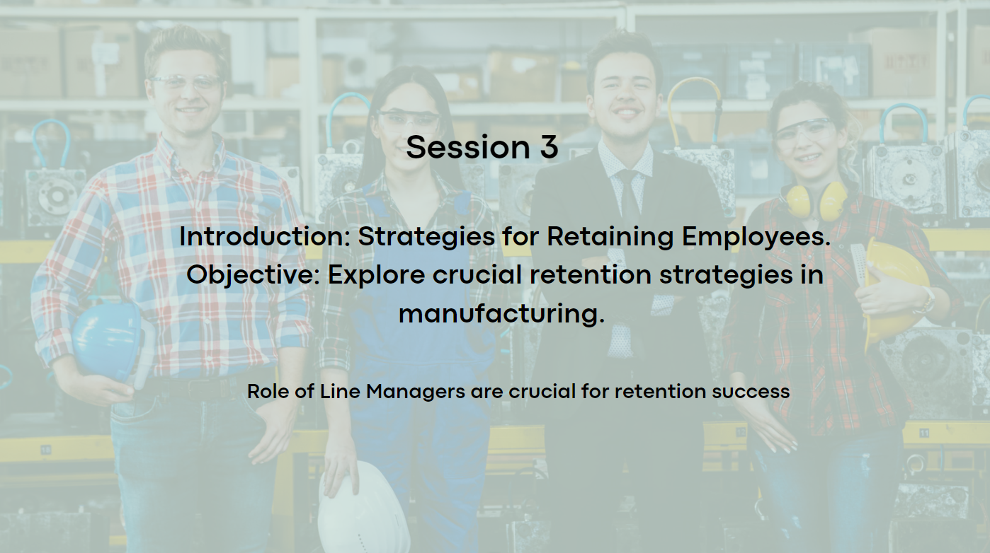
Today, we're delving into essential retention strategies which are crucial for our success. We'll highlight the pivotal role of line managers and introduce Herzberg's Two-Factor Theory and Equity Theory to better understand employee motivations (Indeed Editorial Team, 2023; Nickerson, 2023). Let's explore how these strategies align with our organisational goals and address key challenges.
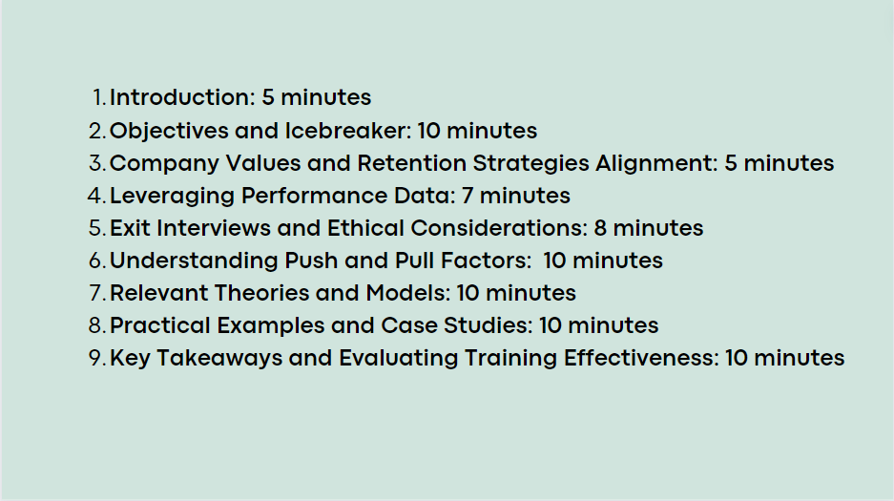
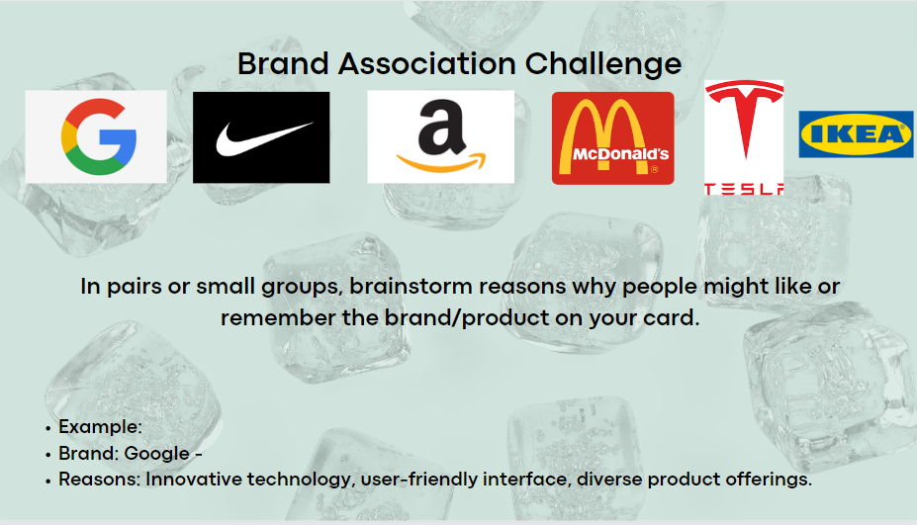
Icebreaker the 'Brand Association Challenge.' Fun way to explore why certain brands stick in our minds and what that says about our preferences. Choose a brand from the list, jot down why you like it, and we'll discuss.
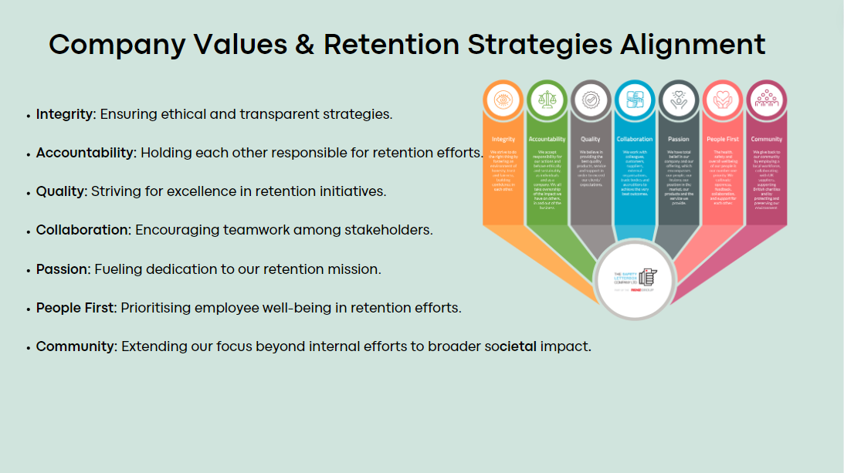
Our company values—integrity, accountability, and quality—guide our retention strategies, ensuring they're effective and ethically grounded. Integrity ensures ethical and transparent strategies. Accountability holds us responsible. Quality drives excellence. Collaboration promotes teamwork. Passion fuels dedication. People First prioritises employee well-being. Community extends our impact (Odom, 2023; CIPD, 2024).
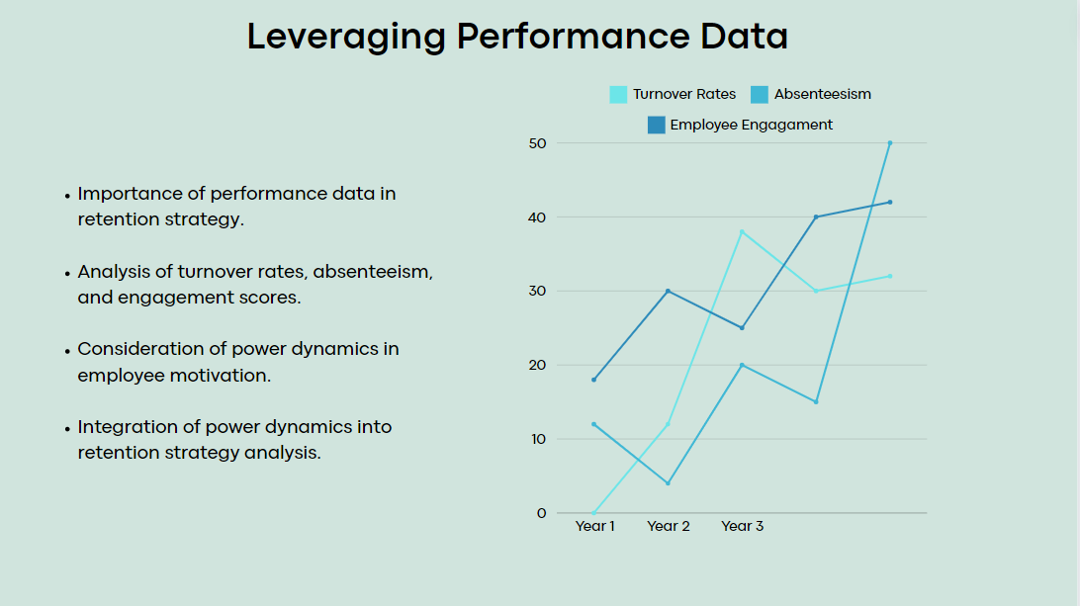
- Understanding the dynamics of employee performance through data analysis is crucial in our journey toward effective retention strategies (Cambridge Spark, 2023).
- Metrics such as turnover rates, absenteeism, and engagement scores provide invaluable insights into our workforce's behavior and needs.
- Recent research, as highlighted by (Hartner-Tiefenthaler, 2021), underscores the importance of considering power dynamics in employee motivation.
- By integrating this understanding into our analysis, we can develop more targeted and impactful retention strategies.
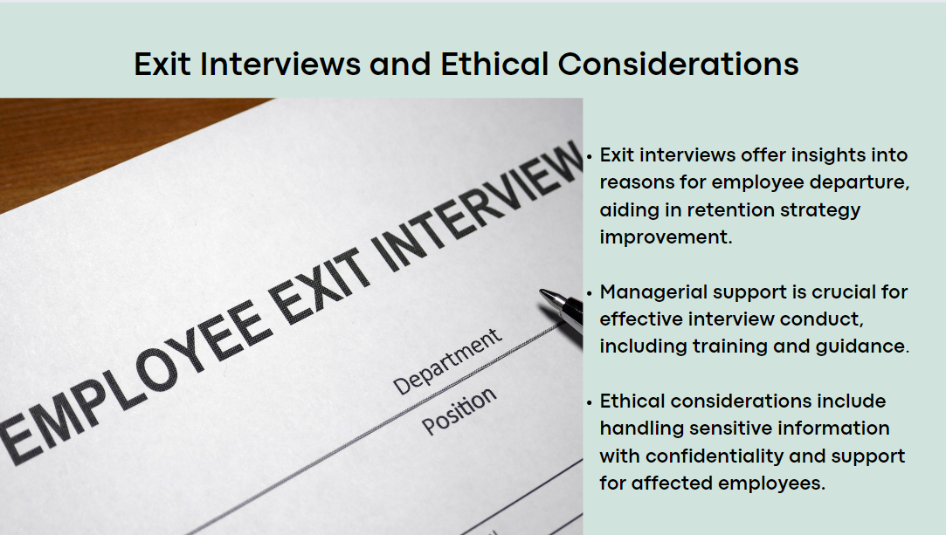
Exit interviews offer vital insights into employee departures, guiding our retention strategies. Managers need support and training to conduct them effectively, ensuring proper handling of sensitive information like harassment disclosures (Spain & Groysberg, 2016; Stewart, 2023).
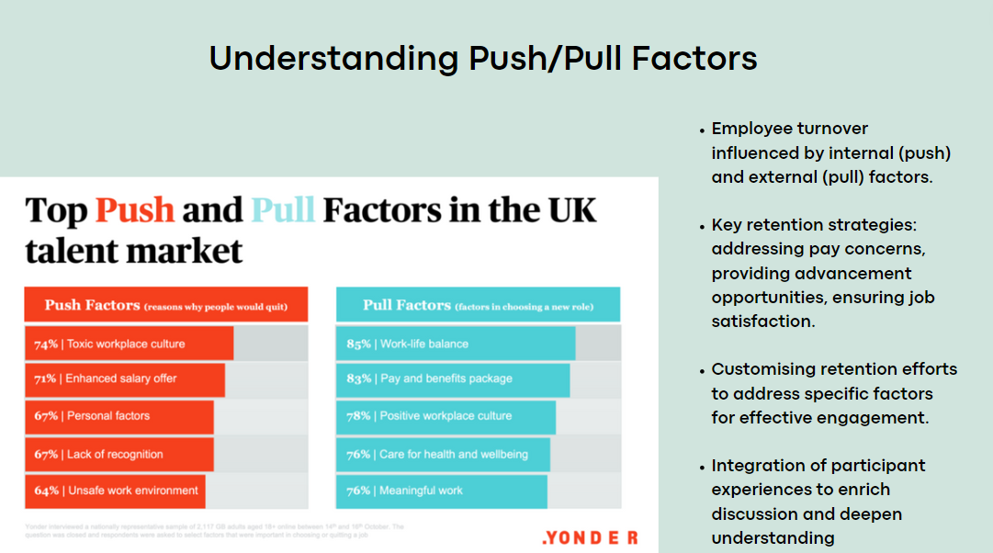
Employee turnover is complex, influenced by internal and external factors. To retain employees, we must address pay, advancement, and job satisfaction. Customising our efforts is crucial for long-term engagement (Chowdhury, 2016; CIPD, 2022).

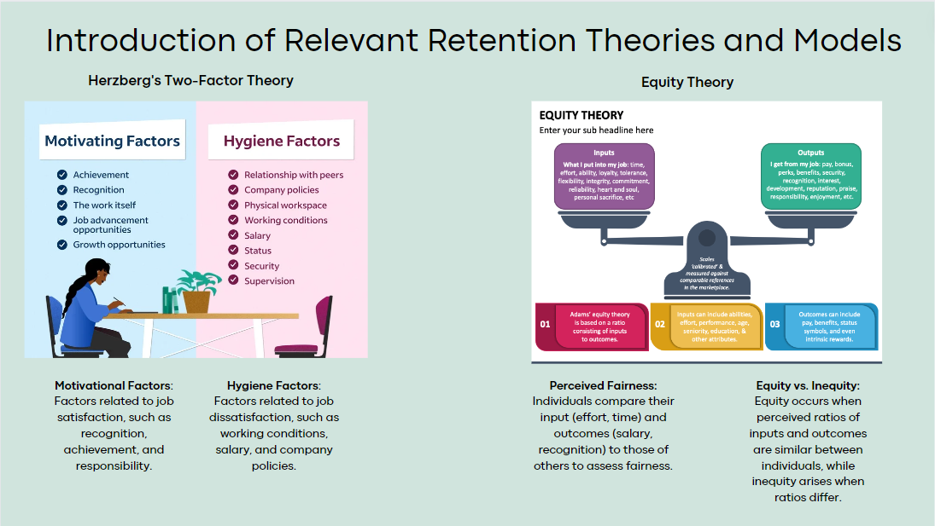
Hersberg's Two-Factor Theory and Equity Theory, vital for understanding employee retention. Hersberg's theory highlights the need to address both hygiene and motivational factors for effective strategies (Main, 2023). Equity Theory emphasises fairness in compensation and advancement, crucial for manufacturing teams. By leveraging these insights, we can develop targeted retention strategies tailored to our workforce dynamics (Davlembayeva & Alamanos, 2023). Appendix -11

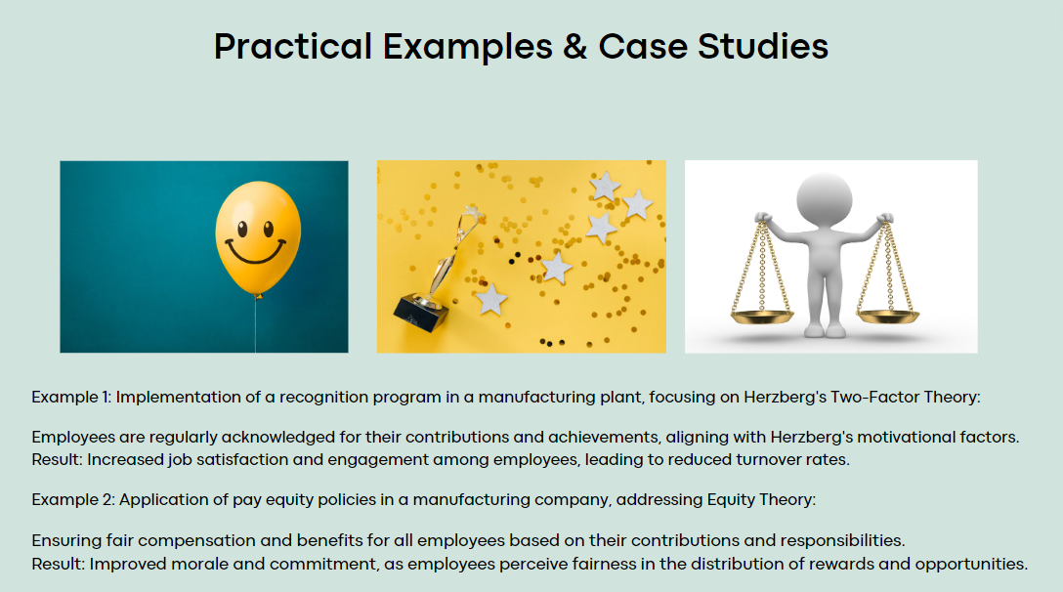
Real-world examples offer valuable insights into retention strategies. LinkedIn’s recognition program boosted job satisfaction, while Facebook’s fair compensation approach improved morale. Let's adapt these strategies to our teams. relate case studies to our session's objectives, aiding practical application to our retention strategies (Crail, 2024; Tolentino, 2015). Appendix -12
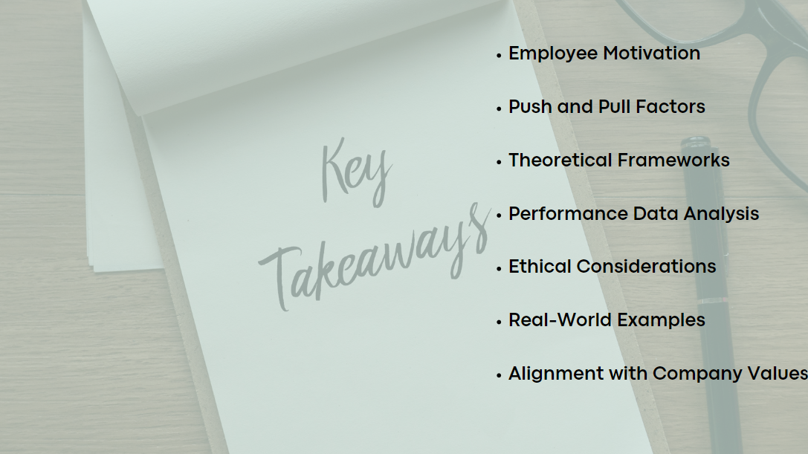
- Understanding employee motivation is crucial for effective retention strategies.
- Employee turnover is influenced by both internal (push) and external (pull) factors.
- Theoretical frameworks like Hersberg's Two-Factor Theory and Equity Theory provide valuable insights.
- Utilising performance data helps identify retention challenges.
- Ethical considerations, such as confidentiality in exit interviews, are essential.
- Real-world case studies offer valuable lessons for implementing retention strategies.
- Aligning retention strategies with company values promotes organisational culture and employee loyalty.

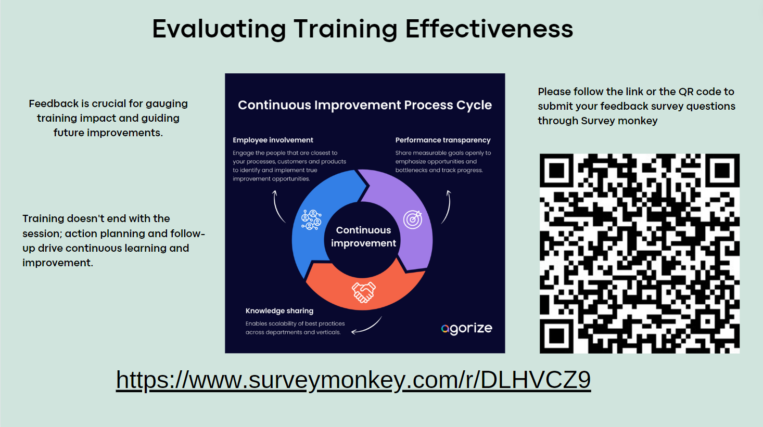
Feedback is essential for evaluating and improving training. Continue the process with action planning and follow-up. Please share your feedback through the provided SurveyMonkey link or QR code (Gnepp, et al., 2020). Appendix -13

Session 4 - Approaches to Managing Capability
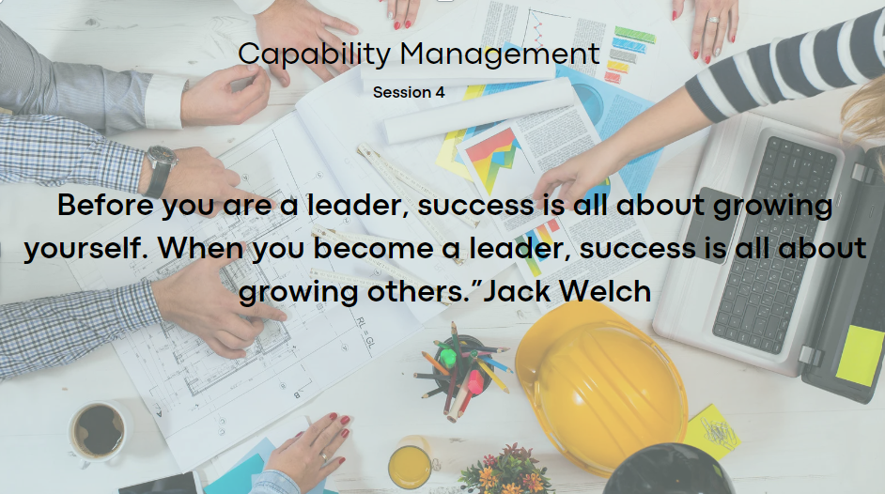
Managing capability in manufacturing teams. We'll explore strategies for enhancing team performance. Effective capability management nurtures improvement and operational excellence (Yeo, 2019; Deloitte, 2021). We'll discuss common challenges, focusing on proactive solutions for competitiveness (Hartner-Tiefenthaler, 2021).
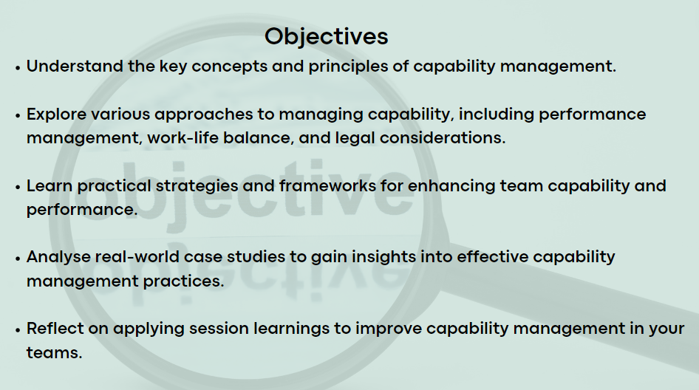
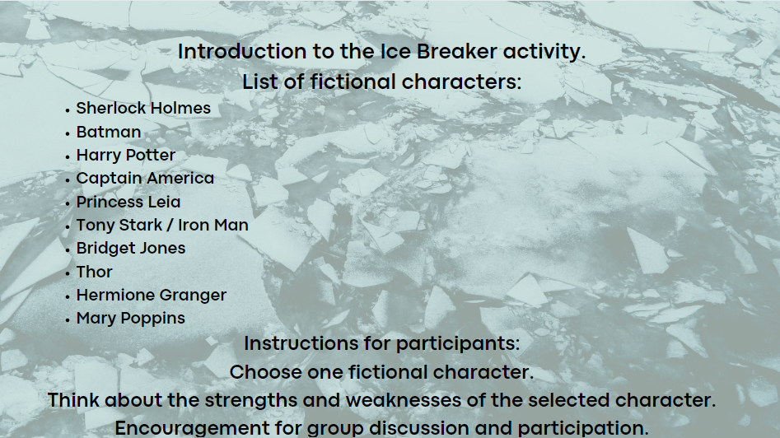
Ice Breaker: "Strengths and Weaknesses" We'll explore capability management creatively through fictional characters. I'll introduce ten characters. Each pick one, reflects on strengths and weaknesses, then we'll discuss as a group.
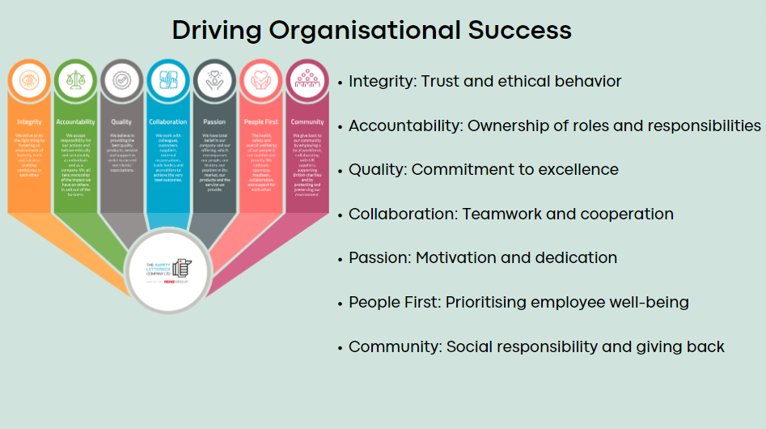
Integrity: Crucial for fairness and ethical standards.
Accountability: We take responsibility for results.
Quality: We strive for excellence.
Collaboration: Leveraging strengths for effective solutions.
Passion: Driving continuous improvement.
People First: Prioritising well-being and development.
Community: Demonstrating social responsibility.
Embedding these values develops success (The Safety Letter Box Company Ltd, 2023; Gorenak & Košir, 2012; CIPD, 2024)
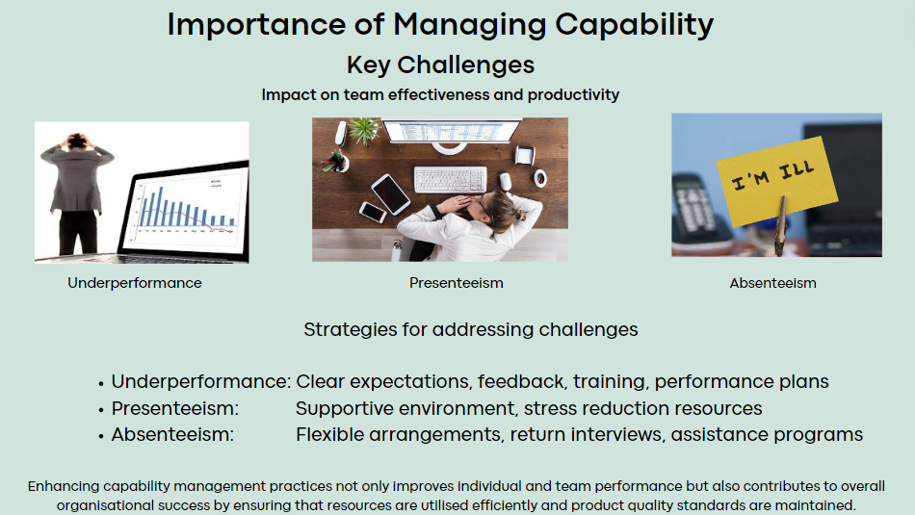
Managing capability in manufacturing teams is critical for productivity and goal achievement. Key challenges: absenteeism, presenteeism, and underperformance, exploring effective strategies (McKinsey & Company, 2023).
To tackle underperformance, clear expectations, feedback, and training are vital (Armstrong, 2018).
Presenteeism impacts team performance, requiring a supportive environment and stress reduction resources (Karanika-Murray & Biron, 2020).
Absenteeism disrupts workflow, but flexible arrangements and assistance programs can mitigate its impact (Peart, 2019).
Addressing capability challenges enhances success, optimising efficiency and maintaining quality standards (CIPD, 2024; Rees G & French, 2016)
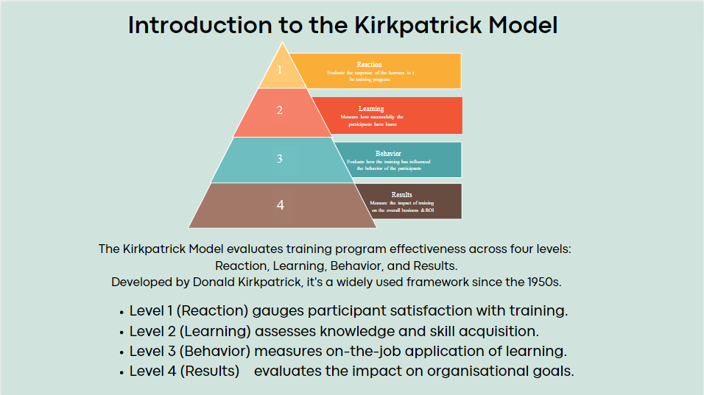
A crucial aspect of capability management: evaluating training programs using the Kirkpatrick Model, developed by Donald Kirkpatrick in the 1950s. Let's consider the significance of the Kirkpatrick Model. It's more than just feedback; it's about understanding training impact across levels, from individual reactions to organisational results. This underscores the importance of a systematic approach to training evaluation, ensuring alignment with organisational goals (Kirkpatrick Partners, 2024; Nawaz, et al., 2023).
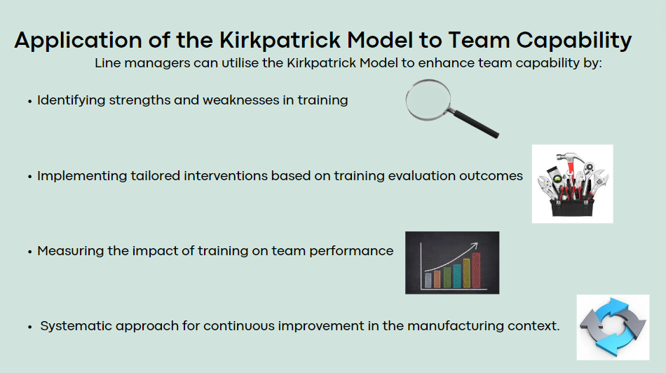
Line Managers are pivotal in driving team performance and capability. Leveraging the Kirkpatrick Model enables you to identify training strengths and weaknesses, tailor interventions, and demonstrate the value of your efforts in enhancing team capability. It's about pinpointing areas where training excels and falls short, allowing you to address the specific needs of your team members and drive tangible results (Paull, et al., 2016). Appendix -14
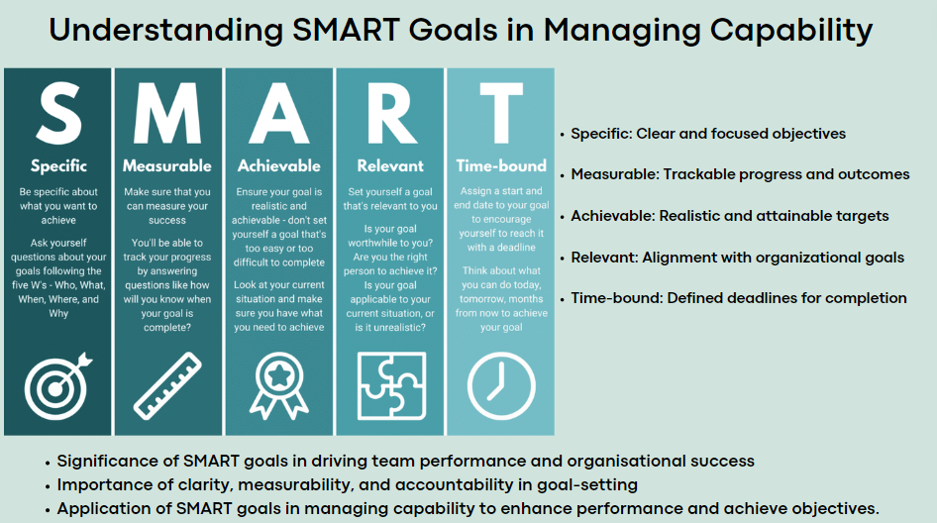
Setting SMART goals is fundamental in managing capability. SMART goals offer a structured framework for defining objectives that are Specific, Measurable, Achievable, Relevant, and Time-bound, driving team performance and enhancing organisational success (Pervaiz, et al., 2021). Appendix -15
SMART goals ensure clear, measurable, and achievable objectives aligned with organisational goals. They provide clarity, alignment, and accountability, developing a culture of continuous improvement (McKinsey & Company, 2017).
SMART goals guide performance expectations, identify development needs, and measure progress, enhancing team effectiveness and driving organisational objectives (Indeed Editorial Team, 2023).

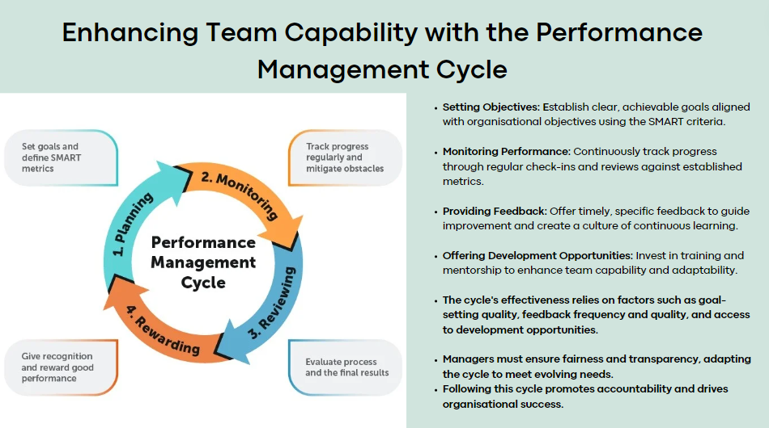
The Performance Management Cycle is essential for managing team capability, guiding us through goal setting, performance monitoring, feedback, and development. It's about developing continuous improvement and aligning performance with organisational goals. Timely feedback and accessible development are essential for team effectiveness. However, its effectiveness depends on factors like goal quality, feedback frequency, and access to development. Managers must prioritise fairness and adapt the cycle to evolving organisational needs (Neher & Maley, 2019; Hartner-Tiefenthaler, 2021)
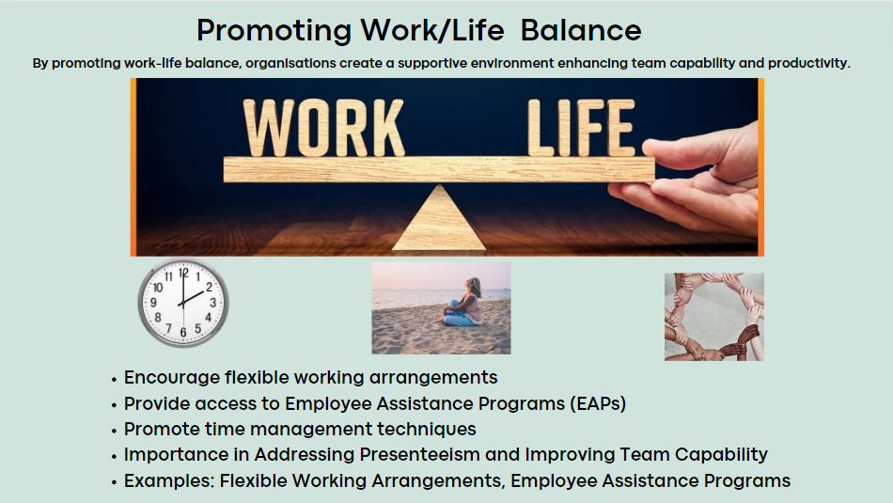
Practical strategies to promote work-life balance are crucial for team productivity. Flexible working arrangements, Employee Assistance Programs (EAPs), and time management techniques combat presenteeism and enhance capability (CIPD, 2019).
Encouraging flexibility, offering EAPs, and promoting time management empower employees, boosting productivity. Prioritising work-life balance reduces stress and develops a positive work culture, maximising performance (American Psychological Association, 2024).
Flexible arrangements and EAPs effectively boost well-being among employees (CIPD, 2024)
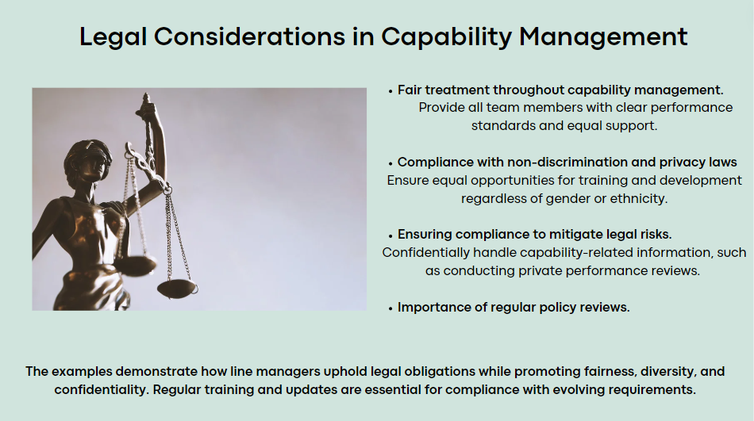
Legal obligations in manufacturing management are crucial for compliance and employee rights. Line managers play a pivotal role in ensuring fair treatment, safety, and diversity. Failure to comply can lead to legal challenges and reputational damage. Staying informed and proactive is essential (Acas, 2024; Rees G & French, 2016).
Managers must ensure fair treatment, comply with non-discrimination laws, and safeguard privacy. This includes providing clear performance standards, equal training opportunities, and confidential handling of information. Regular training is vital to stay compliant (Goundan, 2023; Hutchinson, 2013).

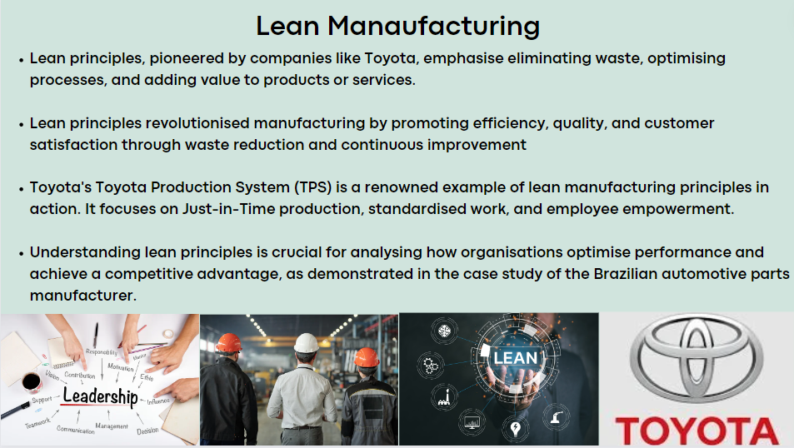
Understanding lean principles is vital for organisations aiming for efficiency and excellence. Lean methodologies focus on waste reduction and continuous improvement, offering a systematic approach to productivity enhancement. Integration with effective leadership styles emphasises collaboration, empowerment, and continuous learning. By integrating lean principles into management practices, organisations develop a culture conducive to long-term success (Do, 2017; Penwill, 2024).

Exploring a Brazilian automotive parts manufacturer's case study showcasing successful integration of lean manufacturing principles and effective leadership strategies, driving team capability and performance enhancements.
• Lean Manufacturing: Focus on waste reduction and continuous improvement led to productivity and quality improvements.
• Leadership Impact: Effective leadership developed innovation and engagement.
• Integration of lean principles and effective leadership resulted in increased efficiency and improved quality. Refer to detailed case study handout for insights (Bento & Tontini, 2019) Appendix-16.
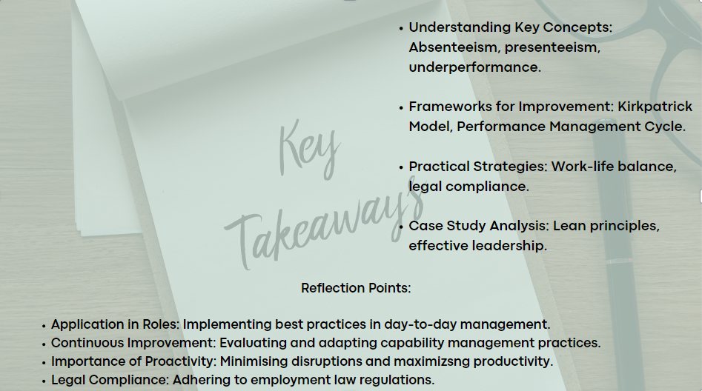
Highlighted crucial capability management aspects: absenteeism, presenteeism, and frameworks like the Kirkpatrick Model and Performance Management Cycle.
Emphasised proactive management's significance in enhancing productivity and sustaining competitiveness in manufacturing teams.
Encouraged practical application of session learnings, driving continuous improvement in teams and organisations.
Let's commit to applying these principles for ongoing success.

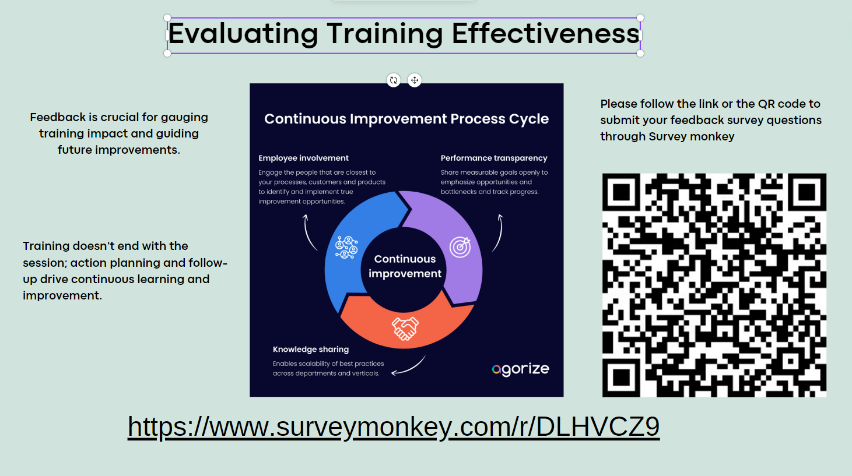

Session 5 – Coaching and Mentoring for Enhanced Performance
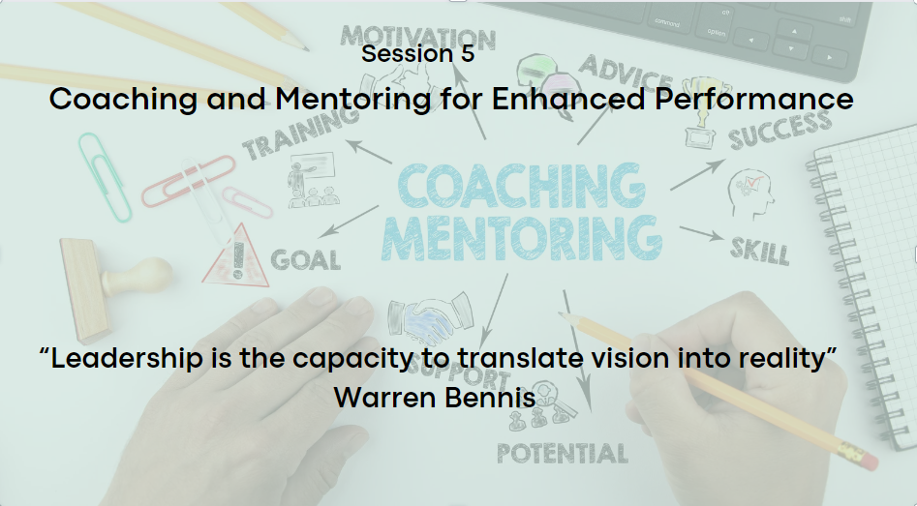
"Leadership is the capacity to translate vision into reality" (Bennis, 2023). This quote encapsulates the essence of effective leadership in guiding organisations toward their goals (Royal College or Surgeons England, 2023).
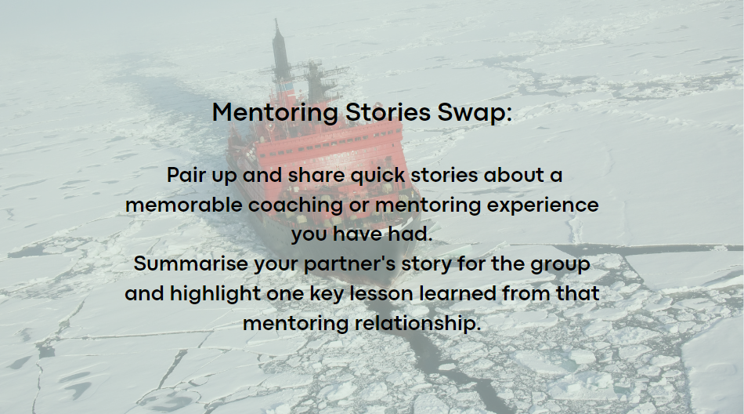
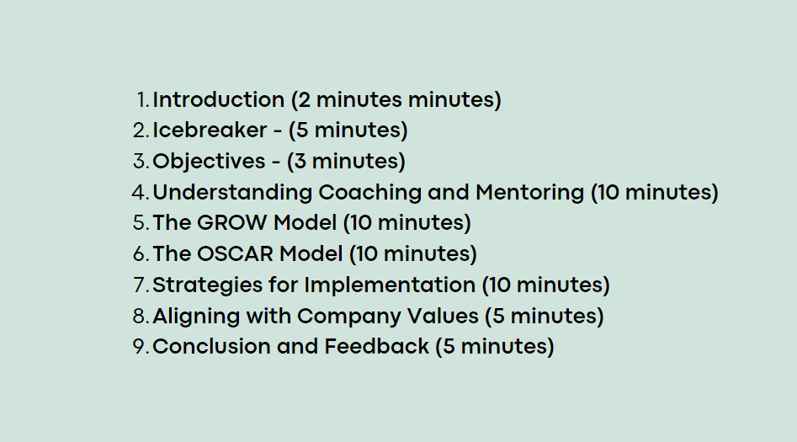
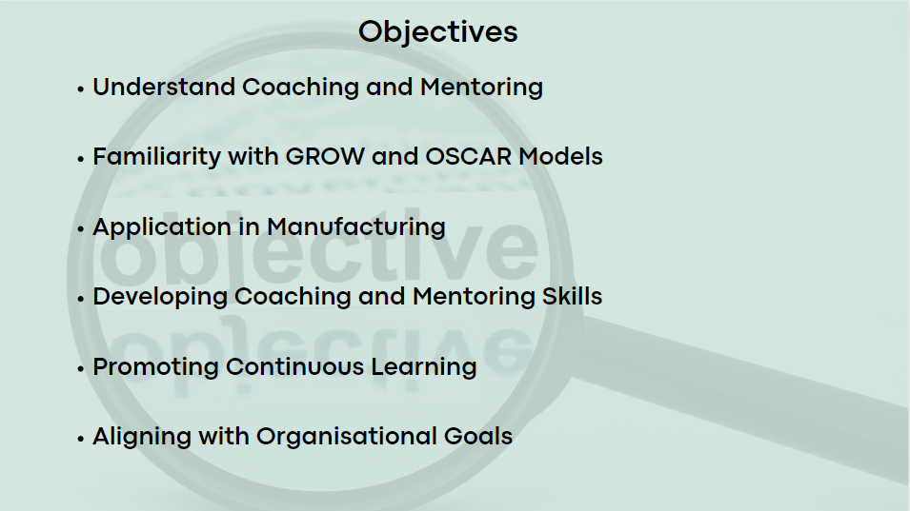

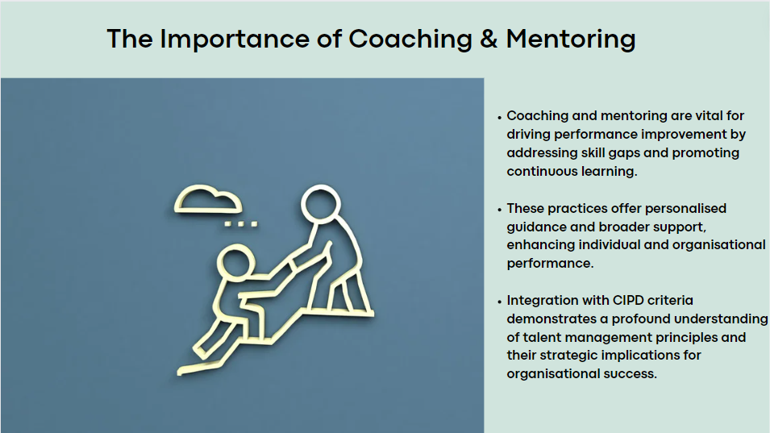
Coaching and mentoring are essential in our manufacturing environment, aiding skill development, motivation, and growth mindsets. Integration by line managers is vital for talent development and performance improvement (CIPD, 2023; Beevers, et al., 2019; Harvard Business Review, 2023)
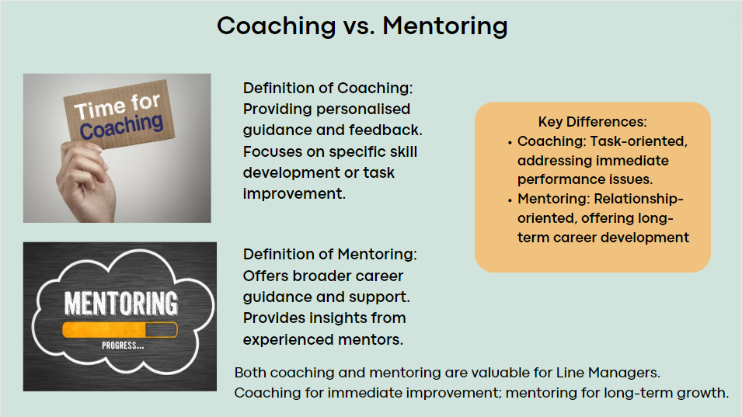
- Overview: Coaching focuses on immediate skill development, while mentoring offers long-term career guidance.
- Critical: Line managers must grasp these distinctions to support employee growth effectively.
- Impact: Coaching enhances productivity, while mentoring develops talent retention (Wheeler, 2011).
- Analysis: Balancing both approaches develops a supportive environment for short and long-term goals (Reeves, 2023; Armstrong, 2018).

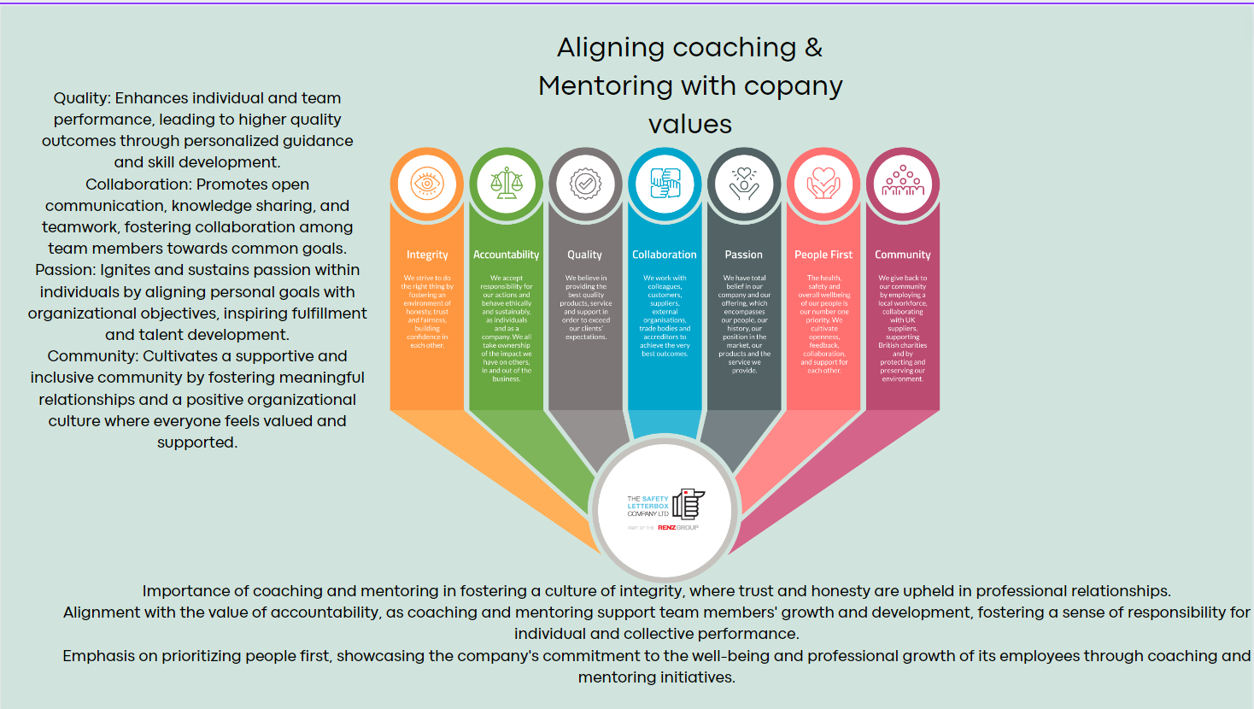
- Sets the stage for discussing coaching and mentoring within the organisation.
- Highlights the alignment of coaching and mentoring with core values like Integrity, Accountability, and People First, reflecting strategic talent development.
- Emphasises the importance of evaluating coaching and mentoring initiatives to ensure effectiveness and address potential challenges.
- Commits to thorough examination of the impact and relevance of coaching and mentoring, promoting evidence-based decision-making and organisational learning (Armstrong, 2018; Rees & French, 2016; Dolan, 2020).

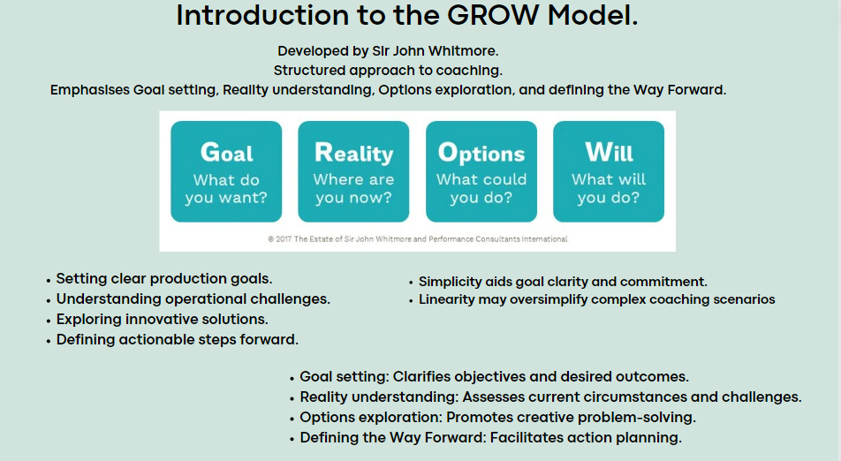
- Introduces the GROW model as a structured coaching approach by Sir John Whitmore.
- Outlines the four components of the GROW model: Goal setting, Reality understanding, Options exploration, and defining the Way Forward. Appendix-17
- Acknowledges the model's simplicity for goal clarity and commitment but highlights concern about oversimplification in complex coaching scenarios (Panchal & Riddell, 2020).
- Discusses the model's relevance in manufacturing, including goal setting, problem-solving, and action planning for operational improvement (Rahim, et al., 2014; Rouse, et al., 2020)

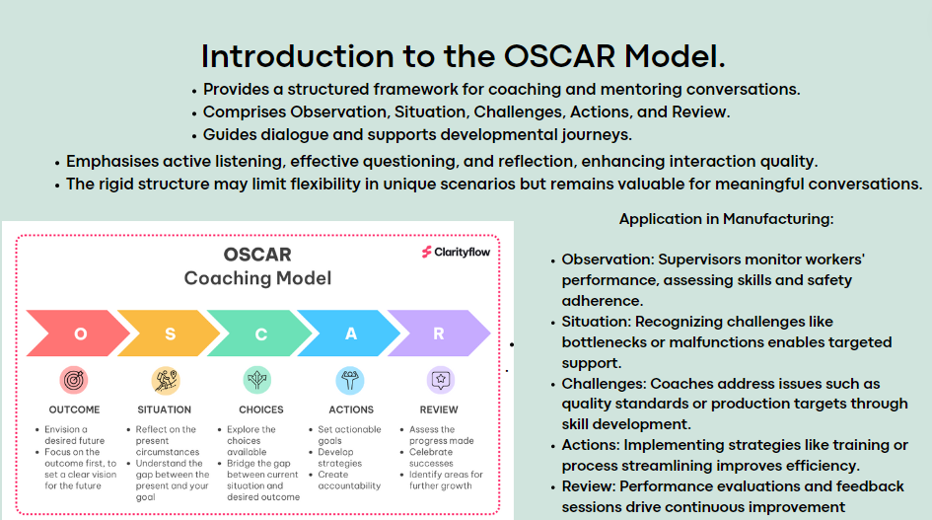
- OSCAR model - a structured framework for coaching and mentoring conversations.
- Components of the OSCAR model: Observation, Situation, Challenges, Actions, and Review.
- Emphasis on active listening and reflection but notes potential limitations due to its rigid structure in addressing unique scenarios.
- Discusses how the OSCAR model guides supervisors in monitoring performance, addressing challenges, implementing improvement strategies, and developing development within manufacturing teams (Pearce & Patent, 2021; Gilbert & Whittleworth, 2009). Appendix- 18
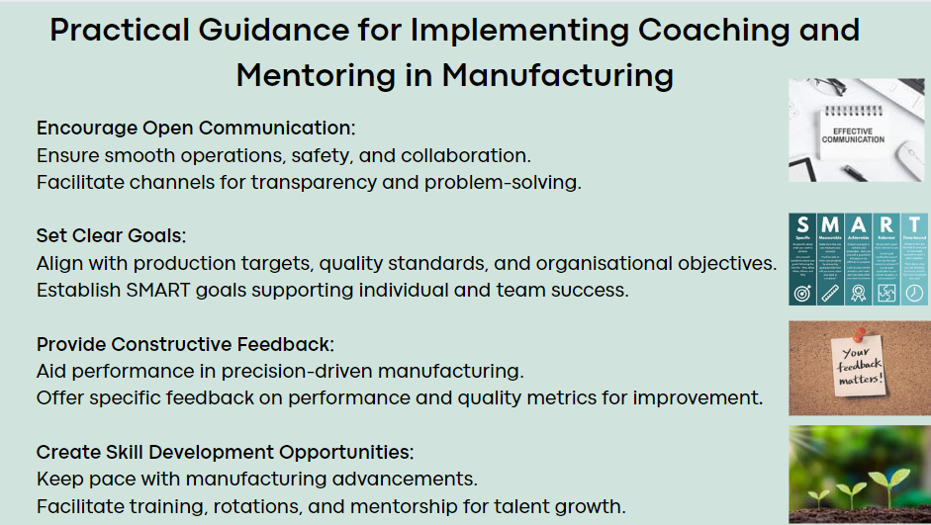
Implementing coaching and mentoring in manufacturing requires open communication, clear goals, constructive feedback, and skill development. These strategies optimise performance, enhance engagement, and drive sustainable growth (Hilali, et al., 2020).
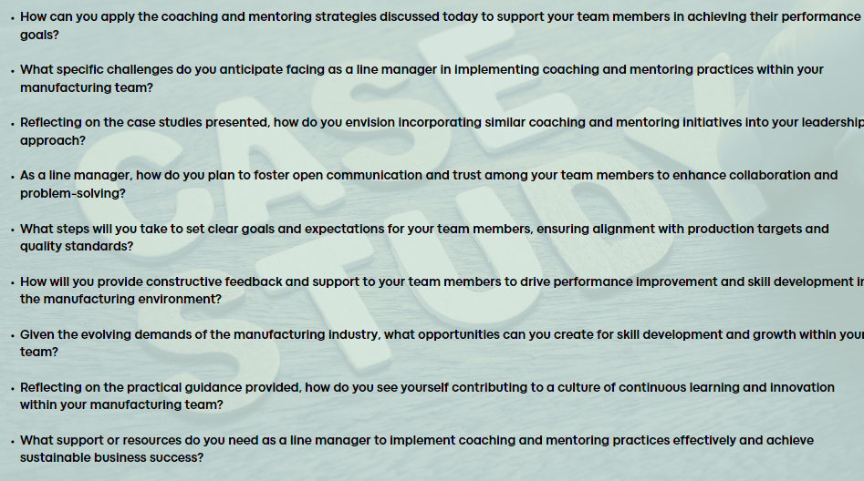
Analyses of coaching and mentoring initiatives from companies like Whessoe Oil & Gas (Coach Mentoring, 2024) and St. John’s Ambulance (Talent for Growth, Unknown). These case studies highlight challenges, strategies, and outcomes. Reflect on the slide's questions. Appendix- 19
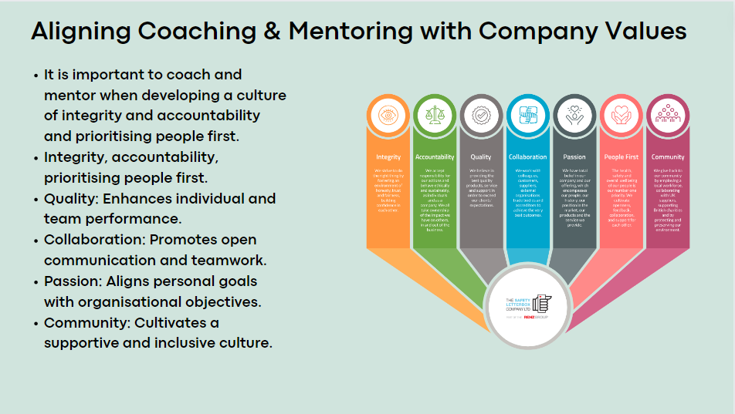
Coaching and mentoring align with our core values, enhancing performance, developing collaboration, and cultivating a supportive community. Integrating these initiatives reinforces our commitment to excellence and drives organisational success (CIPD, 2021).
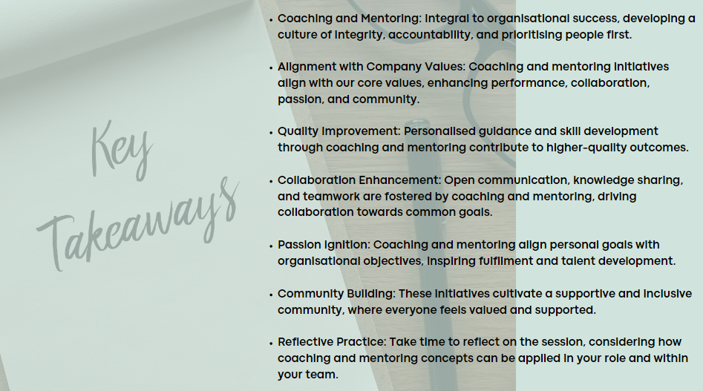
Coaching and mentoring drive a culture aligned with our values, enhancing performance, collaboration, and community. Apply these concepts to drive success in your role and contribute to team and organisational growth (The Safety Letter Box Company Ltd, 2024)

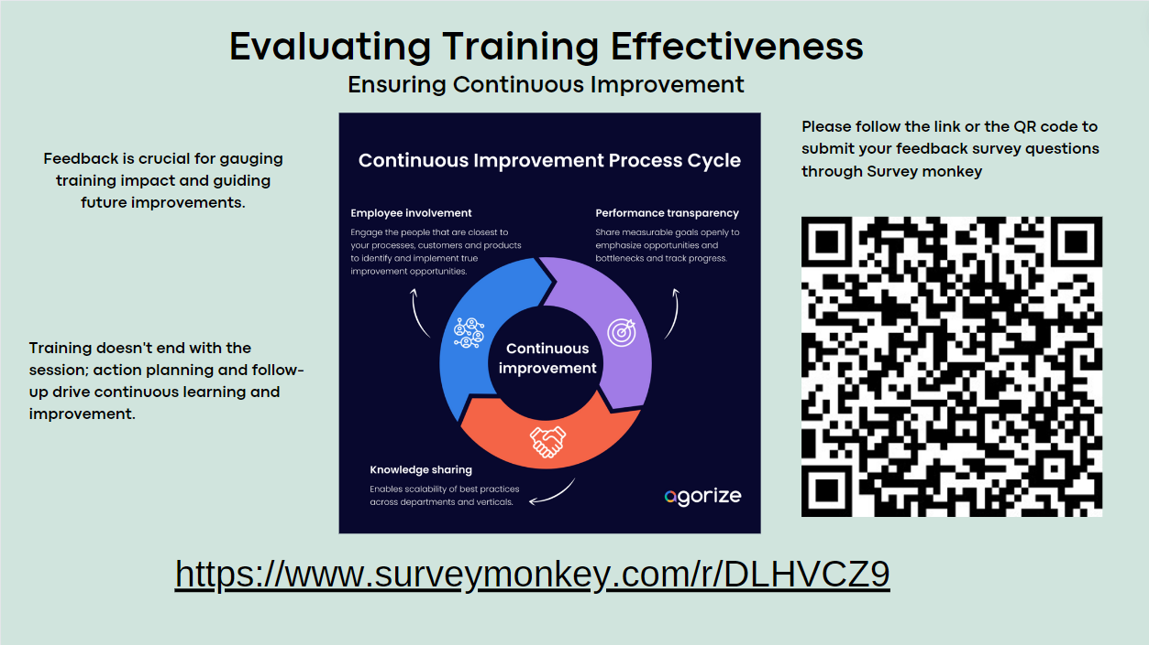
Please provide feedback on the training session by following the link to the feedback questionnaire provided or scanning the QR code. Your input is valuable for improving future sessions (Kirkpatrick, 1959).

References
Acas (2024) Conduct and capability procedures when managing performance. Available at: https://www.acas.org.uk/capability-procedures/(Accessed: 27 April 2024).
American Psychological Association (2024) Levelling up: Supporting employees’ psychological well-being for maximum return. Available at: https://www.apa.org/topics/healthy-workplaces/supporting-employee-psychological-well-being(Accessed: 27 April 2024).
Andersen, E. (2013) 21 quotes from Henry Ford on business, leadership, and life. Available at: https://www.forbes.com/sites/erikaandersen/2013/05/31/21-quotes-from-henry-ford-on-business-leadership-and-life/ (Accessed: 24 April 2024).
Armstrong, M. (2016) Armstrong’s Handbook of Management and Leadership for HR. 4th edn. London: Kogan Page.
Armstrong, M. (2018) Armstrong’s handbook of performance management: an evidence-based guide to delivering high performance. 6th edn. London: Kogan Page.
Beevers, K., Rea, A. and Hayden, D. (2019) Learning and development practice in the workplace. 4th edn. London: Kogan Page.
Belbin (2024) Why use Belbin. Available at: https://www.belbin.com/about/why-use-belbin (Accessed: 19 April 2024).
Bento, G. d. S. and Tontini, i. (2019) Maturity of lean practices in Brazilian manufacturing companies. Total Quality Management and Business Excellence, 30(4) pp. 1-15. Available at: https://www.researchgate.net/publication/335776003_Maturity_of_lean_practices_in_Brazilian_manufacturing_companies ( Accessed: April 26 2024)
Bonebright, D. A. (2010) 40 years of storming: A historical review of Tuckman’s model of small group development. Human Resource Development International, 13(1) pp. 111-120. Available at: https://www.tandfonline.com/doi/abs/10.1080/13678861003589099 (Accessed: 27 April 2024)
Brassey, J., Christensen, L., Dam, N. (2019) The essential components of a successful LandD strategy. Available at: https://www.mckinsey.com/capabilities/people-and-organizational-performance/our-insights/the-essential-components-of-a-successful-l-and-d-strategy/ (Accessed: 20 April 2024).
Cakir, F. S. and Adiguzel, Z. (2020) Analysis of Leader Effectiveness in Organization and Knowledge Sharing Behavior on Employees and Organization. Sage Open, 10(1). Available at: https://journals.sagepub.com/doi/10.1177/2158244020914634 (Accessed: 27 April 2024)
Cambridge Spark (2023) HR Data Analysis: A Guide To Optimising Workforce Performance. Available at: https://www.cambridgespark.com/info/hr-data-analysis-optimise-workforce (Accessed:26 April 2024).
Carlin, D. (2019) Democratic, Authoritarian, Laissez-Faire: What Type Of Leader Are You? Available at: https://www.forbes.com/sites/davidcarlin/2019/10/18/democratic-authoritarian-laissez-faire-what-type-of-leader-are-you/?sh=3a9a49592a6b/ (Accessed:26 April 2024).
Chowdhury, S. (2016) A Quantitative Study on Push, Pull and Personal Factors Affecting Employees’ Turnover Intentions: A Case of Nationalized Commercial Banks (NCBs) in Bangladesh. Information and Knowledge Management, 6(9) Available at: https://core.ac.uk/download/pdf/234672366.pdf (Accessed:25 April 2024)
CIPD (2015) From best to good practice HR: Developing principles for the profession. CIPD research report London: CIPD. Available at: https://www.cipd.org/globalassets/media/comms/the-people-profession/profession-map-pdfs/pff-report-update-pffmay20_tcm29-8731.pdf (Accessed:1 May 2024)
CIPD (2019) Health and Well Being at Work. CIPD research report. London: CIPD. Available at: https://www.cipd.org/globalassets/media/comms/news/iihealth-and-well-being-at-work-2019.v1_tcm18-55881.pdf ( Accessed:27 April 2024)
CIPD (2021) The effects of mentoring on work engagement – a mentor’s perspective. Available at: https://www.cipd.org/uk/knowledge/bitesize-research/mentoring-work-engagement/ (Accessed:1 May 2024).
CIPD (2022) Resourcing and Talent Planning Report. CIPD research report. London: CIPD. Available at: https://www.cipd.org/globalassets/media/knowledge/knowledge-hub/reports/resourcing-and-talent-planning-report-2022-1_tcm18-111500.pdf (Accessed:1 May 2024)
CIPD (2023) Coaching and mentoring. Available at: https://www.cipd.org/uk/knowledge/factsheets/coaching-mentoring-factsheet/#what-are-coaching-and-mentoring/ (Accessed:23 April 2024).
CIPD (2023) High-performing teams: An evidence review. Available at: https://www.cipd.org/uk/knowledge/evidence-reviews/high-performing-teams/ (Accessed: 25 April 2024).
CIPD (2023) Poor managers bad for workers' mental health and performance, new CIPD research shows. CIPD research report. London: CIPD. Available at: https://www.cipd.org/uk/about/press-releases/poor-managers-impact/#:~:text=%E2%80%9CThis%20research%20starkly%20shows%20that,of%20the%20people%20they%20manage (Accessed: 2 May 2024)
CIPD (2023) The Importance of People Management. CIPD Survey Report. London: CIPD. Available at https://www.cipd.org/globalassets/media/knowledge/knowledge-hub/reports/2023-pdfs/2023-report-importance-of-people-management-8329-may23.pdf (Accessed: 2 May 2024)
CIPD (2024) Employee turnover and retention. Available at: https://www.cipd.org/uk/knowledge/factsheets/turnover-retention-factsheet/#:~:text=Employers%20should%20strive%20to%20address,aspects%20that%20support%20employee%20retention (Accessed:19 April 2024).
CIPD (2024) Flexible Working Practices. Available at: https://www.cipd.org/uk/knowledge/factsheets/flexible-working-factsheet/ (Accessed :26 April 2024).
CIPD (2024) Line managers' role in supporting the people profession. Available at: https://www.cipd.org/uk/knowledge/factsheets/line-managers-factsheet/ (Accessed: 25 April 2024).
CIPD (2024) Organisational culture. Available at: https://www.cipd.org/uk/views-and-insights/cipd-viewpoint/organisational-culture/ (Accessed: 28 April 2024)
CIPD (2024) The psychological contract. [Online] Available at: https://www.cipd.org/uk/knowledge/factsheets/psychological-factsheet/#:~:text=As%20the%20psychological%20contract%20is,et%20al.%2C%202007) (Accessed: 27 April 2024).
Coach Mentoring (2024) Whessoe Oil and Gas Ltd. Available at: https://www.coachmentoring.co.uk/coaching/coaching-case-studies.html (Accessed: 27 April 2024).
Crail, C. (2024) 15 Effective Employee Retention Strategies In 2024. Available at: https://www.forbes.com/advisor/business/employee-retention-strategies/ (Accessed: 26 April 2024).
Davlembayeva, D., Alamanos, E.(2023) Equity Theory: A review. In S. Papagiannidi. Available at: https://open.ncl.ac.uk/theories/5/equity-theory/ (Accessed: 26 April 2024).
Deloitte (No Date) Operations Excellence Middle East offering brochure. London: Deloitte. Available at: https://www2.deloitte.com/content/dam/Deloitte/xe/Documents/consulting/me_operations-excellence_offering.pdf ( Accessed: 1 May 2024)
Do, D. (2017) The Five Principles of Lean. Available at: https://theleanway.net/The-Five-Principles-of-Lean (Accessed: 27 April 2024).
Dolan, S. L. (2020) The Secret of Coaching and Leading by Values: How to Ensure Alignment and Proper Realignment. London: Routledge.
Foster Capital (2024) Corporate Leadership: Lessons from Jack Welch. Available at: https://fastercapital.com/content/Corporate-Leadership--Lessons-from-Jack-Welch.html (Accessed: 25 April 2024).
Gallo, A. (2023) What Is Psychological Safety? Harvard Business Review. Available at: https://hbr.org/2023/02/what-is-psychological-safety/ (Accessed: 30 April 2024).
Gilbert, A. and Whittleworth, K. J. (2009) OSCAR Coaching Model: Simplifying Workplace Coaching. London: Worth Consulting Ltd.
Gnepp, J., Klayman, J., Williamson, I. O. and Barlas, S. (2020) The future of feedback: Motivating performance improvement through future-focused feedback, PloS one, 15(6). Available at: https://www.ncbi.nlm.nih.gov/pmc/articles/PMC7304587 (Accessed: 28 April 2024)
Goodwin, J., Haddad, D. and Kirby, a. L. (2023) Five ways to cultivate great managers. Available at: https://www2.deloitte.com/us/en/blog/human-capital-blog/2023/why-invest-in-leadership-development.html (Accessed: 30 April 2024)
Gorenak, M. and Košir, S. (2012) ‘The Importance of Organisational Values for Organisations’, Management knowledge and learning, International conference (Slovenia) Available at: https://www.researchgate.net/publication/239807972_The_Importance_of_Organizational_Values_for_Organization (Accessed: 2 May 2024)
Goundan, B. S. (2023) Legal Aspects of Performance Management. Available at: https://sprintlaw.co.uk/articles/legal-aspects-of-performance-management/ (Accessed: 20 April 2024).
Hartner-Tiefenthaler, M. (2021) Supervisors' power to deal with employees' inner resignation: How perceived power of the organization and the supervisor relate to employees' voluntary and enforced work behavior. European Management Journal, 39(3), pp. 260-269. Available at: https://www.sciencedirect.com/science/article/pii/S0263237320301213?via%3Dihub (Accessed: 25 April 2024)
Harvard Business Review (2023) Leveraging Coaching and Mentoring to Create More Effective Leaders. Available at: https://hbr.org/sponsored/2023/01/leveraging-coaching-and-mentoring-to-create-more-effective-leaders (Accessed: 1 May 2024).
Hilali, K. S. A., Mughairi, B. M. A. and Kian, M. W. (2020) Coaching and Mentoring. Concepts and Practices in Development of Competencies: A Theoretical Perspective. International Journal of Academic Research in Accounting Finance and Management Sciences, 10(1). Available at: https://www.researchgate.net/publication/343680977_Coaching_and_Mentoring_Concepts_and_Practices_in_Development_of_Competencies_A_Theoretical_Perspective (Accessed: 20 April 2024)
Horn, R. (2009) The Business Skills Handbook. London: Kogan Page.
Hutchinson, S. (2013) Performance Management: Theory and Practice. London: Kogan Page.
Ibarra, H. and Scoular, A. (2019) The Leader as Coach - Harvard Business Review. Available at: https://hbr.org/2019/11/the-leader-as-coach/ (Accessed: 30 April 2024).
Indeed Editorial Team (2023) Herzberg's Theory: A Guide for Boosting Employee Motivation. Available at: https://www.indeed.com/career-advice/career-development/herzberg-theory (Accessed: 26 April 2024).
Indeed Editorial Team (2023). How to Develop SMART Goals (With Examples). Available at: https://uk.indeed.com/career-advice/career-development/smart-goals (Accessed: 27 April 2024).
Inside HR (2023) How Google reinvented HR and drives success through people analytics. Available at: https://www.insidehr.com.au/how-google-reinvented-hr/#:~:text=Google%20is%20replacing%20the%2020th,%2Dbased%20decision%2Dmaking%E2%80%9D. (Accessed: 15 April 2024).
Karanika-Murray, M. and Biron, C. (2020) The health-performance framework of presenteeism: Towards understanding an adaptive behaviour, The Tavistock Institute, 73(2). Available at: https://journals.sagepub.com/doi/10.1177/0018726719827081 (Accessed: 23rd April 2024)
Kirkpatrick Partners (2024) The Kirkpatrick Model. Available at: https://www.kirkpatrickpartners.com/the-kirkpatrick-model/ (Accessed: 1 May 2024).
Kirkpatrick, D. L., 1959. Techniques for Evaluation Training Programs, Journal of the American Society of Training Directors, 13, pp. 21-26. Available at: https://www.scirp.org/reference/ReferencesPapers?ReferenceID=1735231 (Accessed: 22 April 2024)
Kraemer, H. (2024) Harry Kramer - Kellogg School of Management Professor, former CEO of Baxter, Best Selling Author. Available at: https://harrykraemer.org/2024/01/08/a-great-example-of-a-true-values-based-leader/ (Accessed: 24 April 2024).
Main, P. (2023) Herzberg's Two-Factor Theory. Available at: https://www.structural-learning.com/post/herzbergs-two-factor-theory#:~:text=hinder%20overall%20motivation.-,Herzberg's%20Two%2DFactor%20Theory%20highlights%20the%20following%20key%20elements%3A,can%20lead%20to%20job%20dissatisfaction/ (Accessed :15 April 2024).
Management in Practice (2023) Teamwork – what is it and how can we make it more effective. Available at: https://managementinpractice.com/practice-intelligence/teamwork-what-is-it-and-how-can-we-make-it-more-effective/ (Accessed: 25 April 2024).
Mazzetti, G. and Schaufeli, W. B. (2022) The impact of engaging leadership on employee engagement and team effectiveness: A longitudinal, multi-level study on the mediating role of personal- and team resources, PloS one, 17(6). Available at: https://doi.org/10.1371/journal.pone.0269433 (Accessed: 23 April 2024)
McGiboney, G. W. (2018) Leadership Theories and Case Studies. Newcastle: Cambridge Scholars Publishing.
McKinsey and Company (2017) How effective goal setting motivates employees. Available at: https://www.mckinsey.com/capabilities/people-and-organizational-performance/our-insights/the-organization-blog/how-effective-goal-setting-motivates-employees/ (Accessed: 25 April 2024).
McKinsey and Company (2021) Losing from day one: Why even successful transformations fall short. Available at: https://www.mckinsey.com/capabilities/people-and-organizational-performance/our-insights/successful-transformations/ (Accessed: 25 April 2024).
McKinsey and Company (2023) The State of Organizations 2023, New York: McKinsey and Company. Available at: https://www.mckinsey.com/~/media/mckinsey/business%20functions/people%20and%20organizational%20performance/our%20insights/the%20state%20of%20organizations%202023/the-state-of-organizations-2023 (Accessed: 3 May 2024)
Mind Tools (2024) Performance Management and KPIs. Available at: https://www.mindtools.com/aia3zkb/performance-management-and-kpis/ (Accessed: 15 April 2024).
Nawaz, F., Ahmad, W. and Khushnood, M., 2023. Kirkpatrick Model and Training Effectiveness: A Meta-Analysis 1982 To 2021. Business and Economic Review, 14(2), pp.35-56. Available at: https://www.researchgate.net/publication/369972325_Kirkpatrick_Model_and_Training_Effectiveness_A_Meta-Analysis_1982_To_2021 (Accessed: 27 April 2024)
Neher, A. and Maley, J., 2019. Improving the effectiveness of the employee performance management process: A managerial values approach. International Journal of Productivity and Performance Management, 69(6), pp.1129-1152. Available at: https://www.emerald.com/insight/content/doi/10.1108/IJPPM-04-2019-0201/full/html (Accessed 1 May 2024)
Nickerson, C.(2023) Herzberg’s Two-Factor Theory Of Motivation-Hygiene. Available at: https://www.simplypsychology.org/herzbergs-two-factor-theory.html (Accessed: 23 April 2024).
Odom, C. (2023). Connecting Purpose and Values Can Help Companies Retain Talent. Available at: https://www.forbes.com/sites/forbescoachescouncil/2023/05/08/connecting-purpose-and-values-can-help-companies-retain-talent/?sh=2d2de9fa4570 (Accessed: 15 April 2024).
Panchal, S. and Riddell, P., 2020. The GROWS model: extending the GROW coaching model to support behavioural change'. The Coaching Psychologist, 16(2), pp. 12-25. Available at: https://psycnet.apa.org/record/2020-89290-002 (Accessed: 30 April 2024).
Paull, M., Whitsed, C. and Girardi, A. (2016) Applying the Kirkpatrick model: Evaluating an Interaction for Learning Framework curriculum intervention. Perth: Teaching and Learning Forum - Purveyors of Fine Learning Since 1992 (Available at: https://www.researchgate.net/publication/297920667_Applying_the_Kirkpatrick_model_Evaluating_Interaction_for_Learning_Framework_Curriculum_Interventions (Accessed: 4 May 2024)
Pearce, A. and Patent, V. (2021) Everyone Can Learn to Coach: Coaching with the OSCAR Model. Available at: OpenLearn. Available at: https://www.open.edu/openlearn/health-sports-psychology/psychology/everyone-can-learn-coach-coaching-the-oscar-model (Accessed: 26 April 2024).
Peart, N. (2019) Making Work Less Stressful and More Engaging for Your Employees. Available at: https://hbr.org/2019/11/making-work-less-stressful-and-more-engaging-for-your-employees (Accessed: 1 May 2024).
Penwill, A. (2024) People Management: The Right People in the Right Place. Available at: https://www.leanpractice.co.uk/articles/people-management-the-right-people-in-the-right-place (Accessed: 1 May 2024).
Pervaiz, S., Li, G. and He, Q. (2021) The mechanism of goal-setting participation's impact on employees' proactive behavior, moderated mediation role of power distance. PloS one,16(12). Available at: https://doi.org/10.1371/journal.pone.0260625 (Accessed: 1 May 2024)
Porter, M. E. (1985) Competitive Advantage. The Free Press, Issue, pp.11-15. Available at https://www.ifm.eng.cam.ac.uk/research/dstools/porters-generic-competitive-strategies/ (Accessed: 30 April 2024)
Potter, A. (2021) Exploring the role of lean managers within the Toyota supply network: Evidence from a social media platform. Production Planning and Control, Volume ABS (3).Available at: https://research.manchester.ac.uk/en/publications/exploring-the-role-of-lean-managers-within-the-toyota-supply-netw (Accessed: 30 April 2024)
Rahim, N. S. A., Mansor, N. N. A. and Anvari, R. (2014) Driving the involvement of line managers’ role in creating coaching culture in Malaysia. Procedia, Social and Behavioural Sciences, 129, pp. 221-226.Available at: https://www.sciencedirect.com/science/article/pii/S1877042814028523 ( Accessed: 30 April 2024)
Rees G and French, R. (2016) Leading, Managing and Developing People. 5th edn London: Kogan Page.
Reeves, M. (2023) Coaching and Mentoring: Essential Components Of Successful Employee Development. Available at: https://www.forbes.com/sites/forbeshumanresourcescouncil/2023/05/03/coaching-and-mentoring-essential-components-of-successful-employee-development/?sh=33de9d6a2ec3 (Accessed: 25 April 2024).
Rogelberg, S. G. (2022) Make the Most of Your One-on-One Meetings. Available at: https://hbr.org/2022/11/make-the-most-of-your-one-on-one-meetings (Accessed: 25 April 2024).
Rouse, J. et al. (2020) How to Develop the People Management Skills of Line Managers. Good Employment Learning Lab. Available at: https://www.mmu.ac.uk/sites/default/files/2022-11/executive-summary.pdf (Accessed: 3 May 2024)
Royal College or Surgeons England (2023). Leadership is the capacity to translate vision into reality. Available at: https://publishing.rcseng.ac.uk/doi/abs/10.1308/rcsfdj.2023.9?journalCode=fdj/ (Accessed: 25 April 2024).
Safety Culture (2024) Training Evaluation Guide. Available at: https://safetyculture.com/topics/training-evaluation/ (Accessed: 19 April 2024).
Setiawan, I. and Purba, H. H. (2020) A Systematic Literature Review of Key Performance Indicators (KPIs)Implementation, Journal Of Industrial Engineering and Management Research, 1(3). Available at: https://www.researchgate.net/publication/345941517_A_Systematic_Literature_Review_of_Key_Performance_Indicators_KPIs_Implementation (Accessed: 1 May 2024)
Shaban, O., Al-Zubi, Z., Ali, N. and Alqtish, A. (2017) The Effect of Low Morale and Motivation on Employees’ Productivity and Competitiveness in Jordanian Industrial Companies, International Business Research, 10(7) p.1, Available at: https://www.ccsenet.org/journal/index.php/ibr/article/view/68738 (Accessed: 1 May 2024)
Shih, W. C. (2022) What Really Makes Toyota’s Production System Resilient. Available at: https://hbr.org/2022/11/what-really-makes-toyotas-production-system-resilient (Accessed: 25 April 2024).
Spain, E. and Groysberg, B. (2016) Making Exit Interviews Count. Available at: https://hbr.org/2016/04/making-exit-interviews-count (Accessed: 27 April 2024).
Stein, J. (no date) Using the Stages of Team Development. Available at: https://hr.mit.edu/learning-topics/teams/articles/stages-development (Accessed: 25 April 2024).
Stewart, Y. A. (2023) Why should employers conduct exit interviews? Available at: https://www.breathehr.com/en-gb/blog/topic/employee-engagement/why-should-employers-conduct-exit-interviews#:~:text=Exit%20interviews%20are%20a%20good,company%20culture%20and%20staff%20performance. (Accessed: 26 April 2024).
Talent for Growth (No Date) St Johns Ambulance - Building coaching capability to support major organisation change, London: Talent for Growth.
Tannenbaum, R. and Schmidt, W. H. (1973) How to Choose a Leadership Pattern. Available at: https://hbr.org/1973/05/how-to-choose-a-leadership-pattern (Accessed: 15 April 2024).
The Economic Times (2023) Ethical Leadership in Innovation: Balancing Ethics with Forward-Thinking Creativity. Available at: https://economictimes.indiatimes.com/jobs/c-suite/ethical-leadership-in-innovation-balancing-ethics-with-forward-thinking-creativity/articleshow/103496943.cms/ (Accessed: 28 April 2024).
The Open University (2024) Consequences of Tuckman’s Model. Available at: https://www.open.edu/openlearn/mod/oucontent/view.php?id=68106andsection=4/ (Accessed: 26 April 2024).
The Safety Letter Box Company Ltd (2023) Organisational Values, Neath: The Safety Letter Box Company Ltd. Unpublished
The Safety Letter Box Company Ltd (2024) Strategic Vision 2024, Neath, The Safety Letter Box Company Ltd. Unpublished.
Tolentino, A.(2015) How the happiest companies in America boost morale and the bottom line. Available at: https://thenextweb.com/news/how-the-happiest-companies-in-america-boost-morale-and-the-bottom-line (Accessed: 15 April 2024).
Toyota (2024) Leading teams with empathy – the Toyota way. Available at: https://toyota-forklifts.eu/toyota-lean-academy/leading-teams-with-empathy-the-toyota-way/ (Accessed: 25 April 2024).
Watson, G. and Reissner, S. (2014) Developing Skills for Business Leadership. 2nd edn. London: Kogan Page.
Watson, J., Evans-Greenwood, P., Peck, A. and Williams, P. (2020) Building the peloton - High-performance team building in the future of work. Available at: https://www2.deloitte.com/us/en/insights/focus/technology-and-the-future-of-work/high-performance-team-building.html (Accessed :25 April 2024).
Wheeler, L. (2011) How does the adoption of coaching behaviours by line managers contribute to the achievement of organisational goals?', International Journal of Evidence Based Coaching and Mentoring, 9(1), pp. 1-15. Available at: https://radar.brookes.ac.uk/radar/items/67c6636b-d3e6-4977-b45d-fc485e1840dd/1/ (Accessed: 1 May 2024)
Williams, L. and Andersen, C. (2023) To Put Your Company Values into Action, Create Working Agreement. Available at: https://hbr.org/2023/11/to-put-your-company-values-into-action-create-working-agreements (Accessed: 26 April 2024).
Yeo, o. K. (2019) From operational excellence to organizational significance: setting the tempo for change. Strategic HR Review, 18(4), pp.142-149. Available at:https://www.emerald.com/insight/content/doi/10.1108/SHR-04-2019-0027/full/html (Accessed: 1 May 2024)
Zaleznik, A. (2004) Managers and Leaders: Are They Different? Available at: https://hbr.org/2004/01/managers-and-leaders-are-they-different (Accessed: 28 April 2024).

Appendix

Session 1: The Role of Line Managers in Influencing Performance

Appendix 1: Case Studies

Contains practical examples of how line managers influence team performance through various leadership strategies.

Appendix 2: Tuckman's Model Example

Demonstrates the application of Tuckman's model in guiding teams through the forming, storming, norming, and performing stages.

Appendix 3: Feedback Survey

A sample survey to evaluate the training based on the Kirkpatrick model (QR code and link are live on the presentation slides)

Session 2: How to Lead Effective Teams

Appendix 4: Armstrong's Performance Management Model

Highlights Armstrong's model for aligning team and individual goals with organisational objectives.

Appendix 5: Toyota Case Study

Explores Toyota's leadership approach in creating effective, collaborative teams.

Appendix 6: Leadership Game

Provides an interactive exercise that enhances team building and leadership skills.

Appendix 7: Belbin Questionnaire

A questionnaire designed to identify team roles and help managers form balanced teams.

Appendix 8: Google Case Study

Analyses Google's innovative team management strategies, encouraging creativity and productivity.

Appendix 9: Manufacturing Case Studies

Case studies focused on data-driven decision-making and effective team leadership in the manufacturing sector.

Session 3: Strategies to Retain Employees

Appendix 10: Action Plan Worksheet

A template to create actionable plans that drive employee engagement and performance.

Appendix 11: Herzberg's Theory and Equity Theory

Explores motivational theories that impact employee retention and satisfaction.

Appendix 12: Case Studies

Offers real-world examples of companies using push/pull factors and data analysis for retention strategies.

Appendix 13: Retention Strategy Planning Template

A strategic template to plan and implement initiatives that effectively retain top talent.

Session 4: Approaches to Managing Capability

Appendix 14: Further Learning: Kirkpatrick Model and Performance Management Cycle

Provides a framework for training evaluation (Kirkpatrick) and an overview of performance management processes.

Appendix 15: SMART Goals Template

Offers a form to set and evaluate Specific, Measurable, Achievable, Relevant, and Time-bound goals.

Appendix 16: Case Studies

Examples demonstrating the importance of managing capability issues, including absence and lawful performance management.

Session 5: The Use of Coaching and Mentoring in Assisting Performance
Appendix 17: GROW Model Example
An example of the GROW coaching model, useful for goal-setting and problem-solving.

Appendix 18: OSCAR Model Example
An example of the OSCAR model, a coaching framework focusing on outcome, situation, choices, action, and review.

19. Appendix 19: Case Study
An in-depth analysis showing the positive impact of coaching and mentoring on employee performance and career growth.
(My appendix shows examples of what I would include in the training session)

Canva Link
https://www.canva.com/design/DAGEFEkUwBI/CVBsvO-1W8JQM_1igXxn-A/view?utm_content=DAGEFEkUwBI&utm_campaign=designshare&utm_medium=link&utm_source=editor

