University Of Wales Trinity Saint David
School of Engineering

PLC Control Systems
ACMA6001

Aled Thomas
2206212
22nd September 2025

Table of Contents
1 Introduction 1
2 Literature Review 2
2.1 Hydraulic 2
2.2 Pneumatic 3
2.3 Electric 3
3 Control System 4
3.1 Inputs 4
3.2 Outputs 4
3.3 Control Behaviour 5
4 PLC Programming 7
4.1 Program structure 7
5 Observations 11
5.1 Test Methodology 11
5.2 Results 11
6 Critical Analysis 14
6.1 Strengths 14
6.2 Weaknesses and improvements 14
7 Conclusion 16
8 References 17

Figure 1 - Factory overview in Factory I/O 1
Figure 2 - Diagram of electric actuator (Xiang, 2021) 2
Figure 3 - Diagram of hydraulic actuator (Salam, 2022) 2
Figure 4 - Simulated PLC input/output map. 5
Figure 5 - Operational flow chart of the simulated factory. 6
Figure 6 - HMI terminal before machine start 7
Figure 7 - Ladder logic code for startup 7
Figure 8 - Startup initiation sequence 8
Figure 9 - Sequential conveyor startup 8
Figure 10 - Pusher actuation code 9
Figure 11 - Scale weight taking procedure and reset 9
Figure 12 - CTU counters and reset ladder code 10
Figure 13 - automatic timer for sorting tests. 11
Figure 14 - Excel bar graph from results in table 2. 12
Figure 15 - HMI terminal after emergency stop test concluded. 13
Figure 16 - Factory state after emergency stop test concluded. 13

Table 1 - Table of actuator types showing advantages and disadvantages (Dings' motion USA, n.d.) 3
Table 2 - Results of sorting test recorded from HMI terminal. 11

Introduction
This report focuses on analysing and evaluating the implementation of an automated material handling system in the simulation program Factory I/O. Ladder logic and structured text will be the programming languages chosen to develop the logic for the programmable logic controller (PLC), which will be implemented using the integrated development environment (IDE) software CODESYS. A fully designed and operational simulated factory environment will be tested and analysed to assess the strengths, weaknesses and any improvements. The factory must satisfy the demand requirements for sorting and handling packages of various sizes and weights. Secondly, a functional human machine interface (HMI) must connect with the factory which will also be analysed. To know if the factory meets the satisfactory requirements, simulation tests, analyses of operational flow charts and the HMI terminal, and testing emergency procedures must be carried out.
This report will demonstrate the technical principles and limitations of PLC programming within the context of the simulated factory environment. Inputs and outputs will be defined within the controller and determined how their logical states dictate the behaviour of the program. The largest logical dependencies are carried out by pushing actuators, this report will consider the advantages and disadvantages of different methods of actuations. A review of pneumatic, hydraulic, and the rising use of electric actuation will be defined and compared.
The system is simplistic, especially compared to the rapidly developing automation possibilities of the 4th industrial revolution (industry 4.0). Providing a valuable comparison of the PLC/ladder-logic system to these higher complexity systems.
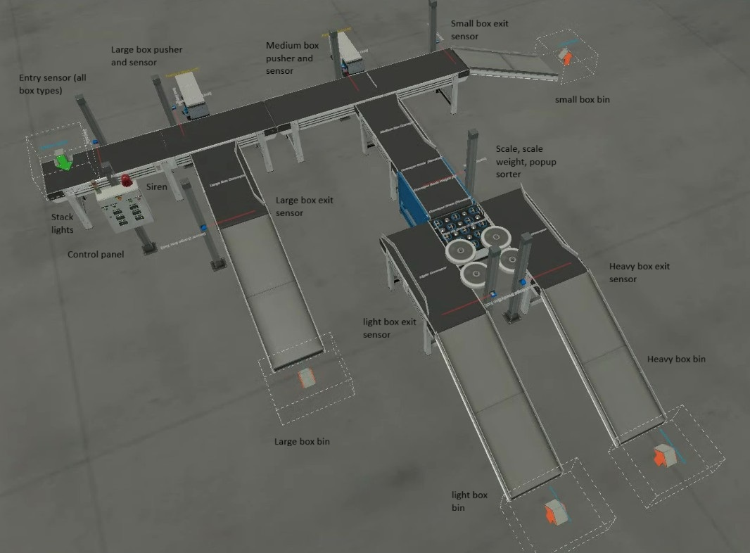
Figure 1 - Factory overview in Factory I/O

Literature Review
The PLC acts as the decision-making centre of the automated simulated factory, but to transfer those decisions to the real world, a method of actuation is required. This is where the field of robotics and more precisely, mechatronics is utilised. Actuators are mechanical devices transferring electrical or fluid power into mechanical working potential (Janocha, 2004). To animate the motion of these actuators, a method of power is required. There are two choices: fluid or electrical power. Electrical systems are simple to understand, usually a motor driving a leadscrew using a gearbox to extend/retract the piston (see fig 2).
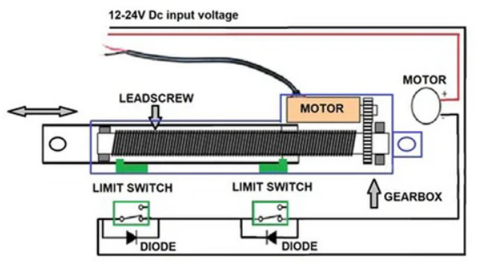
Figure 2 - Diagram of electric actuator (Xiang, 2021)
Within fluid power, pneumatic and hydraulic defines the mixture being pumped into the piston to push the rod out. When pumped out, negative pressure pulls the rod back into the assembly to retract it (Salam, 2022). Hydraulic systems use liquids such as water or oil, and pneumatics use gas which is typically air (see fig 3).
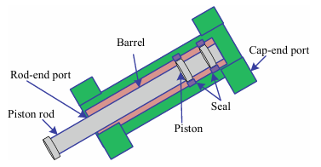
Figure 3 - Diagram of hydraulic actuator (Salam, 2022)

Hydraulic
Hydraulic actuators are employed in high load applications due to the incompressibility of the fluid mixture. Higher pressures can be achieved by the pumps, therefore, are able to extend the piston at a much higher force (Abuowda, et al., 2020). The use of oil and water in a leak can cause many more issues than the failure of the actuator. Contamination of product is a vital concern if using these actuators in a factory environment. These factors equate to the highest maintenance costs (Abuowda, et al., 2020) and the highest force output of the aforementioned options (Pustavrh, et al., 2023). Hydraulics are mostly conserved for use in construction vehicles (Abuowda, et al., 2020) and large gantry cranes (Pawlus, et al., 2016), where the downsides are justified by the extreme loads required.

Pneumatic
Pneumatics are deployed in low to medium load scenarios. This is due to the air used to power actuation being compressible, which causes an unreliable transmission of force. Compressibility combined with the limitation of gas supply pressure and piston area size limit the force output (Salam, 2022). However, pneumatics can deliver the fastest response time with a combination of high velocity and acceleration. Unlike hydraulics, pneumatic power is clean because leaks only emit pure air (Pustavrh, et al., 2023) into the factory environment instead of fluids like water or oil. Making them ideal for factory scenarios (Salam, 2022). Their low load means they are limited for lifting requirements, but pushing, moving, clamping, and stacking objects is much easier to design for (Saravanakumar, et al., 2017). Pneumatic is the most power efficient option of actuation. A low initial set up cost and low ongoing power usage make it the cheapest option to use (Pustavrh, et al., 2023), despite its maintenance being higher than electric. Such as checking for leaks to avoid pressure loss. The system usually has a long service life between repairs which can negate this difference in operational costs (Saravanakumar, et al., 2017).

Electric
Electric actuation is an increasingly more popular actuation method, able to deliver high force outputs and high precision with low maintenance costs. Installation costs are high compared to pneumatic so can be warranted in scenarios where high load, quiet operation, and precision matters (Pawlus, et al., 2016) such as robotics, gate valves (Basu & Debnath, 2015), and packaging/labelling machines (Industrial Quick Search, n.d.). Electric actuators are easily integrated and controlled with the intelligent control methods prevalent in industry 4.0.
Table 1 - Table of actuator types showing advantages and disadvantages (Dings' motion USA, n.d.)
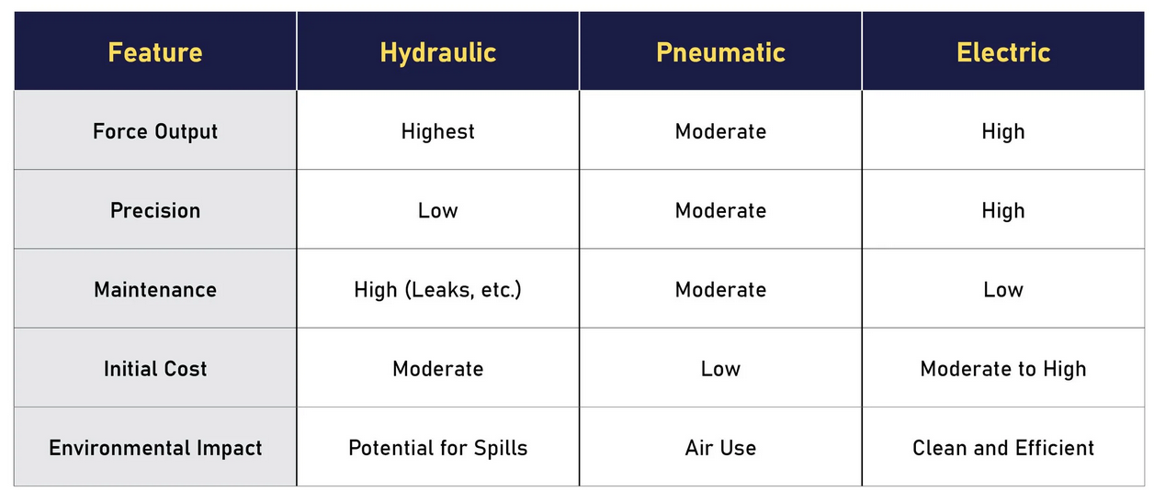

Control System
The simulated factory sections take four packages of varying sizes and weights on a goods-in conveyer. It sorts them by height and further sorts the medium boxes into heavy and light. To program this, Sensors and actuators in the factory were defined as inputs and outputs (see fig 4) so control requirements could be enacted by the PLC in the simulated factory.

Inputs
The inputs are sensors from the factory that allow the PLC to take information in and provide real-time feedback.
- Diffuse sensors to detect packages passing on conveyer.
- Conveyor scale to take weight of boxes to determine where to send them.
- Emergency stop button to safely stop all control mechanisms in event of a hazard. This stop must be instant.
- Start/stop buttons to provide control over startup sequence. Startup sequence is delayed following a two second warning siren before sequentially starting the conveyors.
- HMI inputs to allow remote operators to issue commands from a terminal or VPN connection. Such as start/stop, emergency stop, but also to reset counters for new batch runs or to more easily record productivity tests.

Outputs
The outputs are the PLC’s connection to influence the simulation through motion, sound, or passing of information.
- Conveyor belts to move packages towards their destinations.
- Variables for counters. Total boxes, small, medium and large boxes.
- Scale weight output for HMI terminal for monitoring and troubleshooting purposes.
- Actuators/sorters to redirect packages based on PLC logic and inputs of package characteristics. Pusher/pop-up sorter.
- Warning siren to alert personnel during start up sequence.
- Stack lights to show the state of the machine to operators and the HMI terminal.

Control Behaviour
The operational flow chart (see figure 5) illustrates the process of control behaviour. Starting with the entry conveyor where all the packages enter, to the individual destination chutes, and all the PLC decisions made between. Diffuse sensors are distributed throughout the line: one at the start to keep track of the total number of boxes entering, and one at each end point to track quantities by size. Two diffuse sensors are utilised for sorting by height. The first is placed at the height of the largest box, allowing smaller boxes pass under it, avoiding detection. Bigger boxes are pushed onto a secondary conveyor. The second height adjusted diffuse sensor performs the same, ensuring medium sized boxes are diverted, while allowing the small boxes to continue undetected. The pushers must be fast enough to extend and retract to push the box onto its new trajectory and reset by the time the next box arrives.
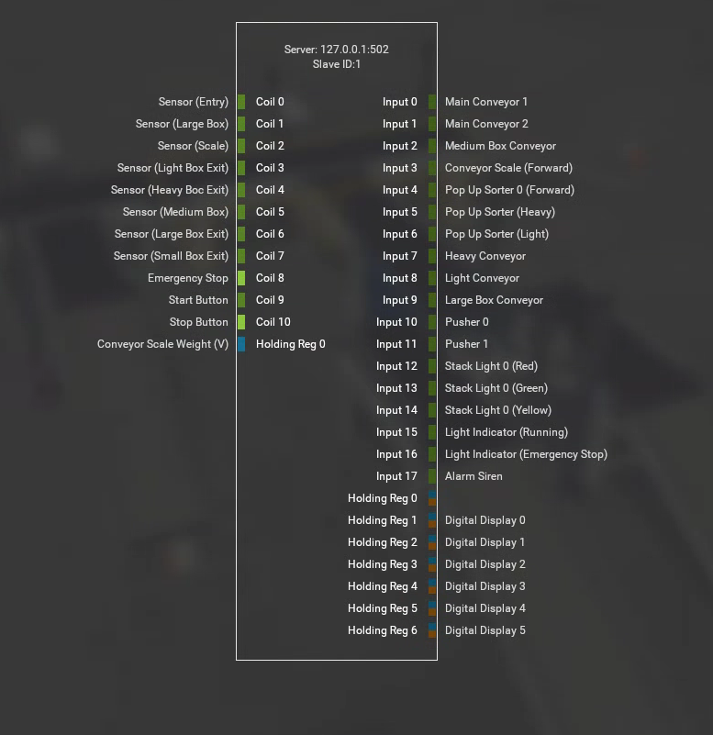
Figure 4 - Simulated PLC input/output map.
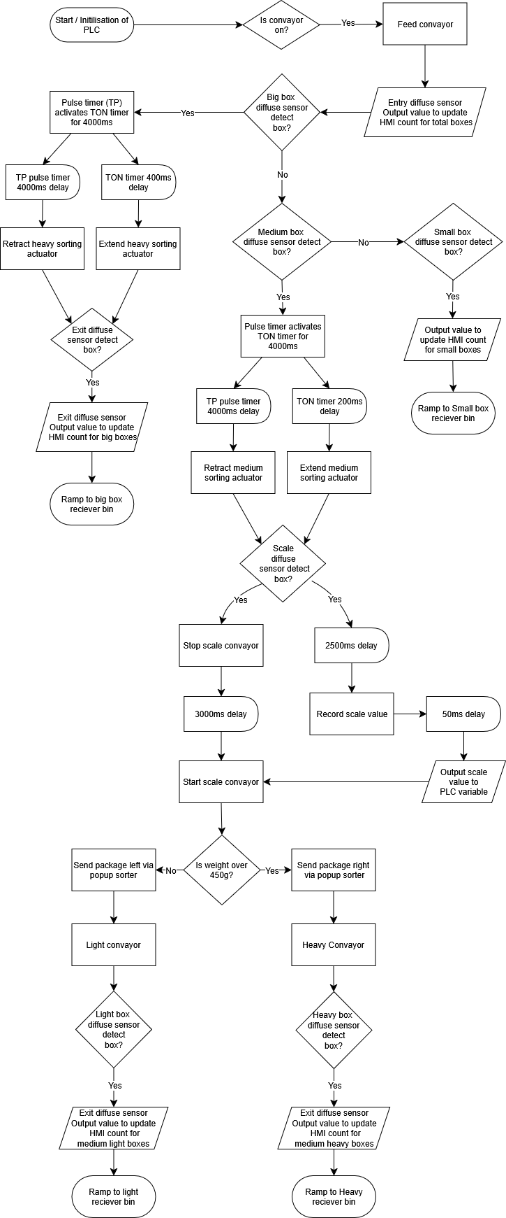
Figure 5 - Operational flow chart of the simulated factory.

PLC Programming
The PLC program was developed using ladder logic in CODESYS. Allowing the coordination between inputs such as sensors and buttons to drive outputs such as conveyors, actuators, the HMI interface (see fig 6), alarms, and lights. Ladder logic programs are organised into individual horizontal “rungs”. On one side of the rung are the inputs, on the other, are the outputs. Logic controllers such as timers, counters, and triggers can be placed between these to dictate how the inputs affect the outputs with the assistance of variables.
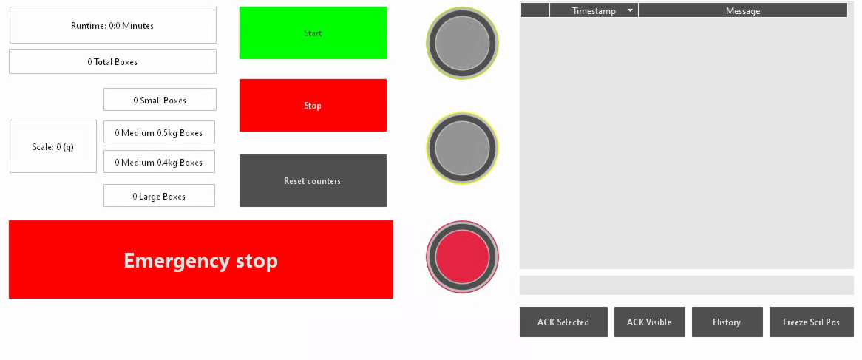
Figure 6 - HMI terminal before machine start

Program structure
To simplify things, there is a variable for startup called ‘ConveyorOn’. This Boolean is made true when none of the emergency stops, or stop buttons are active, and when the start button is pressed on either the HMI or the machine terminal. See ladder line 2 on figure 7. Line 2 also allows the Boolean inputs to be instantly switched to off in the case of an emergency. In the event a stop or emergency button is pressed, line 1 then turns the stack lights to red for safety to show personnel the machine has been stopped and resets the “StartbuttonHMI” Boolean.
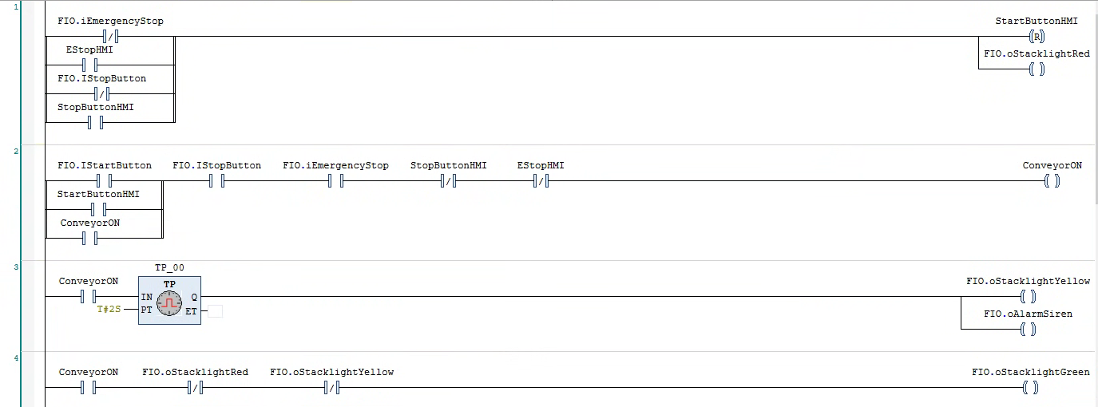
Figure 7 - Ladder logic code for startup
Line 3 (see fig 8) uses a TP pulse timer to turn the amber light and starting siren on for 2 seconds, warning operators that the machine is starting. Line 4 output is then contingent on the second input, which is the reverse state of the amber light. This will only turn the green light on after the 2 second pulse has finished from the line before.
Figure 8 - Startup initiation sequence
Next in the startup sequence is to turn all the individual conveyors on. A sequential startup is required to avoid a large surge in current that could trip fuses. TON (Timer On Delay) blocks are used to delay the start at an incremental delay value of 500ms as shown in figure 9.
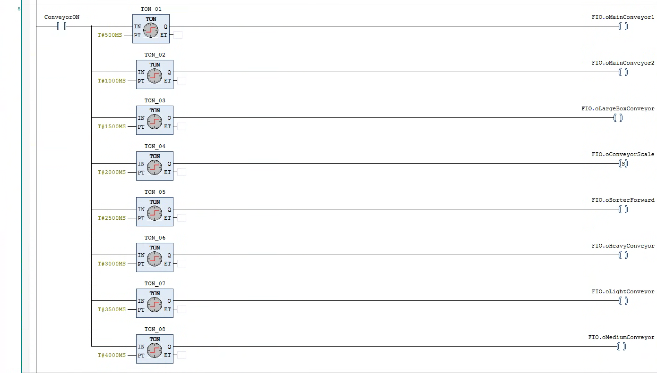
Figure 9 - Sequential conveyor startup
As described in section 3.3, a pusher extends to move the large and medium boxes onto separate conveyor belts. To do this, simple pulse and delay blocks are set up to allow the box to move into position in front of the push plate before it is extended. As shown in figure 10, the TP pulses on for 4000ms in both cases and the TON delays the output before extending the pusher by 400ms for heavy boxes and 200ms for medium. This is the time it takes for the boxes to move into place on the conveyor. This can be calculated using the speed of the belt, the size of the box, and the distance from the diffuse sensor to the actuator. It is important to ensure the box is pushed from its centre of mass and not off-centre, as this could cause the box to turn instead of being pushed to the side.
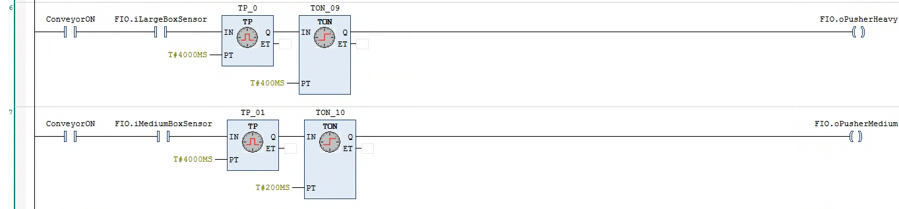
Figure 10 - Pusher actuation code
The sequence for the weight taking works using a pulse timer to reset the belt of the scale conveyor. The package is held on the scale for 3000ms, after 2500ms it then activates a Boolean to allow the weight to be taken. After 50ms the current scale weight is moved to a variable ‘WeightTaken’ and compared to see if it’s 450g or over, or under 450g which determines the pop-up sorter direction configured (see fig 11).
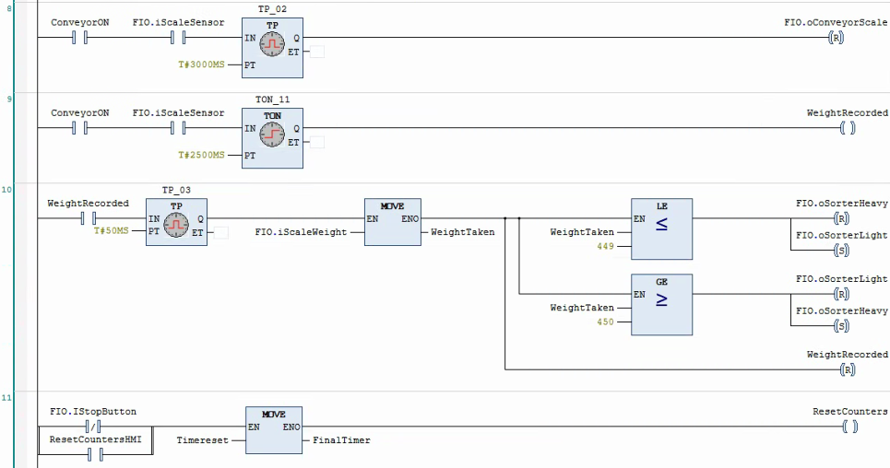
Figure 11 - Scale weight taking procedure and reset
The following figure uses the diffuse sensors, with rising pulse triggers and counters to increment a variable for the HMI display when the sensors are triggered. A ‘ResetCounters’ Boolean enables the HMI operator to reset the counter units.
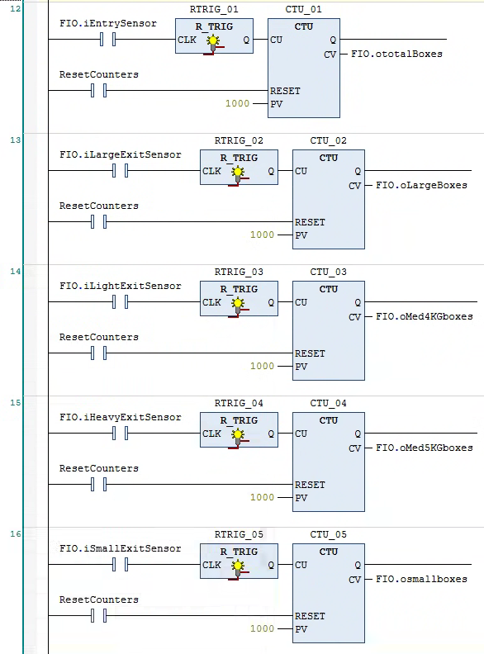
Figure 12 - CTU counters and reset ladder code

Observations

Test Methodology
To test the throughput of the simulated factory and the accuracy of the counter system, simulated tests are required. Three simulation runs of 15 minutes were performed using a TON timer to delay a simulated stop button press after the elapsed time (see figure 13). Data can then be recorded and averaged across the test runs. Using probability, it can be determined that the sorting system is working correctly. The four types of boxes (emitted at random) will each average out at 25% of the total boxes detected at each of the end points. These proportions will come with a degree of variation which should improve with longer simulation runs.
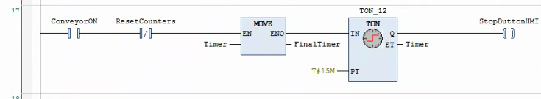
Figure 13 - automatic timer for sorting tests.
A simulation of the emergency stop button press is required to ensure the safety requirements are met. The test requires the machine to have been running for at least two minutes to simulate a normal production state. Emergency stop must be recorded in the warning log on the HMI terminal, activate the siren, and display a red stack light warning on the machine. The results will be recorded for the button press using the HMI terminal and the machine control panel. Unlike startup, everything is required to shut down instantly, essential in an emergency.

Results
Table 2 - Results of sorting test recorded from HMI terminal.
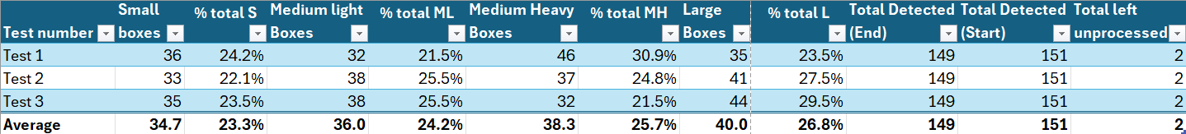
The above results demonstrate the sorter’s ability to correctly sort the boxes into the correct sizes to an acceptable degree. Averaged out over the three simulations of 15 minutes, the percentage total for each size varies between 23.3%-26.8% of the total boxes. Calculating the standard deviation of the four box types equates to 1.6%. A total of 447 boxes were sorted over the three simulation runs; this provides a good dataset to prove the sorting program was functioning correctly.
Displaying the results in a bar graph together with the average shows how small the variation is in the distribution (See fig 14). No boxes were lost during the process, as all discrepancies between the detection value at the start and the end were visually confirmed by inspection of the line at the end. It was confirmed to be boxes that were still being processed when the stop command was sent.
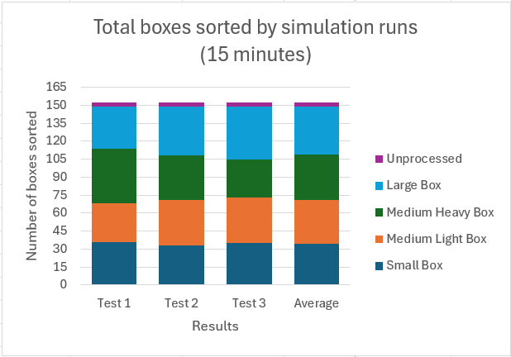
Figure 14 - Excel bar graph from results in table 2.
The system demonstrated a high level of accuracy. If there were sorting errors, one or more of the box types would be constantly mis-sorted between the simulation runs. It is reasonable to assume, as the variation is small and appears random, it was caused by natural probability of individual events. The previous instance of the emitter does not affect the one following, therefore, it will never produce a perfect split between the four box types. Although, the ‘law of large numbers’ states: the mean of a sample of independent random outcomes converges closer to a true expected value as the sample size approaches infinity. For example, a series of coin flips (two outcomes), the proportion of heads approaches 50% (Luxburg & Schölkopf, 2011).
Emergency stop button test performed correctly on machine and HMI terminal (see fig 15). Both were sent to the log system on the HMI indicating where it was pressed. On both tests the machine halted immediately in its current state (see fig 16).
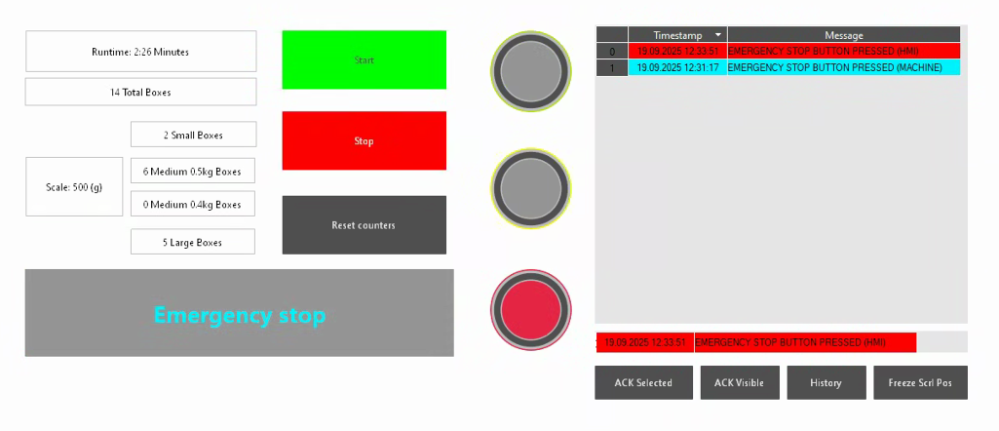
Figure 15 - HMI terminal after emergency stop test concluded.
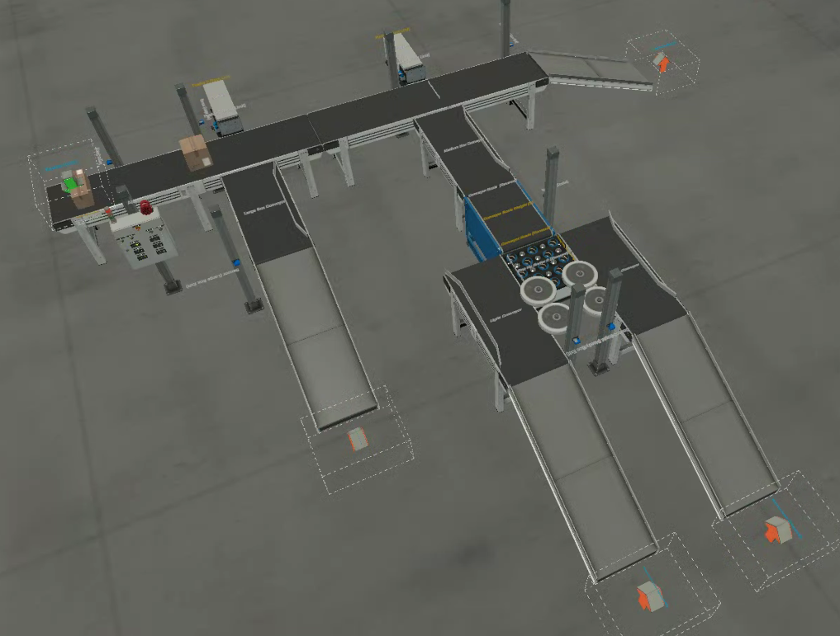
Figure 16 - Factory state after emergency stop test concluded.

Critical Analysis

Strengths
The simulation has proven the PLC program performed well with no issues and satisfied the specified requirements successfully. Packages were sorted and deposited safely and reliably to their respective bins during multiple 15-minute simulation runs. Actuator’s extension and retraction synchronised with the delay timers consistently, and the boxes were pushed from their centre of mass correctly. No boxes were mistimed. The HMI terminal was proven to work and allowed remote monitoring and control over the state of the machine, all controls worked, most importantly the emergency stop performed as expected. A good benefit for the layout of the factory is the modularity. Which allows additional package sizes to be added easily both physically in the factory and within the program. This can be accomplished by adding a new pusher/sensor with a new track, and by duplicating the ladder logic rung of the other sizes.

Weaknesses and improvements
Improvements can be made to the design. For instance, there is a lack of long-term data storage within the counters and overall line performance. Analytics can give information over time helping spot trends and find bottlenecks. As the factory is currently basic and only gives data per run, this doesn’t provide any of these benefits. Metrics like these are fundamental to industry 4.0, where data driven decision making is more adaptable and efficient. As an example, if one section of the factory begins to underperform, the previous sections can be automatically slowed down to avoid accumulation and jams. Such flexible and adaptive decisions are beyond the capabilities of basic ladder logic PLC programming, requiring further integration with higher level systems such as Supervisory Control and Data Acquisition (SCADA) or cloud-based analytics (Curry, et al., 2022).
To optimise the factory, the cycle time could be severely reduced. The factory works well, but there is an opportunity to find a minimum allowable distance between packages. If the speed of the conveyors and emitter were increased until the line could no longer sort the intake, the bottleneck becomes the pusher speed. It is unclear which method of actuation factory IO is simulating, it could be electric. Which means speed can be resolved by switching to pneumatic actuators as was found in the literature review. The pusher fails to retract fast enough, and the next box becomes wedged between the push plate and the actuator assembly. Swivel arm actuators could possibly replace the push actuators to allow for faster movement of the redirection process. Packages can also move faster without worry of inertia as the redirection force is a smooth angular force instead of a direct perpendicular force. This would also be much more reliable as it’s not possible to extend the actuator too early, this gives a much wider window for extension and retraction as new packages cannot get caught in the arm if left extended. A study on automated material handling as part of a manufacturing line revealed, in the optimised state of the line, logical dependencies were dominated by the gripper (47.82%) and the swivel arm (30.85%), while the pusher accounted for just 0.13% (Alkan, et al., 2016).

Conclusion
This project demonstrated the successful design and simulated test of a PLC controlled automated material handling system using ladder logic and Factory I/O. The foremost assessment was to ensure the correct distribution of packages by their size and weight. Proven using the law of large numbers, a mathematical law, and the average counter totals of three timed simulation runs. All packages were accounted for and correctly sorted into their respective bins; this proved the sorting system’s reliability. The HMI terminal added monitoring and safety utility well. Although basic, this allowed remote operators to monitor counters, scale weight, and interact with the machine remotely. The safety control functioned as expected, allowing the emergency stop button to be initiated from both the HMI and the operator terminals. Tests determined correct functionality and safe shutdown and were logged correctly in the warning system; this is essential for the safety of plant operators and the machine.
These tests prove the system meets its objectives and performs as expected, although the system could benefit from some optimisation. The pushers for instance require a large gap between packages, which slows down the throughput of the line considerably. This could be resolved by using Pneumatic actuators or switching to a different kind of motion such as a swivel arm pusher. Another downfall was the simplistic HMI terminal, which could benefit from recording historic trend data and connecting to a more flexible system such as SCADA. This would provide a more comprehensive overview of performance and statistics and allow the system to react to the environment in a more dynamic way.

References
Abuowda, K. et al., 2020. A review of electrohydraulic independent metering technology. ISA Transactions, Volume 98, pp. 364-381.
Alkan, B. et al., 2016. Design Evaluation of Automated Manufacturing Processes Based on Complexity of Control Logic. Procedia CIRP, Volume 50, pp. 141-146.
Basu, S. & Debnath, A. K., 2015. Chapter VI - Final Control Element. In: Final Control Element. Cambridge: Academic Press, pp. 387-441.
Curry, E. et al., 2022. Technologies and Applications for Big Data Value. Cham: Springer.
Dings' motion USA, n.d. High Force Linear Actuators – Comparing Hydraulic, Pneumatic, and Electric Solutions. [Online]
Available at: https://www.dingsmotionusa.com/blog/high-force-linear-actuators-comparing-hydraulic-pneumatic-and-electric-solutions?srsltid=AfmBOoqixKNuY5jhxPktlL-nkCdNYE1HikyGrXohVkeILCWPxXqPWiO8
[Accessed 20 09 2025].
Industrial Quick Search, n.d. Electric Actuators: Types, Applications and Benefits. [Online]
Available at: https://www.iqsdirectory.com/articles/linear-actuator/electric-actuators.html
[Accessed 20 09 2025].
Janocha, H., 2004. Actuators: Basics and Applications. 1st ed. Heidelberg: Springer Berlin.
Luxburg, U. v. & Schölkopf, B., 2011. Statistical Learning Theory: Models, Concepts, and Results. Handbook of the History of Logic, Volume 10, pp. 651-706.
Pawlus, W., Choux, M. & Hansen, M. R., 2016. Hydraulic vs. Electric: A Review of Actuation Systems in Offshore Drilling Equipment. Modeling, Identifcation and Control, 37(1), pp. 1-17.
Pustavrh, J. et al., 2023. Comparison of hydraulic, pneumatic and electric linear actuation systems. Scientific Reports, 13(1).
Salam, M. A., 2022. Fundamentals of Pneumatics and Hydraulics. 1st ed. Singapore: Springer Singapore.
Saravanakumar, D., Mohan, B. & Muthuramalingam, T., 2017. A review on recent research trends in servo pneumatic positioning systems. Precision Engineering, Volume 49, pp. 481-492.
Xiang, G., 2021. Electric Linear Actuators. [Online]
Available at: https://www.electric-linear-actuators.com/blogs/news-1/the-working-principle-of-electric-linear-actuator
[Accessed 20 09 2025].

