

Data Security, Governance and Compliance
(ACCA7028)

Student Name: Hassan Ahmed Khan
Student ID: 2220382

ABSTRACT

Examinations of various security frameworks This assignment delves deeply into data security, governance, and compliance, providing an understanding of how Information Technology (IT) principles and models are implemented in these contexts. The primary goal is to create a link between theoretical concepts and practical application by addressing a specific scenario that emphasises the need of robust data protection mechanisms.

The study begins with a comprehensive analysis of popular IT models and frameworks, including ISO/IEC 27001, COBIT, and ITIL. This analysis aims to build the foundation for future research and implementation by highlighting the key concepts and practices found in these frameworks.

After then, the task is completed in a real-world environment using these IT models and frameworks. Particular attention is paid to data security, which includes encryption, access controls, and threat detection. Through the development of policies, procedures, and accountability frameworks, governance aspects are examined in order to offer an all-encompassing and proactive approach to managing IT resources.

TABLE OF CONTENTS
1. Introduction
2. NG’s security and model
I. Nature Garden's Cloud Services Data Security
II. Compliance for Nature Garden's Cloud Services
3. Research on Security Frameworks
Relevance
4. Approach for NG
Proposed Method and Framework

- INTRODUCTION

Data security, governance, and compliance are fundamental in cloud administrations to guarantee that information is protected, secure, private, usable, and in consistence with both external and internal information strategies. A governance framework is required to coordinate and direct the management of the service. Throughout the course of a service, an efficient governance framework will guarantee that personnel, procedural, technical, and physical controls remain in place. It must also react to modifications in the service, advancements in technology, and the emergence of fresh dangers. Cloud compliance standards are a collection of industry-specific regulations and legal frameworks that specify how cloud-based data handling must be done by organisations. These standards lay-up guidelines for handling confidential information, making sure workloads have appropriate protection, and conducting frequent audits.

- NG’s security frameworks and model

It is essential to secure, manage, and guarantee compliance for Nature Garden's cloud services in order to safeguard confidential information, preserve data integrity, and abide by applicable laws and regulations. Here's a tailored approach for each aspect.

- Nature Garden's Cloud Services Data Security:

- Role-based access restrictions should be put in place to guarantee that only those with permission can access particular data.

- To improve user authentication, make advantage of multi-factor authentication.

- Encryption: For data in transit, use encryption methods (such SSL/TLS). Encrypt data while it's at rest to safeguard cloud-stored information.

- Network Security: To monitor and secure network traffic, use intrusion detection/prevention systems and firewalls.

- A Virtual Private Cloud (VPC) could be a useful tool for network and resource isolation.

- Frequent Audits: To find and fix any vulnerabilities, do frequent security audits and vulnerability assessments.

In order to quickly identify and address security incidents, keep an eye on activity and log it.

- Compliance for Nature Garden's Cloud Services:

- Data Protection rules:

Recognise and abide by the data protection rules that apply in the areas where Nature Garden conducts business, such as the GDPR if those operations take place in the European Union. Put policies in place to safeguard people's rights and privacy, particularly while managing personal data in the cloud.

- Standards for the Industry:

Respect sector-specific guidelines that are pertinent to Nature Garden's activities (such as ISO 27001 for information security management).
Verify that cloud service providers adhere to industry norms and laws as well.

- Consistent Reporting and Audits:

To evaluate compliance with legal requirements, rules, and industry standards, conduct routine compliance audits.
As required, compile and send the applicable reports to the appropriate regulatory bodies.

- Data Standards and Policies: Create and implement data management standards that specify how information is shared, handled, and kept on the cloud. To secure and prioritise sensitive information, set rules for data classification.

- Data Stewardship: Assign data stewards to supervise compliance, quality, and integrity of data in cloud environments. Establish a framework for data governance that addresses ownership and accountability for tasks involving data.

- Metadata Management: To improve the comprehension and usability of data stored in the cloud, record and manage metadata. Make sure the metadata contains details regarding the ownership, sensitivity, and lineage of the data.

Also, we need to ensure that the cloud service provider for Nature Garden has strong security protocols and compliance certifications.
Update security procedures and policies on a regular basis to keep up with new threats and legal requirements. Nature Garden may also need to establish a strong foundation for safeguarding its data, upholding data quality, and adhering to legal and regulatory standards in the cloud environment by incorporating data security, governance, and compliance procedures into its cloud services strategy.

ITIL's methodology can be depicted as a direction system containing shoulds rather than musts. The most widely used strategy for managing and providing IT services is ITIL. It comprises of best works on with respect to individuals, cycles, and innovation to establish a climate that uses the most extreme capability of your association's assets. An organisation can start by using ITIL rules to gain control over its resources. After completing it, companies can think about fulfilling the ISO 20000 criteria. ITIL compliance can facilitate the ISO 20000 certification process, despite its challenging nature.

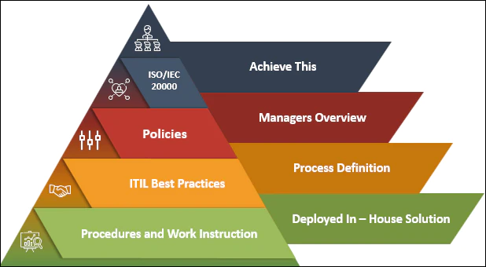

- Research on Security Frameworks and Models

While picking a security system or model for Nature Garden, it's vital to think about the particular necessities, chances, and administrative prerequisites of the association. The following security models and frameworks may be useful for Nature Garden:

- NIST Online protection System (CSF):
The NIST CSF gives an adaptable and extensive way to deal with network safety, zeroing in on capabilities, for example, Distinguish, Safeguard, Recognize, Answer, and Recuperate. It is widely used and suitable for businesses and organizations of all sizes.

- ISO/IEC 27001:
This global norm for data security the board can assist Nature Garden, execute, and keep a data security the executive’s framework (ISMS). ISO/IEC 27001 is especially gainful for associations worried about the assurance of sensitive data.

- Critical Security Controls of the CIS:
To assist businesses in improving their cybersecurity posture, the CIS Critical Security Controls provide a prioritized set of best practices. These controls are common-sense and can be altered to suit the particular necessities of Nature Garden.

- Zero Trust Model:
Adopting a Zero Trust Model can be beneficial in light of the increasing sophistication of cyber threats. This approach expects that no substance, whether inside or outside the association, ought to be relied upon naturally, requiring confirmation for all people and gadgets attempting to get to assets.

- COBIT (Control Targets for Data and Related Advances):
COBIT gives a structure to the administration and the board of big business IT. It addresses topics like risk management, information security, and regulatory compliance and brings IT goals into alignment with business objectives.

- FAIR (Component Investigation of Data Hazard):
FAIR is a structure for evaluating and dissecting data risk in monetary terms. Using a cost-benefit analysis, it can help Nature Garden prioritize security investments.

- ITIL (Data Innovation Foundation Library):
While basically known for IT administration the executives, ITIL additionally incorporates best practices for data security the board. This structure can be significant for associations hoping to coordinate safety efforts into their general IT administration conveyance.

- OWASP (Open Web Application Security Venture):
The OWASP framework can offer guidance on identifying and mitigating security risks in web applications if Nature Garden deals with them. The OWASP Top Ten is a notable rundown of normal web application security chances.

- Bound together Consistence System (UCF):
UCF is a standardized system that combines multiple compliance frameworks into one. This can be helpful for businesses that have to deal with a variety of regulatory requirements.

While carrying out a security system, Nature Garden ought to fit it to its particular industry, functional setting, and administrative scene. Furthermore, continual evaluations and updates are essential for adjusting to changing risks and modifications in the corporate environment. To ensure that the chosen framework meets Nature Garden's specific needs, experts or security professionals should be consulted.

- Use of ITIL and ISO 27000 to NG’s requirement:
ITIL is a set of ITSM practices that aid in coordinating the delivery of services in the information technology sector. The Central Computer and Telecommunications Agency (CCTA) in the UK created ITIL initially, but it has since grown into a widely recognised model of IT service management. It includes an exhaustive list, activities, and procedure that will meet the demands of any organisation utilising it as advice. It defines a wide variety of essential IT practices in great detail.
The NG can use ITIL for data security and governance stems from its idea of structured service management that enables it to satisfy its demands effectively and efficiently. Its frameworks include service design, which has a direct impact on IT system security, as well as ongoing service improvement, which is critical for long-term data security maintenance and enhancement.

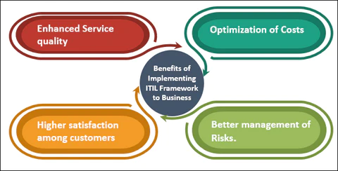

The ISO 27000 series is a collection of international standards that serves as a framework for information security management systems (ISMS). These standards are developed and maintained jointly by the International Organisation for Standardisation (ISO) and the International Electrotechnical Commission (IEC). The ISO 27000 series is widely recognised and implemented worldwide as a standard for establishing, implementing, maintaining, and continuously enhancing information security within organisations.

The series' core standard, ISO/IEC 27001, describes the conditions that must be met in order to create, deploy, maintain, and continuously enhance an ISMS. An information security management system (ISMS) is a methodical approach to handling sensitive data that guarantees the privacy, availability, and integrity of information assets.

This standard offers a methodical and thorough approach to information security, empowering businesses to create and uphold strong security procedures. Organisations that are certified ISO 27001 show that they are dedicated to controlling risks related to information security and putting in place efficient security measures.

Relevance of ITIL and ISO 27000 series

Given that Nature Garden is probably a business that relies on a variety of IT systems to manage operations, marketing, and sales, ITIL (Information Technology Infrastructure Library) can be very applicable. With the help of the ITIL framework for best practices in IT service management, Nature Garden can accomplish the following:

Improved efficiency and cost savings: Streamlined processes for incident management, problem resolution, and change management can reduce downtime and resource waste.
Increased client satisfaction: Better customer experience and loyalty can result from a focus on service delivery and support that is tailored to the needs of the user.
Improved fit with business objectives: ITIL encourages matching IT services to the overarching business plan, guaranteeing that IT assets directly support Nature Garden's prosperity.
Enhanced cooperation and productivity: Clearly delineating roles and duties within the IT department can enhance.

ISO 27000, specifically ISO 27001:2013, establishes a framework for Information Security Management Systems (ISMS). Its relevance for Nature Garden lies in:

Data security and compliance: Implementing an ISMS based on ISO 27001 helps secure sensitive data (customer information, financial records, intellectual property) from unauthorized access, theft, or loss. This can establish confidence with customers and ensure compliance with appropriate data privacy standards.
Risk management: The framework provides a structured approach to identifying, assessing, and mitigating security risks across IT systems and processes.

Improved business continuity: Proactive measures for data backup, disaster recovery, and incident response ensure business operations can continue even in the event of a security breach or system outage.
Competitive advantage: Nature Garden may be able to gain an advantage over its competitors in today's cyber-aware market by demonstrating its commitment to data security through ISO 27001 certification.

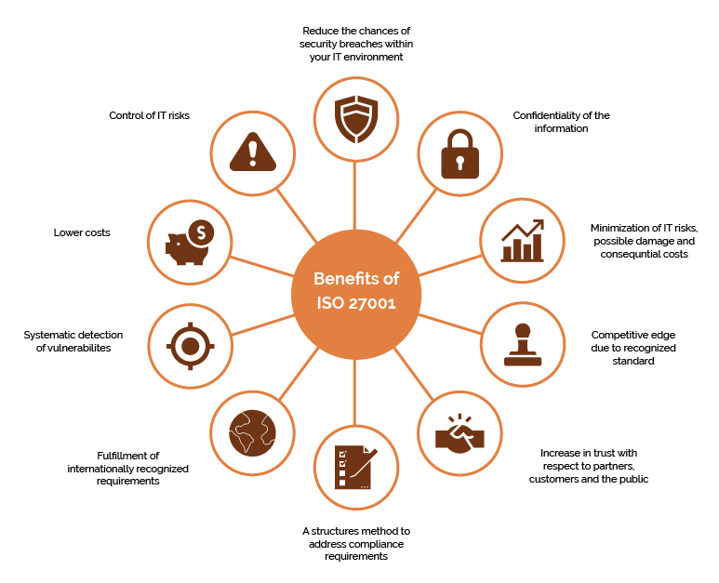

- Approach for Nature Garden

A thorough evaluation of Nature Garden's security requirements must be considered for the organization's operations, IT setup, and corporate goals. Key areas for identifying potential risks, weaknesses, and areas for improvement should be included in the assessment. The following is a thorough method to evaluate Nature Garden's security requirements:

- Requirements for Compliance and Regulation: Determine which regulations apply to Nature Garden's sector. Establish precise compliance standards for privacy, data protection, and other pertinent laws.

- Existing Security Guidelines and Practices: The current security guidelines and protocols and how thorough and effective the present security measures are. If there are any holes or places where policy enforcement needs to be strengthened.

- Access Controls: Assess the efficiency of user authentication procedures and access controls. Evaluation and determination of the least privilege principles are being applied and which places need more robust access controls.
Examine the infrastructure and design of the network for security.
Determine and evaluate the network's weaknesses.
Assess the efficacy of network segmentation, intrusion detection/prevention systems, and firewalls.

While cloud services offer unparalleled scale and connection, NG's adoption of them also exposes the country to a wide range of security risks. To guarantee data integrity, availability, and confidentiality in the setting of ubiquitous "big clouds" and their nebulous infrastructure, security models that transcend traditional perimeters are necessary.

Proposed Method and Framework:
Creating a systematic set of guidelines, protocols, and technological safeguards to safeguard the company's information assets and guarantee the privacy, accuracy, and accessibility of its data is the process of designing a security framework for Nature Garden. A suggested security framework for Nature Garden is shown below:

- Governance and Leadership: Creating a governance framework to guarantee that security goals are in line with corporate goals. For this we have to establish Security Steering Committee tasked with supervising security measures and coordinating them with organisational objectives. Chief Information Security Officers (CISOs) or other security leaders in charge of general security management should be appointed.

- Risk Management: Recognise, evaluate, and control threats to the information assets of the company. Risk assessment: To find possible weaknesses and dangers, do risk assessments on a regular basis. Create and carry out a plan to transfer, accept, or lessen hazards that have been recognised.
- Continuous Monitoring: Put in place systems for monitoring ongoing developments in order to identify and address new threats.

- Policies and Procedures for Information Security: Disseminate policies and procedures that will direct safe behaviour inside the company. We have to use IT systems and resources. Data Classification Policy: To determine suitable handling techniques and classify data according to sensitivity and creating an incident response plan that outlines how we will handle and move past security incidents.

A strong and comprehensive approach to information security is created by coordinating policies, procedures, and technology, as part of Nature Garden's security strategy.

We can also adopt a methodical strategy to manage information security risks and guarantee the confidentiality, integrity, and availability of sensitive information is a necessary part of implementing ISO 27001 for Nature Garden's security. An overview of how Nature Garden can comply with ISO 27001 is provided below:

- Creating the Information Security Management System, or ISMS:

Creating an information security policy defining NG’s organization's security commitment. Specifying the ISMS's reach.
To determine the dangers to information security, conduct a risk assessment.
System for managing documents: Maintain and archive information security guidelines and protocols.
Tools for Risk Assessment: Assist in recognising and evaluating information security threats.

- Implementing Security Controls:

Policies: Implement selected measures to mitigate identified risks in the NG’s security model. Processes: Adopt a set of security controls based on ISO 27001 Annex A.
SIEM (Security Information and Event Management): Keep an eye on and address security events.
Enforce user permissions and access limits with access control solutions.

- Creating an Incident Response Plan. Incident Response and Management. Form an incident response group.
Test and update the incident response plan on a regular basis.
Simplify the reporting and handling of incidents. In the event of an occurrence, forensic tools can assist with forensic analysis.

Nature Garden is able to systematically manage information security risks and continuously improve its security posture by adhering to ISO 27001. This system gives an organized way to deal with laying out, executing, keeping up with, and ceaselessly working on an ISMS. Normal reviews and evaluations will assist with guaranteeing continuous adequacy and consistence.

- Updated Regulations and Practices

Continually having new or refreshed guidelines and norms is viewed as great practice because of multiple factors, especially with regards to data security and consistence. Here are a few key motivations behind why this training is useful:

- Adapting to a Changing Threat Environment: Cybersecurity Risks Cyberthreats are ever-changing, making the threat landscape dynamic. Organisations can remain ahead of developing risks and vulnerabilities by implementing new and updated rules, which guarantee that security measures are in line with the most recent cyber threats.

- Technological Progress: New Technologies: Technology is advancing quickly, posing new threats and difficulties. New technologies' security consequences are considered in updated standards, which also offer recommendations for their safe application.

- Enhanced Reaction to Events: Guidelines for incident response and management are frequently included in new regulations. Organisations can minimise the impact of breaches and respond to security issues with the latest best practices thanks to regular updates.

- Compliance with Law and Regulation: Legal Requirements: Organisations must abide by all applicable regulations by law. Keeping up with upgrades guarantees continuous compliance, which aids businesses in avoiding fines and legal repercussions.

- Trust from Customers and Partners: Proven Commitment Following the most recent standards indicates a dedication to compliance and security. This can build an organization's reputation, draw in business partners, and increase customer trust.
For organisations to be resilient against changing threats, adhere to legal requirements, and show a commitment to efficient information security and risk management, new or updated legislation and standards are crucial. It is a proactive strategy that aids in an organization's adaptation to the evolving cybersecurity environment.

In order to handle compliance, NG would need to keep up with these rules. This entails keeping a close eye on the regulatory landscape on a regular basis, funding compliance-promoting training programmes, and integrating regulation into daily operations.

Furthermore, the implementation of a robust Governance, Risk, and Compliance (GRC) programme by NG will facilitate the organization's handling of these updates with greater efficiency. By making use of such a platform, NG is able to quickly detect modifications to rules and provide guidance for the process of putting new policies and controls into place.

CONCLUSION

Since NG's scope of operations is essentially in line with current laws and norms, it offers a platform for compliance that fosters confidence among stakeholders and clients alike. By implementing comprehensive security policies, managing risks, and engaging in strategic planning, NG may take a proactive stance that enables it to anticipate potential threats and act before they materialise. By preparing for potential security problems and putting preventative measures in place, NG can respond swiftly to them.

Proceeding, NG ought to put resources into progressing security instruction and mindfulness drives for its staff so the business can foster a culture of being wellbeing cognizant. Needing to remain in front of any likely weaknesses, NG ought to routinely refresh its gamble appraisals and security approaches considering winning dangers. Utilizing imaginative advancements, for example, AI to convey expectations for intimidation investigation can give NG best in class apparatuses that ought to help it identify and answer digital dangers.

Reference list
Atlassian (n.d.). Incident Management: Processes, Best Practices & Tools. [online] Atlassian. Available at: https://www.atlassian.com/incident-management#:~:text=IT%20incident%20management%20process [Accessed 9 Jan. 2024].
Ghaznavi-Zadeh, R. (2017). Enterprise Security Architecture—A Top-down Approach. [online] Isaca.org. Available at: https://www.isaca.org/resources/isaca-journal/issues/2017/volume-4/enterprise-security-architecturea-top-down-approach.
Irwin, L. (2019). ISO 27001: The 14 control sets of Annex A explained - IT Governance Blog. [online] IT Governance Blog. Available at: https://www.itgovernance.co.uk/blog/iso-27001-the-14-control-sets-of-annex-a-explained.
ISO (2022). ISO/IEC 27001 standard – information security management systems. [online] ISO. Available at: https://www.iso.org/standard/27001.
Itgovernanceusa.com. (2016). ISO 27001 and NIST - IT Governance USA. [online] Available at: https://www.itgovernanceusa.com/iso27001-and-nist.
ITSM Docs - ITSM Documents & Templates. (2022). ITIL and ISO 20000: All You Need to Know. [online] Available at: https://www.itsm-docs.com/en-gb/blogs/itil-concepts/itil-and-iso-20000-all-you-need-to-know [Accessed 9 Jan. 2024].
SearchDataCenter. (n.d.). What is ITIL (Information Technology Infrastructure Library)? [online] Available at: https://www.techtarget.com/searchdatacenter/definition/ITIL.
www.cybrary.it. (n.d.). CISSP Study Guide: Information Security Models | Cybrary. [online] Available at: https://www.cybrary.it/blog/information-security-models.

