Procurement strategy and policies formed in the decision process of Crossrail in it`s supplier selection

Introduction
The goal of this essay is to evaluate the policies and procurement strategies involved with supplier selection. This evaluation will focus on the development of Crossrail`s policies and procurement strategy and how the selection of suppliers fit into the strategic objectives. The evaluation will be done based mainly on decision making and some of the tools and models used to achieve the desired outcome. The evaluation will be cross referenced with academic literature to assess the strategy used.

Formation of a strategy
According to (Lloyd-Davies, et al 2016) the Crossrail projects procurement practice was first developed during the London Olympics project for 2012 finding the best practice and how to implement it in the most efficient way. The Procurement and Supplier Engineering (PSE) is an innovated approach to managing large infrastructure projects. The model from the Crossrail learning legacy s in the figure below.
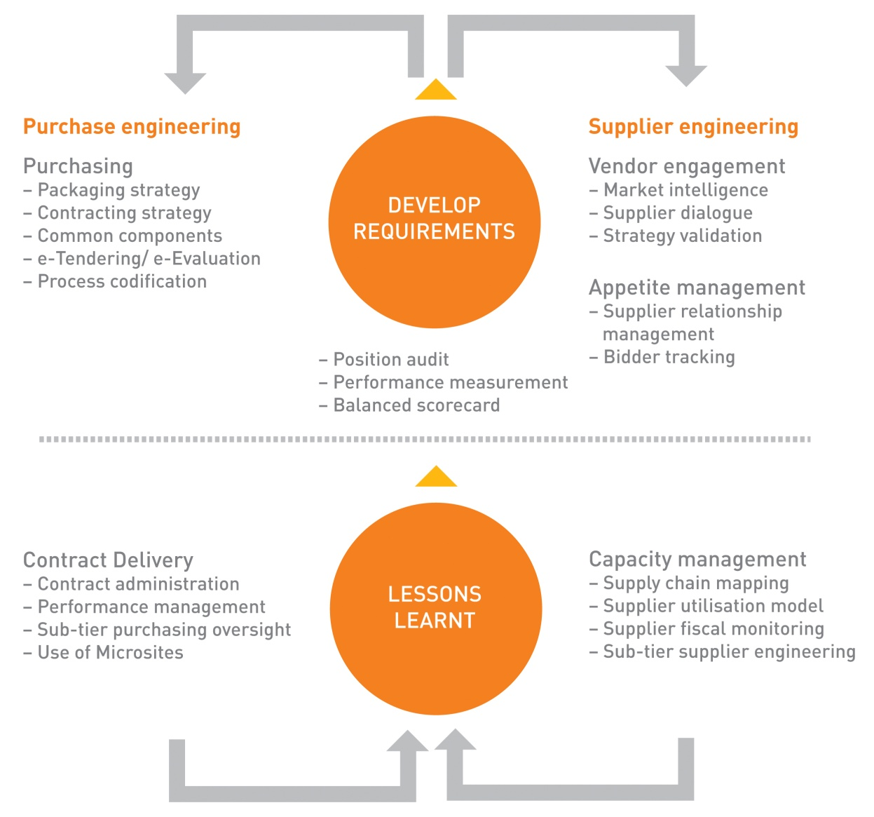

Figure 1 – Procurement and Supplier Engineering (PSE) Model

Even though the PSE model was considered the most effective method of practice at the time moving on from the London Olympics to the Crossrail project, however it took 6 months to implement the model. The reason for the delay in establishing the processes needed to adhere to the PSE model was due to the time it takes to obtain all the appropriately skilled and experienced staff needed for the model`s delivery.
The PSE model was adopted by the Crossrail project however the Procurement Director and team members wanted to put more emphasis on the steps needed for successful acquisition made into a document named the “Procurement Code” governing the methods for delivery for the function of procurement. The “Procurement Code” was later developed into what would become known as the “Six Pillars” of procurement. The Six Pillars would be incorporated into the IUK Project Initiation Routemap (procurement module) in the future.
According to (Lloyd-Davies, et al 2016) the governing body of the project were the key stakeholders at the beginning of the project in 2009, however by May 2010 control was given to the Crossrail board to have full control of financial and procurement functions due to the projects maturity being proven in review. The relinquishing of control was from external stakeholders was needed to make the approval system more efficient, and by simplifying it by means of a-tendering.
According to (Mena et al 2018) A stakeholder is any person or organisation that can affect or be affected by the operations of the project`s organisation. A stakeholder can be a barrier to change negatively effecting the relationships causing delays or impacting on the overall strategy. A stakeholder analysis is done to create a stakeholder map and register to identify threats and areas of cooperation by charting each stakeholders threat and benefits to the strategy rollout by identifying their level of responsibility and commitment to highlight levels of support needed.
According to (Mena et al 2018) the four building blocks underpinning a good strategy execution would be:
- Decision rights
- Designing information flows
- Motivators
- Structure
The first building block is to make clear who is responsible for making decisions and who to hold accountable. The second building block is to provide access to information needed at the right time freely within the organisation. The third building block is to ensure objectives and measures of performance towards expectations are rewarded by the achievements made towards goals, the rewards can be both financial, or non-financial. The fourth building block is to structure the organisation to match the desired strategy limiting how many layers there are within the structure of the organisation preventing the strategy being executed.
In this section the formation of the strategy requires the alignment of the structure of the organisation to match the desired strategy in this instance it’s the model used needing the skilled people in place to make the model work constantly reviewing the state of the model making adaptations for greater efficiencies. The decision making process is key to achieving the strategic goals making sure the right stakeholders are making the decisions to improve speed and clarity, done by assessing the stakeholder` status and mapping out their responsibilities, threats and benefits to the organisations execution of the project`s strategy.

The Procurement Policy
According to (Lloyd-Davies, et al 2016) the Transport for London`s (TFL`s) policy would be where the Procurement policy for the project would fall in line with, and affecting the objectives of the project. The objectives leading the TFL`S policy would be to deliver Crossrail`s objectives at the best value affordable by taking advantage of efficiency improvement opportunities and by utilising TFL`s industry partners try and achieve economies of scale throughout the project. The contractual agreements and the procurement procedures must support Government and TFL`s policies. Controlling and governing policy is there to ensure Crossrail meets legal obligations and does not go beyond its financial limitations maintaining control and allowing accountability. The policy of standardisation of commercial arrangements to deliver effective efficient procurement of products, services, or work, and enforce it to be common in nature. The policy to develop and build and maintain relationships with suppliers and their supply chains is important in achieving the most affordable value possible.
The above policies where used early on in creating the procurement strategy. The four policies above where based of 33 key policy principles established from past infrastructure projects, however they where simplified into four clear policies to keep the strategy in sight.

Supplier strategy
The Crossrail project`s use of supplier and market analysis was to asses 7000 suppliers to be part of the supply chain. The criteria they were assessed on was:
- Supplier solvency
- Secured turnover scored in percentages
- Supplier Delinquency
The supplier solvency is analysed to evaluate the supplier`s ability to pay the supply chain. Where the percentage of turnover is scored it is analysing the capacity of the supplier to see if they are over-committing themselves. Supplier delinquency is to analyse the supplier to assess their trading behaviour such as late payments, CCJ`s and winding up orders. The Dunn and Bradstreet (D&B) delinquency tool is the one mentioned by (Lloyd-Davies, K et al 2016).
The supply chain management team at Crossrail developed a means for SMEs to compete for work in supplying the project with goods or services. This meant that SME`s from all over the UK could bid for work as part of Crossrail`s sustainability initiatives. The Tool used was the CompeteFor portal.
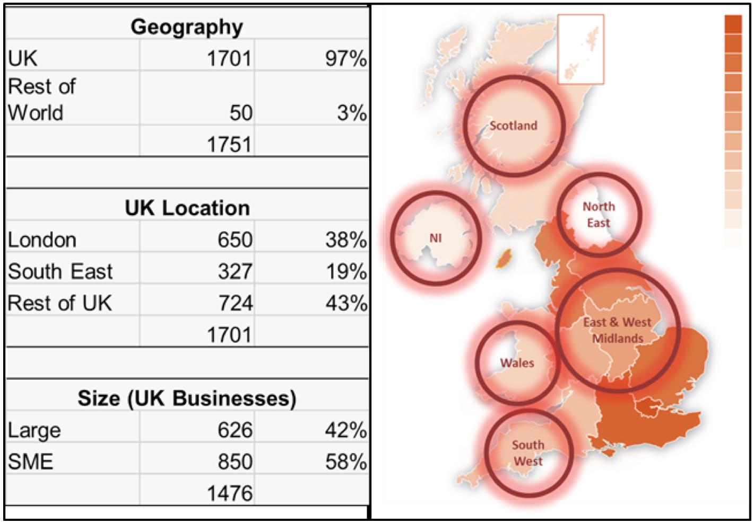

Figure 2 Heat map

The heat map shows the areas that had business through this portal. Over 8000 business representatives were engaged by the SCM team.
All suppliers are only engaged with through the procurement process to maintain fairness and consistency. Communication is paramount to maintaining capability, capacity, and appetite. A clear timeline and format of engagement with suppliers is part of Crossrail`s engagement strategy. Early planning such as risk allocation and communication of the projects potential package with suppliers is essential to a successful engagement strategy (Lloyd-Davies, et al 2016).

According to (Mena et al 2018) the decision process in the selection of suppliers is crucial to the competitiveness of an organisation in the fast-changing environment in todays market. It is an ongoing process of assessing the suppliers against tangible and intangible multiple criteria by assessing qualitatively, and quantitively. This is particularly to make decisions against conflicting criteria from suppliers to make the best strategic decision, the example in the book is of conflicts between tangible and intangible criteria such as price vs satisfaction. The features stated to be key to selection is based on performance such as checking to see if there are differences between receipts and due dates using a flagging system to flag up and be compared against KPI`s pre-determined, and service level agreement checking against delivery quality, orders being on time and in full (OTIF), price variations, and quality ratings. The e-procurement tool is used to reduce unwanted suppliers (not meeting the pre-determined requirements) and adding the suppliers that meet the organisations objectives to be added to the portfolio.
(Mena et al 2018) suggested tools used for the selection of suppliers such as:
- REP
- RFQ
- RFI
- RFT
e-RF stands for electronic request for x (e-RFx), x is a variable that could mean any of the above for example request for a proposal (REP), or quotation (REQ) or information (RFI), or tender (RFT) etc. aligning the module to the procurement strategy is important, asking a series of question to suppliers to gain valuable knowledge of whether they can deliver the required obligations set by the organisation (Crossrail).
According to (Mena et al 2018) management of the contract over its lifecycle is needed for ongoing compliance with the terms set out in the contract. Before real-time data collection from suppliers the supplier had to share any changes that could be outside of the contractual terms such as: price. The software used today gives real-time data to the procurement function showing the data coming back from REP`S, RFI`S or REQ`S etc to renegotiations needed, in a means to add control to the organisation to reduce supplier risk and to improve transparency of supplier contracts. This system improves cash flow and creates opportunity for strategic negotiations with suppliers by means of automation creating a more streamlined acquisition process and ease of maintenance and contractual continuity, and improving supplier retention.

Conclusion
This essay had set out to evaluate the strategy of Crossrail`s procurement in relation to its selection of suppliers and creation of policies. The PSE model had it`s origins from the London Olympics 2012 project that got carried forward and improvements were made on its clarity and efficiency and adaptations were put in place to taylor make the model to suit the needs of the project. Simplifications were made to decision making by a stakeholder analysis to find strength weaknesses amongst them and to evaluate their level of responsibility in search for opportunities or threats from their status or position. A clear command was later established after procuring the experienced staff needed to execute the strategy in full, and a reduction in multi-tier decision making causing less delays in approvals. Crossrail`s policies had to fit within that of the policies from within the TFL`s also from those from the Government. The supplier selection is done by analysing their tangible and intangible qualities to assess their risk factor and their ability to meet the needs of the project. The suppliers are selected through the use of an e-tool asking relevant questions both qualitive, and quantative in nature. A negotiation process takes place to discuss terms and throught the course of the relationship the capacity to meet the terms of the contact are in constant assessment and re-negotiations may take place with real-time data being available to Crossrail` procurement team.

References
Lloyd-Davies, K,. Rowark, M,. Mead, J, & Sell, P. 2016, Crossrail Procurement Delivery, https://learninglegacy.crossrail.co.uk/documents/crossrail-procurement-delivery/ accessed 25/07/2019 at 23:14pm
Mena, C,. Van Hoek, R, & Christopher, M. 2018, Leading Procurement Strategy 2nd edition, Koganpage.

