

Contribution to organisational success through team coaching
Coaching and Mentoring
Student: Zilvinas Miksys
Student nr.:1815997
Module Code: BMSW6105
Tutor: Lect. Julie Thomas
Date of report publication: 10/12/2021
Word count: 2556

Executive summary

The recent positive feedback from colleagues on the coaching exercise to the author of this report was unexpected. The author mentions in his report that it was the first test of his practice as a coaching leader.
A development plan was created following a structured and critical but positive response.
Part of the development plan consists of several necessary improvements that hinder the smooth running of the coaching process.
It is also an action to help make improvements happen as planned.
What resources are needed, and what improvement criteria need to be met to show the end of these processes.
For reflective coaching evaluation, the author will use Kolb's cycle model, which the author believes is better suited for reviewing the instant pay-off method.
In the primary sections of the report, the author will attempt to identify and critically evaluate the differences and similarities between coaching and mentoring.
The author must emphasize that he is not a professional manager or coach. Only with the knowledge provided by this module and with his further education will he achieve a previously unattainable goal.

Contents
Introduction 3
1.Definitions and similarities for coaching and mentoring 3
1.1 Coaching definition 3
1.2 Mentoring Definition 4
1.3 Similarities and differences between coaching and mentoring 4
2. Critical evaluation of the line manager as a Coach/Mentor 8
3. Critical evaluation the role of coaching and mentoring in building resilience 9
4. Critical evaluation of the authors own performance in the peer coaching exercise 10
4.1Development plan 12
5.Conclusions 13
References 14

Introduction

In today's world, coaching and mentoring techniques are widely used in various industries. Individuals' professional development plans should include coaching and mentoring, which can significantly impact performance optimization. There are two diverse approaches to human resources, and the author of this study will use critical theories to help the reader understand which is preferable for new enterprises. Professional development promotion cannot solely focus on coaching and mentoring efforts. To put it simply, time and money are unavoidable considerations in this project. Long-term planning is critical to creating institutions, methods, and funding for coaching and mentoring activities. Rather than emphasising 'charismatic leadership' based on perceived remarkable character and personality qualities, an emphasis on coaching and mentoring may help focus attention on the college model of professional growth. Charisma is not as important as talent, knowledge, and effort in coaching and mentoring because it is not conducive to influence or growth. Personnel, priorities, and resources all play a role in this methodical approach. What is the difference between coaching and mentoring? How does an organisation find or create a good coach or mentor? All these questions and more will be addressed throughout this report.

1.Definitions and similarities for coaching and mentoring

1.1 Coaching definition

The term "coaching" ensures that all steps are correctly executed and that the firm benefits. The diversity of disciplines practises, and beliefs that have shaped coaching explains why there is no single definition (Renton, 2004).
Coaching refers to activities that help an organization's overall capabilities (such as increasing leadership for instructional reform). It also includes assisting management and employees in resource reallocation, data optimization, and activities directly related to improving instructional quality (such as one-on-one observation and feedback on employee instructional strategies and small group learning of new content and pedagogy). Coaching is sometimes defined as a formal relationship between two persons, more experienced and qualified to advise and guide the other.
For example, Tesco observed long-term coaching relationships without review or results. "Their costs were out of control," said Tesco's Gill Chapman. A single platform would allow Tesco to better track coaching help across the company and hence better serve Tesco employees. Tesco sought an external solution when internal systems failed. Using Mye-coach to monitor and control their coaching procedures, the Hub's 37 coaches have increased the quality of coaching across the firm. Tesco can now collect data, monitor instructors, and better understand individual and group coaching needs. It has made the system more accountable and open (Robb, 2021).

1.2 Mentoring Definition

Mentoring is centuries-old teaching, learning, and growing that is becoming increasingly popular as a personal development tool. Traditional definitions of mentorship have included long-term support, direction, and counsel. In the workplace, it has typically referred to a collaboration where a more senior or experienced colleague uses their superior expertise and understanding of the job or workplace to help a more junior or inexperienced member of staff development. An organization's success is directly linked to the long-term personal growth of its employees because of mentors (Mentoring – CIPD Factsheet, 2009)
Amazon Circles, an international peer-to-peer mentoring network, incorporates mentoring studies. Amazon Circles promotes mentorship, professional growth, and personal storey sharing among co-workers. To discuss ideas and obtain assistance from top management, employees form a Circle. To join another Circle, you must be a member or an Advisor (whose role is to inspire, encourage and support). Generally, advisors do better. There is an Amazonian Mentor in each Circle to impart information and support group learning. The group may request extra time. It is suggested that the group be re-launched after a year to allow everyone to expand A colleague's personal or professional dilemma allows you to assess your own (How does peer-to-peer mentoring at Amazon work? 2019).

1.3 Similarities and differences between coaching and mentoring

In both coaching and mentoring, individuals can take charge of their development. Awareness, growth, and transformation occur in a coaching or mentoring relationship. This collaboration helps to uncover potential and then turns it into attainable goals. As a coach, you may be more involved in encouraging specific skill development and transformation compared to a mentor (Zeus and Skiffington, 2008). (Figure 1.3)
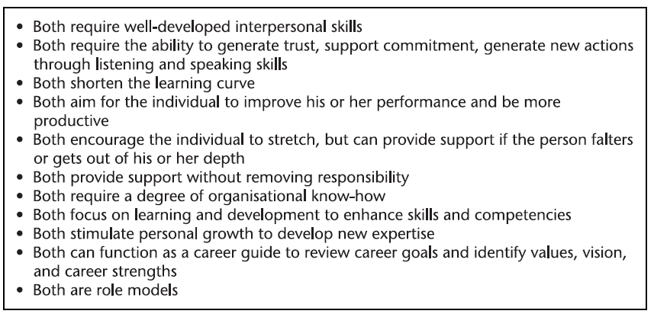
Figure 1.3

One standard definition of mentoring is the "offline support provided by one person to another in accomplishing important changes in knowledge, work, or thinking" (Megginson, 2006). Mentors are often given and received on a volunteer basis by more senior or experienced members of the organisation or profession. It is possible to mentor someone for a short or extended period. For many, it is a means of personal and professional growth.
The positive method of helping clients "astonish themselves" is significantly more beneficial than managerial counselling focusing on correcting performance issues. The coach, according to Rogers (2008), "assists clients to achieve immediate, increased, and enduring effectiveness in their lives and occupations through targeted learning." The coach's primary goal is to assist the client in realising all of his or her potentials, as determined by the client." As demonstrated in figure 1.4, the CIPD (Jarvis 2004: 19) has offered an outstanding description of the differences between coaching and mentoring:
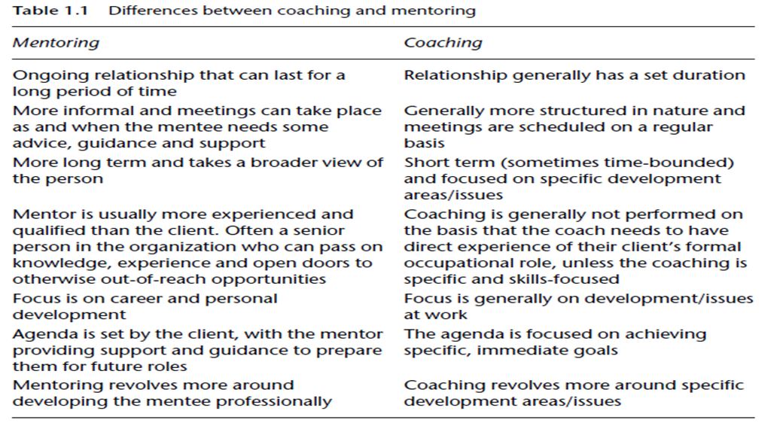
Figure 1.4

In a survey of 100 executives from Fortune 1000 companies, they recorded the frequency of impact across numerous tangible benefits of executive coaching (Figure 1.5)
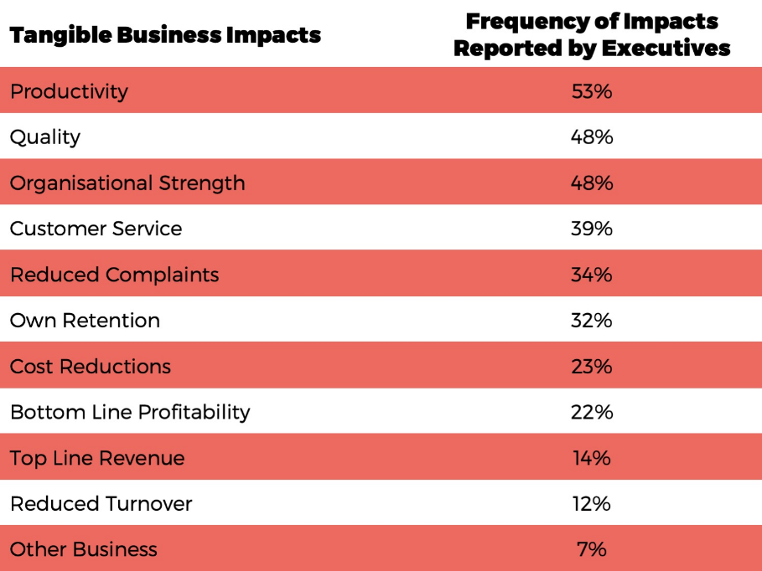
Figure 1.5
According to the International Coach Federation's 2009 report, the following tangible benefits were the most cited (Figure 1.6), (2009 ICF Annual Report, 2009):
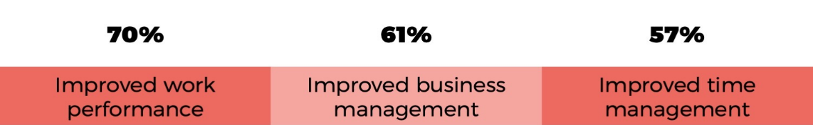
Figure 1.6

Investing in the ability of a coachee to focus on long-term goals rather than short-term goals has a higher return. The importance of both tangible and intangible outcomes during the goal alignment process is why we have always placed a high value on both:
- Goals for both business and personal reasons (tangible)
- Goals for one's conduct (intangible)
This allows the coachees to focus on the business while keeping their personal development.

The following figure 1.7 summarises some of the most claimed intangible benefits of executive coaching:
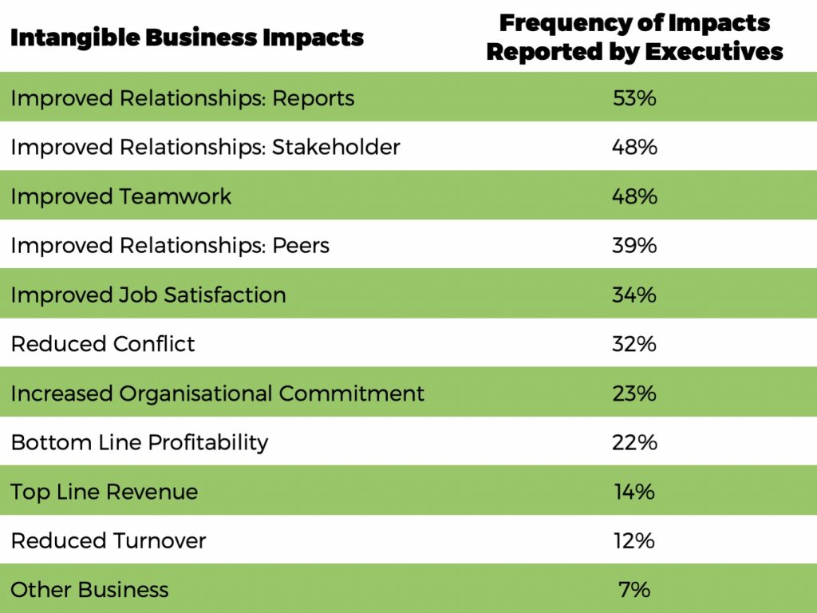
Figure 1.7

This is also in line with what the ICF found (Figure 1.8):
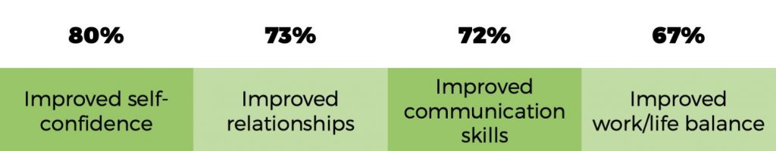
Figure 1.8

As it often turns out, the 'intangible' advantages motivate the measurable results. Individual productivity rises because of a stronger relationship with a manager. An established product's quality can be improved by increasing the creativity and problem-solving skills of the workforce. Expectation mapping is one method of achieving this goal and defining what you hope to gain from the coaching session and its relation to your overall goals. A radar system tells whether a programme or someone is on or off track. Long-term coaching has been proven to be more successful than short-term coaching because of the intangible advantages that take time to manifest. As a result, improved teamwork, more open communication, and better relationships were only some of the tangible benefits. Indirectly, it increased productivity by transferring some processes and planning connected with an individual's personal development to a third party.

2. Critical evaluation of the line manager as a Coach/Mentor

One of the most critical responsibilities of a line manager is to ensure the well-being of their people, according to Clutterbuck (2004). Coaching and mentoring are two of the most potent ways to help people grow. As a result, it was agreed that conflicts and tensions would inevitably arise when functioning as both a coach/mentor and a line manager regardless of the method used. Line managers face the challenge of figuring out the best course of action in any given situation. Individuals who make poor decisions and fail to take advantage of necessary coaching and mentoring opportunities can negatively influence both the team's performance and the team's working relationship.
Several recent CIPD polls have shown concerns regarding line manager-led coaching and mentoring. (CIPPD) Chartered Institute of Personnel and from 2009 to 2011, the Coaching Climate Survey Report outlines the numerous persons involved in coaching throughout organisations. As a result, line managers' position has shrunk from 37% to 32%. The CIPD Learning and Development Annual Survey Report 2014 shows a sustained decline in the percentage of organisations citing line manager mentoring as a successful L&D technique. Much of the time, executives lack the ability to coach and mentor. Effective coaching demands highly trained and motivated coaches.
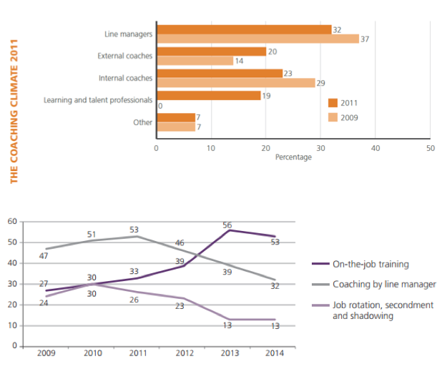
Figure 2

Line managers should not view coaching as a straightforward technique of delegating staff development. Managers can show their employees that they respect their growth by leading by example. The HR professional should notify the line manager that:
- Give the person time to coach/mentor.
- The coach/mentor should not share personal information about the mentee unless explicitly agreed upon. Stressing someone to meet unreasonable deadlines or goals is counterproductive.
- Discuss the person's growth and what they have learnt.
- Boost coaching and mentoring success by rewarding it
To establish a successful coaching/mentoring initiative, HR practitioners must ensure managers understand and apply these concepts.

3. Critical evaluation the role of coaching and mentoring in building resilience

According to Barret (2004), to be resilient, one must possess various attributes present in varying amounts in different people. It is helpful to think of people as preferring one of two change orientations to understand their varying levels of resilience. It is possible to characterise resilience in five characteristics: optimism, concentration, organisation, initiative, and flexibility.
Change management is how a company adapts to its environment to remain relevant, evolve and expand its activities to serve society better. Szamosi and Duxbury (2002) stated that change management is a natural part of life and a constant in most businesses. Companies that successfully manage change have a competitive edge.
As a result, change management is closely linked to an organization's ability to perform and compete effectively. All these processes are internal and are designed to aid management in gaining a commitment to change and enhancing productivity with the least amount of resistance feasible. In the face of ambiguity, change plans provide clarity, help regulate the process, and assist in decision-making.
According to Lewin (1952), the process of change begins with developing the concept that a change is essential, then progresses toward the ideal level of conduct, and finally becomes the norm.
Change is a process. There are often three intertwined elements to change: people, procedures, and culture.
Employees may experience a range of adverse effects because of organisational changes.
Changing an organization's culture can be difficult, especially when resistance from employees and the organisation itself (Sagie and Koslowsky, 1994). This illustrates the adverse effects of organisational change on the employee. Businesses often fail to account for the highly unexpected and stochastic feedback effects of their actions and subsequent assessments and decisions, leading to unfavourable outcomes (Freeman and Hannan, 1989). It is natural for employees to respond to acts taken by their employers. Emotional distress may result from these reactions. The change may affect a company's informal communication system, resulting in a partial breakdown of information flows. These effects harm employees' confidence in the company's future direction. This can lead to mental health issues at work, and in extreme cases, people may have to leave the organisation. When new processes and structures are introduced, employees' attention may be distracted away from their regular duties, resulting in decreased productivity.

4. Critical evaluation of the authors own performance in the peer coaching exercise

People trying to learn new abilities, form new relationships, or change their occupations face more challenges than those who are not. However, to grow as a person and increase productivity in the job, we must all be open to change (Van Oosten, Smith and Boyatzis, 2019).
To reflect on my performance in the peer coaching exercise, I will use a recognised reflective cycle of Kolb's (Figure 4). Several unique qualities characterise Kolb's reflective model. Specifically, the four-stage approach helps users appreciate the links between their experiences, feelings, thoughts, and behaviours – thereby providing a full view of the learning experience. (Kolb, 1984).
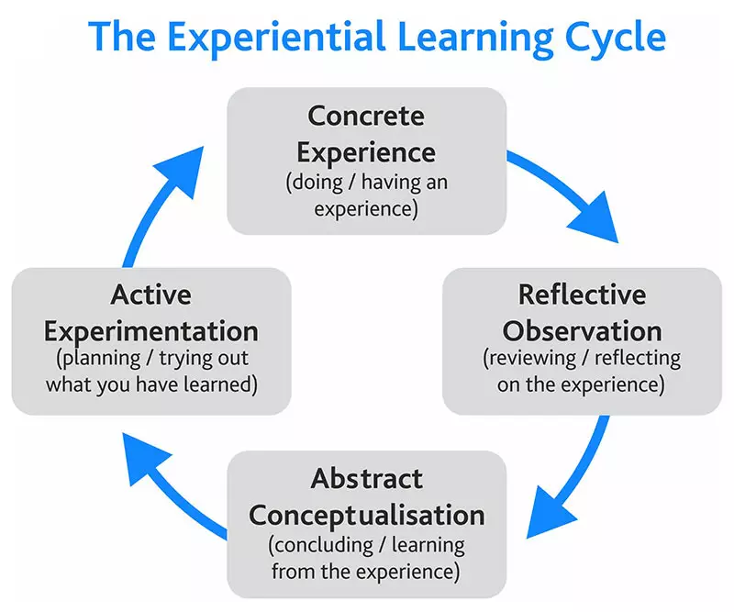
Figure 4

The practical task of the module BMSW6105 was the coaching of colleagues. The lecturer divided into groups of 3 people. Everyone was assigned a task, wherein in authors case, he was a coach, the first a colleague-coachee, the second an observer. For completion of the practical assignment was given 15 minutes, after which group members switched roles. This is the first-time author received such a practical assignment. He felt a little tension during the whole coaching session but had a lot of good emotions at the end of it. As a coach, author chose an instant pay off-model (Landsberg, 1996) because of its simplicity and clarity, and it worked out well because it uses four clear phases that perfectly reflect the current tasks. From the beginning of the coaching, author was able to find an expected pace of conversation with the student. Everything went to the right place. The coachee managed to get the necessary information, which in the next stage of the coaching helped solve his problems. Author was able to motivate and raise colleagues’ self-esteem, which is one of the main factors in coaching. One of the positives of the instant pay-off model is that you do not need big-time or knowledge for complete coaching discussion and build coaches skills.
Author can point out that during the coaching session, he lacked a perfect knowledge of English because sometimes he had to take short breaks to remember the words, and that did not allow the conversation to become smoother. Of course, he could still point out the shortcomings without actual practice. The psychology of human communication should also be explored.
To avoid obstacles during the coaching, author created personal development plan:

4.1Development plan
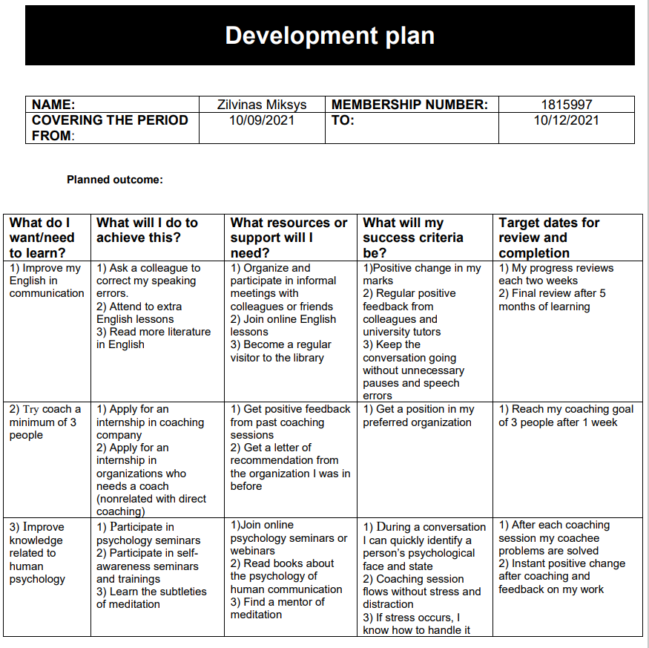
Despite these obstacles, author received positive feedback from his colleague
(observer) and, most importantly, from lecturer, which motivated him and his confidence.

5.Conclusions

Organisations employ various tactics to achieve their commercial and organisational objectives, detailed in this assignment. Research on coaching and mentoring shows that neither term has a singular definition but encompasses various concepts that contribute to a picture of the procedures. Many studies have looked at many models that coaches and mentors can use and modify based on their style and situation. While coaching and mentoring share many principles, coaching focuses on current work performance. It emphasises the use of growth tools, whereas mentoring focuses on long-term goals and the development of capabilities. Coaching is a terrific way to improve as a person. Managers, for example, encounter employees who lack self-confidence regularly. The traditional opinion is to enrol them in an assertiveness training programme and expect to address the problem. The employee's self-confidence may rise because of the employee's new communication skills. When taken on their own, these courses do not have a lasting effect on a person's self-esteem. Even though their external behaviour may change, it must be accompanied by internal cognitive changes. Coaching works best when it is used in this way.

References

- Anderson, V., Rayner, C. and Schyns, B., 2009. Coaching at the sharp end. CIPD.
- Barrett, F., 2004. Coaching for Resilience - ProQuest. [online] Proquest.com. Available at: <https://www.proquest.com/docview/198035290/fulltextwithgraphics/FC656FF9D4C54A3APQ/1?accountid=130472#> [Accessed 4 December 2021].
- CIPD. 2021. Annual review 2011–12. [online] Available at: <https://www.cipd.co.uk/Images/annual-review_2011-12_tcm18-11768.pdf> [Accessed 3 December 2021].
- Clutterbuck, D., 2004. Everyone Needs a Mentor. 4th ed. London: CIPD.
- Connor, M. and Pokora, J., 2007. Coaching and mentoring at work. Maidenhead: McGraw Hill, pp.6, 12-13.
- Freeman, J. and Hannan, M., 1989. Setting the Record Straight on Organizational Ecology: Rebuttal to Young. American Journal of Sociology, 95(2), pp.425-439.
- Herrman, H., Stewart, D., Diaz-Granados, N., Berger, E., Jackson, B. and Yuen, T., 2011. What is Resilience?. The Canadian Journal of Psychiatry, 56(5), pp.258-265.
- Hughes, M., 2007. The Tools and Techniques of Change Management. Journal of Change Management, 7(1), pp.37-49.
- Intelligentne.ee. 2014. CIPD, Learning and Development Annual Survey Report. [online] Available at: <https://intelligentne.ee/wp-content/uploads/2016/02/CIPD-2014-RAPORT.pdf> [Accessed 4 December 2021].
- ISSUU. 2009. 2009 ICF Annual Report. [online] Available at: <https://issuu.com/internationalcoachfederation/docs/2009-icf-annualreport> [Accessed 3 December 2021].
- Landsberg, M., 1996. The tao of coaching. London: HarperCollins, pp.48-49.
- Lewin, K., 1952. Field theory in social science. [London].
- McGovern, J., Lindemann, M. and Vergara, M., 2001. Maximizing the Impact of Executive Coaching: Behavioral Change, Organizational Outcomes, and Return on Investment. [online] Boldanhayes.com. Available at: <http://www.boldanhayes.com/ecroi.pdf> [Accessed 2 December 2021].
- Megginson, D., 2006. Mentoring in Action: A Practical Guide (2nd ed.). Development and Learning in Organizations: An International Journal, 20(5).

- Renton, J., 2004. The Economist: Coaching and Mentoring. [online] Google Books. Available at: <https://www.google.co.uk/books/edition/The_Economist_Coaching_and_Mentoring/4bv-nqH0HBcC?hl=en&gbpv=1&dq=Renton,+2004> [Accessed 24 November 2021].
- Robb, S., 2021. Case Study of our support and management of Tesco's coaching. [online] Mye-coach.com. Available at: <https://www.mye-coach.com/about/mye-coach-case-studies/tesco-case-study/> [Accessed 2 December 2021].
- Rogers, J., 2008. Coaching skills. Maidenhead: McGraw-Hill/Open University Press, p.7.
- Sagie, A. and Koslowsky, M., 1994. Organizational attitudes and behaviors as a function of participation in strategic and tactical change decisions: An application of path–goal theory. Journal of Organizational Behavior, 15(1), pp.37-47.
- Scultz, J., 2021. What is Coaching in the Workplace and Why is it Important?. [online] PositivePsychology.com. Available at: <https://positivepsychology.com/workplace-coaching/> [Accessed 2 December 2021].
- Sheffield.ac.uk. 2009. Mentoring – CIPD Factsheet. [online] Available at: <https://www.sheffield.ac.uk/polopoly_fs/1.110468!/file/cipd_mentoring_factsheet.pdf> [Accessed 1 December 2021].
- Szamosi, L. and Duxbury, L., 2002. Development of a measure to assess organizational change. Journal of Organizational Change Management, 15(2).
- UK Day One Blog. 2019. How does peer-to-peer mentoring at Amazon work?. [online] Available at: <https://blog.aboutamazon.co.uk/working-at-amazon/how-does-peer-to-peer-mentoring-at-amazon-work> [Accessed 27 December 2021].
- Van Oosten, E., Smith, M. and Boyatzis, R., 2019. Helping People Change: Coaching with Compassion for Lifelong Learning and Growth.
- Downey, M., 2003. Effective coaching. Cengage, pp.96-97, 98-99.
- Zeus, P. and Skiffington, S., 2008. The complete guide to coaching at work. Sydney [etc.]: The McGraw-Hill Companies, p.18.

