University of Wales Trinity Saint David

School of Film & Digital Media

GAME AUDIO 1

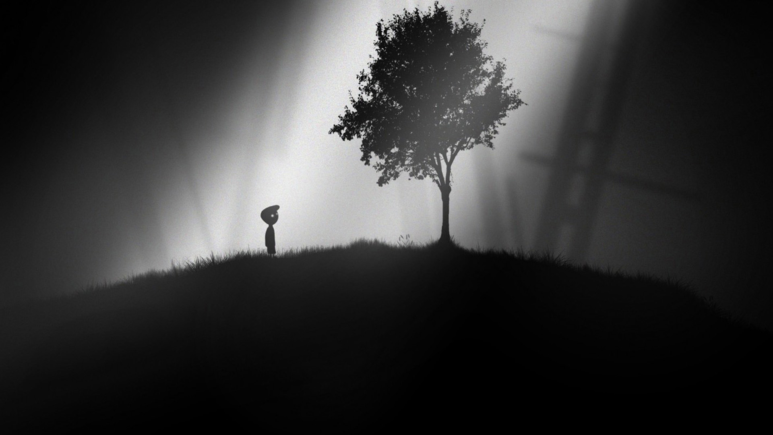

2015-16
Module Title: GAME AUDIO 1
Module Code:
20 Credit Module

Lecture Room: AC203

SEMESTER 2

Module Coordinator: Simon Kilshaw
Email: simon.kilshaw@uwtsd.ac.uk

Office Hours: by appointment

SYLLABUS
This module serves as an introduction to the key concepts of designing and embedding sound into game engines and software environments.
Some sessions will be studio based, allowing for practical experience in recording and audio production, while some will be games lab based, addressing theoretical principles of design and implementation.
There will also be creative group sessions in sound production and effects design. Therefore, the teaching and learning strategy will deploy a mixture of practical and theoretical sessions, with group exercises and individual tutorial sessions.
Through the duration of the module, the students will be encouraged to collect and archive their own large library of sound effects and audio events for use in later projects.

AIMS
- to provide the student with practical and technical skills to enable them to develop and produce audio assets in a given game authoring environment

LEARNING OUTCOMES
Upon the successful completion of this module, the student should be able to demonstrate the ability to:

- Display a practical understanding of audio implementation in games.

- Develop and produce a selection of audio material for a given level.

INDICATIVE CONTENT
- Game Engines (Unity, UDK, PD)
- Game controllers/ Human Interface Devices
- Parsing haptic/ handheld devices’ data to sound
- Audio sources/triggers/zones and platform listeners
- Recording, Editing
- Audio effects and manipulation
- Field recording
- Audio Assets
- Composition / sound design techniques
- Audio narrative in Game Soundtracks
- “world” audio
- Analysis and Critique
- Foley and voice.

MODULE EVALUATION
At the end of the module you will be asked to complete a module evaluation form. Please refer to the learning outcomes when making your evaluation.

TIMETABLE
The course is taught over a twelve week period, starting in week one of semester two.
There will be a feedback week in week six.

BIBLIOGRAPHY

Essential
Crook, T. (2012) The Sound Handbook. Routledge

Marks, A. (2009) The complete guide to game audio: for composers,musicians, sound designers, game developers. Oxford Focal

Stevens, R. (2011) The game audio tutorial - a practical guide to sound and music for interactive games. Oxford Focus

Wilde, Martin Audio Programming for Interactive Games. Oxford 2004

Background
Sanger, G. (2003) The Fatman on game audio: tasty morsels of sonic goodness. Pearson
Collins, K. (2008) Game Sound: an introduction to the history, theory, practice of video game music and sound design MIT

Murray, J. W. (2012) Game Development for iOS with Unity3D. Peters/CRC Press

Collins, K. (2008) From Pacman to pop music: interactive audio in games and new media. Ashgate

Novak, J. & Game Development Essentials: Game Saunders, K.. (2012) Interface Design. Delmar Cengage.

Websites
www.gameaudio101
www.videogameaudio.com
www.gamesound.com
www.epicsound.com/sfx
www.audiogames.net
www.intermorphic.com
www.ieeexplore.ieee.org
www.gamasutra.com
www.sciencedirect.com

COURSE OUTLINE

Week: | Date w/c
1 | 25th Jan | Intro to game audio and UNITY  Analysis and language development.
2 | 1st Feb | Designing your soundworld  First Person – the Audio Listener- Implementing  3rd person- audio sources
3 | 8th Feb | Foley & Sound Effects excercise- Studio  (The fight scene)
4 | 15th Feb | Triggers & Collisions- proximity
5 | 22nd Feb | Assignment Asset creation (Destroyed city)
6 | 29th Feb | FEEDBACK WEEK
7 | 7th Mar | The Soundtrack- (Car Game)
8 | 14th Mar | Environmental audio excercise (Wheather/ rain/ storm)
9 | 21st Mar | Individual work session (VIVA WEEK)
 | 28th Mar | EASTER BREAK
10 | 18th Apr | Individual work session
11 | 25th Apr | Group plenary
12 | 2nd May | ASSESSMENT SUBMISSION DATE
Feedback due: 23rd May 2016

ASSESSMENT

Coursework 100%

This assignment requires you to work individually in the production of a soundtrack to a given game level:

Working in Unity, record and produce an array of audio assets and embed them into the given game level in Unity engine, to provide a soundtrack to the level. The soundtrack can include music, foley, incidental effects, sound design, trigger and collision states.

The audio may derive from student field recordings, studio recordings, electronic compositions, but must all be sourced individually by the student (no downloaded samples to be used).

Choose the sound world that you wish to operate in, and pay careful considerations to the overarching aesthetic values of the soundtrack you create.

The content for this submission will be covered in the classes.

Assignment due: TBC

FEEDBACK

Feedback is an essential part of all education and training programmes. It helps learners to maximise their potential at different stages of training, raise their awareness of strengths and areas for improvement, and identify actions to be taken to improve performance.

Feedback can be seen as informal (for example in day-to-day encounters between teachers and students or trainees, between peers or between colleagues) or formal (for example as part of written or clinical assessment). However, there is no sharp dividing line between assessment and teaching in the area of giving feedback on learning. Feedback is part of the overall dialogue or interaction between teacher and learner, not a one-way communication.

During your studies you will therefore receive feedback in many ways, including the following:

· Dialogue between teachers and students in formal classes

· Direct questions and responses from teachers inside and outside formal classes

· Email correspondence between teachers and students

· Interactions between students and teachers using the module message board on Moodle

· Informal comments and responses to pitches and presentations in classes

· Comments and annotations added to written submissions, such as essays and reflective journals

· Formal written feedback in response to assignments recorded on the summative assessment module feedback forms

In order to confirm that you have received and understood your formal feedback you will acknowledge and respond to the written comments using the facility set up on Moodle.

 |  | School of Film and Digital Media  MMusTech Music Technology | GAME AUDIO 1

Summative Assessment: end-of-module appraisal and feedback on outcomes

Student Name:_____________________________________________________

Learning Outcomes Achieved:
 | Poor | Weak | Average | Good | Excellent
Display a practical understanding of audio implementation in games.

Develop and produce a selection of audio material for a given level.

Staff feedback on the work produced for this module:

Mark:
Assessment 1

*Please note that all marks are provisional until agreed/confirmed at the final Exam Board of the academic year.

NOTES:

