

Programme: Master of Business Administration
Module Name: Human Capital Management
Module Code: LCMB7023

Assignment Topic: Integrated Human Capital Blueprint

Student Name: MD ASIF REZA
Student Id: 2523547

Tutor name: Dr Nerys Dosseh

Wordcount: 2749

Date of Submission:

Executive Summary
The following report involves a coordinated Human Capital Management strategy of Aether Innovations, a technology company of 300 employees with its growth momentum affected, high employee turnover, and decreasing customer satisfaction. Based on the current HRM theory and industry practises, the report critically reviews the current performance appraisal and job design practises in major technology companies and how they are changing their traditional annual reviews to more continuous and feedback-based systems. A new performance management system is suggested to solve organisational issues and include Objectives and Key Results (OKRs), 360-degree feedback, and regular performance reviews. This system improves strategic alignment, transparency, employee development and innovation and engagements are promoted. Simultaneously, the report outlines job analysis, job description, and job specifications of six of the essential executive positions, such as the CEO, CFO, CTO, CIO, HR Director, and Head of R&D. The Job Characteristics Model is implemented to enhance autonomy, variety in the tasks, and relevance of tasks leading to better motivation and performance. Notably, the report shows that the linkage of performance management and the job design enable the company to develop a performance-oriented culture. This integration assures that organisational objectives, leadership functions and employee input are strategically aligned, and this addresses sustainable growth, innovation and better customer satisfaction.

Table of Contents
1. Introduction 1
2. Part 1: Re-Engineering Performance & Job Design 2
2.1 Current Practices in Technology Companies 2
2.1.1 Performance Appraisal Practices in Tech Firms 2
2.1.2 Job Design Practices in Technology Organisations 2
2.2 Proposed Performance Appraisal System for Aether Innovations 3
2.2.1 Objectives and Key Results (OKRs) 3
2.2.2 360 Degree Feedback 4
2.2.3 Continuous Performance Reviews 4
2.2.4 Benefits for Innovation and Engagement 5
2.3. Job Analysis and Job Design for Key Positions of Aether Innovations 5
2.3.1 Job Analysis Approach 5
2.3.2 Job Descriptions for Key Executive Roles 6
2.3.3 Job Specifications for Executive Roles 7
2.3.4 Application of the Job Characteristics Model in Aether Innovations 8
2.4. Linking Performance Management and Job Design 9
3. Conclusion 10
4. Part 2: Reflection 11
4.1 Reflective Learning Using Gibbs Reflective Cycle 11
4.2 AI and Future Career Development 13
5. References 15

1. Introduction
Strategic Human Resource plays a crucial role in enhancing organisational performance, employee engagement and innovation in technology companies (Noe, 2022). Proper alignment between job design and performance management can help organisations to adapt with fast changing market and sustain competitive edge (Kapur, 2021). The report suggests a holistic approach to Aether Innovations, a developing technology firm of approximately 300 employees which facing flat growth, high employee turnover and dissatisfaction amongst customers to overcome these challenges. It examines existing HR practise in large tech companies, outlines a performance management model, and creates executive job descriptions based on job analysis and the Job Characteristics Model.

2. Part 1: Re-Engineering Performance & Job Design

2.1 Current Practices in Technology Companies
The strategic human resource practises are increasingly being embraced by technology organisations to ensure that they maintain innovation, agility and employee engagement in strong digital markets (Agbakwuru, 2023).

2.1.1 Performance Appraisal Practices in Tech Firms
To improve employee development and organisational alignment, modern technology companies are forcing out traditional annual appraisal systems with continuous performance management. According to research by Aguinis (2023), continuous feedback systems enhance motivation, collaboration and strategic performance. As an example, Microsoft has replaced its “forced-ranking stack-ranking model” with a “Connections-based approach” in which managers engage in regular one-to-one discussions centred on priorities, coaching and development instead of annual ratings by themselves. The process is more developmental by evaluating employees based on common commitments, learning objectives and contribution to teamwork and team collaboration (Microsoft, 2023). Likewise, the performance appraisal system of Google does not merely imply establishing OKRs. Under its new Perf process, employees are expected to achieve quarterly OKRs in defining what is expected, although regular quarterly manager check-ins, peer feedback and calibration discussions are also part of the appraisal decisions. For example, a software engineer at Google handling the issue of Google Cloud reliability can have a quarterly OKR of reducing service incident response time by 15% or enhancing the success rate of deployments in a product department. Consequently, the continuous appraisal systems enable technology firms to enhance the commitment of employees and sustain high organisational performance in dynamic environments.

2.1.2 Job Design Practices in Technology Organisations
Technology companies need to effectively design their jobs to facilitate creativity, flexibility, and employee motivation (Armstrong, 2024). Spotify provides an example of a flexible team model (the Squad model) in which small, self-managed teams handle individual product features and projects. Also, Amazon has cross functional teams popularly known as two pizza teams which make decisions box fast and with a stronger teamwork (TechTarget, 2020). These arrangements enable employees to be owners of their tasks and test new ideas. In turn, flexible job design practises can help technology organisations sustain innovation capacity as well as enhance overall organisational performance.

2.2 Proposed Performance Appraisal System for Aether Innovations
Aether Innovations needs to implement a modern performance management system to tie employee efforts with organisational goals to resolve sluggish growth, declining employee engagement and rising turnover.

2.2.1 Objectives and Key Results (OKRs)
Objectives and Key Results are a goal-based performance management model that connects organisational strategy to measurable employee results (Vuong & Nguyen, 2022).
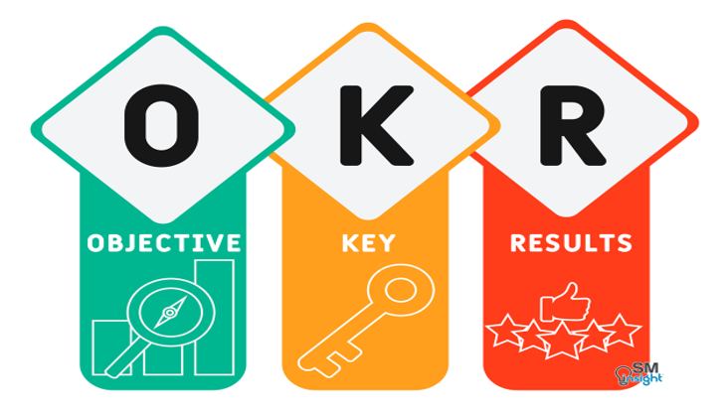
Figure 1: Objectives and Key Results, Source: (Cholifah & Soeling, 2025)
Rompho (2024) states that using OKRs, organisations can articulate strategic priorities in specific objectives with measurable outcomes. Within Aether Innovations, such a system would enable the management to convey priorities like innovation, customer satisfaction and business growth via clearly stated organisational objectives. The employees would then work on the results that are measurable and show progress towards these goals. Such systematic orientation enhances the understanding of performance expectations and aligning the activities of employees with organisational priorities. Consequently, the introduction of OKRs would enhance responsibility, transparency and strategic orientation within the organisation (Cholifah & Soeling, 2025).

2.2.2 360 Degree Feedback
360-degree feedback is a performance appraisal strategy that obtains supervisor, colleague, subordinate and self-assessment notes. According to Irons & Elkington (2021) Multi source feedback enhances leadership development and employee self-awareness by offering a wider assessment of behaviour at work.
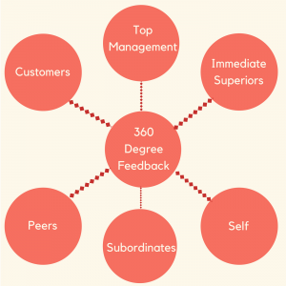
Figure 2: 360 Degree Feedback, Source: (Irons & Elkington, 2021)
The use of this system in Aether Innovations would offer the employees equal feedback about his work, teamwork and communication abilities. These kinds of feedback facilitate transparency and positive communication among teams. When employees are laid off feedback representing various organisational dimensions, they get a better perception of their strengths and areas of development (Chandra Dalvi et al., 2023). This would subsequently assist Aether Innovations in enhancing cooperation, increasing ability to lead and foster organisational learning.

2.2.3 Continuous Performance Reviews
Conventional annual appraisal tools do not work well in dynamically shifting organisational contexts. Continuous performance reviews are regular discussions between employees and managers concerning performance expectations and progress as observed by Aguinis, (2023). At Aether Innovations, the managers can organise frequent performance meetings to understand employee progress on the OKRs and give feedback where needed. This will see the employees getting feedback with time and readjusting their targets when organisational priorities are modified. Constant communication will also minimise confusion over performance expectations (Armstrong, 2024). Thus, on-going performance reviews would promote continuous improvement and enhance contact between the manager and the employee.

2.2.4 Benefits for Innovation and Engagement
Armstrong & Taylor (2023) observe that the integrated performance systems enhance motivation and collaboration in organisations. OKRs would enhance strategic alignment in Aether Innovations, whereas 360-degree feedback would increase the interest to communicate and lead. Constant evaluations would keep employees in cheque to provide guidance. These practises combined would build an open and positive workplace culture that fosters employee engagement, innovation and long-term organisational performance.

2.3. Job Analysis and Job Design for Key Positions of Aether Innovations
Job design and job analysis assist in leadership tasks to favour organisational strategy and innovation (Kapur, 2021). In Aether Innovations, well-identified executive roles would enhance decision making, accountability and alignment between organisational objectives and personnel performances.

2.3.1 Job Analysis Approach
According to Woods et al (2017), job analysis is a systematic activity applied to establish duties, responsibilities, and competencies that an individual must have within a specific position.
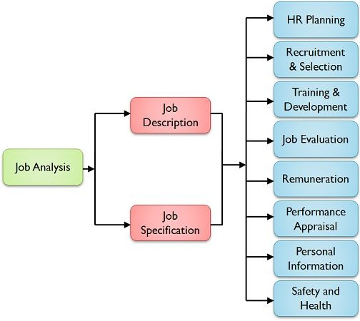
Figure 3: Job Analysis; Source: (Kapur, 2021)
At Aether Innovations, an organised job analysis approach is required to make sure leadership roles are supported by organisational strategy and innovation targets. It is the process that assists in clarifying the duty and anticipation of each role of the executive and assists effective decision making and accountability. A properly structured job analysis framework also facilitates cross functional cooperation and allocation of work effectively (Kapur, 2021). As a result, well established leadership positions allow the organisation to enhance coordination, performance, and long-term organisational development.

2.3.2 Job Descriptions for Key Executive Roles
A job description outlines the role, duties, authority and relationship to reporting of a position in an organisation as stated by Kapur (2021). It explains expectation of the employees, aids recruitment and enhances responsibility in management in performance. At Aether Innovations, executive positions are designed to enhance leadership, innovation and organisational performance.
Position | Job Purpose | Key Responsibilities | Decision Authority | Reporting Line
CEO | Provide strategic leadership and organisational direction | Define vision, lead strategy and supervise executive team | Final authority on strategic and operational decisions | Board of Directors
CFO | Manage financial strategy and organisational resources | Financial planning, budgeting and financial reporting | Decisions on financial investments and budget allocation | CEO
CTO | Lead technology strategy and development | Oversee technology infrastructure and innovation projects | Authority on technology investments and system development | CEO
CIO | Drive organisational innovation | Lead innovation initiatives and explore emerging technologies | Approval of innovation and experimental projects | CEO
HR Director | Manage human capital strategy | Recruitment, performance management and employee development | Workforce planning and HR policy decisions | CEO
Head of R&D | Lead research and product development | Manage R&D teams and product experimentation | Prioritisation of research projects and resource allocation | CTO
Table 1: Job Descriptions for the Key Positions of Aether Innovations

2.3.3 Job Specifications for Executive Roles
Job specifications outline the qualifications, skills and competencies needed to do a job effectively (Woods et al., 2017).
Position | Education | Experience | Key Skills | Leadership Competencies
CEO | MBA or equivalent | 15+ years leadership | Strategic thinking, decision making | Visionary leadership, organisational influence
CFO | Finance or Accounting degree | 12+ years finance leadership | Financial analysis, risk management | Strategic planning, financial governance
CTO | Computer Science or Engineering degree | 12+ years technology leadership | Software architecture, digital strategy | Innovation leadership, technical vision
CIO | Technology or Innovation Management degree | 10+ years innovation leadership | Creative problem solving, technology foresight | Change leadership, strategic innovation
HR Director | HRM or Business degree | 10+ years HR leadership | Talent management, organisational development | People leadership, culture development
Head of R&D | Engineering or Technology degree | 10+ years research leadership | Product development, experimentation | Collaborative leadership, innovation management
Table 1: Job Specifications for the Key Positions of Aether Innovations

2.3.4 Application of the Job Characteristics Model in Aether Innovations
According to Kamani (2020) job Characteristics Model is a theory that explains why job design boosts motivation and performance in five main dimensions. This model can help in innovation, strategy and organisational responsibility at Aether Innovations.
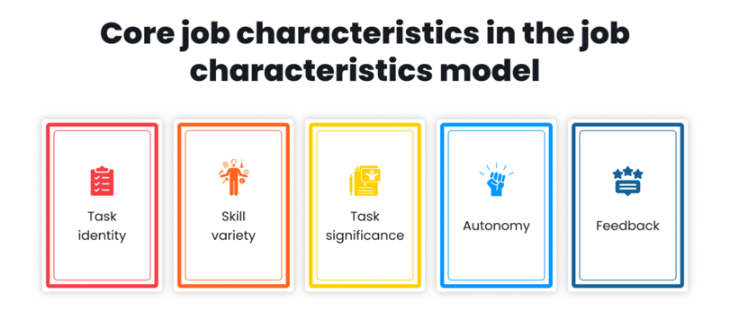
Figure 4: Job Characteristics Model; Source: (Kamani, 2020)

Skill Variety: Aether Innovations involves various competencies in taking up leadership positions as they seek to deal with complicated technological and organisational issues. Leaders like CTO and CIO are required to bring together technical know-how, strategic management and innovation to lead in digital development and product strategy. The assignment of diversified duties to the leaders improves problem solving and helps to make innovative decisions (Ali et al., 2014).
Task Identity: Aether innovation leadership roles are to handle projects between planning and execution. As an example, the Head of Research and Development has charge of supervising the complete product development cycle including development of the idea to launching it in the market. This full accountability enhances the ownership and accountability of leadership (Kapur, 2021).
Task Significance: The executive decisions affect organisational growth, employee engagement and customer satisfaction directly. Understanding the contribution of their actions enhances the dedication of leaders to the achievement of organisations as well as strategic creativity (Tessema et al., 2025).
Autonomy: Decision making powers are given to the executives so that leaders can react to technological changes and market needs swiftly, promoting strategic flexibility and innovation (Kamani, 2020).
Feedback: OKRs and continuous review performance systems will grant leaders periodic feedback on organisational performance to enable them modify strategies and enhance performance results (Aguinis, 2023).

2.4. Linking Performance Management and Job Design
It is important to connect job design with the suggested performance appraisal system to enhance performance in Aether Innovations. Job design outlines the roles, power and ability of leaderships, and the performance appraisal system evaluates the effectiveness with which the leaderships meet organisational challenges (Kapur, 2021). The Objectives and Key Results introduction enable the executives like the CEO, CTO and Head of R&D to transform all their assigned duties into quantifiable innovation, product development and customer satisfaction outcomes (Konjen, 2025). Simultaneously, 360-degree feedback and continuous performance reviews present regular assessment of leadership behaviour, collaboration and decision making. When such systems work in harmony, employees have a clear view of their job and the expected performance outcomes. Therefore, matching job design with the suggested performance management system enhances accountability, promotes innovation, and the overall organisational performance in Aether Innovations (Aguinis, 2023).

3. Conclusion
This report shows that performance management must be aligned with strategic job design to enhance organisational performance at Aether Innovations. By implementing modern appraisal tools: OKRs, 360-degree feedback and ongoing reviews, transparency, accountability, and employee engagement are improved. At the same time, job descriptions defined with the help of the Job Characteristics Model facilitate independence, the use of skills, and creativity. These systems are integrated to ensure that the effort of employees is strongly correlated with the organisational objectives which in the long run assists in the sustainable development, better employee performance and customer satisfaction within competitive technology industry.

4. Part 2: Reflection

4.1 Reflective Learning Using Gibbs Reflective Cycle
The current reflection recognises the reflection cycle suggested by Gibbs to break down my learning practise as a student of the Human Capital Management module and to build an individual career development plan.
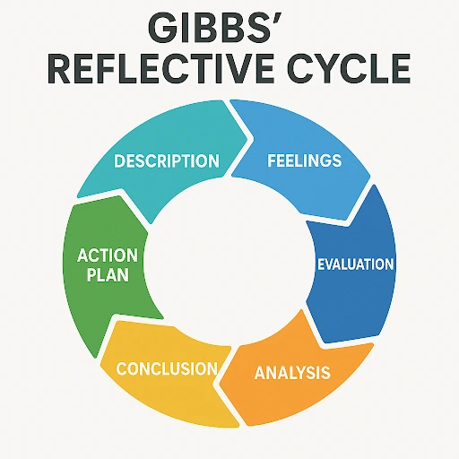
Figure 4: Gibbs Reflective Cycle (Harmon, 2024)
Description
In this module, I played the role of a Human Capital Consultant who must solve the organisational problems within Aether Innovations, a technology firm experiencing zero growth and staff turnover. The task demanded restructuring of job designs and establishing performance management system that was able to enhance innovation and engagement of employees. This entailed the use of human resource management models like the Objectives and Key Results, 360-degree feedback and the Job Characteristics Model. Instead of merely describing theories in HR, the assignment involved an examination of its applicability in real organisational problems. In the process, I gained more insight into how strategic HR practises can be used to align employee performance and organisational objectives and long-term business expansion.
Feelings
At the beginning, the decision seemed to be difficult since I had to combine different HR structures into one organisational strategy with both critical and practical thinking abilities. I was unsure of whether theoretical HR models have the capacity to tackle concerns like dwindling performance and disengagement among employees. Nevertheless, as my analysis went on there was more confidence. I also started to appreciate that HR is not solely an administrative role, but a strategic performance of the organisation. Understanding how organised HR practises influence innovation and employee motivation altered my view of the importance of human capital management.
Evaluation
This was a worthwhile learning experience because it involved critical thinking regarding the job design, motivation to employees and performance at a given organisation. The use of Job Characteristics Model helped illustrate the effect of autonomy, task significance and skill variety on employee engagement and innovation. Planning a performance management system has also brought out the significance of constant feedback and goal synchronisation. One difficulty was to be as analytical as possible whilst writing ideas within the maximum use of academic word count. This experience enhanced my skills on how to explain complicated HR strategies clearly and explicitly.
Analysis
This module highlighted the importance of having integrated HR systems in modern organisations which aid not only organisational performance but also the development of employees. Performance models including OKRs enhance transparency and strategic alignment, which helps employees to know the contribution of their work to organisational goals. Equally, 360-degree feedback encourages organisational learning because employees can have a wider view of their behaviour and leadership prowess. It was also evident that successful job design boosts motivation by granting workers meaningful responsibilities and autonomy. Technology alone therefore does not affect organisational innovation but also leadership practises and employee empowerment.
Conclusion
This module helped me a lot to comprehend strategic human capital management. I came to understand that HR systems should be designed to balance organisational performance with the development of employees. Current HR practises promote the ongoing learning process, teamwork and strategy, which is a key to long-term organisational development.
Action Plan
Development Area | Action Steps | Expected Outcome | Timeframe
Strategic HR Knowledge | Study HR journals and industry reports related to performance management and innovation | Improve understanding of modern HR practices | 6–12 months
Analytical Skills | Analyse organisational case studies and apply HR frameworks | Strengthen strategic problem-solving ability | Ongoing
Leadership Skills | Attend leadership training and professional workshops | Improve communication and decision-making capability | Within 1 year
Professional Networking | Participate in HR professional events and industry forums | Expand professional connections and career opportunities | Continuous

4.2 AI and Future Career Development
The growth of artificial intelligence is affecting the management of human capital and organisational performance in organisations in a rapid manner. Ai based technologies can facilitate numerous functions of the HR including recruitment screening, workforce analytics and employee performance monitoring. These systems allow organisations to handle high amounts of workforce information in a short time and provide insights that can inform decision making. Due to this, AI is emerging as a significant asset in the context of efficiency and strategic workforce planning in contemporary organisations. In conducting this learning process, I realised that though AI has the potential of improving most HR activities, it cannot take the human element of leadership and people management. HR practises demand the presence of emotional intelligence and ethical judgement and interpersonal communication. In my career life, I will apply AI as an assistive technique that reinforces the use of data as the basis to make decisions instead of substituting human capabilities. This will enable me to concentrate on the strategic issues like defeating the employees, developing leaders and the organisational culture. Simultaneously, I will work on my critical thinking, empathy and collaborative leadership abilities to keep working in an more AI-driven work environment.

5. References
Agbakwuru, K. N. (2023). Reconceptualising human resource management. International Journal of Research, 10(4), 243–251.
Aguinis, H. (2023). Performance management (5th ed.). Chicago Business Press.
Ali, S. A. M., Said, N. A., Yunus, N. A. M., Abd Kader, S. F., Ab Latif, D. S., & Munap, R. (2014). Hackman and Oldham's job characteristics model to job satisfaction. Procedia Social and Behavioral Sciences, 129, 46–52.
Armstrong, M. (2024). Armstrong’s handbook of strategic human resource management (8th ed.). Kogan Page.
Armstrong, M., & Taylor, S. (2023). Armstrong’s handbook of human resource management practice (16th ed.). Kogan Page.
Caylan, S. (2024). Role of human resource management on strategic management. In Trends, challenges, and practices in contemporary strategic management (pp. 51–69).
Chandra Dalvi, O. H., Sawant, S. B., Mohite, R. A., & Sambhaji, S. (2023). 360-degree feedback as a tool for improving employee performance. Tuijin Jishu J Propuls Technol, 44.
Cholifah, M., & Soeling, P. D. (2025). Objectives and key results (OKRs) and their role in enhancing employee performance: A systematic literature review. Journal of Management, 4(1), 149–166.
Google. (2023). Alphabet annual report 2023. https://abc.xyz/investor
Harmon, A. (2024). Gibbs’ reflective cycle. EBSCO Information Services. https://www.ebsco.com/research-starters/education/gibbs-reflective-cycle
Irons, A., & Elkington, S. (2021). Enhancing learning through formative assessment and feedback. Routledge.
Kamani, T. (2020). Analysis of the job characteristics model. SSRN.

Kapur, R. (2021). Understanding meaning and significance of job analysis and job design. International Journal of Information, Business and Management, 13(4), 98–107.
Konjen, H. (2025). Algorithmic management and the future of human work. Journal of Human–Technology Interaction, 5(2), 1–15.
Microsoft. (2023). Annual report 2023. https://www.microsoft.com/investor/reports/ar23
Noe, R. A. (2022). Human resource management: Gaining a competitive advantage. McGraw Hill Higher Education.
Rompho, N. (2024). Do objectives and key results solve organizational performance measurement issues? Benchmarking: An International Journal, 31(3), 669–682.
TechTarget. (2020). Two pizza rule definition. https://www.techtarget.com/whatis/definition/two-pizza-rule
Tessema, S. A., Yang, S., & Chen, C. (2025). The effect of human resource analytics on organizational performance: Insights from Ethiopia. Systems, 13(2), 134.
Vuong, T. D. N., & Nguyen, L. T. (2022). The key strategies for measuring employee performance in companies: A systematic review. Sustainability, 14(21), 14017.
Woods, S. A., Hinton, D. P., Fraccaroli, F., & Sverke, M. (2017). What do people really do at work? Job analysis and design. In An introduction to work and organizational psychology: An international perspective (pp. 1–24).

