

LEVEL 7 ASSESSMENT SPECIFICATION

Programme: | MBA- Masters of Business Administration
Module: | Marketing Management – Assessment 2
Module code: | LCMB7001 | Contribution to Overall Module Assessment (%): | 25%
Lecturer: | Tushara Balendran | Internal Verifier: | Gladius Kulothungan

Student name: Jaimish Sureshbhai Gujarati
Student ID: 2106724
Module name: Marketing Management – Assessment 2
Module code: LCMB7001
Lecturer: Tushara Balendran

EXECUTIVE SUMMARY

A well-known brand like Tesco has a long history. In the state of the United Kingdom, this company is extremely popular. Grocery and general merchandise have become extremely popular in the retail market due to the popularity of this brand.
The following research article presents a comprehensive study of Tesco's marketing strategies, educating readers about all strategies, plans and all what girl that nightclub must complete in study. The study also informs readers on how Tesco plans to build steps to achieve future success and expand its territory into the global market. With all the steps and strategies explained in detail, this report explains how Tesco secures its position in the global market.

Table of Contents

Introduction 2
Discussion 2
PESTLE Analysis 4
SWOT Analysis 7
Conclusion 16
Reference 17

Introduction

This article mainly describes the business strategy of a basic business marketing, mainly described in this article as customer satisfaction. It defines metrics to determine how happy customers are with the company's products and ability to satisfy customers. Process is mainly used in marketing as an indicator of marketing management. If the customers are satisfied with the company's products as the business grows day by day, they are mainly described in this article. Businesses have long focused on the touchpoints also described in this document. assignments and how they affect the company's business. Critically evaluate Tesco's innovative marketing strategies and how the brand is progressing for itself, as well as manage and evaluate the customer journey, to ensure customer and stakeholder expectations. Customers are satisfied with certain rules and listen to customers (Sreenivasan et al. 2018)

- Discussion

Customer satisfaction
Customer satisfaction is part of marketing management, and it is a very important part. Tesco mainly provides the social network with specific and detailed queries to customers. This mainly contributes to business growth and earnings. Consistency is one of the most important parts of customer satisfaction. Customer satisfaction mainly defines several key categories. The first is very dissatisfied, satisfied, dissatisfied, naturally, very satisfied. Offer omnichannel, this mainly improves customer satisfaction, it mainly contributes to customer happiness. Tesco mainly provides practical services on company products to add knowledge (Lomoio et al. 2020)
This is the most important part for developing projects and also for increasing projects. The second role is research Theoretical Product Research, which in theory tests mainly determines the main research direction. This is mainly done by theoretical experimental research. It is mainly useful when a research map helps to develop a research paper over time. The number of the research questions is the best methodology for answering the questions. A new conceptual model or a new theory building a literature review. The third one is Brand and campaign development is also important to agency capabilities. Tesco primarily educates and coaches its clients for teamwork. Because great and strong teams always work first and they also achieve their goals and healthy communication is mainly provided by this company. On the other hand, respect for all team members is either: Leadership is the most important component of the business as well as good leadership, as it is very important for employees to manage a group (Kim et al., 2019). This primarily contributes to the development of the business for the use of communication and acquisition data, which primarily contributes to the development of the company's business (Rosnizam et al.2020).

PESTLE Analysis:
The PESTEL evaluation device can examine the unpredictable placing inside which Tesco PLC operates with the aid of using discussing the elements which have an impact on Tesco overall performance and operation. Tesco PLC is not completely supplying retail merchandise but conjointly dealing in broadband, cell networks and coverage services. Here we're going to talk properly the PESTLE evaluation of Tesco.

Political Factor
This organization is running in twelve nations collectively with Asia and Europe. it is uncovered to numerous political elements so as to have an impact at the operations of Tesco. These elements encompass Tax rates, modern and near handy legislation, political instability, pct, the repute of the nation’s anyplace it is operative. For example, price lists on merchandise can have an impact on Tesco because of it imports a few stocks from outdoor GB like China and East Asia.
Tesco Chairman Johan Allan AN outspoken man or woman and businessman stated that what political elements can have an impact at the business. The tax on massive supermarkets cited as “Tesco Tax” become deliberate with the aid of using the local council but GB authorities refused this initiative mostly to keep away from price hikes.

Economic Factors
Labor rate is a completely critical monetary trouble so one can have an impact on GB supermarkets. as an example, its annual salary invoice is amounting GBP four. Five billion. In 2018 GB salary Rate is gathered with the aid of using four.4% for twenty-5 years preceding and onward. This upward shift has rate Tesco numerous kilos in GB.
Diversification and presence in the global marketplace location unit the two essential techniques in beyond years and motives for the fulfillment of the corporate. it is price bringing up that Tesco stays obsessed on the GB marketplace with a twenty-seven. 7% proportion in the GB grocery marketplace.

Social Factors
Consumers searching traits are forever dynamic over time. people have strong schedules and want equal day and brief transport with flexible products come returned policy. they prefer one-prevent searching. Tesco is hoping on Great Britain clients and have to understand and deliver the offerings to fulfill those troubles.
The call for products and offerings is related to the purchaser ideals and attitudes this is any other targeted difficulty. Obesity is any other difficulty in society and clients are a whole lot of problem concerning their health. Tesco have to ponder dynamic conduct and call for natural food.

Technological Factors
A few years returned Tesco became going through troubles like terrible patron knowledge and the horseflesh scandal. Technological development delivered new possibilities to Tesco to regain the patron trust. Tesco embraces development in technological as a hazard with the aid of using adopting available trial technologies. They delivered RFID Technology to increase in-shop knowledge for patrons. It routinely counts inventory and takes away it as soon as sales.

Environmental troubles
Many groups face full-size strain from authorities’ businesses to address environmental troubles. groups’ place unit liable to solution those troubles to analyze society.

Now Tesco encourages its buyers to shop for at tesco.com. Tesco Van Drivers might not entirely use fuel-saving routes but conjointly accumulate undesirable plastic bags from clients and recycle them. Also, Tesco is devoted to the usage of renewable reassets and producing 100% of its power with the aid of using 2030. the company ensures to reduce as much as 5 hundredth carbon footprint with the aid of using 2020.

Legal Factors

In a commercial enterprise criminal setting, don’t undermine key regions anyplace regulation modifications that allows you to have an impact in your commercial enterprise overall performance to acquire your objectives. In 2016, Tesco seventeen personnel took motion in opposition to the chief at the concept of historic and gender discrimination. personnel had been fairly frustrated whilst detected low pay costs for night, weekend and financial institution vacations shifts. Tesco conjointly sweet-confronted motion for accounting fraud and misleading the investors, lastly, united to pay GBP twelve million to settle the motion.

SWOT Analysis of Tesco
The SWOT analysis of Tesco is demonstrated below:
Tesco’s Strengths
Biggest grocery merchandiser in the United Kingdom of Great Britain and Northern Ireland – Tesco is that the main grocery merchandiser and No.1 marketplace in the United Kingdom of Great Britain and Northern Ireland. it is better income and sales compared to exclusive marketplace chains withinside the first-class state. in line with its 2018 annual report. Its annual in operation earnings rose twenty-eighth.
1. Leading marketplace proportion – Amongst the massive 4 supermarkets, Tesco dominates the grocery retail marketplace of the first-class state with twenty-sevenths of marketplace proportion. it is lately turn out to be the most well-preferred marketplace in Eire.
2. Geographically heterogeneous – Tesco functions a thriving global presence with over 6800 shops in fourteen countries. apart from Europe and North America, it is an giant marketplace proportion in Asian markets likewise.
3. A developing kind of shops – From three,751 shops in 2008, Tesco presently operates six,966 grocery retail shops worldwide. Its sales is growing in step with annum as a result of the addition of latest shops in its operational chain.
4. Diversified shops – Tesco has released absolutely exclusive sorts of shops. Its heterogeneous divisions of shops encompass Tesco Home plus, Tesco tube, Tesco further, Tesco specific, One-stop, and Tesco Superstores.

Tesco’s Weaknesses
1. Failed operations in the U.S.A. united states North American nation} and Japan – Tesco needed to go out from the American and Japanese markets in 2012. Its unsuccessful export operations compelled the company to close shops in Japan while nine years and additionally the United States while 5 years.
2. Fraud Trial and Accounting Scandal – In 2017, Tesco become charged with fines due to the fake accounting assertion and falsity of earnings.
3. Decrease in operative earnings – As of October 2018, the percentage expenses of Tesco fell over the September 11 due to the decline in operative earnings. it is evidenced to be the worst overall performance for the company for the reason that Brexit vote.
4. Financial errors – due to its excessive money owed and MasterCard liability, Tesco’s economic earnings rectangular degree deeply affected.

Tesco’s Opportunities
1. Expanding Jacks’ enterprise – Tesco has lately brought Jacks, a brand-new wholesale residence that has proven critical increase. it is a danger to develop this enterprise and can with achievement vie as a reasonably-priced rival with Aldi and Lidl.
2. Strategic alliances with opportunity brands – Developing strategic partnerships with meant organizations can provide a excellent danger Tesco. it will adjust Tesco to deliver extra products and entice extra clients.
3. Joint ventures – there is a danger for joint ventures in the areas anyplace Tesco shops rectangular degree underperforming. The local organizations will provide profound marketplace statistics which can also additionally facilitate up overall performance in such areas.
4. Online looking – Tesco will avail the danger with the aid of using developing and upgrading its on-line looking enterprise nonetheless as domestic shipping services.

Tesco’s Threats
1. Christmas advert contention – Tesco long-confronted social media backlash as soon as it released its Christmas advert in 2017. oldsters boycotted the store claiming a disrespectful act from Tesco towards the Christian religion.
2. ‘Fake Farm’ prison chance – Tesco changed into suspected of misleading clients with fake farm entire names and promoting its meals products below fake call of “Woodside Farms.” It long-confronted extreme prison chance complaints over the hassle in 2017.
3. Brexit vote – With the dominion now no longer in the EU, the alternate offers and cost subjects have uncovered a chance for Tesco.
4. Competition with marketplace giants – With the growing increase and overall performance of Walmart (with ASDA acquisition), Carrefour, and Aldi, Tesco’s largest competitors, Tesco’s marketplace role may be vulnerable.
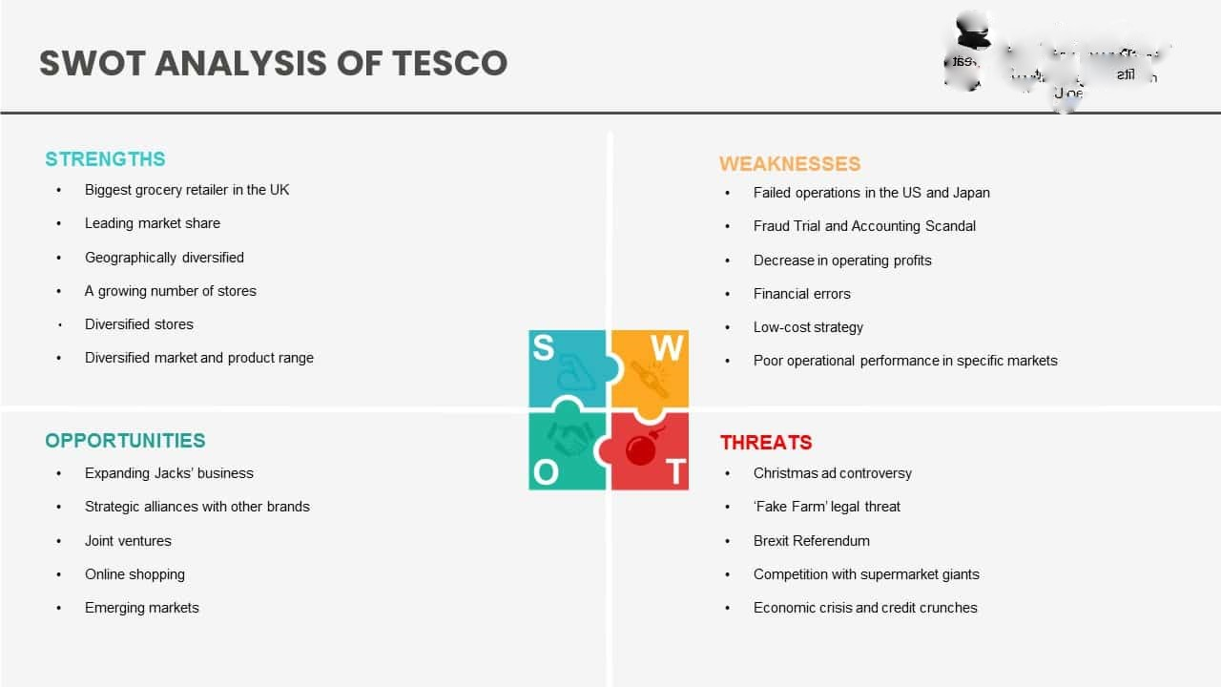

The Tesco brand is a corporate marketing strategy that is known to be very stable, recognizable and every little thing helps. Marketing strategy is basically the process of describing an organization's relationships as well as limited resources as the biggest opportunities and growth in company sales. Business agility also helps get groceries delivered first, and it also helps customers respond to grocery deliveries. The company helps its customers provide fast experiences and fast learning. Because it is important for businesses to adapt their products to the needs of their customers and markets. The market's emergency business solutions are part of business agility. There are many types of business agility, but the most important is business agility. Above all, organizational culture is changing. This is important for the needs of our customers because the organizational culture is not aligned with the market. This culture must change (Peeroo, 2019). Development is an important part of a culture of innovation. Digital champions who embody designs that are also critical to the digital readiness of culture and enhance members and teams. Employee satisfaction is very important in this area. Because when the customer is satisfied with using these products, the company and the project are also renewed. It is mainly a set of achievements that determine a person's various abilities, understanding, and personality. Tesco mainly helps to improve innovative communication strategies and is an important part of the group. Fresh ideas and good conversations help improve the company. Innovative communication strategies are an important part of the group (Teerawatnapong and Fernando, 2018).

Business Environment
The business environment is one of the most important parts of business development and is basically a marketing term for maintaining successful customer relationships. He mainly explained the social, government, client and cultural parts. Tesco sells the brand most often, and some issues, such as climate change, western food, deforestation, sustainable nutrition, exposure to the marine environment, and various types of environmental factors, most often hinder the company's brand. Design is also critical to the digital readiness of a culture that is a digital leader that enhances members and teams. Employee satisfaction is very important in this area. Because when the customer is satisfied with using these products, the company and the project are also renewed. On the other hand, the business environment strategy is the economic environment that occupies the most important part in business development. Economic growth is very important. This economic environment primarily determines domestic production, income and employment (Awadari and Kanwal, 2019). Employability is a set of achievements that primarily determine an individual's diverse skills, interests, and personality. This is the main overview of this project. Various social media service companies and their pros and cons are very useful in collaborating with employees and team leaders. Promotion is a very important part because it helps you expand your business and gives your company's employees access to applications that primarily manage administration. It is very important to evaluate and hire a project manager who must have experience in the

How Tesco fulfills the expectations of a customer on his journey
Tesco creates value for its customers through lifetime loyalty. Some items mainly meet customer needs. This is 1. Knowing your employees and audience is a very important strategy for meeting customer needs. 2. Customer needs are very important to the development of the company's business, and customer satisfaction is very important to the sale of our products. A clear project schedule encourages team collaboration. Roommates in a team are one of the important parts of dividing a team into parts, they are very useful for performing all kinds of tasks, and good communication with team members is important for a good and strong team (DarócziSzabó and Bartosiewicz, 2018).
3. A clear standard generally supported by the entire Tesco team. 4. A culture of innovation is an important part of a culture of digital readiness. Fresh ideas and good conversations help improve the company. An innovative communication strategy is an important part of the group. Fresh ideas and good conversations help improve the company With regard to project implementation, it is very important that the vision of the financial goals of these projects is very conducive to the development of the company's business (Wooyoung et al. 2020). 5. Employee satisfaction is very important in this area. Because when the customer is satisfied with using these products, the company and the project are also renewed. Employability is a set of achievements that primarily determine an individual's diverse skills, interests, and personality. Customer reviews are also important (Nurwidayat et al. 2019).

Segmentation, targeting and positioning strategies Of Tesco

Effective Segmentation criteria
Measurable- the size, getting power and profiles on the segment can be measured (Philip, okay 2008). The goal marketplace of Tesco additional Cheras has kind of five hundred,000 electorate and its average economic advantage on top of different residential districts or nations.
Handy- The marketplace phase could be effective reached and served (Philip, okay 2008). Tesco additional Cheras will definitely attain to its goal customers via mistreatment flyer, television commercial, brochure, catalogue, spam and therefore the cutting-edge one is SMS.
Big- The market segment is massive and profitable to serve (Philip, ok 2008). in step with the sure internet site, we generally tend to knew that capability client of Tesco additional Cheras which includes Taman Tenaga, Taman Ikhsan, Taman Bukit Ria, Taman Pertama, Taman Kobena, Kampung Baru Cheras, Taman Bukit Mewah, Taman Midah etc. round 5 hundred,000 human beings. thence it’s worthwhile sufficient.
Differentiable- The section ar conceptually distinguishable and respond otherwise to absolutely special promoting mixed part and applications (Philip, okay 2008). Tesco additional Cheras mistreatment one promoting combines to achieve the entire marketplace that is supplied cheaper charge and its place that settled in dense space encircled by means of housing area.
focused on
Tesco extra Cheras is exploitation Mass selling targeting method. Mass selling strategy is that the method to disregard marketplace segment versions and target the complete market with one deliver, it specializes in what is common within the wishes of buyers in preference to on what is absolutely extraordinary (Philip, ok 2008).
Its manner that Tesco didn’t differentiate the form of purchaser to serve, they feature many consumers as they may. most of the customers attend Tesco for a trendy would really like that could be a lower price product, for this reason Tesco as a reduced keep, it strives to serve a variety of customers that share a trendy would really like instead of differentiate the shoppers.

Positioning
Positioning is that the act of arising with the employer’s imparting and picture to occupy a particular area inside the thoughts of the goal market. The purpose is to locate the entire within the mind of consumers to maximize the ability edges to the company (Philip, okay 2008).
In this case, Tesco has finished a genuinely smart activity. we can see that Tesco positions itself as a espresso well worth distributer by using exploitation the promotion “cheapest well worth each day” for hand-picked product in its keep (discuss with appendix). This method is pretty productive within the alternate and attracts sufficient clients that come lower back for these specific lower value products. therefore, a perception like “Tesco sells lower fee product every day” can embedding into the consumer thoughts.

Tesco's Distribution Strategy
An Influential Mindset Tesco clearly transforms its ideal customer with a specially tailored brand image. Tesco offers a wide range of objects and relationships in a variety of business districts in a non-psychographic way with specific sectors. Therefore, the Tesco Genuine Market is a visionary people who are passionate about their approach and planning and worth working with (AlSuraihi, 2020). In order to adapt to the changing social conditions, it was initially organized as a low-cost large retailer, but in the late 1990s, it changed its status to a company that promoted Tesco value items at low prices, but the surrounding premium is highlighted. on things. Within the Tesco Finest line (Peeroo, 2019). With this fix, Tesco tried to work with the sweet spot by offering something close to the standard with a "best" range. They remembered that they generally required corner stores to sell everything they needed to buy, at the price they chose to pay, without any classification of reality (AlSuraihi, et al 2020).

Tesco's Advertising Strategy

Tesco is based on customer acquisition through an unprecedented, low-cost methodology. Tesco uses print and media publishing as effective channels for sending time-limited messages to current and prospective customers. Alliances rely heavily on unprecedented customer acquisition and retention planning (Singh, 2021). They continue to offer “get one” deals and discounts both online and in-store. Without having to set up a customer forever, Tesco can choose which club card it supports. Club card holders receive a restorer able focus for added benefit and clipping focus. This is how Tesco develops several methodologies to keep itself best as a market leader with smart things while ensuring integrity and quality (Peeroo, 2019). Moreover, it stands out in their propaganda philosophy. We can check it out. Tesco's advertising structure for limited time and displays is reflected in the process.

Product strategy of Tesco
Tesco is usually associated from the beginning and a little later offers a variety of things in the classroom including Food, Equipment, Prosperity, Books, Clothes, Home & Style, Party & Gifts, Prosperity & Sports, Kids Goods, and Improvements. , meaning, etc. Tesco is a retailer, meeting the diverse needs of customers in different sectors (Singh, 2021). Tesco has its own brand for this diagram. Some of the varieties available in Tesco stores are: Pet Ideas, Food, Frozen Foods, Beverages, Baked Goods, Play Tools, Crafts, Household Appliances, Nurseries and Homes & Stuff. Yourself. (DIY), Toys, Car Supplies, Entertainment and Sporting Goods, Baby Products, Gifts and Party Supplies, Brightness, Health, Jewelry, Clothing, Books and Entertainment.

Tesco Pricing Strategy

At a very basic level, Tesco has a convincing shareholder association that rewards them for leveraging economies of scale and behavior. At Tesco, we don't think of quality as inspiration. They communicate confidently with their customers and try to cut costs negligibly to keep them down. Tesco also adheres to the principle of “sustainability” (Singh, 2021). This provides the lowest estimated inventory without forgetting the value (Bărbulescu, 2018). Tesco works with its suppliers to improve the quality of network deployments and reduce costs. Tesco offers stable and affordable prices as soon as we receive customer feedback. Tesco made unprecedented cost savings to cut costs. Tesco's amazing warranty program allows suffering customers to get a lower value for items lost elsewhere. Tesco will match value by expecting customers to buy a dozen or so, so you can trust your customers will pay the least at Tesco. Tesco actually translated a new low-cost food brand (AlSuraihi, et al 2020). Tesco copied the work to find the best ideas for its customers. In order to serve customers during the pandemic, the store has based its sales on three things written below the main ones.

Marketing Strategies:

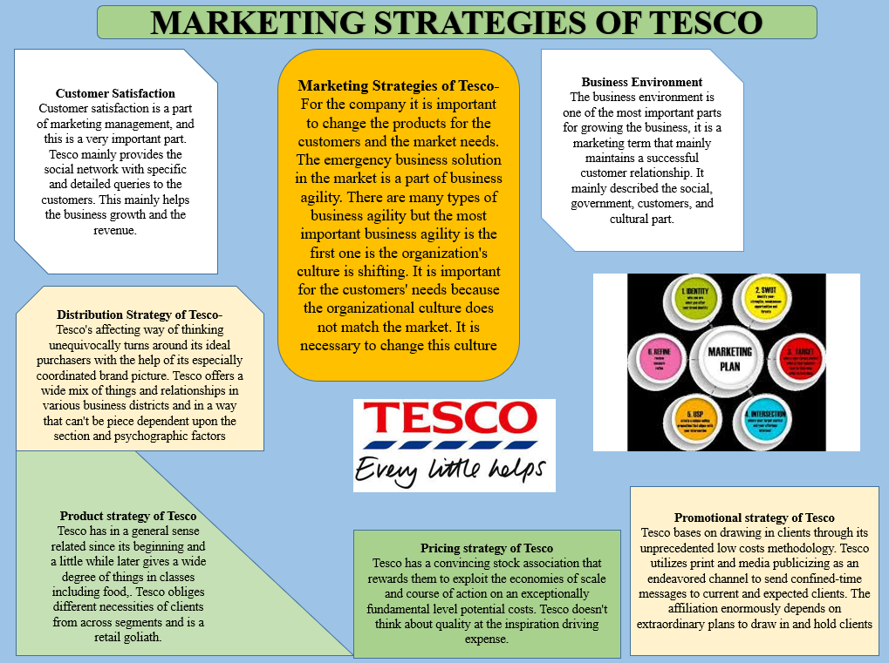

Conclusion
Tesco's enterprise view is the most basic level of spending privileges with added availability, procedures and customer support. Tesco stands out in the UK and around the world for value, comfort and intelligence. Club cards play a key role in the evolution of the grocery chain as they allow shoppers to continually expand their range of action options. With a customer-centric mindset, Tesco has built a very stable customer base and a one-stop brand. The undeniable quality rests on the image of a productive and intelligent chain. Retailers promote consumer consented movements on their websites and in stores to ensure that every purchase is as smooth and rewarding as possible. The Tesco brand is very stable and recognizable and corporate marketing strategies generally known to everyone help to reinforce this. Marketing strategy is basically the process of describing an organization's relationships as well as a company's maximum opportunities and limited resources with increased sales. Customer satisfaction is part of marketing management and is a very important part. Tesco mainly provides social networks with specific and detailed customer requests described in this section (Fachmi and Utami, 2018).

Reference

Rosnizam, M.R.A.B., Kee, D.M.H., Akhir, M.E.H.B.M., Shahqira, M., Yusoff, M.A.H.B.M., Budiman, R.S. and Alajmi, A.M., 2020. Market Opportunities and Challenges: A Case Study of Tesco. Journal of the Community Development in Asia (JCDA), 3(2), pp.18-27.
Singh, P., Ranjith, P.V., Fathihah, N., Kee, D.M.H., Nuralina, N., Nurdiyanah, N. and Nursyahirah, N., 2021. Service Quality Dimension and Customers' Satisfaction: An Empirical Study of Tesco Hypermarket in Malaysia. International Journal of Applied Business and International Management (IJABIM), 6(3), pp.102-114.
Bărbulescu, O., 2018. MARKETING STRATEGIES USED BY RETAILERS ON THE INTERNATIONAL WINE MARKET. Bulletin of the Transilvania University of Brasov. Economic Sciences. Series V, 11(2), pp.9-14.
Al-Suraihi, W.A., Al-Suraihi, A.H.A., Ibrahim, I., Al-Tahitah, A. and Abdulrab, M., 2020. The Effect of Customer Relationship Management on Consumer Behavior: A Case of Retail Industry in Malaysia. International Journal of Management and Human Science (IJMHS), 4(3), pp.32-40.
Bărbulescu, O., 2018. MARKETING STRATEGIES USED BY RETAILERS ON THE INTERNATIONAL WINE MARKET. Bulletin of the Transilvania University of Brasov. Economic Sciences. Series V, 11(2), pp.9-14.
Peeroo, S., 2019. Customer-initiated conversations on Facebook pages of Tesco and Walmart. In Information Systems Design and Intelligent Applications (pp. 43-51). Springer, Singapore.
Yunus, N.K.Y., Abdullah, H.H., Wahid, H. and Rahman, R., The Relationship Between Promotional Mix And Display Strategies With Sales Performance Of Hypermarkets In Malaysia. Strategic Alliance Between AGBA, Millikin University (USA), IIM-Rohtak (India) and Gift Society (India), p.403.
Sreenivasan, R., Ludbrook, L., Fisher, B., Declosmenil, F., Knower, K.C., Croft, B., Bird, A.D., Ryan, J., Bashamboo, A., Sinclair, A.H. and Koopman, P., 2018. Mutant NR5A1/SF‐1 in patients with disorders of sex development shows defective activation of the SOX9 TESCO enhancer. Human mutation, 39(12), pp.1861-1874.
Lomoio, S., Willen, R., Kim, W., Ho, K.Z., Robinson, E.K., Prokopenko, D., Kennedy, M.E., Tanzi, R.E. and Tesco, G., 2020. Gga3 deletion and a GGA3 rare variant associated with late onset Alzheimer’s disease trigger BACE1 accumulation in axonal swellings. Science Translational Medicine, 12(570).
Kim, W., Hallsworth, A. and Kim, H., 2019. On being local and being successful in Korea: Tesco and E‐mart. Area, 51(3), pp.461-469.
Rosnizam, M.R.A.B., Kee, D.M.H., Akhir, M.E.H.B.M., Shahqira, M., Yusoff, M.A.H.B.M., Budiman, R.S. and Alajmi, A.M., 2020. Market Opportunities and Challenges: A Case Study of Tesco. Journal of the Community Development in Asia (JCDA), 3(2), pp.18-27.
Peeroo, S., 2019. Customer-initiated conversations on Facebook pages of Tesco and Walmart. In Information Systems Design and Intelligent Applications (pp. 43-51). Springer, Singapore.
Tirawatnapong, R. and Fernando, M., 2018. Factors Influencing Bangkok People Purchase Intention towards Tesco Lotus House Brand Products. International Research E-Journal on Business and Economics, 4(2), pp.15-29.
Lin, C. and Peng, J., 2018. Analysis and Solution of the Problems in the Distribution of Suning Tesco. Transportation Management, 1(1).
Awadari, A.C. and Kanwal, S., 2019. Employee participation in organizational change: A case of Tesco PLC. International Journal of Financial, Accounting, and Management, 1(2), pp.91-99.
Foabeh, P.A. and Achaleke, H.F., 2020. ATTITUDES AND PERCEPTIONS OF SHOPPERS’GROCERY SUPERMARKET CHOICES: A COMPARATIVE ANALYSIS BETWEEN BIG C AND TESCO LOTUS. International Journal of Research-GRANTHAALAYAH, 8(7), pp.67-79.
Jonah, U.I., 2018. The Influence of Transaction Costs on the Business Performances of Tesco Supermarket. International Journal of Business and Social Science, 9(5).
Daróczi-Szabó, M. and Bartosiewicz, L., 2018. Horse-dog burials from preventive excavations at Dombóvár TESCO. Dissertationes Archaeologicae, pp.243-256.
Woohyoung, K., Kim, H. and Hwang, J., 2020. Transnational corporation’s failure in China: Focus on Tesco. Sustainability, 12(17), p.7170.
Nurwidayat, A., Sudarsono, B., Pratiwi, K. and Havity, M.D., 2019. Implementation of Information System in Submitting Employees’ Annual Leave at PT. Tesco Indomaritim. Sinkron: jurnal dan penelitian teknik informatika, 3(2), pp.97-103.
Fachmi, A.H.N. and Utami, D.S.M., 2018. ETIKA PROFESI AKUNTAN DAN PERMASALAHAN AUDIT STUDI KASUS SKANDAL TESCO DAN KAP PwC. UNEJ e-Proceeding, pp.189-195.

