Reflective Journal Introduction to Publishing (CAMF 4007)
Kelvin Guy student no.1704517
This was a very challenging assessment for me because it was going to be a live project for both the poster and the magazine. The magazine part was going to be developed as a programme instead. I had to design and produce a programme for the Carmarthen Bay Film Festival, which I had done many times before but not using InDesign, or Photoshop for designing the posters. Previously I’ve used programs like serif which in comparison are hobby software and are certainly not for professional use.
I wanted both the poster and the programme to be as professional as possible and hopefully they have turned out that way. I also wanted them to be totally different from anything that I’d produced in the past.
Learning to use both Photoshop and InDesign has also been a challenge especially being a pc user for many years because I had to relearning shortcut keys. But I think I’m getting there.
So where to start, that was the first challenge the design, colours, shapes, font, how do I want to portray the festival. Over a couple of lectures, we looked at different layouts and designs of magazines, artists and designers. And the one style that really stood out was Bauhaus. Why? Because of its retro and modern looking shapes, colours and fonts.
So, I started to research by looking at different books and downloading photos and designs. Then I looked at different colours pallets and finally chose some I liked.

Here are some examples of some I took inspiration from.
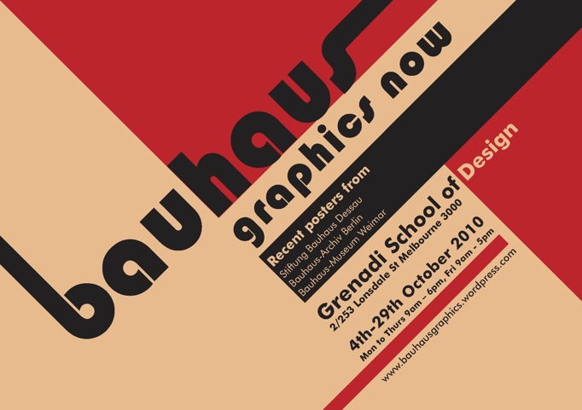
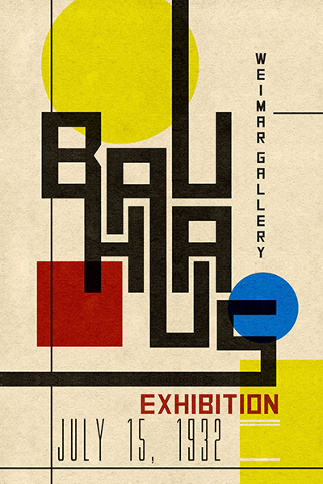 By Paul Klee

So, the first challenge was the poster and getting to grips with designing one using Photoshop. Didn’t get off to a great start but after experimenting with different colours shapes and fonts. I’ve achieved what I think, is a design that portrays the festival with a retro yet modern look and feel.
So here are some examples of previous designs. There were many changes to the font and layout. I did change my mind many times regarding the size of font and where to place them. Again, the same problem with the what shapes to use.
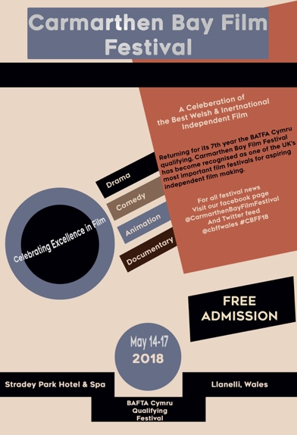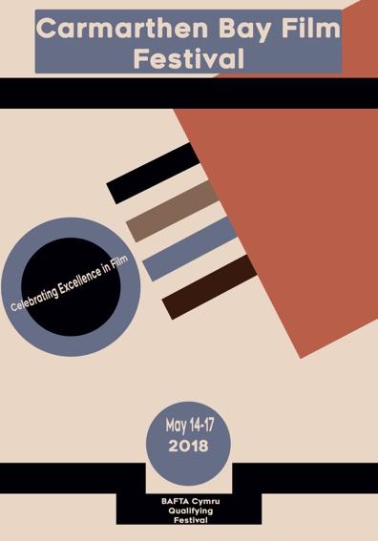
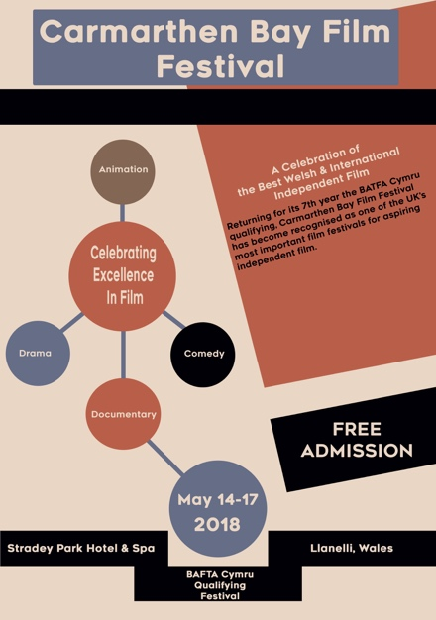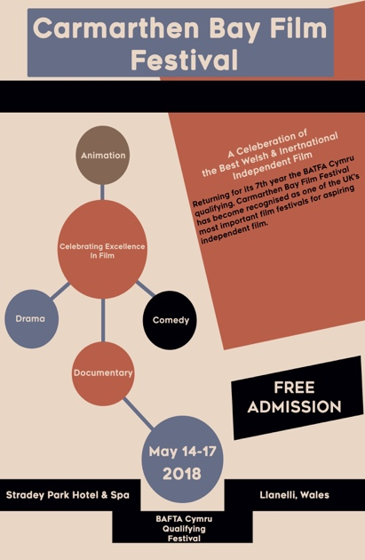
Eventually after many different challenges with fonts and looks I’m happy with the end result. Which I’ve include within the file along with the festival programme.
Next challenge was the festival programme.
Again, I wanted it to be as professional as possible and by using adobe InDesign has without doubt helped make the programme look the most professional its ever looked. But it has gone through like the poster many changes and there have also been many challenges for me to get over and resolve.
I wanted to continue the same theme of Bauhaus with the programme. At first, I thought I would just reproduce the poster as the programme cover. But I wanted to say something different with this. And I also felt it was just the lazy option. The only things I wanted to keep for the cover was the colour pallet and font. I wanted it to be a bit cleaner, maybe a bit less going on. The idea of the poster was to draw people in, to take note of what was happening, the different categories of film on offer and the fact it was a free event. With the programme cover I didn’t want the reader to spend too much time looking at it. But to look inside and discover the content on offer, to generate more interest in what the festival was offering.

Here is an example of a Bauhaus design sheet where I took some inspiration from.
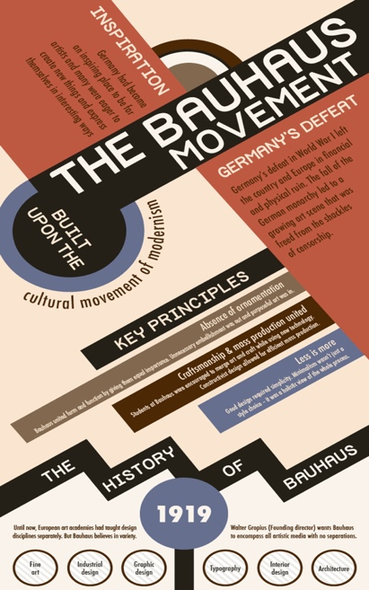

Laying out each page was also a challenge making sure everything made senses and was in order. Collating the information about the main features, photos synopsis etc. Getting the timings right for each day was also a huge task.
So, it wasn’t just the design of the programme that was a challenge it was also all the other aspects of it as well. Did everything go to plan no. There are a few things I would do differently and some I wouldn’t change. I would recommend doing all the writing in word and then copy and paste in to InDesign. Double check the photos you import ratio size etc. Double check all information before you publish timings filmmaker’s information etc.
The end result is more or less want I wanted with both the poster and the programme and it has been a steep learning curve using both Photoshop and InDesign. I have enjoyed it.
I realise there’s still a lot to learn about both these programs, but I think I’m getting there, and I hope that both the poster and the festival programme will help to prove that I am making some progress.

Reference List
Development of Modern Art FA2012 [online] available at http://devofmodartfa2012.blogspot.co.uk/2012/12/bauhaus_6.html
Accessed 4t of APRIL 2018
Klee Paul. (1932) Bauhaus [online] available at http://www.paul-klee.org/bauhaus/
Accessed 4th of APRIL 2018
INFOGRAPHIC: The History of the Bauhaus Movement [online] available at
https://inhabitat.com/infographic-the-history-of-the-bauhaus-movement/
Accessed 4th of APRIL 2018

