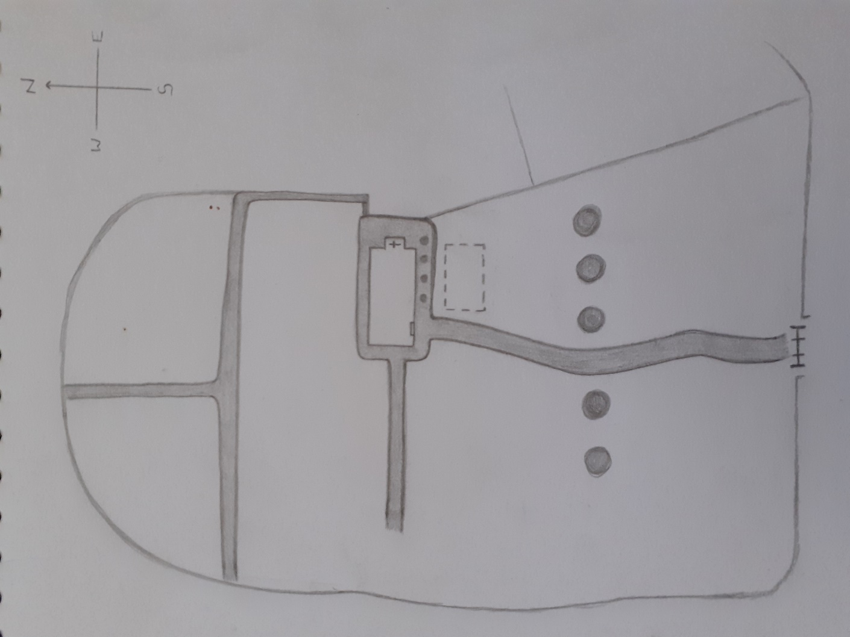
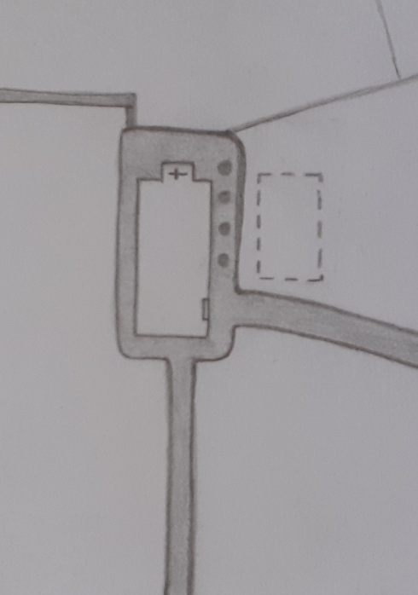
Archaeology:
Introduction to Fieldwork.
Cemetery Survey -
St Peter’s Church, Lampeter.
This project will focus on the cemetery of St Peter’s Church, Lampeter, Ceredigion, examining a number of the site’s graves, and analysing how people are commemorated in relation to wealth.
Site Map:
‘Area I.’
Tree Line.
South gate.
Site of the original church building.
Current church.

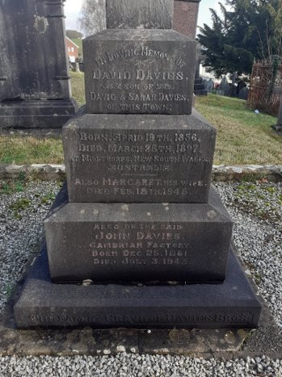
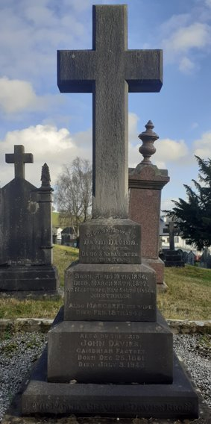
‘Area I’ is situated at the immediate front side of the church, placing it at the centre of the cemetery. ​This area includes the site of the original church building, and many large and decorative ‘obelisk’ style headstones.
​
Below are images of the graves I have recorded from this area:
Area I, Grave 1.
​
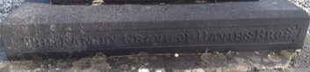
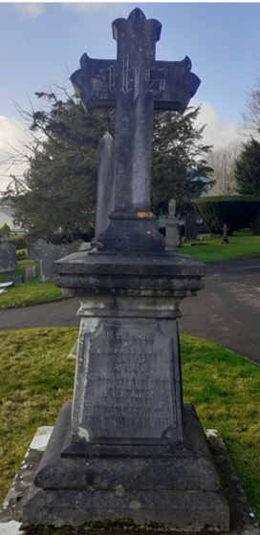
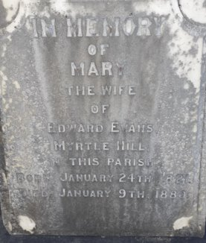
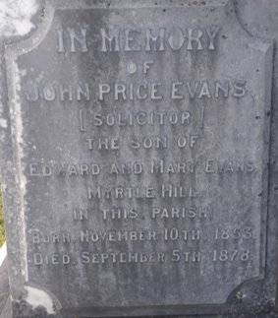
Headstone: Kerbed Obelisk (Cross.) Plot: Family (3 Individuals.) ​
Size: Large and Spacious. ​
Material: Stone.
David Davies, Wife Margaret and brother: John Davies.
Area I, Grave 2.
Headstone: Obelisk (Cross.) ​
Plot: Family (3 Individuals.) ​
Size: Large and Spacious. ​
Material: Marble. ​
Edward Evans, wife Mary and son
John Price Evans.
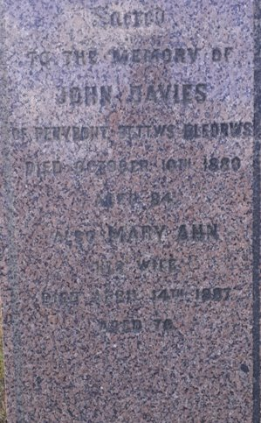
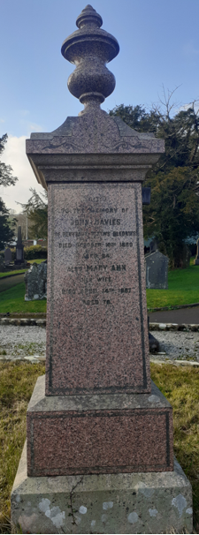
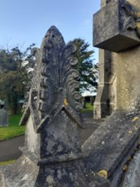
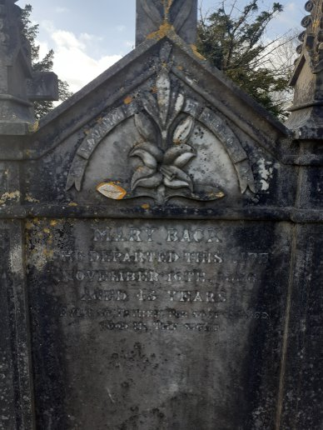
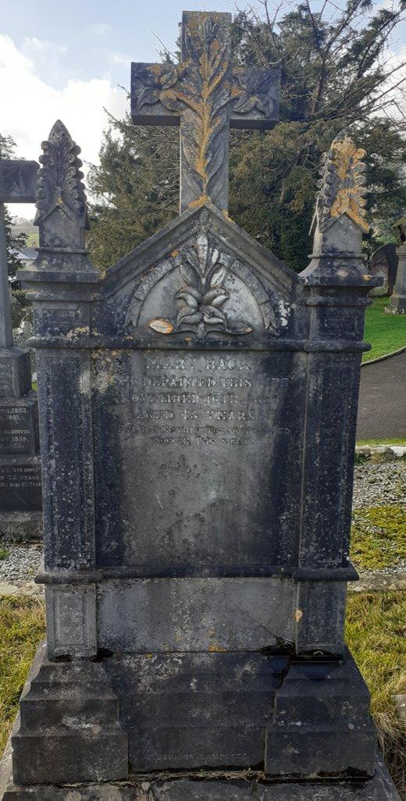
Area I, Grave 3.
Headstone: Obelisk (Urn.) ​
Plot: Spouse (2 Individuals.) ​
Size: Large and Spacious. ​
Material: Red Granite.
John Davies and wife Mary Ann.
Area I, Grave 4.
Headstone: Traditional (Cross/Decorative Carvings.) ​
Plot: Singular Individual. ​
Size: Large and Spacious. ​
Material: Stone.​
Mary Back.

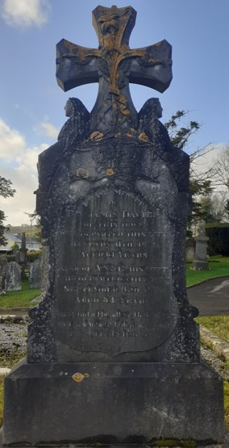
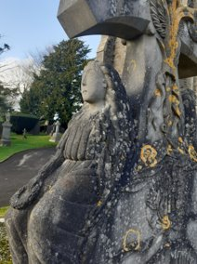
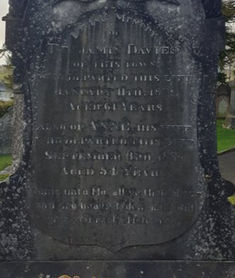
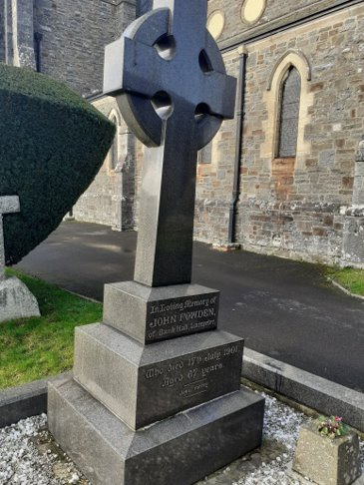
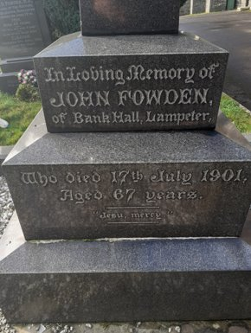
Area I, Grave 5.
Headstone: Traditional (Cross/Decorative Carvings.) ​
Plot: Spouse (2 Individuals.) ​
Size: Large and Spacious. ​
Material: Stone.
Benjamin Davies and wife Anne.
Area I, Grave 6.
Headstone: Kerbed Obelisk (Celtic Cross)​
Plot: Singular Individual. ​
Size: Large and Spacious. ​
Material: Polished Granite.
John Fowden.

Area I, Grave 7.
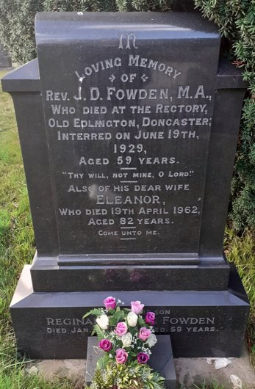
Headstone: Traditional (Decorative Shape)​
Plot: Family (3 Individuals). ​
Size: Medium. ​
Material: Polished Granite.
Rev. J.D Fowden, M.A and wife Eleanor.
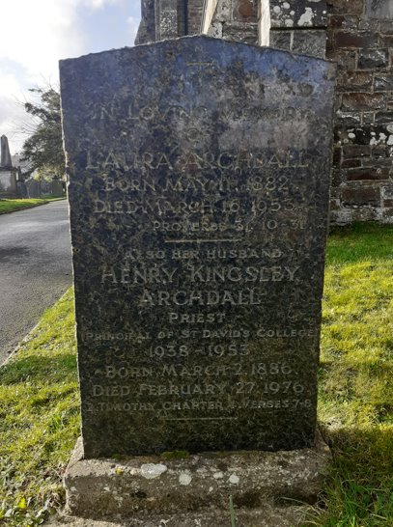
Area I, Grave 8.
Headstone: Traditional ​
Plot: Spouse (2 Individuals). ​
Size: Medium. ​
Material: Marble.
Laura Archdall and husband Henry Kingsley Archdall

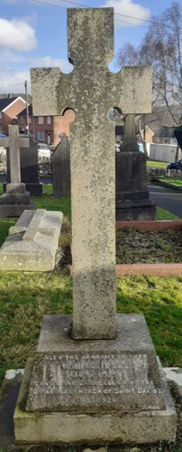
Area I, Grave 9.
Headstone: Obelisk (Cross) ​
Plot: Spouse (2 Individuals). ​
Size: Large. ​
Material: Stone.
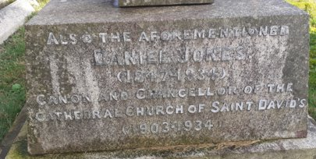
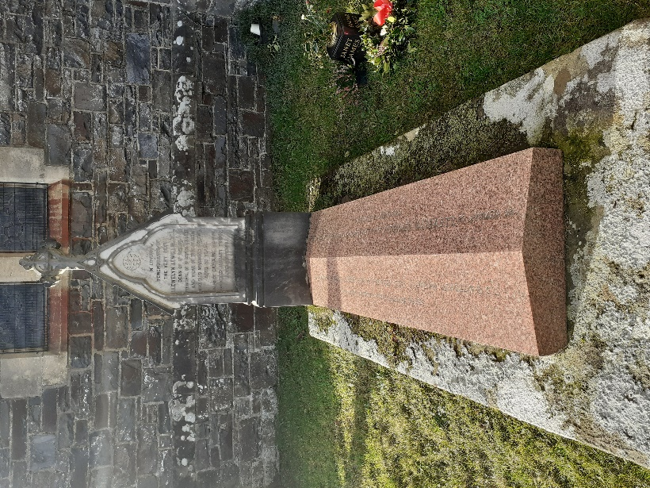
Daniel Jones and wife.
Area I, Grave 10.
Headstone: Traditional Headstone (w/Cross) and Bed.
Plot: Spouse (2 Individuals). ​
Size: Large.
Material: Marble and Red Granite.
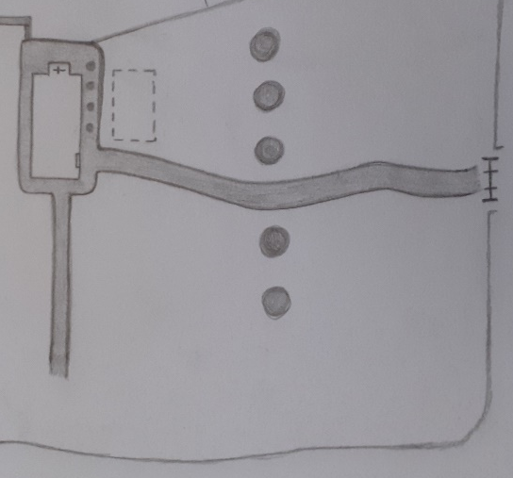
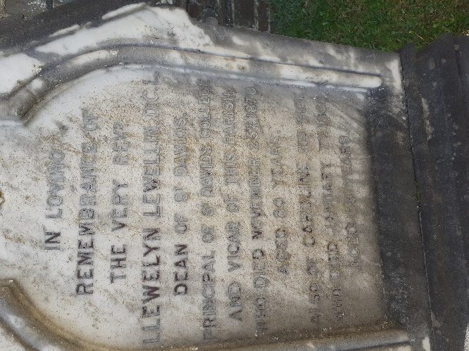
Rev. Llewelyn Lewellyn
‘Area II.’

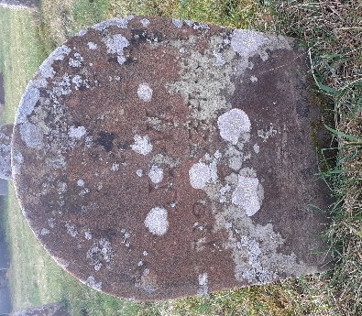
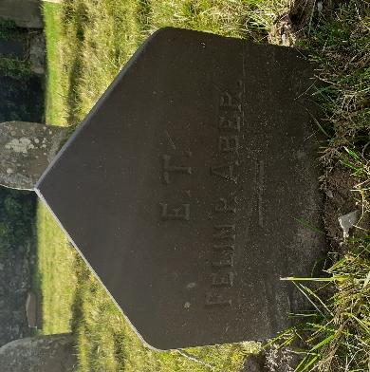
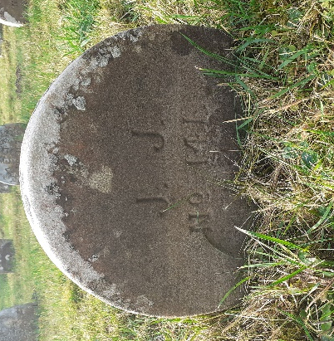
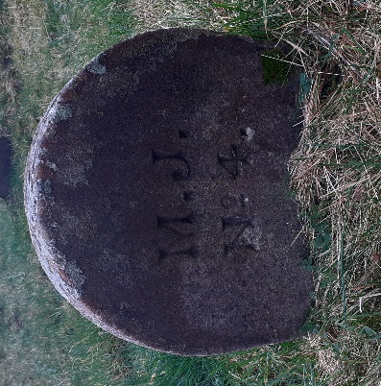
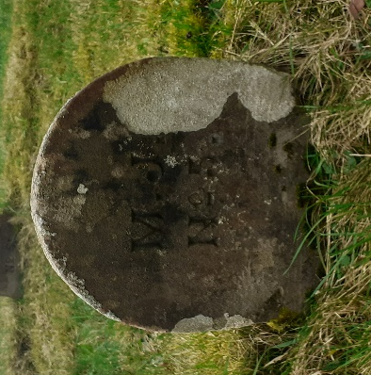
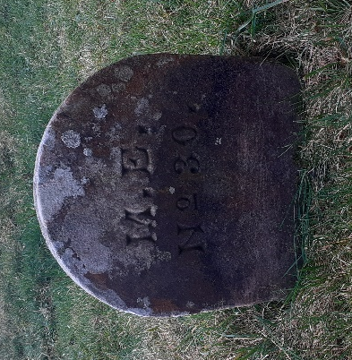
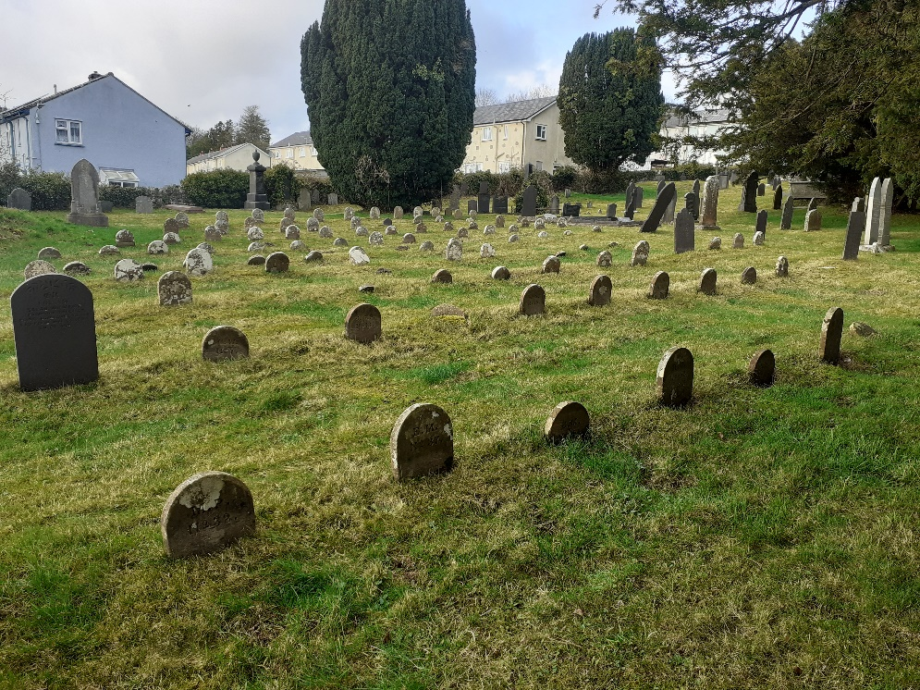
‘Area II’ is situated at the South-West corner of the cemetery, and is largely dedicated to paupers’ graves, which are small, basic and display only initials of the individuals name, and a plot number. However, there are a few larger, and visibly more expensive headstones along the western wall.
Below are images of the graves I have recorded from this area:
Area II: ‘Pauper’s Graves.’
The majority of the pauper’s headstones are made of stone, aside from a few that are made of slate.
‘’J.W.
No. 34’’
‘’E.T
Felin R Aber’’
‘’J.J.
No. 141’’
‘’M.J.
No. 4’’
‘’M.J.
No. 5’’
‘’M.E.
No. 30’’

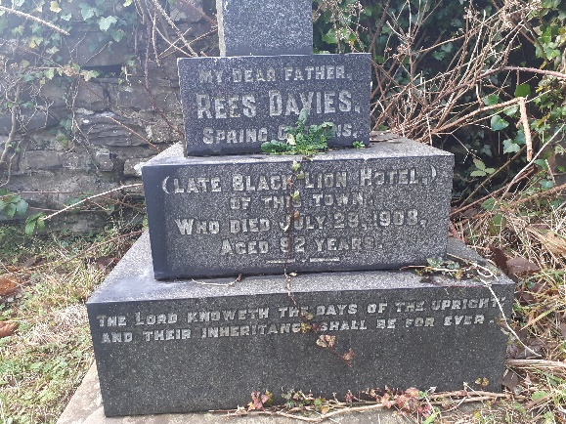
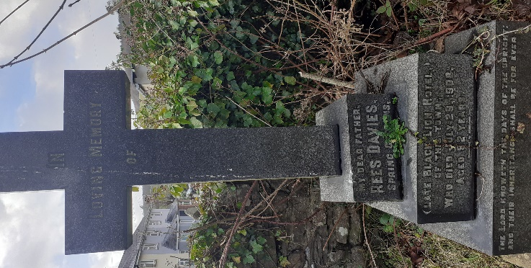
Area II, Grave 1.
Headstone: Obelisk (Cross)
Plot: 1 Individual. ​
Size: Large.
Material: Granite
Rees Davies.
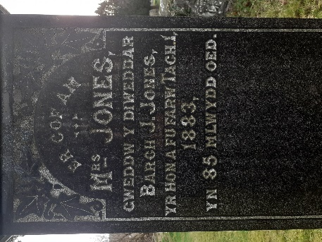
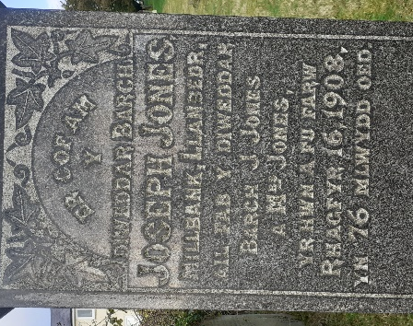
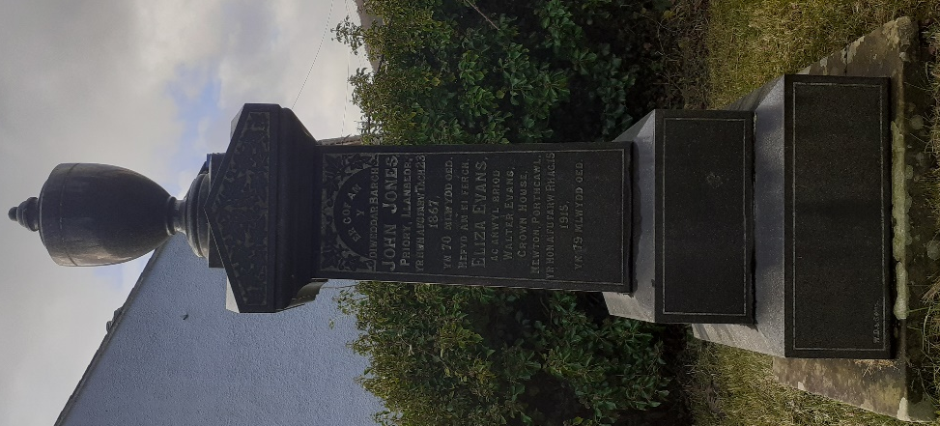
Area II, Grave 2.
Headstone: Obelisk (Urn)
Plot: Family (4 Individuals.) ​
Size: Large.
Material: Granite
John Jones, Eliza Evans, Joseph Jones
and ‘’Mrs Jones’’.

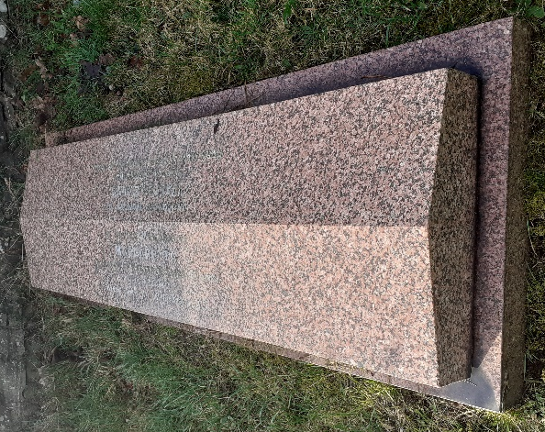
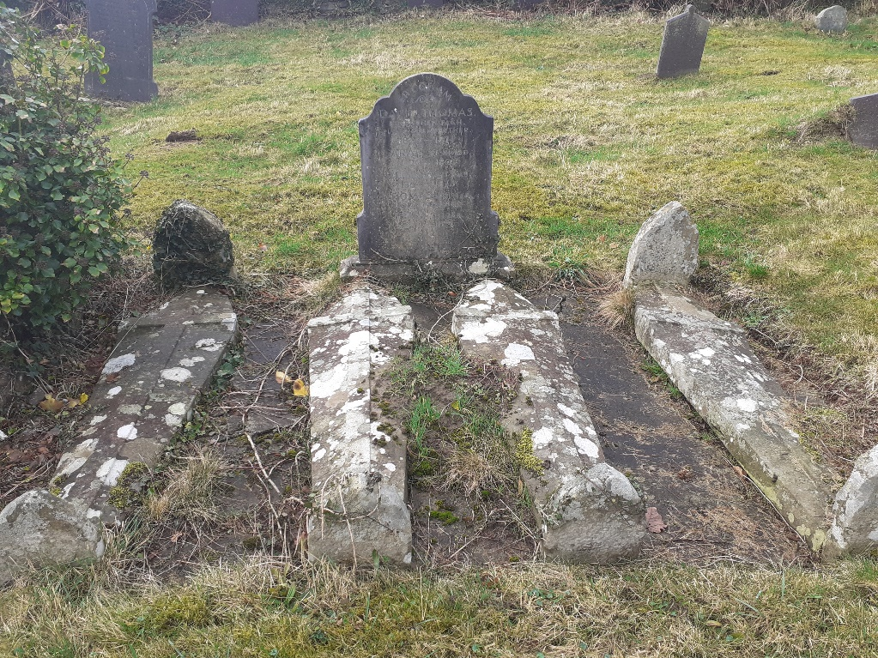
Area II, Grave 3.
Headstone: Bed.
Plot: Spouse (2 Individuals.) ​
Size: Large.
Material: Red Granite.
Walter Evans and wife Margaretta.
Area II, Grave 4.
Headstone: Traditional, (w/coffin shaped beds.)
Plot: Family (4 Individuals.) ​
Size: Large.
Material: Stone.
Area III.
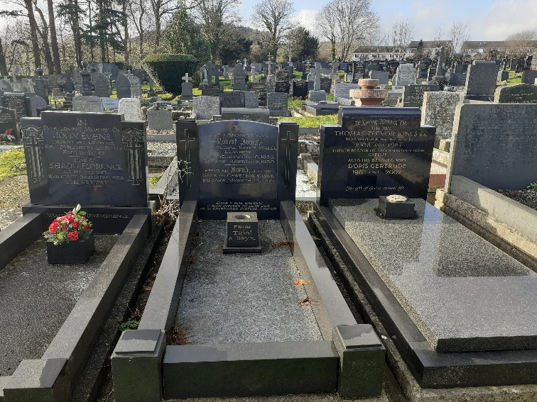
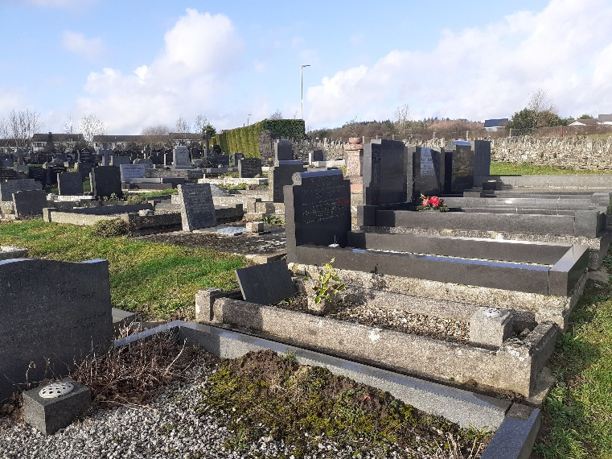
‘Area III’ is situated at the rear of the church, on the East side of the cemetery. This area is very full, with little space between graves/plots (as seen above.)
Below are images of the graves I have recorded from this area:
Area III, Grave 1.
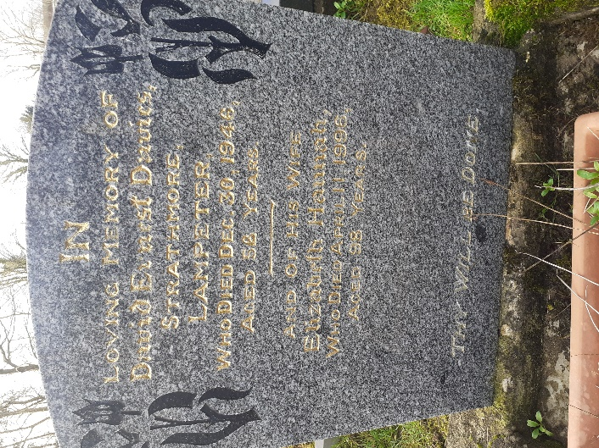
Headstone: Traditional.
Plot: Spouse (2 Individuals.) ​
Size: Medium.
Material: Granite.
David Davies and wife Elizabeth.

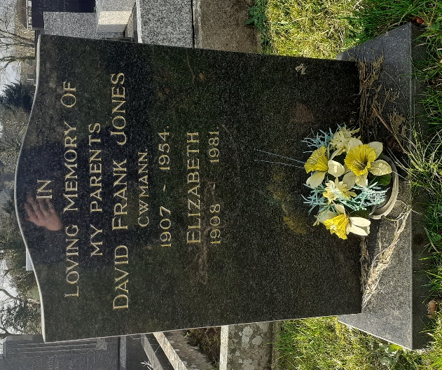
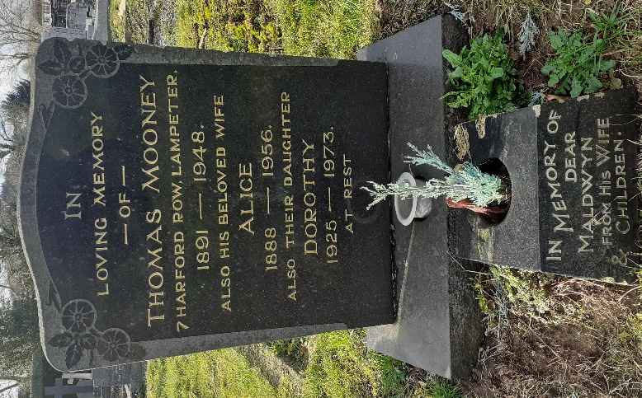
Area III, Grave 2.
Headstone: Traditional.
Plot: Spouse (2 Individuals.) ​
Size: Medium.
Material: Granite.
David Frank Jones and wife Elizabeth.
Area III, Grave 3.
Headstone: Traditional.
Plot: Family (4 Individuals.) ​
Size: Medium.
Material: Granite.
Thomas Mooney, wife Alice and daughter Dorothy.
Also, Maldwyn.

