Module Code: BMIH5007
Module Name: Financial Management for the Hotel Industry
Module Lead: Tristan Hawkins
Assignment Title: Business Report - Comparison of Two Hospitality Organisations
Student Name: Monica Clementina Radu
Student Number: 2209717

Table of Contents

1.Introduction …………………………………………………………………………..…..3
2. About Corinthia Hotels and Ibis Hotels……………………………………….…………3
3. Total Revenue…………………………………...…….…………………………………3
4. Market Position……………………………………………………………….…………4
4.1. Market share…………………………………….……………………..….…..4
4.2. Supply and Demand…………………………………………………………..5
4.3. Customer demographic………………………………………………………..5
4.4. Brand perception………………………………...…………………………….6
5. Growth potential……………………………………………………………………...….7
6. Financial Commitment to CSR…………………………………………………………10
7. Recommendation………………………………………………………………….……12
8. Conclusion ………………………………………………….…………………….……13
9. References………………………………………………………………………………14

Introduction
This report aims to evaluate Corinthia Hotels and Ibis Hotels' financial management strategies and practices in the hospitality industry. The report will focus on key areas such as total revenue, market position, growth potential, and financial commitment to CSR. The analysis will consider revenue sources, trends, and factors driving growth or decline. In Addition, the report will also assess the growth potential of each organization, including expansion strategies, market opportunities, and potential barriers. Moreover, the report will also evaluate the financial commitment to sustainability, community engagement, and ethical business practices. The goal is to provide a comprehensive business report that critically appraises these two organizations' financial management strategies.

About Corinthia Hotels and Ibis Hotels
The Corinthia brand, founded in 1962 by the Pisani family of Malta, is internationally recognised for its timeless and carefree style across a variety of iconic destinations and localities. The Hotel brand is committed to sustaining family values via warmth, outstanding service, and a knowledge of the importance of hospitality in pleasing the senses (Corinthia Hotels, 2023). On the other hand, Accor is the owner of the French low-cost accommodation brand Ibis, which is styled as Ibis and occasionally referred to as Ibis Red (Ibis Hotel, 2023). In 2011, Ibis Styles and Ibis Budget appeared as Accor's economic megabrand, overtaking All Seasons and Etap Hôtel. However, Corinthia Palace in Attard, which was once a restaurant, underwent modifications to become the hotel that introduced the name in 1968 (Corinthia Hotels, 2023). In Addition, well-read people who appreciate travelling choose this brand because travel is a desirable experience that signifies beauty that varies and grows over time. In comparison, the Accor corporation founded the Ibis Hotel group in 1974 (Ibis Hotel, 2023). It manages 700 hotels in 36 countries, including South Korea, Thailand, and China. However, with 1,277 hotels, it grew to become the biggest hotel operator in Europe in 2011. In 2012, Ibis experimented with the robot-based programme Sleep Art.

Total Revenue
The company that oversees the Corinthia hotel chain, International Hotel Investments Ltd (IHI), has a €95.8 million increase in revenue in the first half of 2022 compared to the same period the previous year. In Addition, there was an uptick even though the Omicron variant of COVID-19 caused the year to start poorly. IHI is certain that in the upcoming months, it will fully recover from the pandemic's effects (Corinthia Group, 2023). However, the majority of the group's hotels are located in the United Kingdom, and their performance in 2019 has improved. Pre-tax profit for IHI came to €817,000, a substantial rise over the €30.2 million loss for the same period last year (Corinthia Group, 2023). On the other hand, Accor's current revenue (TTM) is $4.52 billion, according to the company's most recent financial filings. This indicates a $2.49 billion increase in revenue from 2021 to $4.52 billion in 2022. Accor, owner of Ibis Hotel, the world's largest supplier of low-cost and economy hotels, recently commemorated the opening of its 1,000th Ibis hotel worldwide (Accor, 2023). In Addition, by updating its ibis, ibis Styles, and ibis budget brands, the company created a more cohesive portfolio of wellness, modernism, and simplicity (Nasir et al., 2018).

Market Position
Businesses need to use advanced marketing strategies that meet and surpass customer expectations if they want to survive in the unpredictable hotel industry. This is important since different customers possess various needs, preferences, and interests, which are influencing the way modern hotel businesses market their goods and services.

Market share
The two main purposes of the Corinthia Hotel are to accommodate guests and offer catering. The majority of the visitors are leisure tourists, despite the hotel's reputation as a business hotel. However, approximately 64% of the tour operator and leisure categories are represented in the hotel's market share (Corinthia Palace, 2023). As one of the best in the Corinthia group, the firm has an average client retention rate of about 20% (Corinthia Palace, 2023). In comparison, the Ibis low-cost hotels provide premium accommodations and facilities at incredibly low costs to rival lodging chains like Travelodge and Holiday Inn Express. Likewise, market share, or a company's percentage of total sales in the market it serves, is a key indicator of its competitiveness. In Addition, a company's revenues increase at the same pace as the market when it keeps its share of the market. In Addition, with an average yearly growth rate of 5.7%, the sales amounts were $39,086 million, $41,058 million, $44,249 million, and $46,585 million (SIHOMBING and Soewarno, 2020).

Supply and Demand
Changes in the hotel industry are currently driven by market demand and the development of new trends and opportunities. Many factors, such as income levels, travel patterns, and various types of lodging, affect the demand for hotel rooms. A few supply-related considerations are costs, barriers to entry, and current and anticipated capacity. Various external factors such as political stability, problems with the environment, health and safety standards, cultural events, and economic situations can affect the equilibrium of the market. Market strategies need to be implemented to maximise revenues while maintaining competition. In comparison to the hotels, the non-strategic decisions of the Ibis Hotel include details regarding its training programmes, which are intended to equip employees with the skills necessary to resolve customer complaints in fifteen minutes (Indriani et al., 2022). A low-cost differentiation strategy, international expansion into several markets, and a 15-minute happiness programme are some of the non-strategic options available to the Ibis Hotel. Additionally, the Ibis Hotel made poor decisions when it came to promotion and advertising. On the other hand, Corinthia uses a yield and revenue management system to drive hotel segment and sub-segment selling decisions, resulting in high room pricing and occupancy levels (Corinthia Palace, 2023). For forecasting and analysis, the organisation uses cutting-edge technology called IDeaS G3, which saves data in a data warehouse.

Customer demographics
The goal of Corinthia is to improve the quality of life for all of its visitors, employees, and neighbours. This is the hotel's goal for every discussion, choice, and concept. Their Chairman and Founder, Alfred Pisani, always expresses its goal to workers across the globe (Juhász-Dóra, 2015). Corporate and wealthy travellers who are prepared to spend more for upscale facilities and services are frequently drawn to hotels. These guests can be seeking an opulent getaway or a cosy location to stay while attending a business conference or meeting. In Addition, Corinthia has been among the top four hotels while facilitating its customers as shown in the graph below:
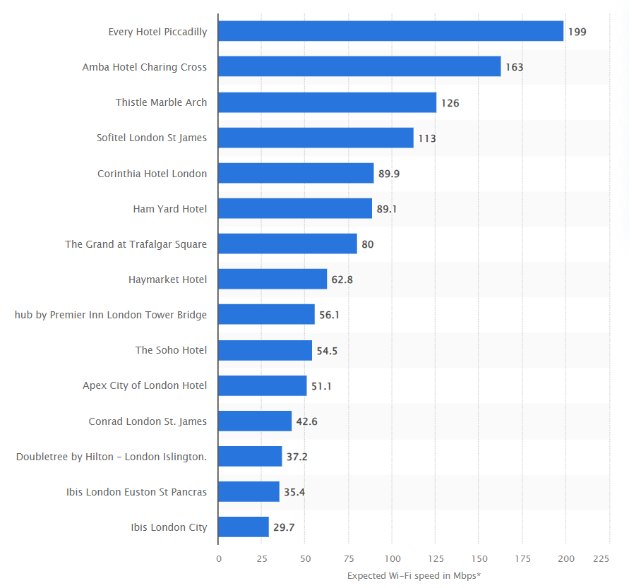
Figure 1: London Hotels Wi-fi Speed (Source: Statista, 2023)
However, the target market for budget Ibis hotels is families, couples, and people visiting a certain location who need to spend the night someplace to get some rest usually close to essential transit routes and they can find their offerings fascinating (Cheng, 2019).

Brand perception
The Corinthia Hotel has its roots in the signature columns of the Villa Corinthia Restaurant, which continues to be a distinguishing feature (Naumik-Gladkaya and Devon, 2018). Relationships with customers, business partners, and members of the Corinthia Group are built around the fundamental values of integrity, honesty, trust, and respect, which are the basis of the company's culture. On the other hand, the urban, carefree, and lively design aesthetic wonderfully captures the essence of the Ibis Hotels brand (Indriani et al., 2022). Ibis's budget hotels are designed to be functional and simple to use. Services are easily visible and accessible. Social interactions are easygoing and enjoyable. Ibis Budget from Etap Hôtel and Ibis Styles from All Seasons were rebranded in 2011 and went on to become Accor's economic megabrands. In the UK, 79% of hotel guests are aware of the Ibis brand as shown in the graph below:
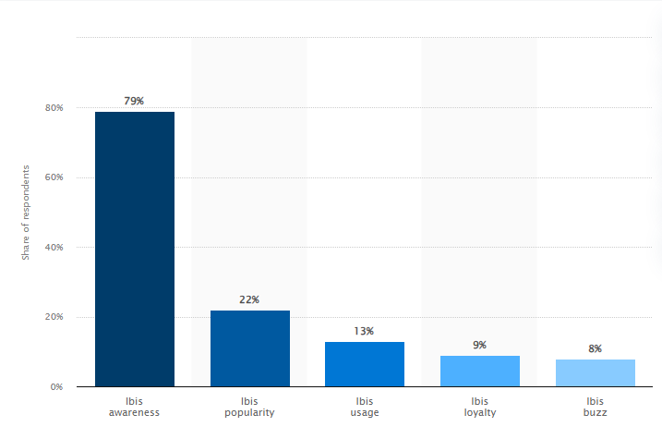
Figure 2: Ibis Brand (Source: Statista, 2023a)

Growth Potential
The purpose of a mission statement is to highlight the unique objective that distinguishes one hotel or hotel chain from the others. However, Corinthia Hotels and United Development Company (UDC) have teamed together with Monaco Marina Management (M3) and the Yacht Club de Monaco to promote sailing at The Pearl Yacht Club (Zámborský and Kruesi, 2018). The partnership aims to raise Pearl Island's profile as a well-liked boating and diving destination around the globe. At Corinthia Yacht Club, M3 has assisted Corinthia Group and UDC in developing and expanding sailing and yachting programmes and services. Along with this, the alliance played a part in the establishment of 'La Belle Classe Destinations,' a Yacht Club of Monaco certification that sets standards for the quality of services, security, and facilities in superyacht marinas (Zámborský and Kruesi, 2018). On the other hand, Ibis Hotel has expanded throughout the world by determined strategic movements, and as of December 31, 2015, it managed a network of 1068 hotels totalling 134,786 rooms (Rachmawati et al., 2020). This move is driven by a desire to gain a competitive advantage by entering a new foreign market, which would require a significant investment of finances and a larger viewpoint. Ibis has also implemented a "15-minute service satisfaction guarantee" that permits staff members to handle customer concerns within 15 minutes of the issue being brought to their attention. If staff members are unable to assist, it is suggested that guests remain at the hotel. On the other hand, the graph below shows the popular hotels in the year 2023:
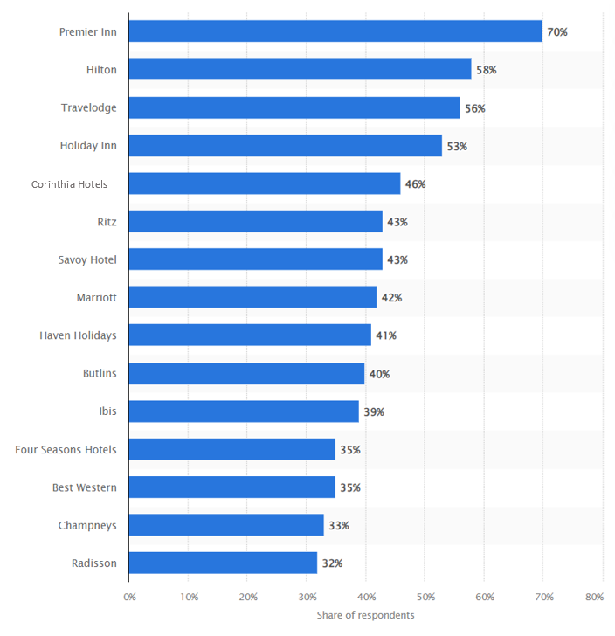
Figure 3: Top hotel brands in 2023 (Source: Statista, 2023b)
Furthermore, Ibis has implemented a low-cost leadership approach, providing the best value at the most affordable prices in comparison to other hotels of similar quality. Through taking these measured risks, the hotel hopes to fulfil its mission of providing excellent services at reasonable costs. Ibis's main business plan is to provide its clients with affordable accommodation that satisfies international standards. This implies that Ibis offers its clients exceptional value for their money. The approach is considered in the design of every Ibis hotel room. On the other hand, the UK hotel industry had 63% of its investments come from inside its borders in 2021, with the three most significant overseas markets being North America, East Asia, and Europe as shown in the graph below:
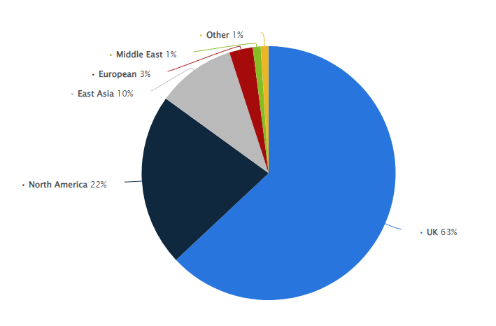
Figure 4: UK Hotel Investment (Source: Statista, 2023)

Financial Commitment to CSR
To lower infant mortality brought on by tainted water and poor sanitation, Corinthia is still collaborating with Just a Drop (JAD), an international organisation that distributes clean water. In Tanzania, Zambia, Uganda, and Kenya, Corinthia has previously sponsored JAD initiatives that have resulted in over 45,000 children and families having access to clean drinking water (Morrison and Morrison, 2016). Additionally, Corinthia sent food and gift baskets for the children at St. Patrick's in Sliema, Malta, as well as 22,000 decent N95 masks to the Active Ageing Parliamentary Secretary. The firm also provided meals for the Ursuline Sisters' children and the sisters of Christ the King Convent. The personnel of Corinthia St George's Bay assisted in the construction of a new youth centre, and the family of the Marina Hotel Corinthia donated to the Ursuline Sisters. However, the income statement for Corinthia Hotels for the years 2021 and 2020 is as follows:
Table 1: Income Statement (Source: Corinthia Group, 2023)
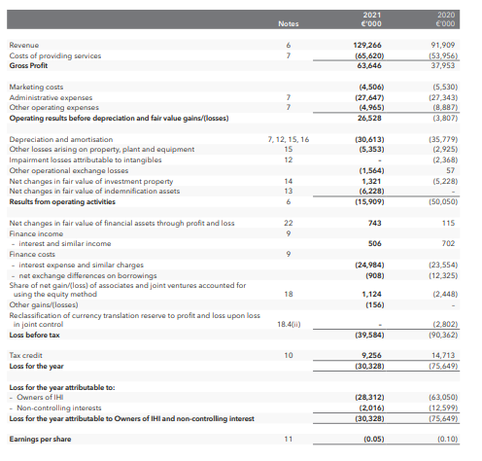
AccorHotels, the world's biggest IBIS hotel operator, has released its 2020 targets and the results of its Planet 21 sustainable development initiative. Sébastien Bazin, the company's chairman and CEO, emphasised the need for innovation and accountability when outlining goals (Nikolenko, 2020). The food and beverage and construction sectors make up the two primary activity zones of Planet 21. To better serve hotels, the internal sustainable development management system, formerly known as Charter 21, has been rebranded as Planet 21 in Action. The fact that more than 90% of hotels have made continuing changes as a consequence attests to the project's effectiveness (Willyanto et al., 2020). However, in 2015, every hotel pledged to protect children from maltreatment, and over 4.5 million trees have been established and planted globally since 2009. Likewise, in the year 2023, Ibis Hotel had a net profit of $248 as shown in the table below:
Table 2: Net Profit (Source: Willyanto et al., 2017)
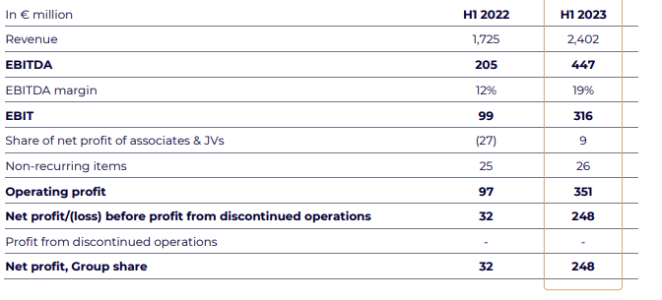

Recommendations
It is recommended for Corinthia Hotels to involve both television and print media communication. An internet communication campaign should reach Corinthia Hotels to target clientele, and sales promotion and direct marketing will increase earnings. Since communication has an impact on many stakeholders both inside and outside the organization (Madura et al., 2018), Corinthia Hotels should combine duties and establish a feedback loop to assess each campaign's efficacy. Its communication strategy should aim to accomplish several goals. In Addition, the communication plan needs to be able to solidify the brand's identity on a worldwide scale, particularly in the European market, which accounts for the vast majority of tourists. The PR approach should be able to emphasise how Corinthia Hotels differs from other opulent five-star hotels. The ultimate goal of the communication strategy should be to close real deals with potential clients for products. Likewise, to accomplish communication goals, Corinthia Hotels should use a multichannel communication strategy.
Moreover, Segmentation is the best way to deal with the problem of Ibis budget hotels' diminishing market share. Therefore, it is recommended that the Ibis budget hotels should involve revenue management strategies like segmentation that concentrate on increasing revenues that work better. Moreover, the Ibis low-cost hotel should be run through an Accor Hotels Group subsidiary, which manages 3700 hotels ranging in price from budget to five-star. As a result of limited resources, a competitive sector may struggle to reach out to a diverse range of cultures. Ibis Hotels may benefit from segmentation by concentrating on the number of prospective consumers who are most likely to become clients and generate revenue (Grozdanovska et al., 2017). However, Ibis Budget Hotel should be a well-known global brand of low-cost hotels that delivers the most basic amenities to visitors on a limited budget. In Addition, segmentation could serve as an effective technique for ibis low-cost lodging. Businesses will be able to better customise their marketing mix to the unique requirements of each audience with less expense, which will boost sales. Therefore, market segmentation is a useful strategy that budget Ibis hotels may employ to split and conquer the needs of different customer categories, generating more profits and income.

Conclusion
The Corinthia brand was founded in 1962 by the Pisani family, and it is well-known for its classic aesthetic and commitment to family principles. On the other hand, Ibis, a low-cost travel firm based in France, manages 700 hotels throughout 36 countries, including South Korea, Thailand, and China. However, the business evolved out of the Villa Corinthia Restaurant and seeks to improve the lives of guests, employees, and neighbours. On the other hand, Ibis Hotel continues to grow globally and currently manages a network of 1068 hotels with 134,786 rooms. Similarly, to gain a competitive advantage, the company wants to break into new overseas markets. Additionally, the company is committed to corporate social responsibility (CSR), funding local charities and participating with Just a Drop (JAD) in reducing the death rate of newborns.

References
Accor, 2023. Ibis family reaches over 1,700 hotels and pursues its pioneering revolution. [online] Available at: https://press.accor.com/la-famille-ibis-depasse-les-1-700-hotels-et-poursuit-sa-revolution-pionniere_5714_5714/?lang=en [Accessed on 25th Jan’23]
Cheng, J., 2019. Research and Suggestions on Declining Market Shares of Ibis Budget Hotels. Open Journal of Social Sciences, 8(1), pp.253-261.
Corinthia Group, 2023. FINANCIAL ANALYSIS SUMMARY. [online] Available at: https://www.corinthiagroup.com/wp-content/uploads/2023/06/IHI_Financial-Analysis-Summary-2023.pdf [Accessed on 25th Jan’23]
Corinthia hotels, 2023. Our story. [online] Available at: https://www.corinthia.com/en-gb/our-story/ [Accessed on 25th Jan’23]
Corinthia Palace, 2023. International Hotel Investments plc: Overview. [online] Available at: https://www.globaldata.com/company-profile/international-hotel-investments-plc/ [Accessed on 25th Jan’23]
Grozdanovska, V., Bojkovska, K. and Jankulovski, N., 2017. Financial management and financial planning in the organizations. European Journal of Business and Management, 9(02).
Ibis Hotel, 2023. All out Brands. [online] Available at: https://all.accor.com/brands/ibis.en.shtml [Accessed on 25th Jan’23]
Indriani, P., Nugraha, R.N. and Ardani, P.A., 2022. THE EFFECT OF FOOD QUALITY ON GUEST SATISFACTION OF IBIS ARCADIA JAKARTA HOTEL. Jurnal Manajemen Pelayanan Hotel, 6(2), pp.368-374.
Juhász-Dóra, K., 2015. Hotel competitiveness measurement methods. Knowledge Horizons. Economics, 7(3), p.94.
Madura, J., Hoque, A. and Krishnamrti, C., 2018. International financial management. Cengage AU.
Morrison, K. and Morrison, K., 2016. Hotels as Strategic Assets, Prestige Targets, and Sanctuaries. Sarajevo’s Holiday Inn on the Frontline of Politics and War, pp.7-32.
Nasir, F., Yusof, A. and Faizal, N., 2018. Corporate Governance and Performance of Hotel Industry in United Emirates Arab. Corporate Governance and Performance of Hotel Industry in United Emirates Arab (May 19, 2018).
Naumik-Gladkaya, E.G. and Devon, V.V., 2018. World luxury hotels and key financial ratios/prices/trends analyze. Комунальне господарство міст. Серія: Економічні науки, (143), pp.2-8.
Nikolenko, P.G., 2020. ANALYSIS OF LOYALTY PROGRAMS IN LLC" SPRING INVESTMENTS": HOTEL" IBIS NIZHNY NOVGOROD". Management Issues/Voprosy Upravleniâ, 63(2).
Rachmawati, M., Handayani, E. and Kuswanto, Y., 2020. The Effect of Service Quality, Consumer Relations Management on Customer Satisfaction and Implications for Customer Loyalty at Ibis Pasteur Bandung Hotel.
Sihombing, r.p. and Soewarno, n., 2022. Resiliensi bangunan cagar budaya dengan konsep adaptive reuse studi kasus: hotel ibis styles braga bandung. Storage: Jurnal Ilmiah Teknik dan Ilmu Komputer, 1(3), pp.1-5.
Statista, 2023. Wi-Fi speed in selected hotels in London as of August 2017. [online] Available at: https://www.statista.com/statistics/314354/wi-fi-speed-in-selected-hotels-in-london/ [Accessed on 26th Jan’23]
Statista, 2023a. Ibis brand awareness, usage, popularity, loyalty, and buzz among hotel customers in the UK in 2022. [online] Available at: https://www.statista.com/forecasts/1335566/ibis-hotels-brand-profile-in-the-uk [Accessed on 26th Jan’23]
Statista, 2023b. Most popular hotel brands in the United Kingdom (UK) as of the third quarter of 2023. [online] Available at: https://www.statista.com/statistics/951262/most-popular-hotel-brands-uk/ [Accessed on 26th Jan’23]
Statista, 2023d. Leading hotel brands in Brazil as of July 2022, by on number of rooms. [online] Available at: https://www.statista.com/statistics/856704/leading-hotel-brands-brazil-number-rooms/ [Accessed on 26th Jan’23]
Willyanto, A.R., Trisnawati, J.D. and Kusumawardhany, P.A., 2017, March. The Effect of Efficiency, Service Quality, Aesthetics, and Play against the Perceived Value, Satisfaction, and Loyalty at Ibis Hotels Indonesia. In The 14th UBAYA International Annual Symposium on Management (pp. 1-16). Department of Management, Faculty of Business & Economics, Universitas Surabaya.
Zámborský, P. and Kruesi, M.A., 2018. Global Hotel Alliance: Strategy Discovery Moving East. SAGE Publications: SAGE Business Cases Originals.

