

Assessment 1 – Reading Task
PART 1: Upload your photo of your A3 in-class notes here:
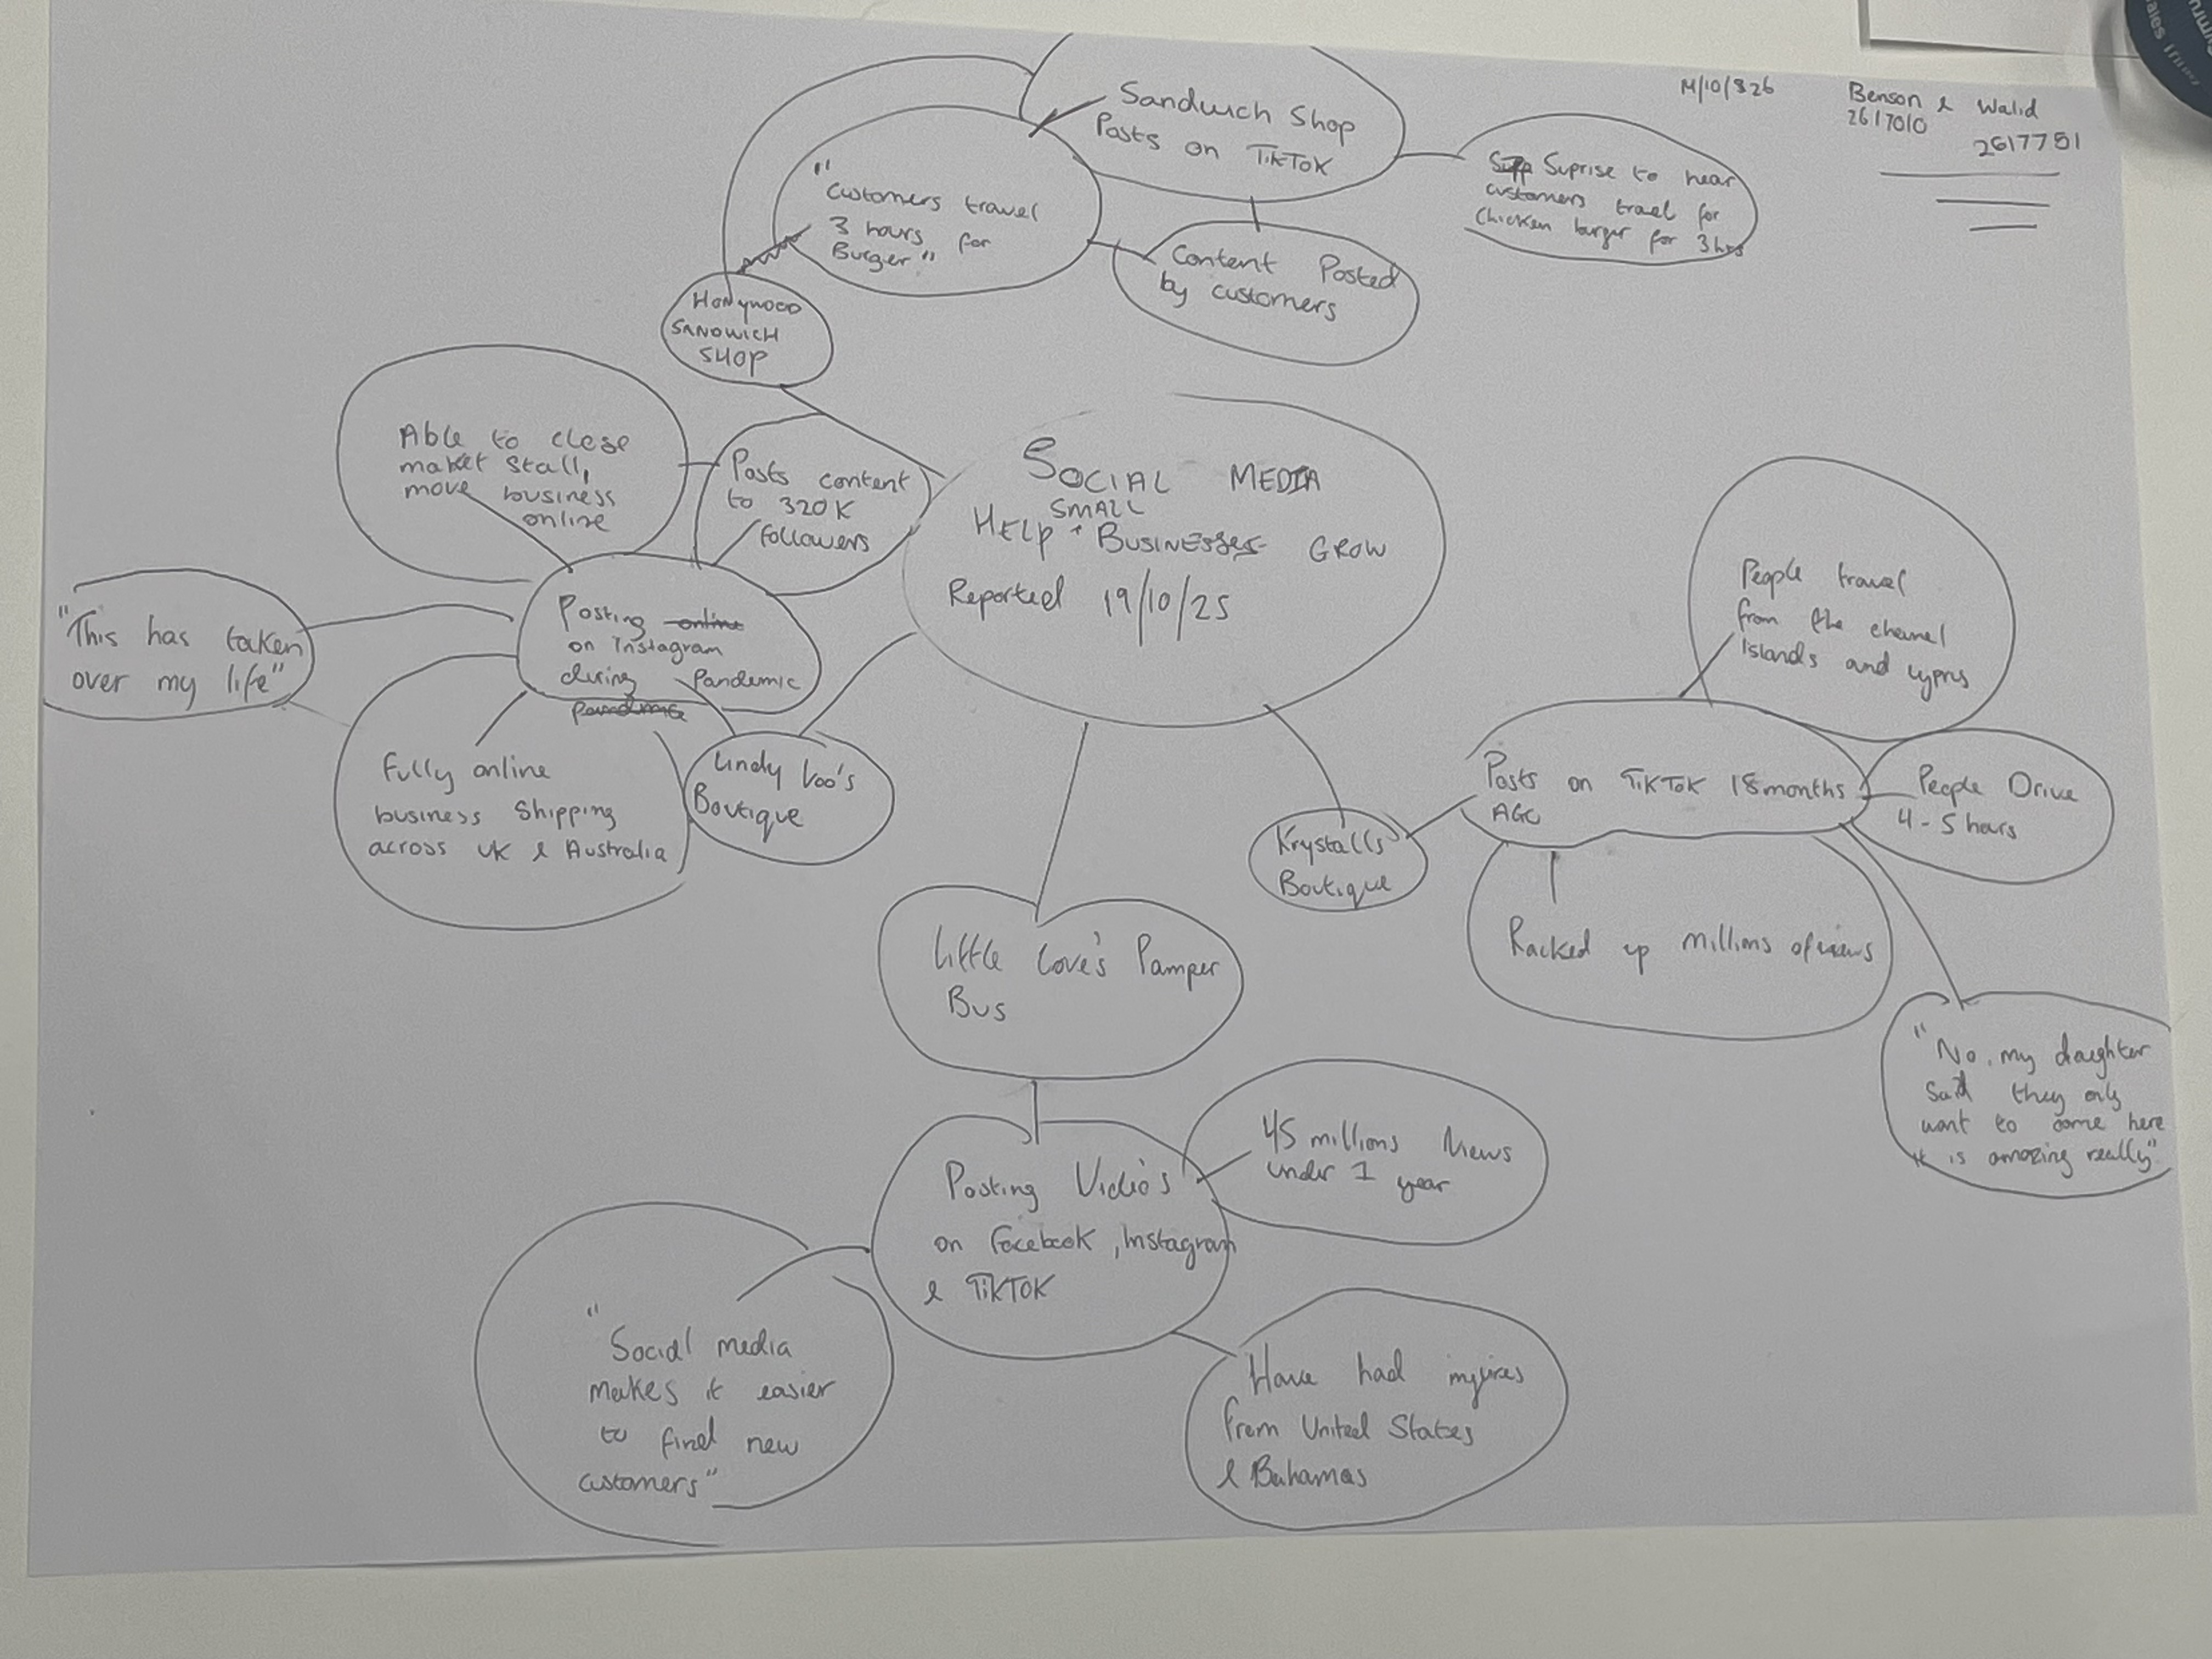

PART 2:
- Answer every question below in 1-3 full sentences.
- Use your own words. Do not use generative AI to answer these questions.
- Include a specific detail from the text when asked.
REMINDER
- The main idea is the overall message of the whole text.
- A key point helps to explain the main idea.
- A specific detail or example from the text shows that the key point is true.

- What is the main idea of the whole text?

The main idea of the whole text is to show how social media can help small businesses grow and attract customers both far and wide.

- What is one key point that supports the main idea, and which specific example from the text shows this?
One key point that supports this is that when Chloe Huggins and Ross Bliss decided to post their business “Love’s Pamper Bus” on TikTok December 2024, within a year the business accumulated 45 million views on the social media platform. “The response on social media has changed our business.” Says Clhoe Huggins this shows her recognising that social media can help business expand.

- What is a different key point that supports the main idea, and which specific example from the text shows this?
Another key point to support this despite Kristy Chamberlain opening her prom shop in 2012, when she and her team decided to post videos over a space of 18 months on TikTok the shop has racked up millions of views. “Some people drive down for 4 or 5 hours just come here.” Kristy Chamberlain expresses how social media has helped her business grow.

- Which part of the text do you think is most important, and why?
The most important part of the text in my opinion is the explanation on how these business owners used social media for a small period of time, and the effect has been beneficial to a small business trying to grow or expand.

Reflection:
- What did you find difficult in this task (including in-class components), and why was it difficult?

One thing I must I find difficult was being able to decipher whether specific information would be a key point or a opinion.

- What helped you with this difficulty, and how did it help you?
What helped was drawing a mind map, pick out key points with extended notes and how to organise it correctly in-class.

