Name: Sebastian Mudzamiri
Student ID: 1913885

Module: Developing Relationships and Workplace Achievements (October 2021)
Module code: BMSW5102

Lecturer: Dr Gregory Cowan

Assignment Title: Individual Report on “Development of a plan by meeting the identified personal development needs and expectations of individual employees in a chosen organisation.”

Word count: 2 500 words (+/-) 10%

Table of contents
1 Executive Summary 3
2 Introduction 3
3 Main body of the report incorporating a) critical evaluation of development vehicles (performance appraisal tools and techniques available to Tescoplc.com and explanation of their effectiveness in identifying and satisfying the development needs of the individual employees to meet both individual and organisational success. B) Propose a professional development plan with clear objectives for Tesco with suitability, feasibility and acceptability to meet the identified needs and expectations of individual employees. In the final analysis relevant human resources management theories will be identified and integrated into the assignment. 3-8
4 Conclusion 9
5 References 10

1 Executive Summary
This report will write about a development plan by meeting the identified personal development needs and expectations of individual employees of Tesco Plc. The main body of the report will be in two parts. Part a) will discuss critical evaluation of development vehicles (performance appraisal tools and techniques) available to Tesco and explanation of their effectiveness in identifying and satisfying the development needs of the individual employees to meet both individual and organisational success. Part b) will propose a professional development plan with clear objectives for Tesco. The report will also integrate relevant human resource management theories. The report will have a professional development plan template for Tesco employees, a conclusion and references.
2 Introduction
Human resources are arguably the most important asset to an organisation than anything else. “Take away all my wealth, take all my machines but leave my men alone and I will become Henry Ford again.” (Henry Ford). However, human resources need to be nurtured, trained and developed in order to be effective in their work. To achieve this goal, the performance of each and every employee needs to be appraised. As part of the performance management system “…the performance appraisal can be defined as the process of identifying, evaluating and developing the work performance of employees to help achieve the goals and objectives of the organisation.” (Investopedia.com, 2021). The purpose of this report is two-fold. The first purpose is to give a critical evaluation of development vehicles (performance appraisal tools and techniques) available to the identified organisation and explanation of their effectiveness in identifying and satisfying the development needs of the individual employees to meet both individual and organisational success. The performance tools and techniques that will be discussed in this report are Coaching, Self-evaluation, Management by Objectives (MBO), 360-degree feedback and 540-degree feedback. The second purpose is to propose a professional development plan with clear objectives for the identified organisation with the suitability, feasibility and acceptability to meet the identified development needs and expectations of individual employees. Tesco Plc will be discussed in this report. It is the largest retailer in the UK, employing over 360 000 employees, with annual profit in excess of £3.5 billion per annum and operates in the Irish Republic, Hungary, Czech Republic, Poland and Slovakia (tescoplc.com, 2021). In the final analysis, relevant human resources management theories will be identified and appropriately integrated into the assignment. The identified performance appraisal tools and techniques will be discussed and evaluated in turn in the main body of this assignment below.
3 a) Couching. The purpose of performance appraisals is to establish strengths and weaknesses in an employee at the workplace. Coaching is used to address poor performance which has to be defined by management (Armstrong, 2011). At Tesco employees receive coaching from their supervisors. Coaching is the advice given to an employee by the supervisor. It is a process that encourages employees to take ownership of their actions, to chieve and offer effective performance in their jobs. The employees are considered as partners in achieving organisational objectives (Armstrong, 2011). There are two approaches to coaching. The first one is the Kinlaw’s Approach which is a reflection of some managers towards subordinates. The managers display a negative view to manage employee behaviour. The alternative way out may be conflict avoidance which results in the good workers being overloaded with work. There is a belief with this approach that managers only talk to employees when there is a problem. The managers use the reactions of employees to form a negative opinion about them. The second approach is called the Fournies’ Approach which displays a positive view of employees. This approach displays an active, positive and participative management style. Workers have a voice and should know what to do, how to do it and are good at problem solving This approach also allows for recognition of achievement when the time is due. (Armstrong, 2011). In both approaches it is advisable to have specific objectives and these goals must be mutually agreed to by both parties. The worker helps set goals for improvement and coaches are supportive. The main drawback of coaching is that the supervisor must be trained and have the right approach when dealing with this issue (Armstrong, 2011). Self-evaluation will be considered next.
Self-evaluation. A self-evaluation is one’s own written review of one’s performance during the evaluation cycle. It means giving ratings on set goals, competences and overall performance. Self-evaluation differs from self-monitoring in the use of external comparisons and reinforcers. It is used most of the time in universities with good outcomes. The benefits of self-evaluation are that one becomes a willing partner. This involvement enables one to give honesty assessments about one’s strengths and weaknesses. This enables one to become more constructive in the evaluation meeting with the supervisor. Self-evaluation enhances one’s commitment and setting goals. It also means is committed to achieve the goals, to be competent at the workplace and to be geared in planning the future (Armstrong, 2011). The next appraisal tool or technique is Management by Objectives (MBO).
Management by Objectives (MBO) is also known as Management by Results or Goal Management is a strategic management theory that is targeted at improving organisational performance. This is achieved by SMART objectives that are agreed to by management and employees. The assumption of this goal is that having a say in setting goals and involvement in setting up actions plans encourages commitment to the cause and full participation by employees. The alignment of both employee and organisational objectives across the company is a motivating factor for the employees (Armstrong, 2011). The word SMART was first used by one George T. Doran in 1981. SMART stands for specific, measurable, acceptable or attainable and time bound. Tesco can use this approach in their operations as well. One major criticism of the MBO theory is that it tends to encourage employees to achieve the objectives by any means and thereby do so at the expense of the organisation. The other criticism is that it is a top-down approach initiated by management and employees are only co-opted at the end. The 360-degree feedback will be considered next.
The 360-degree feedback is widely used in Tesco (times100, 2021). The 360-degree feedback is also known as the multi rater feedback, and it is a system whereby anonymous feedback is gathered about a member of staff from a number of people who work closely with them. This their Managers (Line or Project), Team peers (People within your team or function), Direct reports (People working for you or on your behalf) and Others (Internal contacts outside of your function or external suppliers or vendors) thereby resulting in an all-round “360 degree” (times100, 2021). Just like the purpose of coaching stated above, the 360-degree feedback also is aimed to help each employee to understand their strengths and weaknesses. This theory sheds the light on certain aspects of the employee’s work requiring the assistance of coaching. For this theory to work, it requires supervision of a manager, a coach or a trainer (Armstrong, 2011). There are a number of benefits attached to the use of the 360-degree feedback and these are: -The encouragement of a culture of smart performance -The increase in self-awareness by employees -The creation of a dialogue between the employer and employee -Encouraging the search of new skills and - The promotion of transparency and honesty (Armstrong, 2011). A similar theory to the 360-degree feedback model is the 540-degree feedback.
The 540-degree feedback is an employee performance appraisal and not only includes all the multi raters in the 360-degree feedback but includes feedback from all the people the employee has interacted with during the course of fulfilling his or her job functions. In other words, the 540-degree feedback in an upgrade from the 360-degree feedback. The difference with the 360 is the addition of more stakeholders such as customers and clients. The 540-degree feedback helps in identifying problems which was not possible with the 360-degree feedback or for that matter any other normal feedback system. Even though the 360-degree feedback has worked wonders for Tesco as regards employee motivation, Tesco can still benefit from upgrading to the 540-degree feedback because of the enhancements that it has (Armstrong, 2011) This will guarantee Tesco organisational success and a strong competitive advantage. The last item to be discussed in this report is the proposition of a professional development plan with clear objectives for Tesco.
3 b) Proposal of a professional development plan with clear objectives for Tesco with the suitability, feasibility and acceptability to meet the identified development needs and expectations of individual employees. “Tesco also promotes motivation through its many training and development opportunities. Everyone has access not just to the training they need to do their job well but also to leadership training to grow within the company. Tesco offers strategic career planning to help staff ‘achieve the extra ordinary’: In 2009 Tesco appointed 3000 managers-80% internally” (times100, 2021). “As well as an annual career discussion with every employee, the company also emphasises the development of the whole person…” (times100, 2021). To come up with a holistic approach to clear objectives for a corporate organisation such as Tesco it would be prudent to use the McKinsey 7-S model. This model has 7 elements that covers the entire organisation for it to be successful. The McKinsey tool has hard elements which are structure, strategy and systems and the soft elements that are rather fluid such as skills, style, staff and shared values (jotform.com/blog, 2020). “Strategic objectives establish the boundaries for what your organization’s effort must focus on. They create the top layer of your strategic plan’s framework, articulating what you’ll focus on to achieve you vision of success” (onstrategyhq.com, 2021). There is something in common with most corporate strategic objectives and these are: -They are multi-year in nature as they take several years to achieve which may be 3-to-5 year objectives. This depends on the requirements of the organisation. -The framework has six or less strategic objectives. Three to four are the best option to have as anything more than six might be difficult to implement. -It provides company-wide direction gives the management team focus on priorities and -It is not a mixture of departmental goals (onstrategyhq.com, 2021). The following objectives will be suggested for Tesco to adopt.
1 Customer Retention. To maintain an 80% customer retention strategy as it is cheaper to keep servicing existing customers than get new customers.
2 Operational Excellence. To achieve this objective Tesco will pursue Total Quality Management (TQM) whose motto is “Getting it right first time, every time and all the time”. This means Tesco has to improve on their returns policy by delivering “faster with accuracy” and
3 People Development (onstrategyhq.com, 2021). As highlighted in the above quotations, Tesco places great value on developing their human resources through training opportunities. In this regard, people development is an on-going strategic objective as Tesco aims to maintain its market share which can only be possible with competent staff at every level of the organisation. After the identified training needs analysis, the coaching sessions between managers and employees, the Gap Concept or tool can be used to measure the expected staff competences against the actual competences and the gap can be filled by further training. Below is a professional Employee Development Plan template which can be used by Tesco. On top of the template are the details of the employee, their title, the name of the rater, date, name of reviewer, date, Appraisal type and Appraisal period. The Employee Development Plan helps the organisation through the Human Resources Department to carry out succession planning and to plan for the resources that will be required for doing this. For planning purposes there are three options which are: 1 Short-Range (1 year) for immediate employee needs in their current position. On the right side are Training and Development Goal, Competences or Skills to be Acquired which may be specific to the employee, next is Employee Action Steps, Resources needed and Time frame (totaralearning.com, 2021). 2 Mid-Range (2 years) This is important for the worker to grow in their job and in the future. To the right side are Training and Development Goal, Competences or Skills to be Acquired which may be specific to the employee, Employee Action Steps, Resources needed and Time frame (totaralearning.com, 2021) 3 Long-Range (3+ years) This helps the employee to achieve future career goals and position themselves in an advantageous position As in the above options, to the right side of the Long-Range planning horizon are Training and Development Goal, Competences or Skills to be Acquired by the employee, Employee Action Steps, Resources needed and Time frame needed (totaralearning.com, 2021).
Tesco is advised to adopt this Employee Development Plan and success will follow.
The Employee Development Plan Template below is the product of Totara Learning.

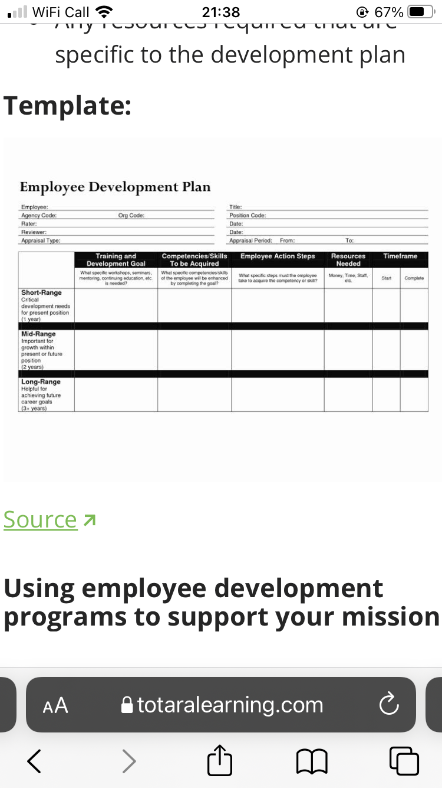
Conclusion
The report made a critical evaluation of development vehicles (performance appraisal tools and techniques) that are available to Tesco. An explanation of their effectiveness in identifying and satisfying the development needs of the individual employees to meet both individual and organisational success. Included in the report are strategic objectives that can be adopted by Tesco in order to achieve success in the future. The report also discussed how an employee development plan can help Tesco achieve both its own organisational goals and those of its employees. The employee development plan follows identified personal development needs and expectations of individual employees.

References
Armstrong, A., 2011. Armstrong's Handbook of Strategic Management. 5th ed. London: Kogan Page Ltd.
Investopedia.com, 2021. What is a Performance Appraisal?, not shown: Investopedia.com.
jotform.com/blog, 2020. 7 gap analysis tools |The Jotform Blog. [Online]
Available at: https://www.jotform.com/blog/gap-analysis-tools/
[Accessed 8th January 2022].
onstrategyhq.com, 2021. Examples of Strategic Objectives. [Online]
Available at: https://onstrategyhq.com/resources/examples-of-strategic-objectives/
[Accessed 8th January 2022].
tescoplc.com, 2021. Annual Report, London: Tescoplc.com.
times100, t., 2021. Business Case Studies. [Online]
Available at: https://www.thetimes100.co.uk
[Accessed 20 November 2021].
totaralearning.com, 2021. Apractical 3-step employee development plan (+ templates). [Online]
Available at: https://www.totaralearning.com/en/blog/a-practical-3-step-employee-development-plan-templates
[Accessed 05 January 2022].

