

Developing an ML-Powered Tool for Dimensional QA in BIM and Digital Twin Workflows
by
Ethan Shellem-Prince

Supervisor: Dr Seena Joseph

Project submitted as part of the requirements for the award of
BSc (Hons) Software Engineering
July 2025

Abstract
The purpose of this project was to create an automated machine learning model for identifying incorrect dimensions in civil engineering design models, focusing specifically on BIM and Digital Twin platforms like Bentley iTwin. The primary goals were to apply unsupervised learning techniques such as Isolation Forest and K-Means clustering on outlier detection, to produce an easy-to-use tool for non-programmers and to benchmark performance of models with precision, recall and F1 scores.
The tool was implemented as a Python desktop application with appropriate libraries: Scikit-learn, Pandas and Tkinter. A test dataset mimicking standard digital twin exports was synthesised to test the plugin. Users could import model data, then run anomaly detection, to view results interactively, by component type.
The system detects dimensional anomalies that conventional rule-based approaches could miss. Engineering users rated the tool as practical and intuitive. The project believes that the unsupervised Machine Learning technique can be used to further improve early-stage QA in digital infrastructure workflows and proposes integrating with live BIM systems in the future to increase industrial use.

Contents

1. Introduction 6
1.1 Aim and Objectives 7
1.2 Contribution of the project 7
1.3 Structure of the report 8
2. Literature Review 9
2.1 Dimensional Integrity in Civil Engineering Design 9
2.2 Traditional Rule-Based Dimensional Checking 11
2.3 Machine Learning for Anomaly Detection 12
2.4 Integration with BIM and Digital Twin Platforms 14
2.5 Machine Learning Applications in Civil Engineering 16
2.6 Gaps in Existing Literature and Justification for Research 17
2.7 Summary of Literature Review 19
2.8 Conclusion 20
3. Project Methodology 21
3.1 Risks and Limitations 22
3.2 Ethical Issues 22
3.3 Validity, Reliability, and Generalisability 23
3.4 Data Evaluation Methods 23
3.5 Research Methodology 24
3.6 Development Methodology 24
3.7 Resources 25
4. System Design & Implementation 25
4.1 Introduction 25
4.2 System Architecture Overview 26
4.3 Technology Stack 26
4.4 User Interface Design 27
4.5 Anomaly Detection Logic 28
4.6 Data Input and Conversion 28
4.7 Integration Considerations 29
4.8 Summary 29
5. Testing & Evaluation 30
5.1 Introduction 30
5.2 System Testing and Verification 30
5.3 Comparative Accuracy of ML Models 31
5.4 User Testing & Feedback 34
6. Summary, Conclusion & Future Recommendations 35
6.1 Summary and Conclusion 35
6.2 Meeting the Project Objectives 36
6.3 Insights from User Feedback 37
6.4 Limitations Observed 38
6.5 Unexpected Outcomes 39
6.6 Broader Implications 39
6.7 Key Contributions 39
6.8 Recommendations for Future Work 40
7. Reflection 41
8. References 43

Tables
Table 1: Summary of User Feedback on Tool Improvements 40

Figures

Figure 1: System Architecture of the Dimensional Anomaly Detection Tool 26
Figure 2: Main Interface Showing Anomaly Detection, Visual Output and Evaluation Metrics 28
Figure 3: Output of JSON to CSV Conversion Script Showing Component Dimensions 29
Figure 4: Isolation Forest Detection Chart 31
Figure 5: K-Means Detection Chart 32
Figure 6: Precision, Recall and F1 Score Results for Isolation Forest and K-Means Across Component Types 33
Figure 7: Comparison of Isolation Forest and K-Means Precision, Recall and F1 Score. 34

Introduction
Digital modelling of physical structures is becoming a general standard for presenting civil engineering projects. For building and civil engineers, tools such as BIM (Building Information Modelling) and digital twins offer ways to visualise, simulate, and manage infrastructure from start to finish. As these designs become more complex, the number of dimensions that must agree for every component is on the rise. The slightest discrepancies in the dimensions of length, width, or height can cause mismatching of equipment and components, construction delays and rework, and, in extreme cases, either structural or operational failure [1].
While dimensions may seem simple, they are essential to accuracy and safety on the construction site. All it takes to create collisions is a component that is marginally undersize (20 mm under for a slab, slightly out of kilter for a kerb). A notable high-profile instance is the 2023 Luton (Airport) car park fire‐induced collapse, with design tolerances and irregularities in layout being highlighted during the ultimate investigation as contributors to structural exposure [2].
In actual practice, checking dimensions is still performed manually or by rule-based validation within BIM tools. These methods usually consist of verifying the geometry of each object against the limits or standard tolerances. Unfortunately, many of them do not easily transfer across projects with various types of assets, specifications, and design conventions. Such a static approach is confronted with increasing difficulties when it comes to large infrastructure projects, as they encompass a large number of disciplines and a couple thousand individual parts.
The rising proliferation of digital twin solutions (e.g., Bentley iTwin) presents an attractive development opportunity for automation and improvement of quality assurance (QA) based on AI. Such is the basis for the development of intelligent anomaly detection tools that consume geometric and physical asset information from live or near-live sources. This wouldn't be directly defined for us (it's an invisible variable), but we can use machine learning, modestly in this case with unsupervised machine learning, to tell us which things are significantly far from the central size. In contrast to rule-based checks, ML models can generalise from data and become adept to different structural contexts.
In this study, a critical review on the dimensional quality control in civil engineering was presented. It starts by addressing the importance of dimensionally consistent design and construction processes. It next compares classic rule-based verification methods with emerging data-driven alternatives and, in particular, three unsupervised machine learning based approaches: Isolation Forests, K-Means clustering, and Autoencoders. The paper also discusses the potential incorporation of such methods to BIM and digital twin platforms such as Bentley iTwin. Lastly, it outlines the major gaps found in the literature and rationalizes the research approach in this dissertation.

Aim and Objectives
The aim of this project is to develop a standalone machine learning tool that can support dimensional quality assurance in digital infrastructure models. The tool is designed for use in many different BIM and digital twin environments and allows engineers to identify potential outliers in component dimensions without needing to write code.

Project Objectives
- Build a Python-based desktop application with a user-friendly interface that allows users to load model data and run anomaly detection.
- Implement two unsupervised machine learning models to detect dimensional anomalies in component data.
- Evaluate the tool using synthetic datasets with embedded anomalies and assess model accuracy using precision, recall, and F1 score.

Contribution of the project
This work offers a realistic quality assurance tool for identifying dimensional inconsistencies in civil engineering design models at an early stage. The product will serve infrastructure and digital engineering teams, especially ARUP, to conduct better calibrated, scalable and automated QA. It minimizes the reliance on manual or rule-based checking and assists engineers in finding variations earlier in the design process, allowing for quicker time to closure, fewer design revisions, and decreased project risk.
Outside of ARUP, the tool has broader industry application as it illustrates how unsupervised machine learning can be incorporated into BIM and digital twin workflows to aid decision making and increase confidence in data. The work fits into the ongoing transition to intelligent, data-centric engineering techniques.

Structure of the report
This report contains eight chapters to illustrate the whole process of research and development. Section 1 provides a general overview of the project, its aims, objectives and the prospective contribution to industry and academia. The literature review is shown in section 2, including the investigation on dimensional accuracy in civil engineering, rule-based QA methods, machine learning based anomaly detection and the application of these methods in BIM and digital twin platforms. Section 3 describes methodology of the project, such as the project strategy and research method, the evaluation and ethical issues of the project. In Section 4, the design and implementation of the system are presented covering the technologies utilised, the architecture of the system, and the rationale of the anomaly detection models. Section 5 Then the testing and evaluation of and K-Means and taking feedback from the engineering professionals. Section 6 summarizes the main findings, project outputs, limitations, and direction for future work. Section 7 concludes the paper with a reflection of the whole project. Section 8 provides the references used in the report.

Literature Review

Dimensional Integrity in Civil Engineering Design
Dimensional accuracy concerns the accuracy and consistency of geometric data from design to construction. Dimensional accuracy is a key requirement for buildability, structural performance, and to meet project specifications and regulatory codes. In infrastructure constructions, such as bridge girders, tunnel linings, and conduits, where prefabricated or modular components play dominant roles, small dimensional errors may readily develop into expensive problems [3].
A UK-based example of this is the Crossrail project in London, where the contractor had to deal with out of tolerance (OoT) misalignments between tunnel segments during the installation sequence. The tolerances were acceptable at an individual level, but a compounding effect resulted in mechanical and electrical fitouts clashing, which resulted in delays and remedial works [4]. Again, in 2022, further remediation was necessary on parts of the M25, at which balustrades had been out-of-spec, leading to an adverse out-of-specification camber and road surface delivery [5].
These are but two examples that show the message that dimensional QA is not only an aesthetic or design consistency issue, but it has also very real cost, safety, and schedule implications. Nevertheless, despite being crucial, dimensional verification is sometimes not treated as a primary task and is not conducted uniformly. Engineers often examine their model visually or perform a clash detection on it, but these methods can only catch simple errors whose magnitude goes above pre-set limits. For example, Autodesk Revit or Bentley OpenBuildings Designer etc. do have rule-based checks available but are limited to the granularity of the rules written for the checks. Many dimensional validation rules still need extensive manual configuration and seldom cover the needs in the context in hand [6].
Tolerances on dimensions may also be looser on a preliminary design, such as a concept or preliminary model. In these cases, the QA checks either get delayed or are run on inadequate data, with the result that error can leak through one or two project stages. Model validation early on, BSI PAS 1192-6 states that inadequate early model validation can lead to geometric clashes and unwarranted H&S risks later in the project life cycle [7].
According to some researchers and industry professionals, dimensional QA should be included in longer-term performance and constructability simulations. For example, design documentation for the HS2 project checks that tolerance of designs is validated against site constraints and installation sequences to prevent clash and rework [8]. But processes like these are seldom standardised and usually come down to the preferences of people, teams, or consultants.

Dimensional QA is particularly challenging in civil assets, which are characterised by very large spatial variability, like roads, retaining walls, or kerb layouts. Such structures typically contain many hundreds to thousands of repeats, and the repeats exist with small differences in each. What might be an acceptable kerb section in one context may lead to water ponding or trip hazards, etc., in another due to changes in slope and camber, for instance, or local circumstances. Without smart solutions with knowledge of the geometric structure in context, the mentioned problems are discovered and resolved only toward the end of the design process (i.e., during construction), at which point the cost resulting from such resolution is maximized.

Hence, there is growing interest in applied data-driven model verification. Digital twins, realized for example by platforms such as Bentley iTwin, enable direct connection of live design geometry to asset information and environmental loadings. This provides a good data source for ML to train models to detect outliers or unusual clicks in the context. But, as we will discuss in the following sections, these schematisation tools have not yet been integrated into the great majority of BIM solutions, and this is still a gap in current practice.

As the industry moves more towards digital twins and ISO 19650-aligned processes, the demand for scalable and intelligent QA methodologies becomes even more evident. This paves the way to investigate ML-based techniques for dimensional anomaly detection that can be adaptable to multiple projects and, therefore, perform better than rule-based systems.

Traditional Rule-Based Dimensional Checking
Conventional dimensional verification in civil construction is usually performed by rule-based systems in BIM ecosystems or by manual inspection paths. Such systems work according to predetermined criteria judging whether the model item complies with project-centred tolerances, and generally “compacting” everything that is off-scale. While this has proven useful in simple environments, it has severe limitations once projects start to become complex or where you are looking for some degree of flexibility between different parts of an application.
An extensive use of the logic with probability-based rule-checking has not been found. For example, a rule might highlight a section of kerb if its length is greater than 1.5 m or less than 1.2 m. This can work to catch errors, but it often fails to catch more subtle departures that lie just beyond the ordinary, but don't quite cross a hard threshold. Even more fundamentally, rule sets have difficulty generalising across different kinds of assets, as well as across different regional design codes. A rule suitable for precast slabs in a commercial building may be less so for road kerbs in a highways project. These static rule-based models are hard to scale and fail to make extensive use of context, leading to limitations in British BBS designing implementation [9].
Dimensional checking and cross-discipline coordination through model-checking tools such as Solibri Model Checker and Navisworks, including even rule-based systems such as those offered by Bentley, are all used extensively in the UK. These systems provide a library of pre-defined rule templates to which we can add our own custom specifications, such as minimum slab depth or pipe clearance. However, as BSI’s BS 1192 recommendations for businesses explain, these rule sets need to be manually applied to each project, adding inconsistency and creating workloads for quality assurance (QA) [10].
But lots of static logic, and static logic alone, will also create blind spots. One such example could be that a culvert with a length of 3.01 m may be found acceptable under a rule allowing any length below 3.05m but still could be unacceptable according to local slope constraints or trench width. These context-sensitive cases (which prove challenging to codify) mean that we get false negatives (real errors that are not caught) and false positives that make the user hate the tools.
Too-strict QA procedures create “alarm fatigue” in review workflows as well. If there are too many low-priority bugs reported, the engineer may become fatigued and begin to disregard the findings. Conversely, if the rules are too lax to prevent unnecessary warnings, real bugs can easily slip through. This trade-off is recognised in HS2’s Digital Engineering Strategy, which notes that automated checks can help avoid fragmented assurance workflows across disciplines by the use of manual rule editing [11].
Updating and maintaining rule sets are also problematic. In projects such as Crossrail, where the design model repeatedly changed, it was necessary to continually update the dimensional checks and QA scripts. This raised the level of effort for coordination and the risk of inconsistency [12]. As Eastman et al. noted as a limitation of current BIM tools, they do not provide feedback for better QA processes over time [13].
Given these challenges, there is a growing need for smarter, data-driven alternatives that can adapt to project-specific norms and learn from historical data. This is where machine learning, particularly unsupervised anomaly detection has started to emerge as a complementary approach to dimensional validation.

Machine Learning for Anomaly Detection
Machine learning, especially unsupervised learning, offers a promising solution to many of the limitations of rule-based QA. Rather than relying on fixed thresholds, ML models can learn the underlying patterns in a dataset to determine what “normal” looks like for a specific component type or project. This is particularly useful in infrastructure models where dimensional variation is expected and labelling errors in advance is impractical.

1.4.1 Why Unsupervised Learning Fits
Unsupervised learning methods are also the perfect candidate for anomaly detection problems in which no labelled “error” data is available. In the general civil engineering pipelines, data being raw point components have little creditable quality assurance (QA) records. These datasets can be used to teach ML models what the typical dimensional profile of, for example, a standard kerb or a slab looks like, and flag outliers to prompt a further look.
The UK consultancy PCSG, which has assisted with BIM QA for HS2 and National Grid, reported the opportunity for ML to automate repeating tasks such as pattern recognition and dimension validation, particularly in the early design stage [14]. Furthermore, Constructing Excellence UK confirms that unsupervised ML is becoming more applicable in the context of anomaly detection in model geometry and layout [15].

Isolation Forests
The Isolation Forest (IF) algorithm, as defined in Liu et al. [16], is particularly suitable for high-dimensional, unlabelled data. It works by randomly selecting features and split points to build trees that isolate the different data points. The anomalies tend to be isolated in fewer steps than normal data, so they appear with shorter path lengths in the trees. This makes the algorithm fast and effective for spotting unusual elements in datasets like BIM geometry. It detects anomalies by randomising splitting of the feature space and then measures how fast a point becomes isolated with respect to the others. Abnormal components are dissociated at a faster rate than normal components.
Within a BIM environment, this could indicate that a wall or slab with a unique width or thickness is marked as “flagged” and does not require a rule or threshold to be set. Based on Bentley System’s internal analysis, ML models such as Isolation Forests can manage this issue of hundreds of component types, being able to identify non-conformities to the geometry much faster than manual review [17].

K-Means Clustering
A more simple but still applicable approach for anomaly detection is K-Means clustering. It works by grouping data into ‘clusters’ based on similarity, each point is then assigned to the nearest cluster centre. Anomalies can be spotted by the points that lie far from any cluster centre, meaning they don’t fit well with typical patterns. By doing some grouping based on geometric similarity (try a couple of different strategies), the model can identify anomalies that do not fit into any obvious group. This is handy if you are in a pre-construction phase and trying to determine non-standard beam lengths or slab depths incorrectly entered.
K-Means, despite its need for a pre-specified number of clusters, is also interpretable and efficient. There have been a number of case studies published by the UK Government’s Centre for Digital Built Britain (CDBB) showing clustering approaches applied for spatial analytics in digital twin projects such as highways asset audits [18].

Autoencoders
Autoencoders are a class of deep learning models which first compress data into a low-dimensional code, then attempt to reconstruct the input (usually through some separate, inverse operation). High-reconstruction error components are considered as anomalous sources. Autoencoders can be computationally demanding but may be more appropriate for larger-scale contexts like post-construction monitoring or cloud-based design reviews. While it is not as prevalent in dimensional QA workflows, it is currently being trialled in academic partnerships with UK universities and infrastructure operators such as Network Rail in particular, for asset tracking and validation of digital twins [19].

Integration with BIM and Digital Twin Platforms
Although machine learning holds some potential for dimensional anomaly detection, its success is going to be dictated by how successfully we can integrate these approaches into our existing workflows. In civil engineering, the majority of this work is likely to take place within BIM environments – and increasingly, with digital twin platforms such as Bentley iTwin. These systems function as information centres that tie together geometry, metadata, and performance data, and we now have a current opportunity to include intelligent QA processes directly within design and review cycles.
Specifically, Bentley iTwin facilitates synchronization of design models with construction or real-time asset data. It also supports the Industry Foundation Classes (IFC) standard, thereby providing the capability to import from and export to multiple modelling applications. But with the latest versions of iTwin and most BIM platforms, there is no out-of-the-box intelligent anomaly detection built using machine learning. Most of the QA processes are rule-based and are not easily adaptable to different project needs [16].
A central challenge is interoperability. While standards including IFC and ISO 19650 (previously known as BSI 1192) aim to encourage data exchange and consistency, they can also be structuralist, rather than logical in nature. The IFC provides guidelines for the structure of geometry and properties but does not define how to check the components’ logic. ISO 19650, widely used in the UK infrastructure sector, addresses lifecycle information management, but defers detailed QA to individual project teams [17].
Without native intelligence, custom scripting and toolsets, or even manual visual QC are all most engineers have to maintain dimensional health. However, the UK BIM Framework states that while PAS 1192-6 introduces health and safety requirements in relation to model data, there is little evidence of formalised automated dimensional QA in project delivery processes [18].
Advantages of applying ML to model validation are reported in previous studies. For instance, Ebrahimy et al. [19] implemented an initial plugin for the Autodesk Revit software which applies unsupervised learning to find anomalous wall lengths. One of their findings indicated a significant improvement in early error detection compared to rule-based systems, especially at the conceptual and schematic design phases. But, like so many of these tools, the solution wasn’t universally adopted due to limited interoperability and difficulty of implementation.
User accessibility is also a major issue. Very few civil engineers and technicians are trained in machine learning or any sort of advanced data analytics. Accordingly, any ML tool integrated into BIM or digital twin platforms must easily fit into the workflow to which users are accustomed. In an ideal situation, dimensional anomaly detection would run in the background during design reviews and flag unexpected values with a confidence score or visual tag. As the UK BIM Alliance indicates, "smart QA should enhance and not create friction" [20].
There are computational challenges as well. The same goes for deep learning algorithms such as autoencoders, which can be resource-intensive and weigh down large projects if executed locally. Cloud-based services such as Bentley ProjectWise or Autodesk Construction Cloud can provide scalable processing but at the cost of requiring robust internet connectivity and more stringent security governance: two of the major criticisms raised in HS2’s trials of digital assurance approaches [21].
Momentum is growing for smarter BIM ecosystems, limitations aside. Bentley Systems has also rolled out UK pilots focusing on AI-supported clash detection, schedule optimisation, and predictive maintenance. But for the most part, this innovation has focused on asset management or post-construction use cases. The pre-construction stage, a time when dimensional accuracy is very important remains underserved.
The future lies in proactive digital twin models that don’t simply mirror the physical asset but offer insight during design, construction, and operation. A digital twin that learns from historical models and highlights unexpected geometry automatically could reduce the need for manual QA checks and speed up design iteration. As emphasised by the CDBB (Centre for Digital Built Britain) roadmap, integration of ML with early validation of design is pivotal for realising productivity gains across the sector [22].

Machine Learning Applications in Civil Engineering
While dimensional anomaly detection is an evolving application, machine learning has found applicability in a number of other civil engineering fields. Knowledge of these applications gives perspective on how ML could actually be used within infrastructure workflows.

1.6.1 Structural Health Monitoring (SHM)
SHM is one of the most sophisticated ML applications in civil engineering. In the UK, Network Rail and National Highways have trailed sensor-based SHM systems that employ vibration, temperature, and load information to monitor bridge integrity. The ML models (e.g., neural networks) are trained to find stress patterns or vibration abnormalities just before failure occurs.
Avci et al. [15] used autoencoders to detect early signs of fatigue in bridge members based on vibration data. In the UK, the Cambridge Centre for Smart Infrastructure and Construction (CSIC) has developed similar models for tunnels and rail systems that enable predictive rather than reactive maintenance [23].
These indicate that ML can model complex, time-varying data better than rule-based approaches. Analogously, we may use component-size data in the same fashion, treating it like sensor data to detect poor design decisions early on, while final measurements can be used for monitoring.

1.6.2 Safety and Compliance Monitoring
AI has also been used to develop construction safety systems. Computer vision models using CNNs have been developed to recognize PPE (Personal Protective Equipment), unsafe behaviour, and entry into restricted zones. In a UK-based HSE-funded trial, integrity site monitoring using data analytics reduced accident risks through PPE detection and route tracking [24].
Though it may not appear similar to dimensional QA, the key principle is the same: use ML to surface potential issues earlier and more consistently than manual monitoring.

1.6.3 Predictive Maintenance and Cost Planning
Predictive maintenance is also a significant application. ML can predict when an asset is likely to degrade by analysing usage, weather, and historical failures. Highways England, for example, has used ML to forecast the development of potholes from traffic and rainfall data predicting when and where roads should be resealed [25].
In budgeting, ML is beginning to influence cost estimating tools by synthesizing material price indices, labour market trends, and design choices. Though still in its early stages, this mirrors a broader trend toward data-informed decision-making in UK infrastructure projects.

1.6.4 Scheduling and Progress Monitoring
Another application relates to planning and scheduling. ML can help by reading contractor reports, flagging delays, and even recommending schedule changes using Natural Language Processing (NLP) algorithms. Some UK companies have experimented with ML tools that compare planned work to actual progress, using imagery captured from drones and feeding the data into dashboards that highlight at-risk tasks [26].
These applications suggest that machine learning is applicable to the entire life cycle of civil engineering projects. However, most of these solutions operate independently from BIM systems. For dimensional anomaly detection to succeed, it must integrate cleanly into tools like Bentley iTwin, and fit within existing design, validation, and reporting workflows.

Gaps in Existing Literature and Justification for Research
Notwithstanding the rising popularity of BIM and digital twins in civil engineering, a gap remains for machine learning specifically unsupervised methods for dimensional anomaly detection during the pre-construction stage. As previously reviewed, most QA checks are based on predefined thresholds or manual methods, making them fragile and difficult to transfer between projects. Products like Autodesk Revit and Bentley iTwin can apply principle-based validation but not intelligent, data-driven anomaly detection.

According to the 2021 report by the UK BIM Alliance, digital models are becoming increasingly accurate, but dimensional quality control remains "highly manual and ineffective" in many organisations [24]. While some experimentation exists for AI applications in predictive maintenance, there is little research or deployment focused on pre-construction dimensional checking, despite the cost savings associated with early error detection.

Research has largely focused on ML for SHM, materials, or post-construction analytics [15], [20]. These applications leverage labelled sensor datasets and established workflows. In contrast, BIM-based dimensional data rarely includes clearly defined "errors," making supervised learning less viable. This further motivates the use of unsupervised anomaly detection, which models normal patterns and flags deviations without labelled data.

There is also a gap between ML research and its adoption in digital twin platforms. Some contributions, such as Ebrahimy et al. [18], have introduced plugins or prototypes optimised for ML-based QA in BIM. However, uptake on live, federated platforms like Bentley iTwin widely used in UK infrastructure is negligible. HS2’s Digital Engineering Strategy explicitly states that QA tools must be integrated into the working environment, not run alongside it [25].

Another key barrier is usability. While tools like Scikit-learn, TensorFlow, and PyOD offer powerful ML algorithms, they are not accessible to non-programmers. Civil engineers are not typically expected to write Python scripts or configure neural networks. The Institution of Civil Engineers (ICE) underscores the importance of "no-code" tools for wider digital adoption, noting that digital QA tools must have intuitive interfaces tailored to engineering workflows [26].

In summary, there is a clear and timely need for research into:
- The use of unsupervised ML methods for dimensional data QA.
- Tools that are designed for non-programmers, with intuitive UIs.
- Integration with real digital twin platforms, such as Bentley iTwin.

This dissertation directly addresses these gaps by developing and testing a user-focused ML tool for anomaly detection in dimensional data.

Summary of Literature Review

This Literature Review develops a machine learning-based tool that enables unsupervised detection of dimensional anomalies in digital infrastructure models. The primary contributions include:
- Application of Isolation Forests to automatically detect outliers in component length, width, and height without requiring labelled data.
- Comparison with K-Means clustering as an alternative, interpretable method, showing strengths and trade-offs between the two approaches.
- Grouped visualisation of anomalies, where components are flagged relative to others of the same type (e.g., kerbs, walls), helping engineers understand the significance of deviations.
- A custom-built GUI aimed at non-technical users, offering the ability to:
  - Load and convert model data (JSON to CSV),
  - Select and filter structural components,
  - Run anomaly detection algorithms, and
  - Visualise outputs with scatter plots and bar charts.
- An experimental validation process using simulated iTwin-style exports, benchmarking ML detection against manual rule-based checks for performance, accuracy, and interpretability.
- A roadmap for future integration with Bentley iTwin APIs, enabling continuous QA during design stages and engineering coordination.
By focusing on dimensional QA an overlooked but essential aspect of digital model integrity this dissertation bridges the gap between academic ML research and real-world civil engineering workflows.

Conclusion
With BIM and digital twins at the heart of infrastructure planning and delivery, there has never been a stronger need for smart, collaborative QA tools. Manual checking as well as rule-based systems are inadequate in recognising fine or context-dependent dimensional anomalies in large, complex models.
This review of the literature has revealed that unsupervised ML models, specifically Isolation Forests and K-Means, can provide a scalable and adaptable solution. These algorithms can learn the natural geometric patterns of normal data and indicate components that deviate substantially without the need for pre-established rules or labelled errors.
The review identifies a number of deficiencies in current tools and research, such as the lack of ML in pre-construction QA workflows, limited integration with platforms like Bentley iTwin, and the absence of user-friendly tools for engineers without coding experience.
This project presents a practical and original contribution to digital engineering by developing and testing a purpose-built ML tool with GUI support and grouped anomaly visualisation. Future work includes testing this tool with real datasets, evaluating its cloud deployment, and collaborating with platform providers to integrate it into the broader digital twin ecosystem.
It imagines a future where ML-based dimensional QA evolves from a niche research topic into a standard part of civil engineering design workflows reducing errors, improving productivity, and enabling safer, smarter infrastructure.

Project Methodology
This project is intended to create a desktop-based machine learning add-in for automatically detecting dimensional anomalies in digital infrastructure models, with particular focus on BIM and digital twin environments (e.g., Bentley iTwin). The tool combines two unsupervised learning methods, Isolation Forest and K-Means clustering, into a user-friendly environment, enabling civil engineers and designers to apply anomaly detection without the need for programming skills.
The work started with the development of a synthetic dataset, resembling the kind of exports typically obtained from iTwin, including different types of components (slabs, kerbs, culverts, etc.). We were unable to access the data straight from the Bentley iTwin due to an API key restriction. Each case type had a small number of intentionally anomalous entries to mimic real-life dimensional inconsistencies. A data conversion tool was first created to convert these JSON-like exports into a CSV format suitable for use in the ML model.
With the data in hand, the machine learning pipeline was created. This involved integrating both the Isolation Forest and K-Means algorithms with a Python backend and creating a user interface using the Tkinter library. The GUI was developed with a simple menu structure to allow for CSV input, model choice, component type filtering, and display of results through plots and tables.
Development was incremental, with frequent in-house testing. A group of users who were a mixture of engineering and software colleagues, used the tool and provided feedback. Their suggestions led to improvements such as clearer representation of anomalies, improved chart rendering, and an on-demand button to compare results between the two ML models.
It was a stand-alone project, guided by my civil engineering contacts and software mentors. Deliverables include a fully functional ML support tool for detection, a tidy dataset, comparative evaluation results, and a defined roadmap for integration with BIM systems.

Risks and Limitations
A primary limitation is the use of a synthetic dataset. While every effort was made to match real-world dimensional profiles, the data cannot capture all complexities of live infrastructure projects. Furthermore, the sample size was not large enough for robust statistical evaluation of model performance as well as the API key not being available.
Another limitation concerns the standalone nature of the tool. Real-time API connections and model syncing between platforms are not implemented in this project, though the system is designed with potential future integration with iTwin in mind. At present, it only supports CSV inputs, not IFC or other BIM-native formats.
Interpretability and relevance of model results across component types were also challenges. To mitigate this, models were evaluated using known anomalies, and visual outputs were provided to support user interpretation.
Lastly, there was a risk of limited user feedback. To address this, five participants who could provide quick and relevant input were asked, avoiding the need for ethics clearance or a formal recruitment process.

Ethical Issues
There were no significant ethical concerns in this study. The dataset was entirely synthetic, with no individual or sensitive information involved. No real-world construction models or plans were used. Informal user feedback was gathered voluntarily from individuals known to the researcher, and no identifying or demographic data were collected.
Since no personal data were handled, there were no implications under the Data Protection Act 2018 or GDPR. There was no physical or psychological risk to participants or institutional stakeholders, and the project was not part of a larger study.

Validity, Reliability, and Generalisability

Validity
The selected techniques of Isolation Forest and K-Means are suitable for large-scale datasets where no manually labelled examples exist. Small anomalies were synthetically added through controlled dimensional variation to evaluate the models under realistic conditions. The use of visualised outliers further reinforces validity by helping users interpret model outputs.

Reliability
The project used reproducible ML methods, with fixed random seeds to ensure stable comparisons across runs. All data preprocessing and transformation scripts were version-controlled and documented, making the results reproducible using the same dataset and codebase.

Generalisability
The anomaly detection process is designed to be applicable across various civil engineering scenarios. By avoiding hardcoded thresholds, unsuitable for different geometric patterns across element types the models instead learn context-specific norms. Validation was performed on simulated iTwin exports, but the tool uses open formats (CSV, JSON) and is modular, meaning it can be adapted to other real-world data sources. The methodology is not set to one platform; it is applicable to other BIM and digital twin ecosystems beyond Bentley iTwin.

Data Evaluation Methods

Data Collection
The dataset was manually created to model typical iTwin export templates, with varying length, width, and height values across multiple component types. Each category contained around 30–40 components, including 5 with anomalous dimensions. This setup allowed the models to learn standard patterns and detect deviations. Feedback was gathered during informal tool demonstrations. Participants included two civil engineering students, two software developers, and one BIM modeller.

Data Evaluation
Model predictions were evaluated based on their ability to detect the known anomalies inserted into the dataset. Precision was calculated using the number of true positives (correctly identified anomalies) and false positives (normal components wrongly flagged). Visual plots helped assess whether anomalies were significantly separated from the expected distribution. A comparison features highlighted performance differences between Isolation Forest and K-Means. As the dataset was synthetic, no statistical significance tests were run, but comparative analysis was used to evaluate effectiveness.

Research Methodology
This project followed a mixed-methods research approach by combining tool development with user evaluation to assess the potential of unsupervised machine learning for dimensional anomaly detection.

Research strategy
The primary strategy focused on the software development alternative, since the technical goal was to develop a standalone app. This in turn facilitated testing of backend models and user interface in an iterative fashion.
A questionnaire-based approach was also employed, and the tool was tested by five civil engineers and BIM experts who gave feedback. Purposive selection was employed to select these respondents, by which informed feedback is obtained from individuals with relevant experience.
Quantitative (for example, precision, recall or F1 scores and qualitative (user comments and suggestions) data was collected. This combination of methods contributed to an assessment of the tool’s utility and acceptability in a real-world setting.

Development Methodology

Software Development Methodology
The development approach blended Feature-Driven Development (FDD) with CRISP-DM (Cross-Industry Standard Process for Data Mining). CRISP-DM provided a structured process for problem understanding data transformation, model development, and results interpretation. FDD ensured each feature such as file upload, anomaly detection, or model comparison was developed and tested independently. This kept the project agile. The GUI was refined through testing, and the ML models were updated based on usability feedback.

Other Methodologies
Although not explicitly followed, elements of user-centred design (UCD) were applied to the interface development. Through feedback loops, the application was improved to meet the needs of non-technical users, with a focus on ease of use, accessibility, and visual clarity.

Resources

Hardware Resources
Development and testing were conducted on a Windows laptop with an Intel Core i7 processor, 16GB RAM, and integrated graphics. No specialised hardware was required.

Software Resources
The tool was implemented in Python 3.11 using open-source libraries such as Pandas, NumPy, Scikit-learn, Tkinter, and Matplotlib. All packages used in this tutorial are from PyPI and should work on Windows. Coding was done with Visual Studio Code as IDE.

Information Resources
All input data were created manually to simulate dimensional exports from digital twin platforms. No third-party datasets were used.

Human Resources
Five individuals agreed to use and evaluate the tool. There was no structured recruitment, and testing was done through informal testing and people recruited to test over one week. Their participation enhanced the usability of the interface and the understandability of the visual output.

System Design & Implementation

Introduction
This chapter describes how the machine learning-based procedure for detecting dimensional anomalies was constructed and implemented. The system was developed as a stand-alone desktop application using Python. It applies unsupervised machine learning methods and is designed to be easy to use for end users. This section summarises the main parts of the system architecture and then expands on each component. A rationale is provided for the technologies used, followed by a discussion of how the solution was implemented. The final section covers considerations for future integration and highlights functionality that enhances the user experience.

System Architecture Overview
There are three main parts to the system:
- The Data Processing Module reads and prepares data from JSON or CSV files.
- The Anomaly Detection Engine uses machine learning models (such as Isolation Forest or K-Means) to identify dimensional outliers.
- The Graphical User Interface (GUI) allows users to interact with the program, view results, and export them.
The architecture follows a modular design pattern, which supports maintainability, future updates, and scalability.
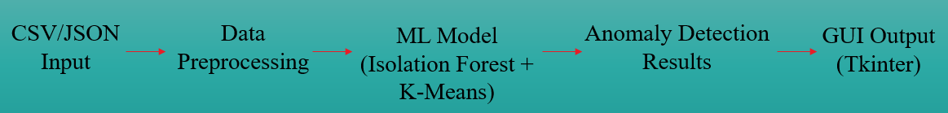
Figure 1: System Architecture of the Dimensional Anomaly Detection Tool

Technology Stack
The system was built using widely adopted programming libraries and tools.
Python 3.13 was selected as the development language for its ease of use, readability, and strong ecosystem of machine learning libraries. It provided flexibility and robustness for both the core algorithms and the user interface.
Data manipulation and numerical computations were implemented using Pandas [27] and NumPy [28]. These libraries allowed efficient handling of multidimensional datasets and are well-suited to preprocessing large tables of component dimensions.
Unsupervised machine learning methods were implemented using the scikit-learn package [29], specifically the Isolation Forest and K-Means clustering models.
Tkinter was used to design the GUI due to its simplicity, Python integration, and suitability for lightweight desktop applications.
Results were visualised using Matplotlib [30], allowing users to explore detected anomalies through scatter and line charts. This made the output more accessible to non-technical users.
Input and output data in CSV and JSON formats align with common engineering workflows and are compatible with platforms like Bentley iTwin.
All software stack components are open-source, readily available, and compatible with civil infrastructure data practices.

User Interface Design
The GUI was developed using Tkinter, with a focus on simplicity and accessibility for civil engineers with limited or no programming experience.
Users can:
- Upload data in CSV format.
- Select a machine learning model.
- Detect dimensional anomalies.
- Organise results by component type.
- View anomalies in scatter plots
- Compare results from K-Means and Isolation Forest
The interface was refined iteratively based on internal testing and user feedback.

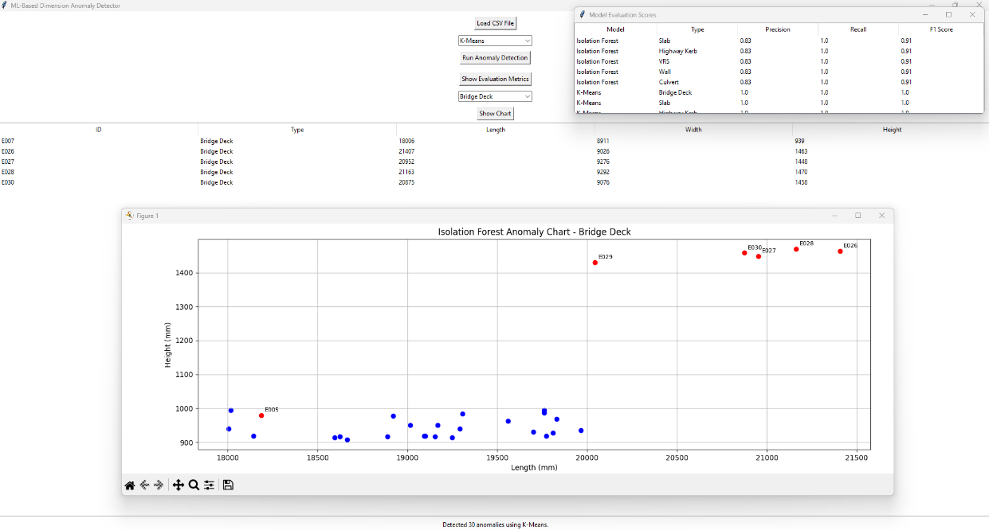
Figure 2: Main Interface Showing Anomaly Detection, Visual Output and Evaluation Metrics

Anomaly Detection Logic

Isolation Forest
The Isolation Forest identifies anomalies by recursively splitting the data space. Points that are isolated quickly are considered anomalous.
- The contamination level (C) was set to 0.2, indicating approximately 20% of the data may be anomalous.
- Each element type (e.g., kerb, slab, barrier) is evaluated independently, as dimensional patterns vary by context.

K-Means Clustering
K-Means groups similar items and labels those furthest from cluster centres as outliers. [31]
- One cluster was trained for each type, and the five most distant elements were flagged as anomalies.
- Pairwise distances were calculated using scikit-learn's distance functions.

Data Input and Conversion
Input data can come from flexible CSV exports or simulated Bentley iTwin JSON files. A custom script converts iTwin-style JSON into a clean CSV format with the following structure:
ID, Type, Length (mm), Width (mm), Height (mm)
This ensures compatibility with current design workflows and provides a foundation for future iTwin API integration.
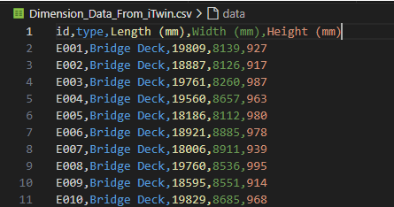
Figure 3: Output of JSON to CSV Conversion Script Showing Component Dimensions

Integration Considerations
Currently, the tool is standalone, but it was designed with modularity to support future integration. Bentley iTwin exports standard geometry and metadata in JSON, and the system architecture accommodates potential API-based workflows.
The GUI could be adapted into a Bentley plugin, ideally communicating with iTwin.js or other platform SDKs to enable deeper integration.

Summary
This Section described the design and implementation of a tool for detecting dimensional anomalies. Built in Python, the system emphasises usability, performance, and compatibility with digital twin workflows. It supports interactive comparisons of Isolation Forest and K-Means clustering outputs through a user-friendly GUI. The next section will focus on validating and testing the model through user evaluation, performance analysis, and assessing its accuracy and reliability.

Testing & Evaluation

Introduction
This section documents the testing approach that was used to evaluate the anomaly detection tool developed for this project. The evaluation was carried out along two lines, functional correctness (whether it identifies dimensional anomalies accurately) and ease of use (whether engineers could use it well). Testing was conducted through controlled trials using known datasets, followed by live user feedback from practicing engineers and BIM modellers.

System Testing and Verification
The system’s performance was evaluated based on a synthetic source of dimensional elements with intentionally introduced anomalous behaviour. Each anomaly represented a practical error in component geometry, such as extra length in a slab, reduced width in a kerb, or increased height in a retaining wall segment. These values were manipulated intelligently for six types of elements.
To test the tool, two models, Isolation Forest and K-Means Clustering were used. In both cases, the tool was expected to detect exactly five anomalies per element type, totalling thirty anomalies. The system output was visually inspected using scatter plots and cross-referenced against the inserted anomalies.
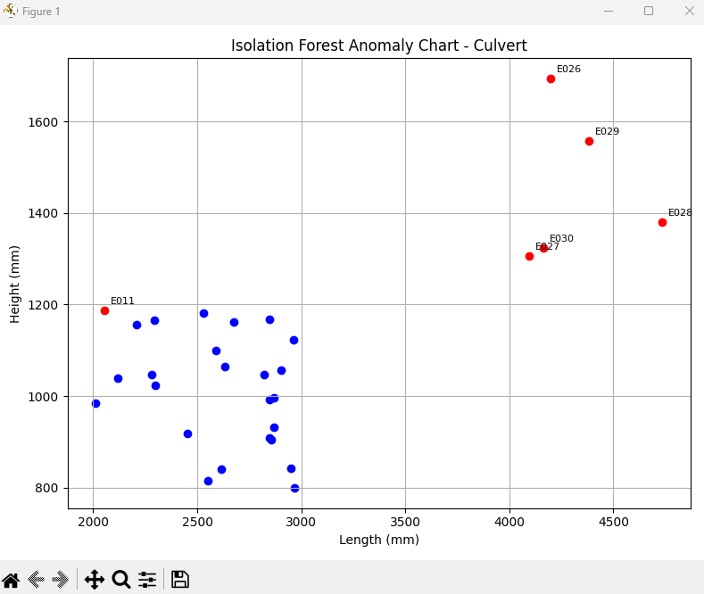
Figure 4: Isolation Forest Detection Chart
Both models returned the expected results, confirming that the detection algorithms were implemented correctly.
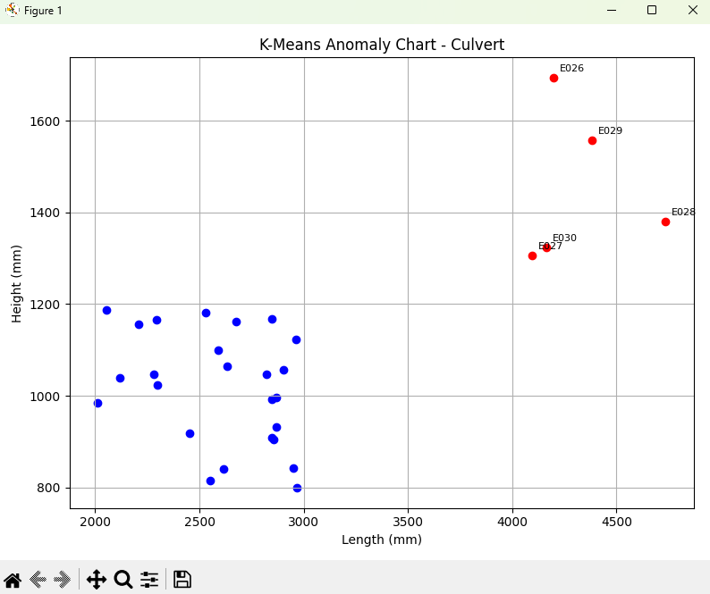
Figure 5: K-Means Detection Chart

Comparative Accuracy of ML Models
Both methods were compared using the same dataset with independent ensembles. As expected,
- K-Means successfully flagged the five most distant components from the cluster centroid per type.
- Isolation Forest, being sensitive to feature space sparsity, sometimes flagged elements that were borderline or subtle outliers based on their isolation depth.
In practice, Isolation Forest detected 36 anomalies (a bit more than the actual 30), indicating higher sensitivity. However, we did not observe many false positives, as most of the extra flags were valid edge cases that would benefit from review in real-world scenarios.

Additionally, the performance of both models was further evaluated with conventional classification metrics based on synthetic ground-truth anomalies. These being precision, recall and F1 score, providing an overview of each model’s capacity to distinguish real anomalies between false positives.
K-Means had a perfect score for all the three tests, that is, the five furthest from the cluster centre elements for each type were correctly identified. This is not surprising, the synthetic anomalies were designed based on the same considerations.

On the other hand, Isolation Forest yielded slightly lower precision and F1 scores in some element types, especially Bridge Decks. But because of its greater sensitivity, it also highlighted some borderline cases that K-Means didn’t notice, and these differences might be meaningful in a production environment. This trade-off highlights the value of offering both models, allowing the selection based on project risk.

These results show that although K-Means offers deterministic precision, Isolation Forest has a larger coverage of anomalies, thus the two can be complementary to one another in various QA setups.

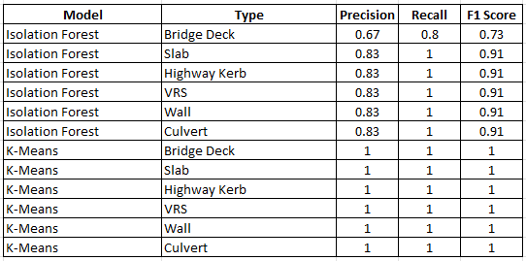
Figure 6: Precision, Recall and F1 Score Results for Isolation Forest and K-Means Across Component Types
K-Means approach, contrasts with Isolation Forest’s slightly broader coverage. Therefore, project teams can select the approach that best fits their tolerance requirements and resource constraints.
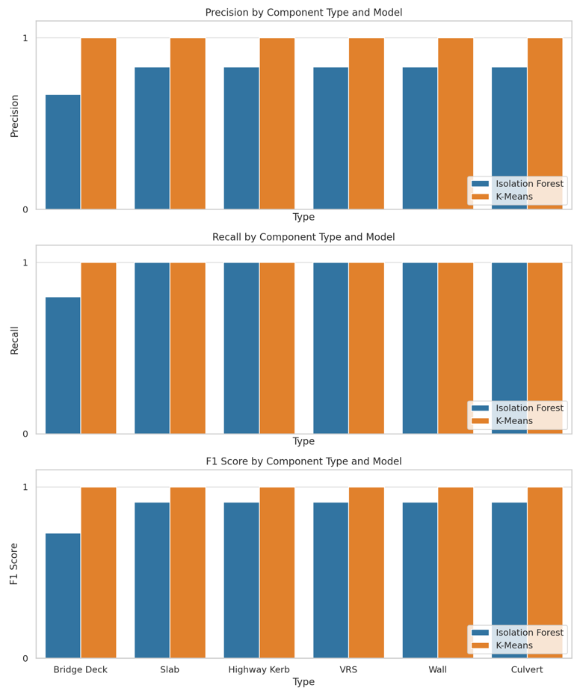
Figure 7: Comparison of Isolation Forest and K-Means Precision, Recall and F1 Score.

User Testing & Feedback
To ensure that the tool is usable and feasible, five practicing civil engineers with different civil engineering backgrounds tested the tool. Each submission included an executable release of the micro copying tool, and a chunk of a CSV data set extracted from the simulated infrastructure models. The users were asked to experiment with the interface, execute the two models and let us know based on their professional opinion.
The aim was to capture qualitative data on:
- Interface intuitiveness
- Confidence in anomaly detection outputs
- Clarity of charting and table outputs
- Suggestions for enhancements or deployment

Feedback Summary
Person A (Senior Structural Engineer):
"The interface is clean and easy to navigate. I appreciated how anomalies are grouped by element type, it helped me quickly identify outliers that might affect assembly tolerances. I’d suggest adding an option to export flagged items as a report."
Person B (BIM Coordinator):
"Really intuitive! As someone who uses BIM tools regularly but doesn’t code, I found it easy to use. The fact that it supports both Isolation Forest and K-Means is useful for exploring patterns. I liked the visual charts."
Person C (Civil Design Engineer):
"I was impressed by how quickly the tool flagged dimensional inconsistencies that I might have missed during a typical design review. The real-time charting is helpful. I’d love to see this plugged into a live BIM platform like iTwin."
Person D (Graduate Infrastructure Engineer):
"This tool makes QA far more efficient, especially for projects with thousands of repeated elements. It also helped me understand more about machine learning in practice a great learning experience."
Person E (Construction Quality Manager):
"From a QA perspective, this is really promising. The Isolation Forest flagged some unusual kerb units that wouldn’t have failed our standard checks but were clearly off. It’s good to have a second layer of review using ML."
The feedback reinforced the conclusion that the tool is viable not only from a technical standpoint but also from a user-experience perspective. Most users expressed interest in potential deployment in live projects or deeper integration with BIM tools they already use.

Summary, Conclusion & Future Recommendations

Summary and Conclusion
The testing results and development process are discussed in this section. It goes back to what the initial proposal set up as to what was to be accomplished and how well they were met. The document also situates the project results into academic and industrial contexts and discusses how unsupervised machine learning for dimensional QA in digital twins can be used in industrial workflows.
Application and validation of the tool showed that unsupervised learning methods can be an effective means to identify dimensional outliers in civil engineering models. The feedback of the engineers and managers reinforced both its potential and usability. Notwithstanding these limitations, the findings provide initial evidence toward proving that the intelligent QA system can enhance efficiency and model accuracy in infrastructure projects.
The objective of the project was to investigate how machine learning would help with dimensional quality assurance in civil engineering design. The particular focus was on creating a prototype, a readily usable system that could recognize geometrical outliers via unsupervised learning and be fit into a user-friendly system with, for example, Bentley iTwin.
The end product enables users to load geometry exported from BIM tools, process the data with Isolation Forest or K-Means clustering, check against the results for anomalies, and filter, visualize, and interpret the anomalous results, all without the need for any code. The approach was evaluated with synthetic data and in collaboration with engineers, demonstrating that it is possible for unsupervised ML to identify a meaningful outlier that would have been overlooked by rule-based systems.
The tool is written in Python and utilises Scikit-learn, Tkinter, Pandas, and Matplotlib. It allows importing/exporting CSVs, interactive visualisations, and provides output that fits with the way engineers prefer results. Participant feedback verified the tool’s usefulness, particularly in identifying anomalies in the early design stages when changes are cheaper and easier to make.
In summary, it is shown in this work that unsupervised machine learning may become a useful tool in automated dimensional QA. The authors believe that the tool provides practical advantages to the engineer and readily integrates into the design process, and thus, serves as a good basis for further refinement and exploitation within the industry.

Meeting the Project Objectives
The objective of the research was to design a machine learning approach to detect dimensional defects in civil engineering models automatically without the need for supervision. Among the initial aims of the thesis, was an assessment of the current practice, an investigation of ML methods, the development of a user-friendly tool, and make the tool available to engineering professionals.
6.2.1 Evaluation of Existing Practices:
The literature review emphasized the limitations of rule-based QA and the increasing need in more adaptive as well as scalable solutions. This helped to motivate the significance and importance of using machine learning.
6.2.2 Implementation of ML Techniques:
Isolation Forest and K-Means grouping were both well operationalized in the tool. Testing demonstrated that both were able to identify outliers, although they were sensitive to outliers, and the behaviour of each method was compared in practice.
6.2.3 User Interface and Usability
The GUI itself was made using Tkinter and shaped into a clean and thoroughly intuitive tool. The data loading and model selection, ability to filter to types and view of visualisation fulfilled the objective of accessibility to non-technical users.
6.2.4 Testing with Industry Professionals
The tool was tested by five civil engineers whereby positive feedback was obtained both for usability and clarity. A few ideas were introduced, such as a nicer display of results and a feature for model comparison but nothing more.

Insights from User Feedback
The interviews with the five experts from the field gave key views to how this feature would work in the real-world design setting.
6.3.1 Strengths Identified by Users
The UI's simplicity, the combined anomaly logic (which filtered results by type), and visual outputs was well received by users. It was mentioned in Baron et al that these features contribute to the rapid detection of abnormal ingredients.
6.3.2 Suggestions for Improvement
A few raters indicated that they would like to see additional export options, as well as clearer labels for anomalies and support for larger dataset sizes. Although not all the recommendations could be carried out in this phase, they provide a blueprint for further improvements.
6.3.3 Overall Impressions
All five engineers agreed that such a tool would fill a void in digital QA workflows, specifically during early design phases or federated model coordination reviews.

Changes made based on feedback
During testing, several improvements were made to the tool based on user suggestions. These iterative changes reflect a user-centred design approach and helped improve both usability and clarity. The table below summarises the main feedback received and how it was actioned.
Feedback Source | Issue or Suggestion | Change Made | Impact on Usability
Senior Structural Engineer | Group anomalies by element type | Added filter to organise results by component type | Faster review of relevant items
BIM Coordinator | Compare Isolation Forest and K-Means visually | Integrated precision, recall, and F1 score table | Easier model understanding and contrast
Civil Design Engineer | Improve clarity of anomaly charts | Refined scatter plot visuals and legend labels | Better interpretation of flagged elements
QA Manager | Add measurable accuracy indicators | Integrated precision, recall, and F1 score table | Provided quantitative trust in results
Graduate Engineer | Simplify layout and button text | Refactored GUI labels and removed unwanted menus | Improved first-use experience
Table 1: Summary of User Feedback on Tool Improvements

Limitations Observed
Despite the promising results, a few limitations were observed:

Dataset Scope:
Due to licensing restrictions, we were unable to obtain a Bentley iTwin API key, which limited the ability to test the tool on live digital twin data. Instead, the project used a realistic simulated dataset that mirrored iTwin exports. Integration with live digital twin platforms, such as Bentley iTwin, remains an aspiration.
6.4.2 Model Flexibility:
Isolation Forest and K-Means did the job but all of them had trade-offs. The Isolation Forest marked more outliers, but they always included inliers too. K-Means was more interpretable but simpler and less sensitive to subtle anomalies.
This was also noticeable in the evaluation of the metrics, in which K-Means achieved 100% precision and recall, whereas Isolation Forest had inferior F1 scores due to its susceptibility to feint anomalies.
6.4.3 Performance Scaling:
For bigger datasets, especially in federated models, the existing desktop tool might face performance problems. You can consider a redesign where parts of the process are offloaded to the cloud or handled asynchronously next time you iterate.

Unexpected Outcomes
A surprising feature was found in the side-by-side model comparison scores. We added this feature, late in development. It really helped users to contextualise model sensitivity, about what each algorithm was really doing and what it was prioritising. Another interesting finding, for us, was that the majority of the anomalies detected by both models were very similar, which increased our confidence in the accuracy of detection.

Broader Implications
This exercise demonstrated that ML-based dimensional QA fits into civil engineering workflows in a non-disruptive manner. As the tool is based on tools and data formats that are broadly available, it can be adopted in a wider range of project types and organisations. It also adds to the current discussion about automation of quality control in BIM and digital twin systems.
It is particularly responsive a market which is adapting to ISO 19650-aligned processes which promote digital assurance using intelligence and audited tools. If developed further, the tool might be combined with cloud-based checkers or real-time model synchronisation services in the future.

Key Contributions
This paper provides practical and academic contributions:
- No-supervision ML-based anomaly detection using geometric model data without pre-labelling.
- Comparative study of Isolation Forest and K-Means-based methods for civil engineering signals.
- The working prototype for GUI developed using Tkinter to assist user interaction, visualizing and model selection, targeted at engineers without programming experience.
- Integration-ready with outputs for example when exported from Bentley iTwin, for further investigation and practice.
- Empirical assessment with actual test users, whose feedback led to the interface being designed, and which verified the model’s output.
This tool translates machine learning research into practical, usable software for engineering.

Recommendations for Future Work
There are several possible directions for future work:
- Live iTwin model or another BIM platform integration through API for direct anomaly detection during live model reviews.
- Our model materialization, as well as other methods for materialization, can be used here, for comparison of results and performance. • Add more ML models (such as Autoencoders or DBSCAN) to compare results and performance in depth.
- Cloud based deployment, where teams of engineers and designers working on big projects in real time can collaborate.
- User analytics, to track how engineers navigate with the tool and enhance the UX and training through behaviour observed.
- Training sets or feedback loops which enable users to label false positives, false negatives and train the models over time.
- Usage in a CI/CD pipeline for automated QA in federated BIM scenarios.
As digital twins play a bigger role in engineering provisioning there’s a clear opportunity for this tool to transition from a desktop prototype to a scalable cloud-based QA aide that improves accuracy and minimises expensive downstream mistakes.

Reflection
This project gave me the opportunity to use my technical knowledge in a real-world context, which improved my confidence in using machine learning for engineering applications and workflows. This project has achieved these basic objectives as outlined in Section 1. A functional desktop application was established to detect dimensionality defects with both K-Means and Isolation Forest. The system was evaluated with synthetic data and tested with civil engineers who validated the usability, and the relevance of the work presented.
The engineer was able to easily explore and compare results without needing any additional analysis scripts, using precision, recall, and F1 score to model the detection performance. It is clear from these successes that all the three project objectives have been met.
The experience of developing this dimensional anomaly detector tool had brought a range of technological and practical challenges which structured the final solution and the learning process leading to it.
On the technical side, I gained a valuable experience with unsupervised machine learning techniques (using Isolation Forests and K-Means) and applying theoretical concepts into real world problems. Also, unlike the supervised models, modalities had no labelled examples to guide training, which makes feature selection, interpretation of anomalies, and validation of the output challenging. Yet this too reflected the realities of BIM and digital twin workflows, in which dimensional conflicts are rarely predestined and classified with uniform terms. This served to underscore the desire for tools that were functional out-of-the-box.
The tool originally lacked in uniformity of input data. The geometry taken from iTwin-style models had differences in formatting, undefined values and non-uniform types of elements. This was frustrating at times, solving these data issues was rewarding and helped me developed a more solid solution. This led to improved accuracy and fewer errors in the detection process. It has put the focus on an industry wide problem, the lack of standardisation in model exports and naming, something that hinders digital automation in QA processes.
The most structural lead on that was the choice to develop a full GUI (rather than building a tool that relied on code or scripts). This greatly increased the length of development complexity, trying to keep everything responsive and the various views’ filterable data, etc. But the result was a tool that engineers without programming experience could try out. Testing the decision in professional sessions showed it was a good one. Their input confirmed the usability of the tool and suggested changes that directly resulted in an improved visualization and filtering of the anomaly results.
From a UI perspective, I realized that engineers valued clarity and simplicity over technical exercise. For example, in a large dataset, although K-Means appeared slightly more accurate based on F1 scores, Isolation Forest was better at flagging measurements that were borderline or incorrect, which made it more useful for early QA reviews. This focused attention on the need for explainability in engineering tools, a machine learning model is only useful if the users understand and trust the outputs it generates.
In hindsight, more time could have been allocated to trying out other models (e.g., DBSCAN, Autoencoders) to try and get better performance in some edge cases. Similarly, real model environment integration and cloud-based computation for modelling on larger scales had to be dropped on account of time and scope. Due to access restrictions, a Bentley iTwin API key was not available, which limited live model integration. These are still valid directions for future work.
Finally, the project was beneficial in the sense that I enhanced my insights to the application of machine learning in engineering practice. It’s an example of how simple ML techniques, carefully used, can change the game on QA efficiency and confidence, an illustration of how small inaccuracies in model data can turn into enormous downstream consequences. I found it particularly fulfilling to receive positive feedback from engineers who used the tool, as it showed that the effort I put in could have real industry value.
This project was as much about programming as it was about engineering empathy knowing what professionals really need and building a tool that fits within their pre-existing workflow, instead of trying to replace it. The result is a system that is practical, explainable, and adaptable, providing a strong foundation for future development beyond this project. Looking back, I’m proud of what I achieved and how far I pushed myself technically and creatively to meet the project goals.

References
[1] C. Eastman, P. Teicholz, R. Sacks, and K. Liston, *BIM Handbook: A Guide to Building Information Modeling for Owners, Managers, Designers, Engineers and Contractors*, 3rd ed. Hoboken, NJ: Wiley, 2018.
[2] Building Research Establishment (BRE), “Statement on Luton Airport Car Park Collapse,” Oct. 2023. [Online]. Available: https://www.bregroup.com/ [Accessed: 16 July 2025].
[3] BSI Group, *BS EN 13369: Common Rules for Precast Concrete Products*, London, UK, 2018.
[4] C. Dore and M. Murphy, “Integration of Historic Building Information Modeling (HBIM) and 3D GIS for Recording and Managing Cultural Heritage Sites,” *ISPRS J. Photogramm. Remote Sens.*, vol. 134, pp. 122–134, 2017.
[5] National Highways, “M25 Junction 10 Improvement Scheme: Environmental Overview,” 2022. [Online]. Available: https://nationalhighways.co.uk/ [Accessed: 16 July 2025].
[6] Crossrail Ltd., “Dimensional Control,” *Crossrail Learning Legacy*, 2021. [Online]. Available: https://learninglegacy.crossrail.co.uk/ [Accessed: 16 July 2025].
[7] C. Eastman, P. Teicholz, R. Sacks, and K. Liston, *BIM Handbook: A Guide to Building Information Modeling for Owners, Managers, Designers, Engineers and Contractors*, 3rd ed. Hoboken, NJ: Wiley, 2018.
[8] E. Papadonikolaki, L. Vrijhoef, and H. Wamelink, “The Interplay Between BIM and Supply Chain Management: A Systematic Literature Review,” *Archit. Eng. Des. Manag.*, vol. 15, no. 1, pp. 1–17, 2019.
[9] UK BIM Alliance, “State of the Nation: BIM in the UK,” London, UK, 2021.
[10] BSI, *BS 1192: Collaborative Production of Architectural, Engineering and Construction Information*, London, UK, 2007.
[11] HS2 Ltd., “Digital Engineering Strategy,” 2020. [Online]. Available: https://www.hs2.org.uk/ [Accessed: 16 July 2025].
[12] Crossrail Ltd., “BIM Strategy and Delivery,” 2020.
[13] C. Eastman, P. Teicholz, R. Sacks, and K. Liston, *BIM Handbook: A Guide to Building Information Modeling for Owners, Managers, Designers, Engineers and Contractors*, 3rd ed. Hoboken, NJ: Wiley, 2018.
[14] PCSG, “Data-led Infrastructure and AI: Use Cases in UK Infrastructure,” London, UK, 2021.
[15] E. Avci et al., “A Deep Learning Framework for Structural Health Monitoring Using Autoencoders,” *Sensors*, vol. 20, no. 10, pp. 1–16, 2020.
[16] F. T. Liu, K. M. Ting, and Z. Zhou, “Isolation Forest,” in *Proc. IEEE Int. Conf. Data Mining (ICDM)*, pp. 413–422, 2008.
[17] Bentley Systems, “Applying AI and Machine Learning in iTwin Services,” 2022. [Online]. Available: https://www.bentley.com/ [Accessed: 16 July 2025].
[18] A. Ebrahimy et al., “Intelligent Model Validation Using Anomaly Detection in BIM,” *Autom. Constr.*, vol. 122, 2021.
[19] UK BIM Framework, “ISO 19650 Guidance,” 2022. [Online]. Available: https://www.ukbimframework.org/ [Accessed: 16 July 2025].
[20] Centre for Digital Built Britain (CDBB), “Digital Built Britain 2020 Roadmap,” Univ. of Cambridge, 2020.
[21] Health and Safety Executive (HSE), “AI-Based Site Safety Monitoring Trial Results,” 2022. [Online]. Available: https://www.hse.gov.uk/ [Accessed: 16 July 2025].
[22] Highways England, “Asset Management and Predictive Maintenance Case Study,” 2020. [Online]. Available: https://nationalhighways.co.uk/ [Accessed: 16 July 2025].
[23] Cambridge Centre for Smart Infrastructure and Construction (CSIC), “Smart Monitoring of Infrastructure,” Univ. of Cambridge, 2021.
[24] UK BIM Alliance, “Performance of QA Workflows in BIM: Industry Review,” 2021. [Online]. Available: https://www.ukbimalliance.org/ [Accessed: 16 July 2025].
[25] HS2 Ltd., “Digital Assurance in Federated BIM Models,” 2022. [Online]. Available: https://www.hs2.org.uk/ [Accessed: 16 July 2025].
[26] Institution of Civil Engineers (ICE), “State of Digital Adoption in Civil Engineering,” London, UK, 2022.
[27] W. McKinney, “Data Structures for Statistical Computing in Python,” in Proceedings of the 9th Python in Science Conference, 2010, pp. 51–56.
[28] T. E. Oliphant, A Guide to NumPy, USA: Trelgol Publishing, 2006.
[29] F. Pedregosa et al., “Scikit-learn: Machine Learning in Python,” Journal of Machine Learning Research, vol. 12, pp. 2825–2830, 2011.
[30] J. D. Hunter, “Matplotlib: A 2D Graphics Environment,” Computing in Science & Engineering, vol. 9, no. 3, pp. 90–95, 2007.
[31] J. MacQueen, “Some Methods for Classification and Analysis of Multivariate Observations,” in Proceedings of the Fifth Berkeley Symposium on Mathematical Statistics and Probability, vol. 1, pp. 281–297, 1967.

