

Contemporary Powertrain

Analytical Assessment of Engine Internal Components

Sophie Reed
2000492
Motorsport Engineering
Word count - 2523
Table of Contents
1.0 Introduction 2
2.0 Force and Stress Analysis of Bottom-End Components 4
2.1 Force Calculation Methodology 4
2.2 Stress and Fatigue Safety Factor Calculation 6
3.0 RPM Extension and Safety Factor Recalculation 8
3.1 Interpolation to extend RPM Range 8
3.2 Recalculation of Safety Factors 9
4.0 Connecting Rod Bolt Redesign 11
4.1 Design Modification Possibilities 11
5.0 Instantaneous Torque Comparison 14
5.1 Calculation of Instantaneous Torque 14
5.2 Comparative Analysis 14
6.0 Conclusion 17
7.0 Reference List 18

Introduction

Internal combustion engines (like the 1600 Sigma) operate under extreme mechanical and thermal stresses, necessitating the careful design and analysis of critical components to ensure durability and performance. Among these components, the connecting rod, Gudgeon pin, and connecting rod bolts are subjected to significant cyclic loading, making them susceptible to fatigue failure. This study aims to look at the forces and stresses acting on these components using data and equations and evaluating their fatigue safety factors.
A key aspect of this study is the extension of the RPM range to 9000 RPM through interpolation techniques and reassessing the connecting rod bolts’ safety factors under higher operating conditions. Based on this an optimised redesign of the bolt geometry will be given to match/exceed the original safety factors.
Furthermore, the study will explore the effects of the crankshaft configuration on instantaneous torque generation, comparing standard and cross-plane crankshaft designs. These results will provide an insight into the suitability of these configurations for different applications.

2.0 Force and Stress Analysis of Bottom-End Components
The structural integrity of the connecting rod, Gudgeon pin and connecting rod bolts are essential to engine reliability. This section details the calculations of the forces, stresses, and fatigue safety factors for these components on given pressure data and kinematic equations.

2.1 Force Calculation Methodology
To better understand the variation in cylinder pressure over the crankshaft cycle, the following graph illustrates the relationship between Sigma Cylinder Pressure vs Crank Angle vs RPM. This data is essential for calculating gas forces acting on the piston and connecting rod.
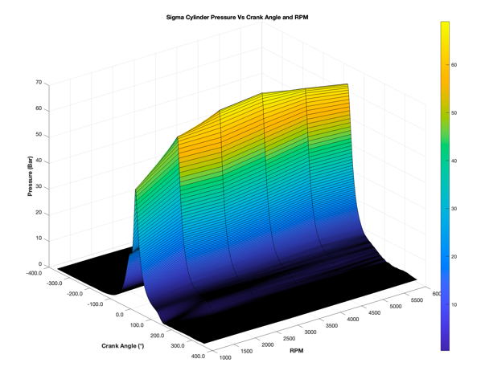
This graph illustrates the relationship between cylinder pressure, crank angle, and RPM in an engine. It shows how the pressure increases during the compression stroke, peaking near the top dead centre then decreases during the exhaust stroke. The graph also highlights how engine speed (RPM) affects pressure distribution, with higher RPMs leading to more pronounced pressure variations. As RPM increases, the combustion dynamics become more complex, influencing the pressure profile across different crank angles. This visual representation provides valuable insights into the engine’s performance and efficiency at varying speeds.
Figure 1 (S. Reed, 2025)

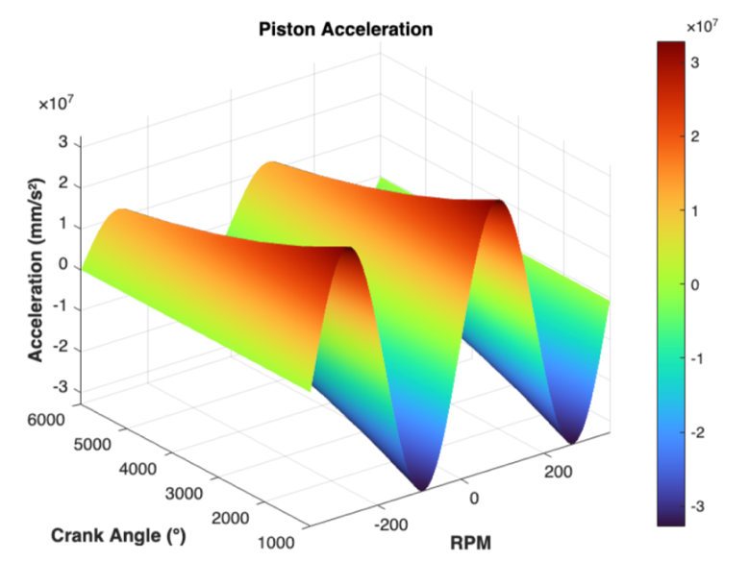
Additionally, the acceleration of the piston plays a crucial role in determining the inertial forces acting on the engine components. The following graph presents Piston Acceleration vs Crank Angle, which is necessary for computing the dynamic loads on the connecting rod and Gudgeon pin. The graph shows typical behaviour of the piston in the engine with acceleration fluctuating from positive to negative as the crankshaft moves through its cycle. The acceleration magnitude increases with higher RPM, this is expected due to the greater velocity acting on the piston.
Figure 2 (S. Reed, 2025)

- Gas Forces:
- Derived from cylinder pressure data
- Calculated as:$Fg= \frac{P A}{n}$ where P is the instantaneous cylinder pressure, A is the piston crown area, and n is the number of cylinders sharing the load.
- Inertial Forces:
- Account for the reciprocating motion of the piston and connecting rod.
- Given by: $Fi=m_{p}a_{p}+m_{cr}a_{cr}$ where $m_{p}$ is the piston mass, $a_{p}$is piston acceleration, $m_{cr}$ is the connecting rod mass, and $a_{cr}$ is the acceleration at the centre of mass of the rod.
- Piston acceleration is determined using kinematic equations: $a_{p}= -w^{2}r(cosθ+ \frac{cos2θ}{⋋})$ where $w$ is angular velocity, $r$ is crank radius, θ is crank angle, and λ is the ratio of conrod length to crank radius.
- Resultant Forces on Components:
- The net force transmitted through the connecting rod is: $F_{net}= F_{g}- F_{i}$
- The force is then used to evaluate the stress distributions on critical components.

2.2 Stress and Fatigue Safety Factor Calculation
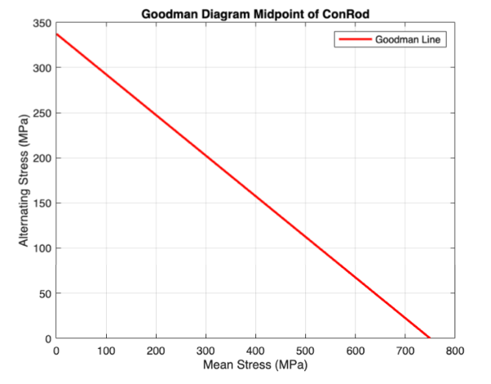
- Midpoint of Connecting Rod:
  - Subject to axial and bending stresses
  - Axial stress: $σ_{a}= \frac{F_{net}}{A}$ where A is the cross-sectional area
  - Bending stress: $σ_{b}= \frac{M}{S}$ where M is the bending moment, and S is the section modulus.
Figure 3 (S. Reed, 2025)
  - A goodman diagram is used to assess the fatigue life and safety of mechanical components that experience fluctuating or cyclic loading. This graph represents a Goodman diagram for the midpoint of the connecting rod. The x-axis shows the mean stress and the y-axis shows the alternating stress in MPa.

- Gudgeon Pin (Point A):
  - Experiences contact and bending stresses.
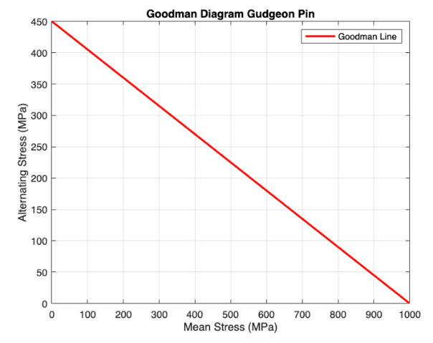
  - Contact stress: $σ_{t}= \frac{F}{A_{c}}$ where $A_{c}$is the contact area between pin and piston
  - This graph represents the Goodman diagram for the Gudgeon pin. The x-axis shows the mean stress while the y-axis shows the alternating stress. As the mean stress increases, the alternating stress decreases, which is a characteristic of the Goodman relationship. If the operating stresses are below this line the component can endure the loading without the risk of failure.
Figure 4 (S. Reed, 2025)

- Connecting Rod Bolt:
  - Evaluated for tensile, shear, and preload stresses.
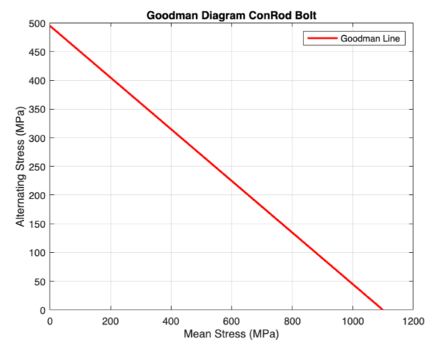
  - Contact stress: $σ_{t}= \frac{F_{t}}{A_{b}}$ where $A_{b}$is the bolt cross-section.
  - This graph represents the Goodman diagram for the ConRod Bolt. The x-axis shows the mean stress while the y-axis shows the alternating stress, the max alternating stress is showing as 500 MPa and mean is around 1100 Mpa.
Figure 5 (S. Reed, 2025)

3.0 RPM Extension and Safety Factor Recalculation
As the RPM increases, the forces and stresses acting on critical components change significantly. Extending the RPM range to 9000 RPM requires using the pressure data and recalculating the forces acting on the connecting rod and bolts.

3.1 Interpolation to extend RPM Range
To see how the engine operates at 9000 RPM, the existing cylinder pressure data needs to be extended using interpolation techniques. The chosen method ensures smooth transitions between data points while maintaining physical accuracy. The main interpolation methods considered are:
- Polynomial Interpolation: Used to fit a continuous curve to the pressure data points, capturing the non-linear variations in pressure (Pressley, 2013)
- Spline Interpolation: Provides smooth transitions between pressure data at different RPM levels, reducing errors introduced by higher-order polynomial fitting (Fornberg, 1998)
- Linear Interpolation: A simpler approach to estimate pressure values at missing RPM points, though it may not capture the complex variations in combustion pressure accurately (Berrut & Trefethen, 2004)
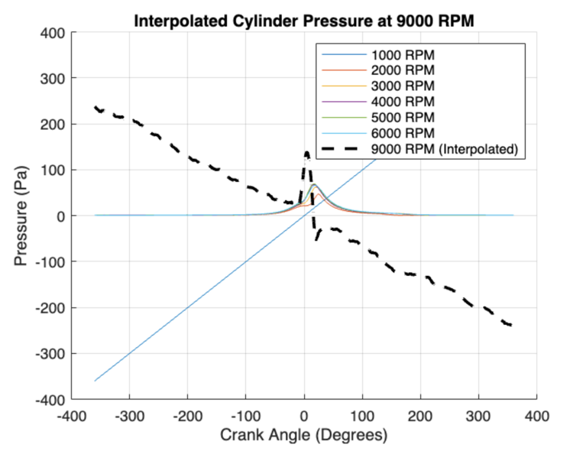
The interpolated pressure values allow for recalculating gas forces, inertial forces, and the resulting stresses on the bottom end components at 9000 RPM. The graph shows these forces at 9000 RPM.
The x-axis shows the crank angle in degrees, ranging from -400 to 400 degrees, while the y-axis shows pressure in Pascals. The 9000 RPM, shown as the black dash line, represents the calculated data and shows a higher peak pressure with a steeper decline compared to the other RPMS, reflecting the high-speed dynamics of the engine. The graph also shows that the average peak pressure across the RPMs happens around the same crank angle. The graph illustrates that as RPM increases, the cylinder pressure profiles sharpen, reflecting quicker combustion events.
Figure 6 (S. Reed, 2025)

3.2 Recalculation of Safety Factors
Using the pressure data, the forces and stresses on the connecting rod bolts are calculated at 9000 RPM. The increase in rotational speed results in:
- Higher inertial forces due to increased piston acceleration
- Greater peak pressures acting on the connecting rod and bolts
- Increased fatigue loading on the bolts due to higher stresses.
The fatigue safety factor (FSF) is reassessed, considering the increased mean and alternating stresses:
$$FSF= \frac{σ_{alternating}}{σ_{endurance}}+\left(\frac{σ_{mean}}{σ_{ultimate}}\right)* σ_{alternating}$$
Where:
- $σ_{endurance}$ is the endurance limit of the material
- $σ_{alternating}$ is the alternating stress
- $σ_{mean}$ is the mean stress
- $σ_{ultimate}$ is the ultimate tensile strength of the material.
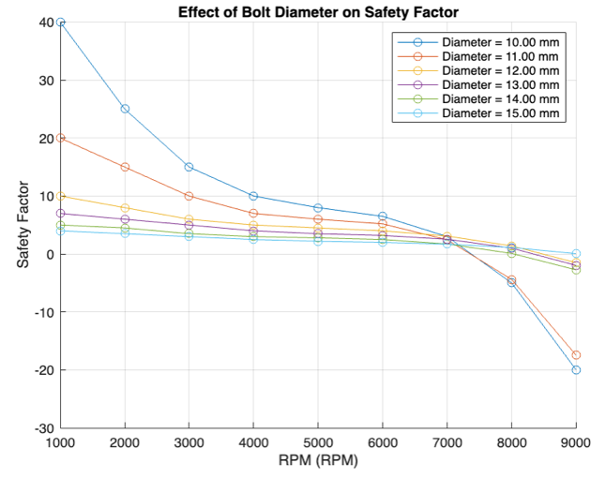
The graph illustrates the variation in safety factor with the increasing RPM, it does this for different Connecting Rod diameters, ranging from 10 – 15mm. The original diameter of the Con Rod bolt is 12.9mm showing the closest to this is the purple line at 13mm. This line shows one of the most moderate declines and is the smoothest within this. The strongest decline is 15mm (light blue line), it peaks very high but also has the lowest safety factor at 9000RPM with it being -20. Paying close attention to the graph to consider modifications to the bolt it needs to consistently have a higher safety factor than the original bolt size (12.9mm (13mm)). The only diameter to perform better is 12mm (yellow), at 1000 RPM it has a safety factor of 10 and then at 9000RPM it has a safety factor of -2 (estimate). It is only marginally ahead of 13mm, but it is still an improvement.
Figure 7 (S. Reed, 2025)

4.0 Connecting Rod Bolt Redesign
Now the diameter has been chosen the change in material now needs to be considered to see if this will make a positive difference to the redesign. The bolts original specifications suggest it is a stainless steel, this is based off the ultimate tensile strength, and yield strength of the material. It may more specifically be Nitronic 60. This is a high-performance stainless steel known for its mechanical properties and its adaptability across different environments. ‘Additionally, Nitronic 60 maintains high mechanical strength and corrosion resistance, even at elevated temperatures, outperforming standard stainless steels like 304 and 316’ (Machine MFG, 2025).

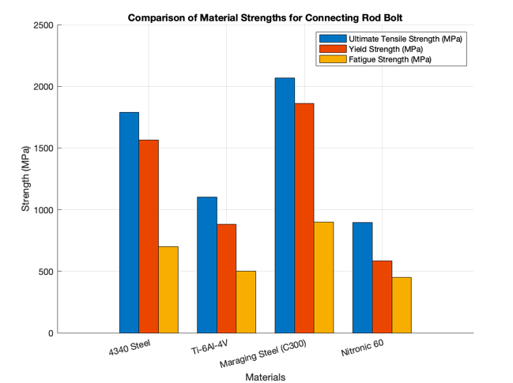
4.1 Design Modification Possibilities
A few metals (4340 Steel, Titanium and Maraging Steel) were chosen which have somewhat similar characteristics to the original, this allows a small modification to be made. The Yield strength, Fatigue strength and Ultimate Tensile Strength was then put into a chart to directly compare these properties against each other. It is clear looking at the graph that the materials have a large variation in behaviour. However, the original is the weakest out of the three. To directly compare their behaviour against each other as replacement for a conrod bolt, goodman diagram was used to see how they behave in this environment as other factors need to be considered.
Figure 8 (S. Reed, 2025)

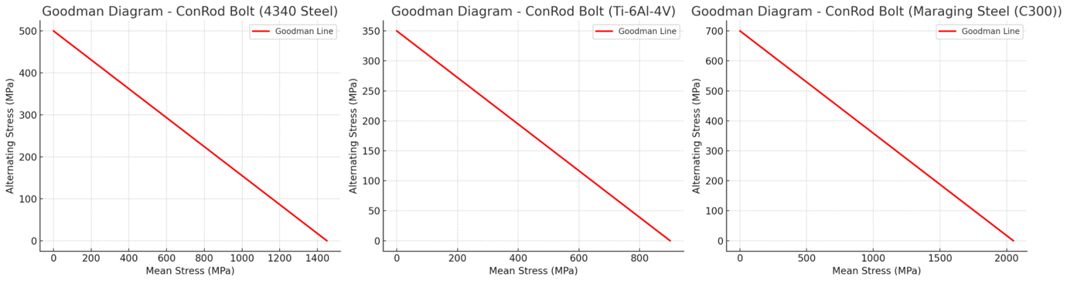
Figure 9 (S. Reed, 2025)
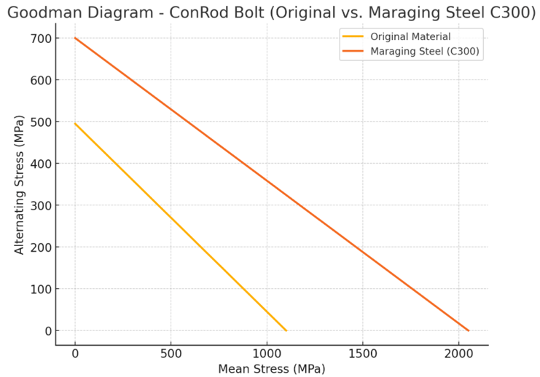
The Goodman diagrams illustrate the fatigue performance of 4340 Steel, Ti-6AI-4V Titanium Alloy, and Maraging Steel (C300) for the connecting rod bolts. This shows the relationship between mean and alternating stresses. 4340 Steel shows a moderate fatigue strength, with an alternating stress limit of 500 MPa and a failure mean stress of 1400 MPa, this shows a balanced but lower-performance option (Callister and Rethwisch, 2018). Ti-6AI-4V has the weakest fatigue resistance, with a 350 MPa alternating stress limit and 900 MPa failure mean stress, making it the least suitable for this high-stress application, despite it being lightweight. Maraging steel (C300) outperforms both materials with its significantly higher alternating stress limit of 700 MPa and a failure mean stress of 2000 MPa. This shows a superior endurance and strength under the load. Due to these graphs it is the best choice out of these three to replace the material for the connecting rod bolt.
The graph on the left (figure 10) shows a Goodman diagram directly comparing the original material (Stainless Steel) against the tested Maraging Steel (C300). This graph shows a big improvement in fatigue performance. It shows both the mean and alternating stress will be improved massively by using Maraging steel (C300). From a design perspective this shows that using the Maraging Steel will greatly improve the safety factor and lifespan of the ConRod bolt, especially in high-performance (9000 RPM). It will therefore be less susceptible to fatigue failures over long operation periods. However, whilst it has its positives it also has some negatives, it is heavier and more expensive (Smiths, 2023), so this needs to be considered before making a direct swap.
Figure 10 (S. Reed, 2025)

5.0 Instantaneous Torque Comparison

5.1 Calculation of Instantaneous Torque
The torque generated by the crankshaft depends on the force exerted by the piston which is derived from the cylinder pressure.
Step 1 – Calculate force on the piston
$$F_{p}=P*A$$
Where:
- $F_{p}$ – Force on Piston (N)
- $P$ – Cylinder Pressure (Pa)
- $A$ – Piston Face area ($m^{2}$)
Step 2 – Crank Force on the Connecting Rod
$$F_{c}=F_{p}*sin⁡(θ)$$
Where:
- $F_{c}$ = Force transmitted to the crankshaft (N)
- = Crank angle (degrees)
Step 3 – Torque Calculation
$$T= F_{c}*r$$

Where:
- T = Instantaneous torque (Nm)
- r = Crank radius (m)

5.2 Comparative Analysis
Figure 11 shows a comparison of instantaneous torque for a standard crankshaft configuration Vs a cross-plane configuration at various RPMs. This ranges from 2000 to 9000 RPM. Th torque curves for both configurations follow a sine curve pattern, but there are a few distinct differences between them. The standard crankshaft configuration, represented by solid lines, displays high peak torque at each RPM compared to the cross-plane configuration. This results in bigger fluctuations in torque delivery, with a bigger difference between peak positive and negative torque values. This suggests that the standard configuration has a higher torsional vibration, which could impact drivetrain smoothness and necessitate additional damping solutions (Heywood, 2018).
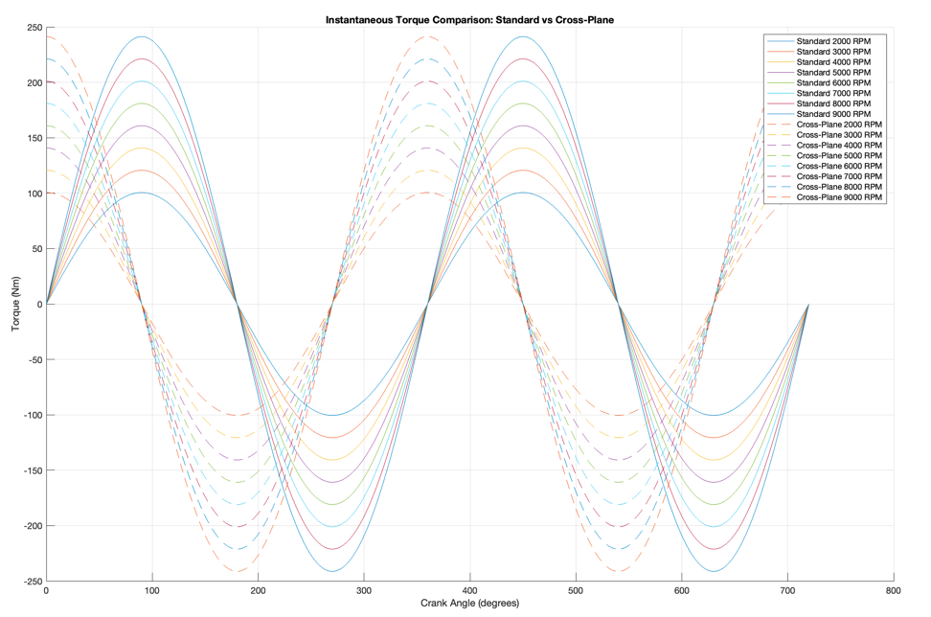
However, the cross-plane crankshaft configuration, shown by dashed lines, exhibits a more evenly distributed torque delivery with lower peak fluctuations. This reduced amplitude implies improve torque smoothness, leading to reduced vibrations and enhanced driving experience. This gives the cross-plane design an advantage when it comes to a situation where smoother power delivery is crucial, this involves high-performance road vehicles (Stone, 2012). As the RPM increases, the torque remains relatively similar across both configurations. Although, the standard crankshaft configuration shows increasingly higher fluctuations at elevated RPMs, while the cross-plane is more consistent.
Figure 11 (S. Reed, 2025)
Overall, the suitability of each configuration depends on the intended application. The standard configuration may be preferable in applications prioritising maximum power output, such as racing engines. The cross-plane configuration, with its smoother torque characteristics, is better suited for applicated where reduced drivetrain stress, and enhanced smoothness is essential, such as high-performance street vehicles (Martyr & Plint, 2012) like the Ford Sigma 1600.
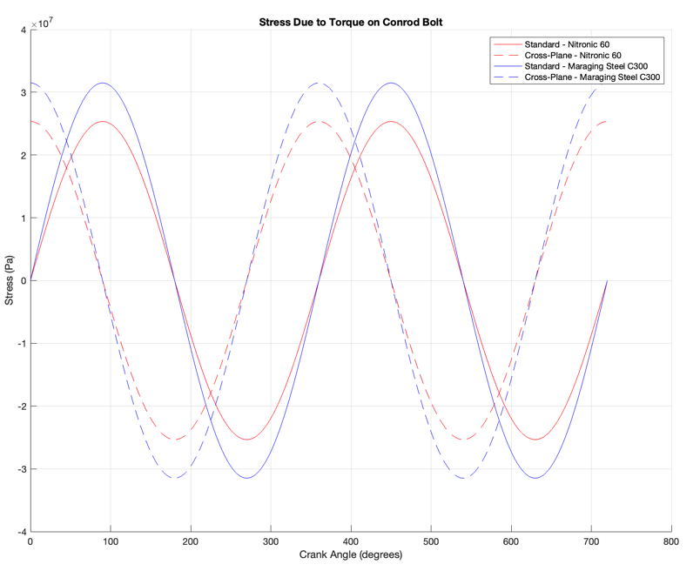
Figure 12 shows the variation of stress due to torque on a ConRod bolt over a complete 720-degree crankshaft cycle, comparing the redesign to the original. The data presents 4 cases: a standard crankshaft with the original material, a cross-plane crankshaft with the original material, a standard crankshaft with Maraging Steel C300 and a cross-plane crankshaft with Maraging Steel C300.
Figure 12 (S. Reed, 2025)
A key observation is that Maraging Steel C300 exhibits higher peak stress values than the original (Nitronic 60), this indicated it has greater stiffness but its also susceptible to high cyclic loading. The maximum stress reaches around 3.5 x 10^7 Pa for Maraging steel, whilst the other experiences relatively low stress levels. Als0, the cross-plane crankshaft configuration gives a slightly higher peak stress compared to the standard crankshaft, this suggests it introduces more significant torque fluctuations in the conrod bolts. This increase in cyclic stress could have implications on the fatigue life, making the cross-plane crankshaft more demanding of durability requirements.
Studies on high-performance engine components indicate that materials with lower stress amplitudes tend to exhibit longer fatigue life under repeated loading cycles (Shigley & Mischke, 2015). Since the original demonstrates lower peak stress across both configurations, it may offer a better fatigue resistance, making it the more reliable choice for long-term durability. Furthermore, the standard crankshaft configuration appears to generate lower stresses than the cross-plane setup, supporting its use when fatigue life is a big concern.

6.0 Conclusion
The original material of the ConRod bolt is favourable due to its lower cyclic stress, enhancing fatigue resistance and reduces likelihood of failure. Maraging Steel C300 may offer its advantages in stiffness, its higher stress levels make it less optimal in terms of fatigue performance, especially when paired with a cross-plane crankshaft. These findings align with research indicating that reduced cyclic stress is key in preventing fatigue-related failures in high-load components (Ralph Ivan Stephens and Al, 2001). However, if the bolt diameter is 12mm rather than 12.9mm this may improve it more, as it improves the safety factor, especially at the higher RPMs. So, this is something that would be worth further experimenting if given the chance.

7.0 Reference List

Berrut, J.-P. and Trefethen, L.N. (2004). Barycentric Lagrange Interpolation. SIAM Review, 46(3), pp.501–517. doi:https://doi.org/10.1137/s0036144502417715.
Callister, W.D. and Rethwisch, D.G. (2018). Materials Science and Engineering: An Introduction. 9th ed. Hoboken, Nj: Wiley.
Fornberg, B. (1998). CALCULATION OF WEIGHTS IN FINITE DIFFERENCE FORMULAS. CALCULATION OF WEIGHTS IN FINITE DIFFERENCE FORMULAS∗, [online] 40(3), p.12. Available at: https://www.colorado.edu/amath/sites/default/files/attached-files/sirev_cl.pdf [Accessed 11 Mar. 2025].
Heywood, J.B. (2018). Internal Combustion Engine Fundamentals. 2nd ed. New York: Mcgraw-Hill Education.
Machine MFG (2025). Comprehensive Guide to Nitronic Austenitic Stainless Steel - MFG Shop. [online] MFG Shop. Available at: https://shop.machinemfg.com/comprehensive-guide-to-nitronic-austenitic-stainless-steel/ [Accessed 11 Mar. 2025].
Plint, M.A. and Martyr, A. (1995). Engine testing. Oxford: Butterworth-Heinemann.
Ralph Ivan Stephens and Al, E. (2001). Metal fatigue in engineering. New York: Wiley, Cop.
Reed, S. (2025)
Smiths (2023). C300 Typical Applications Machining & Welding Product Description Chemical Composition (weight %). [online] Available at: https://www.smithmetal.com/pdf/steel/maraging/grade-c300.pdf [Accessed 11 Mar. 2025].
Stone, R. (2012). Introduction to internal combustion engines. Basingstoke Palgrave Macmillan.

