Louie Brace (1901025)
1901025@student.uwtsd.ac.uk
ACBA 6000 Construction Management
Assignment 1

Contents Page
Introduction Gantt Chart 3
1 Site Report 3
1.1 Time 3
1.2 Cost 4
1.3 Resources 7
2 Issues that may affect productivity 8
2.1 Poor Planning 8
2.2 Slow Decision Making 8
2.3 Fatigue and Overtime 8
2.4 Weather 8
2.5 Skilled Workers 8
2.6 Poor Communication 8
2.7 Materials Shortages 9
2.8 Labour Shortages 9
2.9 Changes to Project/Design 9
3 Incentivisation 9
3.1 Financial Incentives 9
3.1.1 Bonus/Gift cards and vouchers 9
3.1.2 Additional Time Off/Annual Leave 9
3.1.3 Profit-Sharing 9
3.1.4 Retirement benefits 10
3.1.5 Commission 10
3.1.6 Perquisites 10
3.1.7 Co-partnership/Stock option 10
3.2 Non-Financial Incentives 10
3.2.1 Status 10
3.2.2 Organisational climate 10
3.2.3 Career advancement opportunity 10
3.2.4 Job enrichment 10
3.2.5 Job security 10
3.2.6 Employee recognition programs 10
3.2.7 Employee participation and empowerment 10
3.3 Incentive Schemes 10
3.3.1 Pain and Gain 10
3.3.2 Earned Value Management 10
3.3.3 Co-operative incentive negotiation budget (COIN) 10
4 Potential Delays 11
4.1 New Designs 12
4.2 Force Majeure 12
References 12

Introduction Gantt Chart
The Gantt chart shows the progression of the project and the labour, materials and plant used throughout. All RIBA stages have been covered to give an accurate timescale.
The foundations element has many factors which must align in order to stay on budget and on time provided in the pre-construction brief. Figure 2 shows the breakdown of total cost of the project, disregarding elements such as fuel, land purchase, planning permissions. The project will use pile foundations, attached via pile caps to a raft foundation. With a delay to the pour of concrete, this causes many issues with scheduling.

Site Report
This includes the time, cost, and resources necessary to complete the project. Pricing was completed according to Spons or reputable sources found online. Throughout the span of a project there must be a completed spreadsheet of these three elements to ensure that everything is priced accordingly and tracked effectively. However, a BOQ is a more accurate way of pricing elements of a project.

Time
Overall, the project will take 463 days to completion and is due to be completed on the 26th of March 2024. This is considering the 5-week delay. If possible, an updated plan of works could be completed to try to make up for lost time due to the strike. Figure 1 shows the amount of time each RIBA stage takes to complete and be signed off.
Task Name | Duration
RIBA Stage 0 | 45 days
RIBA Stage 1 | 20 days
RIBA Stage 2 | 10 days
RIBA Stage 3 | 15 days
RIBA Stage 4 | 25 days
RIBA Stage 5 | 292 days
RIBA Stage 6 | 41 days
RIBA Stage 7 | 15 days
Total | 463 days
Figure 1: Time Schedule
To reduce the total timespan of the project, the best way would to be to assign more labour and resources to each element. This means that individuals can complete their tasks quicker and move onto something else that has to be completed. The issue with this is cost. The more labour assigned to tasks, the more money you pay on wages.
Initially stage 0 covers the strategic definition and ensure that the project is feasible and can provide all the clients requirements of a building. This considers the risks of the project in terms of budget and scope. Additionally, it is important to get clear information of what the client requires and any designs that they might prefer.

Cost
The cost of the project in total was a little over £6m; however, some things haven’t been accounted for and therefore, a figure of £6.5m would be more likely. This figure includes furnishing and finishes along with the construction of the building.
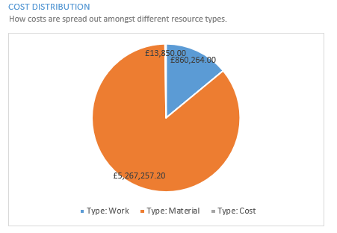
Figure 2: Cost Distribution
This identifies the distribution of cost between materials, labour and cost being either scaffolding or plant. From analysing the graph, it’s clear that materials are the largest proportion of the cost in the project, which is expected, as this is a large-scale project. In comparison labour was only 1/6th of the cost of the materials; however, labour can be increased if necessary to account for the delays in the schedule. It is vital that you select an appropriate contractor to complete the work, as they must be able to complete the project on time and to budget. This includes accounting for delays that could occur. However, there can be negotiations between the client and contractor if unprecedented circumstances occur, for example, Covid-19. The Cost element was based upon the machinery used to complete the foundations element, not the entire project. Therefore, the figure provided seems low and not relative to the other two. If fully completed in detail, there would be an increase in cost for plant.
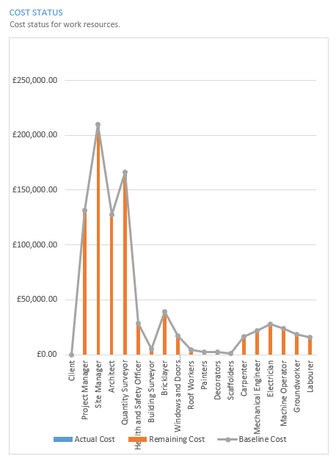
Figure 3: Cost Status
Having enough resources to complete elements on time is vital for the scheduling of a project. Figure 3 shows the variation in labour costs depending on roles within the project. The programme of works must be followed as closely as possible within the critical path. Some elements of work that must completed so that the project remains on track. Additionally, there are some tasks in a project which require a higher amount of labour in comparison to other tasks. For example, there might be a team of 5 bricklayers completing the externals walls of the building, whereas there might be only 2 painters and decorators. This will be calculated in the plan of works and main schedule. Where possible it is good to have float time, as if any delays occur, then this can be used to ensure that the project remains on target.
Materials are crucial for constructing a building, as without the supply of materials, the workers can’t complete their tasks. However, in the construction industry, it is not uncommon to see many delays for different materials. (Construction news, 2022) A survey by the Federation of Master Builders (FMB) released last year found that that 8 in 10 SMEs had suffered delays on projects due to problems getting materials. Fortunately, there are many different supplies that can provide competitive rates; however, last minute deliveries can cost significantly more than others scheduled in advance.

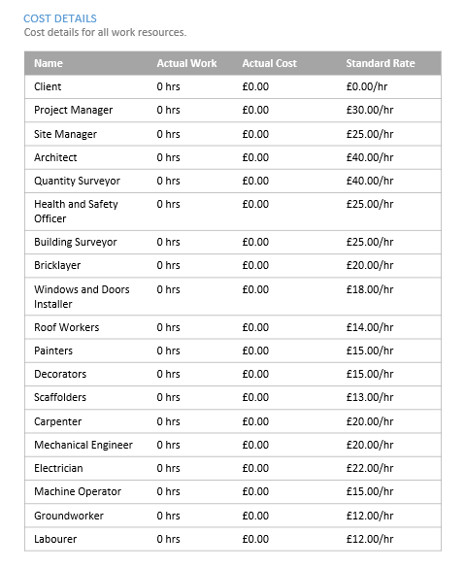
Figure 4: Cost Details
Above shows the rates of the different labour required throughout the project. Professionals will be present throughout the project start to finish, whereas skilled and unskilled labour will only be required during stage 5 of the RIBA plan of works. The rates above could change depending on the circumstances. For example, with the strike occurring, skilled labour would be required for a longer period in comparison to what they were originally scheduled to do.
Figure 5: Cost Status
This shows the differences in labour costs. Some workers are required much more frequently than others and that’s why there is such variety in the costs of different roles. Additionally, figure 4 shows the rates used in this programme.

Resources
These can be allocated differently depending on what must be completed and when. This could be plant, tools, or equipment such as scaffolding. If the project is behind schedule, then more resources can be assigned to the critical path where necessary to reduce the delay.

Issues that may affect productivity

Poor Planning
This can cause many issues to arise where they shouldn’t if careful consideration is not taken for all aspects of a job. (RIB CCS, 2023) preconstruction planning is essential for a productive project ahead. By ensuring that everything is completed correctly beforehand, it should minimise disruption. Poor planning could cause confusion, materials showing up late, insufficient resources required to complete work etc.

Slow Decision Making
When issues arise, if decisive, effective action isn’t taken to rectify issues that occur, then this could cost a contractor a significant amount of money depending on the severity of the issue. (AdamStrong, 2023) Slow decision-making costs you time, money and impacts relationships, culture, and psychological factors.

Fatigue and Overtime
(HSE, 2023) Fatigue results in slower reactions, reduced ability to process information, memory lapses, absent-mindedness, decreased awareness, lack of attention, underestimation of risk, reduced coordination etc. This could be incredibly detrimental to a construction project where millions of pounds could be on the line; therefore, it’s imperative that all professionals are given sufficient time off to ensure that their decision-making is always at a high level. Working overtime can sometimes be detrimental if an individual is feeling overworked, as the quality of work produced might be lower compared to if they were fully rested.

Weather
Weather can affect a project significantly, as if it’s raining the day of a concrete pour, then it must be delayed, as concrete cannot be poured whilst it’s raining. Additionally, it needs time to set. Therefore, a bit of leeway should be left in the scheduling of this element to account for any bad spells of weather throughout the project. Companies providing these services understand that there can be variation depending on different circumstances. (Ehab, 2022) Nearly (44.5%) of productivity of an activity can be influenced by weather. It also shows that temperature is the joint highest factor, alongside the type of work being undertaken.

Skilled Workers
The need for skilled workers throughout the project can be an issue if changes to the critical path are required. The individuals completing the tasks might have very busy schedules and therefore, it could be difficult to reschedule them to a different date. This could mean new workers must be sourced on short notice, which will drastically increase the cost of the work. If skilled labour cannot be sourced at the required time, then training on the job might be required to complete tasks on time.

Poor Communication
This could cause workers to be constructing certain elements in the wrong order, which could have major repercussions if other workers are waiting on them to complete their task. To reduce the likelihood of this occurring, frequent meetings should be organised so that individuals understand clearly must be completed and when.

Materials Shortages
If there are any delays in material supplies, then companies might have to pay above the recommended retail cost for supplies, which can increase the projected cost of the project drastically. Previously, when there were massive shortages around timber, companies struggled to source materials at all, which delayed projects significantly. A way to prevent falling behind on crucial deadlines is to assign more labour to work once materials have arrived on site. This will ensure that tasks are completed quicker, making up for lost time.

Labour Shortages
A lack of labour in the area due to a high number of jobs, then companies will have to pay higher rates to get workers to accept their job. If contractors are unable to source vital labour for tasks on the critical path, then this will cause ongoing delays throughout the project. The best way to combat this is to assign more labour further into the programme of works as an attempt to get the project back on track.

Changes to Project/Design
Any changes to designs whilst work is ongoing could be detrimental to a projects schedule. This is especially the case if work has already been started on elements that must be changed, as it must be taken down and redone. Good planning, checking and preparation should prevent these issues occurring.

Incentivisation
There a variety of different ways companies can incentivise their employees to work more efficiently and to a higher standard. (Carbon Collective, 2021) There are two types of incentives: financial and non-financial. Many tend to include money; however, there can be other options such as increased annual leave.

Financial Incentives
There are many examples of financial incentives that can improve the productivity of employees.

Bonus/Gift cards and vouchers
Lump sums or gift cards can be a great way of rewarding a workforce for achieving targets in the workplace. However, it is vital that these targets are achievable, otherwise it could cause the opposite affect and instead cause them to slack and do the bare minimum. (Hooray, 2022) Profit sharing allows employees to earn performance-related bonuses.

Additional Time Off/Annual Leave
This could be allowing employees to leave early if they’ve completed all required work for the day or allow them to earn extra annual leave by staying and completing other tasks.

Retirement benefits
Could include lump sums that will be paid into employees’ pensions depending on the level of work they’re achieving.

Commission
Rewarding employees for completing a job earlier than scheduled to a high standard or making the company more money than they would’ve otherwise received.

Perquisites
(Sentencedict, 2020) This could involve giving an employee their own designated car to commute into work with as a reward for outstanding work. This shows that the company views the employees as a valuable member of the team.

Co-partnership/Stock option
This involves rewarding individuals for their performance by assigning them a percentage of the company. Alternatively, they could invest a lump sum into stocks for employees. Although, this is not a preferred option for most employees, it could earn the most money.

Non-Financial Incentives
There are other incentives that can be used to reward/motivate hard working employees.

Status
Improvement in reputation means that employees could receive increased work, therefore earning them more money. Additional compensation could be rewarded on top of this.

Career advancement opportunity
Most employees will appreciate a promotion, as there is opportunity to make more money. However, this won’t work with everyone, as some employees are content with their position within the company and don’t want the extra level of responsibility from a promotion.

Job enrichment
(Factorialhr, 2022) This is a strategy used to motivate employees by giving them increased responsibility and variety in their jobs. This allows employees to control what they’d like to work on, which should increase productivity.

Job security
Offer employees a new secure contract which rewards them for performing to a high standard.

Employee recognition programs
This could include company outings or celebrations which could increase morale and further encourage employees to keep working to a high level.

Incentive Schemes
There are many incentive schemes that can be used to increase the productivity of employees.

Pain and Gain
This is a way of partnering where both contractor and client set a target as to when the project must be completed and what the budget for the project is. They both share some proportion of blame depending on different elements of construction. The percentage of is decided in the preconstruction phase.

Earned Value Management (EVMS)
(PMI) This method allows the project manager to measure the amount of work performed on a project beyond the basic review of cost and schedule reports. This allows clear analysis as to which employees are performing well and which require additional assistance to achieve the levels required.

Points-based recognition scheme
(Achievers, 2020) This is a very modern scheme which allows employees to earn points for their work, which can earn them monetary rewards such as gift cards. Additionally, it allows a company to effectively track who’s performing well and which individuals might require additional training or encouragement.

Potential Delays
On the 7th of November it was announced that the local concrete company were going on strike for 5 weeks, which therefore delayed the project. This can be seen in Figure 6.
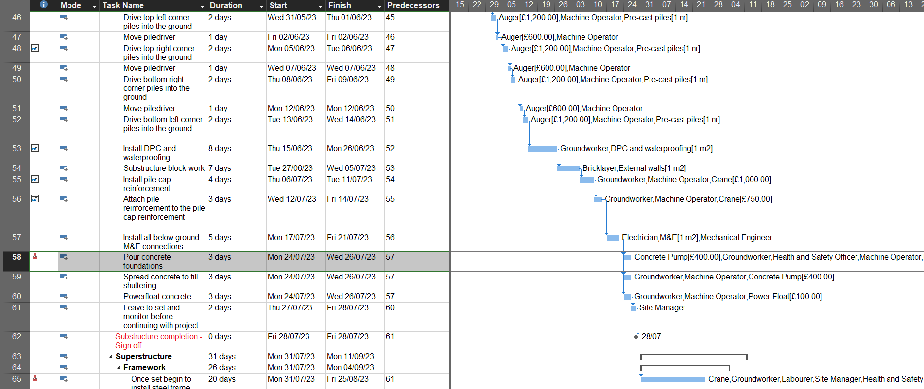
Figure 6: Point of delay in the schedule with baseline
This can cause many issues with the schedule, especially due to the pour now having to be completed deep into winter, which means that finding sufficient days to complete the pour becomes increasingly difficult. To deal with this, the QS must either source a different company to complete the pour or account for the delay in the price. Otherwise, this could cause major hassle, as the concrete pour is along the critical path of construction. This will affect every element of the project if it cannot be rectified or accounted for further down the line. An increased amount of labour must be assigned to other critical elements of the project to rectify the delay. Another option is to adjust the schedule so that other elements overlap where possible to ensure that the project is completed by the required date. However, this could then cause a knock-on effect, as sub-contractors might be required for other jobs at different dates. If other labour must be sourced last minute, then this will cost significantly more in comparison to the agreed dates. This will result in an increase in overall cost; however, if there is no other alternative, then this is required. A delay of 5 weeks could cost up to £12,500 for the running overheads of the site.
Other tasks that could be completed whilst the pour is required could be cleaning up the site. Ensure materials are organised to ensure tasks are completed quickly and effectively to mitigate further delays. Basic landscaping could be completed whilst waiting for the concrete to arrive which could shorten the amount of work required later. By assigning additional labour for after the delay, it should reduce the of time lost due to the strikes.
In this scenario the contractor is culpable for the delay of the project, as sufficient precautions should have been put in place in the schedule for potential issues with supply chains. Therefore, the client doesn’t have to agree a change to the completion date of the project. However, if the client believes an extension is reasonable, they can issue one.

New Designs
These could have a major impact to the project if significant change is required to main elements of the building. Construction must stop immediately until the issue is sorted and changes have been made. This requires the approval of planning permissions, which can add an even bigger delay to the project.

Force Majeure
(Investopedia, 2022) This is a clause that is included in contracts to remove liability for unforeseeable and unavoidable catastrophes that interrupt the expected course of events and prevent participants from fulfilling obligations. In this circumstance neither party is at fault for the incompletion of work. An example of this is Covid-19 where the entire country went into lockdown and work had to be stopped for the foreseeable future.

References
Trevor Blake. (2023). How much does an office fit out cost? [online]. Available from: https://www.trevorblake.co.uk/insight/articles/2020/03/how-much-does-an-office-fit-out-cost/ [accessed 20 January 2023].
Construction News. (2022). Nine out of 10 large projects ‘behind schedule’ [online]. Available from: https://www.constructionnews.co.uk/supply-chain/nine-out-of-10-large-projects-behind-schedule-18-01-2022/#:~:text=A%20survey%20by%20the%20Federation,due%20to%20problems%20getting%20materials. [accessed 20 January 2023].
Carbon collective. (2021). Incentive [online]. Available from: https://www.carboncollective.co/sustainable-investing/incentive#:~:text=There%20are%20two%20types%20of,awards%2C%20privileges%2C%20or%20recognition. [accessed 20 January 2023].
RIC CCS. (2023). What Impacts Construction Productivity & What to Do About it [online]. Available from: https://ribccs.com/what-impacts-construction-productivity/ [accessed 20 January 2023].
Adamstrong. (2023). Is Slow Decision Making Killing Your Business? [online]. Available from: https://adamstrong.net/slow-decisions-making-ruin-business/ [accessed 20 January 2023].
HSE. (2023). Human factors: Fatigue [online]. Available from: https://www.hse.gov.uk/humanfactors/topics/fatigue.htm#:~:text=Fatigue%20results%20in%20slower%20reactions,and%20injury%2C%20and%20reduced%20productivity. [accessed 20 January 2023].
Ehab. (2022). The impact of weather on construction productivity: the hidden cost [online]. Available from: https://blog.ehab.co/impact-of-weather-on-construction-productivity#:~:text=This%20work%20highlights%20that%20nearly,type%20of%20work%20being%20undertaken. [accessed 20 January 2023].
Sentencedict. (2020). Perquisite in a sentence [online]. Available from: https://sentencedict.com/perquisite.html [accessed 20 January 2023].
Hooray. (2022). Is profit sharing right for your business? Here’s what you need to know [online]. Available from: https://hoorayinsurance.co.uk/is-profit-sharing-right-for-your-business-heres-what-you-need-to-know/ [accessed 20 January 2023].
Factorial. (2022). Job Enrichment: Definition, Examples and Strategy [online]. Available from: https://factorialhr.co.uk/blog/job-enrichment/ [accessed 20 January 2023].
PMI. (2006). Earned value management systems (EVMS) [online]. Available from: https://www.pmi.org/learning/library/earned-value-management-systems-analysis-8026 [accessed 20 January 2023].
Achievers. (2020). 10 Employee Incentive Programs to Engage Your Team [online]. Available from: https://www.achievers.com/blog/employee-incentive-programs/ [accessed 20 January 2023].
Investopedia. (2022). What is a Force Majeure Contract Clause, and How Does It Work? [online]. Available from: https://www.investopedia.com/terms/f/forcemajeure.asp [accessed 20 January 2023].

