Is there a relationship between collaboration and job satisfaction, perception of professional improvement and consideration of leaving teaching for teachers in the United Kingdom?

BMDP7009 Quantitative Research Methods

Laura Morris (2317309), University of Wales, Trinity St David

7226 words (excluding appendices)

Contents

Abstract 3

Keywords 4

Definition of keywords 4

Introduction 4

Literature review 5

Methods 8

Measures 11

Results 12

Discussion 25

References 27

Bibliography 30

Appendices 31
Appendix I: Teacher questionnaire
Appendix II: Descriptive statistics
Appendix III: Determining which statistical test
Appendix IV: Raw data

Abstract
Transformation across the Welsh education system has seen a multi-faceted approach to the development of a self-improving school system. Through the implementation of several levers including, but not limited to, changes to curriculum, professional standards, initial teacher education and mechanisms for support and challenge, the focus has been on creating capacity within the system by improving practitioners’ knowledge, skills and adaptability with collaboration being the preferred mechanism in achieving this change. While there is some evidence to suggest that a level of momentum is present, the perils in the system in Wales are proving counter-productive to the realisation of the vision and placing limitations on gains. Emerging findings from research suggests that progress is being made (Kools & Stoll, 2017). However, despite Wales being a small country with only around 2000 educational settings, there is significant variation in the extent to which collaboration is implemented, variation in its formats and therefore variation in its outputs and outcomes (Evans et al, 2022). The available research describing collaboration far outweighs the available research on its impact (Harris et al, 2017). This research therefore seeks to confirm whether the same relationships that have been found in recent empirical studies conducted internationally into the impact of collaboration on teachers, schools and the education system can also be seen in the Welsh context.

This research was to explores available secondary data from the Programme for International Student Attainment (PISA) conducted in 2022 to determine the impact that collaboration and a culture of collaboration has on individual practitioners’ levels of job satisfaction, their perceptions of their own professional improvement and whether they wish to continue in role. The following question was used as a framework for the construction of hypotheses:

Is there a relationship between collaboration and job satisfaction, perception of professional improvement and consideration of leaving teaching for teachers in the United Kingdom?

A quantitative approach was deployed to address this question in relation to participants in the UK and, while this is not addressing specifically the potential outcomes within the Welsh educational system, culturally and contextually it is closer than an international comparator and therefore the results have greater applicability and generalisability in Wales.

The findings demonstrate that both frequency and the quantity of collaboration have a positive impact on teachers’ job satisfaction, their self-perception of professional improvement and whether they have considered leaving teaching. These findings contribute useful knowledge to research in this area and also inform further research going forward.

Keywords
Collaboration, professional improvement, self-improving system, job satisfaction.

Definitions of keywords
Word | Definition
Collaboration | Two or more people working together to create or achieve a target.
Professional improvement | Self-perception of improvement in their professional responsibilities.
Self-improving system | The assumption that much of the responsibility for school improvement sits with the system itself (Hargreaves, 2011).
Job satisfaction | Teachers’ positive emotions to their work and profession as job satisfaction for teachers (Skaalvik and Skallvik, 2010).

Introduction
The Programme for International Student Attainment (PISA) has been a significant driver of changes in the Welsh education system since the 2012 outcomes demonstrated that 15 year olds in Wales were not only below their peers in the three other domains in the United Kingdom but also undesirably occupied a space quite considerably far down the rankings tables of 80 other countries and economies (Dixon, 2016). The changes that have followed have signalled both externally and internally that the education system in Wales is not good enough and needs to improve. Collaboration and collaborative working practices have been evident in various guises for decades within Wales, and, demonstrative of the esteem and value attributed to it, there has been a notable increase in its presence since the 2012 outcomes (Harris et al, 2017; Evans, 2021). There is a general acceptance of collaboration being a significant contributing mechanism in bringing about improvements within schools, across schools and across the system as a whole. There is, however, rather less knowledge about why or how it achieves this and what it impacts on (Harris & Jones, 2018). This sets the scene for this piece of research.

Wales has looked internationally in considering features of highly effective and high performing school systems. In doing so, it appears to have garnered evidence to support high volumes of transformation across the system and high value on progressively developing towards a self-improving system through using the readily available human resources (Evans, 2023). Collaboration can be considered a sensible mechanism; one that facilitates transfer within and across schools. However, there is not yet a body of empirical evidence that supports the impact of this collaboration ‘push’ across the system in Wales. While Wales can, and does, draw on national and international research, there are often wider factors that potentially make the context too dissimilar to apply findings without alteration or adaptation. Hudson et al (2019) discuss the policy implementation gap and how this leads to policies failing; Wales is no exception. Indeed, Dixon (2016) laid out the several failures of the Welsh Government in taking policies from other countries, attempting implementation without adaptation for the context and therefore limiting any potential for positive impacts.

Research findings relating to collaboration even from English ‘neighbours’ are difficult to reconcile. The education systems are different in many important ways. England has a selective school system, Wales does not. England has significantly greater per pupil funding than Wales. England is awash with structural collaboration through its dominance by multi-academy trusts, Wales has a very small number of executive headteachers (Ainscow et al, 2019; Sibieta, 2024). These few examples make important suggestions as to how research into England is not as applicable to Wales as it appears.

'Doing collaboration’ and implementing the principles of various types of collaboration all have significant cost implications which can be increasingly difficult to accommodate given the relatively challenging budget scenarios (Sibieta, 2024). Headteachers across Wales are considering budgets ‘line-by-line' to carefully examine whether costs can be removed, reduced or better value for money can be achieved. Harris and Jones (2022) outline that the amount of available narrative of collaboration and collaborative activity far outweighs the available empirical findings examining impact. The same question, therefore, has to be asked of collaboration; does it provide value for money? What is the impact of the collaborative work that has been undertaken?

The purpose of this research study therefore was to consider current research into collaboration in school settings to determine whether it has an impact on individual teachers in terms of their job satisfaction, their self-perception of progressing their professional practice (referred to as professional improvement) and their consideration of leaving the profession.

Literature review
Collaboration, as a mechanism for enabling change and development has held a central presence in the transformations seen over the past decade. It can be seen in initial teacher education programmes (Furlong, 2016; Furlong et al, 2021), impacting individual teachers through the revisions to the Professional Teaching Standards (Welsh Government, 2019). It is also emerging in the 22 local authorities’ response to the Welsh Government directive for collaborative working and learning in response to the middle tier review (Welsh Government, 2023) which will see school improvement advisory functions sitting with schools rather than external partners. It can also be seen at whole system level with policymakers working internationally through engaging with a wider variety of experts, researchers, other organisations and other education systems than previously (Kools and Stoll, 2017).

There are, however, many factors that could be considered ‘opposing forces’ to the vision of implementation of collaboration across the system, whether intentionally meaning to or not. Wales is a small country, and its capacity to respond to the scale of transformation is questionable. Indeed, the system bemoans the rapidly shifting landscape within Welsh education and professionals are increasingly ‘noisy’ about the pace of implementation and the expectations for individuals through to wider networks with the lack of resource available (Evans, 2021; Welsh Government, 2023). With such significant change, there are notable challenges to implementation at various levels in the system. Welsh Government, in commissioning international researchers to review the system, were informed that progress was evident in only two of seven markers set out in the ‘Schools as learning organisations’ framework document (Kools & Stoll, 2017; Stoll & Kools, 2017).

With such significant and rapid change, it seems somewhat inevitable that there will be sizable variation in what ‘collaboration’ is, what it does, what it looks like and how it is done. Empirical findings about collaboration in Wales detail a high level of variation both within schools and across schools (Harris et al, 2017) and it is therefore more understandable that this has generated a greater volume of descriptive narrative about the types of collaboration rather than asking its impact (Cordingley, 2015).

Much of the available literature on any impact relating to collaboration focuses on the ways in which the teacher creates impact through developing their performance. Justified by several documents, including the 2010 White Paper foreword by the then Prime Minister and deputy prime minister, David Cameron and Nick Clegg, in that “the first, and most important, lesson is that no education system can be better than the quality of its teachers” (DFE, 2010: 3). This set alongside findings such as 30% of the variance in pupil outcomes comes from variability in teachers (Hattie, 2003) has led to the need to develop teachers’ performance being an unquestioned and accepted priority if a country is to improve its own performance in international comparative testing. It makes sense therefore that where the impact of collaboration has been considered, it is with reference to teaching performance. Approaches with the introduction of collaborative working practices in other professions, for example the team approach in GP surgeries, have similarly looked to outputs and outcomes for the ‘customer’ as a measure of impact (Ickovics et al, 2019). Findings accumulated, it is relatively uncontested that collaboration leads to improvements in pupil outcomes as a result of improved teacher performance (Cordingley, 2015). However, much less is known about what factors shape teacher performance and why.

Recent reports detail that there are more teachers leaving the profession now than previously which is problematic given that there are fewer teachers coming into the system (Davies et al, 2018; Hutchinson et al, 2024). Skaalvik and Skaalvik (2010) regard teachers’ positive emotions to their work and profession as job satisfaction for teachers. Job satisfaction has been consistently linked with staying in the teaching profession (Moe & Katz, 2022). Studies of the impact of job satisfaction on teachers themselves or schools are however relatively scarce with most of the research focusing on performance related variables (Liu et al., 2024). Decisions to leave any profession or job are often complex and will include factors unrelated to teaching and the profession itself however knowledge of how to sustainably retain good teachers would be entirely beneficial and therefore it is appropriate to direct research to examine whether any of the changes facing the profession, including collaboration, do or could have an impact in this area as well as those with existing empirical evidence like teacher performance.

For the main or upper pay scale teacher without a teaching and leadership responsibility, they will spend nearly all of their time in a classroom with a class of pupils. Following changes to working terms and conditions in past recent decades (School Teachers' Conditions of Service, 2023), teachers routinely have 10% of their time available for planning, preparation and assessment (PPA) however, other than this, they are teaching classes. In a small number of schools, additional PPA and/or collaboration time can be given however, with budgets being tight, these schools are very few in number. Time available to interact with other professionals is very limited (Reeves et al., 2017). It has further been found that low job satisfaction linked with isolation is a significant factor in teacher burnout (Tatar & Horenczyk, 2003). In addition to this, previous policy has driven a ‘one size fits all’ for teachers’ professional learning and while policy has changed, 'one size fits all' approaches are still evident in schools in parts. Where ‘one size fits all’ approaches are seen, they typically exist in the format of workshops or conferences externally and this results in few intentional opportunities for professional dialogue and interactions (Durksen et al., 2017).

Collaboration, as a means of professional learning, however, can provide teachers with opportunities to engage with their peers and be involved in discussions, evaluations and reflections. At its very core, collaboration is specifically about engagement with others and Plauborg (2018) determined that this alone could improve teaching practices. Teachers that engage in collaboration activities report better well-being and job satisfaction than those that do not or those that engage less frequently; it satisfies teachers’ psychological needs satisfaction (Reeves et al., 2017, Torres, 2019). Liu and Zhang (2024) more recently considered the PISA 2018 dataset and found collaboration to be a ‘mediating’ factor between job satisfaction and job performance; that collaboration was found to positively influence teacher performance and teacher performance influenced job satisfaction. Again, using PISA data from 2015 professional collaboration was found to positively influence teacher self-efficacy and job satisfaction in a sample of 1000 teachers from Hong Kong. This study also determined that collaboration enhances self-efficacy and this, in turn, enhances job satisfaction (Edinger & Edinger, 2018). A sample of Korean teachers from the same PISA dataset further supports these findings (Yoo and Jang, 2022). Edinger & Edinger (2018) highlighted the importance of professional collaborative relationships in job satisfaction.
These studies give rise to interesting findings however the collaborative practices that can be seen in Hong Kong, for example, mean that classroom teachers spend only half their time teaching. The other half is for planning, collaborating and developing. This context is very difference to Wales and therefore there is a question about the transferability and applicability of these findings. Estyn (2024) reports on professional learning communities and provides some evidence that collaboration has a positive impact in Wales. However, overall, research into the impact of collaboration is generally very limited outside pupil outcomes (Kools, 2016).

Methods
From the literature review, the following question has been identified which will be used to build a set of hypotheses: Is there a relationship between collaboration and job satisfaction, perception of professional improvement and consideration of leaving teaching for teachers in the United Kingdom?

Much of the available empirical findings relating to collaboration have been generated from qualitative research, which is reflective of the shift seen across researchers in the past recent decades (Bryman, 2016). This move from quantitative research in this area possibly leaves some gaps in findings. Qualitative methods tend to have smaller samples in the pursuit of depth of knowledge and the strength of quantitative methodology is that it allows for vast volumes of data collection; it can play an important part in eliciting findings that are both exploratory and confirmatory in nature. A further strength of utilising a quantitative approach here is that it provides a different lens to some of the findings already available.

In using quantitative methods this research tends towards positivism and a preference for a more ‘scientific’ approach, this study will work with relatively large volumes of numerical information, using it to test the deductive view that the outcomes will come from the theory which have been identified in the introduction (Bryman, 2016). Through having dependent and independent variables, there is possibly a greater level of justification in making statements around causality. The research is therefore confirmatory in nature (Troisi & Grimaldi, 2022). Its underlying philosophy is objectivist, meaning that any findings connecting phenomena and their meanings are independent of any participants (Bryman, 2016).

The secondary data has been drawn from a questionnaire administered within PISA by the OECD and the sampling frame used was teachers working in the UK as the most contextually similar to Wales. It should be noted that there are likely Welsh participants within the sample. Using a secondary data source gives access to a larger volume of high-quality data that would be beyond the means of any individual researcher. There are limitations of working with secondary data as well. Having had no involvement with the collection of data and having to rely on the original researcher’s description of collection can mean that there can be a lack of familiarity with the data. There are also sometimes nuances of the data that would only be known if the researcher had been actively involved in planning, collecting and handling it (Gorard, 2012).

The aim of this assignment is to examine relationships between collaboration and its potential impact on professional improvements, job satisfaction and consideration of leaving teaching while also identifying any gaps in knowledge using the hypotheses set out below in figure I.

Figure 1: Hypotheses
Does the frequency of facilitated collaboration impact on job satisfaction?

Null hypothesis
There is no relationship between job satisfaction and frequency of collaboration.

Alternative hypothesis
There is a significant difference in job satisfaction with those that have a greater frequency of facilitated collaboration with colleagues.

Does the amount of time spent engaging in collaborative activities impact on job satisfaction?

Null hypothesis
There is no relationship between job satisfaction and hours spent collaborating with colleagues in the past week.

Alternative hypothesis
There is a positive correlation between job satisfaction and hours spent collaborating with colleagues in the past week.

Does job satisfaction impact on consideration of leaving the profession in the next five years?

Null hypothesis
There is no significant difference between the satisfaction levels of those considering leaving teaching in the next five years and those who are not.

Alternative hypothesis
There is a significant difference between the satisfaction levels of those considering leaving teaching in the next give years and those who are not; those that are considering leaving will have lower satisfaction levels.

Does the amount of time spent collaborating and the frequency of facilitated collaboration have a relationship with consideration of leaving the profession in the next five years?

Null hypotheses
There is no significant difference in the amount of time spent collaborating with colleagues between the two groups of teachers (those considering leaving teaching in the next five years and those not considering leaving teaching in the next five years).

There is no significant different in the frequency of facilitated collaboration with colleagues between the two groups of teachers (those considering leaving teaching in the next five years and those not considering leaving teaching in the next five years).

Alternative hypotheses
There is a significant difference in the amount of time spent collaborating with colleagues between the two groups of teachers (those considering leaving teaching in the next five years and those not considering leaving teaching in the next five years); those that are not considering leaving will spend significantly more time collaborating with colleagues than those that are considering leaving.

Does the level of teachers’ qualifications impact on the extent to which teachers engage in collaboration?

Null hypothesis
There is no significant difference between those that have Bachelor’s degrees, Master’s degrees and doctorates and the extent to which they engage in collaboration.

Alternative hypothesis
There will be a significant difference between those that have Bachelor’s degrees, Master’s degrees and doctorates and the extent to which they engage in collaboration; those with higher level qualifications will undertake more collaboration.

Does the perception of there having been a positive impact on professional practice in the past twelve months have a relationship with consideration of leaving teaching?

Null hypothesis
There is no significant difference between those that consider that there has been a positive impact on professional practice in the past twelve months and those that do not in terms of whether they have considered leaving teaching in the next five years or not.

Alternative hypothesis
There is a significant difference between those that consider that there has been a positive impact on professional practice in the past twelve months and those that do not in terms of whether they have considered leaving teaching in the next five years or not; those that do not consider there has been a positive impact will be more likely to have considered leaving teaching.

The teacher questionnaire used to collect data was introduced into PISA studies to add context to each of the tested school settings. It was implemented on a non-mandatory basis for the first time in 2019 and again in the 2022 testing. The forty minute, online questionnaires also ask teachers about their teaching practices and their views. Of the eighty-one countries that took part in the student testing, a limited number of countries opted to take part in the teacher questionnaire option (19). Where countries did participate in the teacher questionnaire option, teachers were sampled from the already sampled schools (OECD, 2023; OECD, 2024).

PISA has set out and published clear guidelines for the ethical considerations that they take into account. This includes information about how the responsible data handling, confidentiality, appropriate reporting, cultural appropriateness and transparency it conforms to. Furthermore, PISA’s governance model has in place groups to ensure that these are followed through appropriate examination and challenge to processes (OECD, 2023). Within the teacher questionnaire, the opening page has participant information which outlines the purpose of the questionnaire, the intended use of the data, the confidentiality and the assurance that no individual teacher will be identifiable (OECD, 2023a).

Measures
The items used to construct the scales for the independent, moderation, and dependent variables were all drawn from the PISA 2022 teacher questionnaires (OECD, 2023a)*.

Figure II: Questions used from PISA and their response types
Concept | Question | Response capture | Type of data
Age | How old are you? | Slide bar | Scale
Level of education | Which is your highest level qualification? | 3 to 8  Used:  6 – first degree  7 – Master's degree  8 – postdoctoral | Nominal
Job satisfaction | TC258  Overall, how satisfied are you with your job as a whole these days? | Slide bar 0 to 10 | Scale
Professional improvement | TC219  Thinking of all of your professional development activities during the last 12 months, did any of these have a positive impact on your teaching practice? | Yes  No  I did not participate | Nominal
Collaboration engagement | QTC216  How many 60-minute hours did you spend on the following tasks during your most recent complete calendar week at this school? | Open response hours | Scale
Facilitated collaboration opportunites | TC046  On average, how often are there opportunities to collaborate with others in this school? | 0 Never  1 Once a year or less  2 2-4 times a yer  3 5-10 times a year  4 1-3 times a month  5 Once a week  6 Multiple times a week | Ordinal
Leaving profession | TC250 This school year, have you seriously considered leaving classroom teaching? | Yes  No | Nominal
*See appendix III for the teacher questionnaire

To ensure relevance to the hypotheses being generated within the context of Wales, the data available from the teachers that identified as working in Great Britain was used as the sampling frame due to it being the closest available context. The information available about the teachers’ individual profiles was limited to age and length of time in teaching with no further information available. Initially, the data was cleansed to remove all variables not under consideration and then to remove participants where there was a non-sampling error of non- response or partial non-response. A probability approach was taken to sampling as this is generally thought to generate a more representative sample (Bryman, 2019), with a systematic selection method used. 150 participants were selected to allow sufficient sample size for statements around generalisability.

Using the following where N=542 and n=150, k = 3.613. Therefore, every third participant was selected for the sample.
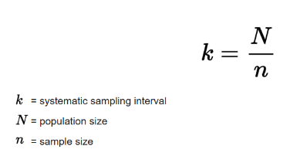
This study included teachers’ age and, while the gender and total years of working experience were collected in the PISA study, they were not used in this. The ages however had a range of 41, with the lowest age being 21. The mean age was 40.1 with a relatively close median of 39. The modal age was 23 however this is visualised well with the histogram in the appendices and this higher frequency of the lowest age banding contributes disproportionately to the distribution of ages meeting the criteria for a normal population. This data is therefore nonparametric. This is not of concern and just highlights higher proportions of younger teachers completing the questionnaire. There is a possibility that this is due to a non-sampling error, in that perhaps the teachers that completed the questionnaire self-elected within the schools that had opted in and possibly that younger teachers are more likely to complete questionnaires.

To demonstrate a level of reflexivity, there is a need to acknowledge the potential for bias with the researcher being an insider to the sector and having also conducted prior research in this area (Bryman, 2016). However, the scientific nature of the quantitative methodology employed #in many ways mitigates against bias as the ‘suredness’ of the significance testing limits interpretations of the data to that which is displayed by the data. The clear benefits to insider research is that the researcher has a good level of insight and this can contextualise the findings and discussion of the data analysis well (Bryman, 2016). There does, however, remain the question as to whether an outsider, with a more objective viewpoint, arrive at the same points of discussion?

Results
Descriptive statistics
Table IV: Descriptive statistics of measures for variables
 | Mean | Median | Mode | Range
Freq collaborating | 2.8 | 3 | 2 | 10
Hours collaborating | 3.0 | 3 | 3 | 8
Satisfaction | 3.8 | 4.1 | 4.1 | 4
Age | 40.1 | 39 | 23 | 44

Looking to the descriptive statistics above, without selecting any variables, there is little to be learned from the mean and the median for the frequency of facilitated collaboration, hours spent collaborating in the past week and satisfaction in role as they all tend towards the central value of the Likert scale that responses were given in. The mode and range give rise to some more interesting interpretations as we can see that:
- The mode for the frequency of facilitated collaboration is 2 which represents 2-4 times per year. If the British school year of 39 weeks per academic year is considered and, within that, six dedicated in school education and training days where opportunities are not being made available.
- The range for the frequency of facilitated collaboration is 10 which is quite large and means that there is quite a diverse range of responses here which could be interesting to further explore.
- The mode for the number of hours spent collaborating in the last week is 3 which is of interest as teaching contracted hours are 32.5 per week and this would suggest around 10% of this time is spent in this way. This assumes that teachers are not working outside contracted hours which is not always true. Again the range for this is quite large at 8 and again this could be interesting to explore further.
- The three measures of average (mean, median and mode) are relatively consistent for the satisfaction rating however the range between 4 on a 5 point scale does suggest a wide set of responses.

Statistical significance testing
Does the frequency of facilitated collaboration impact on job satisfaction?

Null hypothesis
There is no relationship between job satisfaction and frequency of collaboration.

Alternative hypothesis
There is a significant difference in job satisfaction with those that have a greater frequency of facilitated collaboration with colleagues.

Looking to descriptive statistics, it can be seen that generally the mean satisfaction ratings show a level of increase as the frequency of collaboration increases.

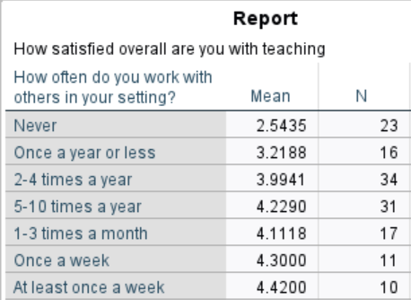

As the data suggests that it does not follow a normal distribution a non-parametric test, the Kruskal Wallis, has been used to determine if there is a statistically significant association between the variables.

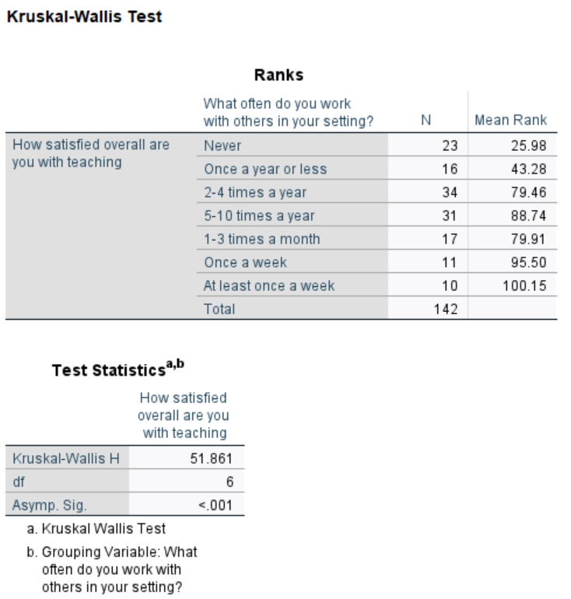

The means of the different groups indicate that generally those that have facilitated collaboration activities more frequently tend to have higher satisfaction scores. Looking to the Kruskal Wallis H value of 51.861, p<0.001, there is a statistically significant difference between the groups and therefore the null hypothesis can be rejected. This lends support to the statement that those that take part in facilitated collaborative activities more frequently tend to be more satisfied than those that take part less frequently.

Does the amount of time spent engaging in collaborative activities impact on job satisfaction?

Null hypothesis
There is no relationship between job satisfaction and hours spent collaborating with colleagues in the past week.

Alternative hypothesis
There is a positive correlation between job satisfaction and hours spent collaborating with colleagues in the past week.

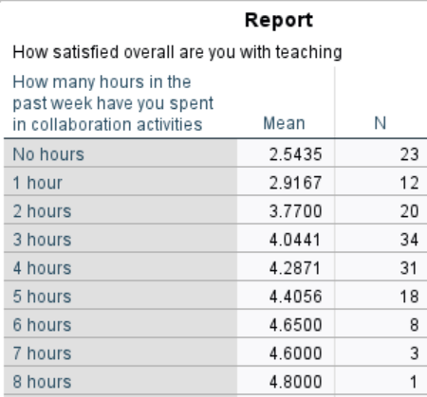

Considering the means of job satisfaction by hours spent collaborating with others in the past week shows that generally the mean satisfaction is higher for participants in the groups that have spent more time collaborating in the past week.
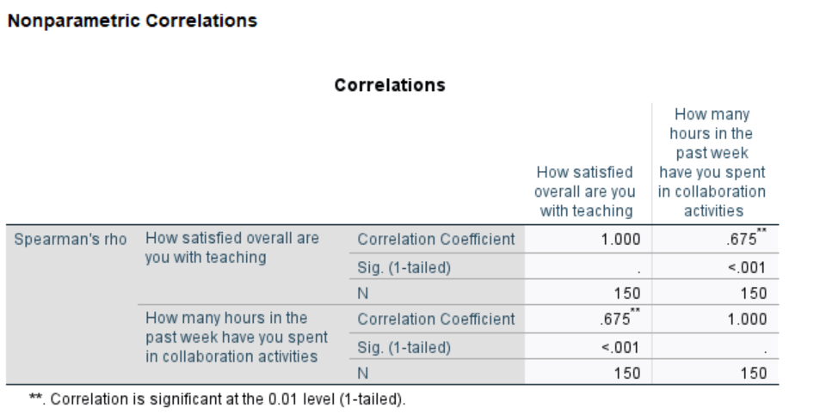
Spearman’s Rho shows a correlation coefficient of 0.675 which is broadly regarded as a strong positive correlation between the two variables. The null hypothesis can therefore be rejected as this demonstrates clearly that as time spent in collaboration activities increases so does satisfaction in role.

Does perceived positive impact on practice from professional learning impact on job satisfaction?

Null hypothesis
There is no significant difference between the satisfaction levels of those who consider that there has been a positive impact on their practice from their professional learning in the past twelve months and those that do not consider that there has been a positive impact.

Alternative hypothesis
There is a significant difference between the satisfaction levels of those that consider a positive impact on practice from professional learning and those that do not; those that are do not will have lower satisfaction levels.

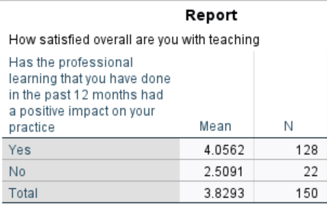

This shows that those that consider that the professional learning has had an impact on their practice have a higher mean than those that do not.

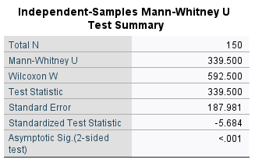

As the distribution for satisfaction as a variable indicates that it is not normally distributed, the data should therefore be treated as non-parametric and, given the ordinal nature of the grouping category, a Mann Whitney test was used. From this it can be concluded that there is a statistically significant difference between the two groups and the null hypothesis rejected (U = 339.5, p < -0.001 and Z value –5.684). Considering the means of the two groups from descriptive statistics, the mean of the group who perceived that professional learning had a positive impact on their practice were significantly more satisfied in their role than those that did not perceive that professional learning had an impact on their professional practice.

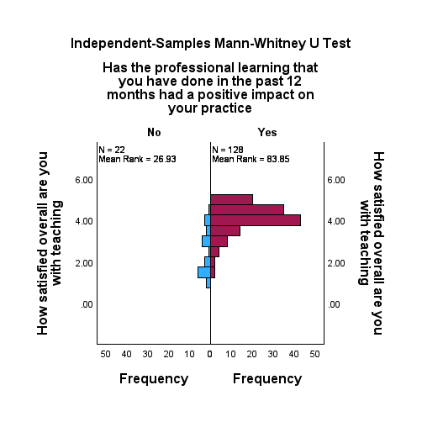

Does job satisfaction impact on consideration of leaving the profession in the next five years?

Null hypothesis
There is no significant difference between the satisfaction levels of those considering leaving teaching in the next five years and those who are not.

Alternative hypothesis
There is a significant difference between the satisfaction levels of those considering leaving teaching in the next five years and those who are not; those that are considering leaving will have lowersatisfaction levels.

It can be seen that those that have not considered leaving teaching in the next five years have a higher mean satisfaction rating than those that have considered leaving.



From the data and the descriptive statistics available in the appendices, there is a suggestion that there is a level of difference between the two different groups (those considering leaving teaching in the next five years and those who are not).

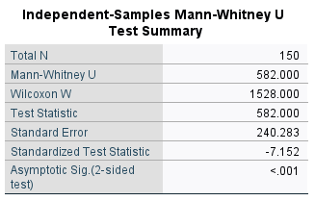

As the distribution for satisfaction as a variable indicates that it is not normally distributed, the data should therefore be treated as non-parametric and, given the nominal nature of the grouping category, a Mann Whitney test was used. From this it can be concluded that there is a statistically significant difference between the two groups and the null hypothesis rejected (U = 582, p < -0.001 and Z value –7.152). Considering the means of the two groups from descriptive statistics, the mean of the group who have considered leaving teaching in the next five years have statistically significantly lower job satisfaction levels than those that have not considered leaving the profession.

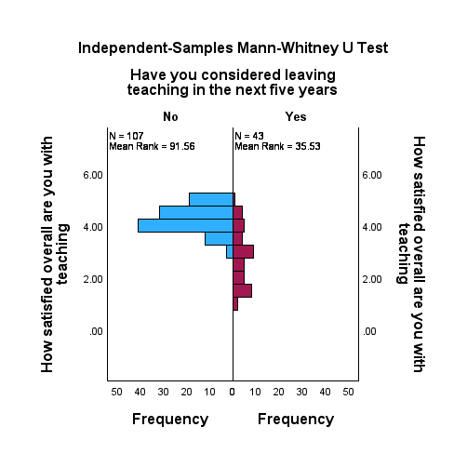

Does the amount of time spent collaborating and the frequency of facilitated collaboration have a relationship with consideration of leaving the profession in the next five years?

Exploring further whether there is a relationship between the amount of time spent in collaborative activities with colleagues and considering leaving the profession, it can be seen from descriptive statistics that there is a difference in the means between the considering and not considering leaving teaching in the next five years groups. The data here presents as parametric and therefore a one tailed independent t test was conducted to ascertain whether the difference in the means between the two groups was statistically significant or not. The hypotheses are as follows:

Null hypotheses
There is no significant difference in the amount of time spent collaborating with colleagues between the two groups of teachers (those considering leaving teaching in the next five years and those not considering leaving teaching in the next five years).

There is no significant different in the frequency of facilitated collaboration with colleagues between the two groups of teachers (those considering leaving teaching in the next five years and those not considering leaving teaching in the next five years).

Alternative hypotheses
There is a significant difference in the amount of time spent collaborating with colleagues between the two groups of teachers (those considering leaving teaching in the next five years and those not considering leaving teaching in the next five years); those that are not considering leaving will spend significantly more time collaborating with colleagues than those that are considering leaving.

There is a significant difference in the frequency of facilitated collaboration with colleagues between the two groups of teachers (those considering leaving teaching in the next five years and those not considering leaving teaching in the next five years); those that are not considering leaving will spend significantly more time collaborating with colleagues than those that are considering leaving.

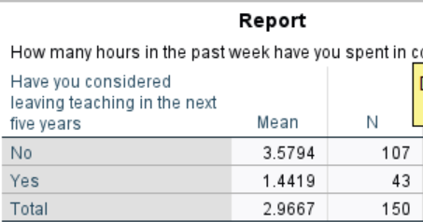

Those that have not considered leaving in the next five years have a higher mean number of hours spent collaborating with colleagues in the past week that those that have considered leaving.

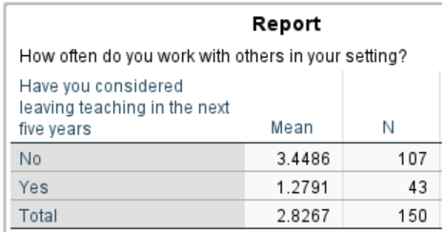

Similarly, there is a higher mean frequency of collaboration for those that have not considered leaving teaching in the next five years than those that have considered leaving.
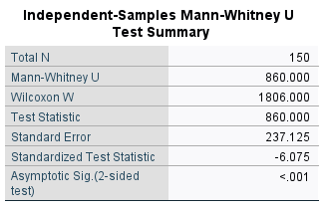

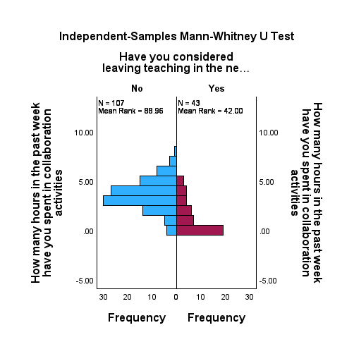
Again, a statistically significant difference between the two groups can be seen and the null hypothesis rejected (U = 860, p < -0.001 and Z value –6.075). Considering the means of the two groups from descriptive statistics, the mean of the group who have considered leaving teaching in the next five years have spent a statistically significantly smaller amount of time collaborating with colleagues than those that have not considered leaving the profession. The mean time spent collaborating with colleagues was 2.10604 hours per week higher for those not considering leaving teaching in the next five years (95%).

Frequency of facilitated collaboration and consideration of leaving the profession in the next five years

Null hypothesis
There will be no relationship between the frequency of facilitated collaboration and consideration of leaving teaching in the next five years.

Alternative hypothesis
There will be a significant association between the frequency of facilitated collaboration and consideration of leaving teaching in the next five years. Those that participate more frequently will be less likely to have considered leaving teaching.

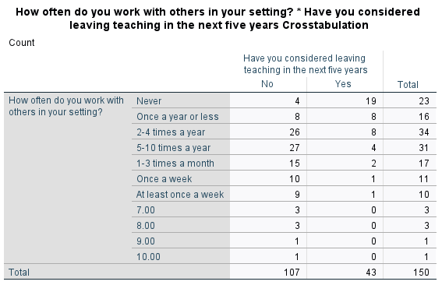

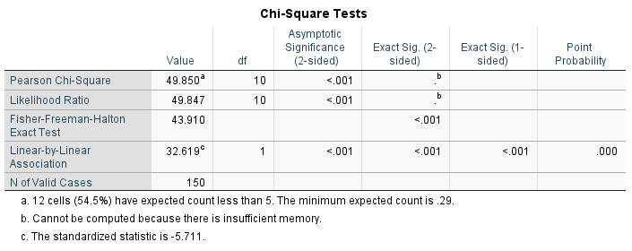

As the distributions when examined as histograms do not present as normal, non-parametric testing needs to be used. With two nominal variables, the Chi Square test would ordinarily be used, however, as over 20% of the cells have a count of less than 5, the Fisher test needed to be used which gives a value of 43.910. The p value here is <0.01 which is less than 0.05 and therefore the null hypothesis can be rejected. This outcome suggests that there is a significant association between the consideration of leaving teaching in the next five years and the frequency with which they engage in facilitated collaboration with those that engage in facilitated collaboration less frequently being more likely to have considered leaving the profession in the next five years.

Does the level of teachers’ qualifications impact on the extent to which teachers engage in collaboration?

Null hypothesis
There is no significant difference between those that have Bachelor’s degrees, Master’s degrees and doctorates and the extent to which they engage in collaboration.

Alternative hypothesis
There will be a significant difference between those that have Bachelor’s degrees, Master’s degrees and doctorates and the extent to which they engage in collaboration; those with higher level qualifications will undertake more collaboration.



There is a different between those with first degrees and those with Master’s and postdoctoral degrees however the differences seem quite small and it should also be noted that there are very few with higher level qualifications, particularly at postdoctoral level.

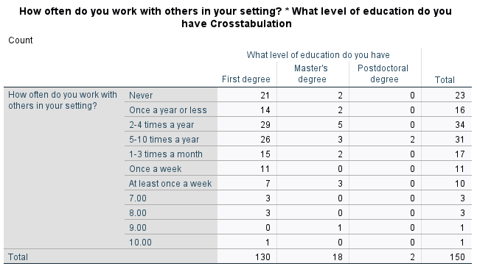

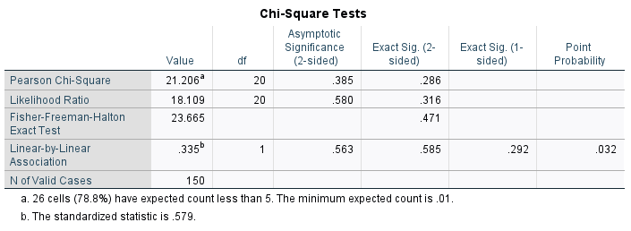
As the distributions when examined as histograms do not present as normal, non-parametric testing needs to be used. With two nominal variables, the Chi Square test would ordinarily be used however as over 20% of the cells have a count of less than 5, the Fisher test needed to be used which gives a value of 23.665. The p value here is 0.471 which is greater than 0.05 and therefore the null hypothesis must be accepted. This outcome suggests that there is not a significant association between the level of education that teachers have and the frequency with which they engage in facilitated collaboration. Level of education has no impact on the frequency of collaboration.

Does the perception of there having been a positive impact on professional practice in the past twelve months have a relationship with consideration of leaving teaching?

Null hypothesis
There is no significant difference between those that consider that there has been a positive impact on professional practice in the past twelve months and those that do not in terms of whether they have considered leaving teaching in the next five years or not.

Alternative hypothesis
There is a significant difference between those that consider that there has been a positive impact on professional practice in the past twelve months and those that do not in terms of whether they have considered leaving teaching in the next five years or not; those that do not consider there has been a positive impact will be more likely to have considered leaving teaching.

A Chi square test was used to consider whether there was a statistical significance in the four groups created from two variable: whether the professional learning that has been done in the past twelve months has impacted positively on practice and whether participants had considered leaving teaching within the next five years or not.

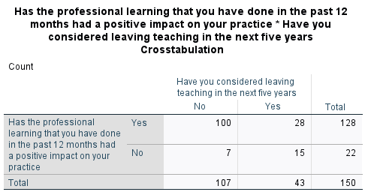

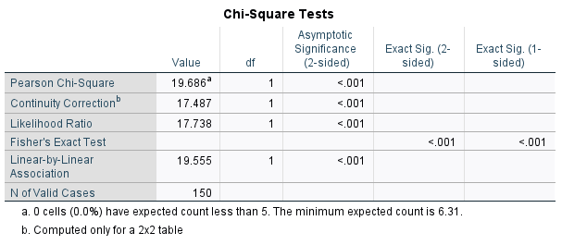
Chi square here has a value of 19.686, p <0.001 therefore the null hypothesis can be rejected and this demonstrates a statistical association between the perception that professional practice has positively been impacted in the past 12 months and consideration of leaving teaching in the next five years. Looking to the crosstabs output:

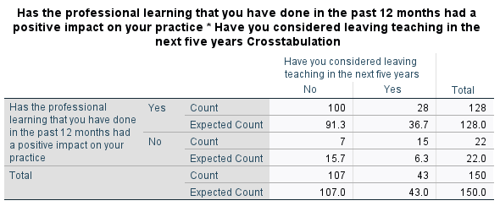
Divergence between count and expected count can be seen. There are more than the expected participants that have considered leaving the profession in the next five years stating that there has not been a positive impact on professional practice in the past twelve months and similarly a disproportionately high number of people who deem that there has been a positive impact on their professional practice who are not considering leaving the profession. The further two comparisons of count and expected counts also add support for the alternative hypothesis; that those who perceive that there has been a positive impact on their professional practice are less likely to be considering leaving teaching.

Discussion
The findings of this piece of research confirm previous findings that there are significant relationships between job the frequency and quantity of collaboration, job satisfaction, self-perception of professional improvement as well as consideration of leaving teaching. Findings identified by other researchers internationally are also evident in the United Kingdom. This research does add to findings as the relationship between collaboration and job satisfaction and consideration of leaving the profession have been found to be direct, rather than mediated by teacher self-efficacy and job performance.

In summary, it can be seen that:
- Job satisfaction for those not considering leaving teaching is significantly higher than for those that have considered leaving.
- Those that perceive that there has been a positive impact on professional practice in the past twelve months are significantly more satisfied than those that did not; they are also significantly less likely to be considering leaving teaching.
- Those that collaborate more frequently have higher job satisfaction and are significantly less likely to be considering leaving the profession.
- Those that spent more time collaborating have greater job satisfaction and are significantly less likely to be considering leaving teaching.
- Level of education has no impact on the frequency of engagement in collaboration.

There are biases present in this piece of research, as there are with all pieces of ‘insider research’ and it is important to note this to demonstrate reflexivity. While all research can be critiqued and more significant attention drawn to the criticisms, there is also a need to acknowledge that the lens given by an insider to the sector can potentially more accurately target the potential use of the findings in applying them to known contexts and situations.

This piece of research also gives rise to recommendations for future research. Collaboration is a very broad term and, as discussed in the literature review, collaboration across the United Kingdom bears similarities but there are also very notable differences, particularly between England and Wales. It is feasible that English teachers have included academy structures in their responses and Welsh teachers have not. Therefore, the first recommendation resulting from this piece of research is that research looks to disaggregate these two in order to generate findings that are specific to Wales to inform evaluation and learning in this area.

The second recommendation is that the impact of different types of collaborative activities that are prevalent in the Welsh education system on job satisfaction, perception of improvement on professional practice and consideration of leaving teaching should be researched. It is possible that some of the variation in responses is accounted for by variance in type of collaboration activity and also both perceptions and misperceptions of what constitutes collaboration. This is particularly relevant and important in the light of very hard headlines about the quantity of teachers leaving teaching for reasons other than retirement in Wales and difficulties to recruit and retain (Welsh Government, 2023; Hutchinson et al, 2024).

The third recommendation for further research is to delve to a greater level of granularity in the research to ask questions such as “at what stage in teaching does collaboration have the most impact”? Is collaboration held in higher regard by those that have worked in this way since the outset of their career in comparison to those that have experienced different types and formats of professional learning? Does collaboration have more impact than other forms of professional learning and development, for example, coaching?

The cost incurred by collaboration and collaborative activity is significant and it is important, within the context of Welsh education and Welsh educational budgets, that there is empirical evidence to support its continued and progressive use as a means of developing education staff. This fully justifies and generates the need for continued research in this area.

References

Ainscow, M., Chapman, C. & Hadfield, M. (2019). Changing Education Systems: A Research-based Approach. Routledge.

Bryman, A. (2016). Social research methods (5th ed.). Oxford University Press.

Cordingley, P. (2015). The contribution of research to teachers' professional learning and development. Oxford Review of Education, 41(2), 234–252. 10.1080/03054985.2015.1020105

Davies, A., Milton, E., Connolly, M. & Barrance, R. (2018). Headteacher recruitment, retention and professional development in Wales: challenges and opportunities. Cylchgrawn Addysg Cymru / Wales Journal of Education 20 (2) , pp. 204-224. 10.16922/wje.20.2.11

Department for Education. (2010). The importance of teaching: The School’s White Paper 2010. London: DFE.

Dixon, P. (2016). Testing times : success, failure and fiasco in education policy in Wales since devolution. Welsh Academic Press.

Durksen, T. L., Klassen, R. M., & Daniels, L. M. (2017). Motivation and collaboration: The keys to a developmental framework for teachers’ professional learning. Teaching and Teacher Education, 67, 53–66. 10.1016/j.tate.2017.05.011

Edinger, S. K., & Edinger, M. J. (2018). Improving Teacher Job Satisfaction: The Roles of Social Capital, Teacher Efficacy, and Support. The Journal of Psychology, 152(8), 573–593. 10.1080/00223980.2018.1489364

ESTYN. (2024). HMCI Annual Report 2022-2023. [PDF file]. Retrieved from https://annual-report.estyn.gov.wales/app/uploads/2024/01/Estyn-Annual-Report-2022.23.pdf

Evans, G. (2021). Back to the future? Reflections on three phases of education policy reform in Wales and their implications for teachers. Journal of Educational Change, 12(3), 456-468.

Evans, G., Llewellyn, S., & Lewabe, J. (2022). Towards a research-engaged teaching profession: insider reflections on a collaborative approach to developing teachers in Wales as professional enquirers. Practice (Abingdon, England), 4(3), 171–190. 10.1080/25783858.2022.2109987

Furlong, J., Griffiths, J., Hannigan-Davies, C., Harris, A., & Jones, M. (2021). The reform of initial teacher education in Wales: from vision to reality. Oxford Review of Education, 47(1), 61–78. 10.1080/03054985.2020.1842180

García Torres, D. (2019). Distributed leadership, professional collaboration, and teachers’ job satisfaction in U.S. schools. Teaching and Teacher Education, 79, 111–123. 10.1016/j.tate.2018.12.001

Gorard, S. (2012). The Increasing Availability of Official Datasets: Methods, Limitations and Opportunities for Studies of Education. British Journal of Educational Studies, 60(1), 77–92. 10.1080/00071005.2011.650946

Hargreaves, D. H. (2011). Leading a self-improving school system. [PDF] [Link: National College for Teaching and Leadership https://assets.publishing.service.gov.uk/media/5a7d98afe5274a676d533001/leading-a-self-improving-school-system.pdf].

Hargreaves, A. (2019). Teacher collaboration: 30 years of research on its nature, forms, limitations and effects. Teachers and Teaching, Theory and Practice, 25(5), 603–621. 10.1080/13540602.2019.1639499

Hargreaves, A., & Goodson, I. (2006). Educational Change Over Time? The Sustainability and Nonsustainability of Three Decades of Secondary School Change and Continuity. Educational Administration Quarterly, 42(1), 3–41. 10.1177/0013161X05277975

Harris, A., Elder, Z., Jones, M. S., & Cooze, A. (2022). Schools as Learning Organisations in Wales: A Critical Exploration of the International Evidence Base. Cylchgrawn Addysg Cymru / Wales Journal of Education, 24(1)10.16922/wje.24.1.3

Harris, A., & Jones, M. S. (2017a). Disciplined collaboration and inquiry: evaluating the impact of professional learning. Journal of Professional Capital and Community, 2(4), 200–214. 10.1108/JPCC-05-2017-0011

Harris, A., & Jones, M. S. (2017b). Professional Learning Communities: A Strategy for School and System Improvement? Cylchgrawn Addysg Cymru / Wales Journal of Education, 19(1), 16–38. 10.16922/wje.19.1.2

Hattie, J.A.C. (2003, October). Teachers make a difference: What is the research evidence? Paper presented at the Building Teacher Quality: What does the research tell us ACER Research Conference, Melbourne, Australia. Retrieved from http://research.acer.edu.au/research_conference_2003/4/

Hopkins, D. (2016). School and System Reform – An Agenda for Wales. Cylchgrawn Addysg Cymru / Wales Journal of Education, 18(1)10.16922/wje.18.1.7

Hudson, B., Hunter, D., & Peckham, S. (2019). Policy failure and the policy-implementation gap: can policy support programs help? Policy Design and Practice, 2(1), 1–14. 10.1080/25741292.2018.1540378

Hutchinson, J., Kelly, K., Sibieta, L. & Zuccollo, J. (2024). Incentives to recruit and retain
teachers in Wales. London: Education Policy Institute.

Ickovics, J. R., Lewis, J. B., Cunningham, S. D., Thomas, J., Magriples, U., Kazak, A. E., Vu, K. L., Proctor, R. W., & Klonoff, E. A. (2019). Transforming Prenatal Care: Multidisciplinary Team Science Improves a Broad Range of Maternal-Child Outcomes. The American Psychologist, 74(3), 343–355. 10.1037/amp0000435

Kools, M., George, B., & Steijn, B. (2020). Developing schools as learning organisations—“Why” and “how”? European Journal of Education, 55(1), 3–8. 10.1111/ejed.12384

Kools, M., & Stoll, L. (2016). What Makes a School a Learning Organisation? OECD Education Working Papers, No. 137. OECD Education Working Papers, 10.1787/5jlwm62b3bvh-en

Liu, Z., Cai, Y., & Zhang, Z. (2024). The moderating role of teacher collaboration in the association between job satisfaction and job performance. Asia Pacific Education Review, 10.1007/s12564-024-10027-w

Moè, A., & Katz, I. (2022). Need satisfied teachers adopt a motivating style: The mediation of teacher enthusiasm. Learning and Individual Differences, 99, 102203. 10.1016/j.lindif.2022.102203

OECD (2023a), PISA 2022 Assessment and Analytical Framework, PISA, OECD Publishing, Paris, https://doi.org/10.1787/dfe0bf9c-en.

OECD, 2023. PISA 2022 Results: The State of Learning and Equity in Education. https://www.oecdilibrary.org/sites/53f23881-en/index.html?itemId=/content/publication/53f23881-en.

OECD (2024), PISA 2022 Technical Report, PISA, OECD Publishing, Paris, https://doi.org/10.1787/01820d6d-en.
Plauborg, H. (2018). Towards an agential realist concept of learning. Subjectivity, 11(4), 322–338. 10.1057/s41286-018-0059-9

Reeves, S., Pelone, F., Harrison, R., Goldman, J., Zwarenstein, M., & Zwarenstein, M. (2017). Interprofessional collaboration to improve professional practice and healthcare outcomes. Cochrane Database of Systematic Reviews, 2018(8), CD000072. 10.1002/14651858.CD000072.pub3

School Teachers' Conditions of Service (England and Wales) (Burgundy Book), 2023.

Sibieta, L. (2024). Major challenges for education in Wales. London: The Institute for Fiscal Studies.

Skaalvik, E. M., & Skaalvik, S. (2010). Teacher self-efficacy and teacher burnout: A study of relations. Teaching and Teacher Education, 26(4), 1059–1069. 10.1016/j.tate.2009.11.001

Stoll, L., & Kools, M. (2017). The school as a learning organisation: a review revisiting and extending a timely concept. Journal of Professional Capital and Community, 2(1), 2–17. 10.1108/JPCC-09-2016-0022
Tatar, M., & Horenczyk, G. (2003). Diversity-related burnout among teachers. Teaching and Teacher Education, 19(4), 397–408. 10.1016/S0742-051X(03)00024-6

Troisi, O., & Grimaldi, M. (2022). Confirmatory research. In The SAGE encyclopedia of research design (2 ed., Vol. 4, pp. 264-265). SAGE Publications, Inc., https://doi.org/10.4135/9781071812082.n105

Welsh Government. (2019). Professional standards for teaching and leadership. Cardiff: Crown. https://hwb.gov.wales/api/storage/19bc948b-8a3f-41e0-944a-7bf2cadf7d18/professional-standards-for-teaching-and-leadership-interactive-pdf-for-pc.pdf

Welsh Government. (2023). Review of roles and responsibilities of education partners in Wales and delivery of school improvement arrangements: terms of reference. Cardiff: Crown. https://www.gov.wales/sites/default/files/pdf-versions/2024/5/3/1716367408/terms-reference-review-roles-and-responsibilities-education-partners-wales-and-delivery-school.pdf

Yoo, H., & Jang, J. (2023). Effects of professional learning communities on teacher collaboration, feedback provision, job satisfaction and self-efficacy: Evidence from Korean PISA 2018 data. Compare, 53(8), 1355–1372. 10.1080/03057925.2022.2036591

Bibliography

Hargreaves, A., & O’Connor, M. T. (2018). Solidarity with solidity: The case for collaborative professionalism. Phi Delta Kappan, 100(1), 20–24. 10.1177/0031721718797116

Hargreaves, A., & O'Connor, M. T. (. T. (2018). Collaborative professionalism : when teaching together means learning for all. Corwin, a SAGE Company.

Hattie, J., & Taylor & Francis. (2023). Visible learning, the sequel : a synthesis of over 2,100 meta-analyses relating to achievement. Routledge. 10.4324/9781003380542

Appendices
Appendix I: Teacher questionnaire
Appendix II: Descriptive statistics
Appendix III: Determining which statistical test
Appendix IV: Raw data

Appendix I: Teacher questionnaire

https://www.oecd.org/content/dam/oecd/en/data/datasets/pisa/pisa-2022-datasets/questionnaires/TEACHER%20QUESTIONNAIRE%20PISA%202022.pdf

Some extracts/examples of the questions used:

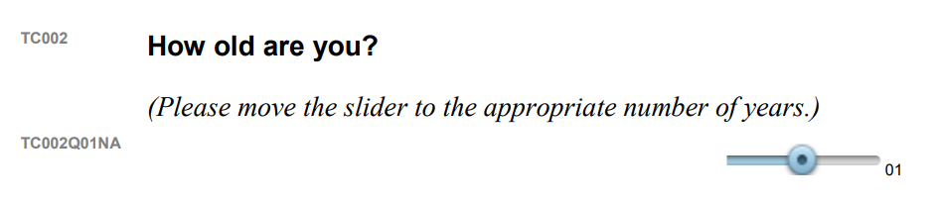

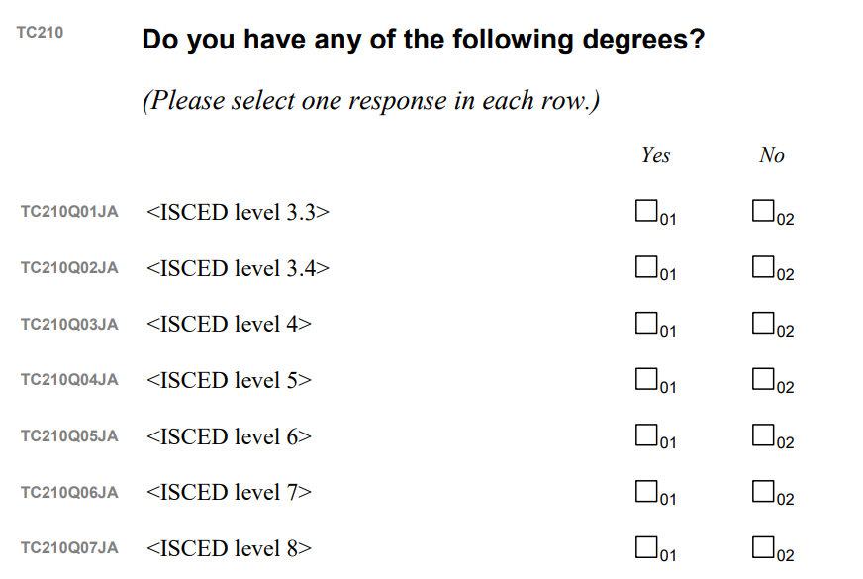

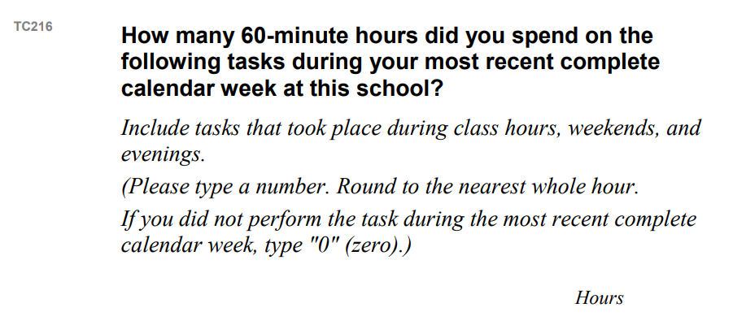

Appendix II: Descriptive statistics

 | Mean | Median | Mode | Range
Freq collaborating | 2.82781457 | 3 | 2 | 10
Hours collaborating | 2.993377483 | 3 | 3 | 8
Satisfaction | 3.837086093 | 4.1 | 4.1 | 4
Age | 40.10596026 | 39 | 23 | 44

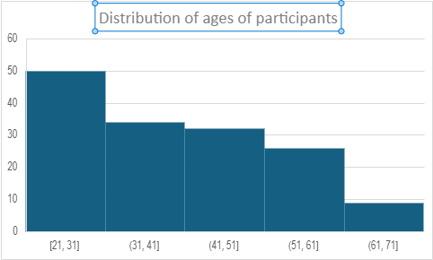

Does not follow normal distribution – use non-parametric testing

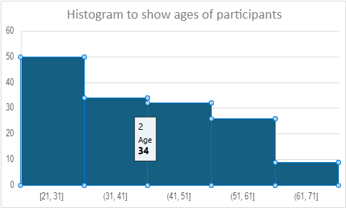

Does not follow normal distribution – use non-parametric testing

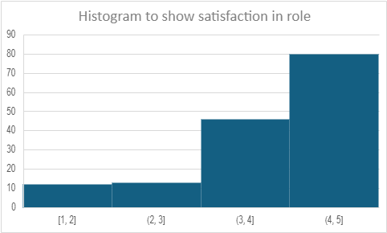

Does not follow normal distribution – use non-parametric testing

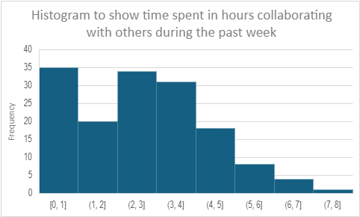

Does not follow normal distribution – use non-parametric testing

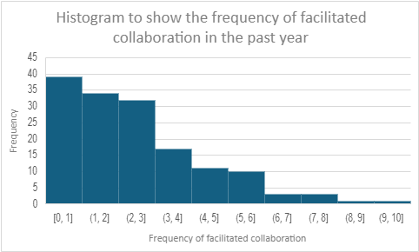

Does not follow normal distribution – use non-parametric testing

Appendix III: Determining which statistical test

Alternative hypothesis | Variable one and type of data | Variable two and type of data | Parametric/non-parametric | Other notes | Test to use
There is a significant difference in job satisfaction with those that have a greater frequency of facilitated collaboration with colleagues. | Job satisfaction | Facilitated collaboration with colleagues | Non-parametric | Less than 5 in some groups | Kruskal Wallis
There is a positive correlation between job satisfaction and hours spent collaborating with colleagues in the past week. | Job satisfaction | Hours spent collaborating in the last week | Non-parametric |  | Spearman’s rho
There is a significant difference between the satisfaction levels of those considering leaving teaching in the next give years and those who are not; those that are considering leaving will have lower satifaction levels. | Satisfaction level | Consideration leaving teaching in the next five years | Non-parametric |  | Mann-Whitney U
There is a significant difference in the amount of time spent collaborating with colleagues between the two groups of teachers (those considering leaving teaching in the next five years and those not considering leaving teaching in the next five years); those that are not considering leaving will spend significantly more time collaborating with colleagues than those that are considering leaving. | Time spent collaborating with colleagues in the past weeks | Consideration leaving teaching in the next five years | Non-parametric |  | Mann-Whitney U
There will be a significant association between the frequency of facilitated collaboration and consideration of leaving teaching in the next five years. Those that participate more frequently will be less likely to have considered leaving teaching. | Frequency of facilitated collaboration | Consideration of leaving teaching in the next give years | Non-parametric |  | Chi square
There will be a significant difference between those that have Bachelor’s degrees, Master’s degrees and doctorates and the extent to which they engage in collaboration; those with higher level qualifications will undertake more collaboration. | Level of education | Hours spent collaborating in the last week | Non-parametric |  | Chi square
There will be a significant difference between the level of positive perception of professional development between those considering leaving the profession in the next five years and those that are not considering leaving the profession in the next five years | Positive perception of professional development | Consideration of leaving teaching in the next five years | Non-parametric |  | Chi square

Appendix IV: Raw data

Column A Country
Column B Considering leaving the profession
Column C Level of education
Column D Satisfaction
Column E Hours spent collaborating in past week
Column F
Column G Perception of professional improvement

GBR 2.00 6.0 51.00 1.00 .00 2.00 .00
GBR 2.00 7.0 32.00 1.10 .00 2.00 .00
GBR 2.00 6.0 52.00 1.30 3.00 1.00 2.00
GBR 2.00 6.0 40.00 1.30 1.00 2.00 1.00
GBR 2.00 6.0 61.00 1.30 1.00 2.00 2.00
GBR 2.00 6.0 54.00 1.60 .00 2.00 .00
GBR 2.00 6.0 36.00 1.60 .00 1.00 .00
GBR 2.00 6.0 39.00 1.70 .00 2.00 .00
GBR 2.00 6.0 22.00 1.70 .00 2.00 .00
GBR 2.00 6.0 54.00 1.70 .00 2.00 .00
GBR 2.00 6.0 53.00 1.80 2.00 2.00 1.00
GBR 2.00 6.0 40.00 2.00 .00 1.00 .00
GBR 2.00 6.0 52.00 2.10 .00 2.00 .00
GBR 2.00 6.0 33.00 2.10 .00 2.00 .00
GBR 2.00 7.0 31.00 2.10 1.00 1.00 1.00
GBR 2.00 6.0 56.00 2.30 .00 2.00 .00
GBR 2.00 6.0 23.00 2.30 1.00 1.00 1.00
GBR 2.00 6.0 42.00 2.30 .00 1.00 .00
GBR 2.00 6.0 64.00 2.70 1.00 1.00 2.00
GBR 2.00 6.0 23.00 2.70 .00 1.00 .00
GBR 2.00 6.0 55.00 2.80 .00 2.00 .00
GBR 2.00 6.0 31.00 2.90 1.00 1.00 1.00
GBR 2.00 6.0 63.00 3.00 4.00 1.00 3.00
GBR 1.00 6.0 44.00 3.00 2.00 2.00 1.00
GBR 1.00 6.0 60.00 3.00 .00 1.00 .00
GBR 2.00 6.0 49.00 3.10 1.00 1.00 1.00
GBR 2.00 6.0 42.00 3.10 .00 1.00 .00
GBR 2.00 7.0 35.00 3.10 .00 1.00 .00
GBR 2.00 6.0 23.00 3.20 .00 2.00 .00
GBR 2.00 6.0 40.00 3.20 .00 2.00 .00
GBR 1.00 6.0 22.00 3.20 3.00 1.00 3.00
GBR 2.00 6.0 39.00 3.20 2.00 1.00 2.00
GBR 1.00 6.0 47.00 3.30 2.00 1.00 4.00
GBR 1.00 6.0 54.00 3.30 1.00 2.00 1.00
GBR 2.00 6.0 38.00 3.40 2.00 1.00 3.00
GBR 1.00 6.0 44.00 3.50 3.00 1.00 3.00
GBR 1.00 7.0 31.00 3.60 4.00 1.00 4.00
GBR 1.00 6.0 51.00 3.60 5.00 1.00 3.00
GBR 2.00 6.0 61.00 3.70 3.00 1.00 4.00
GBR 2.00 6.0 61.00 3.70 2.00 1.00 2.00
GBR 1.00 6.0 52.00 3.70 .00 2.00 .00
GBR 1.00 6.0 53.00 3.70 2.00 1.00 2.00
GBR 1.00 7.0 26.00 3.70 5.00 1.00 6.00
GBR 1.00 6.0 56.00 3.70 3.00 1.00 2.00
GBR 1.00 6.0 38.00 3.70 5.00 1.00 5.00
GBR 1.00 6.0 24.00 3.70 3.00 1.00 2.00
GBR 1.00 6.0 48.00 3.70 3.00 1.00 4.00
GBR 2.00 6.0 63.00 3.70 2.00 1.00 2.00
GBR 1.00 7.0 26.00 3.80 4.00 1.00 3.00
GBR 1.00 6.0 25.00 3.80 2.00 1.00 2.00
GBR 1.00 7.0 31.00 3.80 3.00 1.00 3.00
GBR 2.00 7.0 30.00 3.80 4.00 1.00 2.00
GBR 1.00 6.0 52.00 3.80 3.00 1.00 2.00
GBR 1.00 6.0 55.00 3.80 1.00 1.00 1.00
GBR 1.00 6.0 49.00 3.80 1.00 1.00 1.00
GBR 1.00 6.0 54.00 3.80 2.00 1.00 1.00
GBR 2.00 6.0 62.00 3.80 3.00 1.00 1.00
GBR 1.00 6.0 38.00 3.80 4.00 2.00 4.00
GBR 1.00 6.0 24.00 3.90 3.00 1.00 3.00
GBR 1.00 6.0 54.00 3.90 2.00 1.00 1.00
GBR 1.00 6.0 39.00 3.90 4.00 1.00 4.00
GBR 1.00 6.0 44.00 3.90 3.00 1.00 2.00
GBR 1.00 7.0 30.00 3.90 2.00 1.00 1.00
GBR 1.00 6.0 57.00 3.90 .00 1.00 .00
GBR 1.00 6.0 35.00 3.90 3.00 1.00 2.00
GBR 1.00 7.0 30.00 3.90 2.00 1.00 4.00
GBR 1.00 6.0 25.00 4.00 3.00 1.00 4.00
GBR 1.00 6.0 43.00 4.00 4.00 1.00 3.00
GBR 2.00 6.0 64.00 4.00 5.00 1.00 3.00
GBR 1.00 6.0 46.00 4.00 4.00 2.00 3.00
GBR 1.00 6.0 37.00 4.00 2.00 1.00 5.00
GBR 1.00 6.0 60.00 4.10 3.00 1.00 4.00
GBR 1.00 6.0 49.00 4.10 4.00 1.00 8.00
GBR 1.00 6.0 37.00 4.10 5.00 1.00 3.00
GBR 1.00 6.0 42.00 4.10 3.00 1.00 6.00
GBR 1.00 6.0 22.00 4.10 2.00 1.00 3.00
GBR 1.00 6.0 38.00 4.10 4.00 1.00 3.00
GBR 1.00 6.0 43.00 4.10 3.00 1.00 3.00
GBR 1.00 6.0 33.00 4.10 4.00 1.00 2.00
GBR 1.00 6.0 38.00 4.10 3.00 1.00 2.00
GBR 1.00 6.0 21.00 4.10 3.00 1.00 2.00
GBR 1.00 6.0 52.00 4.10 4.00 1.00 2.00
GBR 1.00 6.0 50.00 4.10 4.00 1.00 6.00
GBR 1.00 6.0 46.00 4.10 5.00 2.00 6.00
GBR 1.00 6.0 50.00 4.20 6.00 1.00 4.00
GBR 1.00 6.0 53.00 4.20 3.00 1.00 5.00
GBR 1.00 6.0 45.00 4.20 .00 1.00 .00
GBR 1.00 6.0 25.00 4.20 2.00 1.00 3.00
GBR 1.00 6.0 23.00 4.20 1.00 1.00 2.00
GBR 2.00 6.0 65.00 4.20 4.00 1.00 3.00
GBR 1.00 6.0 42.00 4.20 3.00 1.00 6.00
GBR 2.00 6.0 60.00 4.20 4.00 1.00 2.00
GBR 1.00 6.0 37.00 4.20 3.00 1.00 5.00
GBR 1.00 6.0 34.00 4.20 1.00 1.00 1.00
GBR 1.00 6.0 24.00 4.30 4.00 1.00 2.00
GBR 1.00 6.0 41.00 4.30 3.00 1.00 2.00
GBR 1.00 6.0 49.00 4.30 5.00 1.00 3.00
GBR 1.00 6.0 39.00 4.30 3.00 1.00 2.00
GBR 2.00 6.0 65.00 4.30 5.00 1.00 4.00
GBR 1.00 6.0 25.00 4.30 7.00 1.00 5.00
GBR 1.00 6.0 47.00 4.30 5.00 1.00 4.00
GBR 2.00 6.0 60.00 4.30 3.00 1.00 5.00
GBR 1.00 6.0 25.00 4.30 4.00 1.00 3.00
GBR 1.00 6.0 44.00 4.30 2.00 1.00 4.00
GBR 1.00 6.0 41.00 4.40 3.00 2.00 5.00
GBR 1.00 6.0 29.00 4.40 4.00 1.00 3.00
GBR 1.00 6.0 26.00 4.40 5.00 1.00 3.00
GBR 1.00 6.0 30.00 4.40 3.00 1.00 5.00
GBR 2.00 6.0 64.00 4.40 .00 1.00 .00
GBR 1.00 6.0 44.00 4.40 4.00 1.00 7.00
GBR 1.00 7.0 32.00 4.40 6.00 1.00 9.00
GBR 1.00 6.0 35.00 4.40 3.00 1.00 5.00
GBR 1.00 6.0 28.00 4.50 2.00 1.00 4.00
GBR 1.00 6.0 23.00 4.50 4.00 1.00 2.00
GBR 2.00 6.0 65.00 4.50 2.00 1.00 1.00
GBR 1.00 6.0 23.00 4.50 4.00 1.00 2.00
GBR 1.00 6.0 39.00 4.50 5.00 1.00 10.00
GBR 1.00 6.0 23.00 4.50 4.00 1.00 8.00
GBR 1.00 6.0 24.00 4.50 3.00 1.00 5.00
GBR 1.00 6.0 26.00 4.50 7.00 1.00 7.00
GBR 1.00 7.0 28.00 4.50 6.00 1.00 6.00
GBR 1.00 6.0 42.00 4.60 6.00 1.00 3.00
GBR 1.00 6.0 25.00 4.60 4.00 1.00 4.00
GBR 1.00 6.0 28.00 4.60 6.00 1.00 3.00
GBR 1.00 7.0 35.00 4.60 3.00 1.00 2.00
GBR 1.00 7.0 43.00 4.60 4.00 1.00 2.00
GBR 1.00 6.0 37.00 4.70 3.00 1.00 2.00
GBR 1.00 6.0 53.00 4.70 4.00 1.00 2.00
GBR 1.00 6.0 34.00 4.70 2.00 1.00 4.00
GBR 1.00 6.0 24.00 4.70 3.00 1.00 2.00
GBR 1.00 7.0 28.00 4.80 4.00 1.00 2.00
GBR 1.00 6.0 49.00 4.80 5.00 1.00 3.00
GBR 1.00 8.0 30.00 4.80 5.00 1.00 3.00
GBR 1.00 6.0 38.00 4.80 8.00 1.00 8.00
GBR 2.00 6.0 47.00 4.80 5.00 1.00 6.00
GBR 1.00 7.0 27.00 4.80 4.00 1.00 6.00
GBR 1.00 6.0 25.00 4.90 3.00 1.00 5.00
GBR 1.00 6.0 41.00 4.90 4.00 1.00 7.00
GBR 1.00 6.0 25.00 4.90 5.00 1.00 6.00
GBR 1.00 6.0 23.00 4.90 4.00 1.00 2.00
GBR 1.00 6.0 29.00 4.90 6.00 1.00 3.00
GBR 1.00 7.0 33.00 4.90 4.00 1.00 2.00
GBR 1.00 6.0 41.00 5.00 6.00 1.00 6.00
GBR 1.00 6.0 27.00 5.00 4.00 1.00 3.00
GBR 1.00 6.0 21.00 5.00 5.00 1.00 3.00
GBR 1.00 8.0 28.00 5.00 5.00 1.00 3.00
GBR 1.00 6.0 30.00 5.00 3.00 1.00 4.00
GBR 1.00 7.0 47.00 5.00 6.00 1.00 3.00
GBR 1.00 6.0 24.00 5.00 5.00 1.00 2.00
GBR 1.00 6.0 50.00 5.00 7.00 1.00 3.00

