

LOCATION: Swansea | LLEOLIAD: abertawe
LEVEL 4 | LEFEL 4
EXAMINATION PERIOD | CYFNOD ARHOLIADAU
March 2020 | MAWRth 2020

MODULE CODE: M4X00385
Engineering Science 1
TIME: 2 HOURS
answer all questions

Equipment or materials required – Scientific Calculator
Adnoddau neu ddefnyddiau sydd eu hangen - Cyfrifiannell Wyddonol

REMEMBER:

Take Gravity as 9.81m/s²

Give al answers to 2.d.p unless otherwise instructed.

1.

Figure 1: Tesla Model S

A Tesla accelerates from rest up to 96.6km/h in 4s. It then acceleratees up to its top speed of 250km/h in a further 15 seconds, before coming back to rest in 350m. Draw a velocity time graph [5 marks] and calculate:
- the total time taken for the movement and [8 marks]
- the total distance travelled in km. [9 marks]

2.
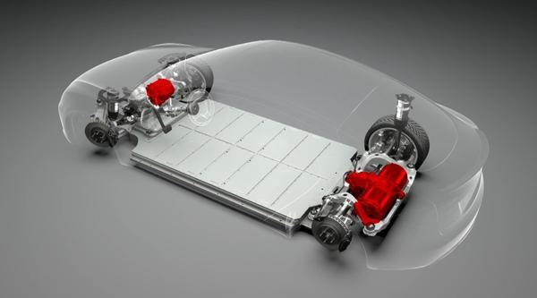
Figure 2: Tesla electric motors

The motors in the Tesla can generate a peak torque of 601Nm. Given that the motor is made up of a single spinning homogenous rotor of diameter 310mm that can spin up to 18000rpm in 1.5 seconds, calculate the mass and kinetic energy (in kJ) of the rotor. [18 marks]

$k^{2}=\frac{d^{2}}{8}$ $I=mk^{2}$ $T=Iα$

3.


Figure 3: Ski lift

A ski lift similar to that in figure 3 pulls skiers up a slope inclined at 45 degrees at a velocity of 3m/s. There is a constant frictional resistance to motion 65N per skier. Given that there can be up to 20 skiers on the lift at any one time and that the power of the lift is 51kW, construct a forces diagram [3 marks] and calculate the maximum allowable mass of one skier.
[12 marks]

$P=F.v$

4.
A heat recovery system consists of a compressor which compresses gas of temperature 25 ºC to a pressure of 6 bar and a new temperature of 48 ºC. Given it compresses the gas to one 6th of the original volume, calculate the original pressure in bar. (1bar = 10⁵Pa). [10 marks]
Given that the final volume is 0.026m³, and the diameter of the compressor is 400mm, calculate the stroke of the compressor. [9 marks]

5.
A concrete delivery system at a building site, delivers concrete of density 2400kg/m^{3.} The concrete is delivered from a storage container, through a horizontal pump. It enters the pump through a diameter of 250mm and exits through a nozzle with a 180mm diameter. Calculate the velocity of the concrete at the entrance to the pump and nozzle and the flow rate given the pressure difference across the pump is 5kPa. [19 marks]

$d_{1}^{2}v_{1}=d_{2}^{2}v_{2}$ $gh_{1}+\frac{p_{1}}{ρ}+\frac{v_{1}^{2}}{2}=gh_{2}+\frac{p_{2}}{ρ}+\frac{v_{2}^{2}}{2}$

6.
A concrete cooling tower or chimney in a factory works through both conduction and convection. The cooling tower can be modelled as a hollow cylinder with a diameter of 5m and a height of 8m. The thermal conductivity of the concrete is 1.7W/mK and the convective heat transfer coefficient is 12W/m²K. Calculate the heat transfer in kW from the 200mm thick tower, given the internal and external temperatures are 68ºC and 15 ºC respectively.
[10 marks]

$Q= \frac{-kA(T_{2}-T_{1})}{x}$ $Q=hA((T_{2}-T_{1})$

7.
Calculate the number of 12mm titanium bolts needed to support a lap joint, given the bolt material has a maximum shear stress of 304MPa and the load on the joint is 165kN.
[11 marks]

8.
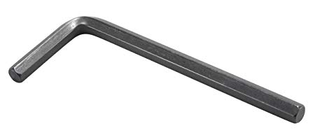
Figure 4: Hexagonal section Allen key

A hexagonal Allen key, similar to that in figure 4, is made from steel with a modulus of rigidity of 78GPa. Given the Allen key as the dimensions of those in figure 5 and it has a length of 140mm, calculate the angle of twist in degrees, when a torque of 10Nm is applied. [10 marks]

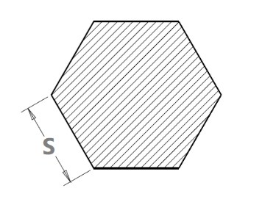
Figure 5: Hexagonal dimensions, s =5mm

$J=\frac{5\sqrt{3}}{8}s^{4}$

Diwedd/End

