Shaun Richards
Student ID 1904543 | March 2021
Research Methods
MSC lean and agile manufacturing

Table of Contents
1.0 Summary 2
2.0 Introduction 3
3.0 Literature Review ……….…………….……………………………………………………………………………….4
3.1 Value Stream Mapping (VSM) …………………………………………………………………………4
3.2 Tracing/Data Capture Technology ..…………………………………………………………………5
4.0 Production Warehouse Current Operations.…….…………………………………………………………7
5.0 Wastes Identified in Current State Process .….………………………………………………………….10
6.0 Comparison of Radio Frequency IDentification V’s Bar-Code ..………………………………….11
7.0 Technology integration into legacy ERP system…………………………………………………………13
8.0 Future State Production Warehouse using lean and Bar-Code technology.……………….14
9.0 Concluding remarks and future research ………………………………………………………………….16
References………………………………………………………………………………………………………………………….17

Summary

This research paper will critically evaluate as a case study the processes currently used at a production warehouse for tracing finished products from the time of packaging through to storage and final shipment either directly to customers or external storage facilities (third party logistics). The research will further evaluate wastes as defined by lean manufacturing using the Value Stream Mapping (VSM) technique within the processes and the potential to drive efficiencies via the addition of product tracing technology considering both Radio Frequency IDentification (RFID) and Bar-Coding along with investigating whether it is feasible to integrate this into the legacy Enterprise Resource Planning (ERP) system.

Introduction

The manufacturing site being studied is a producer of fine particle powders which produces a variety of grades with these initially being stored in bulk silos prior to them either being loaded into bulk road tankers or packaged into a range of Stock Keeping Units (SKU’s) within the production warehouse. The SKUs are further stored in the small production warehouse prior to being shipped onwards to end customers or the larger storage and distribution warehouses both in the UK and Europe.
The processes currently used within the production warehouse for logging and tracing the packaged products are predominantly paper based and completed by the warehouse operators prior to being transferred from one paper based system to another before finally being updated within the ERP system by either the sites Inventory Controller or shipping administrative team with this kind of process being potentially strewn with errors as well as not using personnel effectively or their time efficiently which under Lean Manufacturing Principles is considered as waste which is a direct loss to the business as the customer are only prepared to pay for processes which add value to the product that is being purchased.
When considering the above an approach is therefore required to aid with the identification of waste or as described in Lean Thinking ‘’those actions which don’t create value as perceived by the customer (Type Two Muda) and so can be eliminated immediately’’ (Womack, 1998) in order to drive improvements which in turn should lead to reduced costs, with this being described by Liker as being ‘’The Heart of the Toyota Production System (TPS)’’ (Liker, 2004) with Toyota being seen as pioneers of Lean Manufacturing. The use of the Value Stream Mapping (VSM) technique deemed to be the starting point of Lean Manufacturing will be employed.
The research paper will firstly undertake a literature review of value stream mapping and product tracing technology (automation) followed by a looking at how wastes are defined under lean along with the current state of the process to include a VSM using both qualitative and quantitative methods to analyse the outcomes, a look at the current technologies for product tracing to determine which is best suited for the process in question whilst paying consideration to the technologies ability to be integrated into the legacy Enterprise Resource Planning system and concluding with a proposal for which technology may be adopted along with a future state VSM.

Literature Review

The purpose of a literature review is considered to be two-fold, whilst it firstly looks to map and analyse the available literature in given specific subject fields it also looks to identify gaps which may exist to further develop borders of knowledge in that area in the future. Rowley, Slack propose that a literature study should be done in the following steps: ‘’scanning resources, designing the mind map to structure the literature review, writing the study and building the bibliography’’ (Rowley & Slack, 2004), whilst Dodgson quotes ‘’Although there are many methods for conducting a literature review (e.g., systematic review, scoping review, qualitative synthesis), some commonalities in methodological rigor do exist. If done well, a literature review can provide a critical analysis of the state of the science about a specific discrete phenomenon of interest’’ (Dodgson, 2021)
  - Value Stream Mapping (VSM)
VSM is widely considered as being a fundamental tool in Lean to aid with the unearthing of wastes within the process giving understanding of what activities are considered as valuable from the perspective of the customer. This leads to revealing those activities which are Non- Value adding, however it needs to be understood that some of these are in fact essential in delivering the product or service to the customer. Whilst VSM is a tool with many years in existence demonstrating great results it can be considered static, based on the moment and experience dependent. Use of technology can enable advances to this practice if required based on the complexity of the process being observed!
Bicheno & Holweg state that – ‘’Mapping is the Meta Tool in the Lean Toolbox because the mapping tools should guide the use of many other tools. Remember that all mapping and analysis is waste unless it leads to action. Doing mapping is not the same thing as doing Lean. The real purpose of mapping is to design the future state. It is a visualization exercise – a vision of the current state and of the future state’’ (Bicheno, 2016).
In a paper by Knoll et al VSM was described as ‘’Pen and paper-based value stream mapping (VSM) is the established tool for recording processes, identifying waste and deriving recommendations for action. However, today, its application in manufacturing industry requires a high level of effort and is challenging due to product and process complexity, as well as dynamics’’ (Knoll, et al., 2019).
Whilst studying production warehouse issues Dotoli et al ‘’propose a novel approach to reducing inefficiencies which employs three lean manufacturing tools in an integrated and iterative framework. The proposed approach integrates the Unified Modeling Language (UML) providing a detailed description of the warehouse logistics – the VSM tool – identifying non-value adding activities – and a mathematical formulation of the so called Genba Shikumi philosophy – ranking such system anomalies and assessing how they affect the warehouse. The subsequent re-application of the VSM produces a complete picture of the reengineered warehouse, and using the UML tool allows describing in detail the updated system’’. (Dotoli, et al., 2015).
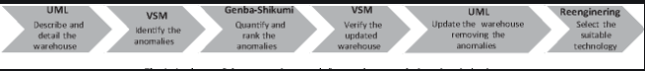
Fig 3.1.1 Demonstrates the process used visually (Dotoli, et al., 2015)
Venkataraman et al discuss VSM along with its limitations and propose a ‘’Dynamic Value Stream Mapping Solution (DVSMS)’’ through technology stating ‘’value stream mapping (VSM) tends to be static and skill dependent. With the advent of Industrial Internet of Things (IIoT), there could be a paradigm shift on how VSM could be leveraged for maximizing results. IIoT makes it possible to convert the VSM as a dynamic one, enhancing with several additional parameters measured simultaneously in real time, making the relationship between cause and effect more visible. Smart manufacturing is a technology enabled manufacturing setup that uses IIoT to monitor and improve production processes’’. (Venkataraman, et al., 2020) .
The limitations of VSM were further discussed in a paper on VSM and system dynamics integration by Stadnicka & Litwin as follows ‘’Not all of the existing problems can be easily identified with VSM because the analysis takes into consideration only a static aspect of the system modelled and the situation on a manufacturing line, affected by many different problems, is dynamic though. Therefore a method that considers system dynamics should be applied’’. (Stadnicka & Litwin, 2019).
Contrary to some of the above quotes where some papers have considered the limitations of VSM Dadashnejad and Valmohammadi argue that VSM is ‘’One of the most important tools for lean production (LP) is value stream mapping (VSM), which identifies and reduces errors, losses, lead-time, and improves value creating time, thus enhances product quality through empowering production unit in terms of production risk and cost reduction in long term’’ (Dadashnejad & Valmohammadi, 2019)
  - Tracing/Data capture technology
There are many ways to capture production data and track/trace products through the value stream within the warehouse from paper-based systems (currently being used in the case study business and discussed in the introduction section of the paper) through to Bar-Coding and Radio Frequency Identification (RFID), each of these systems have many benefits along with limitations, some of these can be seen in Fig 3.2.1.
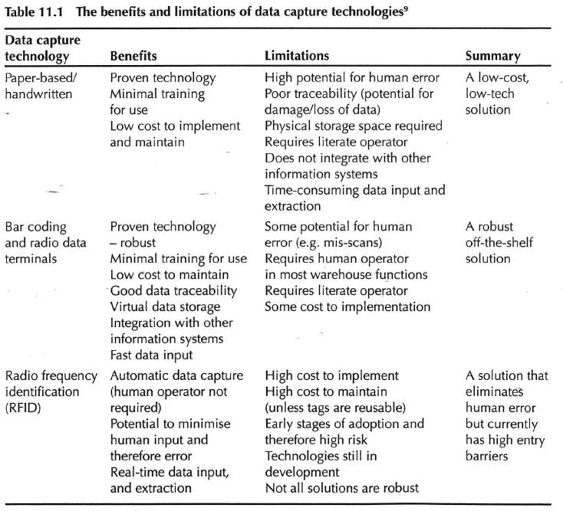
Fig 3.2.1 (Mangan & Lalwani, 2016)
Based on errors being seen in manual data entry within immunization settings Pereira et al firstly set out a feasibility study on implementing barcode scanning followed by implementation itself in a controlled environment with the following findings ‘’Barcode scanning technology enhances patient safety, reduces errors involving drug administration, and increases the timeliness and accuracy of medication-related documentation. Conclusion: Entering vaccine data into immunization records through barcode scanning led to improved data quality, and was generally well received. Further work is needed to improve barcode readability’’ (Pereira, et al., 2014).
During an implementation study for RFID technology Yong-Shin et al stated that ‘’Serialised tracing provides the ability to track and trace lifecycle of products and parts. Unlike barcodes, Radio frequency identification (RFID), which is an important building block for internet of things (IOT), does not require a line of sight and has the advantages of recognizing many objects simultaneously and rapidly, and storing more information than barcodes. Therefore, RFID has been used in a variety of application domains such as logistics, distributions and manufacturing, significantly improving traceability and process efficiency’’ (Yong-Shin, et al., 2018) .

4.0 Production Warehouse Current Operations

As stated in the introduction section of this paper the site being studied operates a production-based warehouse which consists of the packaging and storage of a variety of fine particle powders in paper-sacks and flexible intermediate bulk containers (FIBC’s), see Fig 4.1.
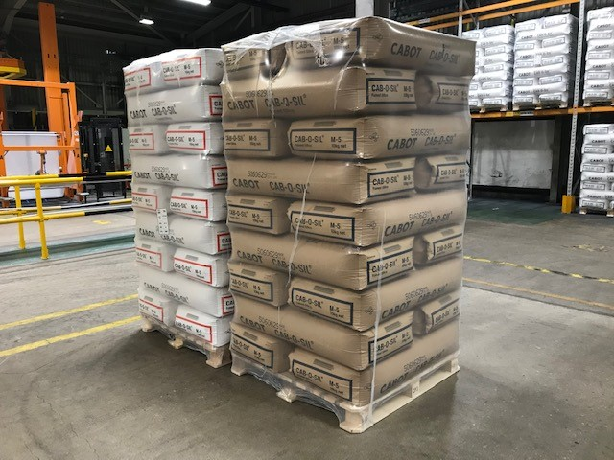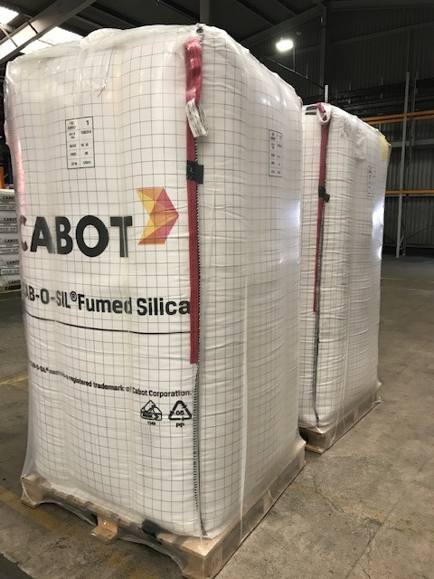
Fig 4.1 Paper-sacks & FIBC’s
Semi-automated filling machines are used for the packaging of the products with the paper-sacks then running through an automated line to be stacked on wooden pallets by a robot, pressed and shrink wrapped to prevent moisture ingress.
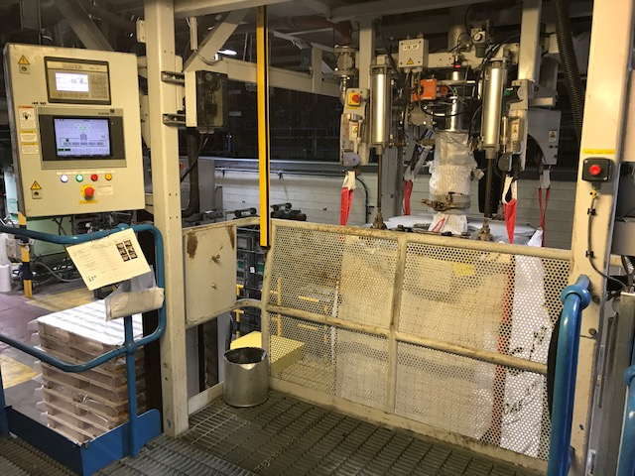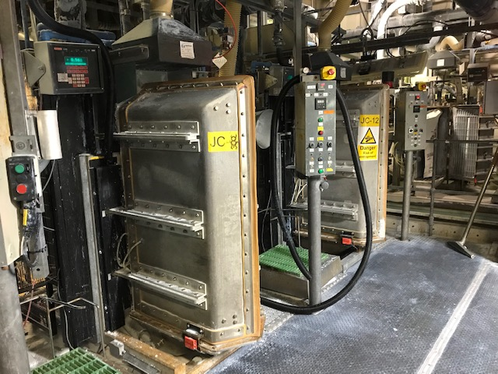
Fig 4.2 Filling machines
Once packaging and wrapping has been completed the palletised products (SKU’s) are removed from the end of the automated line by a Forklift Truck (FLT) and stacked in the storage section of the production warehouse with manual product data logging completed. The warehouse storage section can hold approx. 460 SKU’s in either racking or floor storage areas with a further 300 SKU’s being stored in an alternative smaller warehouse at the other side of the plant with products being moved to the alternative building using a FLT and shunting vehicle. The sites storage space availability allows approx. 3.5 days of running without collections being made.
The stored SKUs are further loaded onto road trailers 22 (full truck load – FTL) at a time for either direct delivery to customers or to third party distribution warehouses in the UK and Europe to enable sufficient inventory to be held in order to maintain an uninterrupted supply chain during fluctuations in order patterns.
In all cases the storage of and further picking of the SKUs for movement or loading is done so using manual documentation data collection by warehouse operatives with this being then either transferred into different manual documentation or handed to the sites inventory control team to then finally be entered into the sites ERP system with this happening in all cases retrospectively leading to this business system not being a live environment. When considering the current practices value stream mapping (see Fig. 4.3) was undertaken from the point of a finished SKU being removed from the end of the packing/wrapping line up to and including the point where the SKU leaves site in order to better understand firstly the inefficiencies of the current methods and secondly where errors could potentially be made as a result of manual data logging and transfer from one person to the next called within the VSM ‘’information handovers’’, as stated in a 2017 paper ‘’Warehousing is a labour intensive process, requiring warehouse operators to use different methods of work and various equipment and to be in constant motion. During this process, various types of errors can occur, which can be reduced with the introduction of a suitable strategy’’ (Skerlic & Muha, 2017).
When evaluating the VSM it has highlighted that 64 process steps are taken of which only 5 are value added as ‘’specified from the point of view of the customer’’ (Bicheno, 2016) and what the customer is actually prepared to pay for which comes under the guise of some kind of transformation, a further 24 steps were considered non value added but essential in order to deliver the product to the customer within the defined specification and packaging requirements. The remaining 35 steps were considered neither nonvalue adding or essential and therefore wasteful when considered under the nine wastes of lean methodology and therefore should be prioritised with a view to elimination through ‘’Kaikaku’’ initially and then ‘’Kaizen’’ as stated in the acclaimed book Lean Thinking;
‘’Once the initial rethinking of value is done (in what might be called kaikaku for value), lean enterprises must continually revisit the value question with their product teams to ask if they have really got the best answer. This is the value specification analog of kaizen which seeks to continually improve product development, order-taking, and production activities. It produces steady results along the path to perfection.’’ (Womack, 1998).
Fig. 4.3 Value Stream Map of current conditions

Wastes Identified in Current State Process

In evaluating the VSM from the current state process this has highlighted not only the potential to generate errors in data recording but also wasteful activities which are currently being undertaken with one of the main aims of Lean Manufacturing being the identification, reduction and/or elimination of waste which is described by Liker as being ‘’The Heart of the Toyota Production System (TPS) (Liker, 2004), principally as discussed by Bicheno and Holweg there were 7 original wastes under TPS (Transport, Inventory, Motion, Waiting, Overproduction, Over-Processing, Defects), however 2 further wastes for consideration have since been added (Human Resources, Environment) with all 9 needing to be considered.
Now that the VSM has been constructed it was important to ensure that the detail of the operations within the process were well understood by simply going to see the process and all of it components in operation (Genba Shikumi approach) which led to the identification of the following wastes;
Waiting – The main concern here was that the shipping department were unable to load products due to waiting for the ERP system to be updated with data entries from the packaging area in order for this product to be released and therefore loaded on waiting vehicles.
Over-Processing – The main concern identified here was that there were too many steps taken to get the required information into the ERP system with initially the data being captured in paper format and passed through 3 different departments and logging systems prior to the final entry into the ERP system.
Motion – The main concern identified here was again related to the paper information transfer being moved from one area/department to another whilst also operators having to walk and find particular goods in the Warehouse(s) as this aspect was not being logged in any of the systems.
Human Resources – The main concern identified here was the under utilisation of those working within the production warehouse along with waiting leading to both frustration and boredom which in turn has the potential to lead to the creation of errors being made.

6.0 Comparison of Radio Frequency IDentification V’s Bar-Coding

As previously stated in section 3.2 there are many ways to capture data with each having benefits and limitations. The current state in the production warehouse is predominantly paper based with a final entry to the ERP system which is retrospective leading to firstly the potential for errors and secondly having a business system which is not live or current with regards to production flow.
The study will compare RFID and Bar-Coding to determine the most suitable technological advancement for data collection within the production warehouse, Rick Barlow explained in a recent paper whilst quoting some of B. Braun Christiansen’s work ‘’Both RFID tags and bar codes are effective in tracking bulk items in the store room or warehouse, ’’he indicated’’. Although, bar coding is much more popular today, since it is more practical and cost effective to implement in the storeroom, especially with bulk items that only require ‘one at a time.’ Scanning RFID tags, readers and tracking software tend to be more cost prohibitive in the storeroom, and require an ROI to justify implementation’’ (Barlow, 2020). It is however important to note that as items being labelled/scanned will likely end up in a supply chain which may in fact be global that global standards are being adhered too ensuring that the codes and tags being used are of a common language.
‘’GS1 is a global standards organization that manages the standards for bar codes and RFID tags for the worlds leading organisations. It provides data services that ensure the proliferation of products and freight can be uniquely and accurately identified’’ (Mangan & Lalwani, 2016).
Bar-Coding is proven technology and is considered robust, it is relatively easy to use with a low level of training required whilst offering good traceability and tends to be easily integrated into other business information systems. Off the shelf solutions for printing and scanning equipment are offered which in the main are low cost and easily maintainable giving a reasonable return on investment (ROI) opportunity. The limitations are focused on human interaction still being required to scan products which can potentially lead to errors (mis-scan) along with line of sight being required to enable the scan, an element of literacy on the operators part is a pre-requisite. Scanning equipment (see Fig 6.2) can be automated at fixed points within the warehouse or hand-held scanners can be used which is mostly the case due to cost. Bar Codes normally can either be 1D (basic level of information) or 2D (ability to carry greater information and better scanning efficiency) with examples seen in Fig 6.1, a further limitation with bar-codes is once printed they cannot be re-written too by information systems should changes be required meaning a new label will be required.
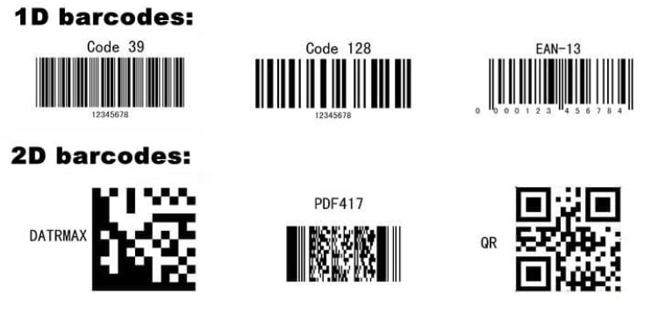
Fig 6.1 Barcode types (Anon., n.d.)
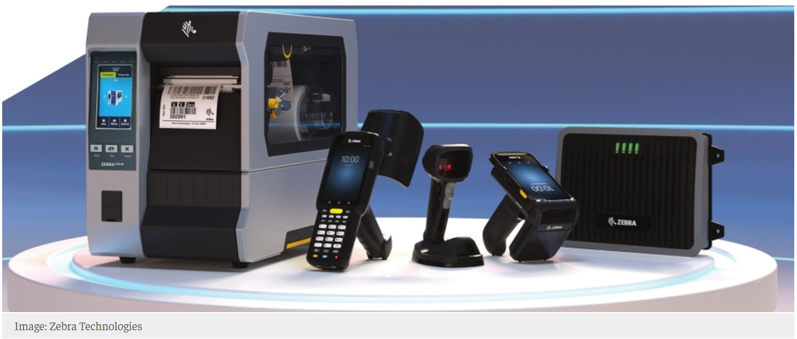Fig 6.2 Printing and scanning technology (Bar-Code and RFID enabled) (Anon., n.d.)
RFID technology is relatively new compared to Bar-Coding particularly within supply chain management but carries advantages over that of Bar-Coding such that it features automated data capture reducing the need for human interaction leading to a further reduction in potential errors generated, the system enables real time data input. As with Bar-Coding the labels/tags can be printed at source (see Figs 6.2 and 6.3), however the RFID labels are more expensive particularly if they are consumable. There are however limitations due to there being a high cost firstly to implement and secondly to maintain increasing substantially on ROI, currently this type of technology is still in development giving rise to risks with not all solutions being robust in nature. Further advantages for RFID over Bar-Coding is the labels/tags contain microchips which enables them to be updated with additional information or re-written.

Fig 6.3 RFID label/tag and antenna for detecting tag (Anon., n.d.)

- Technology integration into legacy ERP system
The legacy ERP system within the case study site is JDEdwards EnterpriseOne which was supplied and is serviced by Oracle. Oracle support the integration of third party applications to this system which is depicted in Fig 7.1 and known as a TranCollector which has an intermediate server between the chosen Bar-Coding devices and the ERP system itself.

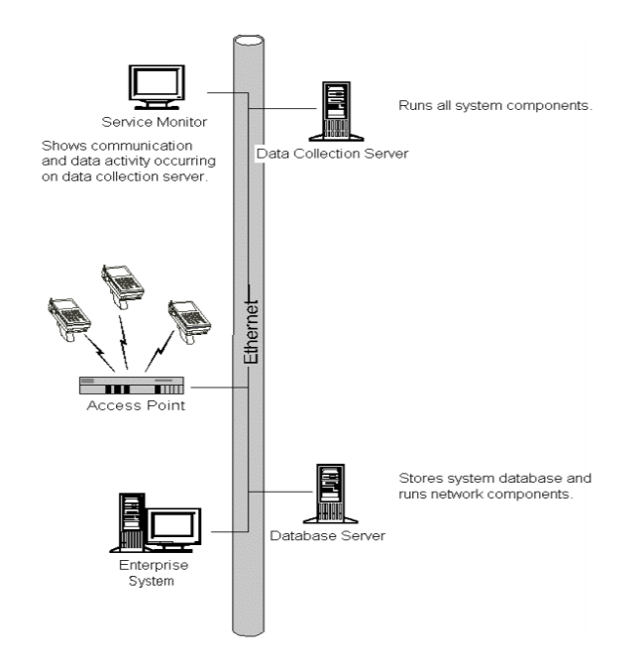
Fig 7.1 TranCollector system requirements (Anon., n.d.)
The ERP system itself also contains an integrated Warehouse Management System (WMS) which to date has been under utilized as a manual paper based system has been employed at the site to transfer information, Jerry Rudd states that ‘’WMS can make major contributions to reducing errors and improving productivity’’ (Rudd, 2019). With this in mind it would make sense that if the processes currently undertaken were to be improved with the adoption of technology that the WSM system also be developed in its use as this would aid with the reduction of bothe errors and wasted steps that currently exist in the prosecution warehouse.

- Future State Production Warehouse using Bar-Coding technology
Based on the comparison of the available technologies as discussed in section 6.0 of this paper and the understanding of the process itself and lack of complexity and throughput within, it has been determined that Bar-Coding technology should be adopted in order to drive the desired improvements regarding the reduction of errors and driving efficiencies within the production warehouse leading to the adoption of lean principles. The main drivers for this choice are based around ease of implementation within the current site infrastructure, operator training and ongoing use along with relatively low costs to maintain and supply consumables for.
Change management will need to be considered as part of any implementation as change can often be difficult if not managed and rolled out correctly as resources both internal and external of the site can often resist the change if they do not understand the purpose of it with this being considered by McCalman et al below.
‘’An organisation can create an operating environment, both internally and throughout its supply chain, which encourages an opportunistic stance to be adopted. However, no matter how welcoming an organisation is to change, it will still face a degree of employee, supplier, distributor, stakeholder and consumer resistance to change. It may manage to reduce the frequency and potency of such resistance but it will never eradicate the fear of the unknown’’ (McCalman, et al., 2016).
A potential future state VSM (see Fig 8.1) has been created which shows a significant reduction in steps throughout the process from 47 in the current state map down to 36 (24% reduction), non-value added steps have been reduced from 21 to 10 (52% reduction), whilst information handovers have been reduced from 15 to 6 (60% reduction) whilst the value added and non-value added essential steps remain the same at 5 and 21 respectively with these being seen graphically in Fig 8.2.

Fig 8.2 Graph representing current versus future state VSM’s - reduction of steps

Fig 8.1 Value stream map of future state with Bar-Coding
- Concluding remarks and future research
This study like many other research studies carried out previously has limitations based in some part due to it being undertaken in a small production warehouse which only manufactures a handful of different products with these also being bulk in nature, additionally the warehouse itself is relatively small in size so relies heavily on products being moved out quickly and efficiently which at the moment can prove difficult based on the systems currently used. It is believed that the proposed integration of Bar-Coding technology into the production warehouse would serve to aid with efficiency and error proofing it is not known whether this would work in other environments successfully so further research in this area would be advantageous.
It is understood from the study undertaken that paper-based systems can create inefficiencies and errors alike, however the integration of technology may drive efficiencies once in place and understood through change management this change may lead to different errors being generated due to the use of the chosen technology with limited literature found on this subject area so this would be interesting to follow up with additional research.
The ERP integration of Bar-Coding technology is to a degree not fully understood as there was limited information available regarding this without commencing discussions with suppliers so whilst this is considered achievable based on the information sourced the cost to implement is largely unknown which may give rise to questions regarding return on investment.
The advent on Dynamic Value Stream Mapping seems to be an area where research is opening up running alongside Industry 4.0, this would therefore be another area which requires additional research to aid with the understanding of industries future coupled with technology and what this means for the familiar paradigm of traditional VSM.

References
Adazon USA, https://www.adazonusa.com/blog/how-to-information/barcodes-101-1d-versus-2d-barcode-labels (14/03/2021).
BarCode Technologies, https://www.barcode-uk.com/ (14/03/2021)
Barlow, Rick Dana. 2020. Bar Coding vs RFID – Win, Lose or Draw. Healthcare Purchasing News Vol.44 (3), p. 14-16, 18-20
Bicheno, John; Holweg, Matthias. 2016. The Lean Toolbox: a handbook for lean transformation, 5th Edition, PICSIE Books.
Dadashnejad, Ali-Asghar; Valmohammadi, Changiz. 2019. Investigating the effect of value stream mapping on overall equipment effectiveness: a case study. Total Quality Management Vol.30 (4), p. 466-482
Dodgson, Joan E. 2021. Critical Analysis: The Often-Missing Step in Conducting Literature Review Research. Journal of Human Lactation Vol.37, Issue 1, p.27-32
Dotoli, M., Epicoco, N., Falagario, M., Costatino, N., Turchiano, B. 2015. An integrated approach for warehouse analysis and optimization: A case study. Computers in Industry Vol.70 (6), p. 56-69
dsLink Integration with Oracle E-Business Suite, www.oracle.com (17/02/2021)
Knoll, Dino; Reinhart, Gunther; Pruglmeier. 2019. Enabling value stream mapping for internal logistics using multidimensional process mining. Expert Systems with Applications Vol.124, p. 130-142
Liker, Jeffrey K. 2004. The Toyota Way – 14 Management Principles from the Worlds Greatest Manufacturer, McGraw-Hill.
Mangan, John; Lalwani, Chandra. 2016. Global Logistics and Supply Chain Management 3rd Edition, Wiley.
McCalman, James; Paton, Robert A.; Siebert, Sabina. 2016. Change Management – A Guide to Effective Implementation 4th Edition, Sage.
Pereira, J.A.; Quach, S.; Hamid, J.S.; Quan, S.D.; Diniz, A.J.; Van Exan, R.; Malawski, J.; Finkelstein, M.; Samanani, S.; Kwong, J.C. 2014. The integration of barcode scanning technology into Canadian public health immunization settings. Vaccine Vol.32 (23), p. 2748-2755.
Rowley, Jennifer; Slack, Frances. 2004. Conducting a literature review. Management Research News Vol.27 (6), p.31-39.
Rudd, Jerry. 2019. A Practical Guide to Logistics – An Introduction to Transport, Warehousing, Trade and Distribution, Kogan Page Limited.
Skerlic, Sebastjan; Muha, Robert. 2017. Reducing Errors in the Company’s Warehouse Process. Transport Problems Vol.12 (1), p. 83-92.
Stadnicka, Dorota; Litwin, Pawel. 2019. Value stream mapping and system dynamics integration for manufacturing line modelling and analysis. International Journal of Production Economics Vol.208, p. 400-411.
Venkataraman, Balaji; Venkumar, P; Sabitha, M S; Amuthaguka, D. 2020. DVSMS: dynamic value stream mapping solution by applying IIoT. Sadhana Vol.45 (38) https://doi.org/10.1007/s12046-019-1251-5
Womack, James P; Jones, Daniel T. 1996. Lean Thinking: Banish Waste and Create Wealth in your Corporation, Touchstone Books.
Yong-Shin, Kang; Hyoennam, Kim; Yong-Han, Lee. 2018. Implementation of an RFID-Based Sequencing-Error-Proofing System for Automotive Manufacturing Logistics. Applied Sciences Vol.8 (1), p.109-125.
Zebra Technologies Enterprise Visibility and Data Capture, https://www.zebra.com/us/en.html (14/03/2021)

