Leading and Implementing Workplace Change

Student Name: Syed Azizur Rahman
Student ID: 1605376
Lecturer Name : Dr Rexon Nting

Table of Contents
Introduction 3
Company Overview 3
Literature Review 4
Analysis of History of Nestle and Impact of Change in External Environment 5
Recent History of Nestle regarding performance and revenue 5
Change in the Factors of External Environment 6
Effect of Change in External Environment in Nestle 8
Developing a Model Incorporating Issue with Strategic Change and How to Manage the Change & Leadership Style 9
A Model of Change to be Followed by Nestle 9
Issues Related with Strategic Change 10
Managing the Change in Nestle 11
Change in Leadership Style 13
Impact of Organizational Culture on Change Management Program 14
Impact of Basic Characteristics of Nestle’s Organizational Culture 14
Impact of Unique Characteristics of Nestle’s organizational Culture 15
Conclusion 17
References 18

Introduction
The objective of this report is to gain a holistic view of how change takes place within an organization, how it is sustained and how to integrate all workforce in it. In order to see the whole process, a company has to be taken into consideration for what Nestle has been chosen in this report. Throwing light on Nestle’s situation, it’s going to be analyzed how a change model can be developed for them by following a model suggested by management specialists. Then, the report will also address how the whole process of the change will take place from inception to anchoring the change into the culture. Finally, we will look into the factors that are affected by the change management program with regard to organizational culture.

Company Overview
Nestle is a Swiss multinational corporation in the food and beverage industry which came into being in the year of 1866 with a condensed milk product. Since then, Nestle has kept on climbing the ladder and up until now, they have added almost 2000 brands to their group (Nestlé Global, 2019). Nestle is currently operating in more than 180 countries now with more than 400 factories and they have made employment for more than 400,000 people all around the globe.


Because of Nestle’s integrity and efficient management, it has won accolades from many consumers of many countries and their customer base is increasing every year. The company is growing almost every year by a significant margin. Last year the company has made a revenue of more than 89700 million dollars from its operation which has increased its share value by a huge margin (the Guardian, 2019). Their most appreciated bands are Maggi, Nescafe, and Nido all over the world and the recent inclusion is Nesquik.

Literature Review
The transformation or change is very important for an organization in order to keep pace with the ever-changing business world in this era. As per the research result of Allaoui, Bourgault and Pellerin (2019), the change in technological side and development in process of doing things have enabled organizations to bring change in both of the sectors easily which will ultimately give the organization a competitive edge over others. A change is not easy to be implemented. It involves a process of planning, outlining the activities, implementing the change, managing the workforce’s reaction to it and sustaining the change. Pellerin in his research paper in 2019 about great importance on people who manage the change. The whole process is governed by a change agent who can be either from the organization itself or a change catalyst.
As per Pendarkhar (2019), the transformation of an organization most often seems to be mandatory because of the external environment’s influence on the organizations. Other than that, Walter (2015) said that when an organization wants to break free from its status quo can bring change as well. While bringing change into the organization, suggested following Kurt Lewin’s change theory should be followed in order to bring effective change in their journal. Also, to affect different factors of an organizational factor while bringing a change Kotter’s theory on change management is suggested to be followed by to get a favourable outcome.

Analysis of History of Nestle and Impact of Change in External Environment

Recent History of Nestle regarding performance and revenue
Here, we have taken the scenarios from the year 2006 to 2018 to analyze the performance of nestle with a view to obtaining knowledge of its history and see what are the changes that have taken place over the course of this timeline. Within this timeline of 2006-2018 nestle added new other product lines and brands such as nestle coffee mate, Nestea, Nesquik and so on. These addition has recently added up to 2000 brands which nestle has right now on their portfolio. Their other new brand nestles water has increasingly attracted people resulting in almost 30% of change that has been brought to the overall change in the group’s selling of all products (Nestlé Global, 2019).
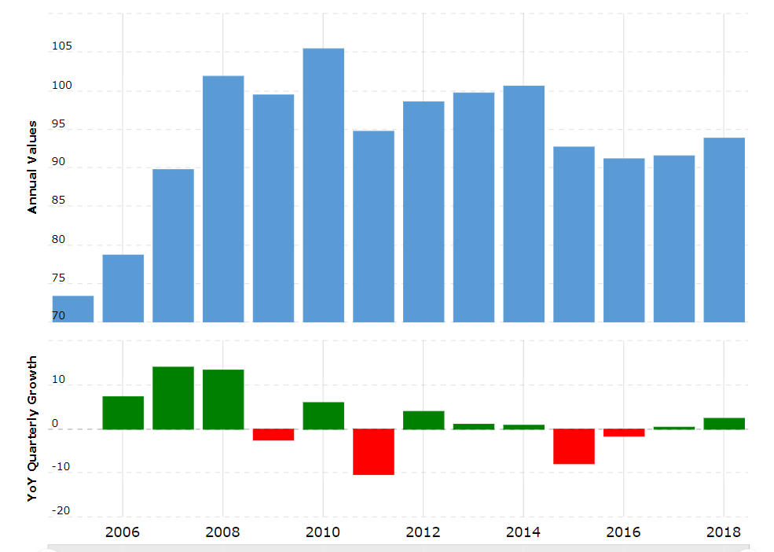
Figure 1: Growth in Nestle's Annual Value (Nestlé Global, 2019)
From the year 2006 to 2010, nestle has seen growth in almost every year except for the years followed by recession and excessive competition from companies producing similar products. The growth in the value is apparent from the graph given below where a reduction in value can be seen only in 4 years. In the year 2013, when Nido scandal was widely spread which caused illness and serious disease, the company suffered loss which led to a constant reduction in the value of the company (the Guardian, 2019).
Since inception to now, Nestle has been faced many challenges and they have always overcome those issues with efficient management followed by strategical change suitable for the company. For this efficiency, Nestle is being able to increase its product line and brand year after year and also being able to absorb a greater share of the consumer market consequently.

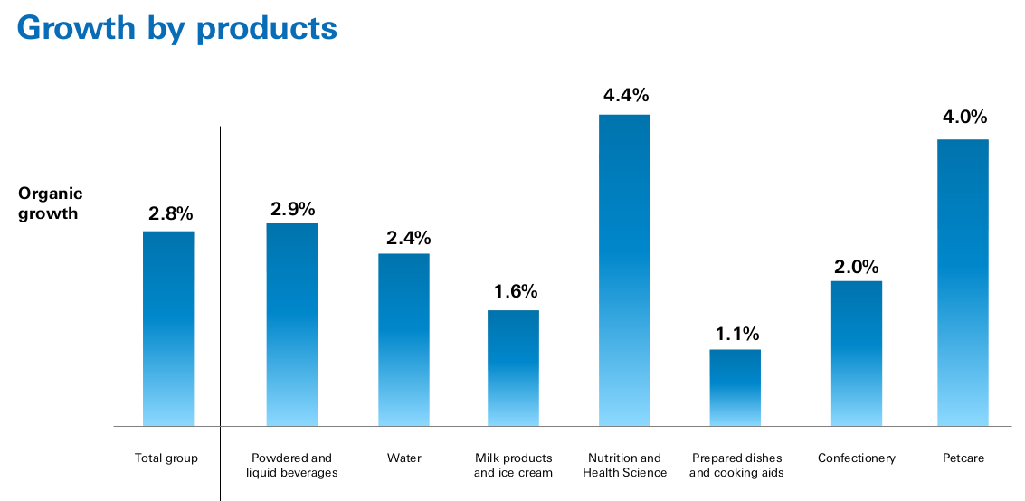
Figure 2: Growth by Products of Nestle Group (Nestlé Global, 2019)

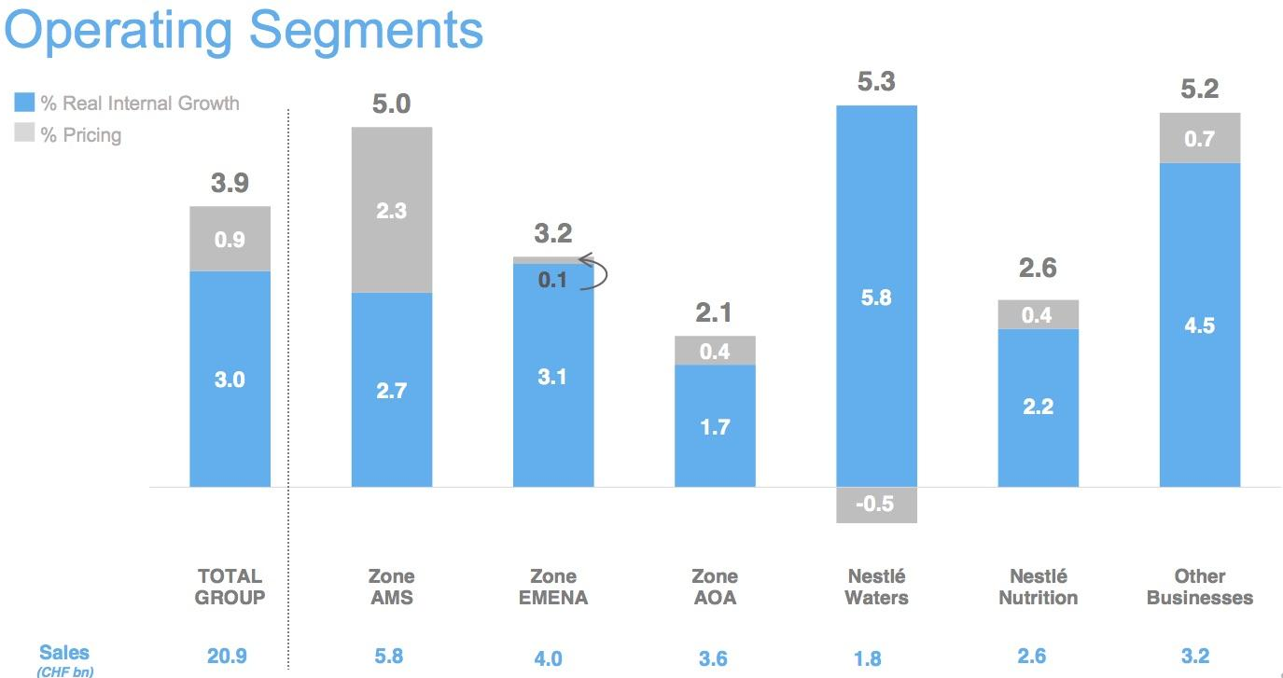
Figure 3: Performance by Product of Nestle (Nestlé Global, 2019)

Change in the Factors of External Environment
From the year 2006 to 2018, there have been so many changes seen in the factors of the external environment in which nestle exists. We will look into the change of these factors by analyzing them through the PESTLE model.
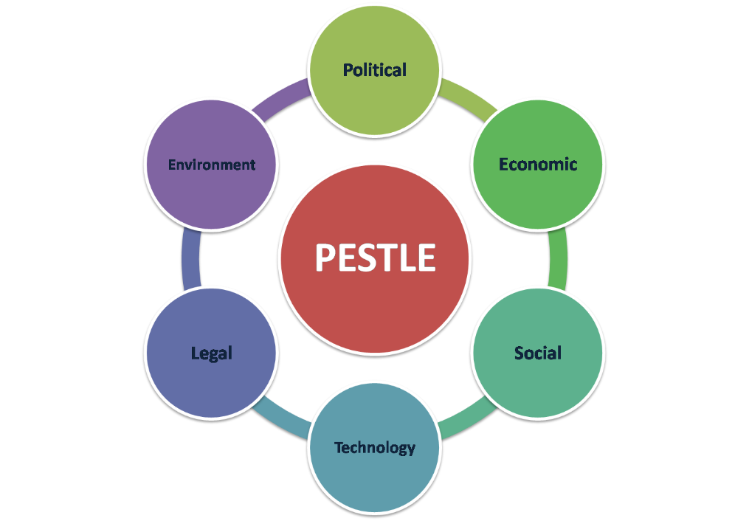
Figure 4: PESTLE Factor
Political Factor: Political factors within an economy of a country affect a company rigorously regardless of the other factors. For instance, change in government, constant procession against the govt, violence, and others affect a company badly in an economy (Pagano and Verdin, 2013). Some cases like these took place within the timeline of 2006-2018 in some countries where nestle operates its business in the middle east.
Economic Factor: One of the most important factors that affect a company is an economic factor. It is basically influenced by inflation, deflation, change in interest rate, spending and so on. Such change can affect a company in a favourable or unfavourable way which can’t be predicted most often what’s going to happen (Bencivenga, 2002). For instance, if unexpected inflation leads to hyperinflation, it may lead to loss of value of all products that a company produces. During the course of our considered timeline, such occurrence took place in some economies.
Social Factor: The social norms, culture, and beliefs affect a company’s sell heavily. For example, if a company produces nicotine-based products or alcohol which society never welcomes, then the future of that company will be endangered (Okeyo, 2015). But, within the last decade, this kind of dogma and social restraint has been changing sharply.
Technological Factor: Change in technological factors affect a company in a good way mostly and gives it an edge of competitive advantage. From the year 2006-2018, there have been sharp changes in technological factors in all economies and in all countries (Pagano and Verdin, 2013). People can avail of the opportunity of technology at a very low cost which has given companies the opportunity to grow rapidly.
Legal Factor: Legal factor basically depends upon a particular country which either makes the legal issues more rigid or less within a course of time. Change in legal factors includes increased restriction of a company’s activity, changing the obligations to be followed by companies regarding HR, operations, and others. Over the course of years, the legal factor has become more rigid and it has been upgraded in almost all countries to ensure a safe and sound environment for the mass people (Allaoui, Bourgault and Pellerin, 2019).
Environmental Factor: This factor mainly involves a change in the natural condition of a country which is not in the hand of people. For example, change in weather, the possibility of natural calamity, characteristic of a particular country to support production and so on. In recent times, environmental factors change has been tackled in some cases by developing the technological aspects (Okeyo, 2015). Still, where natural calamities occurred, companies had to suffer badly.

Effect of Change in External Environment in Nestle
First of all, the adverse political condition seen in the middle east and in Europe (Brexit) has made Nestle suffer in terms of operation and revenue generation. Secondly, the change in the economy in countries where recession took place had affected nestle badly such as Venezuela and Zimbabwe. As a result, they had to incur a huge amount of loss in total revenue (the Guardian, 2019). Then, change in social factors has not been able to affect Nestle’s operation heavily since nestle was welcomed in all society regardless of variation in its norms and beliefs.
Technological change has helped nestle to increase its production multiple times which resulted in a huge amount of increase in Nestle’s total revenue in almost every year. Next, legal factors change affected nestle in an unfavourable way related to the Nido scandal in the year 2013. After nestle had to go through the legal procedure at that time, nestle lost its credibility and then they had to work hard a hundred times to get things in the same place again (Nestlé Global, 2019). Finally, the environmental change could not affect Nestle much since its production does not depend upon environmental factors. But, it could affect the supply chain system only at that time when it took place in different countries.
So, the external environment affected Nestle both in favourable and unfavourable way over the course of the timeline from 2006 to 2010. But, it can be ostensibly concluded by analysing the overall change that the change in the external environment had more good impacts on Nestle than it had bad impacts.

Developing a Model Incorporating Issue with Strategic Change and How to Manage the Change & Leadership Style

A Model of Change to be Followed by Nestle
Here the word change means an alteration in tools, techniques, methods or people who are the basic factors of an organization. It is not likely that a change to be made in the organization will be always welcomed by the workforce in the organization (Fossum, 2017). For that, a particular model has to be followed which will help in planning what is needed to be changed, how the change can be done and how it can be sustained. For helping in this whole procedure Kurt Lewin has suggested a model that is still appreciated everywhere to date.
Unfreezing: Before starting this process, an organization firstly outlines the plan of what they want to change based on what they want to achieve in the long run or in terms of short-run operation. In this step, the focus is basically on providing useful motivation for the workforce to co-operate in the whole change process (Greenfield, 2008). For instance, nestle can either change the work-time structure or benefit structure to motivate their employees to co-operate in the change process so that the change to be brought is not resisted.
Benchmarking: This is arguable where this step should exist in the whole process. There are no hard & fast rules regarding that but putting it on the first in the procedure makes the whole process lot easier. Benchmarking means setting a standard with which Nestle will compare the whole change process and take decisions if it’s acceptable or not.
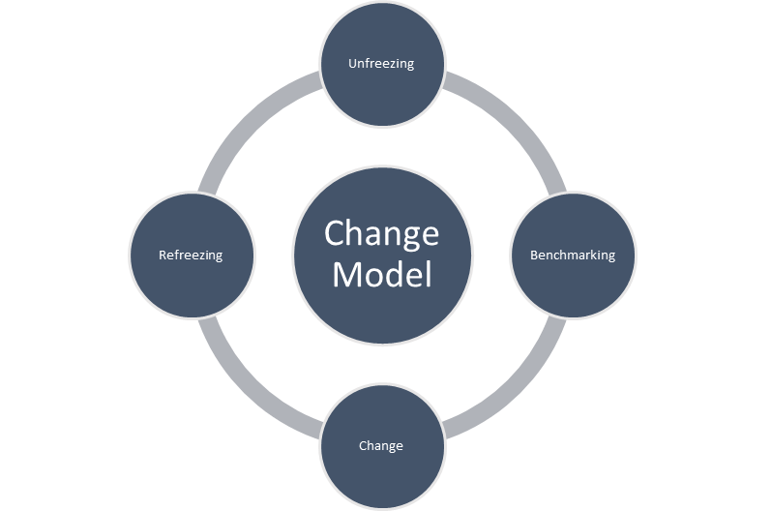
Figure 5: Kurt Lewin's Change Model (Greenfield, 2008)
Changing: In this step, a company will provide new equipment, tools or technique to be followed by the workforce in order to achieve the goal by bringing the change (Cameron and Green, 2012). For example, if nestle wants to increase production then it should introduce the workforce with new equipment or tools. On the other hand, if nestle wants to solve an ongoing problem for a long time, then it can introduce its workforce with new techniques to achieve the goal.
Refreezing: In this step, if the whole change process brings out a result that matches the benchmark will need to be sustained (Greenfield, 2008). For instance, if nestle wants to accelerate the growth of the sales by introducing a change technique and if it’s achieved by the change process they have taken then nestle will sustain the technique that has brought the change until new requirement arrives.

Issues Related with Strategic Change
There are some factors which are needed to be taken care of while a change is aimed to be brought in the organization. Those factors are as follows
Organizational Arrangements: Change in organizational arrangements involves a change in an organization’s policies, procedures, physical settings of various tools, roles, and structures (Cameron and Green, 2012). For instance, if nestle wants to bring change in the total amount of sales then they will need to take a new policy for that, they need to put people in charge to do the work and all. This is a change brought in by the whole organization's arrangements.
People: The term people basically refers to the workforce within an organization. Change in people basically involves a change inability of the workforce, change in motivation, change in attitudes and behaviour (McCalman, Paton and Siebert, 2016). If nestle wants to achieve an increase in production within a particular time period then they may need their workforce to work multiple times than usual. For that, they will need to be motivated by various undertaking and they will also need to be taught how new equipment will operate.
Methods: Change in technology, work process, workflow, and job structure fall under this issue (Forsyth, 2012). For instance, if nestle wants to bring change in their whole production system they will need to acquire new technology, a new way of doing things which will bring the desired change.
Social Factors: Change in social factors basically involves change in culture, leadership and communication system within an organization (Spector, 2013). For better understanding, if nestle wants to accelerate the way of doing things by cutting out the lag time they may undertake a new way of communication which will take less time than usual.

Managing the Change in Nestle
In order to bring the desired change, there is a model by Kotter which can be followed to make the change process smoother than usual. Most often people show rigidity towards a change to be brought within a company. To help to tackle this issue the model developed by Kotter has proved to be successful on any occasion. The process is described below with the recommendation for nestling as well.
Creating a Sense of Urgency: In this step, the change agent needs to sell to people why a change is necessary with stories, data and in other attractive ways that will engage people to work in the change process (Bencivenga, 2002). For instance, Nestle in order to bring a change they can show their workforce data of international business situations and persuade them.
Building a Guiding Coalition: In this step, nestle should create or build a team that will work in order to achieve the goal-related with change (Spector, 2013). This coalition involves delegating power and leadership to other people. The teams built within the company can have formal power or they will just be directed toward the change.
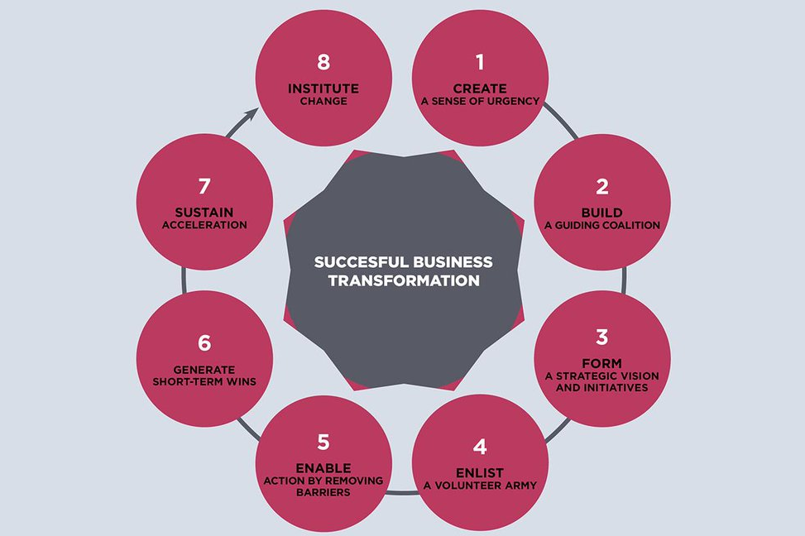
Figure 6: Factors to be Influenced to initiate a change (Bencivenga, 2002)
Forming a Clear Vision & Strategy: In order to bring the desired change, nestle should be able to outline a clear vision of what their workforce will work constantly to achieve (Bencivenga, 2002). They will also be able to clarify the strategy to be followed by the workforce in clear words & instructions.
Empowering Others to Act: In this step, nestle should train up the workforce to work for the change that is desired to be brought within the company and delegating responsibilities to them. Moreover, Nestle should manage those people also who resist change.
Securing Short Term Wins: Securing short term win means getting the desired outcome to be implemented for 6 to 18 months (Rothwell, Stavros and Sullivan, n.d.). Securing short term wins is very much important in order to take a step to bring change in the long term.
Consolidate & Keep Moving: This step basically involves steps of sustaining the acceleration and instituting the change (Dawson, Andriopoulos and Andriopoulos, 2009). After nestle is satisfied the change has affected the company successfully, they will want to keep on their workforces motivated and directed towards achieving the same goal period after period until a new change is felt to be necessary.
Anchoring The Change into The Culture: After being done with the successful implementation of a change program, nestle should put effort into integrating the change that took place in the organization (Bencivenga, 2002).

Change in Leadership Style
A firm aiming to bring a change is affected by the change in its leadership style as well. Such change in leadership may either result in rigidity in terms of delegating power and inclusiveness or openness related to both of them. Changes that are to be initiated in Nestle are as follows:
Change in the Role of Managers: Managers are the key factor who plans, initiate and implement the whole change process. When a change is felt to be necessary for a particular condition, the board of directors just take the initiative of change. But, from planning to implementing of the plan only managers oversee the whole issue (Rothwell, Stavros and Sullivan, n.d.). As a result, the responsibility increases and consequently more power is delegated to them in order to bring success by change management.
Change in Leadership: When a change is mandatory to be brought in an organization, the leadership style may change instantly (Forsyth, 2012). For instance, if nestle have to increase its production by 10% they will have to either force the manpower to work more than usual or they can call for ideas on how to achieve that benchmark easily. The former one reflects the autocratic style of leadership and the later one is a participative form of leadership. Both types can take place based on the situation that has made the change necessary. Some leadership style is as follows.
Autocratic Style: This is the type of leadership where the workforce doesn’t have any say in the company’s activities undertaken other than doing their own work. This kind of leadership demotivates the workforce and as a result, change is not welcomed here. But when a change is mandatory other than the opinion of others in it then this style can be followed.
Democratic/Participative Style: This type of leadership basically incorporates everyone in the organization when a change is supposed to take place. In this process, workers are always motivated and often they bring and initiate the change themselves since they think themselves a part of the company. But this style may be neglected when a change is mandatory and opinion can’t be taken. But as per many research results, this style of leadership has won accolades where change is priority one to be brought in the company.
Laissez Fair Style: In this style of leadership, the leader or manager delegates responsibility to workers and stay relaxed without caring much what is being done. In this style of leadership, workers, if they feel necessary, bring a change or else the status quo is never broken.

Impact of Organizational Culture on Change Management Program

Impact of Basic Characteristics of Nestle’s Organizational Culture
Below is a figure showing a different characteristic that is usually seen in an organization. We will throw light on the basic characteristics that are seen in Nestle and how they might affect the change management program.
Innovation & Risk-Taking: As per survey & research made on Nestle, it has been found in almost all of its branches that workers are willing to take the risk & they come up with any innovative ideas which would bring a change by nature (Miroshnik, 2017). Since these people are less risk-averse and innovative, the change process to be initiated will be much easier as than it would have been in the status quo. But, if these people are trained up and given proper & clear instruction on how a work is to be done, then they will be able to cooperate in the change management program as well. To sum up, the workforce needs to be managed efficiently so that they can be open to any change offered to the organization and they themselves can initiate the change.
Attention to Detail: Nestle company’s workers are very much inclined to know every detail related to work. As a result, the workforce makes an insignificant amount of mistakes in a lot bigger undertaking of responsibilities (McCalman, Paton and Siebert, 2016). This characteristic also helps the workforce to work faster than usual which reduces the lag time resulting from mistakes made in the work. This characteristic will help nestle to bring a change more smoothly than usual and the implementation of a new strategy will be much easier for nestle.
Outcome Orientation: This characteristic measures how much a manager in an organization cares about the outcome other than technique and process to be followed to reach the level of the desired outcome (Dawson, Andriopoulos and Andriopoulos, 2009). As per the research found out on nestle, it has been found that managers care about processes and techniques more than the outcome only. Consequently, the implementation of a new strategy will be much easier for nestle since the managers are inclined to make the workforce ready to adapt with the change by putting extra effort on introducing them with newer techniques and process and by taking time to ensure if they are being actually able to follow the instructions properly
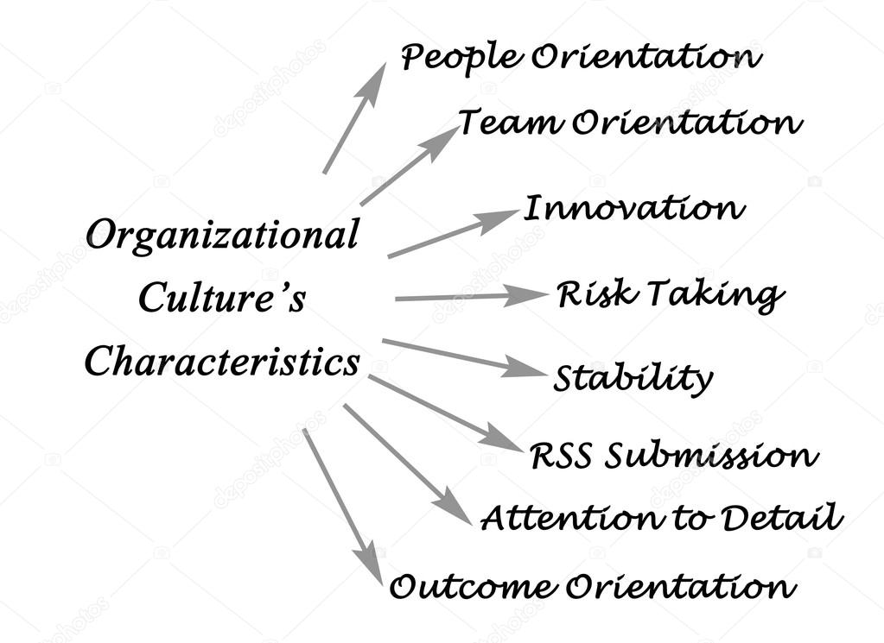
Figure 7: Basic Characteristics of Organizational Culture (McCalman, Paton and Siebert, 2016)
People Orientation: This characteristic basically measures how much importance management puts on seeing the effect on people because of an outcome that happened by a change management program. As per the research and survey, it has been found that nestle takes into consideration what effect the outcome will have on external stakeholders and also on internal stakeholders. Except for the scandal of 2013 regarding Nido, nestle have always put its best effort to make things better for their workforce and their customer. Because of this culture, it will be easier for nestle to implement a change easily since they have already earned credibility from all the stakeholders related to the organization.
Team Orientation: Team orientation shows if a company puts more importance on team-based work or they delegate work to individuals only (Miroshnik, 2017). As per research and survey, nestle has been seen to practice the team orientation characteristic by gathering up individuals in a team and instructing them to do a certain thing. This eases the pressure of implementing a change if it was to be done all alone. Consequently, this culture will welcome a new change policy and implement it easily.

Impact of Unique Characteristics of Nestle’s organizational Culture
Some of the firm-specific characteristics in an organizational culture that are seen in Nestle are as follows
Integrity: Nestle ensures that its operational activities are free from any defect intentionally which might injure the workforce or have a bad impact on people’s health (Nestlé Global, 2019). Because of this particular characteristic, implementing a change management program is much easier in Nestle. Whatever change they bring, that will be appreciated by the customer base and workforce because they already know that nothing which may cause harm to them is involved in this change.
Zero Tolerance: Nestle takes immediate action when they have seen any discrepancy in following the obligations set out by the firm (Nestlé Global, 2019. They immediately take action and make sure that such activities will never occur again. Firms also take helping measures in terms of any discrepancies seen followed by unintentional undertaking.
Inclusiveness: Nestle company integrates all the employees in the change process from inception to final outcome from its implementation. As a result, the company gain necessary suggestions from the employees and takes measure based on their experience previously what they had to go through from the previous application of change management. So, this feature makes the implementation of a change much easier in nestle.

Conclusion
After taking a multinational company into consideration, we have seen how the strategical change takes place into nestling. We have shown the model of change for nestle company by following Kurt Lewin’s change model. Then, we have seen how different factors are needed to be affected in order to bring a change to the company. We have also seen how the external environment affects nestle company through Pestle model and how these changes brought an unfavourable or favourable situation in nestle company. And finally, we have seen how different characteristics of organizational culture affect the change management program in order to implement a change.

References
Bencivenga, J. (2002). John Kotter on Leadership, Management and Change.
Cameron, E. and Green, M. (2012). Making sense of change management.
Dawson, P., Andriopoulos, C. and Andriopoulos, C. (2009). Managing change, creativity and innovation.
Forsyth, P. (2012). Managing change. London: Kogan Page.
Fossum, L. (2017). Understanding organizational change.
Greenfield, A. (2008). The 5 forces of change. Cirencester: Management Books 2000.
Hbr.org. (2019). Change management. [online] Available at: https://hbr.org/topic/change-management [Accessed 20 Nov. 2019].
McCalman, J., Paton, R. and Siebert, S. (2016). Change management. Los Angeles: SAGE.
Miroshnik, V. (2017). Organizational culture and commitment.
Nestlé Global. (2019). Home. [online] Available at: https://www.nestle.com/ [Accessed 20 Nov. 2019].
Okeyo, W. (2015). The interactive nature of business development services in the relationship between the external business environment and firm performance. Advances in Social Sciences Research Journal, 2(2).
Pagano, A. and Verdin, J. (2013). The external environment of business. Champaign, Ill.: Stipes Pub. L.L.C.
Rothwell, W., Stavros, J. and Sullivan, R. (n.d.). Practising organization development.
Spector, B. (2013). Implementing organizational change. Boston: Pearson.
the Guardian. (2019). Nestlé | Business | The Guardian. [online] Available at: https://www.theguardian.com/business/nestle [Accessed 20 Nov. 2019].
Allaoui, S., Bourgault, M. and Pellerin, R. (2019). Business transformation frameworks: Comparison and industrial adaptation. Journal of Enterprise Transformation, pp.1-28.
Woiceshyn, J., Huq, J., Blades, K. and Pendharkar, S. (2019). Microdynamics of Implementing Planned Change on Organizations’ Front Line. Journal of Change Management, pp.1-22.
Bakari, H., Hunjra, A. and Niazi, G. (2017). How Does Authentic Leadership Influence Planned Organizational Change? The Role of Employees’ Perceptions: Integration of Theory of Planned Behavior and Lewin's Three-Step Model. Journal of Change Management, 17(2), pp.155-187.

