



ACCB4017 Software Development

BSc Cloud Computing Level 4
Assignment 1

Student name: Stanimira Staneva
Student number: 2023696

Lecturer: Renuga Jayakumar
Submission Date: 25-Aug-2021
PART A (UNDERSTANDING)

A1. Control structures are considered to be the building blocks of the computer programs. They represent specific commands that analyse the variables and enable the programs to make decisions and execute them. Every programming language, including Python which is a high-level language, can be written using control structures. There are three different types of control structures: sequential, selection, and repetition. Each of them has a particular function. [1]
Sequential programming is when all statements in the program are executed from the beginning till the end one after another in the order they were listed in the program.
Selection control structure is also called conditional execution because it is used for decisions. Based on the certain condition only the statements that meet that condition will be executed, but not all parts of the code.
Repetition control structure is also called looping or iteration. The purpose is to repeat some statements of the code a certain number of times or until the condition has been met.
Selection control structure uses the key word If and allows decision making which is one of the most important concepts of computer programming. Based on the number of the conditions that we have to check, it could be “Simple If”, “Simple If…Else” and “If…Elif…Else”. [2]
The syntax of the “Simple If” is the following:
if expression:
statements
Expression is the condition that we are going to check – if the condition is TRUE, then the statement will be executed. If the condition is FALSE, then the statement will be skipped. Please consider the following example below.
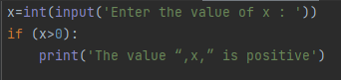
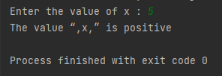
Input (figure 01) Output (figure 02)
“Simple If…Else” has two branches and provides with an alternative solution. If the first statement is TRUE, then the “If” part statement will be executed. Otherwise the “Else” part statement will be executed.
The syntax of the “Simple If…Else” is the following:
if expression:
statements
else:
statements
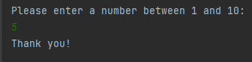
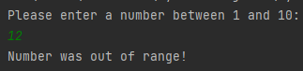
Input (Figure 03) Output (Figure 04 & 05)
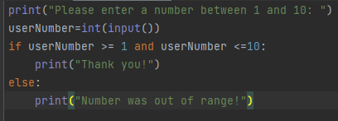

“If…Elif…Else” is a selection control structure with three branches and three conditions to check and has the following syntax.
if expression1:
statements1
elif expression2:
statements2
else:
statements1
In this case, Python evaluates each expression one by one and if a true condition is found, then the statement under that expression will be executed.
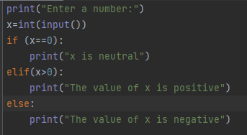
Input (Figure 06) Output (Figure 07)
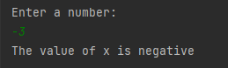

A2. Looping or also called repetition is when a particular statement or group of statements are repeated. Loops have a certain number of iterations and according to that there are two types of looping: “For” loop and “While” loop.
“For” loop uses a key word “For” and has the following syntax. [3]
for iterating_variable in sequence:
statements
“For” loop is performing a definite iteration because the number of repetitions is known and specified in advance. By default Python starts counting from 0 and increments by 1. In the example below the number of loops is defined in brackets and it is 4 which means the program counts 4 times starting from 0 (refer to figure 09).
Input (Figure 08) Output (Figure 09)
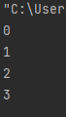
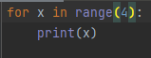

“For” loop can also count in range with a start and end range specified in advance in brackets. In the example below the counting begins from 3 and ends when the program reaches the exit value which is 7.
Input (Figure 10) Output (Figure 11)
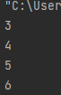
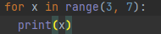

“For” loop can execute also with a defined step value which should be added as a third parameter in the brackets after the start and exit value. Adding the third parameter means the loop will no longer execute with increment 1 by default but will increment according to the newly added third parameter. In the example below with defined starting value 1, exit value 12 and step value 2, the program will start executing from 1, will increment by 2 and will stop running the loop when it gets to the exit value 12.

Input (Figure 12) Output (Figure 13)
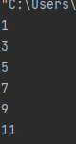
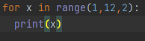

“For” loop is also useful with Python lists. The following example defines a list of vegetables and uses a “for” loop to iterate over the list. The “for” loop assigns an individual element on the veggielist to the veggie variable and prints out the veggie in each iteration.
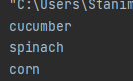
Input (Figure 14) Output (Figure 15)
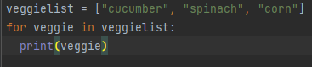

Another type of looping is the “While” loop. With the “while” loop we can execute a set of statements as long as the condition is true. Therefore, the exact number of loops is not known in advance. This makes it different from “for” loop where we have a predefined number of loops. With “while” loop we have more control and we can have another “while” loop inside of the initial “while” loop. The syntax is the following:
while expression:
statement(s)
Example:
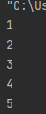
Input (Figure 16) Output (Figure 17)
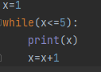

PART B (IMPLEMENTATION)

Exercise 1. This exercise requires to write a program using the three different types of variables – integer, float and string to hold the customer name, price of a product and quantity values. Then a user should be able to input these values and calculate the total price of an order.
- Logical stages:

  - Prompt user to enter a customer name.
  - Define that the customer’s name should be a string type of variable.
  - Prompt user to enter price of a product.
  - Define that the product price should be a float type of variable.
  - Check that the entered number for product price is above 0. If not, back to 3.
  - Prompt user to enter product quantity.
  - Define that the product quantity should be an integer type of variable.
  - Check that the entered number of product quantity is above 0. If not, back to 6.
  - Calculate the total price of the order.
  - Print out the total price.

- Code with annotation:
# Python program showing three different types of variables
print("Enter a customer name: ")
cusName = str(input()) # user enters customer name
print("Enter price of a product: ")
prodPrice = float(input()) # user enters product price
while (prodPrice <= 0): # check price is positive number
print("Try again, must be above 0")
prodPrice = float(input('Try again: ')) # try again
print("Enter a product quantity: ")
prodQuan = int(input()) # user enters product quantity
while (prodQuan <= 0): # check quantity is positive number
print("Try again, must be above 0")
prodQuan = int(input("Try again: ")) # try again
totalPrice = prodQuan * prodPrice # calculate total price
print("Total price of the order is: ", totalPrice, '£') # print out total price

- Testing:

  - Normal values within range.

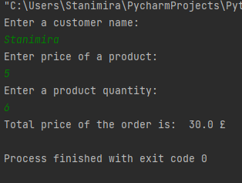
(Figure 18)

Result: Program performed as expected, correct answer calculated.

  - Boundary:

- Test price of a product and product quantity for valid input.
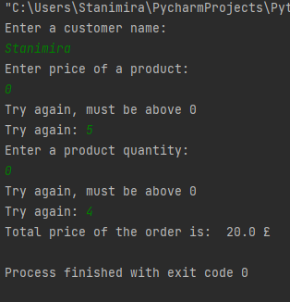

(Figure 19)

Result: User was not allowed to enter 0. Program performed correctly.

- Test for out of range numbers.

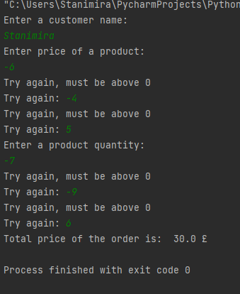
(Figure 20)

Result: User was not allowed to enter out of range numbers. Program performed correctly.

Exercise 2. This exercise requires to design and construct a program allowing the user to calculate a shaded area of a given figure by entering the radii of the inner and outer circles of the figure.
- Logical stages:

- Prompt user to enter radius 1.
- Check that the entered number for R1 is above 0. If not, back to 1.
- Prompt user to enter radius 2.
- Check that the entered number for R2 is above 0. If not, back to 3.
- Define the value of pi.
- Calculate the area of the inner circle using the given formula in the exercise.
- Calculate the area of the outer circle using the given formula.
- Calculate the shaded area.
- Print congratulations message.

- Code with annotation:

# Python program to find the shaded area of the circle
print('Please enter radius R1: ')
R1 = float(input()) # User enters radius 1
while (R1 <= 0): # check radius 1 is positive number
print("Try again, must be above 0")
R1 = float(input('Try again: ')) # try again
print('Please enter radius R2: ')
R2 = float(input()) # User enters radius 2
while (R2 <= 0): # check radius 2 is positive number
print("Try again, must be above 0")
R2 = float(input('Try again: ')) # try again
pi = 3.142 # Defining the value of Pi
area1 = R1 * R1 * pi # Calculates the area of the inner circle using the given formula
print('The area of the inner circle is: ', round(area1, 2))
area2 = R2 * R2 * pi # Calculates the area of the outer circle using the given formula
print('The area of the outer circle is: ', round(area2, 2))
shadedArea = area2 - area1 # Calculates the shaded area
print('The shaded area of the circle is: ', round(shadedArea, 2))
print('\nCongratulations! You successfully calculated the shaded area!')

- Testing:

  - Normal values within range.

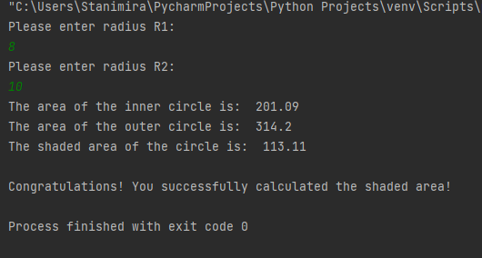

(Figure 21)
Result: Program performed as expected, correct answer calculated.

  - Boundary:

- Test R1 and R2 for valid input.
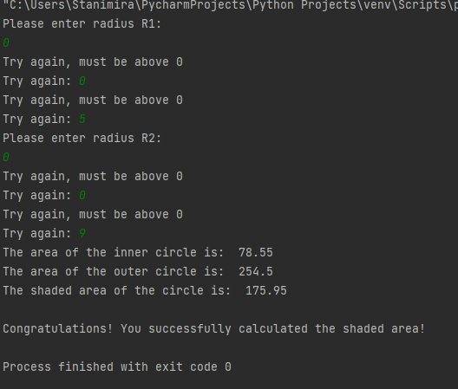

(Figure 22)
Result: User was not allowed to enter 0. Program performed correctly.

- Test for out of range numbers.
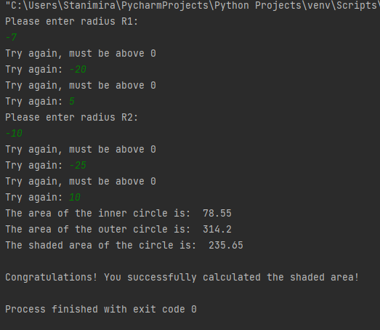

(Figure 23)

Result: User was not allowed to enter out of range numbers. Program performed correctly.

Exercise 3. This exercise requires to write a program for user to enter into two lists the names of five people working in IT department and their monthly salaries. When all five names and salaries are entered, they should be printed on screen. The total amount of money spent for salaries per month should be calculated. Finally, the total amount of money for salary per month with 10% increase should be calculated.
- Logical stages:

  - Creating an empty staff list.
  - Defining the range that the user should enter 5 staff names.
  - Prompt user to enter staff names.
  - Creating an empty salary list.
  - Defining the range that user should enter 5 staff salaries.
  - Prompt user to enter staff salaries.
  - Print out all staff details entered.
  - Calculating the total salary amount.
  - Calculating the salary amount with 10% increase.

- Code with annotation:
# Python program for salary staff calculation
staffList = [] # creating an empty staff list
for counter in range(0,5): # defining 5 user entries
print("Enter staff name: ")
staffList.append(str(input())) # user enters staff names
salaryList = [] # creating an empty salary list
for counter in range(0,5): # defining 5 user entries
print("Enter salary: ")
salaryList.append(float(input())) # user enters staff salary
for counter in range(0,5):
print("Staff details entered: " ,staffList[counter], " ", salaryList[counter]) # print out all details entered
totalSalary = sum(salaryList) # calculate total salary amount
print("The total IT Department employees' monthly salary is: ", totalSalary)
salaryInc = (totalSalary / 10) + totalSalary # calculate total salary with 10% increase
print("Total salary amount with 10% increase would be: ", salaryInc)

- Testing:

- Normal values within range.
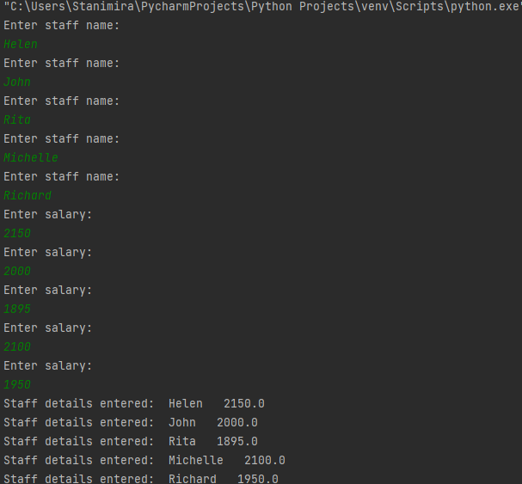
(Figure 24)

Result: Program performed as expected, correct answer calculated.

References list

[1] C. Severance, Python for Informatics: Exploring Information, Version 2.7.3. USA: Charles Severance, October, 2013, p. 24. (accessed Aug. 25, 2021).

[2] C. Singh, “Python Tutorial,” BeginnersBook.com – Tutorials For Beginners, 2018. https://beginnersbook.com/2018/01/python-if-statement-example/ (accessed Aug. 25, 2021).

[3] “Python For Loops,” W3schools.com, 2019. https://www.w3schools.com/python/python_for_loops.asp (accessed Aug. 28, 2021).

