Assignment ONE. Reflective Review of Learning Journey

Danielle tooze
Certificate of Higher Education Skills For The Workplace
University of Wales Trinity Saint David
2000 words
08/03/19

Executive summary

The purpose of this report is to analyse, what I have acknowledged and how I've adapted to university life, since starting the Certificate of Higher Education for Skills in the Workplace course. I feel as though I've acquired a lot of information over approximately the last 8 weeks.
Here in this assignment I will reflect on what I've absorbed from the lectures I've attended.

This report provides an analysis and evaluation of what I've learnt about myself, such as I’m a neuroticism traits person. I engage in group activities and have a passion for research. This assignment is the first of many and a base for learning and growing with my academic skills. This assignment will describe two learning questionnaires that apply to myself, the Go M.A.D Framework, conduct a SWOT Analysis and elaborate on my reflection.

Table of Contents

Executive Summary ………………………………………………………………………… 1
Contents……………………………………………………………………………………...2
Introduction…………………………………………………………………………………. 3
Report………………………………………………………………4/5/6/7/8/9/10/11/12/13
Conclusion……………………………………………………………..…………………14/15
References……………………………………………………………………………………16 Appendices ………………………………………………………………………………17/18

Introduction
My professional career development is the start of my journey on becoming an accounts manager, this course will help me gain a recognised certificate and better understanding of management skills for the future.
Self- awareness is a very important part of life and in business. Knowing who you are is a great start, we use questionnaires such as Vark and Honey and Mumford to find out what type of personality we hold, this gives us a better understanding of how we learn such as watching a YouTube video (visual) secondly could be by reading or writing, thirdly some people like to listen to it (aural) and lastly a lot of people learn more taking the hands on approach (kinesthetics). I am more of a kinesthetics person I always adopt the hands-on approach, I learn a lot more by trying out new activities rather than reading them.

In this report I will be including:
- Executive summary
- Contents page
- Introduction
- Go MAD Framework with an explanation
- SWOT Analysis model and explanation
- Peter Honey and Alan Mumford - learning styles Questionnaire
- The Vark questionnaire
- The five big personality traits
- David Kolb’s Learning Cycle
- Personal Development Plan (conclusion)
- Harvard References
- Appendices


pro-essy-writing.com (2014-2019)
The Big Five Personality Traits

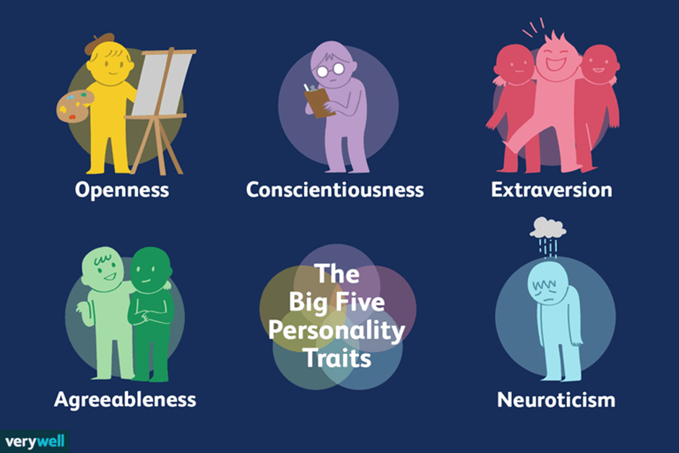
Seong.j (2018)
The Big Five Personality Traits explanation:
Since starting the Certificate, of higher education for Skills, for the workplace course, in January 2019, I have learnt a wide range, of helpful strategies, including the Johari window, the Go Mad theory, also SWOT analysis, Kolb’s learning cycle and lastly Gibbs reflective cycle.
At first I felt like it was all too much, as I hadn’t been in education for a long period of time, now I’m starting to enjoy my classes and like to learn new things such as how to write academically, I’ve learnt what sort of person I am (with the questionnaires in class for example taking the big personality test) the test told me I’m a neuroticism person, I have the personality trait of being emotional, experience alot of stress, gets upset easily, suffer with anxiety and also depressed which is very true. The test asked you a range of 50 questions such as ‘Am I the life of the party?’ or ‘Have I a soft heart?’ and lastly ‘Am full of ideas?’ you must rate all the questions in this format 1-5 with 1 is that you disagree and 5 is agree. Then you calculate the results and the answer can be 1 of 5 traits, including Extroversion -which means you have a personality trait of seeking fulfilment in your life, the next trait is agreeableness – someone who changes their behaviour to suit other people, then you have the conscientiousness - the personality trait of someone hardworking and honest, then you have neuroticism (my trait) someone who is very emotional, lastly is openness to experience – someone who is seeking new experiences and intellectual pursuits.
Always remember a person’s attitude is defined by the situation they are in.
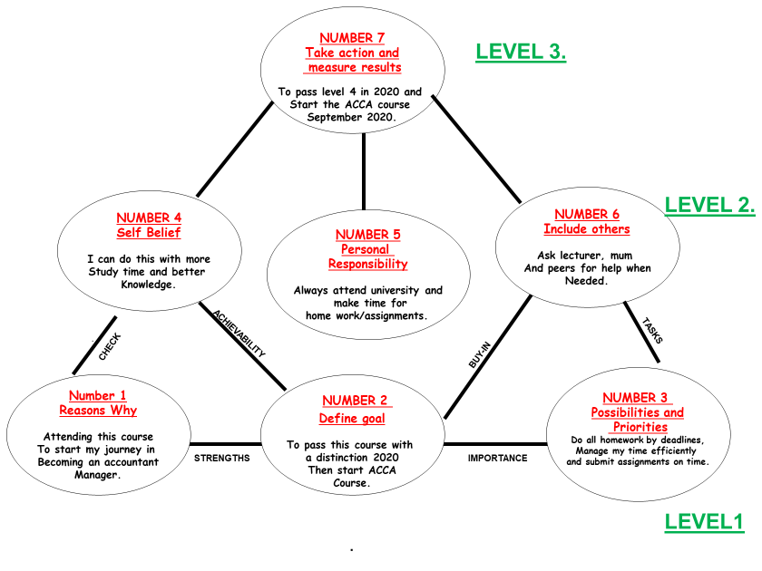Framework from Moodle (accessed 28/02/19)

GO MAD FRAMEWORK

Description
My favourite is this Go M.A.D theory and framework, for me this is the easiest to understand and relate to. In order to reach my goal in the next 5 years I have completed this Go MAD Framework, this model explains how I’m going to get to the end result, there are 7 principles which start from the bottom left hand corner and work across to the right then up and so on, let’s look at the first principle here in this bubble we have my ‘Reason’s why’ I am attending this course as a starting point to learn basic knowledge and skills I will need to grow and get towards my goal which is to become a managing accountant. Onto the second principle ‘Define my goal’ my next step is to pass this Higher Education course with a distinction in January 2020 then start the accountancy course called ACCA (Association of Chartered Certified Accountants) next September 2020. Principle three the ‘possibilities and priorities’ I must do all of the homework that is set in class by my tutor, it must be handed in on time, I must manage my time efficiently for example make time to do my assignments at home and do them at my desk away from distractions. Always hand in assignments by deadlines.

Go Mad – my description continued...

Onto principle four is ‘Self-belief ’I know I can reach my end goal if I make more time to study for instance each week I will write up a plan of study time, I have free time after work and on weekends, this plan will help me complete homework and assignments without rushing to finish them by deadlines. In principle five we explain our ‘personal responsibilities’ we have to make sure that we are responsible for our actions in making sure we move forward and get closer to the goal we want to approach, I will always attend university with a clear mind and a will to learn.
Next, we have principle six ‘include other’s’ This one will help me to understand who I buy-in on my journey to becoming an accountant, first of all I would include my lecturer, as she will educate me, on how, to move forward with valuable information throughout lectures. Lastly we ‘Take action and measure results’ This final step is to pass my current course (skills in the workplace) January 2020 with a distinction and start the ACCA course in September 2020.
This GO M.A.D Framework helps you reach your goal in 7 steps, doing this you can measure your progress to ensure you are moving forward and getting closer to my goal.

This is supported by the Marguerite Ulrich who says…
“We invited Andy Gilbert to be our team coach, conduct a Thinking Effectiveness Audit about the way we worked as a high performing HR Leadership team and then provide feedback and facilitation to improve our performance. Within a couple of sessions, we measurably improved our effectiveness, developed new ways of thinking and are now reaping the results in the way we work. This solution focused approach to thinking is robust, well researched, has great support materials and does what it says – it really helps people and teams Go Make A Difference!”
– Marguerite Ulrich, Chief Human Resources Officer, Veolia UK & Ireland
Go MAD Limited (2019)

David Kolb’s Learning Cycle

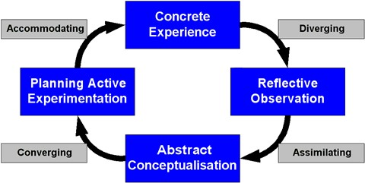
Software example retrieved (2008)
Kolb’s Learning Cycle is based on the John Dewey’s claim that learning must be grounded in experience, Kurt Lewin’s ideas of the importance of active learning, and Jean Piaget’s emphasis on the interaction between person and environment on intelligence.
The four larger boxes in the diagram above represent the four stages that Kolb claims must be fulfilled in order for learning to take place.
Concrete Experience—actually doing the activity
Reflective Observation—reflecting on performance in the activity, considering successes and failures
Abstract Conceptualization—apply theory to the experience of doing the activity
Planning Active Experimentation—consider theory and reflection to guide planning for subsequent experiences

*Soccer Example*
Concrete Experience—player takes part in a training match, attempting to score goals
Reflective Observation—player considers his/her performance, especially her/his scoring attempts
Abstract Conceptualization—player talks to trainer who provides insight concerning scoring techniques Planning Active Experimentation—player uses insights from the trainer as well as experience from the first match to plan for the next match
The smaller boxes refer to the four learning styles that encompass all learners based on an individual’s preferred point of entering the learning cycle
Diverging/Reflectors—Like to think about the activity/concept and observe other peoples’ takes on the matter
Assimilating/Theorists—Relate the task at hand to other experiences or concepts
Converging/Pragmatists—Like to think about how to apply theory in practice Accommodating/Activists—Like to jump in to trying the activity

*Software Example*
How would you first approach learning to use a new software program?
Activist—immediately begin using the software, experimenting with its tools and capabilities
Reflector—Think about your experience with similar software or consult someone who has used this program
Theorist—Read the manual to get a clear grasp on the operations of the program
Pragmatist—Start the software and turn to the help feature to get expert tips
Software example retrieved (2008)

MY KOLB’S REFLECTIVE EXAMPLE
The KOLB learning cycle is an experimental way of learning, for instance the first step is to provide concrete evidence – On the 18th of February 2019 me and 3 other peers (Sam, Monika and Lisa) did a group presentation. The second step is to reflect observation – In all fairness as a group we performed well, our presentation was how Vodafone communicates with its customers, we had 4 questions to research, we split the questions and took one each. Monika had question 1 – The team are required to provide information on the background to the organisation. Further, the team will identify why effective communication is important to Vodafone... Monika did amazing she researched about Vodafone with a fine-tooth comb, she even learnt about scholarships they do.
I had to research question 2 – The team will describe the communication strategies in place for customers currently… I think I did pretty well considering my last presentation was appalling I stuttered and swore a few times which is unacceptable, this performance I was confident, I revised and put a lot of planning an effort in to ensure I didn’t make the same mistake twice.
Thirdly Sam answered question 3 – The team will describe the communication strategies in place currently for other stakeholders... Sam was very confident, knew exactly what she had to say and spoke very clearly.
Then lastly Lisa had question 4 – The team will make recommendations which will further improve communications at Vodafone… I thought Lisa had no idea what she was on about, no one could hear her and she didn’t once look at the audience, she never practiced with us a group which is a shame as we could be marked down for her poor input.

Freepik Company (2013-2019)

Reflective observation - As I reflect on this presentation, I have realised that not everyone will put in the same effort when working in a group and we should be more selective with who we choose to work with in the future.

Abstract Conceptualization – we should have told the lecturer about the problems with communication with Lisa before the day of the presentation and we shouldn’t have included her on our contribution audit as she didn’t do a lot of input to the group performance.

Planning Active Experimentation – here forward we would be more careful who we group with for the next presentation in class, secondly, we could learn a lot more from ted talks and our lecturer on how to present in a professional way.

There are four learning styles...
Firstly, we have the activist - (me) I’m pretty sure I have the traits of an activist – for example I like to jump in and attempt new question sheets the lecturer hands out, for me I like to get on with things and be told when I’m wrong then the next time I will get it correct.
Secondly, we have the reflector – someone who will reflect on something or gather information before attempting something new.
Thirdly we have the Theorist – The smart one who will always read the instructions before putting together a chest of drawers.
Lastly, we have the Pragmatist – The one who will go to the help desk to ask about all the new features on the new smart Televisions.

‘It is not sufficient to have an experience in order to learn. Without reflecting on this experience, it may quickly be forgotten, or its learning potential lost.’ (Gibbs, 1988, p9)

SWOT Analysis
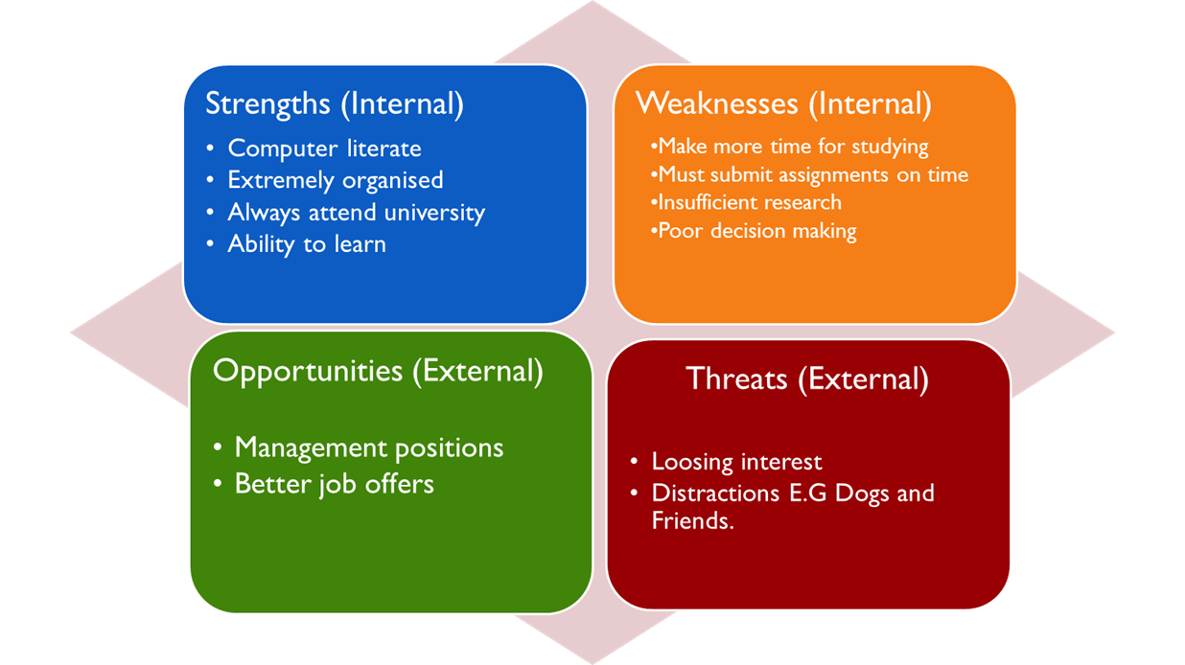

S.W.O.T Analysis is a very simple model with very effective use, this is used in a lot of different sectors such as new businesses, developing businesses, colleges and universities. In our university we use this model to measure our goal and with four steps how we can get there, by thinking about the internal and external problems we may have to address.

(Threat) (Opportunities)
Distractions at my home… Better job prospects….

Banshockcollars.ca (2007) Morocco.D.; (2018)

S.W.O.T ANALYSIS

Applications of SWOT analysis
A SWOT analysis can be used for:
- Workshop sessions
- Brainstorm meetings
- Problem solving
- Planning
- Product evaluation
- Competitor evaluation
- Personal Development Planning
- Decision Making (with force field analysis)

SWOT Matrix:
SWOT Analysis | POSITIVE/ HELPFUL to achieving the goal | NEGATIVE/ HARMFUL/ RISKS to achieving the goal
INTERNAL Origin  facts/ factors of the organization | Strengths  Things that are good now, maintain them, build on them and use as leverage | Weaknesses  Things that are bad now, remedy, change or stop them.
EXTERNAL Origin  facts/ factors of the environment in which the organization operates | Opportunities  Things that are good for the future, prioritize them, capture them, build on them and optimize | Threats  Things that are bad for the future, put in plans to manage them or counter them ©rapidbi.com
RabitBI 1999-2019

- Strengths need to be maintained, built upon or leveraged.

- Weaknesses need to be remedied, changed or stopped.

- Opportunities need to be prioritized, captured, built on and optimized.

- Threats need to be countered or minimized and managed
How to do a SWOT

- Irrespective of whether you or your team are future planning for specific products, work, personal or any other area, the SWOT analysis process is the same.
- Step 1 of a swot analysis– Information collection – In the here and now… List all strengths that exist now. Then in turn, list all weaknesses that exist now. Be realistic but avoid modesty!
  - You can conduct one-on-one interviews. Or get a group together to brainstorm. A bit of both is frequently best.
  - You’ll first want to prepare questions that relate to the specific company or product that you are analysing. You’ll find some questions and issues below to get you going.
  - When facilitating a SWOT – search for insight through intelligent questioning and probing

- Step 2 of a swot analysis– What might be… List all opportunities that exist in the future. Opportunities are potential future strengths. Then in turn, list all threats that exist in the future. Threats are potential future weaknesses.

- Step 3 of a swot analysis– Plan of action… Review your SWOT matrix with a view to creating an action plan to address each of the four areas.
- In summary a swot analysis:

RabitBI 1999-2019
https://rapidbi.com/swotanalysis/
(accessed on 28/02/19)

CONCLUSION

Personal Development Plan

Area of Strength | Ways to use it more extensively
- I have learnt a lot about myself
  - I have learnt to study under pressure and push my limits to complete coursework with tight deadlines
- Capable of completing work within short periods of time | - I have learnt to study under pressure and push my limits to complete coursework with tight deadlines
3. Extremely Organised | - Always have a study plan between work and lectures  - Clear desk away from distractions to do assignments
Area for development | Ways to use address it
- Listen to Lecturer | - Always Listen to lecturer  - Listen to Ted talks  - Research when I don’t understand
- Ask for Advise | - Always ask for help if I don’t understand.  - Ask peers for advice  - Get extra help with student services
- Talk Less | - Listen more, talk less  - Don’t get distracted by others in lecture

My conclusion is as follows, while attending this course at The University of Trinity Saint David’s I have learnt a lot about one’s self, I am an emotional person that likes to learn by action or activity rather than reading or writing. For me all these theories are very apparent but never the less the Go MAD Framework and theory is bold and easy to understand.

References
- 1 Joshua Seong. © Verywell, 2018. https://www.verywellmind.com/the-big-five-personality-dimensions-2795422 (accessed on 29/02/19)

- Framework from Moodle (accessed 28/02/19)

- 3 Go MAD Limited (2019)
https://www.gomadthinking.com/accelerating-results/coaching-facilitation/} (accessed on 02/03/19)

- Mobbs. R.; (2018)
https://www2.le.ac.uk/departments/doctoralcollege/training/eresources/teaching/theories/kolb(ACCESSED ON 01/03/19)

- Soccer example retrieved (2008) example retrieved 1/9/08 from {http://nwlink.com/~donclark/hrd/ styles.html} (Accessed on 01/03/19)

- Gibbs, G.; (1988). Learning by doing: a guide to teaching and learning methods. Oxford: Further Education Unit, Oxford Polytechnic (Accessed on 03/03/19)

- Freepik Company (2013-2019) {https://www.flaticon.com/premium-icon/group_95211] group premium icon (accessed 03/03/19)

- Shock collars (2007){http://www.banshockcollars.ca/studies.php} Ban shock collars (accessed on 06/03/19)

- Morocco.Dakhia.; (2018) {https://chickenloop.com/job/morocco/kitesurf-center-manager} The water sports job board (accessed on 07/03/19)

- pro-essay-writing.com (2014-2019) {https://pro-essay-writer.com/blog/essay-introduction} How to Write an Essay Introduction: Tips and Tricks (accessed 07/03/19)

