

RESULT

ASSIGNMENT DETAILS AND FEEDBACK

SOUTH WEST WALES CENTRE OF TEACHER EDUCATION

Sections marked with * should be completed by module lead
Student name: | Georgia Ivett | Student number: | 1500126
Programme: | BA Primary Education with QTS
Module: * | Pedagogy in Practice 2 – Assessment for Learning | Module Level (4, 5, 6): | 6
Module code: * | ECAD6004/C | Contribution to Overall  Module Assessment (%): * | 50%
Module Lead:* | Mr T. Cox
Start date:* | 3/10/17 | Assignment No (x of x):* | 1 of 1
Submission deadline:* | 15/12/17 | Return date of provisional marks & written feedback:* | 26/1/18
Assignment Title:* | Critically evaluate your creativity and enterprise dispositions in terms of the Entrecomp frame work and how you might develop these to the next level and demonstrate progression.

Referencing: | In the main body of your submission you must give credit to authors on whose research your work is based. Append to your submission a reference list that indicates the books, articles, etc. that you have read or quoted in order to complete this assignment (e.g. for books: surname of author and initials, year of publication, title of book, edition, publisher: place of publication).
Submission: | All assignments must be submitted to Turnitin unless otherwise instructed by the Lecturer.  Note: the Turnitin version is the primary submission and acts as a receipt for the student. Late submission of the electronic version of the assignment will result in a late penalty. Penalties for late submission: Up to one week late, maximum 40%. Over one week late will be recorded as a non-submission. Late submission penalties may be lifted only with the approval of the Extenuating Circumstances Panel. | Date: | 15/12/17

Module lead to tick to indicate if a hard copy version of the assignment must be submitted.* | YES
 | NO | X

marking criteria and Student FEEDBACK

This section details the assessment criteria. The extent to which these are demonstrated by you determines your mark. The marks available for each criterion are shown. Lecturers will use the space provided to comment on the achievement of the task(s), including those areas in which you have performed well and areas that would benefit from development/improvement.

Common Assessment Criteria Applied | Marks available | Marks  awarded
1. Subject Knowledge and Understanding (which includes using research-informed literature and knowledge and understanding of the subject)  Extent of research and/or own reading, selection of credible sources, application of appropriate referencing conventions. Extent of knowledge and understanding of concepts and underlying principles associated with the discipline. | 30
2. Intellectual Skills (Analysis)  Analysis, evaluation and synthesis; logic, argument and judgement; analytical reflection; organisation of ideas and evidence | 30
3. Pedagogic and Professional Applications (Practical Application and Deployment)  Deployment of pedagogic methods, materials, tools and techniques; application of concepts; formulation of innovative and creative solutions to solve problems. Attributes in professional practice: individual and collaborative working | 30
4. Key Transferable Skills  Deployment of appropriate media; presentation and organisation. | 10

Assignment Mark (Assessment marks are subject to ratification at the Exam Board. These comments and marks are to give feedback on module work and are for guidance only until they are confirmed. ) | Late Submission Penalties (tick if appropriate) |  | %
 | Up to 1 week late | 40% Max | %
 | Over 1 week late | 0% | %
ASSESSMENT AND MARKING CRITERIA FOR ECAD5001/C ASSIGNMENT

Assessment Criteria Descriptors for BA Primary Education with QTS
This format emphasizes the holistic nature of judgements to be made by markers. Criteria weighting is adjusted for each module.
 | 0-39 (F) | 40-49 (P) | 50-59 (P) | 60-69 (P) | 70-79 (P) | 80-100 (P)
 | Poor / Weak F | Satisfactory 3rd | Good 2:2 | Very good 2:1 | Excellent 1st
Assessment Criteria | Poor, superficial, unsystematic, incomplete and/or inaccurate | Satisfactory understanding of main issues demonstrated | Good understanding demonstrated with some analysis | Very good understanding of basic principles and relevant evidence, with a coherent and logical argument | Thoughtful answer informed by wider reading, showing clarity of thought and personal insight | Outstanding answer, well written, highly structured and informed, showing striking personal insight and originality
Module Learning Outcomes matched to: | 0-11 | 12-14 | 15-17 | 18-20 | 21-23 | 24-30
Subject Knowledge and Understanding  (Conceptual)  (Reading) | Basic misunderstanding, misconceptions, misinterpretations and/or superficial knowledge in places | Outline knowledge of few key issues with evidence of understanding and application | Defined knowledge of some key issues and wider implications | Wider knowledge of most key issues, concepts and arguments | Clear understanding of the key issues under discussion with logical discussion | Excellent knowledge of key issues, concepts and arguments clearly discussed
Subject Knowledge and Understanding  (Conceptual)  (Reading) | Some inappropriate literature/material with limited reading range and lack of accuracy | Satisfactory range of reading drawn from the recommended list and other sources | Good range of reading drawn from the recommended list and other sources | Very good range of relevant literature from a variety of sources beyond recommended list | Evidence of well-considered thinking from a wide reading base using a variety of sources | Clear evidence of independent thinking informed by an excellent range of reading from a variety of sources
 | 0-11 | 12-14 | 15-17 | 18-20 | 21-23 | 24-30
Intellectual skills  (argument)  (presentation of findings/analysis)  (critical /reflective evaluation) | Argument is weak, little attempt to present differing viewpoints.  Generally too descriptive | The argument is beginning to be balanced with a growing awareness of other viewpoints | A balanced argument is presented while attempting to justify other viewpoints | A balanced argument is presented showing an understanding of different viewpoints and the reasoning behind them | A thoughtful argument is presented with appropriate consideration of viewpoints | A well- structured critical argument is presented with insightful consideration of viewpoints
 | Findings presented within incomplete descriptive framework and few or inaccurate conclusions are drawn | Findings are beginning to be presented in a developing framework with some analysis and reasonable conclusions | Findings are presented in a framework with some analysis and interpretation of data to form reasonable conclusions | Findings are presented in a framework with some analysis, interpretation and evaluation of data to form reasonable conclusions | Findings presented with some analysis and justified conclusions | Findings presented in a critical and analytical framework. Thoughtful conclusions, firmly based upon the evidence presented
 | Lack of evidence of evaluation and/or critical reflection | Evaluation and/or reflection are present but lacks depth | Good engagement with evaluation and reflection | Very good evidence of beginning to evaluate and critically reflect | Evidence of thoughtful critical engagement with evaluation and reflection | Effective and more in-depth critical engagement with evaluation and reflection
 | 0-11 | 12-14 | 15-17 | 18-20 | 21-23 | 24-30
Pedagogic and Professional applications  (linking theory to practice)  (professional reflection)  (ethical conduct where appropriate) | Superficial or lack of understanding of pedagogic and professional context(s) | Relates principles and concepts to underlying theoretical frameworks and approaches with respect to the pedagogic and professional context(s) | Identifies principles/ concepts underlying theoretical frameworks and begins to identify their strengths and weaknesses with respect to the pedagogic and professional context(s) | Evidence of the use of relevant research or developments to inform actions with respect to the pedagogic and professional context(s) | Clear evidence of integration of theory and practice with respect to the pedagogic and professional context(s) | Effective integration of theory and practice with respect to the pedagogic and professional context(s)
 | Little or no evidence of reflection | Reflection is evident | Evidence of good reflection | Beginning to critically reflect | Critical reflection is evident | Effective and in-depth logical and critical reflection is evident
 | Little or no awareness of ethical issues | Awareness of ethical issues | Awareness of ethical issues and able to discuss these in relation to personal beliefs and values | Ethical issues have been discussed showing an awareness of personal responsibility and professional codes of conduct | Ethical issues have been clearly discussed in the context of personal responsibility and professional codes of conduct | Ethical issues have been effectively addressed especially in the context of personal responsibility and professional codes of conduct
 | 0-3 | 4 | 5 | 6 | 7 | 8-10
Key/Transferable Skills  (Referencing techniques) | Weak presentation of written work | Satisfactory presentation of written work | Good presentation of written work | Very good presentation of written work | Effective presentation of written work | Outstanding presentation of written work
Key/Transferable Skills  (Referencing techniques) | A number of basic errors in spelling, punctuation or grammar | Some errors in spelling, punctuation or grammar | Few errors in spelling, punctuation or grammar | Very few errors in written language | Minor errors in written language | No errors in written language
Key/Transferable Skills  (Referencing techniques) | Weak structure with unclear writing style in parts | Satisfactory structure with a mostly coherent writing style | Good structure with a coherent writing style | Very good structure which supports the reader | Effective structure which supports the reader | Highly coherent and mature writing style which fully engages the reader
Key/Transferable Skills  (Referencing techniques) | Little or no use of protocols and conventions of Harvard referencing | Satisfactory use of Harvard referencing protocols and conventions | Good use of Harvard referencing protocols and conventions | Harvard system mainly used accurately, with some secondary sources | Harvard system used accurately including secondary sources | Harvard system used accurately, consistently and effectively with all sources

Student Self Evaluation Form

This section repeats in brief the common assessment criteria detailed on previous pages. The extent to which these are demonstrated by you determines your mark. Using these criteria, tick the box that best indicates the level of achievement you feel you have achieved with regard to each of them.

Common Assessment Criteria Applied | Level of Achievement
Common Assessment Criteria Applied | REFER |  | 3rd | 2:2 | 2:1 | 1st | 1st
 | OUTRIGHT FAIL | UNSATISFACTORY | SATISFACTORY | GOOD | VERY GOOD | EXCELLENT | EXCEPTIONAL
1. Subject Knowledge and Understanding (which includes using research-informed literature and knowledge and understanding of the subject) | 0-29% | 30-39% | 40-49% | 50-59% | 60-69% | 70-79% | 80-100%
 |  |  |  | x
2. Intellectual Skills (Analysis) | 0-29% | 30-39% | 40-49% | 50-59% | 60-69% | 70-79% | 80-100%
2. Intellectual Skills (Analysis) |  |  |  |  | x
3. Pedagogic and Professional Applications  (Practical Application and Deployment) | 0-29% | 30-39% | 40-49% | 50-59% | 60-69% | 70-79% | 80-100%
 |  |  |  | x
4. Key Transferable Skills | 0-29% | 30-39% | 40-49% | 50-59% | 60-69% | 70-79% | 80-100%
4. Key Transferable Skills |  |  |  |  | x
PLEASE COMMENT ON AREAS IN WHICH YOU FEEL THAT YOU HAVE PERFORMED WELL | PLEASE COMMENT ON AREAS you feel that you need TO DEVELOP
I feel like have a sound understanding on what creative and enterprise dispositions are and how they are effective within the classroom.  I understand EntreComp and feel like I could use it in the future. | I don’t feel like I have made my recommendations as clear as I could as I struggled talking about my own dispositions – I struggle writing a personal but yet academic reflection.
Student’s Name | Georgia Ivett | Date | 12.12.17
Student’s Signature | GIvett

Critically evaluate your creativity and enterprise dispositions in terms of the EntreComp Framework and how you might develop these to the next level and demonstrate progress.

This assignment aims to provide a critical evaluation in response to the authors creativity and enterprise dispositions with regards to particular aspects of the EntreComp Framework and how they may develop professionally in these areas to advance to the next level and demonstrate progress. Usher, D (2003) redeveloped Combs’ (1999) five areas of belief of good helpers into five dispositions for effective practitioners, the fundamental expectations of behaviour is one of the only indicators of the effectiveness of a practitioner’s significance from the perceptual state of the practitioners at the time of their actions; that to comprehend the dynamics of their behaviour and its efficiency, attention needs to be focused on personal meanings or dispositions.

The five dispositions of effective practitioners are classed as: empathy, seeking and accepting other’s point of view; positive view of others, believing in the worth, ability and potential; positive view of self, believing in the worth, ability and potential of themselves; authenticity, feeling a sense of freedom and openness to enable honesty and truth; meaningful purpose and vision, committing to purposes that is primarily person-centred, broad, deep, freeing and long range in nature.

The National Council for Accreditation in Teacher Education (NCATE) defines dispositions as the values, professional ethics and commitments which can influence behaviours directed towards learners, families and colleagues to validity and benefit learning, motivation, enthusiasm and development as well as the personal, professional growth of the practitioner. They indicate that dispositions are directed by attitudes and beliefs associated to values such as honesty, fairness, caring and social justice. Similarly, Thorndike-Barnhard’s advanced dictionary conveys dispositions as the qualities that exemplify a person as an individual: the rigid perceptual qualities that establish a person’s natural way of thinking and acting.

Creativity and dispositions work hand in hand, the National Advisory Committee on Creative and Cultural Education (1999) portray creativity as ‘imaginative activity fashioned so as to produce outcomes that are both original and of value’ (p.29). Creativity is the original thought, the spark, the ignition and the blueprint of innovating and imaginative ideas. Creative people are frequently viewed as demanding or ‘difficult’ to manage, the creative mind is by its very nature is uncontrollable – it can be a rare gift, or a huge challenge.

There tends to be natural strain between orderly self-control and innovative desire. There are numerous schools which claim to be creative, but most that the practitioners can do is to create a stimulating and innovative environment and support the learners to nurture it. Developing creativity depends on the learner’s willingness and ability to share it, without creativity, there tends to be no real innovation; practitioners need to encourage learners to become idea generators, modifiers and divergent thinkers. “What we have concluded,” wrote Land (1993), “is that non-creative behaviour is learnt.”

The Dorsolateral Prefrontal Cortex (DLPFC) is the last aspect of the brain to mature, this neurological development usually occurs between the ages of 20 – 24 years old. The DLPFC is responsible for planning and action sequencing and holds information as working memories. During times of improvisation the DLPFC shuts down and deactivates – the brain can work against you when it comes to creativity, it prevents idea generation. This could be the reason practitioners often struggle to come up with innovative, creative and enterprising ideas spontaneously.

“For many teachers and schools, the key task has become to implement the prescribed external expectations for the curriculums and accountability, faithfully, with a consequent diminution of both local creativity and responsiveness to the individual needs of children and young people.” (Donaldson, 2015: 15)

Creativity and enterprise are central features of modern life that should be developed via education. Enterprising and creative contributions engage learners in activities that develop enterprising skills and dispositions; understanding how to exercise their democratic rights and responsibilities. Enterprise education is a high priority for the Government as it equips learners with an enhance capacity to generate ideas and the skills to make them happen for their own benefit and that of the economy and the local community.

Enterprise capability is the ability to be innovative, creative, to take risks and manage them, to have a can-do attitude and the drive to make ideas happen. Engaging practitioners’ in enterprise education can be difficult as many practitioners can be concerned that it will add to their workload, or it may not be relevant to the curriculum. However, the most important message to get across is that this need not be a time-consuming role, many practitioners realise that some of the curriculum activities are already ‘enterprising’ as only few tweaks are needed and it can integrate cross-curricular.

Some may ask, why do we need enterprise education? Well, it is an important aspect which all practitioners should consider implementing within the curriculum as it can help to increase the skill level and in particular it can aid the development of the learner’s knowledge and understanding of real world problems and issues, similarly to the same effects of problem based learning in the classroom. The benefits to this approach of teaching and learning is to improve educational outcomes; reducing alienation from learning; raise awareness of the real world; increase partnerships between the school and businesses in the locality; develop more career paths for the learners; create and increase satisfactions within the learning process.

To build a more entrepreneurial Europe the European Commissioner asked experts from across the EU to elaborate a policy tool to help government, curriculum specialists, and teachers to build an entrepreneurial culture. The experts developed the European Entrepreneurship Competence Framework, also known as EntreComp. EntreComp is an instrument to support and encourage the common understanding of entrepreneurship competencies which facilitates people to sustain their life chances and employability. EntreComp is a common indication which recognises fifteen competencies in three key areas that describe what is means to become entrepreneurial. The EntreComp Framework has numerous possibilities in which can be implemented in an array of ways.

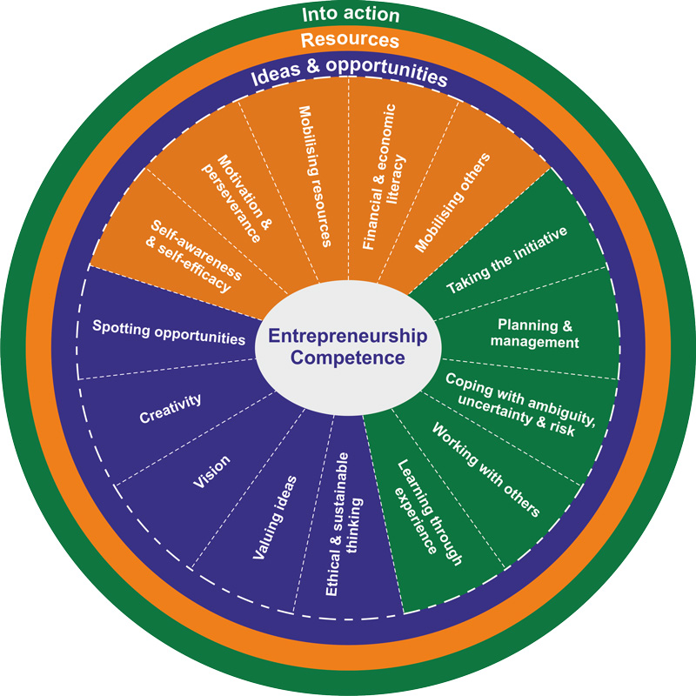
https://ec.europa.eu/jrc/en/entrecomp/entrepreurship-competence-framework

[Accessed 10.12.17]

[

EntreComp can be used throughout various sectors and can be a key provision for partnerships and developmental work by educators, employers, trainers, professional bodies and policy-makers. Dunker (1985) debated that innovation is one of the main tools of entrepreneurship, both innovation and entrepreneurship demands creativity. “Creativity and entrepreneurship seem to be central concepts for understanding the driving forces in 21st century capitalist economies and societies.” (Stemburg and Krauss, 2014:1). Wyckoff et al. (1999) defines creativity as new and useful, it is the act of seeing things from a different perspective and making new connections that no one else has made. Creativity is the aptitude of making or bringing into existence something new, whether it is a solution to a problem, a new method or device, or a new artistic form or object.

Each pillar of the EntreComp Framework identifies specific competencies which should be promoted to bring value to individuals and their communities. These competencies include creativity, working with others, learning through experience and valuing ideas. Each of the competencies include learning outcomes for all levels of education and training, each learning outcome increasingly builds upon others creating a lifelong learning series.

The author’s creativity is not as prominent and engaging as they wish it to be, they often struggle to force and generate ideas on the spot, their DLPFC is developing which prevents ideas on occasions from surfacing. Everyone has substantial creative ability, but they need to believe in themselves and explore something new, accept change and be willing to play with ideas and possibilities.
Developing creative and purposeful ideas (1.2 – EntreComp) doesn’t come as easy to the authors as it may do for others, on occasions they may only come up with one successful idea throughout the day, and on average people are usually developing at least four ideas a minute. However, when they do find an idea which is purposeful it tends to combine knowledge and resources to achieve valuable outcomes and effects for teaching and learning. These outcomes include finding better solutions to existing and new challenges by exploring and experimenting innovative approaches. Actively engaging in exercises which nurture divergent or unconventional thinking which inspire the initiation of several ideas and opportunities to create value and worth. When the author is examining various solutions for their own innovative creativity, mind-maps are a powerful way to come up with lessons and/or ideas to gain clarity around a specific topic (See Appendix 1). Mind-mapping helps the author focus on one focal point.

In relation to the EntreComp Framework the author would place themselves within level two as they are able to explore new ways to make use of existing resources, can work co-operatively, can explore open-ended problems to produce several resolutions and is able to improve in order to meet the differentiated needs of others (See Appendix 2). In order to improve and develop professionally with creativity and enterprise the author needs to actively search for solutions that can improve the teaching and learning process and develop and deliver values by applying them into different design approaches to create new products, processes or services. Donaldson (2015) suggests that the learners as well as the practitioner’s experiences at schools should be stimulates through imagination using techniques that stimulate excitement, are personally fulfilling and foster creative thinking. They need to be ready to enter the working world with disposition skills and attitudes which will be essential for them to become life-long learners.

The author tends to value all possible ideas (1.4 – EntreComp) which are generated either by themselves or their learners whilst on teaching practice, they judge what values are in terms of social, cultural and economic positions and recognise the potential of an idea for creating value and identifying suitable ways of making the most out of it. The author has a gate-keeping role to play when it comes to integrating creativity and enterprise into the curriculum. Generating and valuing ideas for the author is at the heart of all academic disciplines and feels fundamentally that they, as well as those they educate should work together to produce academic work which should be a creative and innovative process. When the author starts a new topic or project during teaching practice they ask the learners what they would like to find out and what they didn’t understand as they want to support the learners to achieve their maximum potential. Educating learners should make full use of wider skills within and across the curriculum, predominantly when it comes to problem solving, creative and critical thinking. They wanted to provide a challenging and stimulating curriculum for all, through a secure, happy and inclusive learning environment, they wanted to promote an ethos where all the learners felt a sense of belonging and pride in themselves and their work. Corresponding to the philosophy of ‘The Leonardo Effect’, allowing the learners to participate fully in the planning process to ensure they felt valued and give them a sense of ownership. The EntreComp Framework looks at life-long learners, just like Donaldson (2015). In relation the EntreComp, the author would classify themselves as level one as they are able to find examples of ideas which are beneficial for themselves as practitioners and for their learners and are able to clarify how any idea can be used, whilst respecting everyone’s rights in relation to the United Nations Conventions of the Rights of the Child (Appendix 3). In order for the author to progress professionally and personally they need to advance in decision making to aid the type of values they want to act upon to choose the fitting pathway to do so and the reasons behind the purpose of sharing and protecting the ideas created (Appendix 4)

The author got criticised by their class mentor on teaching practice for doing this due to the fact they believed the practitioner should have sole responsibility of what the learners learn and shouldn’t ask what they did and did not understand. The author wanted to express the learners’ beliefs and creativity, not just their own, ensuring that they are enterprising, creative contributors, promoting. Dunker noted that this problem requires participant to overcome their tendency for ‘functional fixedness’. “However, if the aim is to create a high-performing system, approaches should focus less on central direction and more on the need to develop local responsibility and decision making, build capacity and engage teachers and schools more creatively in the improvement process” (Donaldson, 2015: 99).
When professionally reflecting, the most significant aspect of the authors creative and enterprise dispositions arise from working with others (3.4 – EntreComp) and learning from experiences (3.5 – EntreComp). Working together and co-operating with others to develop ideas and putting them into action whilst networking; solving conflicts and facing up to competitions positively when necessary. The author uses their own initiative when all else fails to support creative and enterprising learning opportunities, by reflecting and learning from both success and failure (Appendix 5).
To conclude, there are copious descriptions of innovation and creativity. Personally, creativity and enterprise are centralised around innovation as they are a process which similarly generate new stimulating ideas and implementing them successfully. Encouraging and engaging practitioners to work collaboratively and creatively across the prospectus in a cross curricular manner, in the context of Donaldson’s (2015) four curriculum purposes is key as practitioners need to have the ability to support learners to make valuable links across teaching and learning, to bring together significant philosophies for enterprising, creative contributors. Practitioners, like the author, need to have the ability to connect and apply knowledge and skills to create ideas; think creatively to solve problems; identify and grasp opportunities; take reasonable risks; and express ideas through multi-media approaches.

In a nutshell, practitioners need to have enterprise and entrepreneurial skills as well creative attributions to become successful in their profession. Explicitly the essential skills such as networking, risk taking, observing, collaborating and being proactive in teaching and learning opportunities. Crucial features of an enterprising teaching and learning environment should ensure that the curriculum is relevant to each individual learner’s needs and abilities - practitioners and learners should be able to appreciate that all learning areas can be integrated cross-curricular, at the same time, they need to understand enterprising skills and attitudes can be developed across the board.
The EntreComp Framework and all the 15 competencies develop personal and profession creativity and enterprise characteristics, it is an inclusive, adaptable and multi-purposeful guide to understand the knowledge, attitudes and skills to encourage creative and enterprise dispositions for all. It explores the relevance and practical application of entrepreneurial learning outcomes in various settings, in the authors case for a primary education perspective.

Nevertheless, successful teaching and learning should promote highly determined, confident, creative and innovators. “Creativity can solve almost any problem. The creative act, the defeat of habit by originality overcomes everything.” (George Lois). For many practitioners and schools, the mission has developed to implement the proposed external probabilities for the curriculum and accountability, with dwindling results of the creativity and awareness for the individual needs of the learners and practitioners.

References:
- Bacigalupo, M., Kampylis, P., Punie, Y., Van d en Brande, G. (2016). EntreComp: The Entrepreneurship Competence Framework. Luxembourg: Publication Office of the European Union
- Bridge, J., O’Neill, K. & Cromie, S. (2003) Understanding Enterprise, Entrepreneurship & Small Business, Basingstoke: Palgrave Macmillan.
- Combs, A.W. (1999) Being and Becoming: A filed Approach to Psychology. New York: Springer Publishing Company.
- Craft, A. (2000) Creativity Across the Primary Curriculum, Abingdon: Routledge.
- Department for children, schools and families (2015) A Guide to Enterprise Education. [PDF] Available at: http://www.readyunlimited.com/wp-content/uploads/2015/09/Guide_to_Enterprise_Education-DCSF.pdf. [Accessed 9 December 2017].
- Donaldson, G. (2015) Successful Futures. Cardiff: Welsh Assembly Government.
- Dunker, P.F. (1985) Innovation and Entrepreneurship. London: Pan Books Ltd.
- EU Hub. (2016) EntreComp Support Material. [ONLINE] Available at: https://ec.europa.eu/jrc/en/entrecomp/support-material. [Accessed 11 December 2017].
- EU Hub. (2017) Entrepreneurship Competence – European Commission. [ONLINE] Available at: https://ec.europa.eu/jrc/en/entrecomp/entrepreurship-competence-framework. [Accessed 10 December 2017].
- Fumoto, H., Robson, S., Greenfield, S. & Hargreaves, D. (2012) Young Children’s Creative Thinking, London: SAGE Publications Ltd.
- Land, G., and Jarman, B. (1993) Breaking point and beyond. San Francisco: Leadership 2000 Ltd.
- National Advisory Committee on Creative and Cultural Education. (1999) All our Futures: creativity, culture and education. London: DfEE.
- Sternberg, A., and Krauss, G. (2014) Handbook of Research and Entrepreneurship and Creativity. Cheltenham: Edward Elgar Publishing Ltd.
- The European Entrepreneurship Competence Framework (2016) Employment, Social Affairs and Inclusion. [ONLINE] Available at: http://ec.europa.eu/social/main.jsp?catId=1317&langId=en. [Accessed 12 December 2017].
- The National Council for Accreditation in Teacher Education (2014) Programme Standards and Reports. [ONLINE] Available at: http://www.ncate.org/Standards/ProgramStandardsandReportForms/tabid/676/Default.aspx [Accessed 12 December 2017].
- Throne, K. (2007) Essential Creativity in the classroom, Inspiring Kids. Oxon: Routledge.
- Thorndike, E.L. (1996) Thorndike-Barnhard Dictionary. Illinois: Pearson Scott Foresman.
- University of Plymouth. (2017) Enterprise, creativity and self-employment. Available at: https://www.plymouth.ac.uk/your-university/teaching-and-learning/employability-in-the-curriculum-and-beyond/enterprise-and-self-employment. [Accessed 12 December 2017].
- Usher, D. (2003) 2nd National Symposium on Educator Dispositions. Nurturing five Dispositions of Effective Teachers. [PDF] Available at: http://dartep.org/handouts/Dispositionsproceddingssession_P.pdf [Accessed 10 December 2017].
- Welsh Dimension, International Perspectives and Wider Skills Working Group 3-4, November 2016, Park Plaza, Cardiff.
- Woods, P. (1995) Creative Teachers in Primary Schools, Buckingham: Open University Press.

Appendix 1:
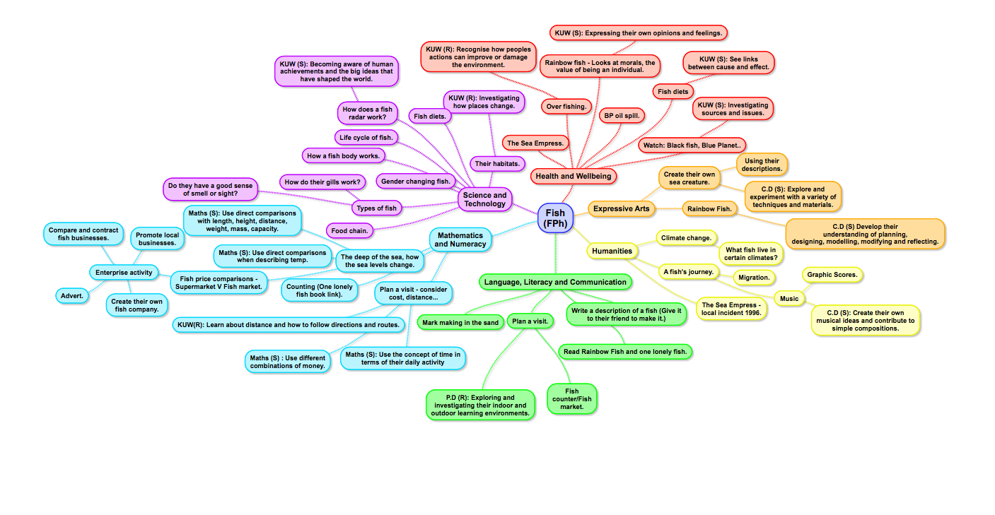
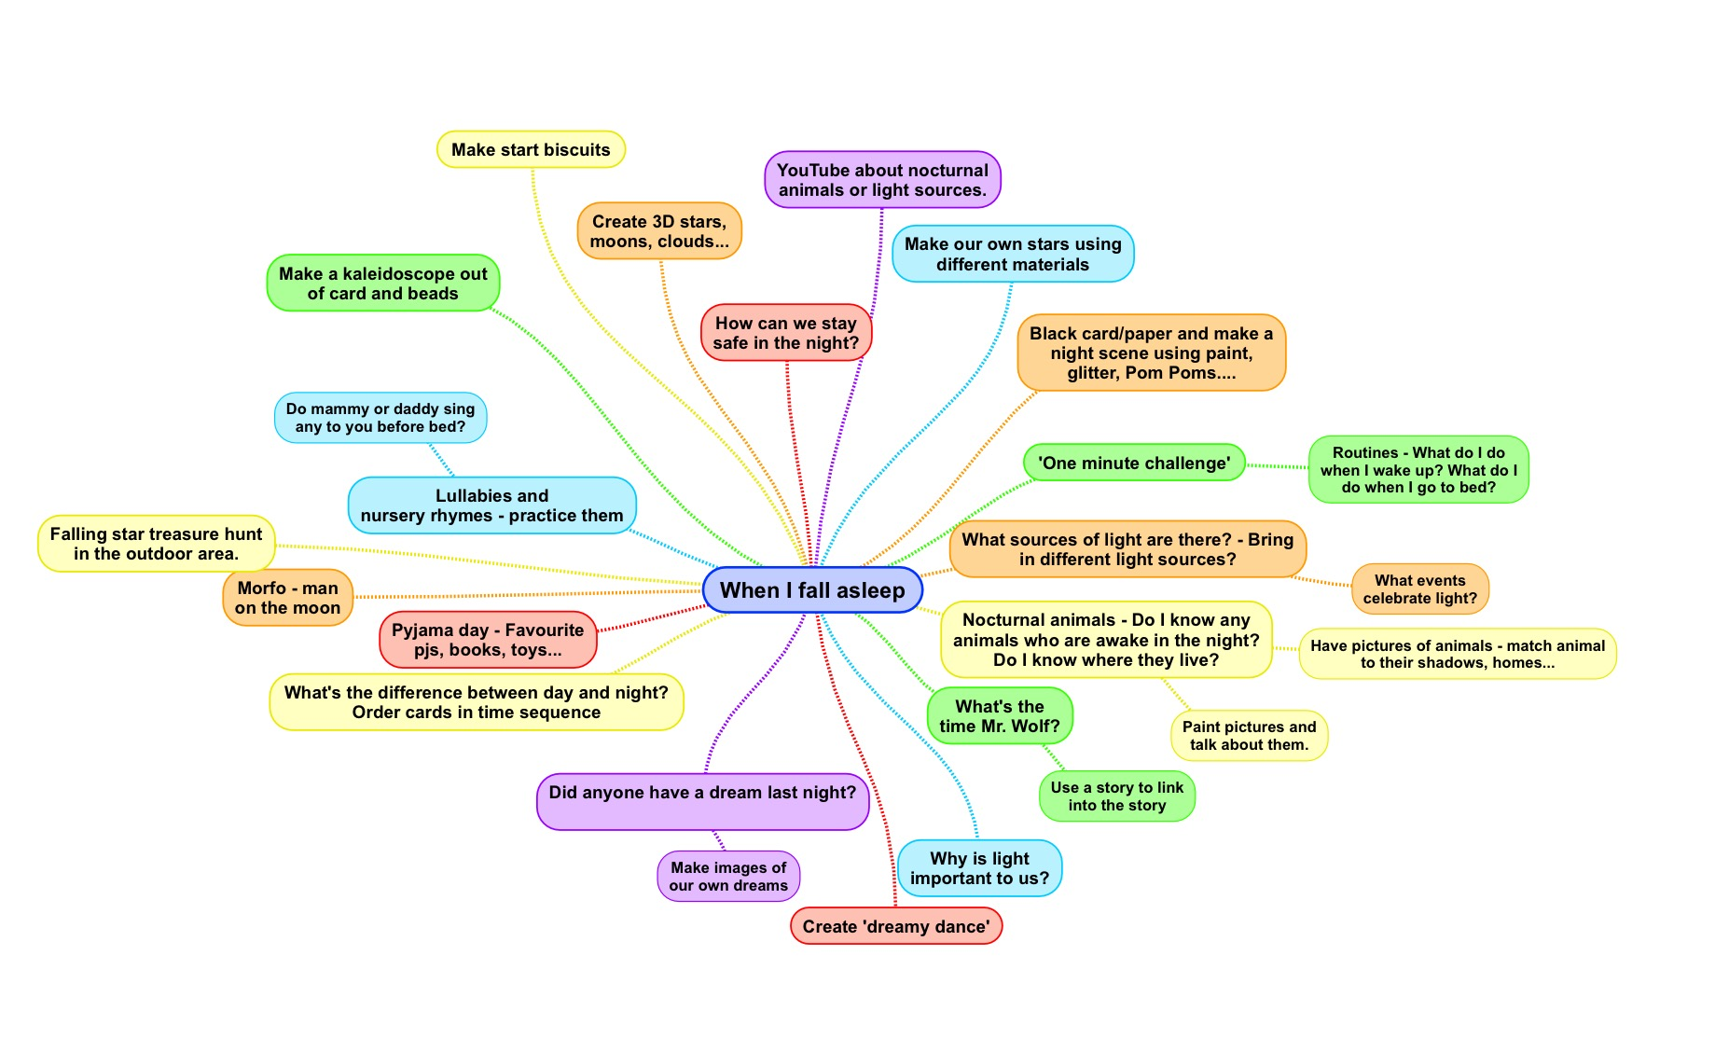

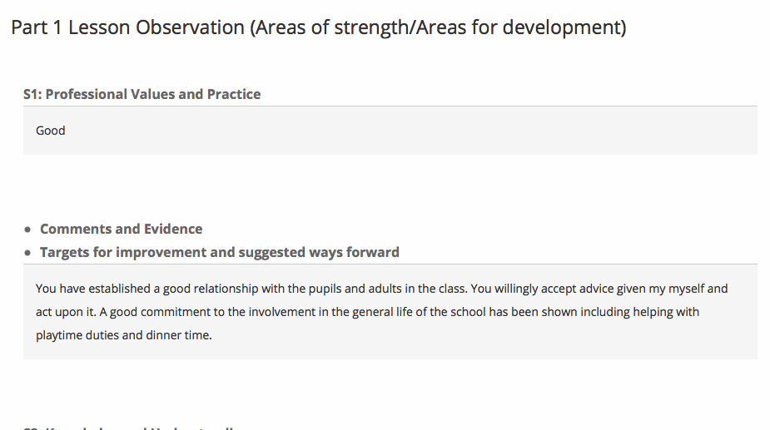
Appendix 2:
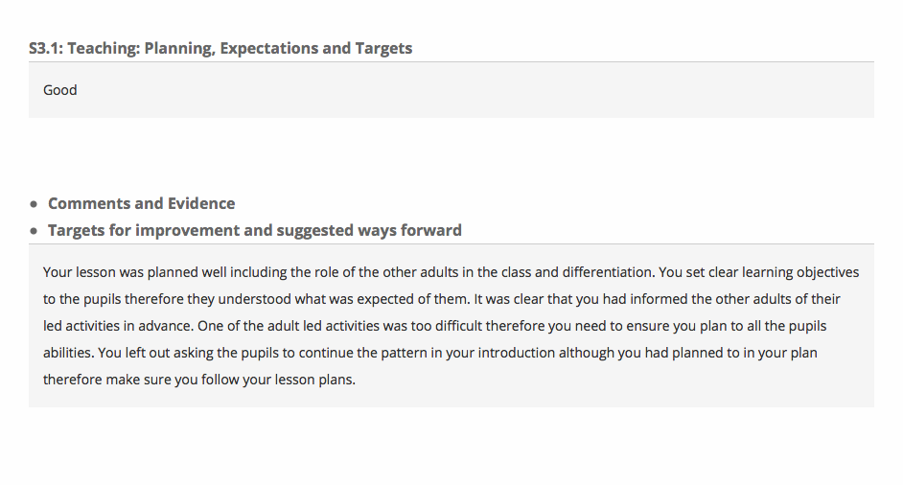

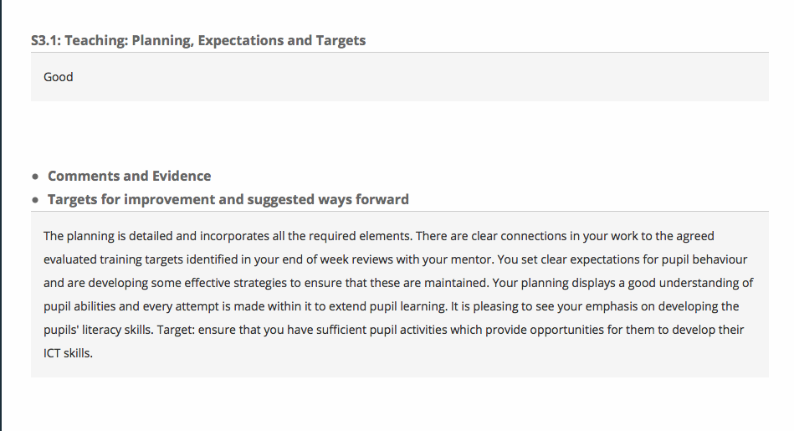
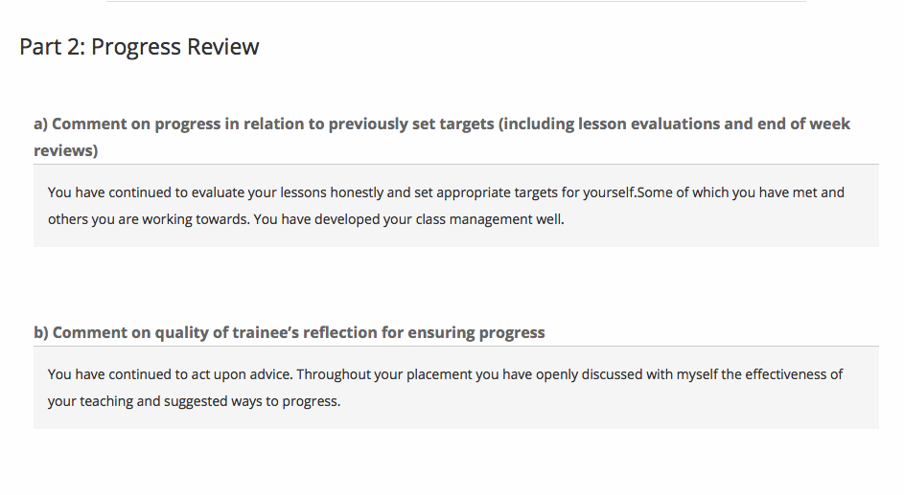
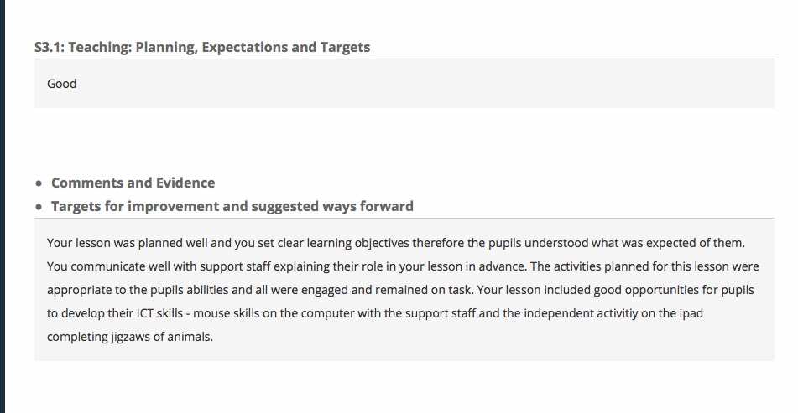

Assisted Reflective Conclusions (ARC) Model
Date: 28-03-17
Critical incident (focus): To read and understand a poem – answering comprehension questions.
Experience

Feelings | I feel like this session very went, it went a lot smoother than expected.  All the children enjoyed the poem, they describes the poem as ‘gruesome’, ‘gory’ and ‘fun’, because the children enjoyed listening and exploring the poem they got involved and completed the task to the highest standard.  There were not behaviour issues in this session and every member of the class was on task from the moment the session started, to the moment it ended.  I was proud with how well the children worked for me during this session and the end results - I feel like having a lot of confidence in a subject area had a positive effect not only on myself but on the children.
Remember and Understand | Elements that went well:  - All the children participated in the session and worked extremely well.  - They all read and understood the task and answered the questions using full sentences.  - The children all participated in the introduction when we were sharing ideas.  - The children were able to justify their answers to each of the questions they were asked.  - There was guided reading involved – after listening to the poem the children had the opportunity to read the poem together as a class.  - We went over 2 of the questions together as class orally so the children knew what was expected of them.  - I was confident, due to this the lesson ran smoothly and I was able to project my voice (despite being ill).  - The plenary went well as it allowed me to gage what the children learn from the session – they played a game of ‘hot seating’ and acted as the pig or the farmer, this could be improved on by having more open ended questions.  Disappointing elements:  - I went over the basics of what comprehension is and how to do correctly, however, I could have explained in more detail the different aspects of comprehension reading – skim, scanning…  - Even though I orally went over answers with the children, I could have wrote on the whiteboard the full sentence so they had something to refer back to when it came to answering their questions.  - I planned a M.A.T question sheet for one of the pupils in the class, however I didn’t give her the sheet. I gave her the higher ability work – I need to concentrate on individual needs and abilities rather than just ‘lower, middle or higher’.  - Majority of the questions were closed, in future include more open ended questions.  - After reading over the poem, I should have asked if there were any unfamiliar words and discussed them with the children to avoid any confusion.
Evaluate and analyse | What I would keep the same:  - Majority of the children seemed to enjoy the poem because it was funny and told them a vivid story of the pig.  - I thought the think, pair, share of ideas and questioning was good and relevant to the task.  - The lesson was fun and engaging for the children.  - The children were able to answer majority of the questions.  - Keep the guided reading aspect the same as it helped the children digest the poem.  What was the cause of the most disappointing element:  - Explain in more detail what is expected by giving/showing the children a physical example to refer back to if they start to struggle.  - P.W needs to be pushed even further in her work, I should have given her the M.A.T work to see if that was more her level.  - Understand each induvial child’s needs and abilities and use that to aid planning of tasks such as this.
Conclusions and actions | Solutions:  - Try to project and raise my voice when teaching.  - Model in even more detailed so there is an example of the board for the children.  - Try not to use as many closed questions, include open question to get the children to justify their response.  - Ask for individuals ability levels in comprehension tasks to gage what is the most suitable activity for them to complete.  - Don’t be afraid to stop the class mid-session if they get off task or don’t understand.  - Show the children that I am in charge and I am the teacher running the class in my planned session.
Y profiad newydd / Transformed experience

Appendix 3:

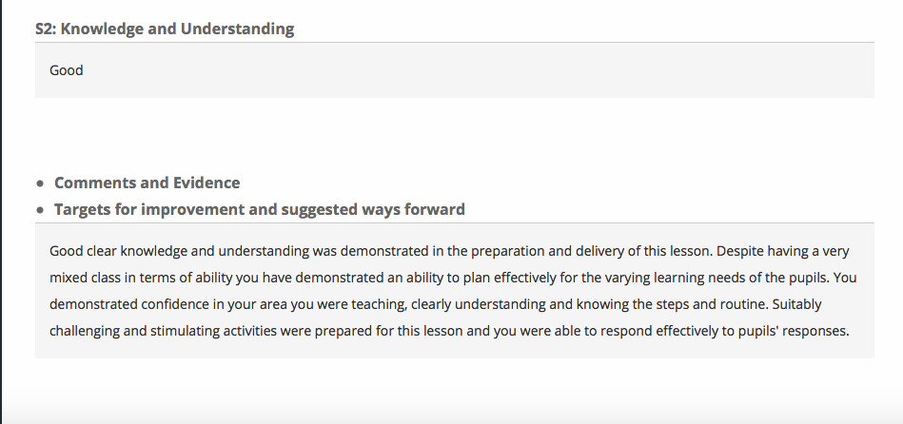

Appendix 4:
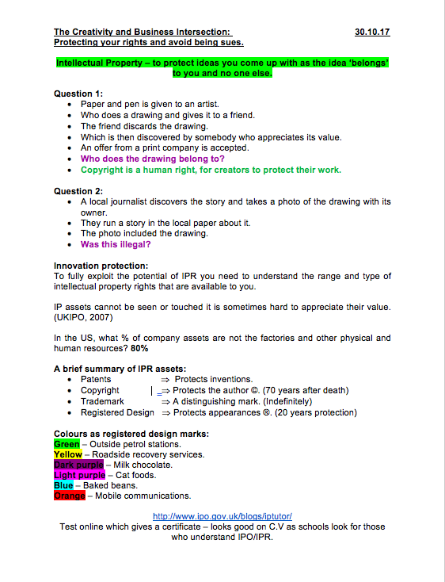

Appendix 5:


