Internet Technology and Security
  - Module ACCA4018 Assignment
by
  - John Dunkley-Williams
1903715

Contents

- Task
  - Background
  - Scenario
  - Task
- Introduction
  - Bring Your Own Technology
- Computer Security
  - Vulnerabilities
  - Recommendation
- Network Security
  - Network Infrastructure
  - Firewalls
  - Physical Security
- Information Security
  - Data Encryption
  - Implementation
- Conclusion and Evaluation
- References
- Appendices

Task

Background
Cyber Security has become one of the major threats globally. The increase in cybercrime has become major a concern to companies, organisations and countries in general. The proliferation of mobile Internet devices such as laptops, tablets, smartphones, mobile phones, PDAs and even Satnavs is called IT consumerism. People use these mobile devices to connect to the Internet to make payments for services, email, blogging, social interaction, shopping, entertainment, research etc. There is immense pressure on IT managers and IT policy makers in corporate environments to allow employees, senior staff, and even clients of the companies to access their corporate networks using their personal mobile devices. The use of these personal Internet mobile devices to access corporate networks is called Bring your Own Device (BYOD) also referred to as Bring Your Own Technology (BYOT), See figure 1, example of a BYOD deployment.

Figure 1: BYOD deployment at a corporate LAN.
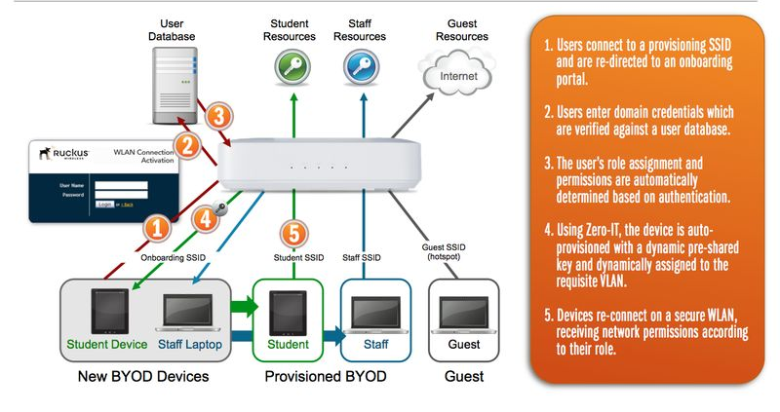

Scenario
CoffeeCapulus sells Blue Mountain Peak coffee from Jamaica, one of the best and most sought-after blends in the world. CoffeeCapulus has an extensive presence around the globe. The company uses cloud services to deliver IT services to its staff and clients. It is estimated that almost 95% of the company's network is wireless based. The company also has a massive online presence and social media presence to promote its activities.
Owing to its large staff and customer base, the company has recently come under immense pressure to allow both its staff and customers to use their personal devices to access the company's network/resources. Security of personal staff's data and client's data is the company's major concern. The company is also concerned about protecting its intellectual properties, which is worth billions.

1.3 Task
You are an IT Security Consultant hired by CoffeeCapulus to recommend guidelines on IT security policy framework that covers all aspects of its enterprise network, including online and offline resources.

State all assumptions made in the completion of the report (Make it relevant to your course stream)

From the scenario given above, develop the BYOT framework that covers all aspects of the CoffeeCapulus enterprise network:
Computer Security
- Discuss the main vulnerabilities, threats, and attacks to system security in the organisation, and how these affect balancing security and access.
- Suggest some techniques that the company’s in-house Information Technology (IT) professional could employ to make devices and servers more secure.
Network Security
- Use Cisco Packet Tracer (CPT) to design and describe the main network infrastructure (backbone) and servers that need to be secured on the network. Hint: protective measures must be implemented on the design devices.
- Explain packet filtering firewalls and their advantages and disadvantages.
- Characterise the physical protections that you need to provide to ensure the physical security and availability of the main infrastructure.
Information Security
- Explain the principles of data encryption and provide examples of how this can be implemented.
- Devise a strategy for implementing information security in the organisation (Hint: a written policy).
- What mitigating strategy will be deployed when the owner of a participating device leaves their employment or the device is lost, stolen, or fails (Hint: Mobile Device Management Software is a useful tool).
- What type of data is retained by the mobile devices connecting to CoffeeCapulus network?

Introduction

2.1 Bring Your Own Technology
Bring Your Own Technology (BYOT) or Bring Your Own Device (BYOD) refers to the trend that has risen, particularly in the last 10 years, with staff and students bringing their own personal electronic devices to use at work or school. [1]
The trend reportedly originated among executives who would often have superior personal smartphones, laptops and tablets to the office issued equipment, or were simply away from their work devices when the need to access secure work applications and data urgently arose. [2]
The trend has grown dramatically in the last decade, with the BYOD market being worth $30billion in 2014, now being predicted to be worth $367billion by 2022. [3] According to the 2016 Cisco Annual Report [4] companies save an average of $350 per year, per employee with a BYOD policy in place, but there are obvious risks to consider too.

3. Computer Security

3.1 Vulnerabilities
The key risks to the organisation with Bring Your Own Technology implementation are listed below.

3.1.1 Loss of Hardware
Losing a mobile device is stressful on the best of times, but when that device is company property, or even just contains sensitive organisational data, the risk is much greater. [6]
There is the initial impact to the employee’s productivity while the device is recovered or replaced.
More significant however, is the risk to organisational data held on the device. Mobile security measures, such as passwords or PINs are far from perfect security measures, and if cracked, the cost or damage to the organisation whose data has been lost can be huge.

3.1.2 Security Issues
The most basic consideration is that the more devices there are connected to the organisation network, the more access points, and therefor access risks there are. [7] BYOT will bring with it a lack of uniformity among devices. On a base level, considering just mobile phones, the same software is not always available on Apple and Android devices, and when it is it doesn’t always perform to the same standard.

3.1.3 Untrained Users
User error or ignorance can be very damaging. Computer viruses and other malicious software is everywhere. [6] It is easy to connect to unsecure public networks with mobile devices. It is vital that users be equipped with the knowledge to prevent potential harm to the organisation. [8]

Recommendation
Steps can be taken to mitigate the above risks. The following recommendations should be considered to minimize the potential harm the above vulnerabilities might result in. Mobile Device Management (MDM) services are available and should be utilized.
MDM allows organisations to apply custom policies to mobile devices that can be administered and regulated remotely. [9] It can be used to protect data, require approval for software installation and prevent unauthorised access. [10]

Loss of Hardware
With MDM, devices can be set up for remote connection so that in the event of hardware loss, a device can be remotely wiped of all organisational data. [6] This will enable the organisation to react as quickly as the loss is reported.

Security
Ensure device software is kept up to date. This is critical for all technology; software updates often include critical patches to combat the latest security risks. [11] Where organisational access is a possibility, steps should be taken to ensure application security is as up to date as it could be. MDM allows administrators to keep track of this.

MDM can also be utilised to control the installation of software by requiring administrator approval to do so. [12] This should be activated so as to prevent BYOT users installing potentially harmful software that might in turn access sensitive data, or hack the access point entirely.

User Training
Ensuring employees are adequately trained is standard practice for risk management [13] and the success of this framework depends on the employees engaging with it. [14] Keeping employees trained and up to date on the importance of IT security, the risks of Malware, phishing and other email scams, and on the basics of using technology and the internet is vital with regards to IT security as a whole, and particularly in this case with the implementation of BYOT in the organisation.

4. Network Security

Network Infrastructure

Basic network infrastructure
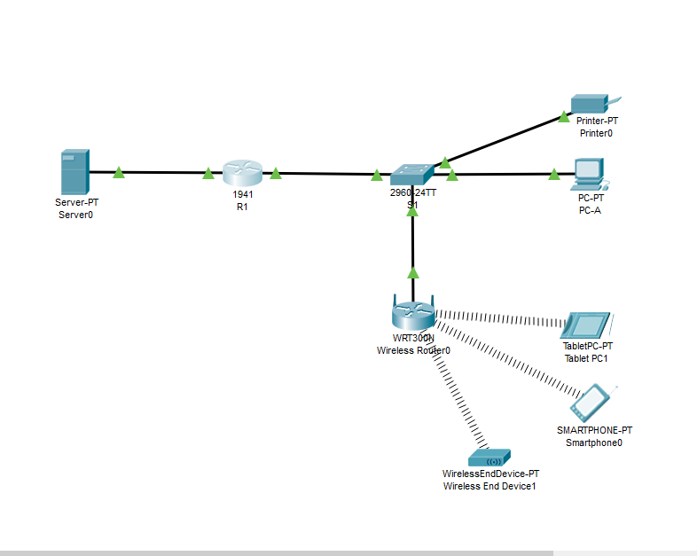
Wireless security configuration
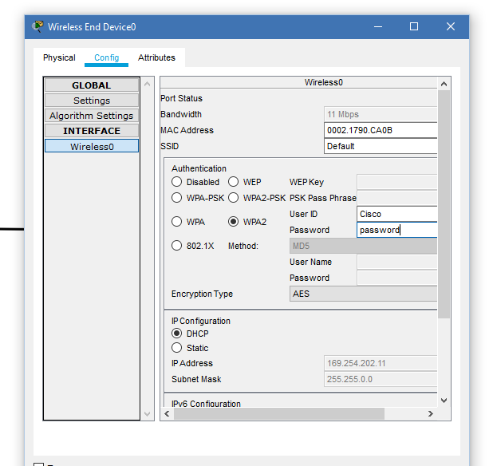

Firewall enabled
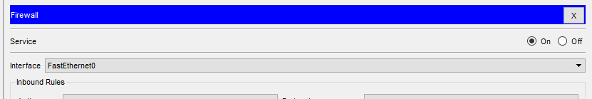

Firewalls

A firewall is a network security measure that monitors network traffic and either allows or blocks that traffic based on the predefined network security rules. [15]
A packet filtering firewall operates at the network layer of the OSI model, and makes decisions based on network addresses, ports or protocols. [16]
A packet-filtering firewall is the simplest form of firewall. It can filter on IP addresses, TCP/IP protocols, IP precedence, TCP and UDP port numbers and TCP control flags, then make a decision to either allow or drop that data based on the network rules. It can also be set to inform the user of this action or do so without announcement. Announcing the firewall action to the user is useful in an internal environment, as it allows the using to contact a network administrator to have the settings altered and allow the data through. However if the user is a hacker, the response will tell the hacker that filtering is in process, allowing the hacker to respond to that and potentially find a way through. [17]
Advantages of packet-filtering firewalls
- Fast process speeds
- Can easily match on most fields in layers 3 and 4, providing flexibility
- Low cost
Disadvantages of packet-filtering firewalls
- Can be complex to configure
- Cannot prevent application layer attacks
- Susceptible to certain TCP/IP protocol attacks
- Does not support user authentication of connections
- Limited logging capabilities [17] [18]

Physical Security

The easiest way to access the network is physically. A hacker can quickly overcome most security measures with direct access to the server, and so the security of the server room is of the highest priority. Some initial basic steps to ensure physical security include:
- Lock the server room
- Limit the people with access to the server room key
- Keep a log of people with server room keys
- Disable the floppy drive on the server
- Ensure that additional hardware is also securely locked away, i.e. switches, routers. [19]
Additional consideration for physical security should be given to:
- Controlled destruction of sensitive physical data
  - Written usernames and passwords
  - Printed network logs
  - Printed reports
- Back-up servers at a separate location and subject to at least the same security as the primary servers
- Surveillance
  - CCTV
  - Physical ID authentication
- Use rack-mounted servers [20]
The physical security implications of the BYOT implementation are significant, as it presents more physical access opportunities to the network, and by nature, these devices are portable and more difficult to keep track of than servers and other static access points.
In addition to the soft security detailed in Section 3, additional physical security measures should be in place.
- Never leave a device unattended
- Ensure devices are locked when not in use
- In the event of a device being lost or stolen, report immediately
- Use the device for only approved purposes [21]

5. Information Security

Data Encryption
Data encryption is used to protect data both in transit and in storage. Encryption fundamentally scrambles readable text, and requires the data recipient or accessor have a secret code or decryption key in order to access that data. [22]
Data stored on company servers should be encrypted so that in the event of a cyber-attack, that data is unreadable to the intruder.
Data in transit, even internally should also be encrypted to ensure that the data is not intercepted on route to the intended recipient. There are numerous types of encryption available to accomplish this task.
- Data Encryption Standard (DES)
- Triple DES
- RSA
- Advanced Encryption Standard (AES)
- TwoFish [22]
These are the most common types of encryption, but all types come under one of two categories:
Symmetric Encryption
Symmetric encryption requires a single key for both encryption and decryption. This is the simpler and faster method, but leaves the user with the problem of securely exchanging the key the intended recipient.
Asymmetric Encryption
Asymmetric encryption uses two keys; one public key and one private key. It is considered more secure but the process is also slower. The public key is shared and used to encrypt data, while the private key is retained, and is the only method by which that data can then be decrypted. [23]

Implementation
Cyber security is often approached with a “three-pillar” methodology; people, process and data. Data should be properly protected and managed by the implementation of an information security policy. [24]
Another concept directly related to data security is the “CIA Triad”: confidentiality, integrity and availability. Utilising this concept aids in ensuring the key aspects of data protection are addressed.

Information Security Policy
The purpose of this policy is to ensure that all data and information handled by the organisation is properly protected, processed and managed. All staff must adhere to his policy.
The implementation of this information security policy ensures a collective effort is made to protect against security risks and the misuse of data. In the engagement with this policy, care is taken for the protection of our customers and their rights, as well as the responsibilities of the organisation to meet its legal and ethical requirements, ensuring a robust reputation.
Confidentiality
All data processed by the organisation should be treated with confidentiality. Staff should only access data where they have the authorisation to do so. Examples: staff should only access the data of customers with which they are directly engaged. Managers should only access the staff information for members of their team.
Sensitive documentation should be kept in secure cupboards, or password protected folders and only shared with those authorised to view the information contained, and only when it is required they do so.
Digital data should only be saved to the organisational network storage. This will only be accessible while connected to the organisation network, and will be protected by data encryption. Should off-site access to this data be required, employees can apply for a VPN.
Passwords should be secure, following company guidance.
- At least 8 characters long
- Containing letters, numbers and a symbol
- Updated at least every 3 months
- Do not share your password with anyone
Access control lists should be regularly reviewed.
Integrity
Data will be subject to encryption, both at rest and in transit. In addition to password protected folders, where Cloud storage is in use, similar access controls will be in place. When sharing data, ensure the person with which you are sharing that data is authorised to view it, and has a requirement to do so.
Backups of organisation servers will be updated daily and physically located at an alternate site.
Version controls must be used on all company data.
All staff must complete mandatory training on the subject of Information Security. This should be revisited every 3 years of continual employment.
All data management is required to be GDPR compliant.
Availability
Hardware should be well maintained and securely located.
Software and software updates will only be authorised by designated IT administrators, once the reliability of the software has been assured. Staff should ensure they are connected to the organisation network, physically or by VPN at least once per day.
Network resilience will be closely monitored. In the event of an unavoidable loss of network, a backup network will be in place to switch over immediately.
A data recovery plan should also be implemented. [25]

  - Mobile Device Management
Mobile Device Management software is in place across the organisation.
All mobile devices engaged with organisational applications or data must have MDM installed. This allows organisational IT to exercise a degree of control remotely, and ensures IT policies are enforced. [12]
Key MDM features:
- Remote configuration
- Access controls
- Working hours log
In the event of the loss or destruction of a device, contact the IT Service Desk immediately. MDM can be utilised to immediately erase all company data and protect the organisation from unauthorised access.
At the end of employment, organisational data will be purged.

  - Data Retention
GDPR enforces strict rules regarding the retention of data by organisations. Data should only be as long as is necessary, and should be erased when it is no longer needed.
Customer data should not be retained for longer than two years after a period of inactivity. Where customers engage with the CoffeeCapulus network, this count is restarted.
Customer data retained by the company could include
- Name
- Address
- Telephone number
- Email address
- Order history
- Survey response
Staff data retained by the company could include
- Name
- Address
- Telephone number
- Email address
- Qualifications
- Record of training
- Period of employment
- Bank account details
- Staff review files
- Disciplinary actions
Individuals may request to look view data held on them and for the removal of that data in line with GDPR. [26] [27]

Conclusion and Evaluation

The task of writing a framework for cyber security is made simpler by the breakdown in to the key concepts, illustrated by the “Three Pillars” and the CIA abbreviation. By addressing each aspect in turn, policy almost overlaps between concepts to aid in building a robust framework.
Almost all organisations have mandatory compliance training around IT security and GDPR at this point, and so it is an area that should be well known to all of us when it comes to engagement. Researching supporting evidence to reinforce the policies one would be looking to implement in designing such a framework further cements that experiential learning.
There are useful tools available that also make cyber security more manageable, not least, Mobile Device Management software which takes away a large percentage of the risks when the BYOT concept comes in to play. The weak link in almost all security concepts is the user rather than the technology, and MDM maintains that state to a large extent.
Physical security measures can, as always, be applied to the network and servers, but BYOT introduces a much bigger risk where physical network access points are concerned. Device authentication will only go so far, so there is a large trust requirement on individuals utilising the BYOT concept to keep their devices secure and not left unattended, and to keep track of those devices so that loss and damage can be reported in the shortest amount of time, and the MDM can be activated.
BYOT has serious advantages to combat the serious security risks. Efficiency and cost saving throughout the organisation are significant enough to warrant the risk once mitigation is in place, but employee training, awareness and engagement will be vital to the success of BYOT in the organisation.

References

[1] | M. Rouse, “BYOT (bring your own technology),” TechTarget, December 2011. [Online]. Available: https://searchmobilecomputing.techtarget.com/definition/BYOT-bring-your-own-technology. [Accessed 1 December 2020].
[2] | “Bring Your Own Technology (BYOT),” techopedia, 26 October 2012. [Online]. Available: https://www.techopedia.com/definition/28145/bring-your-own-technology-byot. [Accessed 1 December 2020].
[3] | L. Bullock, “The Future of BYOD: Statistics, Predictions and Best Practices To Prep For The Future,” Forbes, 21 January 2019. [Online]. Available: https://www.forbes.com/sites/lilachbullock/2019/01/21/the-future-of-byod-statistics-predictions-and-best-practices-to-prep-for-the-future/?sh=4f91a4251f30. [Accessed 1 December 2020].
[4] | Cisco, Cisco, 2016. [Online]. Available: https://materials.proxyvote.com/Approved/17275R/20161014/AR_300358/INDEX.HTML#/40/. [Accessed 1 December 2020].
[5] | L. Grensing-Pophal, “Be Careful with BYOD,” Credit Union Management, vol. 37, no. 10, pp. 18-21, 2014.
[6] | DMS Technology, “3 Big Risks of BYOD,” dms, 12 October 2017. [Online]. Available: https://dmstechnology.com/3-big-risks-of-byod/. [Accessed 1 December 2020].
[7] | RSI Security, “Pros & Cons of Bring Your Own Device (BYOD),” RSI, 6 June 2019. [Online]. Available: https://blog.rsisecurity.com/pros-cons-of-bring-your-own-device-byod/. [Accessed 1 December 2020].
[8] | Network Telecom, “BYOD in the workplace - pros and cons,” Network Telecom, 4 December 2019. [Online]. Available: https://www.networktelecom.co.uk/news/byod-in-the-workplace-pros-and-cons/. [Accessed 1 December 2020].
[9] | A. Wood, “BYOD: The Pros and Cons for End Users in Business,” Credit Control, vol. 33, no. 7, pp. 68-70, 2012.
[10] | g2, “Best Mobile Device Management (MDM) Software,” g2, [Online]. Available: https://www.g2.com/categories/mobile-device-management-mdm. [Accessed 1 December 2020].
[11] | G. Davis, “Why Software Updates Are So Important,” McAfee, 19 September 2017. [Online]. Available: https://www.mcafee.com/blogs/consumer/consumer-threat-notices/software-updates-important/#:~:text=Software%20updates%20are%20important%20because,critical%20patches%20to%20security%20holes.&text=They%20can%20also%20improve%20the,making%20the%20user%20exper. [Accessed 1 December 2020].
[12] | National Cyber Security Centre, “Mobile Device Guidance,” NCSC, [Online]. Available: https://www.ncsc.gov.uk/collection/mobile-device-guidance/choosing-and-using-mobile-device-management-services. [Accessed 1 December 2020].
[13] | D. Tattam, “Why Risk Training Is Important,” Protecht, 8 January 2020. [Online]. Available: https://www.protechtgroup.com/blog/why-risk-training-is-important. [Accessed 1 December 2020].
[14] | I. Lifshitz, “Reducing Risk: How to Make BYOD Safer,” Security Magazine, 28 April 2015. [Online]. Available: https://www.securitymagazine.com/articles/86319-reducing-risk-how-to-make-byod-safer. [Accessed 1 December 2020].
[15] | Cisco, “What is a Firewall?,” Cisco, [Online]. Available: https://www.cisco.com/c/en_uk/products/security/firewalls/what-is-a-firewall.html. [Accessed 4 December 2020].
[16] | D. Rountree, “Packet Filtering Firewall,” 2011. [Online]. Available: https://www.sciencedirect.com/topics/computer-science/packet-filtering-firewall. [Accessed 04 December 2020].
[17] | eTutorials, “Firewall Categories,” eTutorials.org, [Online]. Available: http://etutorials.org/Networking/Router+firewall+security/Part+I+Security+Overview+and+Firewalls/Chapter+2.+Introduction+to+Firewalls/Firewall+Categories/. [Accessed 04 December 2020].
[18] | S. Simic, “Types of Firewalls,” PheonixNAP, [Online]. Available: https://phoenixnap.com/blog/types-of-firewalls. [Accessed 04 December 2020].
[19] | dummies, “Network Security: Physical Security,” dummies, [Online]. Available: https://www.dummies.com/programming/networking/network-security-physical-security/. [Accessed 4 December 2020].
[20] | DMAC Security, “10 Physical Security Measures Every Organisation Should Take,” DMAC Security, [Online]. Available: https://dmacstrategic.com/10-physical-security-measures-every-organization-should-take/. [Accessed 04 December 2020].
[21] | C. Brook, “The Ultimate Guide to BYOD Security,” Digital Guardian, 24 November 2020. [Online]. Available: https://digitalguardian.com/blog/ultimate-guide-byod-security-overcoming-challenges-creating-effective-policies-and-mitigating. [Accessed 4 December 2020].
[22] | Norton, “What is encryption and how does it protect your data?,” Norton, July 2020. [Online]. Available: https://us.norton.com/internetsecurity-privacy-what-is-encryption.html. [Accessed 04 December 2020].
[23] | N. Li, “Asymmetric Encryption,” in Encyclodpedia of Database Systems, Boston, Springer, 2009.
[24] | DNV.GL, “The three-pillar approach to cyber security: Data and information protection,” DNV.GL, [Online]. Available: https://www.dnvgl.com/article/the-three-pillar-approach-to-cyber-security-data-and-information-protection-165683. [Accessed 07 December 2020].
[25] | M. Rouse, “Confidentiality, integrity and availability (CIA traid),” TechTarget, August 2020. [Online]. Available: https://whatis.techtarget.com/definition/Confidentiality-integrity-and-availability-CIA. [Accessed 07 December 2020].
[26] | European Union, “Complete guide to GDPR compliance,” [Online]. Available: https://gdpr.eu/. [Accessed 07 December 2020].
[27] | L. Irwin, “How to write a GDPR data retention policy,” IT Governance, 16 October 2020. [Online]. Available: https://www.itgovernance.co.uk/blog/top-tips-for-data-retention-under-the-gdpr. [Accessed 07 December 2020].
[28] | A. Kumar, “Taking String input with space in C (3 Different Methods),” GeeksforGeeks, [Online]. Available: https://www.geeksforgeeks.org/taking-string-input-space-c-3-different-methods/. [Accessed 16 March 2020].
[29] | N. Kanralkar, “Scansets in C,” GeeksforGeeks, [Online]. Available: https://www.geeksforgeeks.org/scansets-in-c/. [Accessed 16 March 2020].
[30] | P. Bruder, “Gadgets Go To School: The Benefits and Risks of BYOD (Bring Your Own Device),” NJEA Review, pp. 15-18, November 2014.

Appendices

marking criteria and Student FEEDBACK

This section details the assessment criteria. The extent to which these are demonstrated by you determines your mark. The marks available for each criterion are shown. Lecturers will use the space provided to comment on the achievement of the task(s), including those areas in which you have performed well and areas that would benefit from development/improvement.

Common Assessment Criteria Applied (Assignment 1) | Marks available | Marks  awarded
1. Engagement with Literature Skills
Extent of research and/or own reading, selection of credible sources, application of appropriate referencing conventions.
The key concepts discussed. You have used a number of reference sources. However, you should consider other credible sources; academic journals are normally highly credible sources while websites require careful consideration/selection and should be used sparingly. (Grade mark: 66.67%) | 15 | 10
2. Knowledge and Understanding Skills
Extent of knowledge and understanding of concepts and underlying principles associated with the discipline.
You have demonstrated understanding of the overall assignment. You have not used the IEEE report format. (Grade mark: 66.67%) | 15 | 10
3. Cognitive and Intellectual Skills
Analysis, evaluation and synthesis; logic, argument and judgement; analytical reflection; organisation of ideas and evidence
There is no need to repeat the assignment task it will flags up as plagiarised work within Turnitin. Instead just a written general introduction will suffice. It would be good to inter-relate your discussions to the case study. How will these apply or benefit the company? All diagrams should be numbered, named and refer to in your discussions. Good evaluation, your conclusion should summed up all the key aspect of the report. (Grade mark: 70.00%) | 40 | 28
4. Practical Application Skills
Deployment of methods, materials, tools and techniques; application of concepts; formulation of innovative and creative solutions to solve problems.
A simplistic practical design with no security measures implemented/considered within the routers/switch. No annotation or explanation, this could have been discussed within your report as an example to showcase your knowledge and understanding (Grade mark: 50.00%) | 20 | 10
5. Transferable Skills for Life and Professional Practice
Attributes in professional practice: individual and collaborative working; deployment of appropriate media; presentation and organisation.
Your report flow but could do with formatting & justified. There are some minor grammatical errors. (Grade mark: 65.00%) | 10 | 6.5

Assignment Mark (Assessment marks are subject to ratification at the Exam Board. These comments and marks are to give feedback on module work and are for guidance only until they are confirmed. ) | Late Submission Penalties (tick if appropriate) |  | 65%
 | Up to four weeks late |  | 65%
 | First Attempt? |  | 65%

