

LEVEL/ LEFEL 5 Term 2
MODULE CODE: ACCC5000
Cloud Computing Technologies by

Aleksandar Nedelchev
BCs Cloud Computing

Executive Summary

This study sheds light on a topic named “Cloud Computing Technologies”. Taking case of London Bikes Ltd, a business process needed for enhancing operational activities through implementation of cloud computation needs to be incorporated within the organization. In this study, an underlying aspect of background and terminology of Cloud Computing has been detailed in this study. Essential characteristics and recommendation for a model of cloud computing have been entailed this study. Moreover, service models recommended for London Bikes has been provided in this study.
Table of Contents

Introduction 3
Background and Terminology of Cloud Computing 3
Essential Characteristics and benefits expected from implementation of potential solutions 5
Service Models and available real-world services 7
Deployment Models and recommended model for London Bikes Ltd. 8
Virtualization and its link to Cloud Computing 10
Migration Strategies of Cloud Computing 12
Concerns of security 13
Implementation process of SaaS for London Bikes 14
Conclusion 16
Reference List 17

Introduction
Cloud Computing includes a variety of services that range from virtual computing to storing and gaining access to data as well as computer services on an internet. Most of on-demand services are processing, storage, networking as well as applications which are components of cloud computing. London Bikes Ltd is an SME based in heart of London city. The company has been seeking to learn about Cloud Computing and its solutions to enhance its business processes for consumers as well as staff members. In this study, the main focus has been to understand a background of Cloud Computing and service models in a real-world available. It also aims to signify a recommended model for London Bikes Ltd and explains migration strategy for Cloud Computing. Similarly, concerns for a security and implementation process of SaaS for London Bikes have been entailed in this study. Relevant security concerns has been described for assisting staff to meet requirements of Cloud Computing.

Background and Terminology of Cloud Computing
Cloud computing is a software that helps in managing and storing data through the application of multiple computer-based resources such as a server, networking, databases and software. Through the aid of an effective cloud computing system in place, an SME would be able to deliver service to more than one service at one time. By enabling cloud computing systems, electronic devices can have greater accessibility to the web along with relevant data and software for running. As a paradigm, Google mail is a cloud computing which can be accessed any time for transferring files or applications through the internet and it is having a huge number of users. Implementing a cloud computing system would be useful for London Bikes to enable its efficiency in dealing with complex issues by privileging upgraded technology in management.
Cloud computing started in 1960 when an “intergalactic computer network” was broadly suggested whereas over the past few years innovative techolp0hges have paved enterprise IT and supplier landscape. John MacCharty suggested selling computing systems like any other services such as water, utility or electricity in 1961 while giving a speech at MIT. Despite being a brilliant idea, it was not implemented at that time due to not having appropriate up-gradation of technology. Day by day that idea has accumulated a few corporate minds which have compelled them to update their system with such recommended digitalisation. Salesforce.com started using computing services to deliver applications to users through the internet during 1999. Therefore, Amazon started its online store in 2002 to provide computing, storage and human intelligence services whereas in 2006 introducing Elastic Computing Cloud has opened a new age of trading. Hence, in recent times Amazon has adapted AWS for their higher business productivity, agility and operational resilience (amazon.com 2020). Moreover, Google applications also took their step to a next level in 2009 by providing cloud computing enterprise applications. Apart from that, Windows Azure was launched by Microsoft in 2009 companies like Oracle and HP emerged their game by making cloud computing as their mainstream. Younas et al. (2016) stated that installing and implementing a cloud computing environment helps in agile development by flourishing the collaboration of employees and customers. It would leverage London Bike in providing IT-related services through the internet and in real-time both.
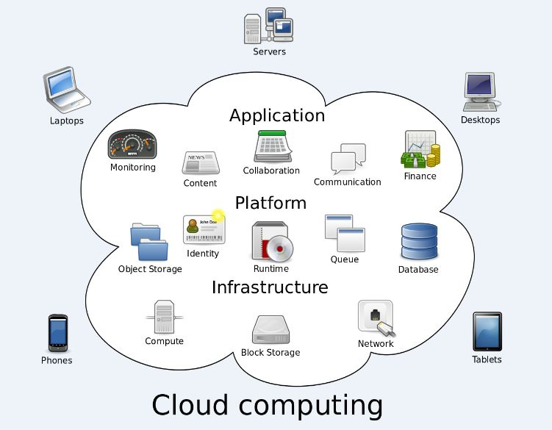
Figure 1: Cloud Computing Environment
(Source: As influenced by Younas et al. 2016)
However, overwhelmed terminologies of cloud computing would be effective for employees of London Bikes to understand respective roles and market adaptabilities of such technologies. It would be beneficial for them to optimise their business with cloud computing solutions through pronouncing it with different names for conceptualising its multiple aspects and functions. Cloud computing often calls out by cloud application, cloud backup, cloud backup service provider, cloud computing reseller, cloud enablement, cloud computing accounting software, cloud management, cloud enablement and cloud migration. Cloud application can be accessed online without installing it on computer devices, cloud backup store data through enabling its remote network whereas cloud computing provides reliable resources to other devices on-demand. Cloud backup service providers would allow the users to remote backup servers and cloud computing accounting service would assist in dealing with larger amounts of data to be processed. Therefore, cloud computing resellers are effective in reselling he purchased hosting services to its customers whereas cloud enablement would aid the users of London Bike for enabling infrastructure, software or resources.

Essential Characteristics and benefits expected from implementation of potential solutions

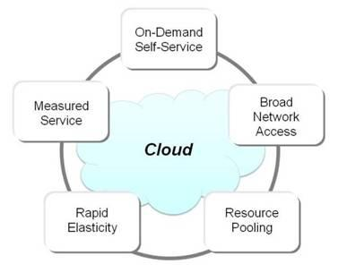
Figure 2: Characteristics of Cloud Computing
(Source: as inspired by Qadir et al. 2016)

On-demand self-service
Cloud computing systems are quite efficient to get accessed on their own without having any intervention of human intelligence which makes it convenient in producing self-service. Moreover, it can be provisioned in London Bike by adding extra computing resources if needed without having a cloud service provider. London Bike can use a web self-service portal as an interface for accessing their cloud accounts to supervise their services within a short time.
Accessibility into broad network
Cloud computing resources can be retrieved from different customer platforms and would be available on the broader networks or in preferably high broadband communiqué relations such as the internet or LAN. it would aid London Bike in serving time-sensitive service applications which would be related to the quality of service (QoS) on respective networks.
Multi-tenancy
Multi-tenant models usually get support from cloud computing resources which allow different consumers to segment the same requests or physical infrastructure during privacy and secure retention. Multi-tenancy attributes of cloud computing enable a global network where each customer tends to have quality service for fulfilling theory different needs. Through this system, London Bike would be able to gain rapid popularity in the current aggressive market which would exaggerate the competitive edge for this brand.
Resource pooling
Resource oolong is associated with providing the same quality and features of service to multiple customers from the same physical resources. Resource pool must be large and accountable to fulfil different requirements of customers and also to provide economies of scale. Performances of critical serviceable applications must not be affected by resource pooling. As stated by Qadir et al. (2016), resource pooling works for wireless networks that can deliver resilience, high utilisation and suppleness at an affordable and approachable cost. Therefore, it can be stated that London Bike would be able to meet the needs of customers due to their predetermined strategies in making vehicles in regards to customisation.
Scalability and flexibility
Elasticity is a core characteristic of cloud computing which can scale-up and down rapidly according to business demand without any additional contract and penalty. As viewed by He et al. (2016), virtual machine-based cloud computing is quite transparent in securing and protecting networks with attaining flexible scalability with virtual middlebox load. Therefore, it would be useful for London Bike to accelerate their business with scalable cloud computing which would also help them in keeping confidentiality of their respective data. Moreover, scalable cloud computing would aid London Bike in reducing capital expenditure due to having additional computing resources. Thus, in case of adding more capacity by London Bike in its system, cloud computing can tackle through scaling up or scaling down.

Service Models and available real-world services
Cloud Computing is an on-demand obtainability of assets, especially in connection to data storage and computing power, devoid of any kind of vigorous engagement with users. In other words, a cloud servicing mainly comprises three services which include, IaaS (Infrastructure as a Service), PaaS (Platform as a Service) and Saas (Software as a Service) (Tadapaneni, 2017). Cloud computing deals contact to a number of technologies by dropping barriers to entry as well as technical expertise and costs.
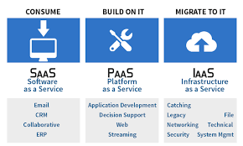
Figure 3: Service Models of cloud computing
(Source: Influenced by Diaby and Rad, 2017)
Software as a Service (Saas)
One of a largest segments of cloud computing is Saas. Such a segment generates greater than half of total revenue for cloud computing and has become a delivery model in most enterprise solutions. Major applications of SaaS include consumer relationship, as well as enterprise resource planning software. On basis of this model, consumers generate access to software and databases, while management of infrastructure and platforms are carried out by service providers (Mukundha and Vidyamadhuri, 2017). For instance, Microsoft, Adobe and SAP are basic players in this segment. In context of London Bikes Ltd, SaaS as a service model, would provide applications retrieved over web, and non-managed by a business. It helps relieve such a business from continuous burden of maintenance through software, administration of infrastructure, network security as well as data availability in operational activities of running businesses.
Platform as a Service (PaaS)
PaaS grants consumers access to cloud platforms for development of applications. Such a platform includes an operating system, web-savers, databases as well as gaining access to one or greater than one programming device. Salesforce can gain the highest level of market share through PaaS segment, though there are established segments like Amazon and Microsoft which hold sizable portions of business (Diaby and Rad, 2017). It is predicted that a cloud platform market is likely to reach a smaller computing segment on a marginal basis. London Bikes Ltd, as an SME can gain access to a cloud computing environment wherein customized solutions can be included in its basic features. In addition to this, it offers users to customize features that need to be included within their subscriptions.

Infrastructure as a Service (IaaS)
Consumers gain access to off-site sustenance in custom of storage, servers, machines that are virtual and networking through use of IaaS. It generates consumers with off-site support and research has indicated that IT infrastructure is generating more contribution towards adopting cloud infrastructure solutions (Jain and Mahajan, 2017). Leading providers like Amazon control a share of market, a combined aspect of two providers mainly, Microsoft as well as IBM. In context of London Bikes Ltd, application of IaaS would enable resources like storage facilities, networks and virtual power servers that generate high levels of private servers. Under this model, “pay as you go” is owed by factors of how much storing is used upon or an volume of dispensation power is consumed above a particular time-span (statista.com, 2020). On other hand, is a service model, there is no management of infrastructure and it is on basis of provider to grant a contracted amount of resources as well as availability.

Deployment Models and recommended model for London Bikes Ltd.
A cloud deployment model basically, indicates how well, cloud services are made appropriate to users. Four basic deployment models in respect to cloud computing are public cloud, private cloud, hybrid cloud and community cloud (Krieger et al. 2018). As a consultant, it is essential to portray how each cloud deployment model resides control over infrastructure and which model is recommended for London Bikes Ltd.
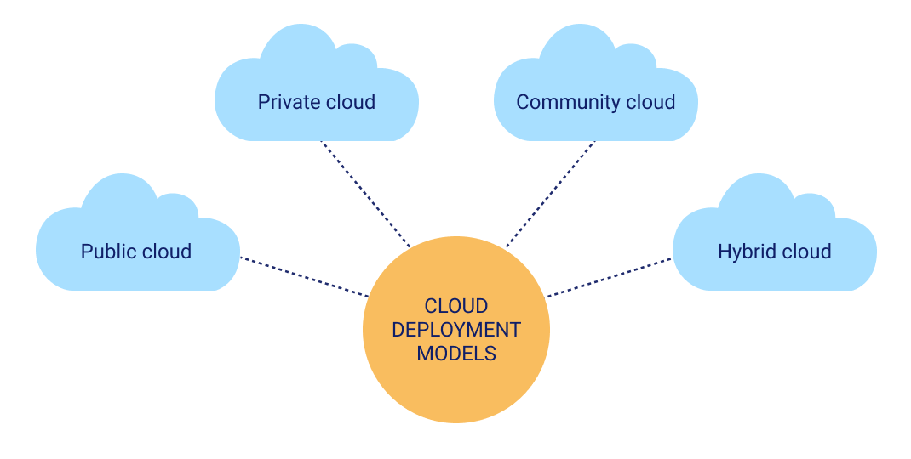
Figure 4: Deployment Models of Cloud Computing
(Source: Influenced by Apolónia et al. 2017)
Public Cloud
Public Cloud is a type of model that makes support to all operators for wanting to make usage of computing resources mainly, hardware or software on a basis of subscription. Most shared uses of public clouds are a development of request through testing, critical tasks including file sharing as well as email service.
Private Cloud
Private Cloud in contrast to that is an infrastructure used by an organization. Such an infrastructure might be managed in-form for support of user-groups that are taken upkeep of either on-site as well as off-site. “Private Clouds” are costlier than “public clouds” as a result of expenses required to acquire and maintain them (Apolónia et al. 2017). On other hand, private clouds address issues of security and privacy in today’s organization.
Hybrid Cloud
In hybrid clouds, a mixture of public and private clouds is taken into account. Organizations make use of this model for scaling up of IT infrastructure in leveraging public clouds to complement this volume available for a private cloud. Hybrid Cloud, therefore, indicates a combination of on-premises infrastructure as well as a private and public cloud through orchestration from innumerable platforms.
Community Cloud
This kind of a deployment model ropes multiple organizations in distribution of computing devices as a part of a community. Entrance to a community cloud environment is controlled towards supporters of a community (Fung, 2017). Community cloud in computing, therefore, is a cooperative power in which a specific amount of infrastructure is shared among several groups from a precise community having mutual fears. In computing amenities, a community cloud is an effort in which infrastructure is ultimately united in and managed by third parties either internally or externally.
Recommendation for London Bikes Ltd
London Bikes Ltd needs to assure that a computing environment is created wherein a mix of private cloud as well as public cloud is made through orchestration made between two parties through application of hybrid computing. An underlying reason behind this is that hybrid cloud has basic underlying advantages like:-
- Development of better support for a workforce that is remote with on-demand access to data.
- Promotes a reduced level of costs along with generation of greater security for controlling data processes.
- Generates better level of scalability and control over IT services, through higher control over data.
- Creates an increased level of agility and innovation to increase speed in market through optimization of IT performance.
- Business continuity is enhanced through scalability and spike in a hike.
Since, hybrid cloud generates beneficial solutions and is a more cost-effective method to ensure data processes, staff at London Bikes Ltd needs to make use of such a model for generating higher sales and profitability to consumers.

Virtualization and its link to Cloud Computing
Virtualization is a significant component in cloud computing as it changes physical machines into virtual machines through assistance of cloud computing services. People have confusion regarding two, as cloud computing is a kind of device that enables storing of transformed data (Konate et al. 2019). It is crucial for applications of cloud computing for generating virtual machines to work for them. Virtualization is a process that creates virtual networks to be processed on cloud platforms (Alhazmi et al. 2017). It assists in creating virtual networks as well as servers to be uploaded on cloud platforms.
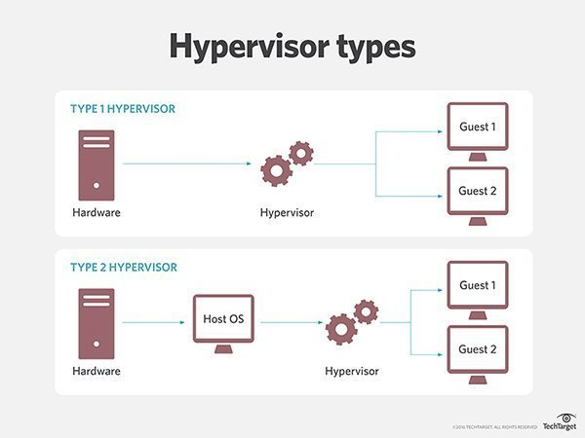
Figure 5: Sources of Virtualization and its link to cloud computing
(Source: Influenced by Annane and Ghazali, 2019)
Type 1 Hypervisors
A type 1 Hypervisor is run on host machines’ physical hardware and does not have a bare-metal hypervisor. Having suitable access to hardware, Type 1 hypervisors are considered to be most efficient hypervisors on computing devices. Such types of hypervisors are run basically on hardware and are extremely secure (Annane and Ghazali, 2019). In most cases, such a system hosts VM and OS management software that enables management of physical systems through management tools like Microsoft System Centre.
Type 2 Hypervisors
A type 2 Hypervisor is run on top of an existing OS and is hosted hypervisor that makes use of pre-existing machines to manage CPU, memory, storage as well as network resources. Type 2 Hypervisors include Oracle VM VirtualBox, Parallels as well as VMWare Workstations (Boukhris, 2017). Type 2 Hypervisors are existing systems based upon OSES deployed as a layer of higher software. Also, security flows are compromised through VM's run above it.
Therefore, taking into context requirements of London Bikes Ltd, it is recommended that Type 1 hypervisor is included as it provides ease of software and increased performance in optimal hardware. Moreover, it is a cost-effective method of reaching out at meaningful operations systematically at a reduced level of costs.

Migration Strategies of Cloud Computing
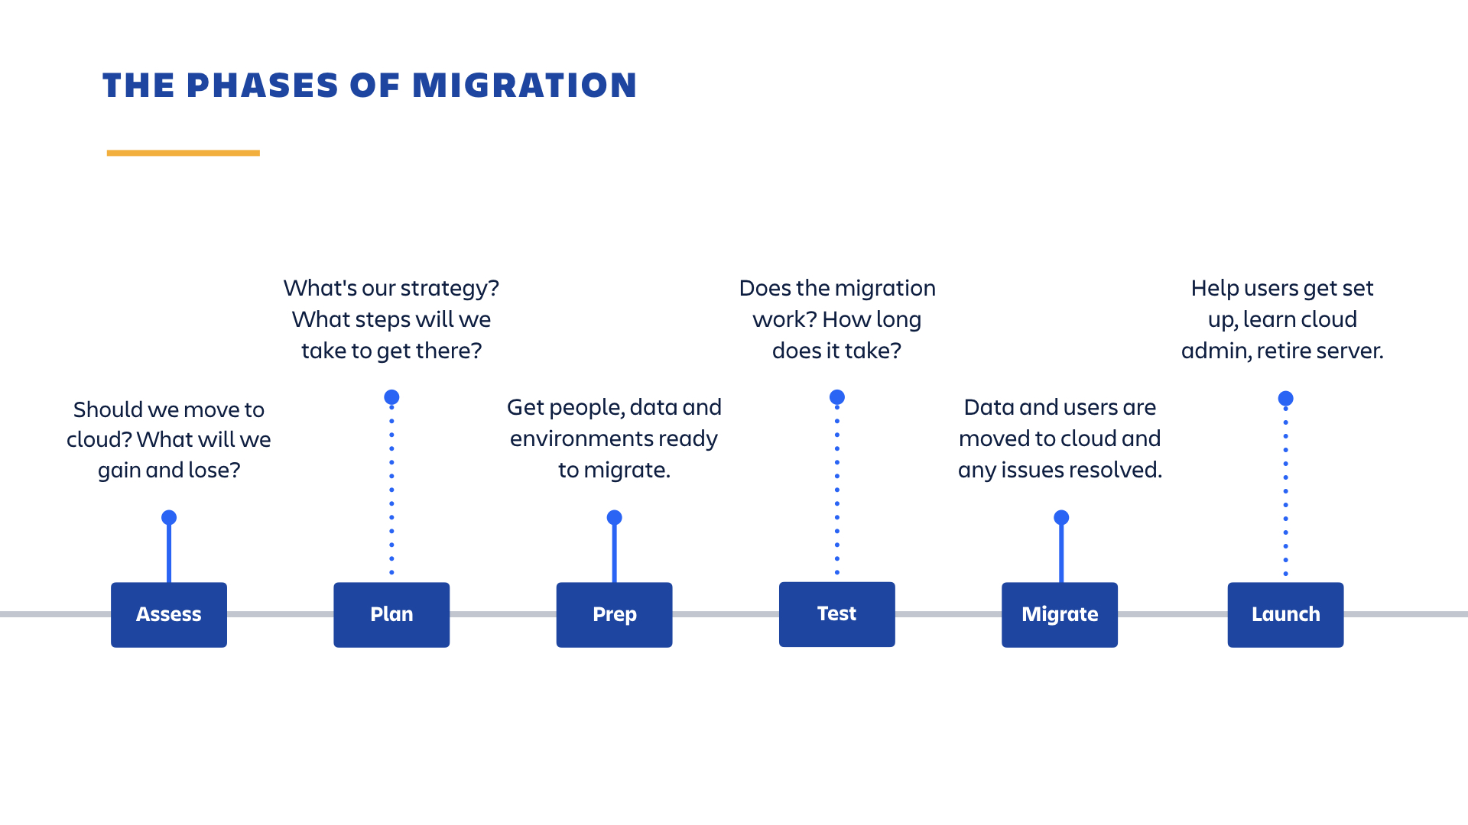
Figure 6: Migration Strategies for Cloud Computing
(Source: Influenced by Wang et al. 2020)
A cloud migration strategy is a plan that is made upon by a business to change its data and claims from on-premises to cloud services. Based on benefits of workload it is significant for benefiting and running on cloud-based infrastructure invalidate and focus on appropriate way to migrate upon applications and is a documented strategy to be crucial (Wang et al. 2020). The formidable steps in migration process involve:-
- Planning for migration
Firstly, it is crucial to assess the current environment to ensure which strategy is going to support them in the best manner. Calculating upon requirements of a cloud server, based on application of current survey it is essential to avoid more buying than is needed. An application of APM solution, therefore, requires complete visibility to an environment through rolling up of strategy in a process.
- Selecting a cloud environment
In order to gain visibility through success, it is essential to decide upon a kind of cloud model that is necessary for adopting. It would depend on which serves best and future needs of an organization. Therefore, selecting an environment that serves best interests has to be incorporated.
- Migration of apps and data
After planning in a secured manner, it is essential to create actual migration that includes plain sailing of items. Keeping in mind, basic concerns regarding security such as complying with security policies and planning for back-up retrieval is significant. Also, performance on a high scale level is of crucial importance.
- Validating success post-move
Appropriate evidence is necessary to declare success of cloud-migration. Application of solutions like AppDynamics and Business IQ, advantages of cloud migration through associating pre and post-move presentation is necessary (Iqbal and Colomo-Palacios, 2019). It is essential both for a technical as well as low-risk environment from a low-risk environment.
London Bikes Ltd. needs to make application of these processes for assessing the environment and determination of factors necessary for governance. During a first stage, it is crucial for proper planning to assess an environment and determine factors responsible for controlling migration (Xu et al. 2017). After assessment of background is made, execution becomes crucial. Underlying challenge is in an aspect of generating nominal disturbance to cloud to regular operations at lesser cost and at a limited time. Migration of data is followed by an investigation of real-time variations in critical infrastructure for predicting conflicts in workload

Concerns of security
Migrating infrastructure without expansion of attack surface or increasing security overheads require preparation. Successful cloud migration requires migration towards security to cloud to deploy and manage a single framework spanning the entire infrastructure of cloud computing. It is, therefore, crucial to generate concerns for security in the following way.
- Planning for requirements of Brand-width
Understanding data-flows and bandwidth requirements ensure a need for security solutions to meet performance requirements through VPN tunnels.
- Understanding issues related to compliance
It is significant to meet data requirements that are processed and data that moves alongside differing clouds in networking environments. Essential consultation requires to be dealt with before adoption of a cloud program.
- Provision of greater accessibility and disaster recovery
Terror faced upon beholding of cloud solutions for addressing of trepidations in context of security makes incorporation of cloud-based resources. Recognizing scaling and adapting to security solutions makes it crucial to encounter necessities of performance that are of prime importance.
- Usage of right security at right place
Cloud security requires placing upon a firewall at a crux of cloud-infrastructure. An extensive range of solutions is to be applied for relying upon services and applications that are used. Running upon a “next-generation firewall solution” is a mutual tool founded upon but other answers are required such as WAF, IPS and CASB.
- Establishment of a Life-Cycle Management Framework
Ensuring consistency between tools of security solutions and establishing a span of multiple environments is significant. Security tools require to be established not only on basis of operating in a specific cloud platform but also through security policy life cycle deployed upon in other environments. Inclusion of consistent changes in policy, dynamic provisioning and integration to central ITMS solution and central log creation is essential.
Upon implementing security for cloud migration, London Bikes Ltd needs to incorporate in business technical and business considerations for securely running of cloud-development platforms. Primary business considerations make involvement of cloud-based solutions and setting upon significant goals and objectives. Analysing needs of consumers and drawing up their needs and aspirations is of prime importance for generating a sustainable path in achievement of business growth. In addition to that, technical considerations taking form of protection, integrity, safety as well as continuity would enable adapting towards newer methods. By this way, consumers can gain compliance with standards of business that are of prime concern.

Implementation process of SaaS for London Bikes
SaaS implementation is a set of tasks that needs to be completed to successfully enable an environment of cloud computing. SaaS occurs through a self-service system for simple applications that is applicable through public clouds. SaaS operations are designed for undertaking enablement to occur (Philip and Bharadi, 2016). An implementation process in a private cloud is simple or complex, depending upon a scope of elements to be used in a business process through creation of multiple levels of implementation.
- Formation of an appropriate team
Identification of a task force is carried out through development of a proposed software for selection of individuals matured enough for an understanding of concepts and technologies. Ideally, team members have acquired expertise in multiple technologies based upon industry's best practices.
- Characteristics of infrastructure
Upon understanding of business objectives, designing a table and ideally connected infrastructure requires it to be set up. Infrastructure consists of centring on a robust form of architecture. Therefore taking into account bandwidth requirements is of prime importance.
- Considerations for hosting
Basic facilities for hosting and developing seamless connectivity in public channels are to be considered. Data-centre connectivity is governed by a system of handling outrages and failure of hardware in testing frequency medium. Hence, connectivity through data-centre is governed by redundancy to handle failures.
- Disaster Recovery as well as plans for business continuity
A concrete method of disaster recovery is to set upon a guarantee for availability of an option. In ability for responding to a disaster situation, restoring operations of application will have a consequent effect on business availability of business.
- Monitoring solution in a comprehensive manner
On being applied in a market, a need for ensuring a constant back-up of consumer resources is of prime importance. In an aspect of achieving this, a robust system of consumer support is an underlying notion for success of an application. Such applications are backed up by consumer support necessary for generating support emails to a relevant business team.
- SLAs and process of documentation
SLAs consist of software applications necessary for defining scope, time, and availability of application along with response time. An underlying factor is in development of a software application in a documentation process. Such documentation needs to include aspects of infrastructure as well as components (Hasheela Miss et al. 2016). It generates a basis for any type of alteration necessary to be implemented. Documentation enables facilitation of users to manage any kind of unexpected behaviour for application.
SaaS would be implemented through usage of different technologies and models at London Bikes Ltd. To do this, a proper understanding of information is crucial for an understanding of business goals and objectives at initial stages of development. SaaS, therefore, requires accessibility of data through monitoring of data usage that needs to be effectively incorporated at London Bikes Ltd.

Conclusion
Cloud Computing Technologies refers to a wide range of services from storing and accessing data as well as other devices on internet. Many types of on-demand services like processing, storage as well as networking and applications are a crucial part of cloud computing. In this study, an underlying concept has been dealt with how London Bikes Ltd would incorporate Cloud Computing solutions in its IT services. In order to implement solutions and bring progress in its business, such a company has been aiming to strive upon its business sales and profitability. Therefore, wanting to start with a back-up solution and to ensure that confidential data is free from any kind of potential loss, it is crucial for studying underlying aspects of concerns related to security. In this study, a background, as well as terminology for Cloud Computing solutions to a staff of London Bikes Ltd, has been addressed. It has also aimed at specifying significant features as well as benefits to be expected for implementation of plausible solutions. Along with that, service models and deployment models for London Bikes Ltd have been addressed. Similarly, migration strategies, as well as concerns related to security, have been provided in this study. Lastly, the concept of the implementation process of SaaS for London Bikes has been addressed.

Reference List
Alhazmi, K., Shami, A. and Refaey, A., (2017). Optimized provisioning of SDN-enabled virtual networks in geo-distributed cloud computing datacenters. Journal of Communications and Networks, 19(4), pp.402-415.
amazon.com (2020). Migrate with AWS. Available at: https://aws.amazon.com/cloud-migration/?nc2=h_ql_sol_use_cm [Accessed on: 25/07/2020]
Annane, B. and Ghazali, O., (2019). Virtualization-based security techniques on mobile cloud computing: research gaps and challenges.
Apolónia, N., Freitag, F. and Navarro, L., (2017). Leveraging deployment models on low-resource devices for cloud services in community networks. Simulation Modelling Practice and Theory, 77, pp.390-406.
Boukhris, Y., (2017), March. Cloud Computing and Virtualization in Developing Countries. In International Conference on Emerging Technologies for Developing Countries (pp. 205-213). Springer, Cham.
Diaby, T. and Rad, B.B., (2017). Cloud computing: a review of the concepts and deployment models. International Journal of Information Technology and Computer Science, 9(6), pp.50-58.
Fung, H.P., (2016). A tool to map applications to information technology deployment models. Journal of Management of Roraima, Forthcoming.
Hasheela Miss, V.T. and Mufeti Dr, T.K., 2016. An investigation of factors leading to the reluctance of SaaS ERP adoption in Namibian SMEs. The African Journal of Information Systems, 8(4), p.1.
He, J., Dong, M., Ota, K., Fan, M. and Wang, G., (2016). NetSecCC: A scalable and fault-tolerant architecture for cloud computing security. Peer-to-Peer Networking and Applications, 9(1), pp.67-81.
Iqbal, A. and Colomo-Palacios, R., (2019). Key Opportunities and Challenges of Data Migration in Cloud: Results from a Multivocal Literature Review. Procedia Computer Science, 164, pp.48-55.
Jain, A. and Mahajan, N., (2017). Introduction to cloud computing. In The Cloud DBA-Oracle (pp. 3-10). Apress, Berkeley, CA.
Konate, C.A., Oiseomaoje, J., Alyas, M., Ivan, S. and Altaweel, Z., (2019). Network Virtualization Technologies and Challenges.
Krieger, C., Breitenbücher, U., Képes, K. and Leymann, F., (2018). An Approach to Automatically Check the Compliance of Declarative Deployment Models. 12th Advanced Summer School on Service-Oriented Computing (SummerSoC 2018), pp.76-89.
Mukundha, C. and Vidyamadhuri, K., (2017). Cloud computing models: a survey. Adv. Comput. Sci. Technol., 10(5), pp.747-761.
Philip, J. and Bharadi, V.A., 2016. Signature verification SaaS implementation on Microsoft Azure cloud. Procedia Computer Science, 79, pp.410-418.
Qadir, J., Sathiaseelan, A., Wang, L. and Crowcroft, J., (2016). “Resource Pooling” for Wireless Networks: Solutions for the Developing World. ACM SIGCOMM Computer Communication Review, 46(4), pp.30-35.
statista.com, (2020). About cloud computing- Statistics and facts. Available at: https://www.statista.com/topics/1695/cloud-computing/ [Accessed on 1 June 2020]
Tadapaneni, N.R., (2017). Different Types of Cloud Service Models. Available at SSRN.
Wang, Z., Yan, W. and Wang, W., (2020), June. Revisiting Cloud Migration: Strategies and Methods. In Journal of Physics: Conference Series (Vol. 1575, No. 1, p. 012232). IOP Publishing.
Xu, M., Tian, W. and Buyya, R., 2017. A survey on load balancing algorithms for virtual machines placement in cloud computing. Concurrency and Computation: Practice and Experience, 29(12), p.e4123.
Younas, M., Ghani, I., Jawawi, D.N. and Khan, M.M., (2016). A framework for agile development in cloud computing environment. Journal of Internet Computing and Services, 17(5), pp.67-74.

