Continental Hotel
Budget Planner

Module: Financial Management for the Hotel Industry
(BMIH 5007)

Lecturer: Dale Clarke
Student: Mihai-Andrei Matei (2021030)

Content page
Executive summary _____________________________________________3
Introduction _____________________________________________4
Zero-based budget & Traditional-based budget _______________________5,6
Differences in between budgets ___________________________________7
Budgeting and sustainability ______________________________________8,9
Conclusion ____________________________________________________9
References _________________________________________________________10,11,12

Executive summary
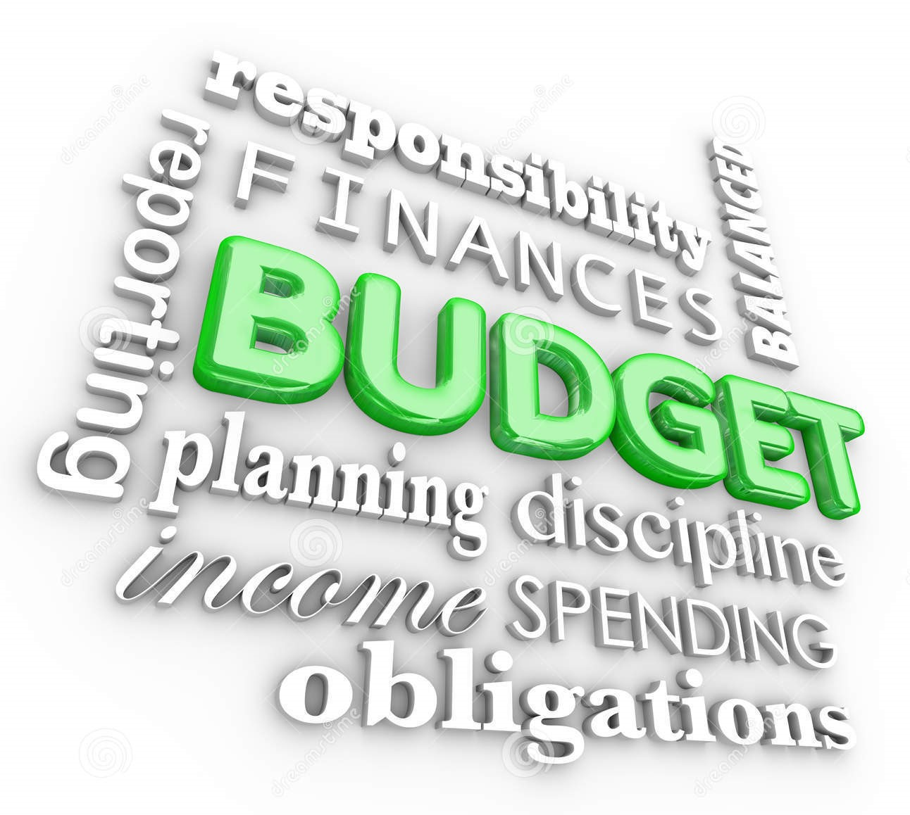
(https://thumbs.dreamstime.com/)

The objective of this report is to provide the accounts directors of the Continental Hotel with a comprehensive overview of the various steps that will be taken in developing a zero-base budget system for the hotel. The report also aims to identify the improvements that will be made in the system in the next few years.
The report will also introduce a detailed plan presented in Excel, which will explain the various steps involved in developing a zero-base budget system for the hotel. After that, we will discuss the details of the traditional and zero-base budget systems and how they work.

Introduction

Nowadays, it is very important that businesses are run in a way that is both fast and profitable. It is not always easy to start a new business, especially since there are so many factors that go into running a successful business. Having a well-defined plan is also very important to avoid potential problems that could arise due to the lack of proper resources and management (Ekholm, B.G. and Wallin, J. (2000). In the hotel industry, there is a lot of money at stake, especially when it comes to providing a good customer experience and establishing a reputation for the hotel itself. Having a well-defined expense plan is also very important to avoid potential issues, and for this, an expense plan must be followed in detail, for an easier attitude towards the business . This is done through the Excel report below, which shows the various expenses that the Continental Hotel has during the year.
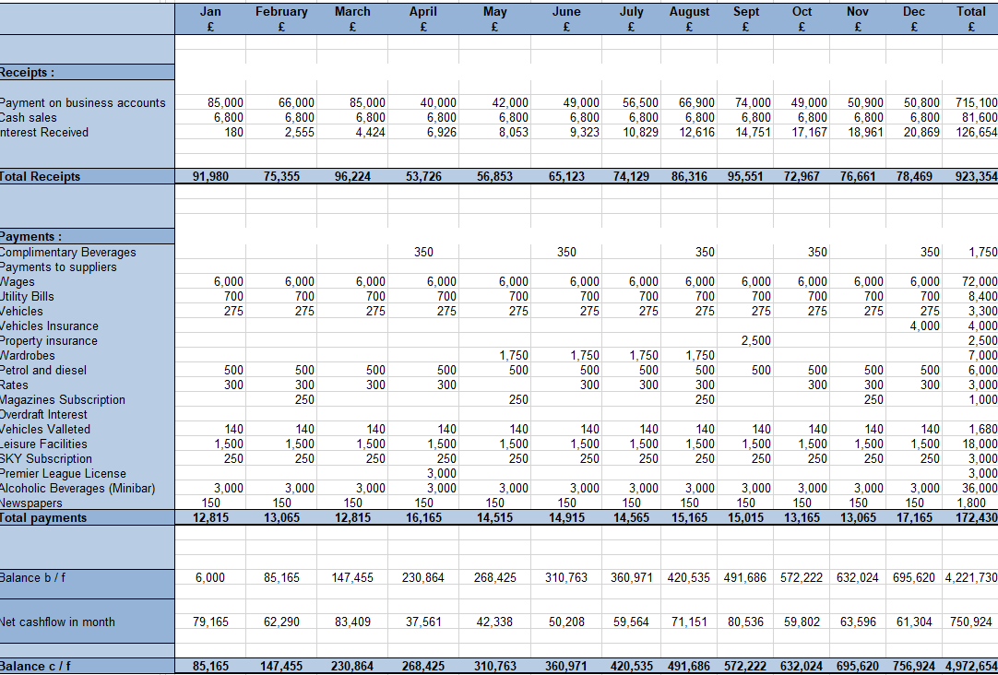

Having a well-defined cash flow strategy is also very important to avoid potential problems that could arise due to the lack of proper resources and management. It can help the company make informed decisions and avoid potential bankruptcy. Having a well-defined budget can additionally help the management make informed decisions.
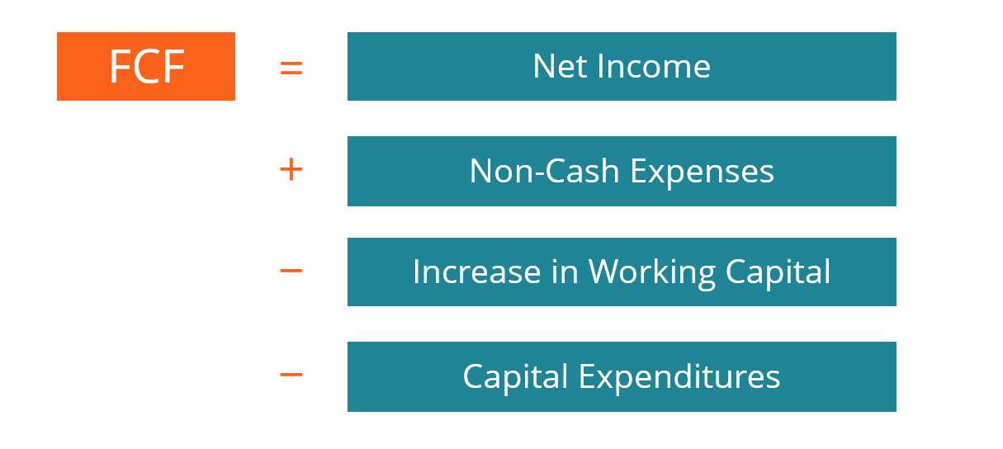
The net cash flow is a simple calculation that can be used to determine the amount of money that flows into a given account. It is done by taking the income-payments and converting them into the cash flow (www.investinganswers.com). (Income – Payments = Net Cash Flow) . The net cash flow is a measure of the amount of money that flows into and out of a company's accounts. It shows whether a company's liquid assets are growing or decreasing. A positive net cash flow means that a company can use its cash to pay its debts and reinvest in its operations. Free cash flow is the amount of money that a company has left over after all its operating expenses and capital expenditures have been taken care of (Stice, K. & Stice, J. ,(2015) ). Having this type of cash flow shows that a company is planning on using its available resources. It can also pay dividends and buy back its shares. The free cash flow formula is used to determine the amount of money that a company has left over after all its operating expenses and capital expenditures have been taken care of . It is then deducted from the company's net income (Reimers, J.L. (2003) ).
( www.bing.com )
Zero-based budget & Traditional-based budget; facts and differences.
There are various types of budget creation tools that organizations can use. The most common approach is a traditional budget, while the zero-based budget is used for certain tasks. (Fraser, R. & Hope, J. (2003) are mentioning that traditional budgets cannot handle the current environment due to their complexity. They also believe that they are better suited for situations with more stable conditions. This paper aims to provide a comprehensive understanding of the differences between the two types of budgets.
(Reka, C. I., Stefan, P., & Daniel, C. V. (2014) are mentioning that the traditional budget is a method that involves the use of cost accounting techniques to allocate and absorb the various expenses associated with a company's operations. It can be described as an incremental approach, which involves creating a new budget based on the previous year's budget. This process usually involves the introduction of new strategies and methods that will allow the organization to increase or decrease the budget. Various factors such as the projected demand, the interest rate, and inflation are also taken into consideration to come up with a budget that is appropriate for the company. A zero-based budget is a method that combines the various factors that are considered during the creation of a budget (Callaghan, S., Hawke, K., & Mignerey, C. (2014). It can be described as an incremental approach, which involves creating a new budget based on the previous year's budget. Since the process is very specific, the top management usually approves the budget. Unlike the traditional budget, the zero-based budget relies on the decisions made by the various decision units within an organization. This method of budgeting is more responsive and transparent.
In the following, few aspects will be discussed and easy examples of differences in between these two methods will be displayed :
- A traditional budget is focused on the amount of money that has been spent in the past. On the other hand, zero-budgeting focuses on the creation of a new economic proposal.
- The traditional budget is usually focused on the accounting principles. On the other hand, zero-budgeting is more decision-oriented.
- In the case of a traditional budget, the project's justification is not necessary. However, in zero-budgeting, it is important to consider the various benefits and costs associated with the project.
- Compared to traditional budgeting, zero-based budgeting is more responsive and clearer. It allows people to make informed decisions and manage their projects more effectively.
- One of the biggest disadvantages of traditional budgeting is that it allows managers to easily achieve their goals despite the elimination. In contrast, zero-based budgeting requires a comprehensive analysis of the proposal, which means that if the managers adjust their goals, they are exposed.
Although it's good to compare the two budgets, they have very different roles and results. For instance, while one budget aims to achieve success, the other one might not be able to achieve the same results (Lindsey, T. & Waterhouse, J.H. (1996).

Comparison | Traditional budget (T.R) | Zero-based Budget (ZBB)
Meaning | The traditional budget is a method used to prepare a budget for the coming year. It considers the previous year's expenses and then comes up with a new budget | A zero-based budgeting system is a method of budgeting that involves reassessing the activities of the budget after it has been established
Based on | Previous spendings | Economic development in the future
Orientation | Accountant | Plans
Goal | This method aims to reduce the spending levels that were excessive in the past. It also requires the implementation of new programs and inflation | The decision-making unit is composed of various decision-making packages. These are categorized according to their relevance
Approach | Timid approach | Straight approach

One of the biggest issues with implementing a zero-based budgeting system is that it can be very time-consuming. Since it involves preparing the budget right from the beginning, it can take a long time to get it done. On the other hand, implementing a traditional budgeting method can be very timesaving. Since the previous year's budget was already changed to meet the needs of the current year, half of the work has already been completed (Wallander, J. (1999).
Zero-based budgeting is a process that can be used in a business to decide or take a certain action. It can also bring various negative and positive aspects:
Aspects with positive impact :
- Transparency
- Stopping spending without clear reasons
- Focusing on a financial profit
- Helping to increase the basic budget
- Creating plans
- Straight approaches and decisions

Few aspects with negative impact :
- It takes time when comes to create
- Unexpected income may create a difficult approach

How important is budgeting when comes to sustainability

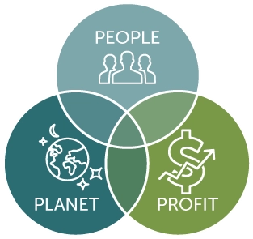
The goal of an entrepreneur is to bring added value to a community through the activities that he or she does. To achieve this, an entrepreneur must first implement the necessary solutions and develop new ways to reduce the impact of their business on the environment and society. This can be done through the development of new ideas and the implementation of strategies that are geared toward improving the efficiency of their operations (www.ingenius-hub.eu). The goal of an entrepreneur is to make a positive impact on the communities that he or she serves. This is done through the development of new ideas and the implementation of strategies that are geared toward improving the efficiency of their business. The survival and development of an enterprise are the only goals that an entrepreneur can pursue. Although it might seem like a daunting task, budget preparation and control is not as difficult as it sounds. This process can be done through the implementation of various operational controls and processes that you have already established in the company. The implementation of a budget process can be done through the training of the various staff members in the company. This process can help minimize the risk of errors and improve the efficiency of the organization. Although it might seem like a daunting task, it is still worth the effort to see the results. In addition to maintaining a healthy and profitable business environment, budget management can also help support and maintain the sustainability of a hotel business (Leon, R., 2020). This can be done through the training of staff members and the reduction of unnecessary expenses.

Conclusion

The hotel industry needs a well-defined budget to ensure that it can maintain its profitability. This can be done through the development of a well-thought-out monetization plan. Besides the presence of tourists, the other factors that can be considered when it comes to maintaining a successful hotel environment include the quality of the staff and the overall guest experience. The presence of different types of budgets in the hotel industry has brought attention to the importance of having a well-defined and organized budget. This can be done through the development of a well-thought-out plan and the proper handling of the budget. The pandemic has also affected many businesses around the world, causing many companies to adopt a more cautious approach when it comes to their budget (Kim, J.J. and Han, H. (2022).

References

Callaghan, S., Hawke, K., & Mignerey, C. (2014). Five myths (and realities) about zero-based budgeting. Available at : https://www.cfo.com/accounting-tax/2014/10/five-myths-zero-based-budgeting/ , [Accessed on 28/06/2022]

Ekholm, B.G. and Wallin, J. (2000), "Is the annual budget really dead?", European Accounting Review, Vol. 9 No. 4, pp. 519-39 Available at : https://econpapers.repec.org/article/tafeuract/v_3a9_3ay_3a2000_3ai_3a4_3ap_3a519-539.htm [Accessed on 27/06/2022]

Hope, J. and Fraser, R. (2003a), Beyond Budgeting: How Managers Can Break Free from the Annual Performance Trap, Harvard Business School Press, Boston, MA Available at: https://www.scirp.org/reference/ReferencesPapers.aspx?ReferenceID=2530899

Kim, J.J. and Han, H. (2022) ‘Saving the hotel industry: Strategic response to the COVID-19 pandemic, hotel selection analysis, and customer retention’, International journal of hospitality management, 102, pp. 103163–103163 Available at : https://librarysearch.uwtsd.ac.uk/discovery/fulldisplay?docid=cdi_proquest_miscellaneous_2619214870&context=PC&vid=44WHELF_UWTSD:44WHELF_UWTSD_VU1&lang=en&search_scope=MyInst_and_CI&adaptor=Primo%20Central&tab=Everything&query=any,contains,pandemic%20influence%20in%20hotel&offset=0

Leon, R., (2020). Strategies for Business Sustainability in a Collaborative Economy. IGI Global. Available at: https://doi-org.ezproxy.uwtsd.ac.uk/10.4018/978-1-7998-4543-0

Lindsey, T. and Waterhouse, J.H. (1996), "Predicting change in management accounting systems", Journal of Management Accounting Research, Vol. 8, pp. 137-50. Available at : https://www.coursehero.com/file/pmuuri/Libby-T-and-Waterhouse-JH-1996-Predicting-change-in-management-accounting/

Reimers, J.L. (2003) Financial accounting : a business process approach. Upper Saddle River, N.J: Prentice Hall. , Available at : https://librarysearch.uwtsd.ac.uk/discovery/fulldisplay?docid=alma9925502502421&context=L&vid=44WHELF_UWTSD:44WHELF_UWTSD_VU1&lang=en&search_scope=MyInst_and_CI&adaptor=Local%20Search%20Engine&tab=Everything&query=any,contains,cash%20flow&offset=10 , [Accessed 26/06/2022]

Reka, C. I., Stefan, P., & Daniel, C. V. (2014). Traditional budgeting versus beyond budgeting: A literature review. Annals of Faculty of Economics, 1(1), 573-581. Available at : https://www.semanticscholar.org/paper/Traditional-Budgeting-Versus-Beyond-Budgeting%3A-A-R%C3%A9ka-Stefan/41871edc4ffeb838d5445002534d77d3e789301b

Stice, K. & Stice, J. (2015) Running a Profitable Business: Understanding Cash Flow. Carpenteria, CA: linkedin.com , Available at : https://librarysearch.uwtsd.ac.uk/discovery/fulldisplay?docid=alma99100409613202421&context=L&vid=44WHELF_UWTSD:44WHELF_UWTSD_VU1&lang=en&search_scope=MyInst_and_CI&adaptor=Local%20Search%20Engine&tab=Everything&query=any,contains,cash%20flow , [Accessed 25/06/2022]

Wallander, J. (1999), "Budgeting: an unnecessary evil", Scandinavian Journal of Management, Vol. 15 No. 4, pp. 405-21. Available at : https://www.researchgate.net/publication/280193259_Beyond_Budgeting_and_change_A_case_study , [Accessed on 29/06/2022]

https://thumbs.dreamstime.com/z/budget-d-word-collage-planning-finances-spending-saving-money-accounting-bookkeeping-terms-like-responsibility-obligations-56465885.jpg
[Accessed 24/06/2022]

https://investinganswers.com/dictionary/n/net-cash-flow
[Accessed 24/06/2022]

https://www.bing.com/images/search?view=detailV2&ccid=aLYPP%2fjY&id=7D82C3C99E6B7C56C609BE8E3399B569CA2DCB9C&thid=OIP.aLYPP_jY62JwA32fvykDBQHaDU&mediaurl=https%3a%2f%2fcdn.corporatefinanceinstitute.com%2fassets%2fdetailed-fcf-formula.png&cdnurl=https%3a%2f%2fth.bing.com%2fth%2fid%2fR.68b60f3ff8d8eb6270037d9fbf290305%3frik%3dnMstymm1mTOOvg%26pid%3dImgRaw%26r%3d0&exph=544&expw=1215&q=free+cash+flow+formula&simid=608014855213118788&FORM=IRPRST&ck=A9A49526A4B9370B4560DECC85DD921A&selectedIndex=8&ajaxhist=0&ajaxserp=0 [Accessed on 23/06/2022]
https://sustain.wisconsin.edu/sustainability/triple-bottom-line/ [Accessed on 26/06/2022]
https://ingenius-hub.eu/ce-presupune-o-afacere-sustenabila/ [Accessed on 27/06/2022]

