

Student name: HUGUETTE DORA EDJANGUE

Student ID number: 2429780

Program: Cert HE Business Skills for the Workplace

Module: Employability and Career Development

Module code: LCLM4005

Assignment Title: REFLECTIVE ESSAY

Leads: Jaya Gopalkrishnan

TABLE OF CONTENTS
PART I JOB ADVERT COMPARISON
- KEY SKILLS
- KEYS KNOWLEDGE
PART II: SELF-ASSESSMENT & EVIDENCE OF READINESS
- Self-assessment
- Evidence of Readiness for Employability and Personal Advancement
PART III: SET EMPLOYMENT GOALS & PERSONAL DEVELOPMENT PLAN
- Employment Goals
- Personal Development Plan
PART IV: REFERENCES
PART V: Appendices

PART I: JOB ADVERT COMPARISON
- Key Skills
Skills | Job advert 1 | Job advert 2 | Job advert 3 | Job advert 4
 | Information Security Analyst Governance, Risk and Compliance (GRC) - Starling | Cybersecurity Governance, Risk and Compliance Consultant - Candour | Governance, Risk and Compliance Consultant - Phoenix | Cyber Governance Analyst - Fruition Group
1:  Incident detection, monitoring & response: | Security Information and Event Management (SIEM) monitoring, threat detection, and incident response procedures | Risk-based monitoring, reporting incidents, compliance-driven alerts | Real-time detection, response playbooks, and log analysis | Cloud & enterprise monitoring, escalations, triage
2:  Vulnerability Management | Running scans, interpreting reports | Compliance-driven risk assessment | Scan scheduling & remediation support. | Vulnerability assessment + patch cycles
3.  Use of Security Tools | SIEM (Splunk, Sentinel), Incident Detection System/Incident Prevention System (IDS/IPS), firewalls | GRC tools (Archer, ServiceNow GRC), SIEM basics | Endpoint Detection and Response (EDR) tools, SIEM, vulnerability scanners | SIEM, Security Orchestration Automation, and Response (SOAR), EDR, scanning tools
All roles require detecting, analysing, and responding to security incidents, using SIEM/EDR or monitoring tools, and identifying and tracking vulnerabilities.

- Key knowledge
Knowledge | Job advert 1 | Job advert 2 | Job advert 3 | Job advert 4
1:  Cyber Security Frameworks | International Organisation for Standardisation (ISO)27001 basics | ISO, NIST CSF, General Data Protection Regulation (GDPR) | National Institute of Standards and Technology (NIST) basics, SOC processes | GDPR, NIST/ISO experience
2:  Security Operations Knowledge | Security Operations Centre (SOC) workflows, alert triage | Risk impact on operations | SOC monitoring, incident lifecycle | Incident lifecycle, remediation steps
3:  Networking & Infrastructure | Transmission Control Protocol/ Internet Protocol (TCP/IP), firewalls, and routing | Risk of network changes | Network security concepts | Network architecture & attack paths
All roles require an understanding of frameworks, the deepest GRC knowledge, an understanding of how security operations work, and fundamental networking knowledge.

PART II: SELF-ASSESSMENT & EVIDENCE OF READINESS
- Self-assessment
A structured personal assessment enables me to evaluate my strengths, weaknesses, and overall readiness for employment and long-term professional development. By using the SWOT framework, I identified several key attributes that reflect my current level of employability.
Weaknesses
• Limited hands-on experience with SIEM, EDR, vulnerability scanners
• Low confidence in high-pressure incident response
• Need deeper understanding of ISO27001, NIST, GDPR
• Balancing academic and practical learning
• Need more practical cybersecurity exposure
Strengths
• Strong capacity to learn quickly
• Excellent ability to analyse information and resolve complex issues
• Clear communication of technical concepts
• Reliable and self-motivated
• Good organisation and time-management skills

Opportunities
• Growing cybersecurity job market
• Ability to earn industry certifications
• Hands-on experience through virtual labs and simulations
• Networking and collaboration opportunities
• Learning through workshops and cyber events
Threats
• Fast-changing technology requiring constant upskilling
• Highly competitive entry-level job market
• Automation reducing some entry-level tasks
• Time constraints between study, development, and work
• Competing with candidates with stronger hands-on experience

2- Evidence of Readiness for Employability and Personal Advancement
Reflective thinking has supported my growth by helping me review each task, identify what went well and what I struggled with, so that I can improve. Roessger (2015) explains that structured reflection enables learners to transform experience into meaningful skill development, which reflects my own progress. By combining essays, group work, and presentations, I have enhanced important employability skills, including critical thinking, communication, and problem-solving, which are fundamental to success in GRC and cybersecurity positions. Virtual labs and real-world-style exercises have deepened my understanding of technical concepts, such as incident detection and SOC processes. Continuing learning on a free platform such as LinkedIn and achieving the Certified in Cybersecurity (CC) certification with ISC2 has helped me build stronger technical and professional skills and prepared me more effectively for my future career. This combination of practical exercises and reflective learning aligns with industry expectations highlighted in frameworks such as (NIST, 2018) and (ISO, 2022).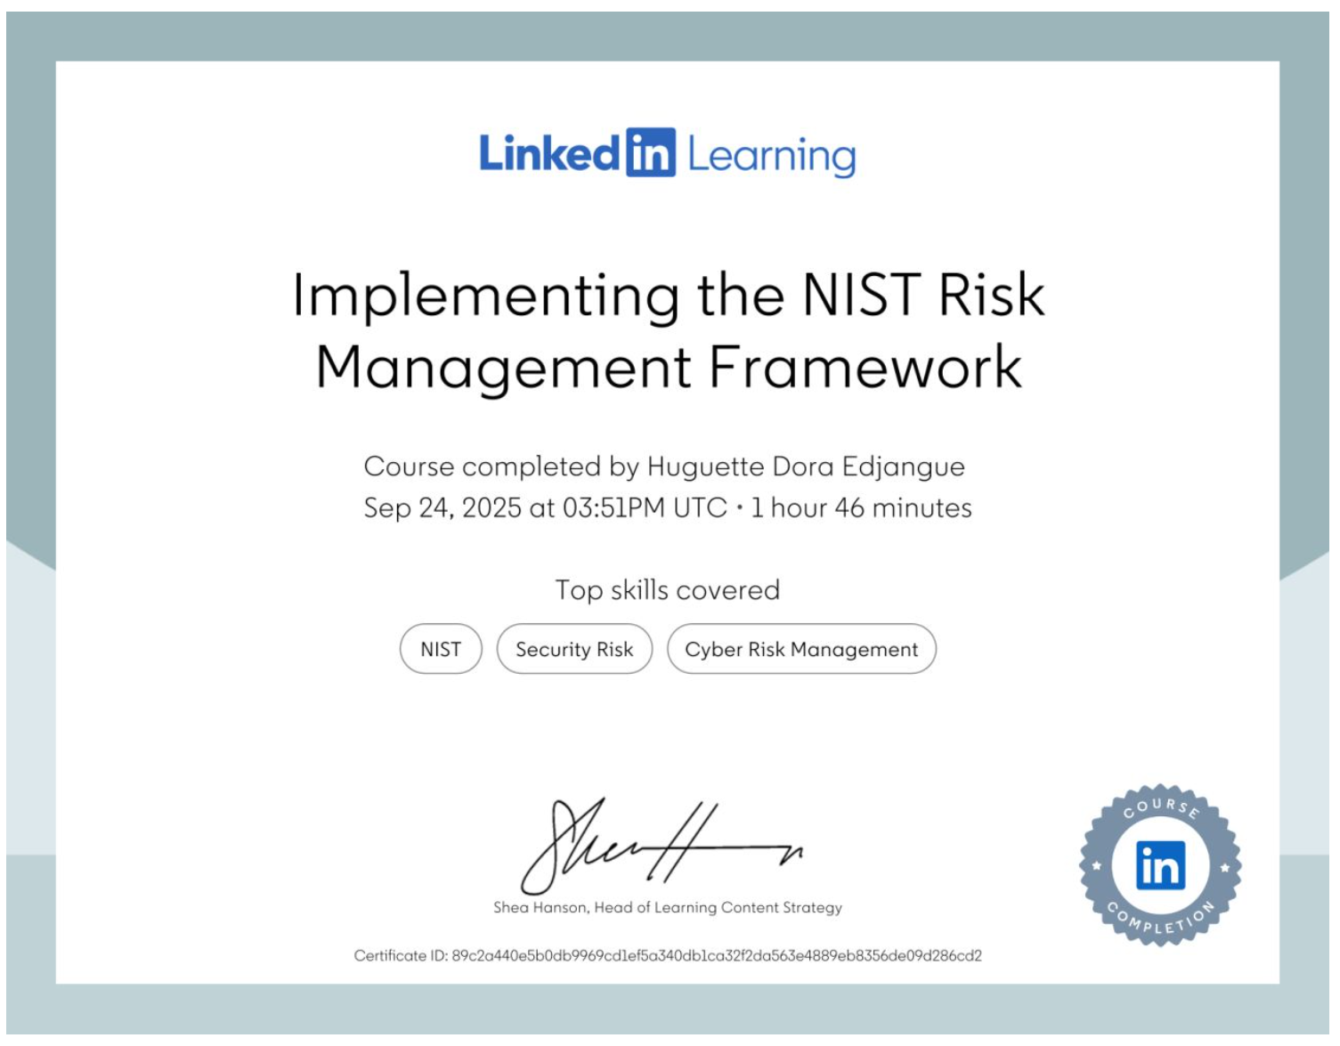
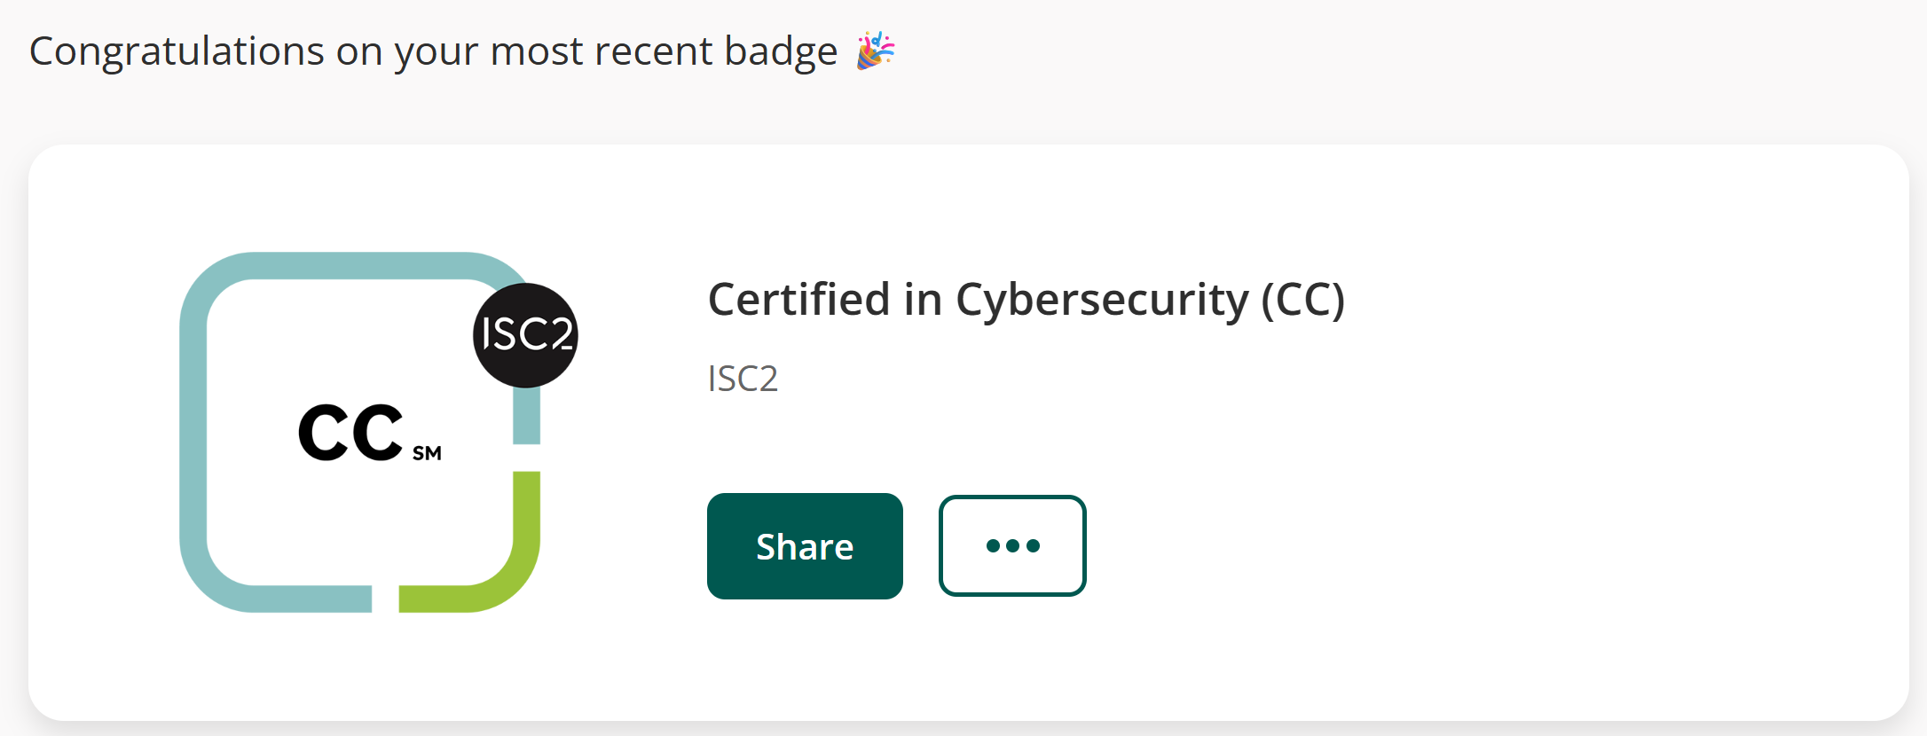
PART III: EMPLOYMENT GOALS & PERSONAL DEVELOPMENT PLAN
- Employment Goals
My short-term career goal is to secure an entry-level job, such as a GRC Analyst Intern or Junior Cybersecurity Analyst. This will allow me to address the technical weaknesses identified in my SWOT analysis by gaining experience with SIEM, EDR, and vulnerability management tools. Additionally, the position will allow me to familiarise myself with ISO 27001 and NIST CSF. Cottrell (2019, p. 10) emphasises that students progress more effectively when they personalise their learning and set clear, achievable goals, reinforcing my decision to begin my career in a structured entry-level role.
My long-term goal is to become a GRC Consultant, providing risk assessments, compliance audits, and advisory services. Achieving this will require advanced certifications, a strong professional portfolio, and deeper industry experience. According to the UK Cyber Security Council (2023), professional pathways develop progressively from foundational to expert practice, reinforcing the importance of building stepwise competence. Additionally, ISACA (2024) highlights that consultant-level roles require strategic skills, business awareness, and advanced analytical capability.
Together, these goals outline a realistic progression from addressing weaknesses to achieving long-term professional independence.
- Personal Development Plan
 | Short-Term Time Frame  What do I want to  accomplish in the next  three to six months? | Mid-Term Time Frame  What do I want to  accomplish in the next  six months to two years? | Long-Term Time Frame  What do I want to  accomplish in the next  two to three years?
Section 1 - My Goals  What are the overall goals that I want to accomplish in this time period?  Example: become a Student Affairs Officer; learn computer graphics | • Employment as a Governance, Risk, and Compliance analyst  • Develop practical skills using SIEM, EDR, and vulnerability management tools  • Apply for roles such as GRC Analyst Internship or Cybersecurity Analyst | • Complete my BA in leadership and management skills for the Workplace BA Leadership at UWDST in London  • Develop practical skills using SIEM, EDR, and vulnerability management tools  • Improve understanding of compliance frameworks such as ISO27001 and NIST CSF | • Develop specialisms in areas such as threat intelligence, incident response, or GRC  • Complete industry certifications including Security+, CySA+, and ISO27001 Lead Implementer  • Build a strong professional portfolio  • Launch my GRC consultant company
Section 2 - Skills and Knowledge to be  Learned  What specifically do I need to learn? What project do I need to work on?  Example: Student advising;  Banner; Dreamweaver; develop a procedures manual | - Gain foundational knowledge of GRC concepts and terminology  - Learn about key frameworks such as ISO 27001 and basic risk management principles  - Develop skills in using common GRC and compliance tools  - Improve professional writing skills for risk reports, policies, and procedures.  - Strengthen communication and stakeholder-engagement skills for working with business units. | - Deepen knowledge of governance frameworks, internal controls, and audit processes.  - Develop a strong understanding of regulatory requirements relevant to my chosen sector.  - Enhance leadership, teamwork, and decision-making skills through BA Leadership modules.  - Gain experience leading small GRC-related tasks or projects at work or during placements.  - Learn and apply project management methods | - Develop advanced skills in strategic risk management and enterprise risk assessments.  - Learn the fundamentals of running a small business (finance, marketing, operations, business planning).  - Build consulting skills, including client needs analysis, solution design, and presentation skills.  - Strengthen my professional network in the GRC field and build a visible personal brand.  - Gain advanced professional certifications relevant to GRC and consulting.
Section 3 - Next Steps  How am I going to acquire the skills and knowledge? How am I going to do this project?  Example: take Dreamweaver class; do an  informational interview; set up a project outline | - Enrol in online courses in GRC, risk management, and information security.  - Update and tailor my CV and LinkedIn profile to focus on GRC-related skills and interests.  - Apply for GRC analyst roles, internships, or entry-level compliance positions every week.  - Complete short online trainings on ISO 27001 basics and risk assessment techniques.  - Join professional communities (e.g., ISACA local chapter, LinkedIn GRC groups) to start networking. | - Continue progressing through my BA in Leadership and Management, focusing on modules that support my GRC career.  - Seek opportunities at work or on placement to shadow senior risk, audit, or compliance professionals.  - Take small projects or responsibilities, such as helping with policy reviews or risk registers.  - Begin working towards an intermediate certification (e.g., ISO 27001 internal auditor or similar).  - Collect evidence of my work (e.g. project on GitHub) to build a professional portfolio. | - Draft a detailed business plan for my future GRC consultancy, including services, pricing, and target market.  - Continue building my professional network by attending events, conferences, and webinars.  - Develop a simple website or online presence to showcase my expertise and services.  - Work towards advanced certifications (e.g., CISM, or ISO 27001 Lead Implementer/Lead Auditor).  - Explore funding options, grants, or part-time consulting opportunities to support the business launch.
Section 4 - Resources  What resources do I need?  Example: free time; funding | - Access to online learning platforms (e.g., TryHackMe, LinkedIn).  - A reliable training and job searching.  - Scheduled weekly study time for completing cybersecurity labs and applications.  - Guidance from tutors or career advisors to refine CV and interview skills.  - Free tools for practising SIEM, EDR, and basic security concepts. | - Funding and support to complete my BA in Leadership and Management.  - Access to workplace learning opportunities, projects, and shadowing.  - Project management tools (such as Trello or similar) to organise tasks and deadlines.  - Study materials and practice exams for professional certifications. | - Funding for advanced certifications  - Legal and financial advice for registering and operating a GRC consultancy.  - Access to professional networking groups (ISACA, UK Cyber Security Council).  - Tools for developing professional documentation  - Conference attendance for ongoing professional development.
Section 5 - Time Schedule  What is my time schedule? | Build core GRC/cyber fundamentals, complete basics, and apply for entry-level roles. | Advance academic and technical skills, including SOC/IR practice and Security+/CySA+. | Develop specialist expertise, gain ISO 27001 LI, build a portfolio, and prepare for GRC consultancy work.
When will I start? | Start immediately | Start at Month 6 of the plan. | Start at the beginning of Year 2
When do I expect to finish? | Within 6 months of the start date | By the end of Year 2 | By the end of Year 3
Section 6 - Completion  When have I completed each  step? | □Complete SIEM/EDR/GRC training  □10/12/2025  Date  □10/06/2026  Date | □Complete BA Leadership modules  □02/02/2026  Date  □02/02/2027  Date | □Build a professional portfolio  □02/02/27  Date  □02/02/2030  Date

PART IV: REFERENCES

Cottrell, S. (2019) The Study Skills Handbook. 5th edn. Red Globe Press.
ISACA (2024) Career Pathways in Governance, Risk and Compliance. Available at: https://www.isaca.org (Accessed: 10 December 2025).
ISO (2022) ISO/IEC 27001:2022 Information Security Management Systems – Requirements. Geneva: International Organisation for Standardisation. Available at: https://www.iso.org/standard/82875.html (Accessed: 12 December 2025).
NIST (2018) Framework for Improving Critical Infrastructure Cybersecurity. Gaithersburg: National Institute of Standards and Technology. Available at: https://www.nist.gov/cyberframework (Accessed: 12 December 2025).
Roessger, K.M. (2015) ‘But does it work? Reflective activities, learning outcomes and instrumental learning in continuing professional development’, Journal of Education and Work, 28(1), pp. 83–105
UK Cyber Security Council (2023) Cyber Security Career Framework. Available at: https://www.ukcybersecuritycouncil.org.uk (Accessed: 10 December 2025).

PART V: Appendices https://www.linkedin.com/learning/certificates/89c2a440e5b0db9969cd1ef5a340db1ca32f2da563e4889eb8356de09d286cd2?u=77966930
https://www.credly.com/badges/36a618e3-1ec4-43fe-91fe-a4e97c324c2f/public_url

