Sarah Ali, BMIH5003

Culture Awareness

Rodrigo F. Aguilera

Report Hotel Handbook for Intercultural Competence

Executive summary
This report will summarise the key findings and understanding of Cultural awareness between two chosen countries, Hotel based in Spain and oversees guest from Bangladesh. Using Hofstede’s six-dimensional model for understanding cultural differences, the following aspects of Bangladesh society and cultural norms, and reviewing how Hofstede’s 1970’s stats have changed with time, as Globe (2007) adapts with further dimensional investigation into cultural aspects, demographical, technological, and economic values using graphs and atlas for the findings. This will engage managers and motivate staff to achieve a high level of understanding of importance of respecting guest culture that exists, leading to better hospitality attitude and a profitable revenue from oversees guests. Many nationalities have their own unique ways of communicating its important to know each country’s etiquette to make guests feel welcome and avoid a situation that could cause displease. Considering the communication barrier and making it important for housekeeping to get the timing right entering a room, for guests that pray a certain level of knowledge and understanding of uses of technology apps, mobile language interpreting apps and online training should be offered to staff on services and catering department to host the unique needs of international guests with confidence. “Spanish people like to live in the moment, without a great concern about the future. Spain is the country that has given the meaning of ‘fiesta’ to the world” (Hofstede insight, 2022). Bangladesh (2020) Muslim people would not approve of or attend such events, Traditions such as the tomato festival an event full of having fun throwing tomatoes outside in a street party, carnivals, loud street music is the essence of the culture.

Contents Page

- Cover page

- Executive Summary

- Contents Page

- Introduction

- A - Hotel based in Spain

- B - Guests from Bangladesh, Bengali culture (Islamic Faith)

- Cultural difference

- Cultural difference, Dimensions.

- Hotel handbook

- Conclusion and Recommendation

- Bibliography

- Bibliography

Introduction

Country A- hotel destination is ‘Spain’, Country B- Oversees guest arriving from Bangladesh. Staff are to manage guest services to accommodate and welcome guests for cultural differences. Culture and traditions compared using methods of research for Intercultural competence, Hofstede (1980) and Globe (2007). Country analysis based on Spain and Bangladesh. Bangladesh has a high culture of Islamic faith, these can cause issues of being uncomfortable for guests with religious needs for no music at prayer times as Spain is known for being the second loudest country the culture of Spanish people is music, alcohol and dancing, with the oversees guest culture of religious activities such as dress code prayer times, forbidden of certain meats and forbidden on Alcohol this will require a strong degree of cultural sensitivity.

Country A, Hotel location is Spain.

The hotel is based in the Kingdom of Spain, shown in world Atlas (2021) Spain is in “Southwestern Europe, being the third largest country in Europe with just under a population of fifty million, divided into “17 autonomous communities. The Capital of Spain is Madrid known for the many cultures and it economically being the centre of Spain. The official language being Espanyol (Spanish).

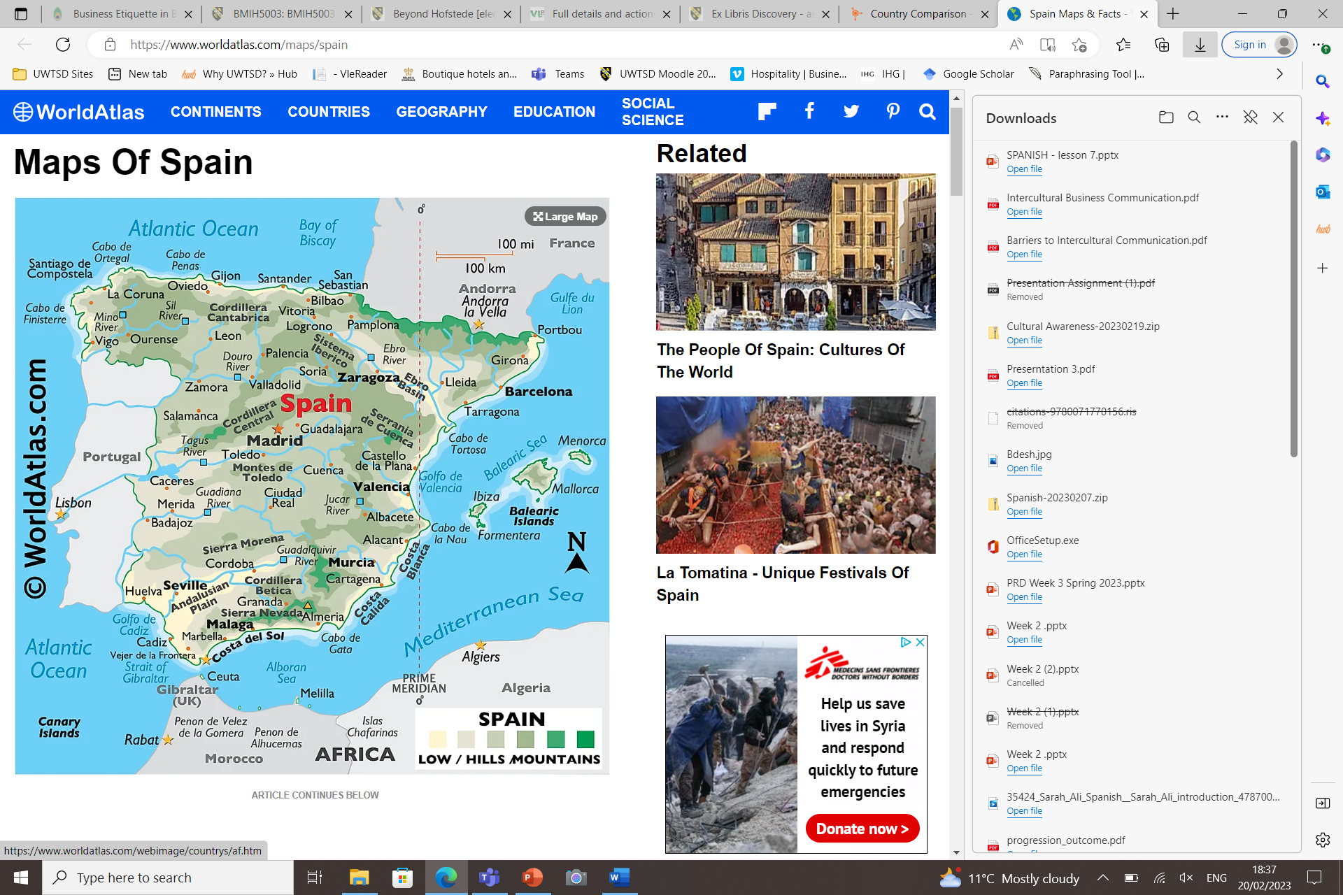
(World Atlas, 2021)

Introduction to my chosen country B oversees guests from Bangladesh, faith Islam.

Bangladesh is situated in the eastern part of the South Asian sub-continent lies between latitudes 20°34´ and 26°38´ North, and longitudes 88°01´ and 92°41´ East, (Embassy of Bangladesh,2020). Official language is Bengali. The standard greeting in Bangladesh is "As-salaam mu alaykum," which translates to "may peace be upon you" in Arabic. The reply is "Wa alaykumu s-salam," which means "may peace be upon you as well.”

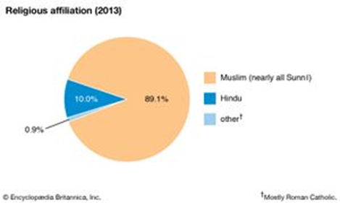

Cultural Difference

Cultural difference between Bangladesh and Spain, both scoring high on hierarchy both Spain and Bangladesh considered to Hofstede’s Insight is a collective society, making “spaniyards quite easy to relate with certain cultures mainly non-European.” Bangladesh more a masculine society compared to Spain is more Feminine. Bangladesh future unknown on uncertainty avoidance and Spain score is high score yet it is the second noisiest country and both countries have a pragmatic approach to long term orientation, Bangladesh is a nation under culture restraint this places less value on leisure time and restrict the satisfaction of their wishes than Indulgent societies do. Spanish people like to live in the moment with structure and education to prepare for the future, Bangladesh has no direction, future is unknown of youngsters, results showing low indulgence, putting others first, (Insight, 2022).
Bangladesh is influenced by three great religions Hinduism, Buddhism and Islam with Islam having the most impact (2013). Understanding of the Global manager (French, 2011), looks at culture, Democracy, culture awareness, political system, environment, attitudes, economies in a single world-wide market, (Aguilera. R, Moodle, 2023)

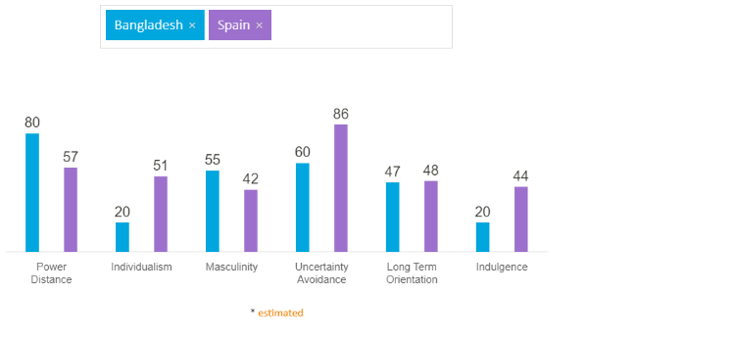
(Hofstede Insight, 2022)

Hofstede dimensions (1980), focusing on six dimensions nation, with four aspects of national culture, Hofstede’s dimensions being outdated, with opportunities for Globe to add further five dimensions, (house et al, 2004) global studies adapt on Hofstede’s dimensions elaborates on organisational leaderships,

performance with looking at nations updated by looking at what you do at work at home culture and in society investigated and expanded more than Hofstede’s dimensions (Waters et al, 2017). In class discussion researcher the Trompenaars and Hampden-Turner Dimensions also looked at nations a group of ppl the ways to act to solve problems being similar to Hofstede’s, with new perspective. Culture based on Hofstede does not outdate, and known not to change with time, and technology keeps progressing with time with introduction of clever gadgets, to achieve data, knowledge, and training for the hospitality industry. Globally the unknown of how advanced smart technology has proven from writing letters to ‘chat botts’, (Aguilera. R, 6th February 2023), Trumpinar thinks on trends and had more advanced resources developing. According to ‘Beyond Hofstede’ Hofstede (Nakata. C, 2009), Factors affecting national culture of Spain, for oversees guests is music, political system, values soft culture trends.

Handbook

Do’s Do not
Greet with ‘Assa-la-mu-aliykum’ or Same gender soft handshake, Polite nod ‘Good afternoon, morning, evening, for opposite gender | Opposite gender no physical contact, this is not acceptable and seen as rude.
Right hand to give and receive, or use of both hands together | Using left hand is impolite, as it is used for cleaning.
Offer prayer mats | No animal gelatine unless it states it is Halal
Advise kitchen and bar staff, front of house of Dietary requirements | No Alcohol  No Pork
Halal food on the menu
Prayer room | Do not have guests overlooking social activities such as sports, swimming, gym
Offer the direction of prayer in room, toward the kiblah, can be found NE of the compass | Enter room with shoes
In the bathroom toilet bidet or lota | Enter a female’s room without permission as they might not be wearing their head scarf known as hijab.
Cutlery place on the right
 | Cross one’s legs Infront of guests this is impolite, (Etiquette, Scroope.C, 2017)

(Sucri. A, et al, pp201-241, 2020)

Cultural advice to hotel colleagues
- Kitchen, food products Halal option, a Muslim guest will have no Alcohol or Pork is a forbidden meat.
- Bathroom cultural norm to have a “lota,” (Amazon, 2022) in bathroom, to accommodate the guests this ‘Lota’ is available at ‘Amazon online’ to buy.
- Avoid booking parties that clash with religiose events to avoid seeming disrespectful.

Conclusion
Success in the International oversees hospitality industry starts with the global understanding of creation of clusters by globe to compare, analyse data of culture within hospitality. Understanding politics, demographics, technological aspects. Sufficient training for employees to be confident in communicating with international guests, is essential to create motivated staff and managers. Recognising the needs of a guest’s culture and faith from around the globe will avoid embarrassing encounters as gestures in one culture can be impolite in another culture (Hofstede 2010). Creating a standard for the hospitality industry and cultural intelligence is benefiting one’s own understanding, becoming valuable to the employer.

Further Reading Recommendations
- https://culturalatlas.sbs.com.au/bangladeshi-culture/bangladeshi-culture-do-s-and-don-ts#bangladeshi-culture-do-s-and-don-ts , “symbols and Bangla language. People respect their elders, so avoid any remarks that criticise or disregard an older person’s status or opinion” (2023).
- Mäkelä, L., Kinnunen, U. and Suutari, V. (2015) ‘Work-To-Life Conflict and Enrichment Among International Business Travelers: The Role of International Career Orientation’, Human resource management, 54(3), pp. 517–531. Available at: https://doi.org/10.1002/hrm.21629. (UWTSD Library)

Bibliography

- Aguilera. R, (6TH February 2023) Moodle in class discussion (Accessed 6th, 12th Feb)

- Hofstede Insight Comparison(1984), Country Comparison (2022), Country Comparison - Hofstede Insights (hofstede-insights.com) (Accessed 6th -17th February 2023)

- Hofstede, G. (2010) Cultures and organizations: software of the mind. Third edition. New York: McGraw-Hill.

- Moran, R. (2017) Managing Cultural Differences. 10th ed. Taylor and Francis. (pp17,514. UWTSD, library)

- Nakata, C. (2009) Beyond Hofstede [electronic resource]: Culture Frameworks for Global Marketing and Management. 1st ed. 2009. London: Palgrave Macmillan UK ; Imprint Palgrave Macmillan. doi:10.1057/9780230240834.

- Bangladesh (2020), Culture in Bangladesh – Embassy & Permanent Mission of the People's Republic of Bangladesh, (bangladootvienna.gov.bd) (Accessed 18th February, 2023)

- Bangladesh, Religion | History, Capital, Map, Flag, Population, & Facts." 14 Feb. 2023, https://www.britannica.com/place/Bangladesh.
(Accessed 19th February 2023)

- Global Manager, (French 2011) 10 attributes of the global Manager, Accessed 6th February

- Google map atlas (2023), Spain Maps & Facts - World Atlas, https://www.worldatlas.com/maps/spain#:~:text=All%20maps%2C%20graphics%2C%20flags%2C%20photos%20and%20original%20descriptions%20%C2%A9%202023%20worldatlas.com, (Accessed 18th Feb 2023)

- Assessing the applicability of Hofstede’s cultural dimensions for Global 500 corporations’ (2017), Facebook profiles and content’, Journal of communication management (London, England), 21(1), pp. 51–67. Available at: https://doi.org/10.1108/JCOM-04-2016-0021. (Accessed 20th February 2023)

- Sucri. An et al, (2020) ‘Muslim-friendly assessment tool for hotel: how halal will you serve?’ https://doi.org/10.1080/19368623.2020.1775746

- Scroope.C, (2017) Bangladeshi culture, https://culturalatlas.sbs.com.au/bangladeshi-culture/bgladeshi-culture-etiquette online (Accessed 3rd, 19th, 20th February 2023)

- Lota, (2022),sold at Amazon price scrapper, Plastic Grey Lota / Bodna / Toilet Wash Jug : Amazon.co.uk: Home & Kitchen, (Accessed 20th February 2023)

