MODULE TITLE: ANALISYS SWOT AND PDP

ASSIGNMENT TITLE: ANALISYS SWOT AND PDP

STUDENT NAME: IOSIF DANIEL STAN

STUDENT ID NUMBER: 1815337

LECTURER NAME: DALE CLARK

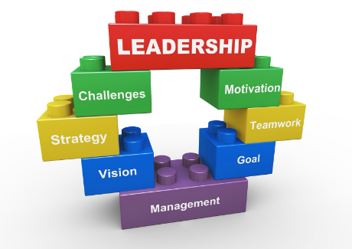



Presentation………………………………………….3

SWOT………………………………………………...4

Self-improvement Plan………………………………5

Scholarly Skills ………………………………………6

Employability Skills…….….....................................6-7

End………..............................................................7

References……………………………………………8

I need to set up a report utilizing SWOT and PDP to break down my scholastic and work abilities and to feature how I expect to utilize these aptitudes to get a new line of work in the inn and lodging industry.

Introduction

During the process my aim is that I need a swot on myself, where I will analise what my strenghts,weaknesses,opportunities and threats are.
By doing this will have an a better understanding where I need to improve a well as what my strenghts are.
Once I know I can then focus on improving the areas that I am weakest at and develop them into strenghts.
It is an opportunity to explore oneself openely and honestly and perhaps learn about myself in way that I wouldn’t have considered.
I am looking forward to the outcome and relish the challenge that it may bring.
Taking all the inmformation I develop a PDP peronalised to cater for all learnings and it is somethibng that will help me analise all my improvements and failings.
As I go forwards I then can capitalise and inbed into my academic learning and implement then with confidence.
As I grow so will my confidence develop and my understanding florish, therefore leading me into going forwards with confidence with my new skills into the world of employment with the necessary tools to do the very bet and what is expected of me.
In the end hard work pays and thi is my aim, work hard and achieve my goals.

Individual SWOT examination is a successful system that encourages you settle on significant choices about your profession and individual life. SWOT examination encourages you distinguish your qualities, which you can profit by, yet in addition disconnect viewpoints that should be improved. Along these lines, you will have an exceptionally clear image of the level at which you are in your profession and you will become more acquainted with yourself better.
SWOT examination can be utilized both to assess a business, a task, yet in addition an individual.

Peronal SWOT Analysis

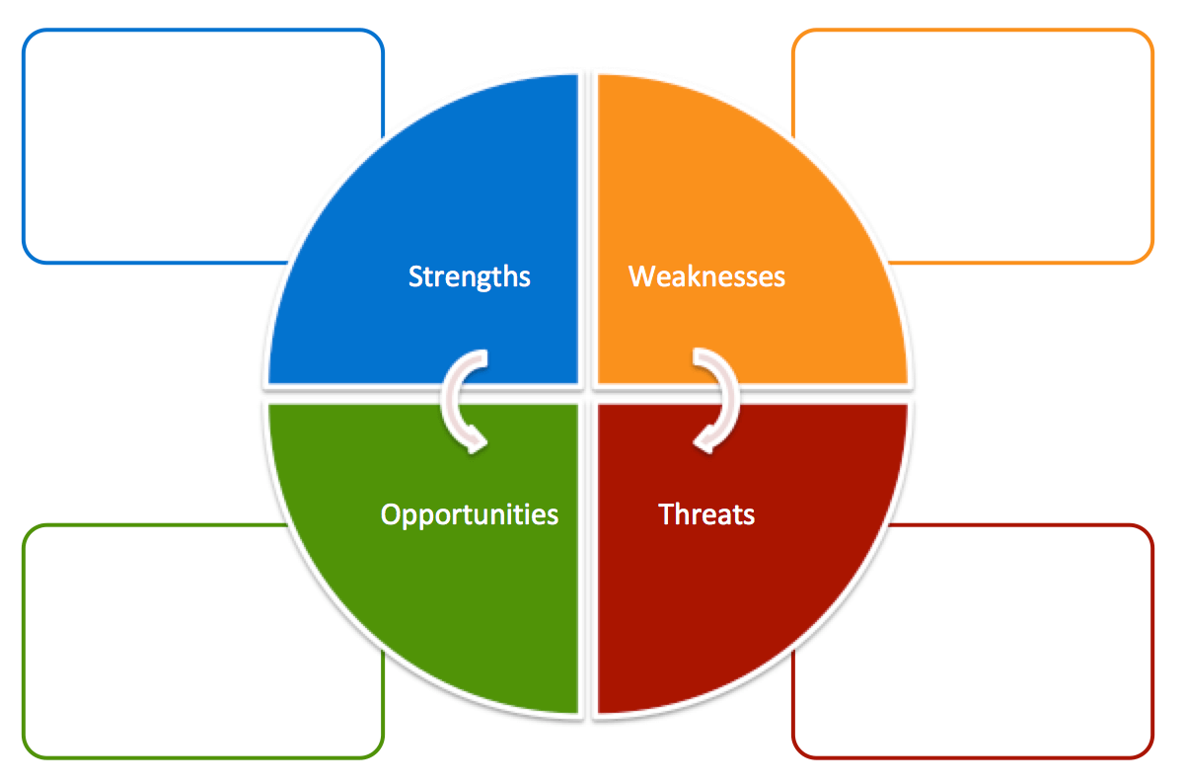
-serious
-opened to new ideas
-patient and calm
- sociable
-wide range of availability and abilities
-love for children
- poor experience of the field
- trust in individuals
- certainty with how I manage a few dangers
- absence of budgetary inspiration

-information in the field
- various types of preparing
- joint effort with my better half
- the nation's exit from the EU

- permanent social transformations
- new trends in the field
-the salary
-routine

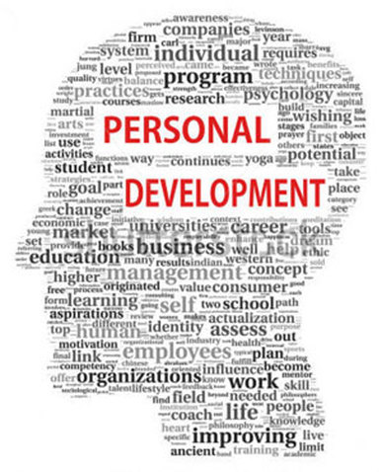


Personal Development Plan (PDP)

A self-improvement plan (or PDP) isn't only an obligatory something that supervisors causes you to do before a yearly evaluation; they're likewise that firm shake that enables your fantasies and wants to remain in sight. A PDP (Personal Development Plan) is a helpful device that means to improve your odds of getting what you need, regardless of whether in business, self-improvement, connections, or life by and large. A PDP does this by breaking down your positive and negative characteristics, your past and current execution, and applying an organized.
1. Set Yourself Goals-Search for the things you truly need throughout everyday life, these are your long-haul objectives
2. Organizing Your Goals-you have to consider all the little advances that will enable you to accomplish your huge objectives.
3. Set Yourself Deadlines-Knowing when you need to accomplish an objective is pivotal and imagining your future is a significant wellspring of inspiration and motivation.
4. Perceive dangers and openings There will be sure things they could be outer things or a component of yourself that, on the off chance that you let them, will keep you from accomplishing your objectives or postpone you on your way.
5. Create yourself-Once you have a thought of what could obstruct you and what could support you, this is the point at which you can profit by those open doors you perceived. Make an activity arrangement about how you'll gain that ground.
6. Utilize your encouraging group of people the following thing you have to acknowledge is that: You don't need to do everything independent from anyone else. You can utilize the help from system
7. Measure advance Whether it's huge or little, after you've accomplished some advancement set aside effort to think about how far you've come.

 | Transient Time Frame  What would I like to achieve in the following three to a half year? | Mid-Term Time Frame  What would I like to achieve in the following a half year to two years? | Long haul Time Frame  What would I like to achieve in the following a few years?
Segment 1-My objectives  What are my general objectives that I need to achieve in this timespan? | - Improve my composition  - Improve correspondence in business language  - Improve my processing abilities | -Review last six months find out if I on track and carry on improving it. | -To finish the course  -To open a business  -To be ready to lead a team with confidence
Segment 2 – Skills and Knowledge to be Learned  What explicitly do I have to learn? What tasks do I have to take a shot at? | -Learning management  -Learning to make a better assessment  -Learn how to search the right materials with ease. | -Improving my customer relationship  -format my projects in the right way easily  -complete tasks confidently | -be confident in all aspects of the course  -use my learning to benefit my life  -move on to my next challenge
Segment 3 - Next Steps  How am I going to gain the aptitudes and learning? How am I going to do this task? | -utilise all tool available to me  - be confident in asking for help  -not be afraid to try something different. | -share ideas with others to gat bet results  -prepare all facts and plan ahead  -organise my workload | -always be ahead of all tasks  -use skills gained with confidence  -be ready to try new ideas and share opinions openly

Academic Skill
Study aptitudes, scholarly ability, or study techniques are strategies associated with learning. They are generally essential to achievement in school, considered principal for acquiring not too bad assessments, and important for learning for a stunning length.
- Scholarly uprightness and written falsification. Scholastic composition. Basic reasoning.
- Computerized abilities. Employability. Maths and insights.
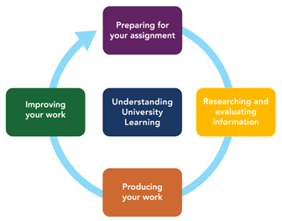
- Note making. Referencing. Update and tests.
- Scanning for data. Time the board.

Employability Skill

There are many factors that are important asides from just ability, qualifications etc. knowing your stuff sometimes is not enough, personality, presentation, organisation are just some qualities others looks for also.
Of course, what makes you unique from a professional point of view matters, but long-term success depends on certain indispensable skills
In other words, there is a range of competencies sought by any employer.
- Communication skills (verbal and written)
- Analytical and research skills
- IT skills
- Flexibility and prioritization
- Interpersonal skills

Employability aptitudes are a great deal of capacities and practices that are essential for every movement. Employability capacities are every so often called sensitive aptitudes, fundamental aptitudes, work-planning capacities, or occupation accessibility capacities.

• Employability aptitudes empower you to:

• speak with partners

• take care of issues

• comprehend your activity inside the gathering

• settle on careful choices, and

• assume obligation regarding your very own livelihood

Conclusion

Thusly, the end (for instance the finishing) of the SWOT is the time when you accomplish a full cognizance of your: Strengths, Weaknesses, Opportunities, and Threats. By totally getting them, you can begin to choose decisions that reinforce your Strengths, get ready for Weakness, benefit by the Opportunity, and reduce the Threats.

The end (for example the appropriate response) from a SWOT is especially the following stage toward tending to those regions. Be that as it may, the appropriate response isn't total, and you should take direct another SWOT in a convenient way (for example contingent upon the arrangements you actualize) to decide whether those choices were successful.

Considering, we present ourselves through both eye to eye and online correspondence. Transforming into a capable communicator emphatically influences our own and social associations. Moral and incredible correspondence ends up being much progressively central when our messages are passed on around the globe electronically. By separating eye to eye and online social capacities, I perceived my characteristics and weaknesses and developed certain musings on the most ideal approach to improve my social capacities to transform into an inexorably capable and capable communicator. I expect to be a fruitful and good communicator by further teaching myself around there and practicing verbal, nonverbal, and full focus capacities that I learned in the correspondence course.

Reference
- Visitor (2011), 'Human Resource Development worldwide', Volume 14, 2011-Issue 5

- Coman, An and Ronen, B (2009) "Centered SWOT: diagnosing basic qualities and shortcomings, pp 5677-5689

- Murphy, H A, Herbert, W, and Hildebrandt, J T, (1991) Effective Business Communications

- Execution and Development Record (2017) @ Marks and Spencer

- Employment Profile - Hotel Manager (2019) Available at: www.prospects.ac.uk (Accessed at 15 July 2019)

- The Importance of Career Networking (2019) Available at www.thebalancecareers.com (Accessed 16 July 2019)

