1A
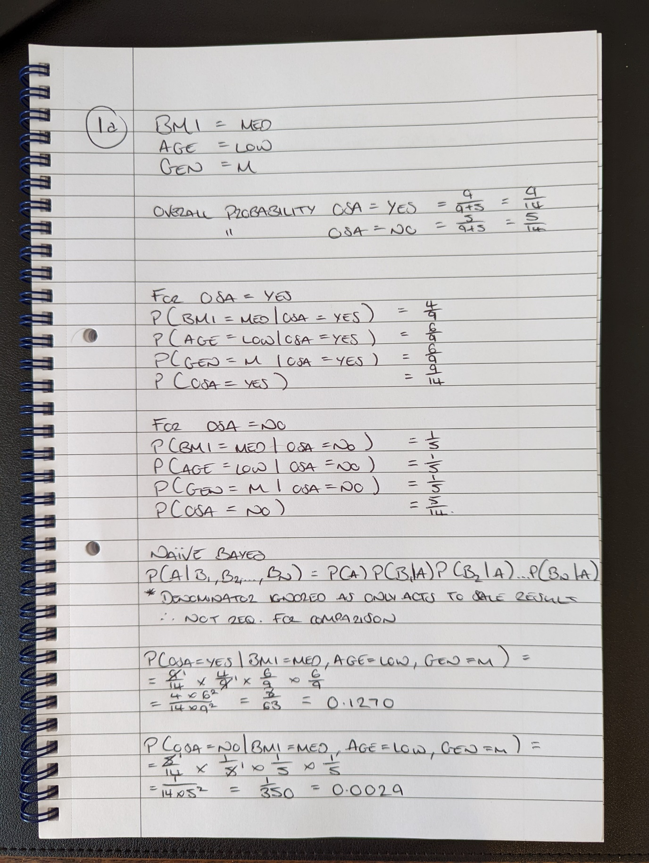

1B
A solution to overcoming the issue of very small probability values from Naïve Bayes leading to numerical errors, is to use the log method. By working in log space, the log of probability values do not become exceeding low and therefore underflows (of a value being so close to 0 is it is evaluated as 0) can be prevented. Utilising the log of a probability will instead give a value of between negative infinity and 0 rather than 0 and 1, however for comparison purposes this works fine because if a < b then ln a < ln b – the actual resulting numbers are not required for comparison. To perform calculations, the log of a product is equivalent to the sum of the logarithms of the elements within that product, making for simple calculations resulting in numbers further from 0.
2A
Uninformed Search:
Doesn’t utilise information on the goal state or search space to perform its search, often referred to as a blind search or a brute-force search. They typically look through whole search space in an ordered manner for all possible solutions to a given problem. It is typically less efficient than an informed search.
Example: Dijkstra’s Algorithm
Informed Search:
Utilises extra information on the goal state to estimate, for example by estimating the distance/cost from a current search node to the goal node, and using this to inform a next best move. It is typically more efficient than an uninformed search.
Example: A* Algorithm
2B
Dijkstra’s algorithm is used to resolve a shortest path problem, finding the shortest path from a starting node to any other node within a graph. Its operation works by considering a starting node, and looking at all connected nodes, using edges to determine the next best move, as explained below.
- Set starting node to closed, record distance as 0 and last visited as itself.
- Look at neighbouring nodes to starting node, determine their distance and add all to open list with ‘last node’ as the starting node.
- Select the node with the shortest distance on the open list, and move this to the closed list – the shortest path to this node has now been found. Set this node as the ‘current node’
- Look at neighbouring nodes to the current node, and add the distance between these nodes to the distance recorded for the current node, record all in the open list with the current node as their last visited. If any of these nodes are already in the open list, check the distance against the newly calculate distance from the current node, if it is shorter update the node in the open list with the new shorter distance, and the current node as the last visited node.
- Repeat 3 & 4 until the open list is empty, or until the shortest path to the destination has been found (it has been added to the closed list)
If V is the number of vertices and E is the number of edges, time complexity is O(|V|²) with standard vector or array implementation, but can be improved to O(|E| + |V|log|V|) if a priority queue is utilised. Space complexity can be given as O(|V|²).
2C
Dijkstra’s algorithm can be enhanced with some tweaks to become the A* algorithm, this can be achieved by adding a heuristic function to estimate the best possible next move, shown in the below evaluation function.
f(n) = g(n) + h(n)
f(n) is the evaluation function for the node
g(n) is the actual cost from start to current node, this is also the case for Dijkstra’s Algorithm
h(n) is the estimated cost to the goal
As an example, for a graph with x,y coordinates, it could achieve this by calculating the direct distance from each potential node to the destination node, and using this to weight next possible moves, with the shortest direct distance being preferable. In this simple example there may not in actuality be a path direct between two nodes even if they are physically close in the space, therefore a more complex heuristic function to take into account the specific of the problem could be employed. There is also the chance that A* will find a path, but not necessarily the shortest path, utilising a admissible heuristic function which ensures the estimated cost is always lower than or equal to the actual cost will ensure the shortest path is found.
2D
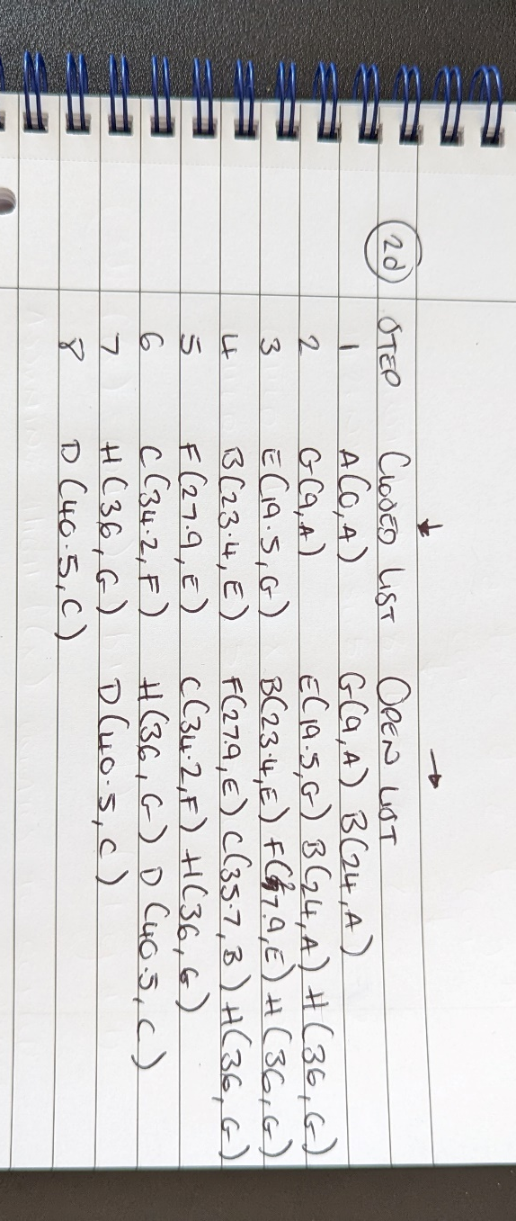
3A
START
Generate a population of fixed length strings
WHILE (terminating condition not reached) {
Evaluate fitness of individuals
Evaluate total fitness of population
Iterate through population to determine candidates with highest fitness
Generate new population using highest fitness individuals identified
Apply genetic operators such as crossover or mutation to individuals
}
END
3B
Multiple terminating conditions can be used to determine when a genetic algorithm will stop evolving, a discussion of some of these is below:
Manual Inspection:
Manual inspection of solutions take place to determine when a reasonable solution has been found, this can be useful in examples where it is hard to define a solutions criteria arithmetically and a more subjective approach is required. This terminating condition is difficult and slow in practice as it requires a human to stop the algorithm at certain points and perform a manual inspection.
Minimum Criteria:
In a scenario where it is possible to define minimum criteria for a solution, such as a set of requirements for a reasonable solution, these minimum criteria can be utilised by the algorithm to monitor each generation, and once a suitable solution has been found that matches these criteria the termination can take place. This is a potentially useful condition to utilise where minimum criteria has been defined, but does mean the algorithm won’t necessarily work towards an optimal solution, as it will cease once a ‘good enough’ solution has been found.
Setting a limit
An alternative is to utilise limit setting, for example to allow the algorithm to run until a budget ceiling has been reached (time, money, number of generations) which can be used to find the best possible solution with a given limiting factor. Otherwise, there is the potential to terminate should a plateau have been found where further iterations no longer produce drastic improvements – suggesting a good solution has been found (however, this may not definitively be the case, as a plateau could be reached and then results take off again on the way to an optimal solution).
Combinations:
The above conditions could be combined depending on the required scenario to get the best possible results for a particular problem given relevant limitations.
3C
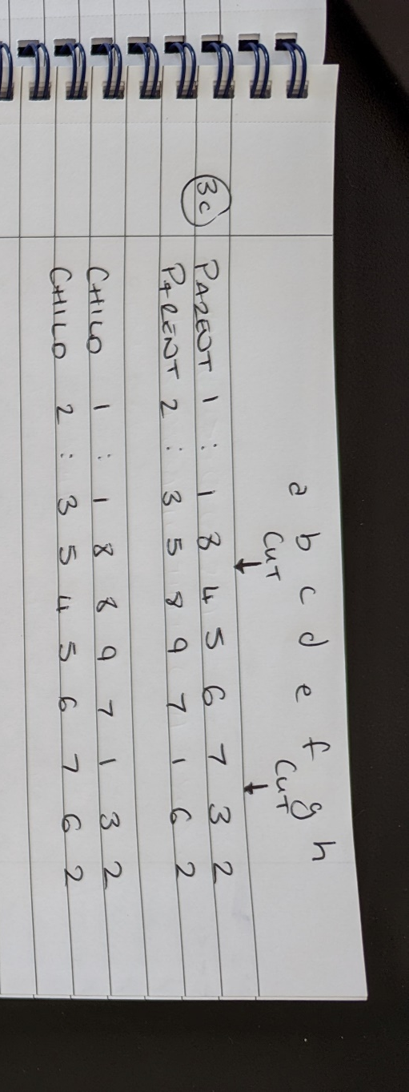
3D


