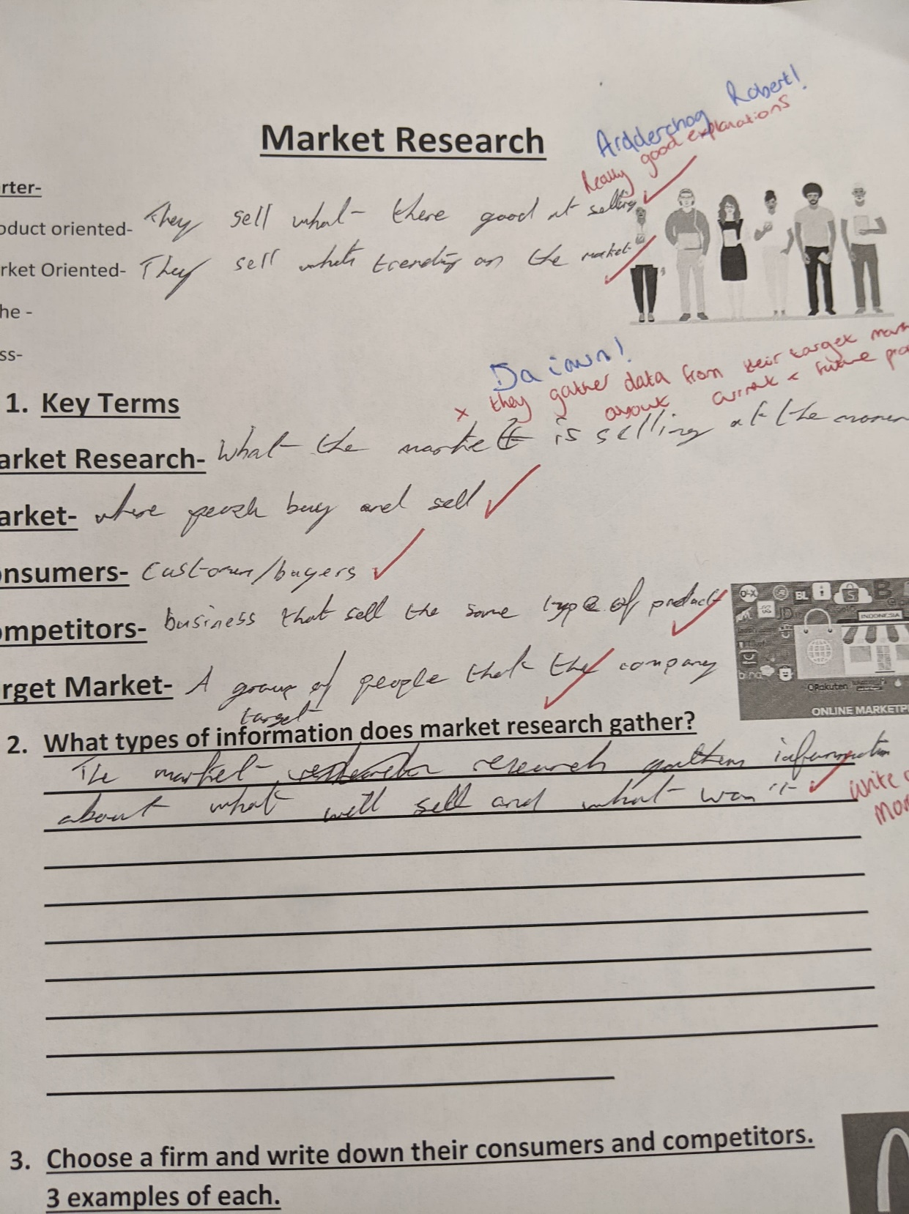
Evidence of correcting a learner's work.

