DS 1 Assignment

My Screenshots/Photos
- Please add 4–6 screenshots or photos of your digital life.
- You can use your phone or laptop.
- For each screenshot, write one or two sentences explaining what it shows.

Screenshot/Photo 1
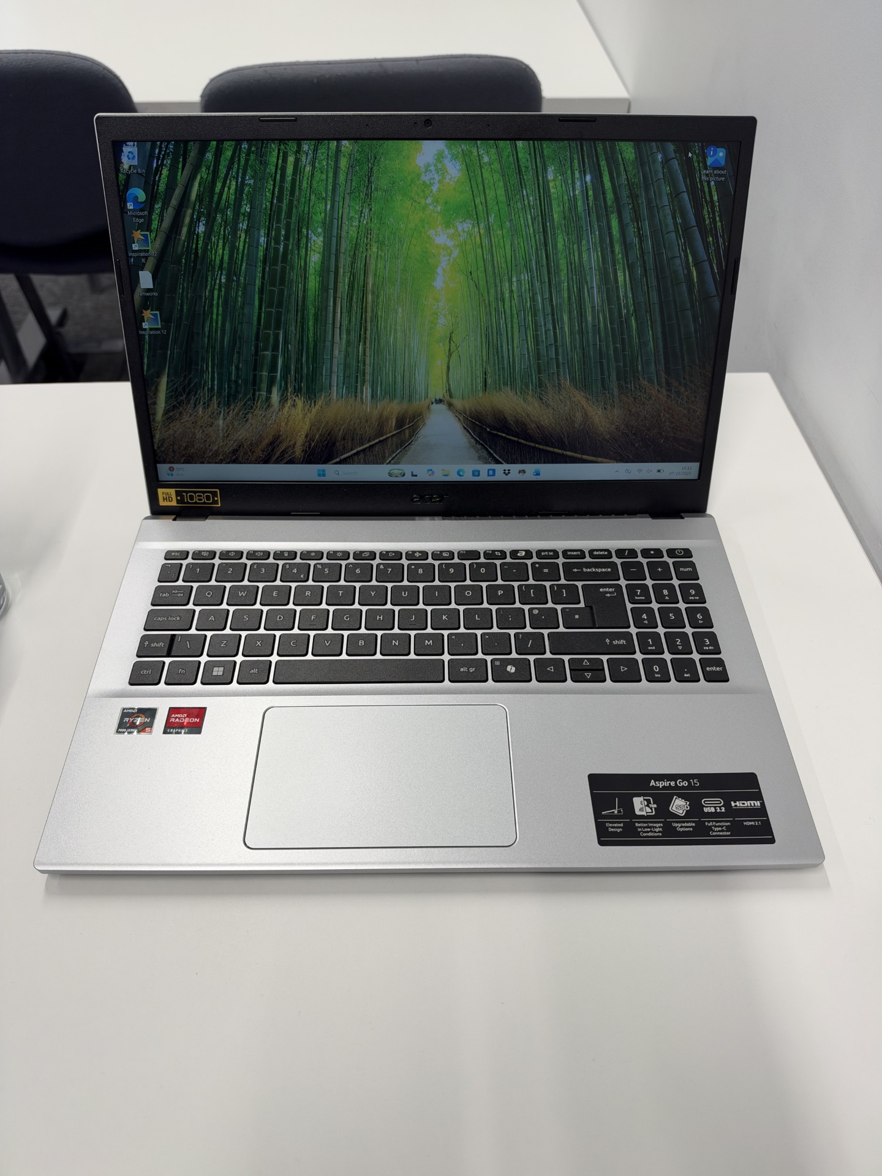
This is my laptop, which I use for my university work and other things in my free time. I use it to complete assignments, search for information on the internet, check my emails and use software like Microsoft word. Sometimes I also use it to watch films and play games on it. I feel confident using my laptop for these activities, but I would like to improve my skills with different software and learn about different features. These skills are important because they help me with my studies and will also be useful for applying for jobs in the future.

Screenshot/Photo 2
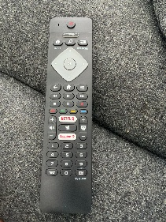
The picture above is my TV remote, which I use to control my TV. I use it to either turn the volume up or down, change what channels I want to watch. I also use it to watch films on Netflix, Prime videos and HBO max, watch YouTube and connect my game console using the source button. I am good at using the remote to find the apps I want and to control my TV. I would like to learn more about the other buttons and features. These skills are important because they help me use technology in my everyday life.

Screenshot/Photo 3
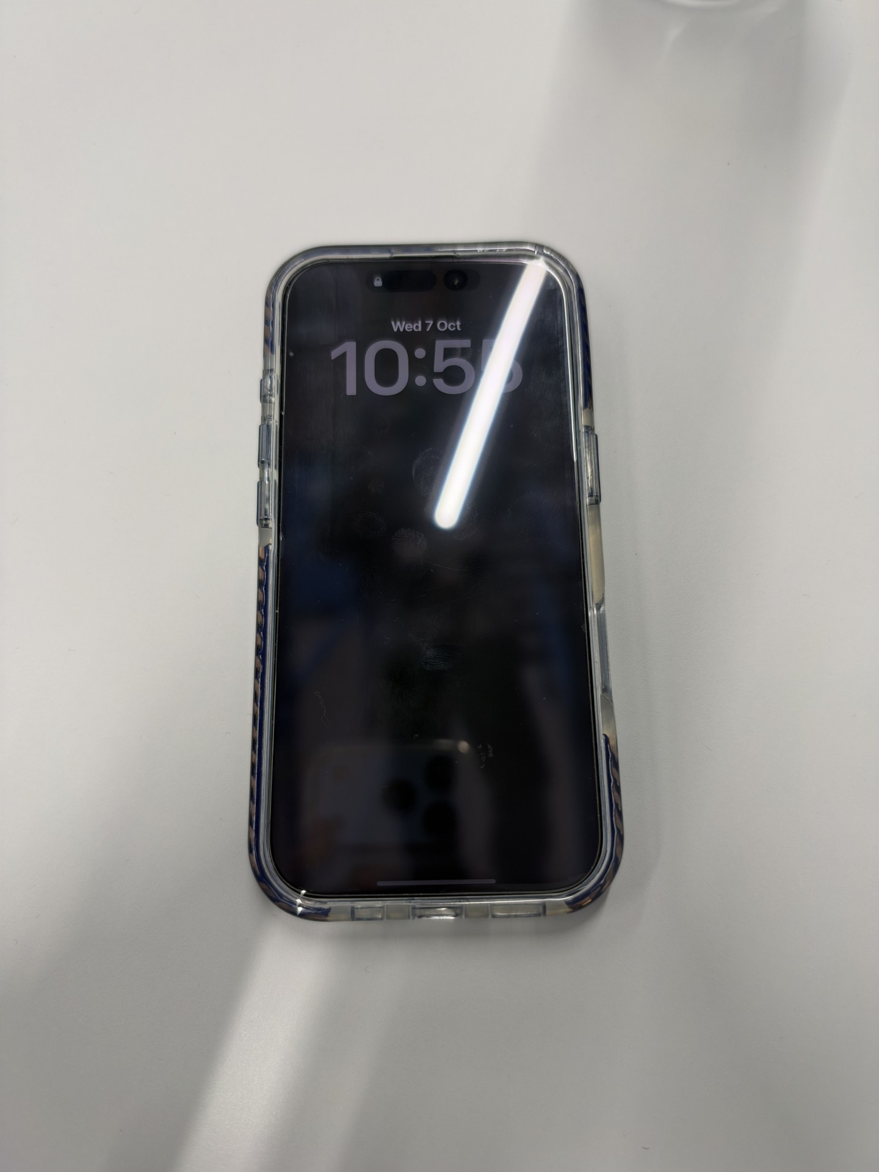
The picture above is my phone. I use it to check social media, take some pictures or videos, send text messages to friends and family and to make a phone call. I also use it search and access information on the internet. I am confident in using this because I tend to use it a lot in my everyday life. The only thing I would like to improve is How I use it for different activities. For example, using different apps and learning about the features. These skills are important because phones help us communicate, find information and do many things in everyday life.

Screenshot/Photo 4
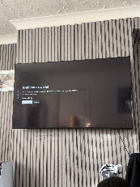
This picture above is my Tv. I use often in my everyday to watch movies, use other streaming services and to connect my console. I’m happy to use my tv as I know how to use it and access what im looking for. Id like to know more about other features and how to use it. These skills are important because this is used in everyday life and knowing how to use this is a

Screenshot/Photo 5
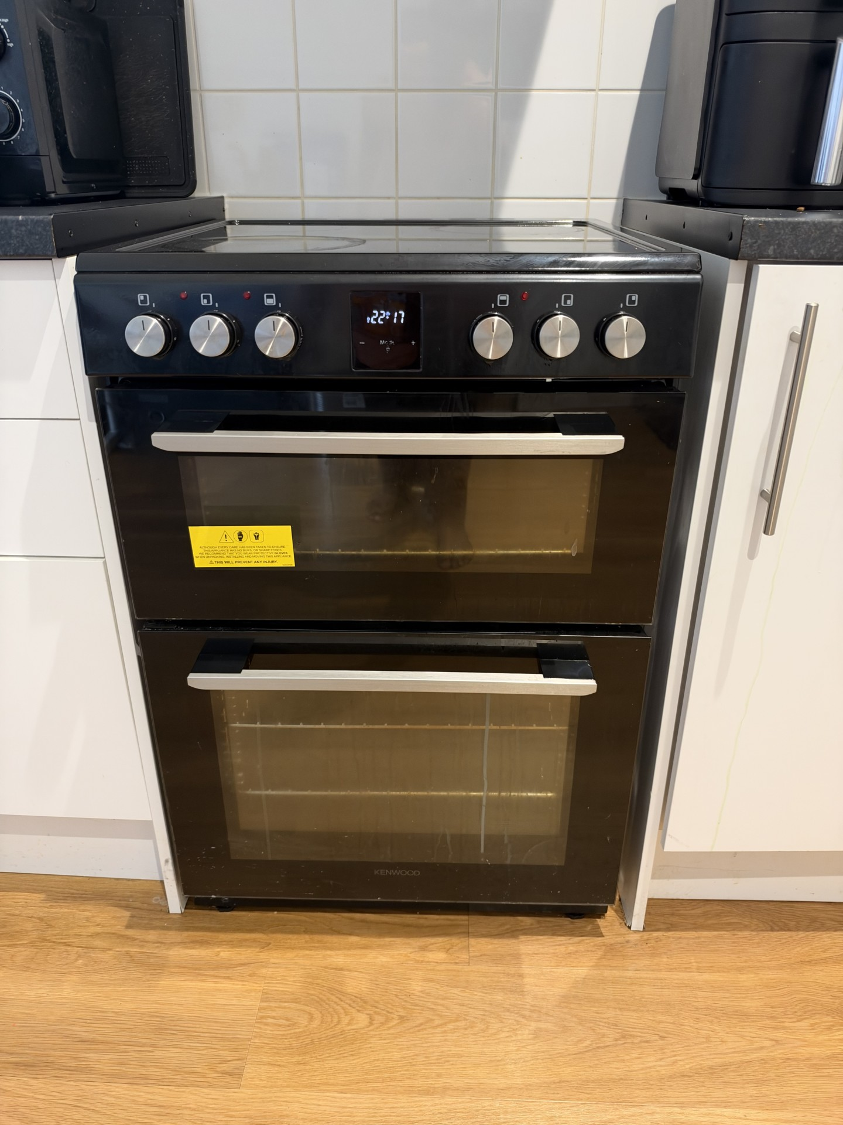
The picture above is an electric cooker that I use to cook food and also grill food in the oven. I use the temperature control setting to decide how hot I want it to be. I feel good about using these settings when making food. I would only like to learn more about the other features and settings on the cooker so I can use the cooker properly and safely. Knowing how to use kitchen appliances helps me cook safely

Screenshot/Photo 6
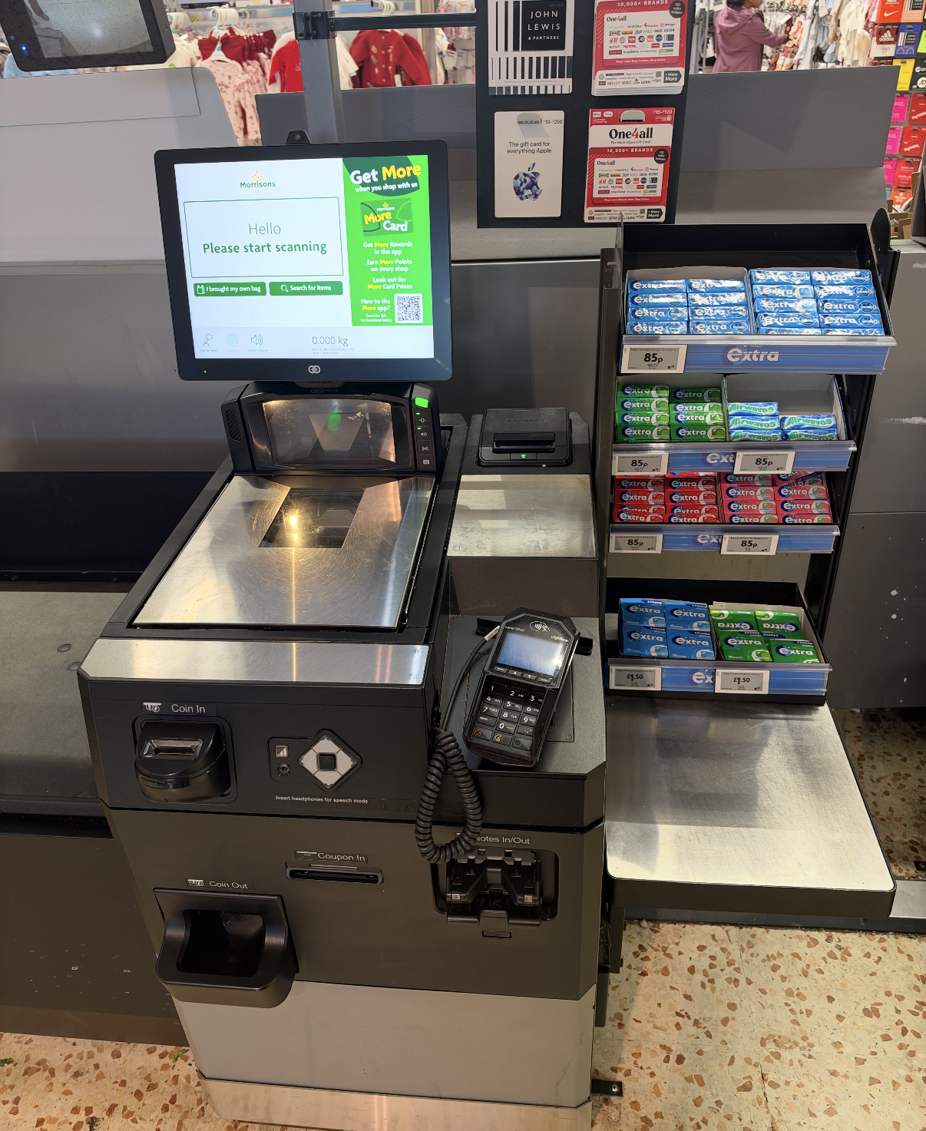
The picture above s is a self-checkout machine I use when I go shopping. I use it to scan my items, check the prices and pay for my shopping wether its using Apple Pay, paying by card directly or using a gift card. I feel good using it because I know how to scan my items and follow instructions on the screen. The only thing I would improve is my skills in using the machine if any problems occur come up. These skills are important because self-service check outs are used in many shops and knowing how to use them makes shopping easier

My Short Reflection
- Write 5–8 simple sentences about your digital life.
- You can use the sentence starters below if helpful.
I use digital tools in my everyday life for studying, entertainment and staying in touch with people. My phone and laptop is used to search for information online, check emails, go on social media and complete my university or any other work. But my smart TV I often use it watch films and access different apps. I feel extremely confident using these devices because I use them regularly. I want to improve my skills with different software’s and learn more about features I don’t use. Sometimes I find it difficult to learn something new on a device, but I try to work it out. I hope this module will help me become more confident with technology. Digital skills are important to me because I need them for my education, work and everyday life.

Sentence starters
- I use digital tools to …
- I feel confident when I …
- I want to improve …
- I often use these tools: …
- I sometimes feel nervous about …
- I hope this module will help me …
- Digital skills are important for me because …
You can write more if you want.

Submission Checklist
Before you submit, please check:
​​​ ☐ I added 4–6 screenshots
☐ I wrote short sentences for each screenshot
☐ I wrote my short reflection
☐ My work is my own
☐ My file opens correctly
​​☐ My file opens correctly

