BUSINESS PLAN REPORT

Summary
B-plan for a company dog walking business has been discussed in this assignment. However, this business has great aims and some objectives, by which it will be the richest pet industry in the UK. Thus, the start-up expenses of the business for next 3 years has been forecasted. Based on this, the company will provide the services and offers to the customers. Proper technological plans, management and organizational plan and CSR need to be maintained, by which dog walking companies can create proper B-plans for the future. Thus, the market trend and market strategies need to be followed for becoming the greatest services provider. However, with competitive edges, employees’ salaries as well as financial requirements have been discussed, which will be required for the B-plan of dog walking business in the UK.

Table of Contents
Technology plan
Management and organization plan
Social Responsibilirty and Sustainability
References

Technology plan
To be able to keep up with the fast-developing technology and people needs, Dog Walking will implement different technological strategies for their customers:
- Create a business website, with easy access and smooth navigation for all the visitors interested in Dog Walking
- Develop a tailored App that will be easy to download on any smart device, easy to navigate and make bookings and payments. This will also include customers account with safe stored personal details and preferences
Create business accounts on Social Media platforms, to reach a wider audience and keep the followers updated on the latest services and even



Based on the analysis, it can be observed that various kinds of significant marketing strategies need to be used by the business person of the dog walking business. However, according to these analysis, it can be observed that this dog walking business want to provide high quality services to the customers of UK, who are literally dog lovers and use dogs for professional purposes. As well as, there are some customers who want to care about their dogs, however they have too busy schedules and health issues, by which they cannot provide proper training to their dogs. However, this dog walking company will use various significant technologies, by which they can reach their customers to provide quality service (Fichter and Tiemann, 2020).
This fog walking company needs to create their “own business websites' ', in which they are able to provide online services to the customers. A positive impression can be achieved, which will make the business more successful. At those websites, the company can provide their company details along with their services details, by which visitors and customers can easily connect with the company for getting services. In simple words, through this “business websites' ', the fog walking company is able to engage with their potential and target customers digitally. Customers can book their appointment with the company due to various purposes just like dog training, exercising and others through using the “tailored mobile app” (Jiaet al.2021). This app is too effective for increasing the service efficiency as well as scalability. Mobile apps are too flexible for maintaining and tracking all services. It will also be effective for receiving customer feedback about their service quality, which can attract new customers in coming days.
Thus, it has been recommended to the dog walking company for opening the “social media business accounts” for connecting with the potential customers. The social awareness will be increased about the services and immense potentiality. Advertising can be easy due to these social media accounts, by which the engagement of potential customers can be increased through offering various company offers.
Market trend and segmentation
According to the analysis, it can be said that the pet industry has increased tremendously in the last few years, the “dog walking business “can be consistently enhanced as well as its services. Thus, through disturbing the research of the UK pet industry, the “dog walking services” are the most successful services in the UK.
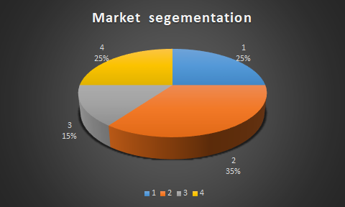
Figure 1: Market segmentation
Sales strategy and forecast
Effective sales strategies along with “sig walking business ideas' ' need to be followed by the management of the bruins, by which the sales of the business can be increased. However, according to the sales strategies, proper “transportation facilities' ' need to be provided to the customers, by which customers can easily “and their dogs' ' to the dog walking company. However, the business of dog walking will provide and offer “special packages” as well as “discounts” for the “dealers”, organization and shelter .
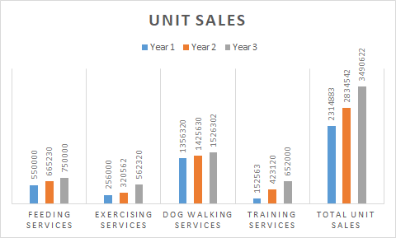

Management and organization plan

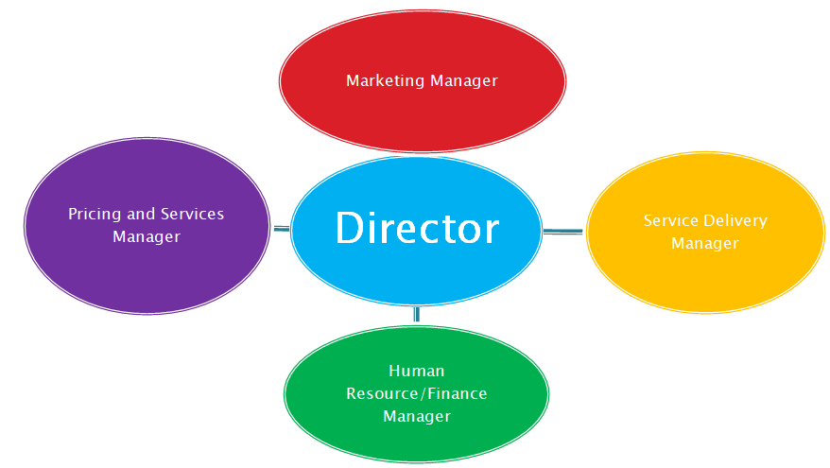

Director – Ibrahim
Marketing manager – Everton
Prices and Services Manager – Apostal
Service Delivery Manager – Georgel
Human Resources/Finance Manager -Ramila

Company aims and objectives
Aim: This business has a great aim, to make a proper Business plan for dog walking.
Objectives: Various objectives have been formed in this business for meetingthe aim of this B-plan of dog walking company. Those objectives are just as follows:
●To create a “service-based” company through launching the business approaching “£20k per month”
●To develop a “sustainable business” through surviving its own “cash flow”
●To enhance sales by 15% per year for becoming profitable
Mission
Through analyzing the company aims and objectives, the mission of the company can be known easily. However, the main mission of this company is to provide “highest quality service to its customers and become the best dog walking business” in the UK. Thus, the management has made the plan to open more branches as well as dog walking centers across the countries. Thus, next 3 years profits will be forecasted properly.
3 Years profit forecast
 | Year 1 | Year 2 | Year 3
sales | £ 6,000.00 | £ 9,500.00 | £ 12,000.00
gross margin | £ 5,500.00 | £ 7,500.00 | £ 10,000.00
net profit | £ 1,500.00 | £ 2,000.00 | £ 25,000.00
Years profit forecast

Management and customers
UK market analysis is important for making the plan for management and organization. According to this analysis, the organizational structure if dog walking company will be cleared. Through those structural entails, the active and significant person, who will play a great role in the Business plan of the dog walking business can be informed. According to the analysis, it can be known that there are various level managers and front line staff, who will be involved in this Business plan of dog walking . However, those managers are just like: Marketing managers, Pricing and services managers, service delivery managers, financial management and human resource managers, who will play key roles in adequate management, proper reputation management and financial forecasting for appraising the start-up funds and expenses.
Through their involvement, a plan needs to be made, by which the strengths, weaknesses, opportunities and threats of the company will be identified. In simple words, the objectives of the dog walking company will be cleared, by which the activities of the B-plan can be prioritized easily and the goals of the plan can be achieved. Thus, through this management plan, they have the aim to provide quality and excellent services to the customers through online or walk to customers home, who will not come to the center for various purposes (mitre.org, 2021). Thus, to fulfill this plan, they need to make a proper financial plan and financial requirements plan, by which the sales profit, all maintenance costs and next 3 years profit will be forecasted properly. Due to this plan, the dog walking business can profit £ 20K per month and sales of the company will increase by 15% per year.
The “dog walking services' ' of the company has the target to provide services to those customers, who generally remain on a busy schedule. Apart from these, there are many customers, they cannot go to the company due to their health issues (Vidal, 2017). This company will provide the services to walk to the customers home, by which the dogs of customers can get proper training, “exercising, feeding, and other veterinary services' '.

Social Responsibility and Sustainability
Corporate social responsibility
Definition: The self-made business model that will help Dog Walking business be socially responsible towards its customers, its employees and all people involved within the business (Investopedia, 2021).

CSR importance: Dog Walking will be socially responsible by operating in ways that the community and the environment will not be affected but benefit from its services (Investopedia, 2021).

Sustainable development is important and best for dog walking companies. This development can impact on the economy of the company in a significant way. It indicates the dog walking business needs to use the “Self-made business model”, by which the dog walking business can become socially responsible and beneficial, by which customers can get the quality services. According to this business transformation and “sustainable approach” the management of the
The dog walking business can be beneficial. Due to this social responsibility, the dog walking business can achieve “long-term value”. Those are just as follows:
- Implement an ethical business model: this will encourage all employees to act on issues such as ethics, values of the business, the planet, diversity, respect for each other and promote a great customer service
- Create a Health and Safety plan for the business: that has set clear requirements from the employees so that work environment is safe for the staff and the customers. It will also comply with the legal business requirements
- Use marketing strategies that bring social responsibility awareness to the audience and employees: avoid averts that could be misinterpreted, manipulative and damaging to the public and the planet. Respect any social responsibilities outlined for Dog Walking company to avoid criticism and reputation damage
- Environmental business commitments: adopt and promote different policies and practices within the business activity that are environmental friendly: sustainability report, use recycled materials, not use paper, use electronic systems only, manage wastage
- Through maintaining these CSR strategies, the dog walking business will be effective in resource management, by which the amount of operations cost can be redacted and maintained.
- The company will be effective in risk management also along with the issues of economic, environmental and social
- The modern challenges as wellas potential threats can be reduced through following this CSR strategy, by which sustainability of the company can be increased and the company will be socially responsible and prove beneficial services
- Select suppliers that are CSR friendly: only get materials from suppliers that have social responsibilities that they follow, are using recycled materials and goods, are environmental friendly, clarify Dog walking business expectations
- Consider B Corp certification: B Corps companies have a reputation of being beneficial companies as they bring revenue and other benefits to the community within. They are transparent and take accountability for their services and action and have a positive impact on the public and the environment (BDC, 2021).

Important assumptions
According to these assumptions, the dog walking company is able to follow proper financial strategy for business start-up

.
General assumptions
 | year 1 | year 2 | year 3
plan month | 1 | 2 | 3
current interest rate | 9% | 10% | 11%
Long-term Interest Rate | 8% | 8% | 8%
Tax Rate | 25.62% | 26.53% | 27.12%

References
“Corporate social responsibility definition”. Available at URL: https://www.investopedia.com/terms/c/corp-social-responsibility.asp. [Accessed on the 15th of August 2021].
Technology plan for dog walking businesses”. Available at URL: https://sitstay.com/blogs/good-dog-blog/adding-technology-to-dog-walking. [Accessed on the 15th August 2021]. “
Cotton, M.M. and Dark, G., 2017. Use of technology in tax administrations 1: developing an information technology strategic plan (ITSP). United States: SA International Monetary Fund.
Vidal, D., 2017. Fail to Plan, Plan to Fail: How to Create Your School’s Education Technology Strategic Plan. United States: Rowman& Littlefield.

Ferreira, F.M. and Pinheiro, C.R.M.S., 2018. Circular Business Plan: entrepreneurship teaching instrument and development of the entrepreneurial profile. Gestao&Producao, 25, pp.854-865.
Ferreras-Garcia, R., Hernández-Lara, A.B. and Serradell-López, E., 2019. Entrepreneurial competences in a higher education business plan course. Education+ Training. Available at https://www.emerald.com/insight/content/doi/10.1108/ET-04-2018-0090/full/html [Accessed on 18.8.2021]
Fichter, K. and Tiemann, I., 2020. Impacts of promoting sustainable entrepreneurship in generic business plan competitions. Journal of Cleaner Production, 267, p.122076. Available at https://www.sciencedirect.com/science/article/pii/S0959652620321235 [Accessed on 18.8.2021]
Jia, C., Ding, H., Zhang, C. and Zhang, X., 2021. Design of a dynamic key management plan for intelligent building energy management system based on wireless sensor network and blockchain technology. Alexandria Engineering Journal, 60(1), pp.337-346. Available at https://www.sciencedirect.com/science/article/pii/S1110016820304063 [Accessed on 18.8.2021]
Mateu, M., Cobo, C. and Moravec, J., 2018. Plan Ceibal 2020: future scenarios for technology and education—the case of the Uruguayan public education system. European Journal of Futures Research, 6(1), pp.1-12. Available at https://eujournalfuturesresearch.springeropen.com/articles/10.1186/s40309-018-0134-z [Accessed on 18.8.2021]

