LEVEL 7 ASSESSMENT SPECIFICATION

Student name: | Ramim Ahmed | Student ID number: | 2516509
Programme: | MBA
Module: | Managing Marketing Change
Module code: | BMMB7026 | Contribution to Overall Module Assessment (%): | 75%
Lecturer: | Gwyneth Jones | Internal Verifier: | Marie Pitson
Assignment Title: | Future Developments in the  Field of Marketing  (Individual Report) | Word count (or equivalent): | 3,750 words  (+/- 10%)
Submission deadline: | Wednesday 7th January 2026 | Return date of provisional marks &  written feedback: | Wednesday 4th  February 2026

Executive summary
This report is the critical review of Unilever and its shift to the marketing purpose-based approach, which presents sustainability as the key to competitive edge. There is evidence of the commercial success of this strategy as Sustainable Living Brands increases in popularity at a rate 69% faster than mainstream lines. Nevertheless, there is the dangerous strategy-execution gap. The operational emissions have reduced by 72 but Scope 3 supply chain emissions (90% load of the footprint) have been off-track, with a 14% decrease only against the 30.3% target. The resulting disconnect poses a great threat of a severe assortment of greenwashing, which can be harmful to brand equity.
To solve this the report will offer a future development plan through the SOSTAC framework that is based on Radical Transparency. Some of the top recommendations are Supplier Climate Programme, which requires science-based targets, a verification initiative via a Blockchain Trust, a real-time tracking initiative called AI Data Platform, and Circular Economy pilots. These measures will be able to match the operation potential with the marketing guarantees, gaining the market leadership in the long-term.

Table of Contents
Executive summary 2
1. Introduction 4
2. Task 1: Critical Evaluation 5
2.1 Strategic Role of Marketing & Resource Allocation 5
2.2 Macro and Micro Environment 6
2.3 STP Strategy Analysis 10
2.4 Critical Review of the Marketing Mix (7Ps) 11
2.5 Metrics & Measuring Success 12
3. Task 2: Conclusions 13
3.1 Conclusion 1: The 'Scope 3' Blind Spot 13
3.2 Conclusion 2: The 'Trust and Transparency' Risk 13
3.3 Conclusion 3: The 'Capabilities' Gap 14
Task 3: Recommendations (SOSTAC Marketing Plan) 14
4.1 Situation Analysis 14
4.2 SMART Objectives 14
4.3 Strategy 15
4.4 Tactics (The Four Strategic Pillars) 15
4.5 Action Plan & Feasibility 16
4.6 Control 17
Reference 18

1. Introduction
Unilever plc is an enormous industry in the fast-moving consumer goods (FMCG) industry with its headquarters in more than 400 brands in 190 countries and a portfolio that encompasses household names such as Dove, Lifebuoy and Hellmann (Unilever PLC, 2025). Nevertheless, the shift in the organisation to a clear paradigm has been one in which the sustainability has moved beyond the Corporate Social responsibility (CSR) to be the main focus of marketing change (Capucho, Leitão and Alves, 2025). This report critically assesses this reincarnation on the assumption of sustainability becoming a business necessity that is influencing the whole value chain in Unilever and not an aspect of ethics that is on the periphery.
Personal care is Unilever's biggest product category, followed by nutrition and beauty & well-being. Personal care earned 13.6 billion euros in 2024 (Watty, 2024). Overall, the company earned 60.8 billion euros that year. Unilever is founded in the UK, but most of its income comes from outside, mainly the US. Unilever's personal care brands, including Dove, are among the most valued internationally due to their global FMCG presence. As of 2024, Dove was the top US deodorant brand (Watty, 2024).
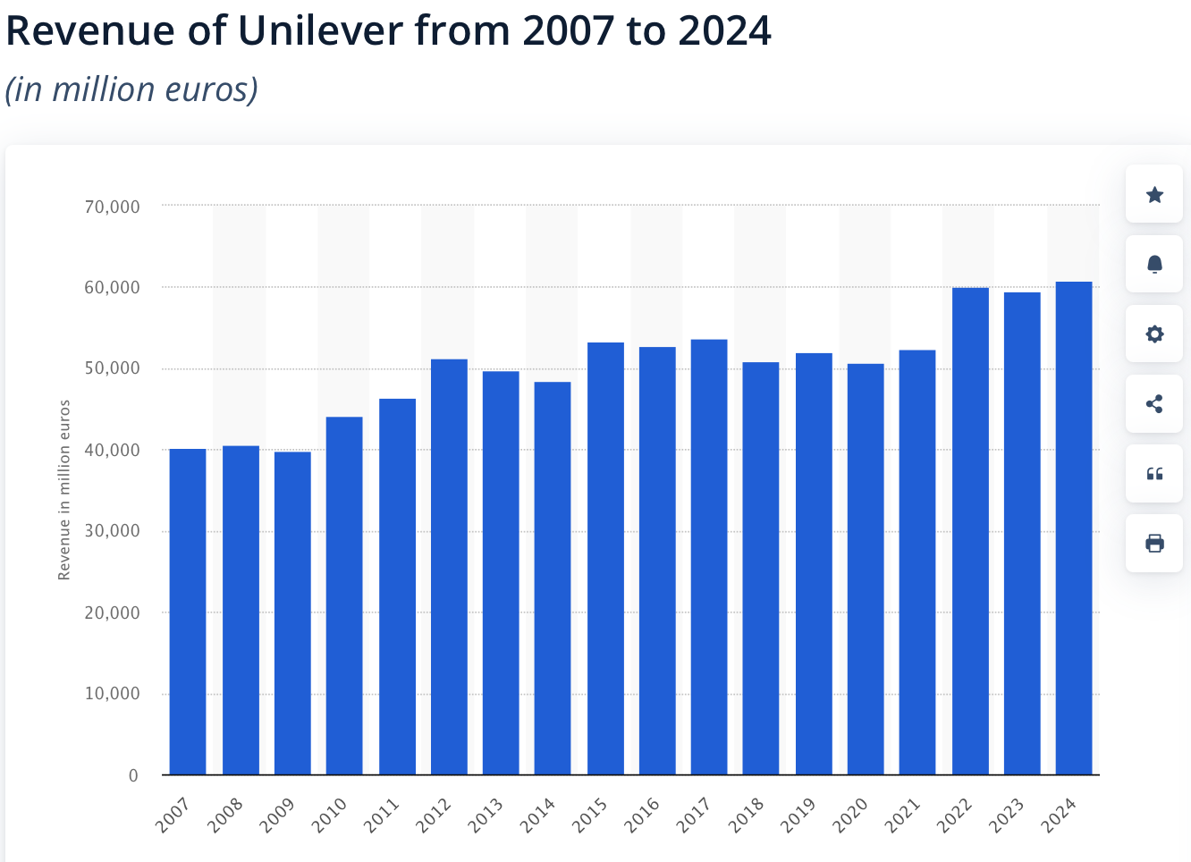
Figure 1: Revenue of Unilever (Watty, 2024)
Even though Unilever has managed to establish itself as a pioneer in the field of purpose-led marketing, a critical review shows that the gap between strategy and action has been growing (Ahsan, Jamil and Rais, 2024). Unilever’s updated climate plan targets reducing Scope 1 and 2 emissions 70% by 2025 and to zero by 2030, having already achieved 74%. Replacing its previous halving goal, new absolute Scope 3 targets aim for a 42% reduction in key value chain areas and a 30.3% cut in forest, land, and agriculture emissions by 2030 (Robinson-Tillett, 2024). Previous shareholder support reached 99%. This mismatch implies that the current sustainability marketing of Unilever runs ahead of the supply chain potentials posing the threat of greenwash and loss of customer confidence.
This report is organised into three separate tasks. Task 1 critically analyses the existing marketing strategy and environment of Unilever through PESTEL, five forces model of Porter, and the 7Ps framework with view to strategically misalign strategies. Task 2 is the synthesis of such findings towards the conclusion of the key shortcomings that are jeopardising the brand’s equity. Lastly, Task 3 employs the SOSTAC model to deliver evidence-based suggestions, such as an AI-based data platform, a supplier climate programme to bridge the execution gap and ensure that Unilever gains a competitive edge in the future.

2. Task 1: Critical Evaluation

2.1 Strategic Role of Marketing & Resource Allocation
Unilever has re-positioned the strategic purpose of marketing to a purpose-led model by replacing the conventional functional promotion with the literal purpose of sustainability as the main cause of competitive advantage (Oyedeji, 2025). This has been a commercially disruptive shift; it has been confirmed that Unilever's strategic pivot has seen its Sustainable Living Brands, Dove and Lifebuoy, grow quicker than the conventional ones. Moreover, these purpose-based brands are already contributing the total portfolio revenues of the group, which confirms the thesis that the combination of integrating sustainability into the marketing mix serves as a better motor of financial performances instead of just being a responsibility of Corporate Social Responsibility (CSR) (Laursen and Andersen, 2023).
Nonetheless, the critical analysis of the resources distribution patterns of Unilever shows that there is an unsafe disequilibrium between the resource strategic ambition and the operational power. Although much effort is put into the so-called Purpose-driven campaigns and use of emotional brand storeys, the technological aspects of the matter, i.e., the Systems, are under-invested (Shaoping, 2023). According to McKinsey analysis, 7S, the gap that consists of data infrastructure is crucial because it states that the data collection on Product Carbon Footprint (PCF) is underdeveloped, and providers are not properly tracked (Hu and Zeng, 2024).
This asymmetry indicates that Unilever is spending a fortune to promote sustainability but not the monitoring mechanisms to demonstrate it. The corporate strategy is considered as Strong, but the supporting systems infrastructure are far below the pace of the ambition. Such a mismatch leaves a precarious strategic stance as the marketing pledges run the risk of overwhelming the supply chain (Zou, 2021). Unless Unilever allocates resources to AI-powered data platforms to bridge this "Systems" gap, the company runs the risk of increasing the wall between the promise of making sustainable living commonplace and accusations of greenwashing since it cannot be verified.

2.2 Macro and Micro Environment
Unilever is in a fluctuating environment with the pace of external sustainability requirements rising faster than the organisation is adjusting its ability to modify its supply chain (Stanley et al., 2022). Such a disparity in speed is a direct challenge to the Unilever business model of Sustainable Living since the demand to be transparent, even within legal and social spheres, is increasing faster than the time the company can gather information on its intricate supplier chain.
Table 1: PESTLE Analysis of FMCG Sustainability
Category | Detail Analysis
Political | The regulatory landscape has shifted from voluntary CSR to mandatory compliance, with 107 countries now committed to net-zero targets (United Nations, 2025). New frameworks like the Corporate Sustainability Reporting Directive (CSRD) and TCFD mandate public disclosure of ESG performance. This political pressure forces Unilever to expose its entire value chain to scrutiny, removing the option to conceal poor environmental performance and making transparency a prerequisite for market access (Kouloukoui, Nathalie and Warin, 2025).
Economic | While the FMCG market is projected to reach $21.88tn by 2034, Unilever faces a dichotomy of opportunity and cost pressure (Market Research, 2025). Sustainable products command a verified price premium of 9.7%, validating the commercial viability of the "Purpose-led" strategy . However, sustainable ingredients cost 10-15% more than conventional alternatives , creating a "margin compression" of 2-3% across sustainable lines (PWC, 2024; Gutsa, 2023; ESG News, 2024). This economic tension necessitates a strategy that can justify higher prices through irrefutable value to offset rising input costs.
Social | A profound shift in consumer values has occurred, with 67% of Millennials and Gen Z prioritising sustainable purchases (Andrews, 2023). Crucially, 85% of shoppers now assess a company's sustainability practices before buying (PwC, 2024). However, this demographic is highly skeptical; 77% of consumers state they would abandon a brand if they suspected "greenwashing" (Andrews, 2023). This creates a fragile "Trust Gap," where Unilever’s marketing claims must be flawlessly authentic to retain its most valuable customer segment .
Technological | Technology offers the primary solution to transparency challenges, yet adoption lags behind strategy. AI-driven supply chain optimisation and blockchain traceability are critical for validating claims (Cardona-Acevedo et al., 2025). However, Unilever currently faces a significant data deficit, as inconsistent Product Carbon Footprint (PCF) calculation methods hinder accurate tracking (Uijen, 2024). The lack of digital maturity among most of the suppliers creates a barrier to the real-time visibility required to substantiate marketing narratives (Packmohrvan, 2023).
Legal | The legal environment has become punitive regarding sustainability claims. Regulators are increasingly enforcing anti-greenwashing laws, with potential fines and brand equity damage estimated at £2-5bn for misleading claims (CMA, 2024). Furthermore, Extended Producer Responsibility (EPR) legislation is forcing manufacturers to take financial responsibility for the entire lifecycle of their packaging (Bustamante et al., 2025). This transforms sustainability from a marketing asset into a strict legal liability if claims cannot be auditably proven.
Environmental | Climate change is no longer just an ecological issue but a direct operational threat, as extreme weather impacts agricultural raw materials that make up the bulk of Unilever's supply chain. Scope 3 emissions (supply chain) constitute over 90% of the total carbon footprint, yet Unilever has only achieved a 14% reduction in Forest, Land, and Agriculture (FLAG) emissions against a 30.3% target (Comello, Reichelstein and Reichelstein, 2021). This "execution gap" in the environmental sector represents the single biggest risk to the company's "Net Zero 2040" commitments .

Table 2: Porter’s Five Forces Analysis
Force | Intensity | Key Drivers & Evidence
Buyer Power | High | Consumers are highly sensitive to authenticity; 77% are willing to abandon brands over "greenwashing" concerns (Daou et al., 2025). Switching costs are low, and trust is fragile .
Supplier Power | High Complexity | While individual supplier power is low, the collective complexity of most suppliers creates a "control deficit". Only 14% of suppliers have science-based targets.
Competitive Rivalry | High | Sustainable brands are growing 69% faster than conventional ones, intensifying the race for ESG leadership (Markets and Management, 2019).
Threat of Substitutes | Moderate | Consumers easily substitute purpose-led brands if credibility is lost.
Threat of New Entrants | Medium | Agile, "born-sustainable" brands can enter niche markets without legacy supply chain burdens.
Table 3: SWOT Analysis
Strengths | Weaknesses
Commercial Proof: "Sustainable Living Brands" grow 69% faster than conventional lines and now deliver 40% of total portfolio revenue.  Operational Success: The company has successfully achieved a 72% reduction in Scope 1 and 2 operational emissions. | Execution Gap: Scope 3 emissions, representing 90% of the footprint, are off-track with only a 14% reduction against the 30.3% target (Robinson-Tillett, 2024).  Systems Deficit: A critical lack of Product Carbon Footprint (PCF) data infrastructure limits supplier transparency.
Opportunities | Threats
Premium Pricing: Consumers are willing to pay a verified "sustainability premium" of 9.7% for authentic green goods.  Circular Revenue: Scaling circular economy models offers a potential £500m in new revenue streams. | Greenwashing Risk: 77% of consumers state they would abandon a brand due to greenwashing concerns.  Financial Liability: Misleading claims pose a risk of £2-5bn in brand equity damage and regulatory fines.

Ansoff Matrix of Unilever
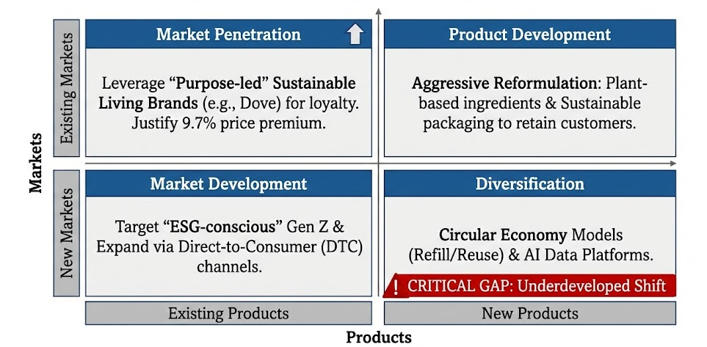
Figure 2: Ansoff Matrix of Unilever
Critical Analysis
The macro-environmental forces are critically synthesised to show a threatening strategic bottleneck. The Social demand with 67% of consumers noting that sustainable purchases are important is converting with the ever-constraining Legal frameworks that brand unwarranted claims (PDI Technologies, 2023). This PESTEL convergence amplifies the Porters Five Forces war: Buyer Power cannot be satisfied with anything less than undisputed transparency, and with Supplier Power divided, Unilever operates with a lack of available data to report on (Archer, 2021). This disconnect of operations reveals an underlying SWOT weakness: the Strength of the Unilever "Purpose-led" positioning is compromised by the Weakness of the Scope 3 data systems, posing a real Threat of greenwashing lawsuits. This threatens the growth strategy of Unilever based on Product Development as a reason to charge a 9.7% sustainability premium. The strategy is Market Penetration that achieves a sustainable branding, but as the execution gap prevails, marketing claims are more assertive than consumption chain capabilities now. Without Unilever narrowing this gap to validate its claims, the approach will turn into a competitive edge to a reputational cost, and it will not provide the real sustainable living the market deserves.

2.3 STP Strategy Analysis
Table 4: Critical Evaluation of Unilever’s STP Strategy
Strategic Element | Analysis of Approach | Critical Evaluation: The "Trust Gap" & Portfolio Risk
Segmentation & Targeting | Unilever’s targeting is heavily weighted towards Millennials and Generation Z, a demographic where 67% actively prioritise sustainable purchases (Keuya, 2024). The strategy further isolates "ESG-conscious shoppers," acknowledging that 85% of consumers now assess corporate sustainability practices prior to purchase. This targeting logic aims to capture the "Sustainability Premium" of 9.7% available in the market (PWC, 2024). | While the target segment is lucrative, it is also the most skeptical. These "conscious consumers" are hyper-vigilant regarding authenticity. By targeting a demographic that actively scrutinises corporate behaviour (Rahman and Nguyen‐Viet, 2022), Unilever exposes itself to immense risk if its operational reality fails to match its marketing claims.
Positioning | The core positioning is defined as "Purpose-led brands that make sustainable living commonplace". This moves beyond functional benefits to emotional and ethical positioning, exemplified by "Sustainable Living Brands" (e.g., Dove, Lifebuoy) which account for 40% of revenue (Barkemeyer et al., 2022). | This positioning relies entirely on trust. A "brand trust gap" is currently widening between Unilever’s sustainability narratives and consumer perception. With 77% of consumers willing to abandon brands over greenwashing concerns, any failure to hit climate targets threatens to collapse this positioning. Furthermore, applying this "purpose-led" label across a massive portfolio of 400+ brands risks dilution (Pirzada et al., 2023). Attempting to position chemical-heavy functional brands with the same "purpose" rhetoric as Dove can confuse consumers and erode the credibility of the entire portfolio. If the "Trust Gap" widens, the positioning shifts from "Visionary" to "Deceptive."

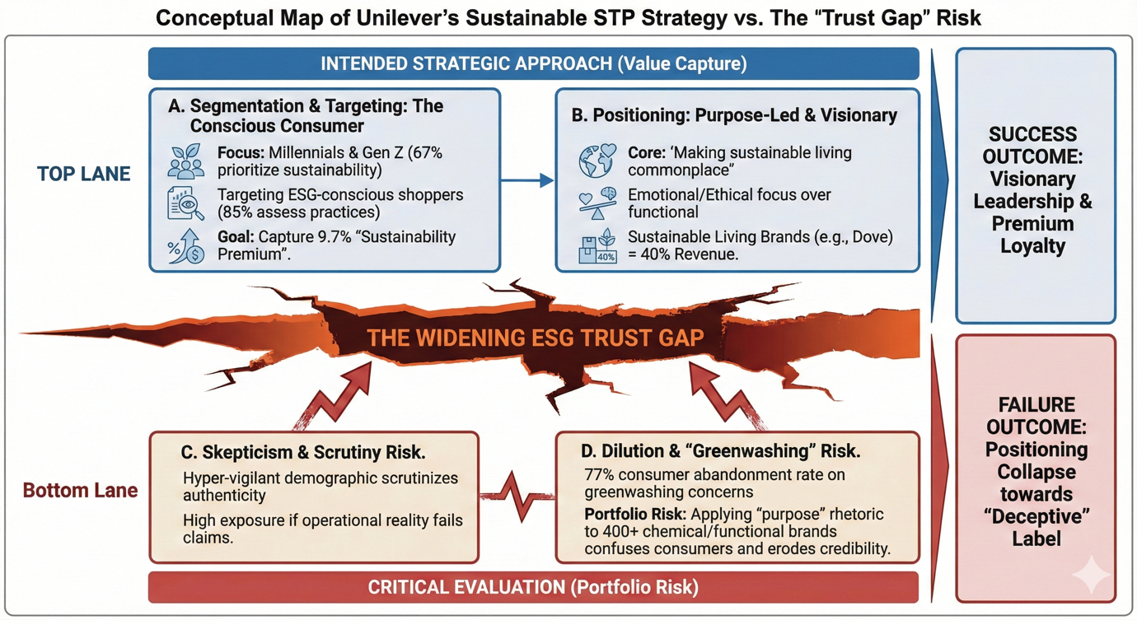
Figure 3: Unilever STP Analysis (Author made)

2.4 Critical Review of the Marketing Mix (7Ps)
Table 5: Critical Evaluation of Unilever’s Sustainable Marketing Mix
Element | Critical Evaluation & Sustainability Integration
Product | Unilever has aggressively pursued product innovation through plant-based reformulations and certified sustainable sourcing (Estrada, 2024). However, a significant vulnerability exists: the product strategy relies heavily on agricultural raw materials (Scope 3), which account for over 90% of the carbon footprint yet remain difficult to track and control. The product promise is strong, but the supply chain verification behind it is opaque.
Price | The strategy employs a "Sustainability Premium," charging 9.7% more for sustainable goods (PWC, 2024). While commercially attractive, this pricing power is fragile. In an inflationary economy where margin compression is already 2-3%, maintaining this premium requires irrefutable proof of value. If consumers suspect greenwashing, this premium becomes a barrier rather than a differentiator.
Place | Distribution has shifted towards an omnichannel model, with a specific target of 45% e-commerce penetration by 2027 to facilitate Direct-to-Consumer (DTC) engagement (Trường, 2025).
Promotion | Promotion has pivoted from functional benefits to "purpose-driven campaigns" with social impact KPIs. This creates high visibility but high risk. With 77% of consumers willing to abandon brands for greenwashing, promoting sustainability achievements that the company cannot fully verify (due to missed Scope 3 targets) turns promotional assets into potential liabilities (Oyeyemi et al., 2024).
Process | The operational "Process" is currently broken. Effective sustainable marketing requires granular data, yet Unilever lacks consistent Product Carbon Footprint (PCF) calculations. Only 14% of Tier 1 suppliers have science-based targets, leaving a massive data blind spot (SBT, 2025).
People | While leadership commitment is strong, there are significant capability gaps in data analytics and advanced sustainability expertise among staff, hindering the execution of data-driven strategies.

2.5 Metrics & Measuring Success
The Unilever measurement system has a severe dichotomy of operational success and the supply chain openness. Though the organisation does well in monitoring and controlling direct emissions having recorded a commendable impact of 72 per cent cut in both Scope 1 and 2 emissions, it is failing on the measure that has the biggest total impact on the organisation. The reduction of the carbon footprint by Scope 3 emissions, which contribute more than 90% of the total emissions, has been only by 14%, instead of the required 30.3% (McKinsey, 2024). This implies the use of "lagging" indicators such as the declines that have occurred but not the "leading" indicators such as the real time supplier data. Unilever cannot take the initiative of mitigating the supply chain risks that challenge its 2030 goals without switching to predictive metrics.

3. Task 2: Conclusions
The critical analysis of the marketing strategy of Unilever shows that there is an underlying paradox in that the organisation has an exemplary strategic vision of sustainability but experiences a severe execution gap in their overall delivery. The so-called Purpose-led positioning has been effective to spurt the growth of revenues in the short term, but the background infrastructure needed to support the positioning is inadequate at present. In the light of the analysis carried out in Task 1, three significant strategic gaps have been established that put the future sustainability of Unilever as the market leader in jeopardy.

3.1 Conclusion 1: The 'Scope 3' Blind Spot
The biggest conclusion is that of the lack of correlation between the consumer-facing marketing pledges and the reality of Unilever supply chain. Although the marketing team is doing a great job of selling a storey about bringing sustainable living to the mainstream, operating as is, Scope 3 emissions, which comprise more than 90% of the total carbon footprint of the firm, are almost beyond the control of the marketing team (McKinsey, 2024). The present decrease of 14 out of a critical of 30.3 ratio in Forest, Land, and Agriculture (FLAG) emissions show that the supply chain is not changing at a quick enough rate to reflect the sustainability assertions of the brand. This blind spot implies that Unilever is successfully selling a standard of environmental guardianship, which it is yet to attain operationally.

3.2 Conclusion 2: The 'Trust and Transparency' Risk
This delay in operations builds a major risk in commercial terms with respect to consumer confidence. Modern consumer, who is hyper-vigilant, will not tolerate a shift to another brand that is seen to practise greenwashing, and 77% of them do this (Andrews, 2023). Unilever is in a hazardous encumbrance of blind faith because it cannot assess its Scope 3 advancement using detailed data. By not including undeniable evidence regarding its environmental effects, and potentially still levying a 9.7% sustainability premium on its consumers, the organisation is opening itself to questioning which rethey are trying to present as purpose-driven campaigns but pass as false marketing. The financial harm of such a collapse of trust is estimated at 2.5 billion of brand losses and means that it is a real financial risk, not a reputational one (Rybska and Shabong, 2024).

3.3 Conclusion 3: The 'Capabilities' Gap
The underlying cause of these problems is a misunderstanding of organisational fit as determined by the McKinsey 7S model. The Strategy (Net Zero 2040) and Shared Values("Sustainable Living), are of a quite weak rating (Strong), but its Systems and Skills are significantly weak. The organisation does not have the technological framework, namely in AI and blockchain, to monitor suppliers successfully. As a result of this, the "Systems" are not ahead of the "Strategy" and the marketing teams will have to sell valid ambitions without the required data to prove those. Until Unilever overhauls its internal capabilities to suit the rhetoric, there will lack the notion of the so-called tech to support the talk, halting any real movement.

Task 3: Recommendations (SOSTAC Marketing Plan)
According to the strategic shortcomings found in the Conclusion, including the Scope 3 blind spot, the greenwashing trust risk, and data capabilities gap, the following section will outline a redressive marketing plan designed under the SOSTAC framework (Situation, Objectives, Strategy, Tactics, Action, Control).

4.1 Situation Analysis
Critical analysis shows an apparent "Execution Gap. Although this strategy of Unilever is really visionary, it does not find implementation due to opaque supply chains (only 14% Scope 3 FLAG reduction) and lack of data systems. This lack of connection sets high chances of abandonment among consumers because of greenwashing practises, which jeopardises the premium positioning of the brand (Inês, Diniz and Moreira, 2023). This gap will be bridged by the following plan which will ensure that operational reality and marketing ambition are optimally aligned.

4.2 SMART Objectives
To secure long-term competitiveness and close the execution gap, the following Specific, Measurable, Achievable, Relevant, and Time-bound objectives are set for 2027:
- Operational Objective: Achieve 100% Science-Based Targets (SBTi) validation for the top 500 strategic suppliers (covering 80% of Scope 3 emissions) by 2027, facilitating a 40% reduction in FLAG emissions.
- Brand Trust Objective: Increase the Net Promoter Score (NPS) regarding sustainability by +15 points and reduce consumer perception of greenwashing to <15% by 2027.
- Commercial Objective: Generate £500 million in new revenue streams through circular economy innovations and protect £800 million in brand equity by verifying sustainability claims.
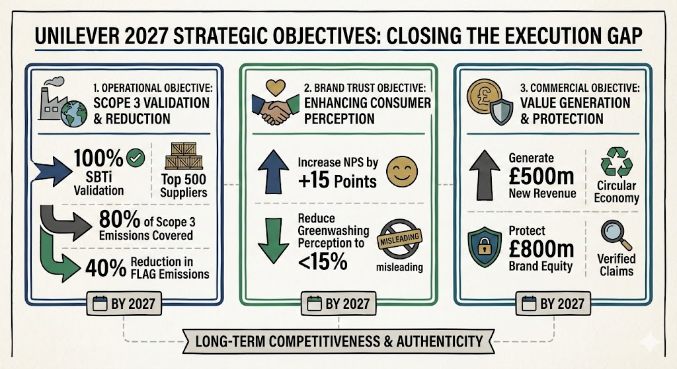
Figure 4: SMART Objectives of Unilever (Author made)

4.3 Strategy
The fundamental strategic plan is the Radical Transparency and Tech- Enablement. Unilever needs to change its marketing paradigm, which is Storytelling (depending on emotive storeys) to Storey-proving (depending on a verified factual basis).
The strategy resonates with the Marketing 5.0 theory that determines the application of data-driven technology to the benefit of humanity (Dutt et al., 2024). With the incorporation of innovative approaches in the marketing mix, through the provision of superior data infrastructure, Unilever will be able to convert the reputational threat associated with sustainability into a legitimate competitive advantage. The reasoning of this is that in a time of scepticism the only meaningful advertising that is efficient is tested reality.

4.4 Tactics (The Four Strategic Pillars)
To implement this strategy four combined strategies have been suggested which implement a direct solution to the weaknesses of the "Marketing Mix" as has been determined in Task 1.
- Tactic 1: Supplier Climate Programme (High Priority)
  - Action: Requirement SBTi validation as a business requirement of top 500 suppliers. This strategy directly addresses the weakness that exists in the Product and Process by solving the source of the emissions.
  - Rationale: Mobilising supply chain is the it-gives you-the-volunteer army that is necessary in the change model of Kotter to deal with the 90 percent of emissions that Unilever has no control over at present.
- Tactic 2: Trust & Transparency Programme (High Priority)
  - Action: Develop blockchain traceability and third-party verification of 50 high-impact SKUs.
  - Rationale: This wins the price (which justifies the 9.7 percent premium) and Promotion aspects. Omitting the support chain, Unilever transforms the Trust Gap into a point of difference and eliminates the charge of greenwashing by a transparent supply chain evident to customers through QR codes.
- Tactic 3: AI Data Platform (Medium Priority)
  - Action: £200 million Investment in an AI-based real-time Product Carbon Footprint (PCF) tracking and predictive analytics.
  - Rationale: This is as a way of bridging the Systems and Skills gap as indicated in McKinsey 7S analysis. It also replaces the annual reporting that used to lag with the operational intelligence that is transparent during the operation thus decision making can be done faster.
- Tactic 4: Circular Economy Pilots (Medium Priority)
  - Action: Buy refill/reuse packaging models of present pilots (e.g., Dove, Lifebuoy) to 10 major brands.
  - Rationalisers: This will be a Product/Place innovation, appealing to the 58 percent of the consumers seeking plastic decreasing and developing a proprietary lock-in environment to re-purchase it again.

4.5 Action Plan & Feasibility
It will be rolled out in stages, a Repair-Verify-Scale program to become complete in 2027.
- Year 1 (Repair): Activate AI Data Platform prototype and amend the SBTi decreed to suppliers.
- Year 2 (Verify): Year 2 & Detail Certify 50 SKUs and realized 50% supplier data coverage.
- Year 3 (Scale): Implement circular pilots in all parts of the world and resolve 100 percent validation of suppliers of SBTi.
Feasibility & ROI: This is a financially practical plan and a business need plan. The returns on the investment in these programmes are very high:
- Cost Avoidance: Supplier Supplier Climate Programme is expected to bring in $1.2 billion cost avoidance in terms of energy and waste efficiency.
- Brand Protection: The Transparency Programme defends $800 million of brand value that is under threat due to greenwashing scandals at the moment.
- Efficiency: The AI platform is projected to result in $400 million in savings in the annual cost through the optimization of the supply chain (Tsolakis et al., 2022). The cumulative ROI will be estimated at a cumulative $3 billion plus by 2030 which indicates an 86 net return on investment.

4.6 Control
To enable implementation to be on track, a Comprehensive Performance Scorecard will be applied, which tracks measures under four dimensions namely:
- Environmental: Reduction as a scope 3 percentage (Goal: 30.3%).
- Commercial: Sustainable Living Brand development vs. Baseline (Target: +12%).
- Brand: Net Promoter Score and the Greenwashing Sentiment Index (Target: <15% negative).
- Operational: Supplier Data coverage (Target: 90%)
- This balanced scorecard is such that there is no more risk of marketing assertions (Promotion) beating up operational reality (Process), thus cementing Unilever to be the true leader in sustainable business.

Reference
Ahsan, N., Jamil, S. and Rais, M. (2024). The Influence of Social Media Influencers on Consumer Decision-Making: A Comprehensive SEM Analysis. International Journal of Social Science & Entrepreneurship, 4(2), pp.317–341. doi:https://doi.org/10.58661/ijsse.v4i2.286.
Andrews, R. (2023). Over half of UK consumers prepared to boycott brands over misleading green claims. [online] KPMG. Available at: https://kpmg.com/uk/en/media/press-releases/2023/09/over-half-of-uk-consumers-prepared-to-boycott-brands-over-misleading-green-claims.html.
Archer, M. (2021). Imagining Impact in Global Supply Chains: Data-Driven Sustainability and the Production of Surveillable Space. Surveillance & Society, 19(3), pp.282–298. doi:https://doi.org/10.24908/ss.v19i3.14256.
Barkemeyer, R., Young, C.W., Chintakayala, P. and Owen, A. (2022). Eco-labels, Conspicuous Conservation and Moral Licensing: An Indirect Behavioural Rebound Effect. Academy of Management Proceedings, 2022(1). doi:https://doi.org/10.5465/ambpp.2022.236.
Bustamante, D., Londoño-Pineda, A., Cano, J.A. and Weyers, S. (2025). Overcoming Barriers to Circular Economy in Plastic Packaging: Enablers and Integrated Strategies in Multinational Companies. Sustainability, [online] 17(21), pp.9757–9757. doi:https://doi.org/10.3390/su17219757.
Capucho, J., Leitão, J. and Alves, H. (2025). Mapping and linking well-being, tourism economics, sustainable tourism and sustainable development: an integrative systematisation of the literature and bibliometric analysis. Discover Sustainability, 6(1). doi:https://doi.org/10.1007/s43621-025-01122-y.
Cardona-Acevedo, S., Agudelo-Ceballos, E., Arango-Botero, D., Valencia-Arias, A., Ramírez Dávila, J.D.L.C., Jimenez Garcia, J.A., Flores Goycochea, C. and Martínez Rojas, E. (2025). Applications of Machine Learning (ML) in the context of marketing: a bibliometric approach. F1000Research, [online] 14, p.92. doi:https://doi.org/10.12688/f1000research.160010.2.
CMA (2024). Greenwashing: CMA Issues Tailored Guide for Fashion Brands. [online] GOV.UK. Available at: https://www.gov.uk/government/news/greenwashing-cma-issues-tailored-guide-for-fashion-brands.
Comello, S., Reichelstein, J. and Reichelstein, S. (2021). Corporate Carbon Reduction Pledges: An Effective Tool to Mitigate Climate Change? SSRN Electronic Journal. doi:https://doi.org/10.2139/ssrn.3875343.
Daou, L., Sayegh, E., Atallah, E., Maalouf, A. and Sarkis, N. (2025). Greenwashing as a Barrier to Sustainable Marketing: Expectation Disconfirmation, Confusion, and Brand–Consumer Relationships. Sustainability, 17(22), p.9979. doi:https://doi.org/10.3390/su17229979.
Dutt, A., Kasilingam, D., Angell, R. and Singh, J. (2024). The future of marketing and communications in a digital era: data, analytics and narratives. Journal of Strategic Marketing, 32(8), pp.1–9. doi:https://doi.org/10.1080/0965254x.2024.2386002.
ESG News (2024). Consumers Willing to Pay Average of 9.7% More for Sustainable Goods: PwC Survey. [online] ESG News. Available at: https://esgnews.com/consumers-willing-to-pay-average-of-9-7-more-for-sustainable-goods-pwc-survey/.
Estrada, S.M.D. (2024). Green Washing and Consumer Trust Practices of Selected Eco-Friendly Products: A Proposed Sustainability Action Plan. International Journal For Multidisciplinary Research, 6(6). doi:https://doi.org/10.36948/ijfmr.2024.v06i06.31948.
Gutsa, A. (2023). Are Sustainable Products More Expensive? [online] Ecoswap. Available at: https://ecoswap.uk/are-sustainable-products-more-expensive/.
Hu, Y. and Zeng, Y. (2024). Achieving Sustainable Operations: Challenges, Countermeasures, and the Case of Unilever. SHS Web of Conferences, 181(2), p.01036.
Inês, A., Diniz, A. and Moreira, A.C. (2023). A review of greenwashing and supply chain management: Challenges ahead. Cleaner environmental systems, [online] 11(11), pp.100136–100136. doi:https://doi.org/10.1016/j.cesys.2023.100136.
Keuya, F. (2024). 67% of Gen Z Consumers Prefer Sustainable Brands — Is Your Content Keeping Up? [online] Medium. Available at: https://medium.com/illumination/in-todays-world-it-s-not-enough-to-just-create-you-need-to-show-you-care-2a6963b63e89.
Kouloukoui, D., Nathalie, de M.-W. and Warin, T. (2025). Barriers, Opportunities, and Best Practices for Corporate Climate Transition Plans: A Literature Review. Climate, [online] 13(5), p.88. doi:https://doi.org/10.3390/cli13050088.
Laursen, L.N. and Andersen, P.H. (2023). Resource and supplier interaction in network innovation governance: The case of innovating at Unilever. Journal of Business Research, 156, p.113465. doi:https://doi.org/10.1016/j.jbusres.2022.113465.
Market Research (2025). FMCG Market Size and Share Outlook - Forecast Trends and Growth Analysis Report (2025-2034). [online] Marketresearch.com. Available at: https://www.marketresearch.com/Expert-Market-Research-v4220/FMCG-Size-Share-Outlook-Forecast-41479935/.
Markets and Management (2019). Unilever’s purpose-led, Sustainable Living Brands outperform. [online] petnology.com. Available at: https://www.petnology.com/online/news-detail/unilevers-purpose-led-sustainable-living-brands-outperform.
McKinsey (2024). What are Scope 1, 2, and 3 emissions? [online] McKinsey & Company. Available at: https://www.mckinsey.com/featured-insights/mckinsey-explainers/what-are-scope-1-2-and-3-emissions.
Oyedeji, M. (2025). Strategic Business Operations and Competitive Positioning of Unilever: A Case Study Analysis. ICONIC RESEARCH AND ENGINEERING JOURNALS, 8(9), pp.1466–1474.
Oyeyemi, O.P., Anjorin, K.F., Ewim, S.E., Igwe, A.N. and Bulya, N.J.S. (2024). The intersection of green marketing and sustainable supply chain practices in FMCG SMEs. International Journal of Management & Entrepreneurship Research, 6(10), pp.3559–3576. doi:https://doi.org/10.51594/ijmer.v6i10.1661.
Packmohrvan, S. (2023). Barriers to Digital Transformation in SMEs: A Quantitative Study. Lecture notes in business information processing, pp.3–17. doi:https://doi.org/10.1007/978-3-031-42788-6_1.
PDI Technologies (2023). The Green Generation: Tracking Gen-Z Trends in Sustainable Purchasing Habits. [online] PDI Technologies, Inc. Available at: https://pditechnologies.com/blog/tracking-gen-z-consumer-trends-sustainability/.
Pirzada, K., Ahmed, K. and Moens, G. (2023). Corporate Strategies for Sustainable Development and Adoption of New Technologies. Foresight-Russia, 17(4), pp.1–4. doi:https://doi.org/10.17323/2500-2597.2023.4.1.4.
PWC (2024). Consumers willing to pay 9.7% sustainability premium, even as cost-of-living and inflationary concerns weigh: PwC 2024 voice of the consumer survey. [online] PwC. Available at: https://www.pwc.com/gx/en/news-room/press-releases/2024/pwc-2024-voice-of-consumer-survey.html.
PwC (2024). Voice of the Consumer Survey 2024 | PwC. [online] PwC. Available at: https://www.pwc.com/gx/en/issues/c-suite-insights/voice-of-the-consumer-survey/2024.html.
Rahman, S. ur and Nguyen‐Viet, B. (2022). Towards sustainable development: Coupling green marketing strategies and consumer perceptions in addressing greenwashing. Business Strategy and the Environment, 32(4).
Robinson-Tillett, S. (2024). Unilever updates Scope 3 targets in new climate plan - Real Economy Progress. [online] Real Economy Progress. Available at: https://real-economy-progress.com/unilever-updates-scope-3-targets-in-new-climate-plan/.
Rybska, A. and Shabong, Y. (2024). Nestle, Unilever sales disappoint as consumers hunt for value. [online] Reuters. Available at: https://www.reuters.com/business/retail-consumer/nestle-misses-first-half-organic-sales-estimates-lowers-full-year-guidance-2024-07-25/.
SBT (2025). 227% jump in companies setting comprehensive climate targets as corporate climate planning accelerates - Science Based Targets Initiative. [online] Science Based Targets Initiative. Available at: https://sciencebasedtargets.org/news/227-jump-in-companies-setting-comprehensive-climate-targets-as-corporate-climate-planning-accelerates.
Shaoping, L. (2023). Unilever Global Sourcing and Purchasing Strategies: a Case Study of Trade and Logistics between the EU and UK Post-Brexit. Industrial Engineering and Innovation Management, 6(10), pp.124–131. doi:https://doi.org/10.23977/ieim.2023.061016.
Stanley, A.O., Ovie, E.A., Ughovero, B.A. and Ijoyah, C.T. (2022). Sustainable Production Strategy and Product Availability: A Study of Unilever Nigeria PLC. LAFIA JOURNAL OF ECONOMICS AND MANAGEMENT SCIENCES, 7(1), pp.44–65.
Trường, M.X. (2025). eCommerce Statistics For 2024: Growth and Trends To Watch. [online] Magenest - One-Stop Digital Transformation Solution. Available at: https://magenest.com/en/ecommerce-statistics-2024/?srsltid=AfmBOopUuEu78z5bIAUnl-pO85jTZHemXOR373qNsAxrh0Pl-mYFFjnj [Accessed 3 Jan. 2026].
Tsolakis, N., Schumacher, R., Dora, M. and Kumar, M. (2022). Artificial intelligence and blockchain implementation in supply chains: a pathway to sustainability and data monetisation? Annals of Operations Research, [online] 327(1), pp.157–210. doi:https://doi.org/10.1007/s10479-022-04785-2.
Uijen, W. (2024). To ensure it meets its ambitious climate goals, Unilever is leading the way in product level transparency across its supply chains. | PACT Success Stories. [online] Carbon-transparency.org. Available at: https://www.carbon-transparency.org/stories/to-ensure-it-meets-its-ambitious-climate-goals-unilever-is-leading-the-way-in-product-level-transparency-across-its-supply-chains.
Unilever PLC (2025). Unilever at a Glance. [online] Unilever. Available at: https://www.unilever.com/our-company/at-a-glance/.
United Nations (2025). For a livable climate: Net-zero commitments must be backed by credible action. [online] United Nations. Available at: https://www.un.org/en/climatechange/net-zero-coalition.
Watty, F. (2024). Unilever revenue 2024| Statista. [online] Statista. Available at: https://www.statista.com/statistics/269190/global-revenue-of-the-unilever-group-since-2007/?srsltid=AfmBOooL6UPdDfVApFtqO0TQpmKGcmkaZbH9Vx4mPEJCpdlctJvXDBjA [Accessed 2 Jan. 2026].
Zou, S. (2021). Analysis on the Recovery of MNEs from the Financial Crisis: A Case Study of Unilever. Proceedings of the 1st International Symposium on Innovative Management and Economics (ISIME 2021), 185. doi:https://doi.org/10.2991/aebmr.k.210803.017.

