P1.

STUDENT NAME: Andrea Lester

STUDENT NUMBER: 1912330

MODULE: Change makers: Creativity and Value Creation

MODULE CODE: BMHP5014_BIRM

LECTURE NAME: Dr Azora Hurd

ASSIGNMENT TITLE: E- Portfolio Evidence of Learning, Task 1 and 2

P2.

TASK (1) MIND MAP

2. New Changes made to the Health World?
5. New ways to Create the Future?

1.
INTERNET

3. New Healthcare Innovation Developments?
4. Impacts and Effects

P3.

The internet will be my main focus of discussion, this will be based on how the internet has changed and continues to change the health and social care sector worldwide, the benefits of using this technology has proven to be helpful and beneficial to individuals who have questions relating to a health issues or disability, the internet develops new innovation technologies that can provide individuals with information about new innovation ideas and changes made or that will be made in the future.

DISCUSSION

1. Internet

2. New Changes made to the Health World

3. New Healthcare Innovation Developments

4. Impacts and Effects

5. New ways to create the Future

P5.
- INTERNET
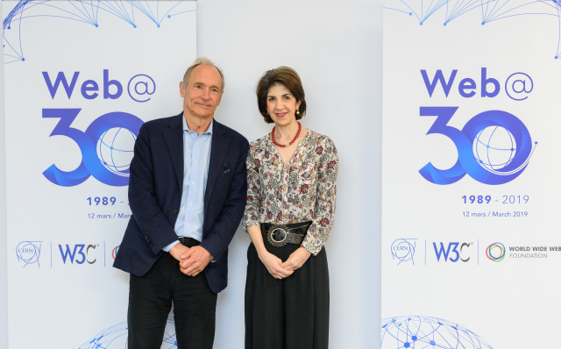

Berners, T. (1994) World Wide Web images gallery/cern accelerating science. Available at:
http://home.cern/resources/image/computing/world-wide-web-images-gallery
[Accessed 17 February 2021].

The biggest world- wide communication network, first though of by the United States Department, and first connected in October of 1969, designed to create and develop new innovation ways and technologies En Wikipedia (internet, 2021).

P6.

- CHANGING THE WORLD
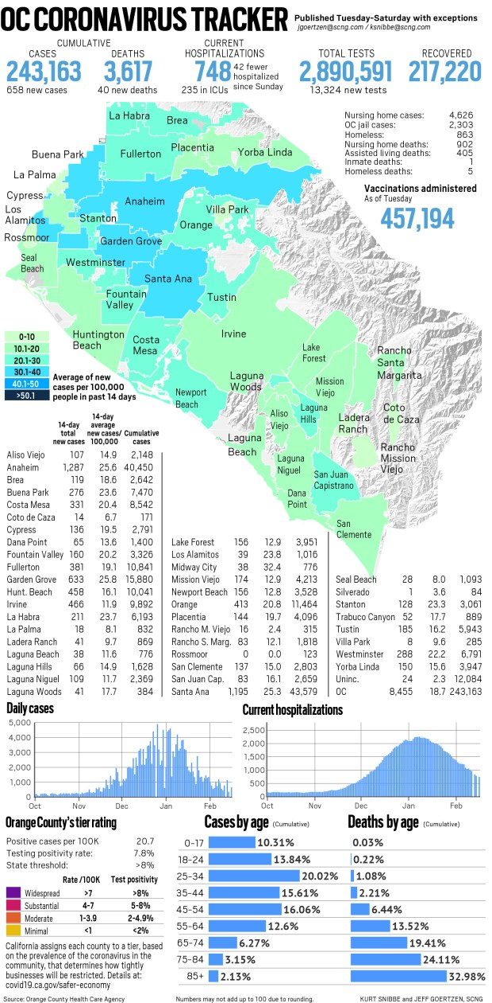
The OCR. (2021). ‘Coronavirus orange county reported 658 new cases, 40 New Deaths as of Feb 16. Available at: http://ocregister.com/2021/02/16/coronavirus-orange-county-reported-658-new-cases-40-new-deaths-as-of-feb-16/
[Accessed 17 February 2021].

The internet has changed society’s everyday life drastically due to the pandemic we are currently facing relating to covid19 we are now able to see the amount of deaths, cases etc., online it has changed the way we interact with each other, for example using online videos, Calls, Consultations for social and healthcare communication needs.

P7

- NEW INNOVATION DEVELOPMENT



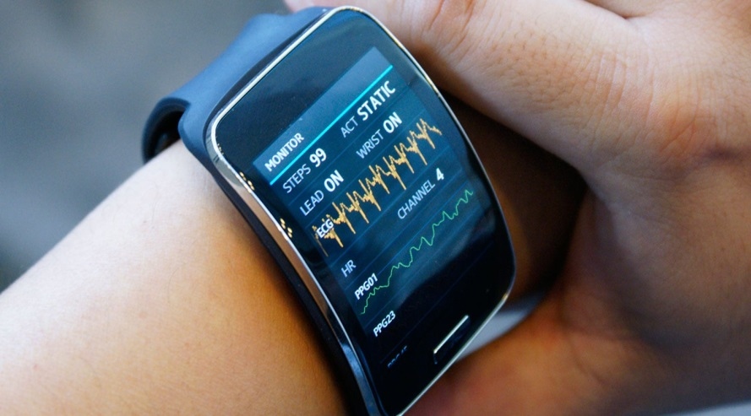
Telegraph, (2017) ‘Healthcare in the open economy.
Available at: http://telegraph.co.uk/business/open-economy/new-technologies-transforming-healthcare/
[Accessed 17 February 2021].

The internet’s innovation technology developments have contributed enormously to the health and social care sector, each day coming up with new ideas to create new technologies that give individuals who are suffering with a disability or health issue a better chance to live a normal life (Stier, 2016).

P8

4 IMPACTS AND EFFECTS

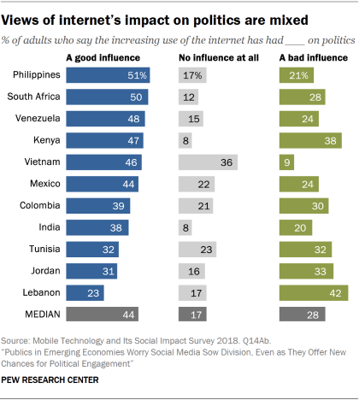
Publics Think Technology Impacts the Political Environment in Positive and Negative Ways (2019) Pew Research Centre Internet & Technology.
Available at: http://pewresearch.org/internet/2019/05/13/publics-think-technology-impacts-the-political-enviroment-in-both-positive-and-negative-ways/
[Accessed 10 February 2021].

Tests and Swot Analysis were performed to identify the positive and negative impacts the internet will have on society today and in the near future.

P9

- CREATING THE FUTURE

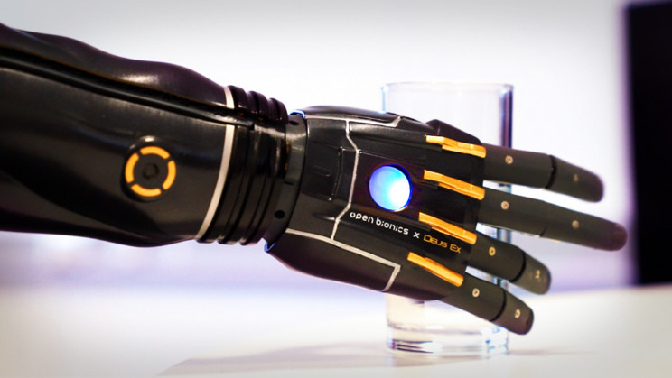
Young, C. (2020). 10 Technologies that will drive the Future of Healthcare Interesting Engineering.
Available at: http://interestingengineering.com/10-technologies-that-will-drive-the-future-of-healthcare
[Accessed 14 February 2021].

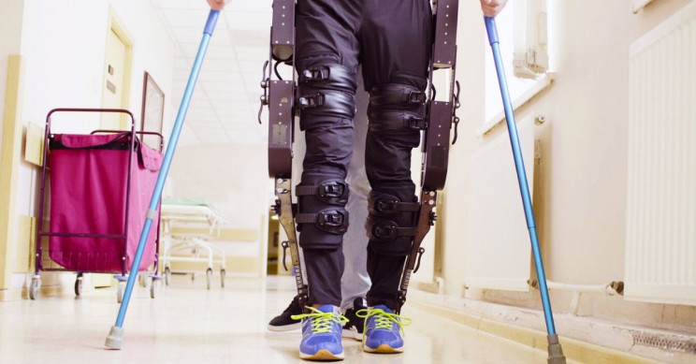
Young, C. (2020). 10 Technologies that will drive the Future of Healthcare Interesting Engineering.
Available at: http://interestingengineering.com/10-technologies-that-will-drive-the-future-of-healthcare
[Accessed 14 February 2021].

P10.

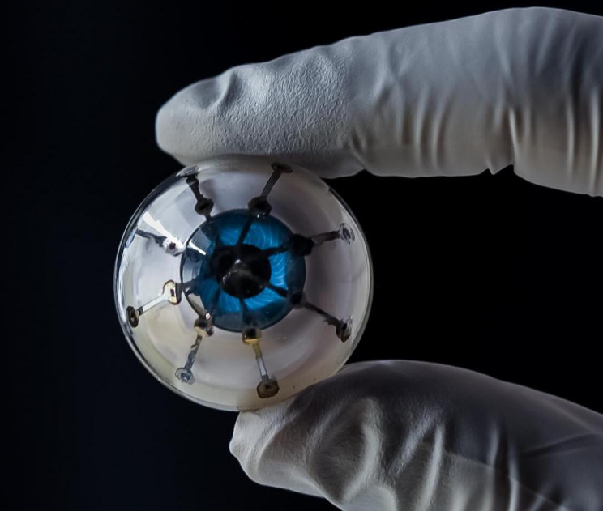
Young, C. (2020). 10 Technologies that will drive the Future of Healthcare Interesting Engineering.
Available at: http://interestingengineering.com/10-technologies-that-will-drive-the-future-of-healthcare
[Accessed 14 February 2021].

The internet will create the future by creating new innovation technologies that are and will be beneficial to the healthcare sector and humanity worldwide for example internet bodies has been designed to collect our physical data by using a range of devices that can be implanted swallowed or worn( Young, 2020).

P11.

TASK (2) BLOG

Fung, A, (2015). Putting the public back into governance: the challenges of citizen participation and its future. The Available at: http://onlinelibrary.wiley.com/doi/abs/10.1111/puar.12361
[Accessed 16 February 2021].

Pompilio E, (2019). The pros and cons of technology in nursing. elite healthcare, [ Available at: http://elitecme.com/resource-centre/nursing/the-pros-and-cons-of-technology-in-nursing
[Accessed 16 February 2021].

Telemedicine, (2010). Telemedicine Opportunities and developments in member states Available at: https://www.who.int/goe/publications/goe_telemedicine_2010.pdf
[Accessed 18 February 2021].

BLOG- This blog has been created as a gap has been identified relating to public feedback, innovation ideas and technologies are being created and developed each day all over the world to improve health and social care, though most innovation developments have proven to be successful, individuals have not had the chance to get involved to have their say on how they feel the new idea or technology well benefit society worldwide after all they are part of the reason these innovations have and are being created.

GOAL- is to create a website that allows individuals world-wide to have the chance to voice their views and opinions that relate to new changes made to the health and social care sector for example new information, technologies and developments.

BENEFITS OF CREATING THIS WEBSITE:
.
- So, citizens feel their opinions are valued.

- Citizen participation to advance innovation technologies.

- Enhancing forms of citizen participation.

- A better understanding of new innovation technologies that will be developed (Fung, 2015).

P12

However, I agreed with the statement (Pompilio, 2019) made stating that healthcare providers and other health professionals can provide important details of the new technologies to different countries all over the world, I did disagree with one point made about malfunctioning equipment, as a backup
plan should already be put in place to prevent this happening if an error occurs
(Pompilio, 2019).

In this blog I have covered all areas of my idea, from what the blogs about, the goals and the benefits, If you like this blog, and agree with me and think it is a good idea to create this website and feel it would be beneficial, please post to family, friends, peers and work colleagues etc.

Telemedicine (2010). Telemedicine opportunities and developments in member states Available at:
https://www.who.int/goe/publications/goe_telemedicine_2010.pdf
[Accessed 18 February 2021].

REFRENCE LIST

En Wikipedia, (2021). Internet
Available at:https://en.wikipedia.org/wiki/internet
[Accessed 29 January 2021].

Fung A, (2015). Putting The Public Back into Governance the challenges of citizen participation and its future. the American society for public administration Available at: http://onlinelibrary.wiley.com/doi/abs/10.1111/puar.12361
[Accessed 16 February 2021].

Pompilio E, (2019). The pros and cons of technology in in nursing. elite healthcare Available at: http://elitecme.com/resource-centre/nursing/the-pros-and-cons-of-technology-in-nursing
[Accessed 16 February 2021].

Stier S, (2016). Internet diffusion and regime type temporal patterns in technology adoption Available at:http://www.elsevier.com/locate/telpol
[Accessed 29 January 2021].

Young C, (2020). 10 technologies that will drive the future of healthcare Available at: http://interestingengineering.com/10-technologies-that-will-drive-the-future-of-healthcare
[Accessed 14 February 2021].

