


Assignment 2

Total Engineering Management

Engineering Management – SGDM6020

Callum McFenton
Contents

Task 1 3
a) Taguchi Design of Experiments (DOE) 3
b) 3
c) 4
Task 2 4
SWOT Analysis 4
PESTEL Analysis 4
Porter’s Five Forces 5
Task 3 6
Kano Model 6
a) 6
b) 7
Task 4 8
a) 8
b) Checks for special causes to indicate whether the process is in a state of statistical control 9
c) 9
Task 5 10
Tuckman’s team progression and implications for team activities 10
Stage 1 – Forming (Orientation) 10
Stage 2 – Storming (Power struggle) 10
Stage 3 – Norming (Cooperation and integration) 10
Stage 4 – Performing (Synergy) 11
Stage 5 – Adjourning (Closure) 11
Bibliography 11

Task 1

Taguchi Design of Experiments (DOE)
The eight steps to follow using the Taguchi DoE method are as follows:
- Identify the main use of the product, its side effects and failure mode.
- Identify the Noise factors, testing conditions and quality characteristics
- Identify the objective function to be optimized
- Identify the control factors and their levels
- Select the orthogonal array matrix experiment
- Conduct the matrix experiment
- Analyse the data, predict the optimum levels and performance
- Perform the verification experiment and plan future action.

b)
L9 | A | B | C | D | Deterioration
1 | 1 | 1 | 1 | 1 | 20
2 | 1 | 2 | 2 | 2 | 12
3 | 1 | 3 | 3 | 3 | 10
4 | 2 | 1 | 2 | 3 | 48
5 | 2 | 2 | 3 | 1 | 28
6 | 2 | 3 | 1 | 2 | 20
7 | 3 | 1 | 3 | 2 | 20
8 | 3 | 2 | 1 | 3 | 16
9 | 3 | 3 | 2 | 1 | 8

In order to calculate T, the following formula was used:
$$T=20+12+10+48+28+20+20+16+8$$
T = 20.2222

T | 20.2222
A1 | 14 | B1 | 29.33333 | C1 | 18.66666667 | D1 | 18.66667
A2 | 32 | B2 | 18.66667 | C2 | 22.66666667 | D2 | 17.33333
A3 | 14.6667 | B3 | 12.66667 | C3 | 19.33333333 | D3 | 24.66667

Levels | A | B | C | D
1 | 14 | 29.33333 | 18.66667 | 18.66667
2 | 32 | 18.66667 | 22.66667 | 17.33333
3 | 14.6667 | 12.66667 | 19.33333 | 24.66667
Diff | 0.6667 | 6 | 0.666667 | 1.333337
Rank | 3 | 1 | 4 | 2

Using the tabulated results, the optimum parameter setting can be found. It would be:
Optimum Parameter setting = A₁B₃C₁D₂
We can then use the formula to obtain the average parameter values and predict the outcome for the settings:
$$Y=\left(A1+B3+C1+D2\right)-3T$$
$$Y=\left(14+12.66667+18.66667+17.33333\right)-(3 x 20.2222)$$
$$Y=62.66667-60.6666$$
$$Y=2.00007$$

c)
 | LEVEL | 1 | 2 | 3
A | Material cost (£/load) | 2,500 | 2,400 | 2,200
B | Process temperature (C) | 600 | 625 | 650
C | Process time (Hours) | 2 | 1.75 | 1.5
D | Percentage additive | 2% | 4% | 6%

Considering the above information, the optimal parameter settings will be affected. A1 is the highest material cost at 2500, B3 the highest process temperature of 650, C1 the longest process time of 2 hours, and finally D2 the second highest percentage additive at 4%.
In a real-world situation, it is not always the best choice to choose the most optimum parameters if they are more costly and inefficient than other choices. It is important to hit spec, but also reduce costs.

Task 2

SWOT Analysis
A SWOT Analysis allows the user to identify characteristics of the business in order to plan for the future. It identifies the businesses Strengths, Weaknesses, Opportunities and Threats. The user can list all these characteristics and make informed choices on how it will change or move into the future. The SWOT Analysis takes into account factors internally within the business, such as the workforce or working methods, as well as external factors such as the economy and competitors.

PESTEL Analysis
The PESTEL Analysis is used to assess the businesses position within the market, and its market growth. It takes into account Political aspects such as Government policies and regulations, Economical aspects such as spending by consumers or tax rates, Social factors like consumer choice and trends, Technological factors such as technical advancements, Environmental issues such as its impact or the environment and regulations it must abide by, and finally Legal factors such as national laws ad tax levels. A business using a PESTEL Analysis can identify the macro forces which will affect it.

Porter’s Five Forces
By using this tool, a business can identify its strengths and its opportunity within the market for generating profits. By understanding the forces within the market or the business environment, strategic moves can then be made by the business to ensure it is better suited to the challenges it may face or become a stronger competitor.

These tools can each be combined in order to crossover into each other’s criteria. For example, The PESTEL analysis findings can be used to populate the Opportunities and Threats criteria for the SWOT Analysis. A further example of this would be identifying economic factors such as growth in consumer spending can be listed as an opportunity in a SWOT Analysis, and new government laws can be used as a threat.
I believe that each of the tools are important, and that all businesses should utilise all of them, as it helps identify weaknesses in the business, which can be ultimately focused on and turned into positives, the companies position in the market and the worlds economy and what it can do to improve and plan for the future.

Task 3

Kano Model
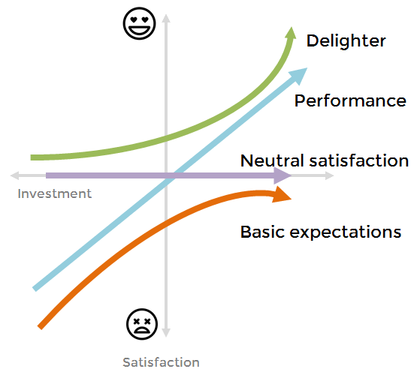

Figure 1 - Kano Model, image obtained: https://medium.com/@solmesz/kano-model-product-design-and-startups-a-powerful-combination-61eacf1a6f30, Date: 15/5/2020

a)
Basic – These are things that the customer expects to be there in the design. An example of this would be ice in a drink, or cup holders in a car. If they are not there, the customer would feel disappointed and this may affect the product.
Performance – An example of performance factors would be the ease of turning on a TV, or the speed of a kettle boiling. These are known as faster, easier or more factors, meaning that they can always be improved upon.
Delight – These are things that the customer did not expect in the design but create great satisfaction. An example of this would be a DAB radio in a car, or a complimentary drink at a hotel. These are provided with very little extra cost, but they may become expected from the customer, and this would then make them basic factors. (Medium.com, 2019) (Sireli, Kauffmann, & Ozan, 2007)

b)
i) A company should use Quality Function Deployment to ensure that its products produced are in line with the technical requirements of the customer.
QFD can provide the supplier with a much more focused and structured approach to the quality of the product. Firstly, the Product planning stage helps the supplier define and prioritise its customer’s needs. It also helps them identify opportunities and helps them design a product which meets the requirements of the customer. Assembly/part deployment helps the supplier identify critical parts or assemblies, and Process planning determines the critical process and process flow, while also establishing important process parameters, and finally, Process or Quality control can help determine critical part or process characteristics, and help establish test and inspection methods.
It can also be used as a language that can be understood by the customer and the business so that the development process is easier for both parties. Using QFD ensures that the products are developed in line with what is expected by the customer, at a lower cost and significantly faster with less problems.
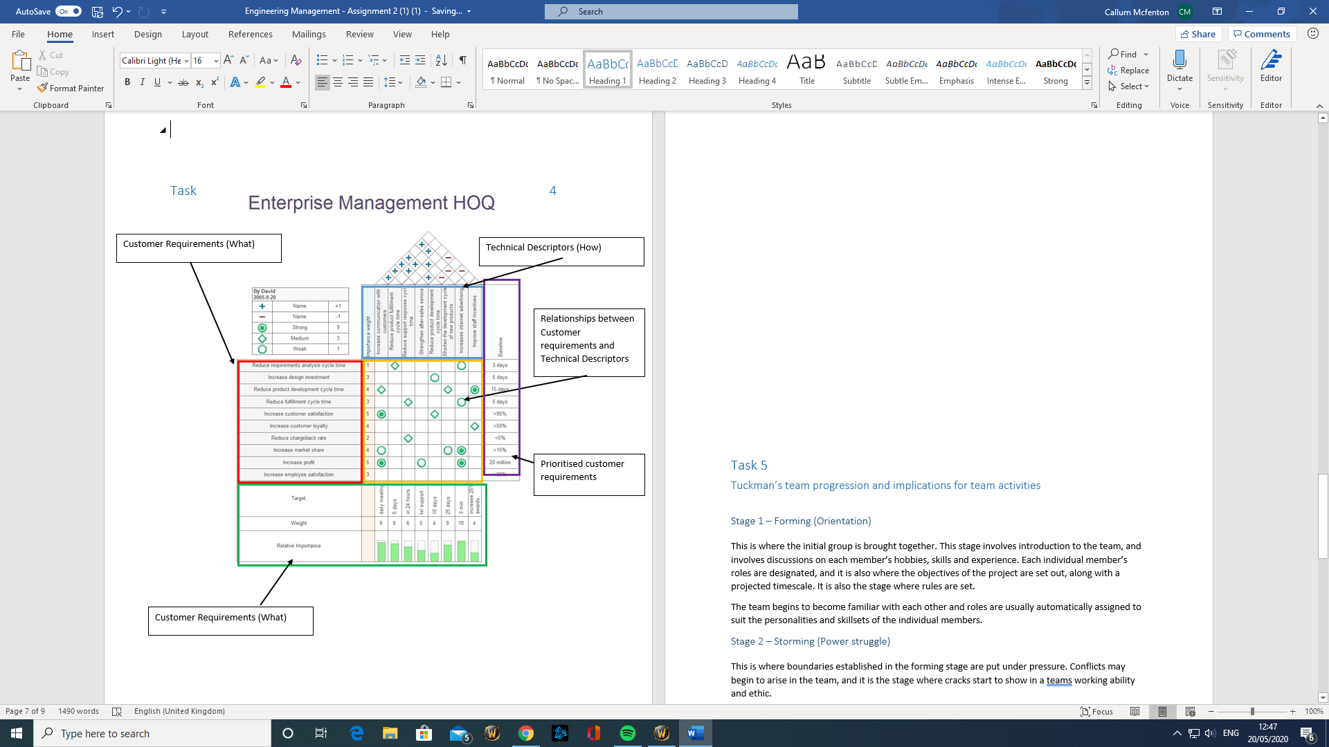
ii)
(Tapke, Muller, Johnson, & Siec, n.d.)

Task 4

a)

Sample No. | 1 | 2 | 3 | 4 | 5 | 6 | 7 | 8 | 9 | 10
X1 | 20.11 | 20.13 | 20.12 | 20.06 | 20.22 | 20.13 | 20.21 | 19.96 | 20.13 | 20.2
X2 | 20.12 | 20.04 | 20 | 20.14 | 20 | 20.04 | 20.02 | 19.97 | 20.14 | 20
X3 | 19.97 | 20.1 | 20.15 | 20.23 | 20.15 | 20.11 | 19.97 | 20.21 | 20.1 | 20.5
X4 | 20.05 | 20 | 20.11 | 20.11 | 20.1 | 20 | 20.05 | 19.9 | 20 | 20.11
X5 | 19.88 | 20.2 | 19.9 | 20.12 | 19.9 | 20.22 | 19.88 | 19.9 | 20.12 | 19.99

Firstly, the Sum, Mean and Range of the collected data had to be calculated:
Sum | 100.13 | 100.47 | 100.28 | 100.66 | 100.37 | 100.5 | 100.13 | 99.94 | 100.49 | 100.8 | Sums
Mean | 20.026 | 20.094 | 20.056 | 20.132 | 20.074 | 20.1 | 20.026 | 19.988 | 20.098 | 20.16 | 200.754 | 20.0754
Range | 0.24 | 0.2 | 0.25 | 0.17 | 0.32 | 0.22 | 0.33 | 0.31 | 0.14 | 0.51 | 2.69 | 0.269

This data could then be entered into a Process Control Chart:
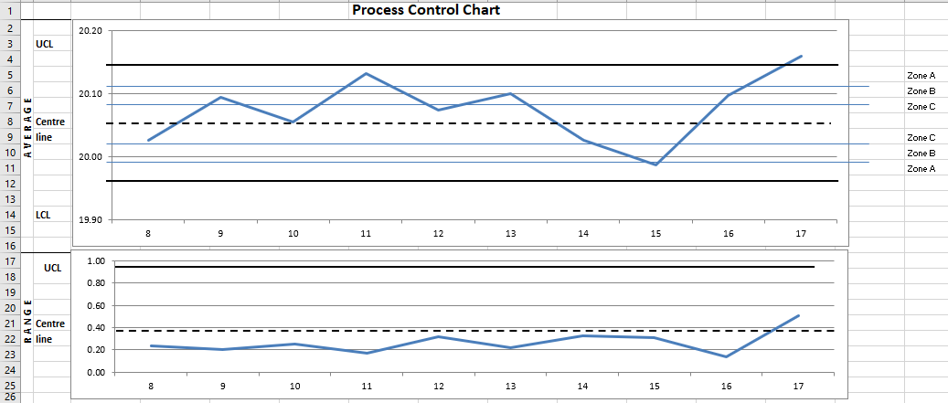

The Average Upper and Lower control limits then had to be calculated using the following formulas:

Along with the range UCL and LCL using the following calculations:

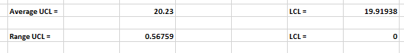

Checks for special causes to indicate whether the process is in a state of statistical control
Using a run chart, if 8 points are consistently on one side of the centre line, this indicates that the process has been affected by a special cause.
If 6 or more points are consistently moving in the same direction, this also means that the process has undergone a special cause due to a trend.
If there is a consecutive pattern that points follow for a period, then the process is being affected by a special cause.
Using a Control chart, all collected data will fall within the control limits, and where points deviate outside of these, should be investigated as they may be influencing the process.

c)
Finally, the C_{p} and C_{pk} values were calculated using the following formulas:
C_{p =} Total specified tolerance
6 σ

C_{pk =} Upper Specified Limit - or - Lower Specified Limit
3σ 3σ

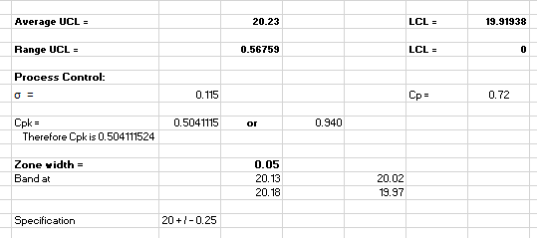
The process has a Cp value of 0.72. This means that the process is not capable, as this value should usually be more than 2.

Task 5

Tuckman’s team progression and implications for team activities

Stage 1 – Forming (Orientation)
This is where the initial group is brought together. This stage involves introduction to the team, and involves discussions on each member’s hobbies, skills and experience. Each individual member’s roles are designated, and it is also where the objectives of the project are set out, along with a projected timescale. It is also the stage where rules are set.
The team begins to become familiar with each other and roles are usually automatically assigned to suit the personalities and skillsets of the individual members.

Stage 2 – Storming (Power struggle)
This is where boundaries established in the forming stage are put under pressure. Conflicts may begin to arise in the team, and it is the stage where cracks start to show in a teams working ability and ethic.
The reason conflicts arise, is that there are differences in working styles, and this may lead to people becoming frustrated with each other or the lack of progress being made. Authority may be challenged, and people’s roles may change during this phase.

Stage 3 – Norming (Cooperation and integration)
This stage follows the Storming phase, and it is where the team begins to resolve their differences and begin to work together, using their strengths and weaknesses. A leaders authority is then respected, and the group begins to make progress.
Friendships are now growing, and team members begin to rely on each other to work together and for help, and constructive feedback begins to form between the team.
The transition from Storming to Norming is usually overlapped, as the team may fall back into the Storming stage.

Stage 4 – Performing (Synergy)
The team is now established, and the project begins to make positive progress. The team is working together with very little friction, the leader is ensuring that tasks are completed when required, and their authority is not challenged.
Individuals are now developing with the help of the team leader, and members leaving or joining the group now have little effect on the performance.

Stage 5 – Adjourning (Closure)
This is the stage when the project has been completed, and the team is disbanding and moving onto other things. Team members go their separate ways but may miss the team atmosphere.

Bibliography
Archived copy. (n.d.). Retrieved 5 21, 2020, from https://www.mindtools.com/pages/article/newLDR_86.htm
Medium.com. (2019). Kano model, product design and startups: a powerful combination. Retrieved from www.medium.com: https://medium.com/@solmesz/kano-model-product-design-and-startups-a-powerful-combination-61eacf1a6f30
Sireli, Y., Kauffmann, P., & Ozan, E. (2007). Integration of Kano's Model Into QFD for Multiple Product Design. IEEE Transactions on Engineering Management, 54(2), 380-390. Retrieved 5 21, 2020, from https://ieeexplore.ieee.org/document/4160190
Tapke, J., Muller, A., Johnson, G., & Siec, J. (n.d.). House of Quality: Steps in Understanding the House of Quality. Retrieved 5 21, 2020, from http://www.public.iastate.edu/~vardeman/IE361/f01mini/johnson.pdf

