Essential skills for Study and Employment
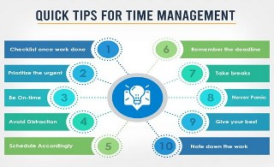
Asktalentservices.com (2022)
Time management

According to Levin, time management is vital in essential skills for study and employment (Levin, 2007).
There is Increased self-confidence: If you Learn a new skill, it can help to take on new tasks at work. Also, it can increase your ability to articulate to employers how you can be effective in the workforce. The advantages of time management are substantial when being employed.
According to Levin time management plays a crucial role in essential skills for study and employment (Levin, 2007).
There is Increased self-confidence: Time management's advantages are substantial when employed.
Management is a worthy goal for many human activities (Stoilov, 2012) learnt that time is excellent for work. It is an advantage.
According to research conducted outside of the educational setting, effective time management techniques may also help principals achieve workload requirements, lessen workplace stress, and perform better. (Grissom et al., 2015). It was understood that it is important thing to understand this concept of time management its good for promotion etc.
Peter Levins, the book shows you, to plan your weekly routine, prioritise tasks, and manage two or more tasks at once, use your time productively and effectively, and make sure you meet deadlines on/ well ahead of time (Levin, 1936).
To conclude, I want to pursue a career with this IT (Information Technology) course as I have always been passionate about it. The main job I want to go into is becoming an IT technician. The reasons behind this are unlimited options; I would always have flexibility in where I would like to work as the hiring demand is exceedingly high for IT technicians.

References:

1)Levin, P. (2007) Skilful time management! Open University Press: Maidenhead, England.

2)Stoilov, T. (2012) Time Management. Rijeka, Croatia: InTech.

3)Grissom, J.A., Loeb, S. and Mitani, H. (2015) “Principal Time Management Skills,” Journal of Educational Administration, 53(6), pp. 773–793. Available at: https://doi.org/10.1108/jea-09-2014-0117.

4)Skilful time management! Levin, Peter, 1936- : Free download, Borrow, and streaming (1970) Internet Archive. Maidenhead, England; New York: Open University Press. Available at: https://archive.org/details/skilfultimemanag0000levi (Accessed: February 13, 2023).

5)Image reference - 10-time management techniques to work efficiently (2022) askTalentServices. (Accessed: February 13, 2023).

Reflection to Improve
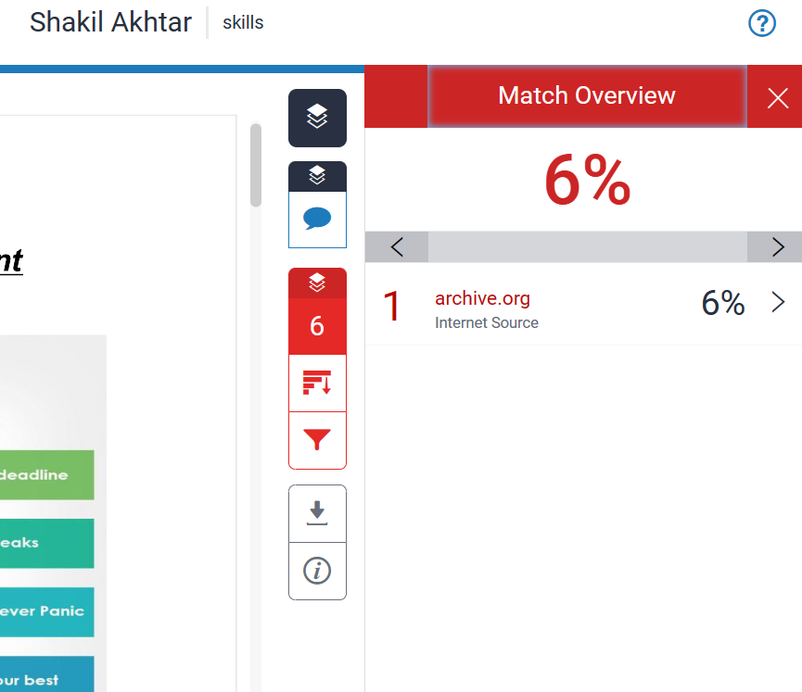
I received a similarity rating of 6%. It has been advised that anything under 30% is good. The lower the score, the better because there are fewer chances of plagiarism.
I marked myself 50% to 60 % out of the Assessment criteria. I referenced the appropriate range of literate. Showed knowledge and good understanding. My work was organised and structural. Looking at this in the future, I must use quotation marks, deeper analysis and not to rely on the internet as much to receive a higher grade for similarity.
The references I looked up while working on the task were the material I consulted. I would demonstrate a thorough comprehension of the task's concepts and guiding principles.
In the future, I should use fewer internet resources and do more research using books and journals. I can include quotes or a bibliography and statistics for a better mark. I should employ both my own writing and information from texts in equal measure.

Task two
E-portfolio link:
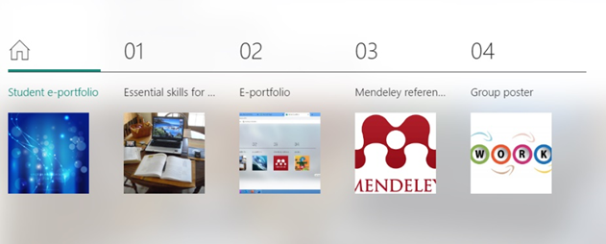
In Microsoft Sway, I have constructed my electronic portfolio. In this portfolio, I have included all the tasks. Section 1 on page 1 of my electronic portfolio has task number 1 Essential skills. The e-portfolio itself is task two. The third is the Automatic Referencing tool (Mendeley). The last thing is Teamwork Poster.
Link for sway: https://sway.office.com/tUjGeuMwcI41n05B
Video link for sway:
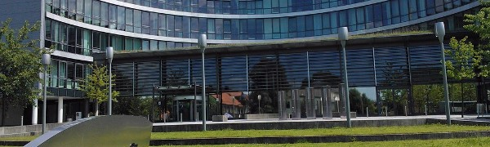
LEARNING DIGITAL ERA Shakil Akhtar 2224840
Asktalentservices.com (2022)
Go to this Sway

Task three is about the Mendeley reference manager tool.
Mendeley Reference Manager
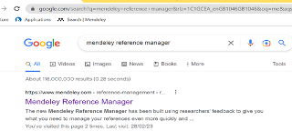
A) Firstly, search for Mendeley reference manager on Google. After arriving at the website, you must download the application and accept all cookies.
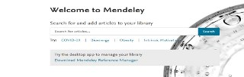
B) Secondly, when the application gets downloaded. To create a new account, you must provide your email etc.
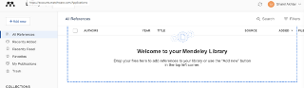
C) Then you enter your email address and password again. You should see your Mendeley library when the application loads, as displayed above.

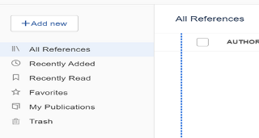
D) There are three ways to load the necessary data for your job. One option is to manually enter the author and website information. The second approach is to utilise the identification tool you can get from the search results page, copy the code, and put it there. A web importer is the third choice.

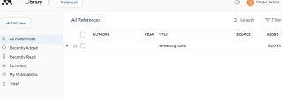
E) After this, I added a reference.
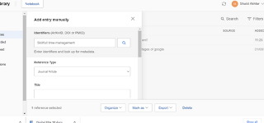
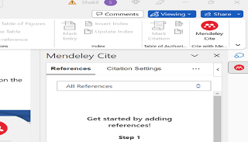
F) Microsoft Word can now include the Mendeley reference tool.

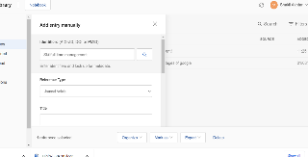
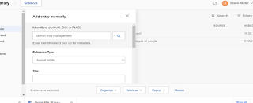
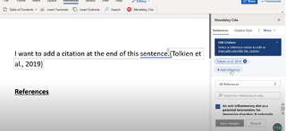

G) On Microsoft Word, I utilised the Madeley Reference feature. As demonstrated in the image above, with your library on the right, it will display on the task once you have clicked it.

The fourth task was a group poster.

Collaborative Teamwork and Professional Academic poster

POSTER:
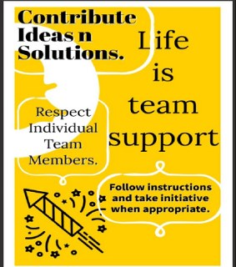MAIN POSTER
 QR CODE CREATED FOR THE POSTER
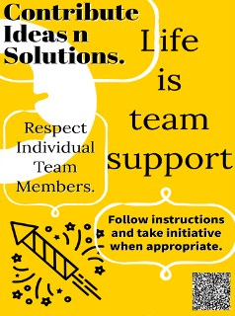 QR CODE ON THE ACTUAL POSTER

1)Respect 2) Coordination 3) Ideas and solutions 4) Instructions and take the initiative when appropriate.

We had four members in our team.

Group members name Matthew Cronogue, Majib Miah, Corey Harrison, and myself, Shakil Akhtar.
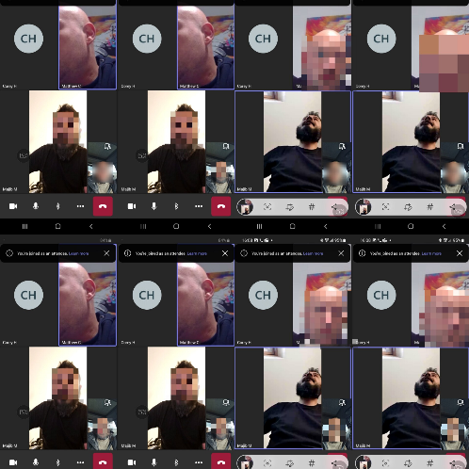
We are discussing and sharing views about our work on task 4 of the assignment on Microsoft teams.


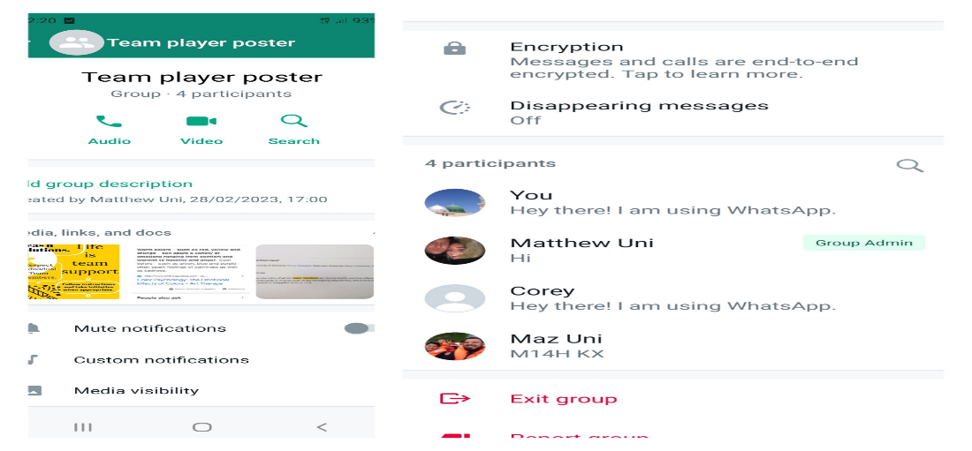
We also created a group on WhatsApp and shared ideas there and face to face.

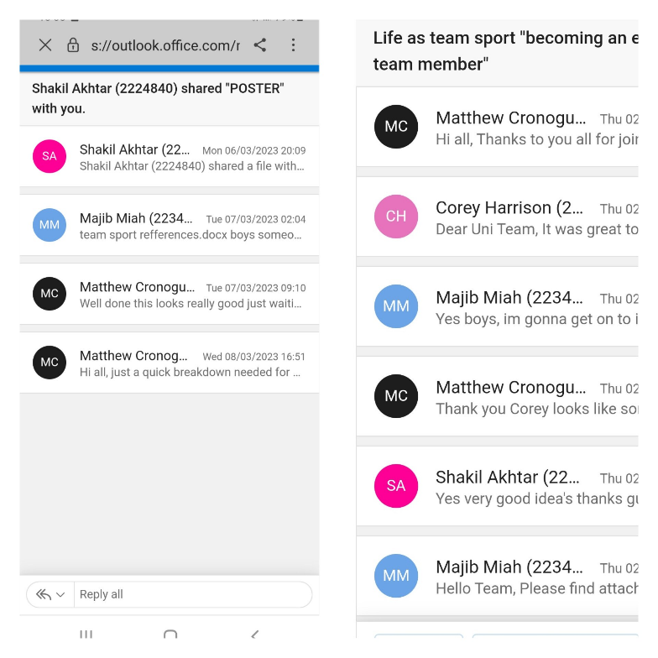
we also sent emails to each other and added one another to see the emails and get our points across.

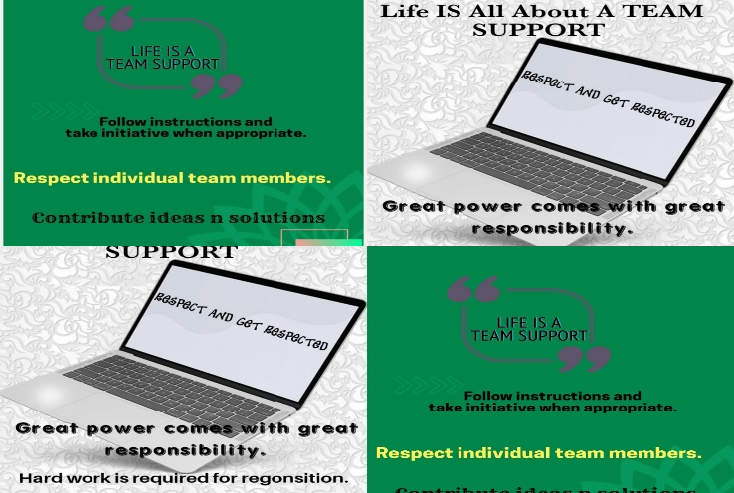
A few designs which I have created.
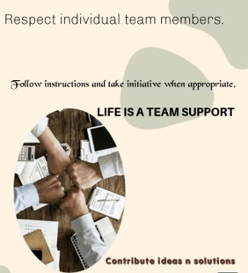
This was the poster which had been selected to be used.

Respect – “Respect helps employees to think innovatively and work hard as they know that their ideas would be appreciated” (’Khan 2020)

Coordination – “coordination concerns the level of mutual understanding about how and what each member contributes, and the interrelationship between their contributions. Clear goals and priorities are integral to this.”(’Khan 2020)

Contribute ideas n solutions- "Since a project has a defined ending, each contributor to the effort must know the desired result”(’Kuijsters 2015)

Follow instructions and take the initiative when appropriate - Observe directions while taking the industry when necessary. We can do this by advising how to respond "Explain a situation where you took the initiative”. Went above and above to assist a person or see that a situation was resolved. Even without supervision, you were able to work well on your own. You suggested a fresh concept or method that was implemented and started a successful new initiative.

My assignment was to produce a concept for a group poster. My task was to make a poster with bright colours and a message. I had to make it distinct and ensure the poster message was understood. I achieved that by using several fonts and sizes. I made the poster's focal point pop with vibrant colours. I also gave my team writing prompts that would Centre around our sign. I made 4-5 posters but ended up with the bright yellow colour one at the end. It stood out more. We worked well as a team, listening carefully to one another's ideas. In my group, there were four members. We communicated through Teams, WhatsApp, outlook emails and face-to-face. We got to know each other a lot better. Matthew set up the groups on Teams, Outlook, and WhatsApp. He arranged the times etc. Corey created the wording for the poster. Majib did the referencing. We discussed each task thoroughly.

The topics we came up with follow and contribute ideas and solutions- suggestions and solutions are welcomed. We should ask questions and get information from each other for a better result.

The next was Life is team support - The teamwork of Life is essential. According to research, problem-solving in groups produces superior results. If they have a team behind them, individuals are more inclined.

Respect Individual Team members - Treat each team member individually. Employees can feel valued for their accomplishments, skills, and traits when they have mutual respect. Being respected and valued at work fosters an environment where employees are engaged, loyal, and driven to give their all. Managers are not the only ones who deserve respect in the workplace. Each member of the team needs to be aware of appropriate behaviour. Also, employees at all levels should understand how to spot disrespectful actions.

Group members' names were Matthew Cronogue, Majid Miah, Corey Harrison and me, Shakil Akhtar.

Respect – “Respect helps employees to think innovatively and work hard as they know that their ideas would be appreciated”(’Khan 2020)

Coordination – “coordination concerns the level of mutual understanding about how and what each member contributes, and the interrelationship between their contributions. Clear goals and priorities are integral to this.”(’Khan 2020)

Contribute ideas n solutions- "Since a project has a defined ending, each contributor to the effort must know the desired result”(’Kuijsters 2015)

Follow instructions and take the initiative when appropriate – "If an idea doesn't align with your key strategy or the larger mission of your organisation, it is likely to be a waste of time and resources”(’Sharon K. and ’Ying Lena 2019)

Respect – “Respect helps ^{employees} to think innovatively and work hard as they know that their ideas would be appreciated” [1]

Coordination – "coordination concerns the level of common understanding about how and what each member contributes, and the interrelationship between their contributions. Clear goals and priorities are integral to this." [1]

Contribute ideas n solutions- "Since a project has a defined ending, each contributor to the effort must know the desired result" [2]

Follow instructions and take the initiative when appropriate – "If an idea doesn't align with your key strategy or the larger mission of your organisation, it is likely to be a waste of time and resources" [3]

References:

[1] S. A. K. ’Khan, “legacycultures.com,” What is the Importance of Respect in the Workplace & How it Affects Employees (Explained), October 26, 2020. https://legacycultures.com/importance-of-respect-in-the-workplace-and-how-it-affects-employees (accessed March 02, 2023).
[2] F. ’Kuijsters, “www.linkedin.com,” 9 Ways to Contribute to Team Success, Aug. 19, 2015. https://www.linkedin.com/pulse/9-ways-contribute-team-success-frank-kuijsters (accessed Mar. 02, 2023).
[3] P. Sharon K. and W. Ying Lena, “hbr.org,” When to Take Initiative at Work, and When Not To, August 21, 2019. https://hbr.org/2019/08/when-to-take-initiative-at-work-and-when-not-to (accessed March 02, 2023).

