

Name: Yuliia Klymiuk
Student ID: 2409933
Module Code: LCLM5003
Lecturer: Xavier Matieni

Module: Project Management
Assignment Title: A Project portfolio.

Program: BA (Hons) Leadership and Management Skills for the Workplace

Submitted on: 27 of April 2026
Table of Contents
Part A (Poster) 2
Part B (Reflection on Feedback) 3
Reflection 3
Conclusion 3
Action Plan 3
Part C (Project management plan) 4
Introduction 4
Project description 4
Scope 5
Work breakdown structure 6
Quad Chart 8
GANTT Chard 9
Stakeholders' involvement 11
Allocation of resources 12
Risk Analysis 13
Conclusion 15
References 15

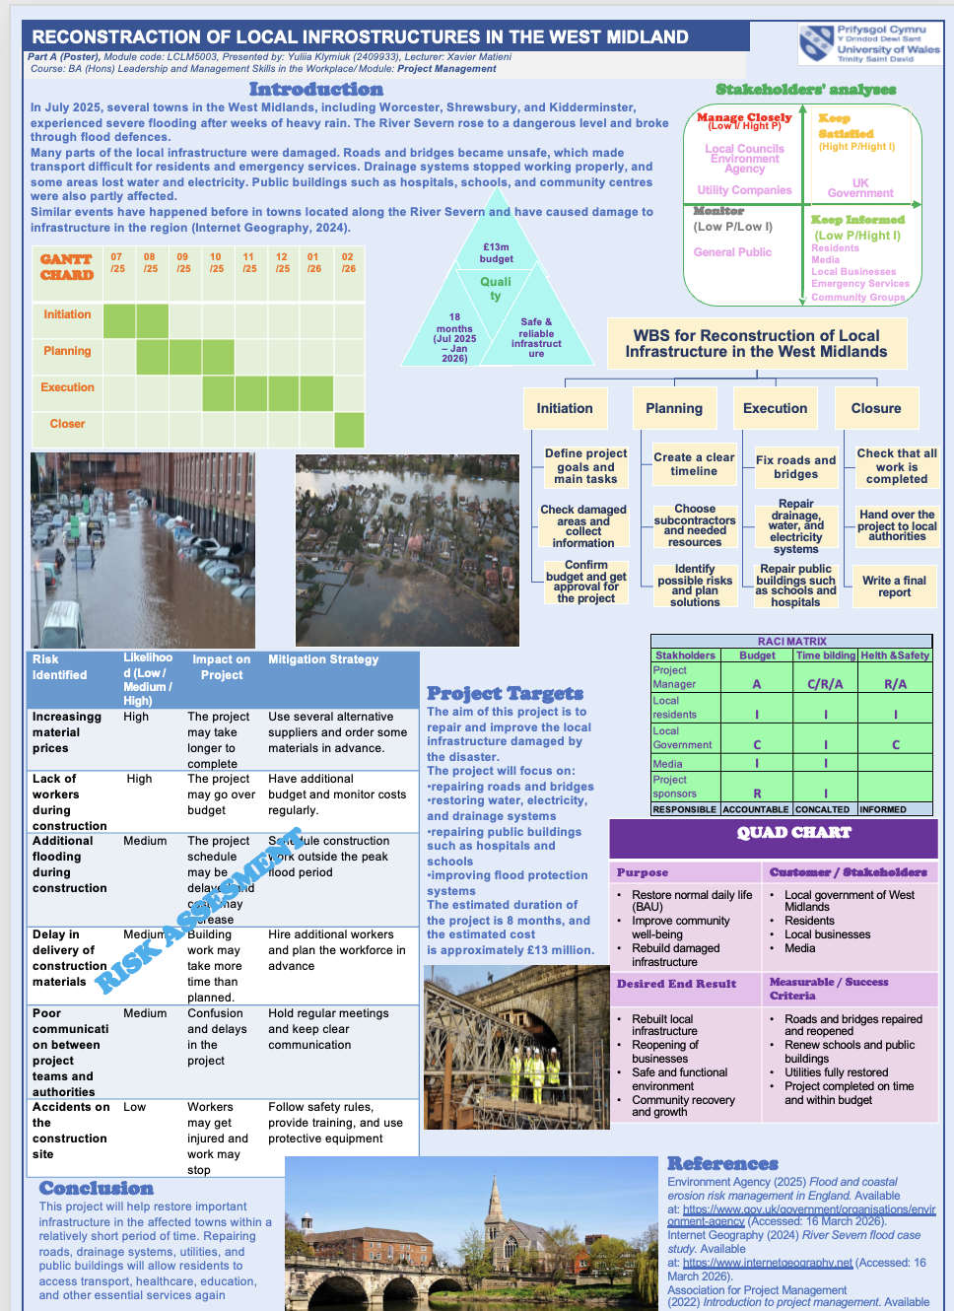

Part A (Poster)

Part B (Reflection on Feedback)

After completing the poster, I would like to reflect on my work using Kolb’s learning cycle based on the feedback received from my tutor and peers.
Experience
During this project, I worked on creating a poster based on a flooding scenario in the West Midlands. From the beginning, I was very excited about the Project Management subject, as I am planning to move into a management career in the future. I worked on the project with strong interest and was engaged in creating the poster and analysing the project step by step. During the lessons, we also worked in cooperation with other students, especially when learning and applying new project management tools. This helped me better understand the material and share ideas. I also received detailed feedback from my teacher twice, which helped me understand that I was working in the right direction. I was very proud in using new tools, not only learning theory but also understanding how to apply them in practice.

Reflection

Looking back at this experience, I can say that I was highly motivated and engaged during the whole process. I enjoyed analysing the project and understanding how each tool works.
I realised that these tools are not just theoretical, but they can be applied in real-life situations. This made the learning process more meaningful for me. I also found it interesting to work both analytically and creatively at the same time. I felt confident while completing the project, especially because I understood what I was doing and why I was using each tool. The feedback from my tutor and peers also helped me reflect on my strengths and understand what I was doing well and what was not so professional, for example I was speaking quietly. It showed me that I was able to apply the tools correctly.

Conclusion
After completing the poster, I was very satisfied with my work. I liked how the poster looked visually, including the colours, layout, and images. I think I was able to combine all the ideas into one clear and structured presentation. I also liked how I organised the information from the beginning of the project to the end. The poster helped me understand all stages of a project, from initiation to closure. After presenting my work and receiving feedback, I felt that I was on the right track. This gave me more confidence in my skills and understanding of project management. The positive feedback from both my tutor and classmates confirmed that I was moving in the right direction.

Action Plan
In the future, I will continue to use these project management tools in my studies and career. I understand that we only explored a part of the tools, and this experience helped me realise that this is the right path for me. Next time, I will try to pay more attention to small details, such as wording and layout. I also want to improve my presentation skills and become more confident in speaking. I will also continue to use feedback from my tutor and peers to improve my future work and develop my skills.

Part C (Project management plan)

Introduction

In July 2025, an extreme weather event caused severe flooding across the West Midlands, including Worcester, Shrewsbury, and Kidderminster. The River Severn exceeded critical levels and breached flood defences, resulting in significant damage to infrastructure, transport networks, and utilities. Such events reflect increasing flood risks in the UK associated with extreme weather patterns (Environment Agency, 2023). Similar events have happened before in towns located along the River Severn and have caused damage to infrastructure in the region (Internet Geography, 2024).
The flooding disrupted essential services and placed pressure on emergency response systems. This project focuses on the reconstruction of local infrastructure to restore services and improve resilience. A structured project management approach is required due to the scale and complexity of the work. This report develops a project management plan using key tool, including Work Breakdown Structure, Gantt chart, stakeholder analysis, and risk assessment, to support effective planning and delivery. Such projects require effective planning and coordination due to the involvement of multiple stakeholders and interconnected infrastructure systems.

Project description

The project involves the reconstruction of infrastructure damaged by severe flooding. The main objective is to restore transport systems, utilities, and essential public services. Due to the critical nature of the situation, rapid recovery of key facilities is required, and activities must be delivered in a coordinated and effective manner within a short period of time.
Key activities include reopening highways, rebuilding critical transport routes, repairing drainage and utility systems, and restoring public buildings such as schools and hospitals. These activities are essential to ensure the safe movement of people and goods and to support community recovery.
The project is multi-disciplinary and requires coordination between different sectors, including local authorities, emergency services, contractors, and utility providers. It also requires active engagement with key stakeholders, such as local councils and affected communities, to ensure that the project meets local needs and is delivered effectively. The project is therefore organised in clearly defined stages to support efficient delivery. The successful delivery of this project is essential to ensure public safety and restore normal economic and social activities in the affected areas.

Scope
The scope of the project defines the key activities required to restore infrastructure and essential services following the flooding. This helps to balance project and ensure successful delivery. The project includes the repair and reconstruction of transport networks, utilities, and public facilities to support safe and functional operations. Project scope defines the work required to achieve project objectives and ensures that activities remain within agreed boundaries (ProjectManager, 2025).
In scope activities include reopening highways, rebuilding main transport routes, restoring water, electricity, and drainage systems, and repairing public buildings such as schools and hospitals. The project also includes coordination with key stakeholders and management of resources required for delivery.
Figure 1

Out of scope activities include long-term urban development projects and large-scale environmental redesign beyond immediate recovery needs. Our target is is safe and reliable infrastructure. These activities fall outside the time and budget constraints of this project. The scope ensures that all critical infrastructure is prioritised for recovery within the given time and budget constraints. The estimated duration of the project is 8 months, with a budget of approximately £13 million. It allows the project to focus on essential services and avoid unnecessary expansion beyond immediate needs. The duration of the project 18 mounts from July 2025 till January 2026. The project scope is aligned with the project management triangle, which considers the relationship between time, cost, and scope in project delivery (PMI, 2021). Defining the project scope and developing a Work Breakdown Structure (WBS) are essential initial steps for effective cost estimation and project planning (Vázquez-López et al., 2024).

Work breakdown structure

The Work Breakdown Structure (WBS) is used to organise the reconstruction project into clearly defined phases and tasks, ensuring that all activities are systematically planned and delivered. It supports the management of complex infrastructure recovery by breaking the project into manageable components (PMI, 2021). Figure 2 shous, the project is structured into four key phases: initiation, planning, execution, and closure. Each phase represents a sequence of activities required to restore infrastructure and ensure safe operations.
During the initiation phase, the project focuses on assessing the extent of flood damage and identifying priority areas for intervention. Key decisions include defining project objectives, collecting data on affected infrastructure, and confirming the project budget and approval. This stage establishes the foundation for all subsequent activities.
The planning phase involves developing a detailed project timeline, allocating resources, and selecting subcontractors. Risk identification and mitigation planning are also carried out to reduce potential delays. At this stage, coordination strategies are defined to ensure effective communication between stakeholders and project teams.
The execution phase includes the implementation of reconstruction works. Priority is given to restoring transport routes, repairing utilities such as water and electricity systems, and rehabilitating public buildings. Activities are delivered in a controlled sequence to minimise disruption and ensure that essential services are restored as quickly as possible.
The closure phase ensures that all project deliverables are completed and meet required standards. Final inspections are conducted, and the project is formally handed over to local authorities. A final report is prepared to evaluate project performance and confirm successful delivery.
This structured breakdown enables effective monitoring, resource allocation, and control throughout the project lifecycle, ensuring that reconstruction activities are delivered efficiently within the defined timeframe and budget. The proposed WRBS method can contribute to identifying significant construction hazards considering the types of projects, work and accidents. (Jeong and Jeong, 2021)

Figure 2

Quad Chart
A Quad Chart gives a clear overview of the project and helps to communicate key information to stakeholders. It presents the main parts of the project in one place, making it easier to understand the purpose, results, stakeholders, and success criteria. Quad Charts are widely used in technical and scientific environments to support clear communication of complex information (Ford and Wei, 2015). As shown in Figure 3, the main purpose of the project is to restore normal daily life, improve community well-being, and rebuild infrastructure damaged by flooding. These goals focus on helping the affected areas return to safe and stable conditions. The project involves several key stakeholders, including local government, residents, local businesses, and the media. Each group has an important role. Local authorities manage and coordinate the project, while residents and businesses are directly affected by the results. The media helps to share information and keep the public informed. The expected results include rebuilding infrastructure, reopening businesses, and creating a safe and functional environment. The project also supports community recovery and future development.
Success is measured through clear criteria, such as repairing and reopening roads and bridges, restoring water and electricity systems, and renewing schools and public buildings. Another important factor is completing the project on time and within the planned budget. This tool helps to present the project in a clear and simple way, making it easier for stakeholders to understand the main goals and expected results.
Figure 3

QUAD CHART
Purpose | Customer / Stakeholders
- Restore normal daily life (BAU)  - Improve community well-being  - Rebuild damaged infrastructure | - Local government of West Midlands  - Residents  - Local businesses  - Media
Desired End Result | Measurable / Success Criteria
- Rebuilt local infrastructure  - Reopening of businesses  - Safe and functional environment  - Community recovery and growth | - Roads and bridges repaired and reopened  - Renew schools and public buildings  - Utilities fully restored  - Project completed on time and within budget

GANTT Chard

A Gantt chart is used to define the project timeline and show the duration of the main phases of the project, including initiation, planning, execution, and closure. It provides a clear visual representation of the schedule and helps to understand how different activities are organised over time. Gantt charts are widely used in project management to plan and control project schedules by showing the timing and sequence of activities (PMI, 2021). As we can see in Figure 4, the project is planned over a period of eight months, from July 2025 to February 2026. The timeline is divided into four main phases, which are arranged in a logical sequence to ensure smooth project delivery.
The initiation phase takes place at the beginning of the project, during July and August 2025. This phase includes identifying project objectives, assessing the level of damage, and confirming the project budget and approval. The planning phase runs from August to October 2025. During this stage, a detailed project timeline is developed, resources are
identified, and subcontractors are selected. Potential risks are also considered, and strategies are prepared to manage them effectively. The execution phase is the longest part of the project and takes place from October 2025 to January 2026. This phase includes the main reconstruction work, such as repairing roads and bridges, restoring utilities, and rebuilding public infrastructure. Activities are organised to ensure that essential services are restored as quickly as possible. The closure phase is scheduled for February 2026. This final stage includes checking that all work has been completed, handing over the project to local authorities, and preparing the final report. Overall, the Gantt chart provides a clear and simple overview of the project schedule and helps ensure that all activities are completed within the planned timeframe. Some phases overlap and can run at the same time, which helps to complete the project faster and use resources more efficiently.
Figure 4

GANTT CHARD | 07  /25 | 08  /25 | 09  /25 | 10  /25 | 11  /25 | 12  /25 | 01  /26 | 02  /26
Initiation
Planning
Execution
Closer

Stakeholders' involvement

Stakeholder analysis is used to identify the key groups involved in the project and to understand their level of influence and interest. This helps to manage communication and ensure that stakeholder needs are considered throughout the project. A stakeholder analysis is used to identify and assess stakeholders based on their level of power and interest, which helps to develop effective communication and management strategies (Interreg, 2024).
In Figure 5 a power-interest matrix is used to classify stakeholders into four groups: manage closely, keep satisfied, keep informed, and monitor. This allows a clear understanding of how each group should be managed. The “manage closely” group includes local councils, the Environment Agency, and utility companies. These stakeholders have high influence on the project and are directly involved in decision-making and implementation. They require regular communication and active involvement throughout all project phases. The “keep satisfied” group includes the UK government. This stakeholder has a high level of power but lower direct involvement in daily activities. It is important to keep this group informed about progress and ensure that expectations are met. The “keep informed” group includes residents, local businesses, emergency services, community groups, and the media. These stakeholders are highly affected by the project but have less influence on decisions. Regular updates are required to keep them informed and maintain trust. The “monitor” group includes the general public. This group has low influence and low interest but should still be observed to ensure there are no unexpected issues.
Figure 5
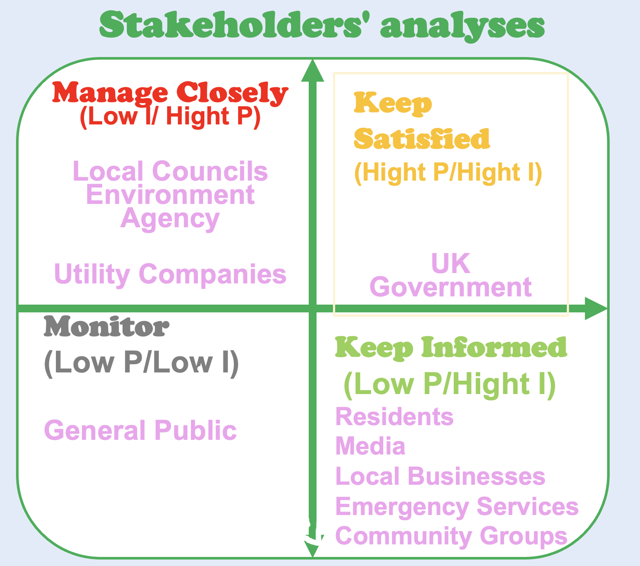

Stakeholder analysis helps to organise communication, improve coordination, and ensure that all key groups are appropriately managed during the project.

Allocation of resources

Successful project delivery depends on the effective use of available resources. This includes managing people, budget, and materials required for reconstruction activities. This includes the management of human resources, financial resources, and physical materials required for reconstruction activities.
Human resources include the project manager, local authorities, contractors, and utility companies, all of whom are responsible for different aspects of the project. Financial resources are estimated at approximately £13 million and are allocated to key activities such as infrastructure repair, utility restoration, and public building reconstruction. In addition, physical resources include construction materials, equipment, and technical support required for project execution. To support the effective management of human resources, a RACI matrix is used, as shown in Figure 6. This tool defines the roles and responsibilities of stakeholders by identifying who is Responsible, Accountable, Consulted, and Informed for key project activities. It helps to ensure clear communication and avoid confusion during project delivery. The project manager is accountable for overall project performance, while local government and sponsors provide support and guidance. Effective project management requires careful allocation of resources and consideration of potential risks to ensure successful project delivery (APM, 2022). Contractors and utility companies are responsible for executing the main tasks. Other stakeholders, such as residents and the media, are kept informed about project progress. Effective resource allocation ensures that all required inputs are available and properly managed, supporting the successful completion of the project.

Figure 6
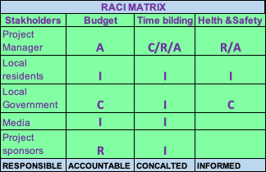

Risk Analysis

Risk assessment is an important part of project management, as it helps to identify potential problems and prepare solutions in advance. It reduces uncertainty and supports better decision-making during the project lifecycle. Effective risk management involves identifying, analysing, and responding to potential risks to reduce their impact on project objectives (Kerzner, 2022; Hopkin, 2018). Key risks in this project include delays caused by bad weather, increases in project costs, and shortages of materials and workers. In addition, there is a risk of poor communication between teams and possible delays in delivery of construction materials. These risks can directly affect the project schedule, budget, and overall performance. To reduce these risks, several strategies are planned. For example, instead of relying on a single supplier, multiple suppliers will be selected. This reduces the risk of delays or poor-quality materials. In addition, part of the budget will include a contingency allowance to manage unexpected price increases, including fuel costs and material prices. This approach helps to ensure financial stability throughout the project. Labour availability is another critical factor. Due to high demand for skilled workers, competitive salaries and good working conditions will be offered to attract and retain staff. This also helps to avoid delays and ensures that the project can be completed within the planned timeframe. There is also a risk of additional flooding during construction, which may stop work and increase costs. To reduce this risk, construction activities will be scheduled outside peak flood periods where possible, and emergency response plans will be prepared. Clear communication between all stakeholders is essential to prevent misunderstandings and delays. Regular meetings and updates will be used to ensure that all teams are aligned and informed.
Effective risk management helps to minimise negative impacts and supports successful project delivery within the defined time, cost, and scope constraints (APM, 2022; Hillson, 2017)

Figure 6

Risk Identified | Likelihood (Low / Medium / High) | Impact on Project | Mitigation Strategy
Increasingg material prices | High | The project may take longer to complete | Use several alternative suppliers and order some materials in advance.
Lack of workers during construction | High | The project may go over budget | Have additional budget and monitor costs regularly.
Additional flooding during construction | Medium | The project schedule may be delayed and costs may increase | Schedule construction work outside the peak flood period
Delay in delivery of construction materials | Medium | Building work may take more time than planned. | Hire additional workers and plan the workforce in advance
Poor communication between project teams and authorities | Medium | Confusion and delays in the project | Hold regular meetings and keep clear communication
Accidents on the construction site | Low | Workers may get injured and work may stop | Follow safety rules, provide training, and use protective equipment

Conclusion

This project focuses on restoring essential infrastructure in the affected areas within a relatively short period of time. Repairing roads, drainage systems, utilities, and public buildings will allow residents to regain access to transport, healthcare, education, and other important services. The project involves a wide range of stakeholders, including local government, national authorities, residents, local businesses, and emergency services. Their involvement is important for effective coordination, decision-making, and successful delivery of the project outcomes. The using of project management tools, such as Work Breakdown Structure, Gantt chart, stakeholder analysis, and risk assessment, supports effective planning and organisation of the project. These tools help to manage resources, control risks, and ensure that all activities are completed in a structured and efficient way.
A clear project plan improves coordination between stakeholders and helps to achieve project objectives within the defined time and budget constraints (Association for Project Management, 2022). The project contributes to community recovery, improves safety, supports economic activity, and ensures long-term stability in the West Midlands region.

References

Association for Project Management (2022) What is project management? Available at: https://www.apm.org.uk/resources/what-is-project-management/ (Accessed: 16 April 2026).

APM (2022) Risk management. Available at: https://www.apm.org.uk/resources/what-is-project-management/what-is-risk-management/ (Accessed: 25 April 2026).

Environment Agency (2023) Flood and coastal risk management in England. Available at: https://www.gov.uk/government/organisations/environment-agency (Accessed: 25 April 2026).
Hillson, D. (2017) Practical project risk management: the ATOM methodology. 3rd edn. Vienna: Management Concepts.

Hopkin, P. (2018) Fundamentals of risk management. 5th edn. London: Kogan Page.

Jeong, Jaemin and Jeong, Jaewook (2021) “Novel approach of the integrated work & risk breakdown structure for identifying the hierarchy of fatal incident in construction industry,” Journal of Building Engineering, 41. Available at:https://doi.org/10.1016/j.jobe.2021.102406.

Internet Geography (2024) River Severn flood case study. Available at: https://www.internetgeography.net (Accessed: 26 April 2026).

Interreg (2024) Enhancing stakeholder engagement through the power-interest matrix. Available at: https://www.interreg-central.eu/news/enhancing-stakeholder-engagement-through-the-power-interest-matrix/ (Accessed: 25 April 2026).
ISO (2018) ISO 31000: Risk management – Guidelines. Geneva: International Organization for Standardization.

ProjectManager (2025) The triple constraint in project management: time, scope and cost. Available at: https://www.projectmanager.com/blog/triple-constraint-project-management-time-scope-cost (Accessed: 25 April 2026).

Vázquez-López, E., Solís-Guzmán, J. & Marrero, M. 2024, "A Work Breakdown Structure for Estimating Building Life Cycle Cost Aligned with Sustainable Assessment—Application to Functional Costs", Buildings, vol. 14, no. 4, pp. 1119.

Ford, J.D. and Wei, T. (2015) ‘Quad charts in the classroom to reinforce technical communication fundamentals’, Journal of Technical Writing and Communication, 45(3), pp. 275–284. Available at: https://doi.org/10.1177/0047281615578848.

