Restaurant and menu design
Student name: Ciprian Anghel (2223637)
Module name: Food and Beverage Operations
Tutor name: Muhammad Cassamo
Assignment title: Menu Engineering
Words counts:403 words

Part 1


Restaurant concept
The “Hotel Trinity Hotel Chain” will be established in Leeds, one of the biggest cities in the United Kingdom in the coming Christmas Eve. The concept of the restaurant is to offer continental and traditional British dishes with contemporary twists. “Vintage royal” is the theme of the future Hotel Trinity in Leeds, and the Logo replicate the theme which will; optimize British tradition and food habits. British are the representation of the art, culture, and royalty and in the modern age to reconstruct the royalty the Vintage theme-based restaurant is planning to be established. The restaurant concepts reflect thew traditional British culture, so that the British visitors can relate with their culture and tradition.

Targeted audiences
The targeted population will be the 0.81 million population of Leeds, where 67% of the population belongs to the age group of 15 to 64, who are the fundamental visitors to explore innovative dishes (Populationdata.org.uk .2023). In Leeds 85.1% of the population is British, this is the reason for the emphasis on traditional British food and the specific theme (Populationdata.org.uk .2023).

The reason behind the menu
Securing the traditions of the British and to optimizes food habits by experiencing traditional foods with continental food types is the prime reason behind the menu. Additionally, to satisfy all the food habits person, and to enhance sustainability and food awareness the menu has been generated by using all organic and fresh ingredients (Wang et al. 2019, p.213).

Sustainability
Organic, fresh ingredients like mushrooms, pulses, seaweeds, vegetables, and fruits will be the core ingredient for the Trinity Hotel (van der Heide et al. 2021, p. 2308). Additionally, zero use of plastic in the Hotel and recycling of packages to manage the waste. The entire charge of electricity will be generated by bioenergy (Salama and Abdelsalam 2021, p. 3103).
Challenges
High competitiveness in Leeds, as there are 360 restaurants in Leeds which are already quite remarkable and are in the first row for the targeted customers' preferences. Additionally, cost management in a new place is another challenge for the hotel (Amin et al. 2020, p. 10164).
Alternative Solution and Recommendation
Execution of a strong supply chain, and self-dependence in the organic food supply, are the alternative solution for the challenges (Anggraini and Tanjung 2020, p. 649). Regarding this, the implantation of global collaboration with stakeholders is the prime recommendation for the Trinity Hotel (de Grosbois and Fennell 2022, p. 104404).

Part 2

Figure: Logo
(Source: Author)
Determination for pricing strategy
Competitor pricing analysis is the fundamental strategy for the future Hotel (Sánchez-Pérez, Illescas-Manzano, and Martínez-Puertas 2020, p. 102364). Dakota Restaurant, Fleur Restaurant, Dastaan Leeds, and others are the key competitors of the future Trinity Hotel, which mainly offers Asian food, and the average price start from 14 GBP to 48.92 GBP in Dakota Restaurant (Tripadvisor 2023). The price range is 19 GBP to 31 GBP in Fleur Restaurant (Tripadvisor 2023). In Dastaan Leeds it starts from 16 GBP to 32 GBP (Tripadvisor 2023). Therefore, to attract the targeted population Trinity Hotel must maintain a wider range (12 GBP to 35 GBP) of price charts.
The impact of the pricing strategy on the targeted audiences by the Trinity Hotel can be a positive turnover for the hotel business as the hotel is planning to offer traditional British, continental food, and others in a lesser price range. The pricing strategy will depend on the quality of the food rather than quantity and attractive combos will be offered at a lesser price to hit the targeted population (Zhong and Moon 2020, p. 464).

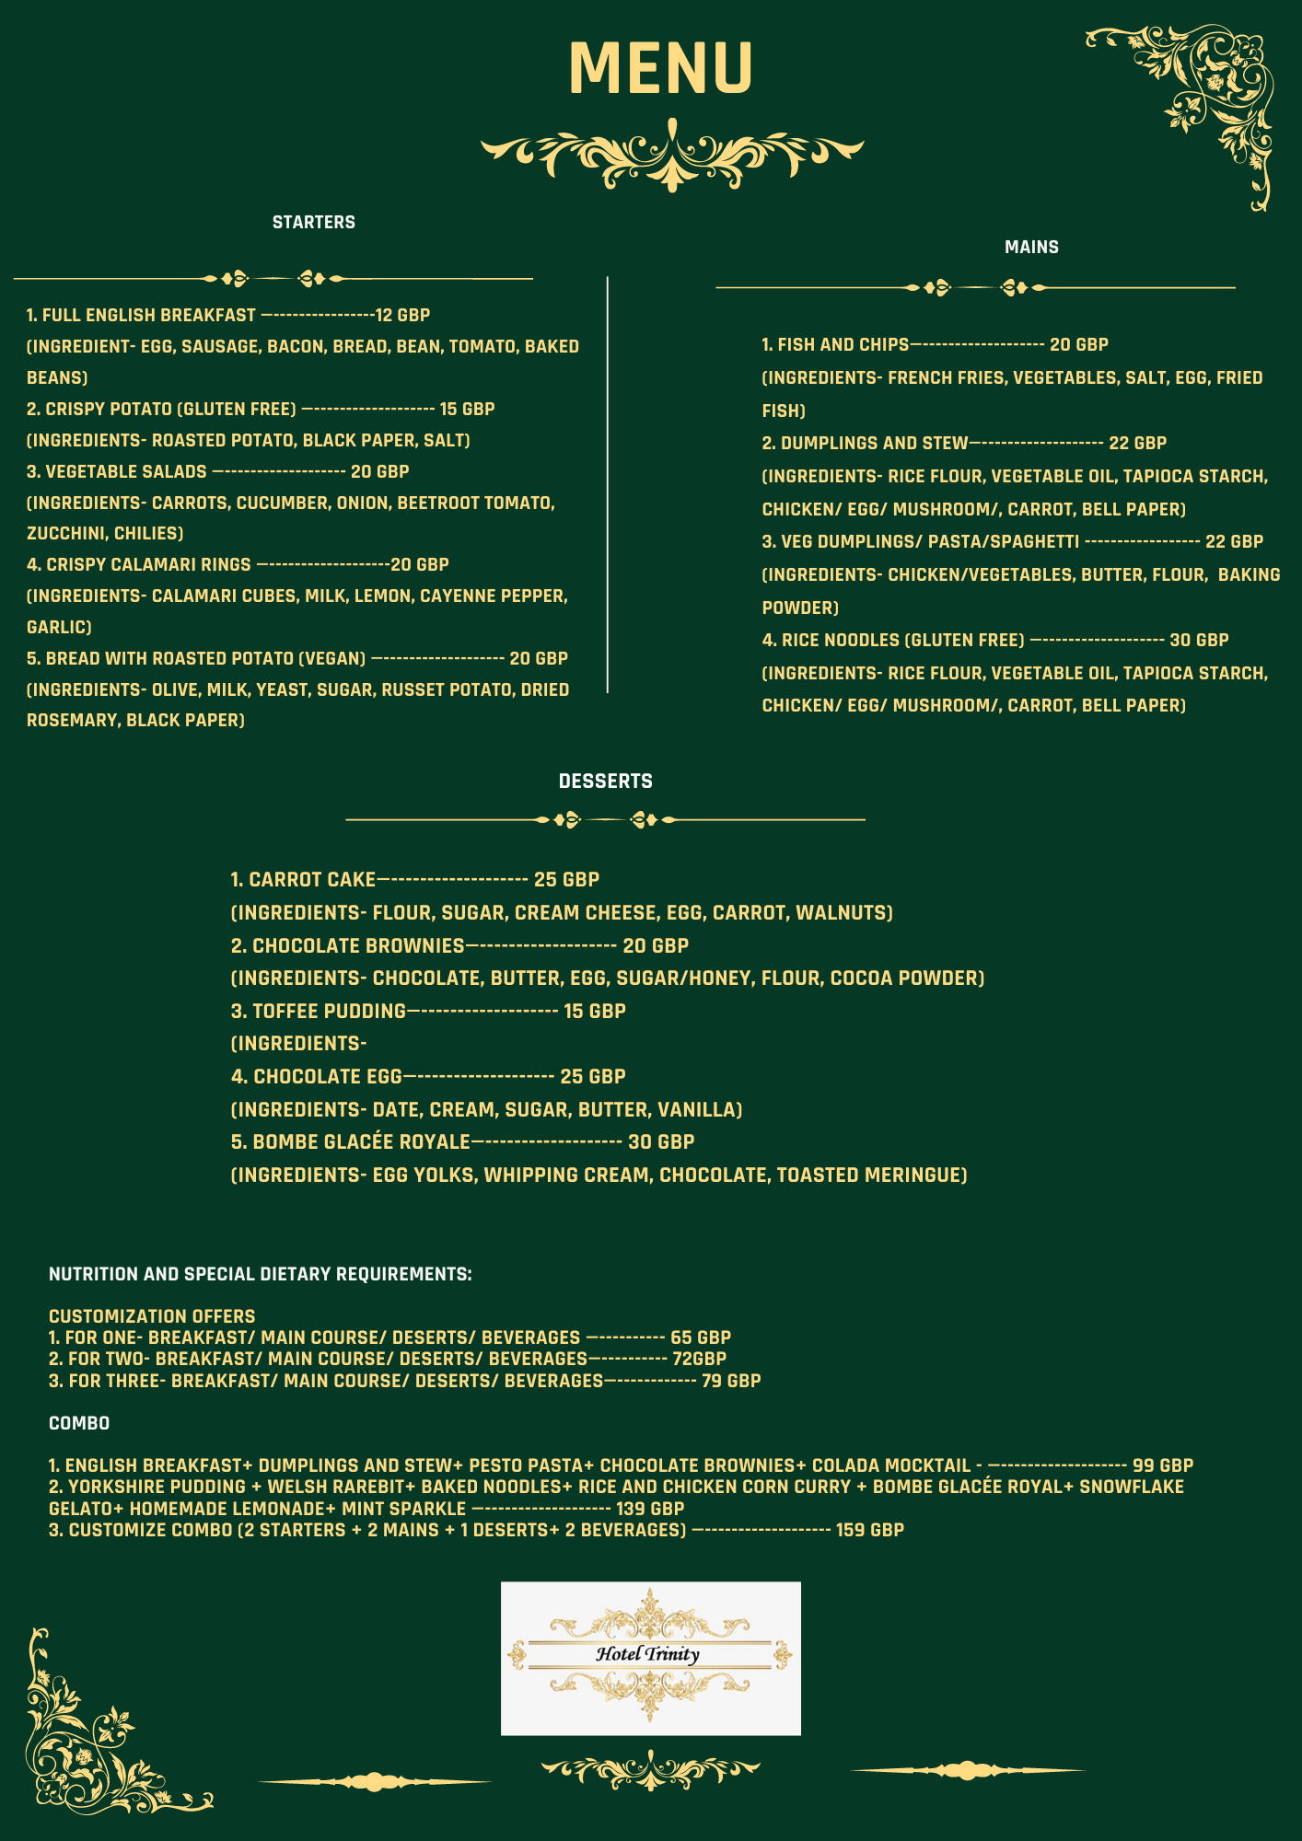
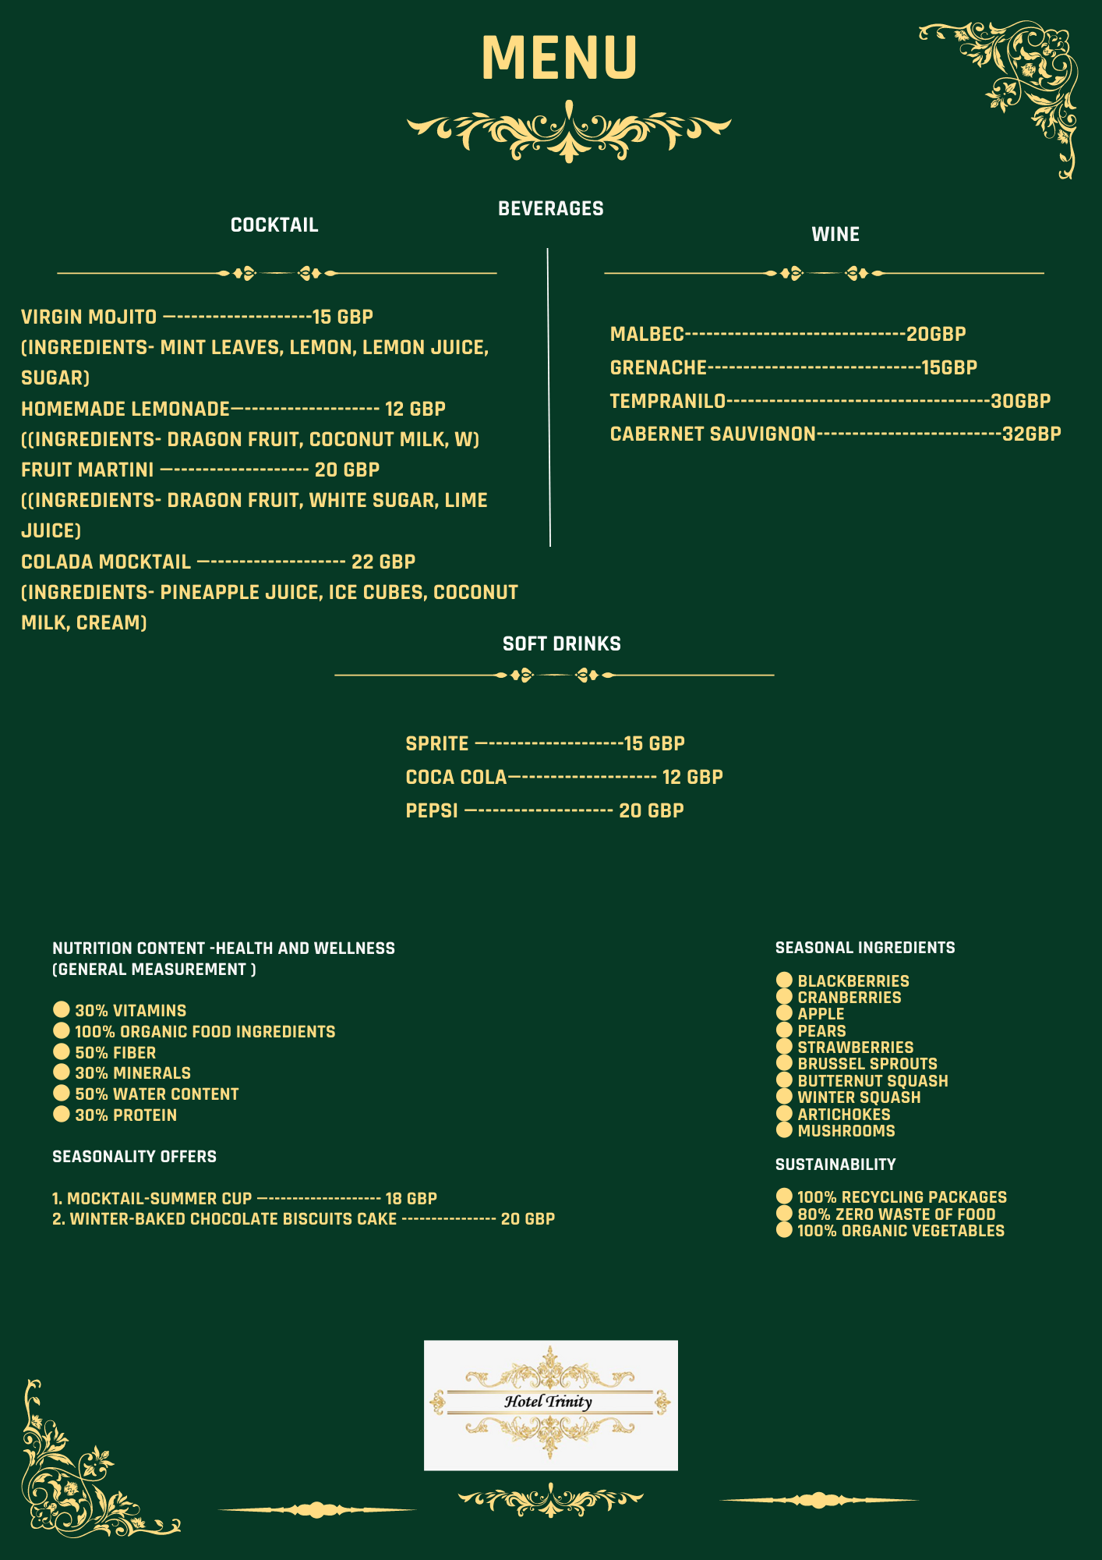
Figure: Menu design
(Source: Author)
Reference

Amin, A., Tareen, W.U.K., Usman, M., Ali, H., Bari, I., Horan, B., Mekhilef, S., Asif, M., Ahmed, S. and Mahmood, A., (2020). A review of optimal charging strategy for electric vehicles under dynamic pricing schemes in the distribution charging network. Sustainability, 12(23), p.10160.
Anggraini, D. and Tanjung, P.R.S., (2020). Company value: Disclosure implications of the sustainable supply chain, profitability, and industrial profile. International Journal of Supply Chain Management, 9(2), pp.648-655.
de Grosbois, D. and Fennell, D.A., (2022). Determinants of climate change disclosure practices of global hotel companies: Application of institutional and stakeholder theories. Tourism Management, 88, p.104404.
Populationdata.org.uk .(2023). Leeds population 2023. Available at: https://populationdata.org.uk/leeds-population/(accessed on: 31.2.2023)
Salama, W. and Abdelsalam, E., (2021). Impact of hotel guests’ trends to recycle food waste to obtain bioenergy. Sustainability, 13(6), p.3094.
Sánchez-Pérez, M., Illescas-Manzano, M.D. and Martínez-Puertas, S., (2020). You’re the only One, or Simply the Best. Hotels differentiation, competition, agglomeration, and pricing. International Journal of Hospitality Management, 85, p.102362.
Tripadvisor (2023). Dakota restaurant Available at: https://www.tripadvisor.in/Restaurant_Review-g186411-d12281618-Reviews-Dakota_Restaurant-Leeds_West_Yorkshire_England.html (accessed on: 31.5.2023)
Tripadvisor (2023). Dastaan Leeds. Available at:https://www.tripadvisor.in/Restaurant_Review-g186411-d24980397-Reviews-Dastaan_Leeds-Leeds_West_Yorkshire_England.html(accessed on: 31.5.2023)
Tripadvisor (2023). Fleur restaurant Available at:https://www.tripadvisor.com/Restaurant_Review-g186411-d19845206-Reviews-Fleur_Restaurant_and_Bar-Leeds_West_Yorkshire_England.html(accessed on: 31.5.2023)
van der Heide, M.E., Stødkilde, L., Værum Nørgaard, J. and Studnitz, M., (2021). The potential of locally-sourced European protein sources for organic monogastric production: A review of forage crop extracts, seaweed, starfish, mussel, and insects. Sustainability, 13(4), p.2303.
Wang, X., Pacho, F., Liu, J. and Kajungiro, R., (2019). Factors influencing organic food purchase intention in developing countries and the moderating role of knowledge. Sustainability, 11(1), p.209.
Zhong, Y. and Moon, H.C., (2020). What drives customer satisfaction, loyalty, and happiness in fast-food restaurants in China? Perceived price, service quality, food quality, physical environment quality, and the moderating role of gender. Foods, 9(4), p.460.

