DIGITAL SKILLS AND RESEARCH METHODS
Name of the student: Name - Zaheed Ullah
Name of the university: University Wales Trinity Saint David
Student’s ID: 1814933

Contents
Introduction 3
Overview of the use of Digital Technology in the workplace 4
Use of Technology in the workplace during Covid-19 Pandemic 8
Benefits of Digital Technology in the workplace 10
Disadvantages of the use of Digital Technology in the workplace 12
Conclusion 14
References 16

Introduction
Digital technology is one of the philanthropies of the new world. The concept has its application in almost every sector of human society such as the educational field, government offices, public or private enterprises, etc. The Application of digital technologies in the workplace has enabled companies to identify new and effective ways of working. It enhances the engagement of the employees and their agility and helps the company to exploit the technologies and the customer-driven styles. Therefore, digital solutions at the workplace mainly represent the natural evolution of the workplace. It gathers various technologies, tools, and platforms for digital employees for being able to deliver the best results. These Digital technologies create a centralized warehouse for the employees to have the access to the relevant information and to perform their responsibilities regardless of where they are placed or the device they use. Digital technology provides a great variety of fast and new tools of communication such as video conferencing, collaborative tools that are used on a real-time basis, instant messages, and community or internet board. All of these technologies combined need to reduce the overall time spent by the people to gain access to information. Besides, this new aspect or way of business enhances the transparency within the organization.

Overview of the use of Digital Technology in the workplace
Digital technology provides a series of tools that are effectively used by organizations today for digitizing the method of work. There are mainly six important technologies that are mainly used in the workplace.
Cloud storage tools
The amount of data that is created daily within an organization is huge and its organization for easy accessibility and appropriate insights is important. A system of document management in the cloud can serve as one of the effective ways of managing such data (Menig et al., 2019). This system of document management provides other facilities such as a platform for adaptive learning for the employees where the information can be accessed sequentially; power search features for making it easy to access the information throughout the organization. These systems have gradually evolved into robust alternatives, which also offer analytics features from all forms of structured data.
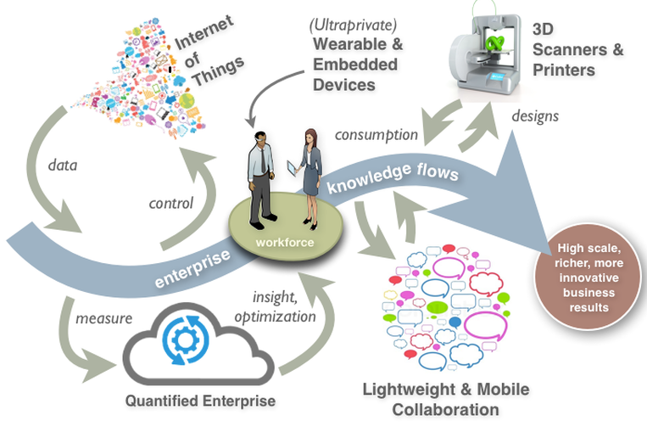
Figure 1: Digital Technologies
(Source: Brown et al., 2020)
Social and collaborative tools
Earlier, the companies mainly depended on the conventional communication system in the business. However, the level of engagement then created was not effective for the organization (Brown et al., 2020). Therefore, the concept of instant messaging and chat apps have been used for one-to-one conversations in the entity. This type of collaborative tool is more effective for employees who are placed in geographically different areas. The best platforms of instant messaging also have video and audio capabilities for effective collaboration. They also have enhanced automated responses, boards, and artificial intelligence. Besides, cloud-based file system solutions are also the other alternatives available for collaborative services within businesses (Kuczabski et al., 2021). The cloud-based storage and sharing of information with synced data across the devices help in effective collaborations.
Chatbots: Chatbot is one of the effective solutions for both internal and external collaborations. The solutions offer self-service capabilities to the employees for HR and other firm desk functions. It enhances the accessibility of resources within organizations. It reduces the overall cost of customer service by around 30% (Castillo et al., 2019). It provides quick responses to do queries of the customers and saves time in attending to the unique challenges in day-to-day operations.
Cyber security tools
With the advancement of technology, the bigger concern for organizations today is the breach of data. Therefore, the company is continuously trying to increase security. The cyber security tools arrow cloud please applications, which in hands is the security of the data, stored within the organizational premises. The breaches happening both external and internal to the organization can be easily prevented by using such tools (Ifenthaler et al., 2018). The internal breach of data can be prevented by creating restrictions on the accessibility of sensitive data. Email phishing is one of the important channels of safeguarding external attacks on data security. This significantly reduces the risk of data exploits through external sources.
Data analytics tools
The data analytics tools have received their hi-end application within the companies, which are available from many vendors. This tool provides an insight both on customer and employees scale and related to the workplace. The power of analytics applies to the end-users even without any prior expertise in managing data sciences (Haddud et al., 2018). The application of these tools at an individual level can provide information about the level of expertise of the employees. The leaders, in an organization, can know and administer the expertise of the employees for managing the teams. They can also identify the skill gap with better visibility.
The series of new tools that are being introduced in the workplace provides a better opportunity for control and insights by the organizations.
Application of artificial intelligence
Sentiment analysis is one of the important tools, which are finding its application in customer support, marketing, and other internal operations. These provide very precise predictions about personal emotions (Wenker et al., 2022). The customer thoughts can also be appropriately predicted by using these artificial intelligence alternatives for deciding on the type of service to be provided to the customers
Virtual assistants
Virtual assistants are a substitute for personal assistance, which assists employees in their daily tasks. It observes the behaviors of the users and suggests the appropriate actions that are to be taken by them at the right time (Brown et al., 2020). It also helps to automate the task of accessing information.
IoT
IoT is one of the primary alternatives available for the integration of devices and networks within the workplace for an automated flow of work. It ensures that all the operations are run smoothly and on a real-time basis. It helps to create a coordinated work that runs itself.

Use of Technology in the workplace during Covid-19 Pandemic
The outbreak of the COVID-19 pandemic has accelerated the requirement for virtual reality in the place of work, mainly due to the inability of physical collaborations. Virtual reality refers to a situation or connection, which provides efficiencies and time savings in the workplace (Marklund et al., 2019). The outbreak of Covid-19 disease has elevated the application of digital technology in the workplace. Almost all the organizations around the world largely relied on such technologies for conducting business for limiting face-to-face contact.
Application of Various digital tools by employers
The sudden lockdown around the work as a preventative measure against Covid-19 brought the operations to a halt. The organizations during this time realized that with the help of digital technologies the operations could be undertaken without physical contact. The use of Artificial Intelligence helped organizations recruit and onboard employees (Castillo et al., 2019). The team management tools helped the employers to keep a track of the tasks performed by the employees. The maintenance of digital attendance schedules and work schedules helped to monitor the performance of the employees. The team managers also used tools to promote the productivity of the employees. The designed tools laid down the appropriate work schedules along with the precise timing of tasks and the breaks in between tasks.
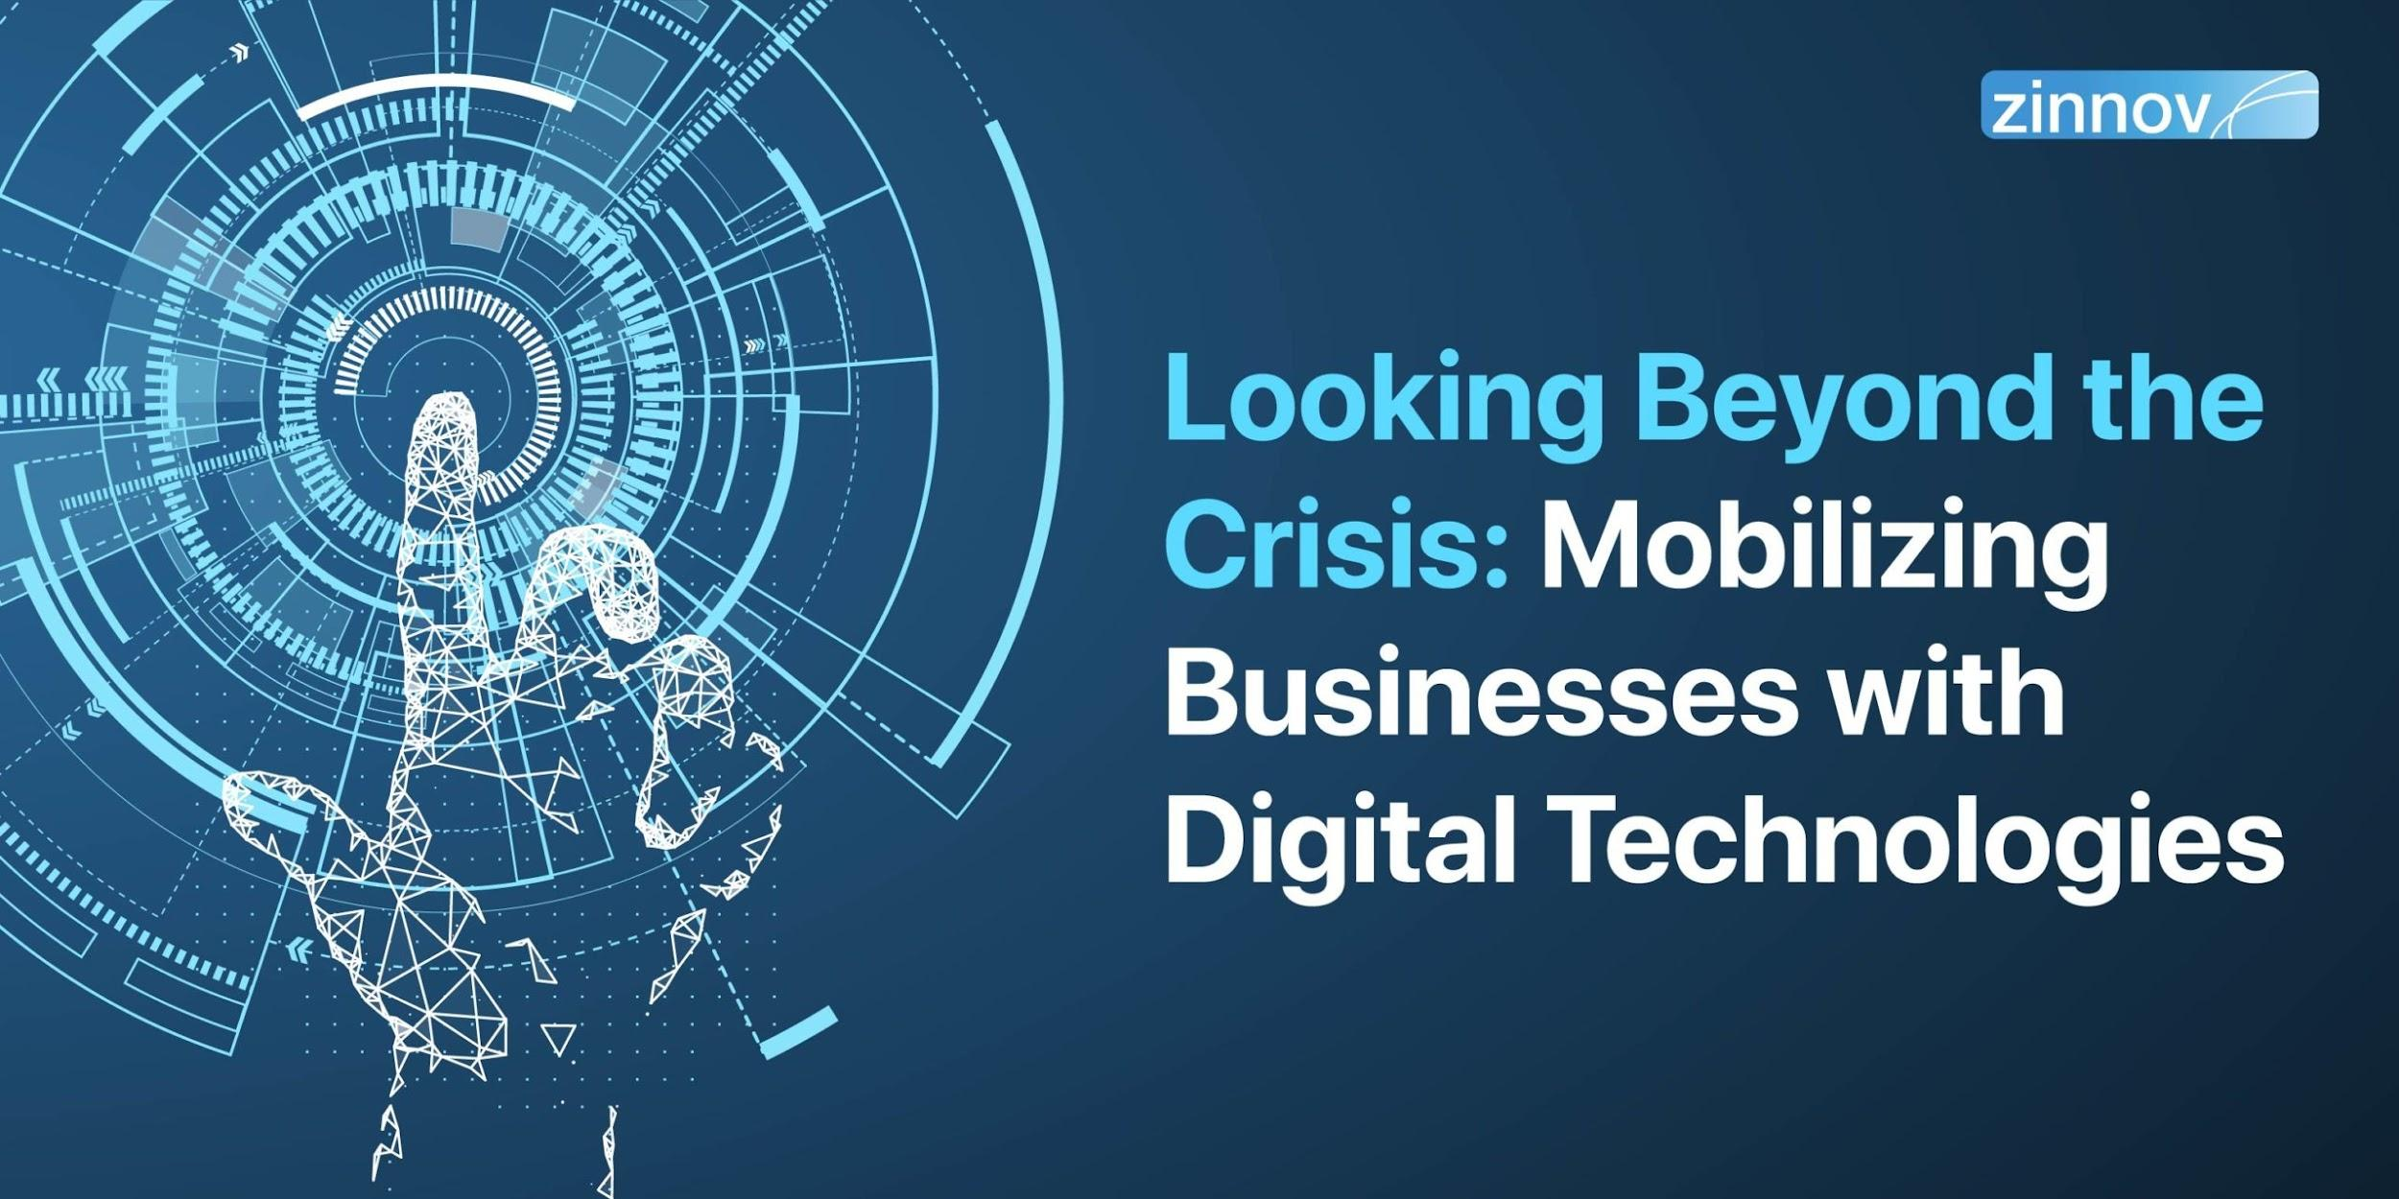
Figure 2: Digital Technologies during Covid-19 Crisis
(Castillo et al., 2019)
Reinvention of meetings
The use of digital technologies at the workplace helped the managers to conduct quick meetings for proper monitoring of work performed. The virtual meetings provided flexible timing for attending the meeting to undertake significant discussions (Gkinko and Elbanna, 2021). Besides, frequent meetings helped to resolve the issues quickly for better operations of the organization.
Better Customer Responses
The use of digital technologies during Covid-19 fastened the channels of responding to customer queries. Since the transparency of the channel of communication was enhanced by the digital technologies, the customer's queries were met better.

Benefits of Digital Technology in the workplace
The use of digital technology in businesses has been greatly appreciated for the level of efficiency it provides to its owners (Cijan et al., 2019). Therefore, the benefits of the digital technology in the workplace can be summarised as below:
Enhanced transparency in internal collaboration and communication
The application of digital technology within companies is opening new communication flows. It provides new opportunities for keeping in touch with the management and the peers on a real-time basis. This alternative provides new and fast communication tools like video conferencing, instant messaging, internet boards, etc (Hughes et al., 2019). All of these reduce the time employees spend searching for the information and enhance the transparency among organizations.
Enhances employee experience and engagement
Digital technologies enhance the work culture to improve the productivity of the employees and the performance of the business. With the use of these alternatives, the companies can act based on employee feedback for fostering better relationships. It helps to find new ways of boosting employee engagement and satisfaction.
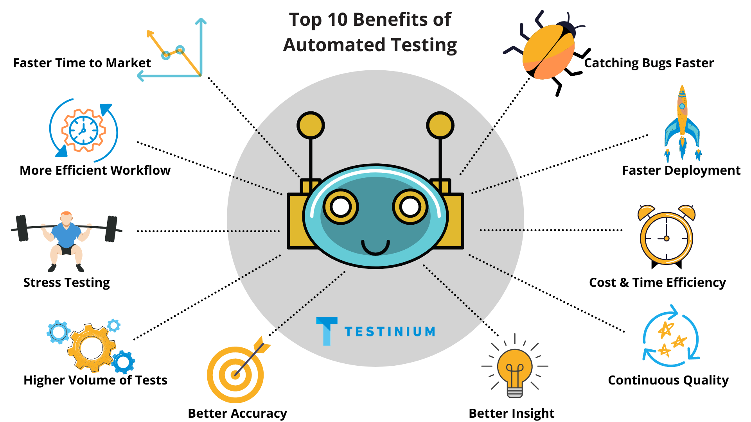
Figure 3: Benefits of Digital Technologies
(Williams et al., 2018)
Better accessibility and sharing of knowledge
The digital solutions provide a centralized hub for information storage and documentation. Therefore, this provides easy accessibility to the knowledge that the employees usually look for while performing the tasks (Williams et al., 2018). It reduces the time that the employee is required to look for specific information.
Improve customer satisfaction
The digital solutions help to enhance the overall experience of their employees by making it easier for the team members to find the information about the customers on a real-time basis. The centralized management of this information helps to provide better customer service (de Jong et al., 2020). With enhanced services, the organization sustains a win-win position to boost the profits
Enhanced remote work capacity
Digital solutions provide access to data from remote geographical situations. Therefore, it provides an opportunity for the employees to work from remote areas with utmost ease and flexibility.

Disadvantages of the use of Digital Technology in the workplace
The benefits of using digital technology are immense in the workplace. However, certain disadvantages limit its application in practical life.
Issues related to the use of technology
Digital Technology has given impetus to virtual reality. Therefore, due to the lack of face-to-face setup, it is difficult to resolve technological issues. The connectivity issues can also restrict the application of the resource (Kuczabski et al., 2021). Besides, the employees can also fail to understand and adapt to the new technologies.
Reduced Team Bonding
Team bonding at the place of work is also reduced with the use of digital technology. The absence of face-to-face communication restricts workplace employee collaboration and conversations. Mutual understanding and helping are wiped off in the digital workplace, which is negative to the effective working of the companies.
Dependency on the computer system
In a digital workplace, the employees mainly depend on the technologies for the accomplishment of the goals. Any technical glitch can cause the entire system to come to a halt causing unplanned delays in operations (Ifenthaler et al., 2019). In the case of businesses that solely depend on the computer system, it is impossible to run the business without resolving the glitch.
Obsolescence of Technology
Technological upgrades are quite frequent in the digital workplace. The frequent changes in the technology require upgrades in the systems that the organizations use. Therefore, the process of upgrades can be a costly as well as time-consuming process. Besides, significant changes in the technology require proper training, which is again costly to the organization.
Privacy Concerns
The maintenance of privacy in digital technology is a difficult task for organizations. The maintenance of personal privacy is almost impossible when using digital technologies (Attaran, 2020). Therefore, the risk of a data breach is prevalent in the case of digital applications.
Cyber Crimes
Digital Technology is the epicenter of malicious activities by data intruders. The digital solutions may contain certain loopholes that provide an opportunity for cybercriminals to perpetrate in the system and cause significant harm to the data and information.

Conclusion
Digital technology is one of the blessings of scientific discoveries. Various tools applied by the organizations to automate their processes have significantly enhanced the efficiencies. The employees are not integrated with the help of the systems. The sharing of information among the employees has also become easy. The employees can gain access to information from remote places. Therefore, the business responses to environmental situations have also increased. The use of digital technologies in the workplace has improved customer engagement. Digital technologies have also helped organizations bridge the gaps in the physical presence of the workers during the Covid-19 pandemic. During the Covid-19 pandemic, the use of digital technology in the workplace gained immense popularity. However, such technologies have high costs of maintenance. Therefore, it is difficult for small-scale organizations to maintain such systems with limited budgets. Besides, the loopholes of digital technologies also restrict their application in the organization. Such technologies require huge investments for safeguarding against their inherent faults. Therefore, it can be concluded that digital technologies have been a smart solution for enterprises. However, its application can be successful only with continuous monitoring of the system implementation and checks.

References
Attaran, M., (2020), July. Digital technology enablers and their implications for supply chain management. In Supply Chain Forum: An International Journal (Vol. 21, No. 3, pp. 158-172). Taylor & Francis.
Brown, J., Pope, N., Bosco, A.M., Mason, J. and Morgan, A., (2020). Issues affecting nurses' capability to use digital technology at work: An integrative review. Journal of clinical nursing, 29(15-16), pp.2801-2819.
Castillo, J., Galy, E., Thérouanne, P. and Do Nascimento, R., Study of the mental workload and stress generated using digital technology at the workplace. In H-Workload (2019): 3rd International Symposium on Human Mental Workload: Models and Applications (Works in Progress) (p. 105).
Cijan, A., Jenič, L., Lamovšek, A. and Stemberger, J., (2019). How digitalization changes the workplace. Dynamic relationships management journal, 8(1), pp.3-12.
de Jong, A., Donelle, L. and Kerr, M., (2020). Nurses’ use of personal smartphone technology in the workplace: scoping review. JMIR mHealth and uHealth, 8(11), p.e18774.
Gkinko, L. and Elbanna, A., (2021), September. AI in the Workplace: Exploring Chatbot Use and Users’ Emotions. In Conference on e-Business, e-Services and e-Society (pp. 18-28). Springer, Cham.
Haddud, A. and McAllen, D., (2018), August. Digital workplace management: exploring aspects related to culture, innovation, and leadership. In 2018 Portland International Conference on Management of Engineering and Technology (PICMET) (pp. 1-6). IEEE.
Hughes, C., Robert, L., Frady, K. and Arroyos, A., (2019). A Hiring Paradigm Shift through the Use of Technology in the Workplace. In Managing Technology and Middle-and Low-skilled Employees. Emerald Publishing Limited.
Ifenthaler, A., (2019). Deconstructing Paper-Lined Cubicles: Digital Literacy and Information Technology Resources in the Workplace. Int. J. Adv. Corp. Learn., 12(3), pp.5-13.
Ifenthaler, D. ed., (2018). Digital workplace learning: Bridging formal and informal learning with digital technologies. Springer.
Kuczabski, M.J., (2021). Threats associated with digital technology in the workplace.
Marklund, L., (2019). Swedish preschool teachers’ perceptions about digital play in a workplace-learning context. Early years, pp.1-15.
Menig, A., Zimmermann, V. and Vogt, J., (2019). Digital transformation of the workplace–risk or opportunity?. DIGITALISATION AND COMMUNICATION: SOCIETAL TRENDS AND THE CHANGE IN ORGANISATIONS, p.29.
Wenker, K., (2022). A Systematic Literature Review on Persuasive Technology at the Workplace. arXiv preprint arXiv:2201.00329.
Williams, S.P. and Schubert, P., (2018). Designs for the digital workplace. Procedia computer science, 138, pp.478-485.

